上机1
对线程的理解：
package com.captain.demo;

import java.util.ArrayList;
import java.util.List;

public class ThreadMain {
public static void main(String[] args) {
//第一个的演示示例
List<String> list = new ArrayList<>(1000);
for(int cnt=0;cnt<1000;cnt++){
list.add("abc");
list1.add("abc");
}
ThreadSafeDemo1 demo1 = new ThreadSafeDemo1(list);
ThreadSafeDemo1 demo2 = new ThreadSafeDemo1(list);
Thread thread1 = new Thread(demo1);
Thread thread2 = new Thread(demo2);
thread1.start();
thread2.start();
}
}
package com.captain.demo;

import java.util.Iterator;
import java.util.List;
import java.util.Random;
import java.util.concurrent.TimeUnit;

public class ThreadSafeDemo1 implements Runnable{
private List<String> list;
public ThreadSafeDemo1(List<String> list){
this.list = list;
}
@Override
public void run() {
Random random = new Random();
synchronized(this){
System.out.println("线程："+ random.nextInt());
Iterator<String> iterator = list.iterator();
int cnt = 0;
while(iterator.hasNext()){
iterator.next();
iterator.remove();
cnt++;
try {
TimeUnit.MILLISECONDS.sleep(10);
} catch (InterruptedException e) {
e.printStackTrace();
}
}
System.out.println("移除元素的数量："+cnt);
}
}
}
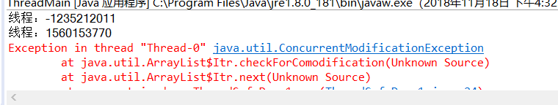
出现问题的原因：
synchronized(this)是锁定当前对象，当声明两个Thread thread1 = new Thread(demo1); Thread thread2 = new Thread(demo2);对象的时候，thread1.start(); thread2.start();启动线程，而因为synchronized(this)的原因两个线程会并行，因为thread1.start()，synchronized锁定的就是thread1这个对象，而thread2.start()锁定的是thread2这个对象，而thread1，thread2又是用的同一个数组，iterator.next调用方法如下：
final void checkForComodification() {
if (modCount != expectedModCount)
throw new ConcurrentModificationException();
}比较modCount和expectedModCount两个是否相等。modCount是ArrayList从AbstractList继承来的属性，可知，modCount表示列表（list）被结构性修改（structurally modified）的次数。structurally modified是指造成列表中元素个数发生变化的操作，ArrayList中的add,addAll,remove, fastRemove,clear, removeRange, ensureCapacity, ensureCapacityInternal, ensureExplicitCapacity等方法都会使modCount加1，而batchRemove,removeAll,retainAll等方法则根据删除的元素数增加modCount的值。而同时对一个数组进行操作的话就会导致modCount和expectedModCount两个值不相等，从而报错。
更改方法1：
将synchronized(this)更改为synchronized(list)，对list锁住，所以每次只有等thread1跑完才会开始跑thread2
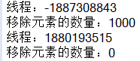
更改方法2：
增加一个数组，使thread1，和thread2指向不同的数组，即使同时操作也没事

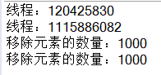

验证synchronized(this)为锁定当前对象

package com.lbs.Syn;

public class MainTest {
public static void main(String[] args) throws InterruptedException {
ObjectService service=new ObjectService();
ThreadB b=new ThreadB(service);
ThreadA a=new ThreadA(service);
b.start();
Thread.sleep(2000);
a.start();
}
}

package com.lbs.Syn;

public class ObjectService {
public void objectMethodA(){
System.out.println("run----objectMethodA");
}
public void objectMethodB(){
synchronized (this) {
try {
for (int i = 1; i <= 10; i++) {
System.out.println("synchronized thread name:"+Thread.currentThread().getName()+"-->i="+i);
Thread.sleep(1000);
}
} catch (InterruptedException e) {
e.printStackTrace();
}
}
}
}

package com.lbs.Syn;

public class ThreadA extends Thread{
private ObjectService objectService;
public ThreadA(ObjectService objectService) {
super();
this.objectService = objectService;
}
@Override
public void run() {
super.run();
objectService.objectMethodA();
}
}

package com.lbs.Syn;

public class ThreadB extends Thread{
private ObjectService objectService;

public ThreadB(ObjectService objectService) {
super();
this.objectService = objectService;
}
@Override
public void run() {
super.run();
objectService.objectMethodB();
}
}
