镜像使用方法（三种办法任意一种都能解决问题，建议使用第三种，将配置写死，下次用的时候配置还在）:

1.通过config命令

npm config set registry https://registry.npm.taobao.org npm info underscore （如果上面配置正确这个命令会有字符串response）

2.命令行指定

npm --registry https://registry.npm.taobao.org info underscore

3.编辑 ~/.npmrc 加入下面内容

registry = https://registry.npm.taobao.org

搜索镜像: [https://npm.taobao.org](https://npm.taobao.org/" \t "_blank)

建立或使用镜像,参考: [https://github.com/cnpm/cnpmjs.org](https://github.com/cnpm/cnpmjs.org" \t "_blank)

npm --registry=https://registry.npm.taobao.org install cnpm -g

官网给出的安装命令：

> brew install node # get node.js > npm install -g appium # get appium > npm install wd # get appium client > appium & # start appium > node your-appium-test.js

/Applications/Appium.app/Contents/Resources/node/bin/node' '/Applications/Appium.app/Contents/Resources/node\_modules/appium-doctor/appium-doctor.js'

info AppiumDoctor ### Diagnostic starting ###

info AppiumDoctor ✔ Xcode is installed at: /Applications/Xcode.app/Contents/Developer

WARN AppiumDoctor ✖ Xcode Command Line Tools are NOT installed!

info AppiumDoctor ✔ DevToolsSecurity is enabled.

info AppiumDoctor ✔ The Authorization DB is set up properly.

info AppiumDoctor ✔ The Node.js binary was found at: /usr/local/bin/node

info AppiumDoctor ✔ HOME is set to: /Users/AA

WARN AppiumDoctor ✖ ANDROID\_HOME is NOT set!

WARN AppiumDoctor ✖ JAVA\_HOME is NOT set!

WARN AppiumDoctor ✖ adb could not be found because ANDROID\_HOME is NOT set!

WARN AppiumDoctor ✖ android could not be found because ANDROID\_HOME is NOT set!

WARN AppiumDoctor ✖ emulator could not be found because ANDROID\_HOME is NOT set!

info AppiumDoctor ### Diagnostic completed, 6 fixes needed. ###

info AppiumDoctor

info AppiumDoctor ### Manual Fixes Needed ###

info AppiumDoctor The configuration cannot be automatically fixed, please do the following first:

WARN AppiumDoctor - Manually configure ANDROID\_HOME.

WARN AppiumDoctor - Manually configure JAVA\_HOME.

WARN AppiumDoctor - Manually configure ANDROID\_HOME and run appium-doctor again.

info AppiumDoctor ###

info AppiumDoctor

info AppiumDoctor Bye, run appium-doctor again when the all the manual fixes have been applied!

info AppiumDoctor

成功后

'/Applications/Appium.app/Contents/Resources/node/bin/node' '/Applications/Appium.app/Contents/Resources/node\_modules/appium-doctor/appium-doctor.js'

info AppiumDoctor ### Diagnostic starting ###

info AppiumDoctor ✔ Xcode is installed at: /Applications/Xcode.app/Contents/Developer

info AppiumDoctor ✔ Xcode Command Line Tools are installed.

info AppiumDoctor ✔ DevToolsSecurity is enabled.

info AppiumDoctor ✔ The Authorization DB is set up properly.

info AppiumDoctor ✔ The Node.js binary was found at: /usr/local/bin/node

info AppiumDoctor ✔ HOME is set to: /Users/AA

info AppiumDoctor ✔ ANDROID\_HOME is set to: /Users/AA/development/android-sdk-macosx

info AppiumDoctor ✔ JAVA\_HOME is set to: /Library/Java/JavaVirtualMachines/jdk1.8.0\_66.jdk/Contents/Home

info AppiumDoctor ✔ adb exists at: /Users/AA/development/android-sdk-macosx/platform-tools/adb

info AppiumDoctor ✔ android exists at: /Users/AA/development/android-sdk-macosx/tools/android

info AppiumDoctor ✔ emulator exists at: /Users/AA/development/android-sdk-macosx/tools/emulator

info AppiumDoctor ### Diagnostic completed, no fix needed. ###

info AppiumDoctor

info AppiumDoctor Everything looks good, bye!

info AppiumDoctor

连接inspect时报错

Could Not Launch Appium Inspector

Could not start a new session

Be sure the Appium server is running with an application opened by using the "App Path" parameter in Appium.app (along with package and activity for Android) or by connecting with selenium client and supplying this in the desired capabilities object.

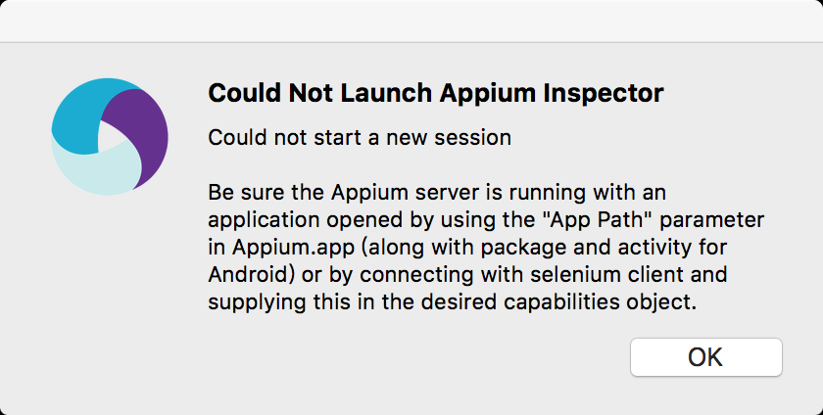

报错的日志

[AndroidDriver] Looking for a device with Android 4.1

[debug] [ADB] Setting device id to adb server version (32) doesn't match this client (36); killing...

[ADB] Getting device platform version

[debug] [ADB] Getting connected devices...

[debug] [ADB] 1 device(s) connected

[debug] [ADB] Running /Users/AA/development/android-sdk-macosx/platform-tools/adb with args: ["-P",5037,"-s","adb server version (32) doesn't match this client (36); killing...","shell","getprop","ro.build.version.release"]

[debug] [ADB] Running /Users/AA/development/android-sdk-macosx/platform-tools/adb with args: ["-P",5037,"-s","adb server version (32) doesn't match this client (36); killing...","shell","getprop","ro.build.version.release"]

[ADB] Error: Error getting device platform version. Original error: Error executing adbExec. Original error: Command '/Users/AA/development/android-sdk-macosx/platform-tools/adb -P 5037 -s "adb server version (32) doesn't match this client (36); killing..." shell getprop ro.build.version.release' exited with code 1{"stdout":"","stderr":"error: device 'adb server version (32) doesn't match this client (36); killing...' not found\n","code":1}

at Object.wrappedLogger.errorAndThrow (lib/logger.js:60:13)

at ADB.callee$0$0$ (lib/tools/adb-commands.js:46:9)

at tryCatch (/Applications/Appium.app/Contents/Resources/node\_modules/appium/node\_modules/babel-runtime/regenerator/runtime.js:67:40)

at GeneratorFunctionPrototype.invoke [as \_invoke] (/Applications/Appium.app/Contents/Resources/node\_modules/appium/node\_modules/babel-runtime/regenerator/runtime.js:315:22)

at GeneratorFunctionPrototype.prototype.(anonymous function) [as throw] (/Applications/Appium.app/Contents/Resources/node\_modules/appium/node\_modules/babel-runtime/regenerator/runtime.js:100:21)

at GeneratorFunctionPrototype.invoke (/Applications/Appium.app/Contents/Resources/node\_modules/appium/node\_modules/babel-runtime/regenerator/runtime.js:136:37)

at run (/Applications/Appium.app/Contents/Resources/node\_modules/appium/node\_modules/babel-runtime/node\_modules/core-js/library/modules/es6.promise.js:104:47)

at /Applications/Appium.app/Contents/Resources/node\_modules/appium/node\_modules/babel-runtime/node\_modules/core-js/library/modules/es6.promise.js:115:28

at flush (/Applications/Appium.app/Contents/Resources/node\_modules/appium/node\_modules/babel-runtime/node\_modules/core-js/library/modules/$.microtask.js:19:5)

at \_combinedTickCallback (internal/process/next\_tick.js:67:7)

at process.\_tickCallback (internal/process/next\_tick.js:98:9)

[Error: Error getting device platform version. Original error: Error executing adbExec. Original error: Command '/Users/AA/development/android-sdk-macosx/platform-tools/adb -P 5037 -s "adb server version (32) doesn't match this client (36); killing..." shell getprop ro.build.version.release' exited with code 1{"stdout":"","stderr":"error: device 'adb server version (32) doesn't match this client (36); killing...' not found\n","code":1}]

[debug] [AndroidDriver] Shutting down Android driver

[MJSONWP] Encountered internal error running command: Error: Error getting device platform version. Original error: Error executing adbExec. Original error: Command '/Users/AA/development/android-sdk-macosx/platform-tools/adb -P 5037 -s "adb server version (32) doesn't match this client (36); killing..." shell getprop ro.build.version.release' exited with code 1{"stdout":"","stderr":"error: device 'adb server version (32) doesn't match this client (36); killing...' not found\n","code":1}

at Object.wrappedLogger.errorAndThrow (lib/logger.js:60:13)

at ADB.callee$0$0$ (lib/tools/adb-commands.js:46:9)

at tryCatch (/Applications/Appium.app/Contents/Resources/node\_modules/appium/node\_modules/babel-runtime/regenerator/runtime.js:67:40)

at GeneratorFunctionPrototype.invoke [as \_invoke] (/Applications/Appium.app/Contents/Resources/node\_modules/appium/node\_modules/babel-runtime/regenerator/runtime.js:315:22)

at GeneratorFunctionPrototype.prototype.(anonymous function) [as throw] (/Applications/Appium.app/Contents/Resources/node\_modules/appium/node\_modules/babel-runtime/regenerator/runtime.js:100:21)

at GeneratorFunctionPrototype.invoke (/Applications/Appium.app/Contents/Resources/node\_modules/appium/node\_modules/babel-runtime/regenerator/runtime.js:136:37)

at run (/Applications/Appium.app/Contents/Resources/node\_modules/appium/node\_modules/babel-runtime/node\_modules/core-js/library/modules/es6.promise.js:104:47)

at /Applications/Appium.app/Contents/Resources/node\_modules/appium/node\_modules/babel-runtime/node\_modules/core-js/library/modules/es6.promise.js:115:28

at flush (/Applications/Appium.app/Contents/Resources/node\_modules/appium/node\_modules/babel-runtime/node\_modules/core-js/library/modules/$.microtask.js:19:5)

at \_combinedTickCallback (internal/process/next\_tick.js:67:7)

at process.\_tickCallback (internal/process/next\_tick.js:98:9)

[AndroidDriver] Cannot shut down Android driver; it has already shut down

黄色部分可以看出由于adb的冲突，启动Inspect失败。发现目录下有两个地方存在platform-tools文件夹。删除一个，重新配置.zshrc文件。启动成功。

[H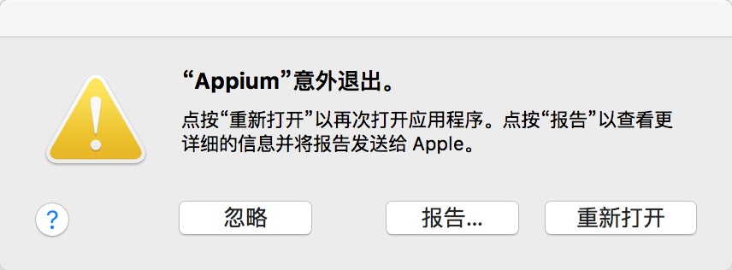 TTP] npm -g --registry http://registry.cnpmjs.org install appium

npm WARN peerDependencies The peer dependency continuation-local-storage@~3 included from cls-bluebird will no

npm WARN peerDependencies longer be automatically installed to fulfill the peerDependency

npm WARN peerDependencies in npm 3+. Your application will need to depend on it explicitly.

npm WARN peerDependencies The peer dependency bluebird@>=1.0.3 included from cls-bluebird will no

npm WARN peerDependencies longer be automatically installed to fulfill the peerDependency

npm WARN peerDependencies in npm 3+. Your application will need to depend on it explicitly.

> appium-selendroid-driver@1.3.4 install /Users/AA/.nvm/versions/node/v5.3.0/lib/node\_modules/appium/node\_modules/appium-selendroid-driver

> node ./bin/install.js

Error: Cannot find module 'yargs'

at Function.Module.\_resolveFilename (module.js:326:15)

at Function.Module.\_load (module.js:277:25)

at Module.require (module.js:354:17)

at require (internal/module.js:12:17)

at Object.<anonymous> (index.js:4:26)

at Module.\_compile (module.js:398:26)

at Object.Module.\_extensions..js (module.js:405:10)

at Module.load (module.js:344:32)

at Function.Module.\_load (module.js:301:12)

at Module.require (module.js:354:17)

at require (internal/module.js:12:17)

at doInstall (/Users/AA/.nvm/versions/node/v5.3.0/lib/node\_modules/appium/node\_modules/appium-selendroid-driver/bin/install.js:12:24)

at Object.<anonymous> (/Users/AA/.nvm/versions/node/v5.3.0/lib/node\_modules/appium/node\_modules/appium-selendroid-driver/bin/install.js:34:3)

at Module.\_compile (module.js:398:26)

at Object.Module.\_extensions..js (module.js:405:10)

at Module.load (module.js:344:32)

\

> appium-chromedriver@2.9.2 install /Users/AA/.nvm/versions/node/v5.3.0/lib/node\_modules/appium/node\_modules/appium-android-driver/node\_modules/appium-chromedriver

> node install-npm.js

info Chromedriver Install Installing Chromedriver version '2.21' for platform 'mac' and architecture '32'

info Chromedriver Install Opening temp file to write chromedriver\_mac32 to...

info Chromedriver Install Downloading http://chromedriver.storage.googleapis.com/2.21/chromedriver\_mac32.zip...

RequestError: Error: read ECONNRESET

at new RequestError (/Users/AA/.nvm/versions/node/v5.3.0/lib/node\_modules/appium/node\_modules/request-promise/lib/errors.js:11:15)

at Request.RP$callback [as \_callback] (/Users/AA/.nvm/versions/node/v5.3.0/lib/node\_modules/appium/node\_modules/request-promise/lib/rp.js:60:32)

at self.callback (/Users/AA/.nvm/versions/node/v5.3.0/lib/node\_modules/appium/node\_modules/request-promise/node\_modules/request/request.js:200:22)

at emitOne (events.js:77:13)

at Request.emit (events.js:169:7)

at Request.onRequestError (/Users/AA/.nvm/versions/node/v5.3.0/lib/node\_modules/appium/node\_modules/request-promise/node\_modules/request/request.js:831:8)

at emitOne (events.js:77:13)

at ClientRequest.emit (events.js:169:7)

at Socket.socketErrorListener (\_http\_client.js:265:9)

at emitOne (events.js:82:20)

at Socket.emit (events.js:169:7)

at emitErrorNT (net.js:1256:8)

at nextTickCallbackWith2Args (node.js:455:9)

at process.\_tickCallback (node.js:369:17)

npm ERR! Darwin 15.3.0

npm ERR! argv "/Users/AA/.nvm/versions/node/v5.3.0/bin/node" "/Users/AA/.nvm/versions/node/v5.3.0/bin/npm" "-g" "--registry" "http://registry.cnpmjs.org" "install" "appium"

npm ERR! node v5.3.0

npm ERR! npm v2.14.15

npm ERR! code ELIFECYCLE

npm ERR! appium-selendroid-driver@1.3.4 install: `node ./bin/install.js`

npm ERR! Exit status 1

npm ERR!

npm ERR! Failed at the appium-selendroid-driver@1.3.4 install script 'node ./bin/install.js'.

npm ERR! This is most likely a problem with the appium-selendroid-driver package,

npm ERR! not with npm itself.

npm ERR! Tell the author that this fails on your system:

npm ERR! node ./bin/install.js

npm ERR! You can get their info via:

npm ERR! npm owner ls appium-selendroid-driver

npm ERR! There is likely additional logging output above.

npm ERR! Please include the following file with any support request:

npm ERR! /Users/AA/npm-debug.log

➜ ~

<-- POST /wd/hub/session 500 5349 ms - 581