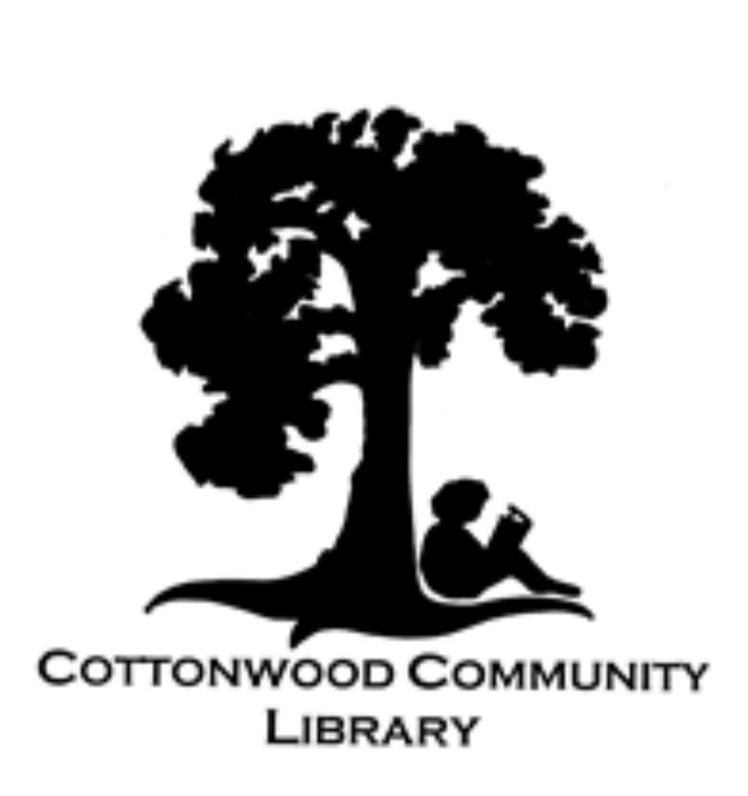
3427 Main Street,
PO Box 1807
Cottonwood, CA 96022
(530) 347-4818

SUMMER 2026

CHECK IT OUT….
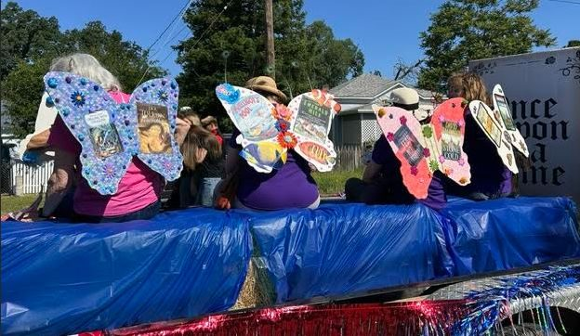
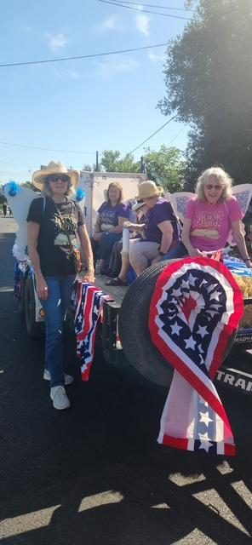
We had so much fun at this year’s Cottonwood Rodeo Parade! The “Book Fairies” sported beautiful handmade wings featuring their literary favorites. If you missed us, you can come see our wings which are hanging on our library’s walls - spreading the magic of reading.

Main Street Readers
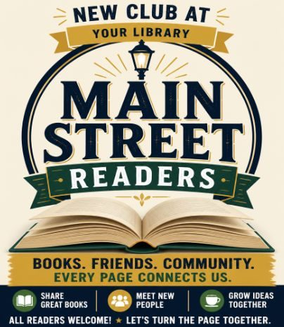
Do you love to talk about books? Are you always looking for great recommendations? Well, Main Street Readers is where you need to be!
This will be an informal group that will meet once a month to discuss the books they loved reading, (and maybe the ones they wished they hadn’t picked up.)
Meetings will be at the library on the third Tuesday of each month, 2:30 pm. Just think, a book club without the homework!
STARTING JUNE 16TH
2:30 pm


Storytime
Bring your little ones in for some great stories, a little bit of singing (and maybe some dancing), a craft and a snack. Wednesdays at 11:30!

Upcoming Themes:
- Manatees
- Red, white, and blue - Happy 250th birthday America!
- The sun
- Turtles
- Beavers
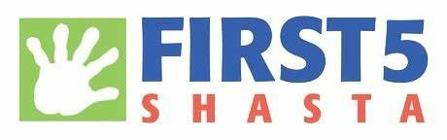
We thank First 5 Shasta for their support!

Our Library. Our Community. Let’s Keep It Covered.
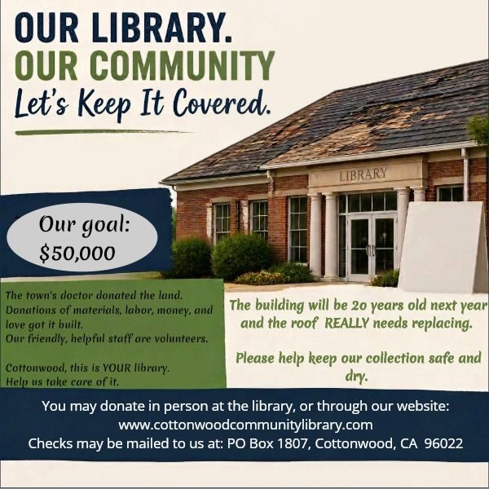
Our goal:
$50,000
The town’s doctor donated the land.
Donations of materials, labor, money, and love got it built.
Our friendly, helpful staff are volunteers.
Cottonwood, this is YOUR library.
Help us take care of it.
The building will be 20 years old next year and the roof REALLY needs replacing.
Please help keep our collection safe and dry.
You may donate in person at the library, or through our website:
www.cottonwoodcommunitylibrary.com
Checks may be mailed to us at: PO Box 1807, Cottonwood, CA 96022

THANK YOU

We are so fortunate to have the level of support that we do in this community. THANK YOU:
- Members First Credit Union for the computers for our computer room. You can’t imagine what a difference they’ve made.
- The Redding Emblem Club #515 for the generous $500 donation.
- First 5 Shasta for their ongoing support of our Storytime program.
- Our remarkable volunteers, without whom we would not exist.

Cottonwood Community Library
3427 Main Street, PO Box 1807
Cottonwood, CA 96022
(530) 347-4818
cottonwoodcommunitylibrary.com
Facebook: Cottonwood Community Library 96022
Instagram: Cottonwood Community Library

OPEN HOURS
Mon 11-5, Tues 11-5
Wed 11-5, Sat 11-2

