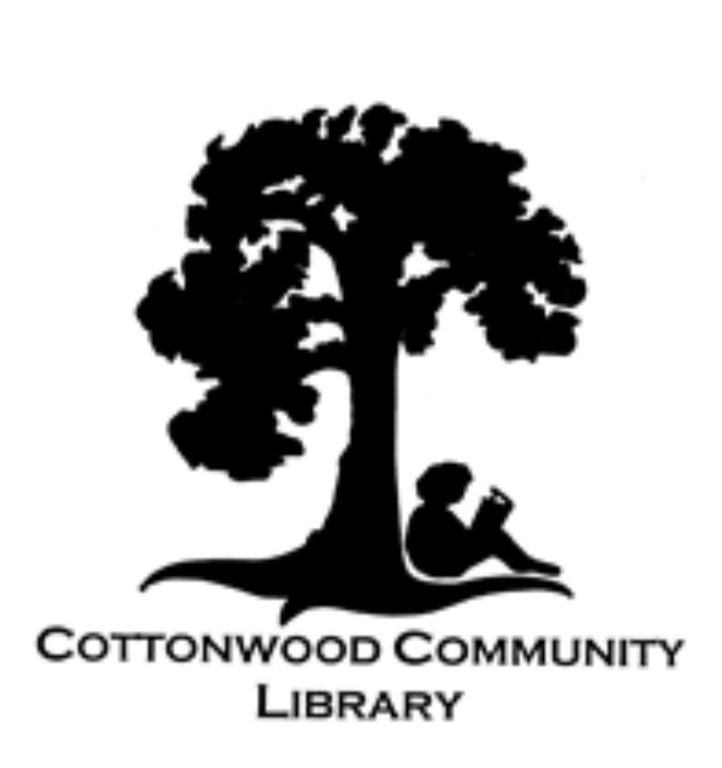
3427 Main Street,
PO Box 1807
Cottonwood, CA 96022
(530) 347-4818

FALL 2026

CHECK IT OUT….

PROTECTING OUR LIBRARY ONE SHINGLE AT A TIME
Our beloved library is nearly 20 years old and its roof is failing. So our focus needs to be on finding the funds for a new roof in order that we may protect the collection of books that we are so proud of. You are going to have opportunities to help us in this by participating in our upcoming online auction and also by “purchasing” a shingle.
Bill Silva built and gifted us a wonderful little birdhouse that we are using to collect donations. A ten dollar donation gets you a tile on the roof. This is a project that really will take a village; if each of our patrons pitched in we could get this library protected in no time.
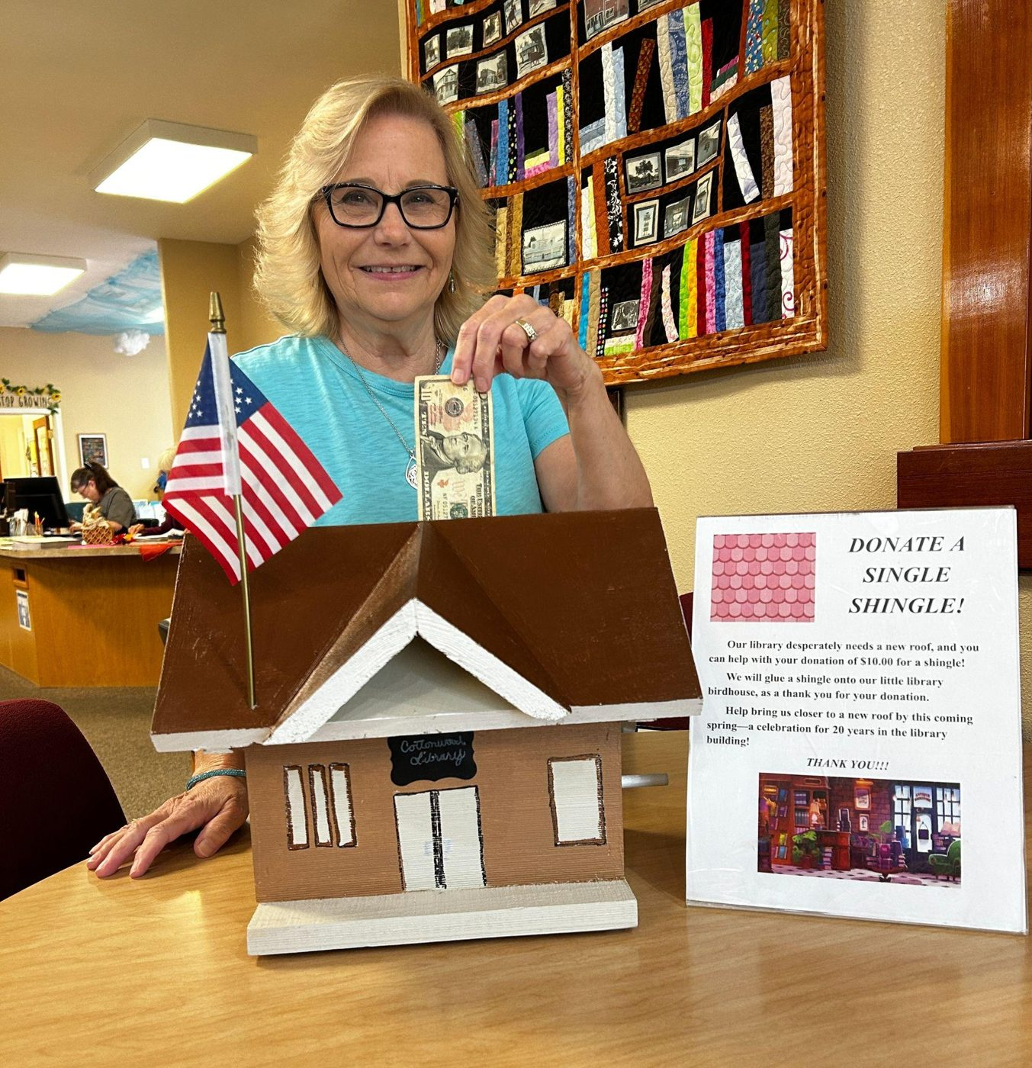
President of the Board of Directors, Donna Mattison, is doing her share.

Storytime
Our popular Storytime program takes place every Wednesday at 11:30 am. It is a lively hour: we read, we sing, we dance a bit, do a craft, and end with a little snack. On October 21st we will be participating in the Shasta Reads event, and then we head into fun with scarecrows, Halloween, and Thanksgiving themes.
As always, we are very grateful to First 5 Shasta as well as to our patron sponsors for helping make Storytime possible .
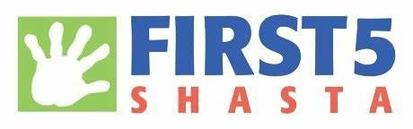

Book Sale
IT’S HUGE THIS TIME!
STARTING OCTOBER 16TH
10 am.
This sale will end Wednesday, October 21st at 5:00 pm

AMAZING DEALS!

NEWS FROM THE BOARD
We are excited to introduce a new Board member, Todd Haines. Todd hails from the Sacramento area, and is now a bonafide Cottonwoodite. His experience on boards will serve the CCL extremely well! Already, Todd has jumped in to lead the charge to revamp our website, which will be ready to roll before the holidays. Welcome, Todd!
As we enter that time of year for giving, we know that you will continue to support the library that Cottonwood built. Now operating for 30 years, all because we wanted to make sure that our little town keeps reading alive, YOU have accepted the challenge to sustain our mission. This year we face the need for a new roof, all while we are preparing to build programs for the community. As you have seen in this newsletter, you have many options for giving, and we appreciate each and every dollar that comes through the doors. Thank you for all that you can give.
Our town, our library, our honor.
With appreciation,
Donna Mattison, President
Cottonwood Community Library

Our Library’s Book Clubs

Our traditional Book Club has been meeting for many years. Participants work together to choose the books they want to read and discuss, then they meet on the third Thursday of each month at 1:00.
Main Street Readers meets every third Tuesday of the month at 2:30 pm. Participants come ready to talk about books that affected them in some way. This is a great way to find your next favorite series or author.
Both clubs are fun and welcoming.

What We’re Looking Forward To
We are in the process of designing a new website! The address will be the same: Cottonwoodcommunitylibrary.com, but the look will be fresh and new.
We are planning another exciting online auction in November. We already have some very high quality items and experiences to auction off. If you have something you’d like to donate, please call Mary Ann at the library. We are a registered non-profit, so your donation may be tax deductible.


Cottonwood Community Library
3427 Main Street, PO Box 1807
Cottonwood, CA 96022
(530) 347-4818
cottonwoodcommunitylibrary.com
Facebook: Cottonwood Community Library 96022
Instagram: Cottonwood Community Library

OPEN HOURS
Mon 11-5, Tues 11-5
Wed 11-5, Sat 11-2

