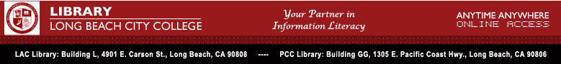

LBCC Library Update # 31



Library Provides Fast, Convenient Access to College Catalogs

Imagine a library of the latest editions of more than 31,000 college catalogs, a virtual library presented in full cover-to-cover, original page format with 2-year, 4-year, graduate, professional and international schools. Imagine the ability to search this remarkable resource by institution name or country, by words in the full text of each catalog’s content, or to search US schools by tuition, enrollment, degrees, or location within a specific radius of a U.S. city.
But that’s not all: besides bringing LBCC students, staff, and faculty up-to-date college catalog information CollegeSource Online has handy links to information that catalog users are also likely to want: Assessment Testing and Preparation, Career Resources, Financial Aid Resources, and College Guides and Planning to name a few.

The CollegeSource Online database is made available through an annual subscription paid for by the LBCC Library. Users must be affiliated with the College and must enter a password and User Name available from either the LAC or PCC Library reference desk.
For more information contact: Nenita Buenaventura, LBCC Library Department Head nbuena@lbcc.edu

