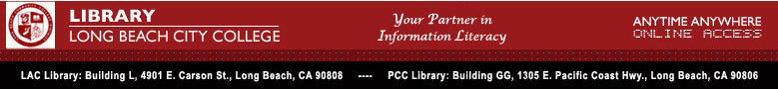

LBCC Library Update # 30


Health & Wellness Resource Center Brings Medical, Nursing and Allied Health Journals to your Desktop

Current, reliable health information isn’t always easy to locate. Web-based resources can be biased, inaccurate, and rife with advertising. That’s why the Library’s health and medical database Health & Wellness Resource Center is so popular with LBCC students and faculty. It integrates the full text and images of respected nursing, allied health, and medical journals, as well as consumer health magazines, newsletters, pamphlets, newspaper articles, and reference books. Articles from more than 600 publications, including more than 40 nursing journals, are provided in full text, and the database also provides articles on alternative medicine and healing therapies. Users have the option to create a marked list of relevant articles, then to print or e-mail them.

Access to Health & Wellness Resource Center is provided through the LBCC Library web page. From any web-enabled pc, point your browser to http://lib.lbcc.edu/ . Click on “Online Databases,” then Health & Wellness Resource Center. Enter the LBCC username and password (available upon request at the LAC or PCC Library reference desk). Then enter your search topic to begin using the database.

In addition to this subscription database, the Library site also will lead you to many trustworthy free sites for additional allied health information. http://lib.lbcc.edu/liblink2.html#NURSING

For more information contact: Nenita Buenaventura, Library Department Head and Electronic Resources Librarian nbuena@lbcc.edu

