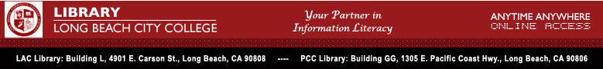

LBCC Library Update # 36

Library Relocation: How will it impact LBCC students, staff, and faculty?

It’s no secret that the LAC Library is going to be remodeled and that this event is fast approaching. Signs of impending construction have begun to appear. Here are the facts, along with some strategies that can help insure that the library’s critical information resources are available to those that need them.

What is the project construction timetable?
- Anticipated start date: June 1, 2007
- Projected completion: December, 2009

What will happen to the book collections during this period?
- Books will be stored in protective off-site facility
- No retrieval of stored items will be possible during construction
- Reserve books (assigned reading) will be accommodated in the interim library facility—up to 5,000 of them
- Academic departments are invited to assume temporary custody of a subject-specific collection (contact Nenita Buenaventura, nbuenaventura@lbcc.edu, for details

Will library services continue to be offered? Where?
- Reference services and library computer research center facilities will relocate temporarily to the basement of the E Building
- Reserve, periodicals, and microtext services will be housed in trailers near the quad

How can I get the information resources I need during the project?
- A large number of the library’s books and journals are digital: access them any time from any web-enabled computer
- The Interlibrary Loan service can obtain needed books and articles from other libraries within 10-14 days
- Despite their own library renovation project, CSULB Library continues to offer reciprocal borrowing to LBCC students and faculty
- 24/7 online reference consultation with a librarian is available on the library web site

“The library staff is committed to making this transition as quick and painless as possible for our customers,” according to Sethuraman Ramchandran, LBCC Libraries Department Head; “We all need to remember that the payoff will be a state of the art, better equipped, and more user-friendly facility in which to deliver library and academic resources services.”



For more information contact: Nenita Buenaventura nbuenaventura@lbcc.edu

