
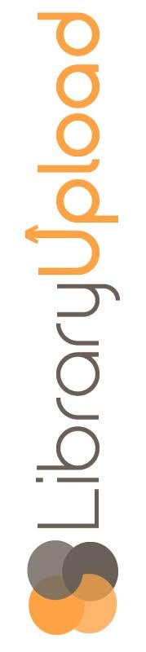
Public
John Q
LibraryUpload 2017
The IT Event for
IT Professionals
in
Public Libraries!
Friday, January 29, 2016,
9:00 a.m. – 3:00 p.m.
Kalamazoo Public Library

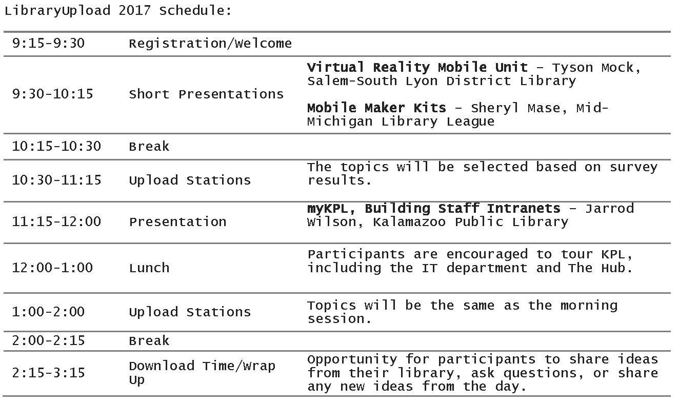
12345000000120

