# Research data management in social sciences and humanities: A survey at the University of Lille (France)

Joachim Schöpfel, GERiiCO laboratory, University of Lille (France) (corresponding author)

Hélène Prost, CNRS, Nancy (France)

<http://libreas.eu/authorguides/>

## Abstract

The paper presents results from a campus-wide survey at the University of Lille (France) on research data management in social sciences and humanities. The survey received 270 responses, equivalent to 15% of the whole sample of scientists, scholars, PhD students, administrative and technical staff (research management, technical support services); all disciplines were represented. The responses show a wide variety of practice and usage. The results are discussed regarding job status and disciplines and compared to other surveys. Four groups can be distinguished, i.e. pioneers (20-25%), motivated (25-30%), unaware (30%) and reluctant (5-10%). Finally, the next steps to improve the research data management on the campus are presented.

## Zusammenfassung

Der Artikel stellt die Ergebnisse einer campusweiten Umfrage an der Universität Lille (Frankreich) über den Umgang mit Forschungsdaten in den Sozial- und Geisteswissenschaften vor. Die Umfrage hatte einen Rücklauf von 270 Antworten, was 15% der gesamten Stichprobe von Wissenschaftlern, Lehrkräften, Doktoranden, administrativen und technischen Personal (Forschungsmanagement, technische Dienste) entspricht; alle Disziplinen sind vertreten. Die Antworten zeigen eine große Vielfalt an Praxis und Nutzung. Die Ergebnisse werden in Bezug auf Berufsstatus und Disziplinen diskutiert und mit anderen Erhebungen verglichen. Vier Gruppen können unterschieden werden: Vorläufer (20-25%), Motivierte (25-30%), Unwissende (30%) und Zurückhaltende (5-10%). Schließlich werden die nächsten Schritte vorgestellt, um das Forschungsdatenmanagement auf dem Campus zu verbessern.

## Introduction

Research data management is a central part of the European Open Science Agenda in the field of research and innovation. For the European Commission (EC),

“‘Open Science’ is the transformation, opening up and democratisation of science, research and innovation, with the objective of making science more efficient, transparent and interdisciplinary, of changing the interaction between science and society, and of enabling broader societal impact and innovation” (Ramjoué 2015, p.169).

‘Open research data’ is one of the key components of the emerging new ecosystem of standards and services, and the EC priorities include “raising awareness regarding data management, interoperability of infrastructure and datasets, and re-usability of data” (*ibid*.). In France, the Conference of University Presidents put the issue of research data preservation and sharing at the top of their priorities during their annual conference in 2015, the Ministry of Higher Education and Research supports and promotes related actions, and all major public research organizations such as the CNRS (Centre national de la recherche scientifique) contribute to the development of data infrastructures and repositories.

The main issues and objectives are the same as in Germany or other countries, i.e. long-term preservation of scientific output and a global policy of open data in order to increase transparency and stimulate research, innovation and economic activity. There is a general consensus about the complexity and the diversity of the field. Not only are research data difficult to define but their handling and processing largely depends on institutional and disciplinary practices and behaviours; obviously, the term research data

“must always be viewed in relation to a particular subject discipline (…) all requirements for the management and long-term availability of research data must be differentiated from each other in regard to both general and discipline-specific aspects and solutions (and) thus far, there is no general agreement on the definition of digital curation, not only in Germany, but on international levels as well” (Neuroth et al. 2013, p.11);

one size does not fit all. Also, organizational or national policies and projects (top-down) require support and back-up from the scientific communities and local structures (bottom-up) to meet the scientists’ needs with success.

“To support the step-by-step development of sound research data management practices, you must first understand researchers’ needs and perspectives” (Ward et al. 2011, p.265). At Lille, we started in 2013 to work in the field of research data management, in particular on the social sciences and humanities campus (Lille 3) with 19,000 students, 580 PhD students, 850 academic and 600 technical staff, in order to gather empirical evidence for the development of data literacy programs and new library-based data services and to raise awareness among scholars and PhD students. This research is conducted together with the GERiiCO laboratory (information, communication and cultural studies), the graduate school and the academic library, with the support of the University’s research department. The following study is work in progress. We present the results of a campus-wide survey on data practices and needs in 2015 and compare them with other studies, including those from Humboldt-Universität zu Berlin (Simukovic et al. 2013, 2014). The complete results have already been published on our institutional repository HAL-Lille 3 (Prost & Schöpfel 2015). The further reading section contains other papers on our research work.

## Methodology

The campus-wide survey was conducted in April and May 2015 (five weeks). The questionnaire contained 22 questions adapted from the survey from Humboldt-Universität zu Berlin mentioned above, comprising six sections: information about the respondent, data typology (sources and results), preservation and backup behaviour, sharing behaviour, opinion and motivation regarding data sharing and data repositories, data-related needs. The questionnaire (in French) was communicated to the whole research community on the social sciences and humanities campus (1,800 persons) in the form of an anonymous online version on a local LimeSurvey server. The data analysis and interpretation was done between June and August 2015, and the data were compared to other results from Berlin (Simukovic et al. 2013, 2014), Strasbourg (Rege 2015, Rebouillat 2015), Iowa (Averkamp et al. 2014), LIBER (Reilly et al. 2011), the European Commission (Kuipers & van der Hoeven 2009, see also Herb 2015) and Austria (Bauer et al. 2015).

## Results

### Response rate

The survey received 270 responses, equivalent to 15% of the whole sample of scientists, scholars, PhD students, administrative and technical staff (research management, technical support services). All scientific departments and research laboratories are represented. Larger and representative sub-samples are from psychology, history, education, information and communication sciences.

Also, all professional groups took part in the survey. The largest group of sub-samples are PhD students (n=73) and senior lecturers (n=69), followed by professors (n=40), scientists (n=16) and other staff (n=13). But the most representative group are professors (26%), followed by senior lecturers (17%) and PhD students (13%).

All respondents were asked to answer to the whole list of 22 questions but no question was obligatory. Multiple answers were allowed for most questions. As a result, no question received 100% answers, and the response rate per question varies between 12% and 82%.

### Current research data management

One part of the questions was about research data behaviour – which kind of data are used and produced, how they are stored, preserved, safeguarded; and how they are shared with other researchers. The responses show a wide variety of practice and usage.

#### Data sources

The survey identified text documents as the most important data source, followed by observations, interviews and survey data (figure 1).

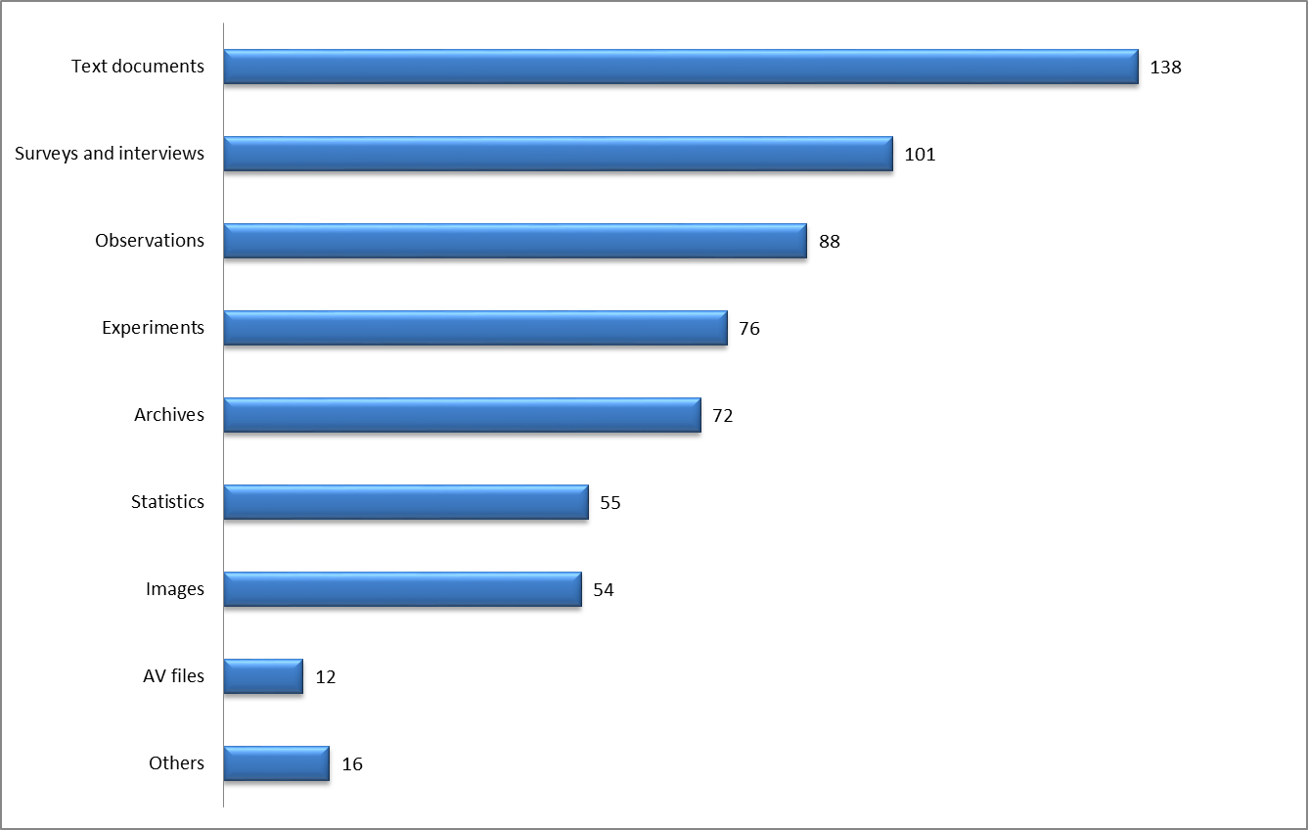

Figure 1: Research data sources (n=214)

Other, less important data sources are experiments, archival material, statistics, images, and audio and video recordings, while log files or simulations are missing, at least in our sample.

#### Data types

Figure 2 shows the research data produced by the respondents. Again, text documents are the most important output type, followed by spreadsheets, databases, multi-dimensional visualisations and models.

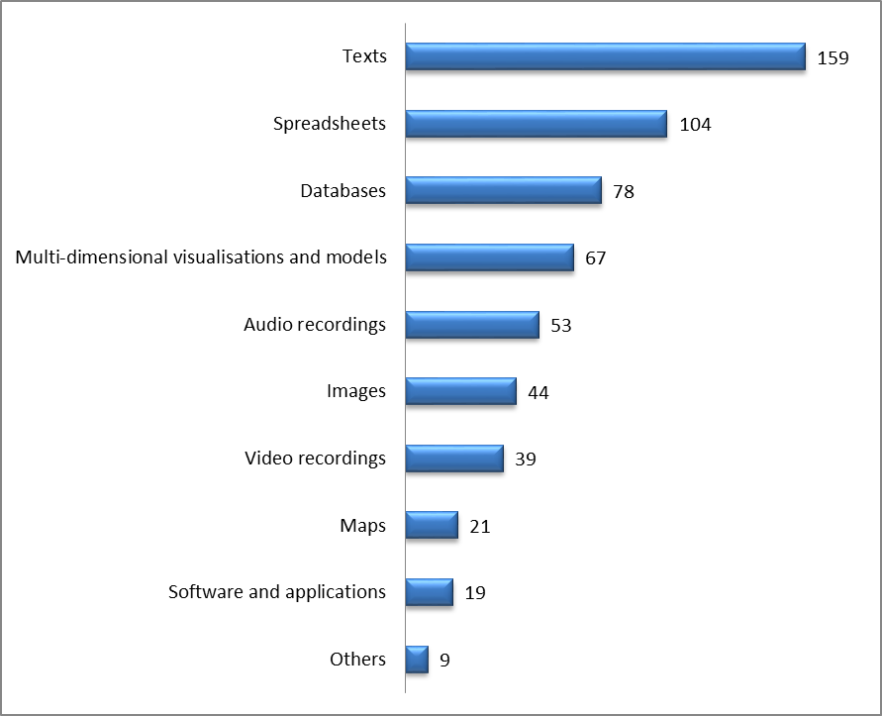

Figure 2: Research data types (n=211)

Other data types like audio and video recordings, images, maps or software are less important.

#### Data storage

Most of the respondents prefer local solutions for the storage of their research data, either the hard disk of their private personal computer (83%), or their professional work-station (49%) (figure 3).

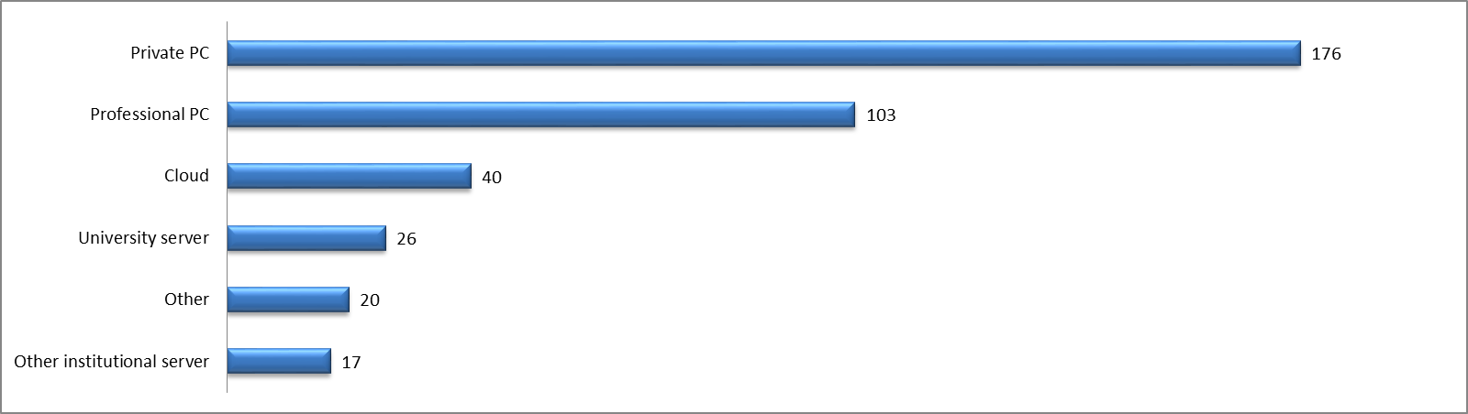

Figure 3: Storage places (n=212)

Only 12% store their data on a campus-based server. 19% conserve their data in the cloud, on a distant server (gratis or not), and 8% store them on another institution’s server, probably in collaborative, multi-site research projects.

55% say that they store their data in two or more different places, which means usually on the personal (private) computer and on the work-station on the campus. 76% say that they also make use of other devices, most often external hard drives (61%) and USB flash drives (46%) while other devices such as CD or DVD are mentioned by few.

How much memory space do they occupy? 38% of the respondents do not know exactly. 51% estimate their storage size at up to 100 gigabytes while only 13 respondents (half of them are psychologists) mentioned 1 terabytes or more. While 28% state that they back up the data on a daily schedule, nearly as many (26%) do it on an irregular basis, “each time when needed” or “from time to time”. Nearly all of them (97%) say that they are the only people in charge of the preservation of their research data and that there is no “data officer” or at least another person specifically designated to perform this task.

Taken together and as a whole, these responses appear to reflect a more or less individual data behaviour, private rather than professional, with available, often private (and cheap) devices but caring for security and backup. We cannot say if the respondents already faced serious problems with their research data (loss of data, security breach etc.); probably they never have because they do not seem really unsatisfied with this situation.

#### Data sharing

Most respondents (64%) do not share their research data with colleagues or other people (figure 4). Nobody, except themselves, have access to their data files.

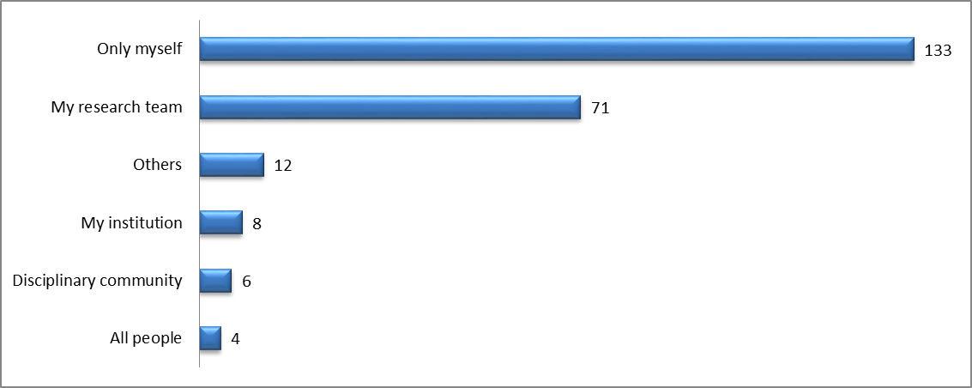

Figure 4: Access to research data (n=209)

Only 34% share data with their colleagues and/or members of their research team, and only 5% share them with a wider audience, in an open data approach *stricto senso*.

Few replied to the question about the reuse of data produced by other researchers (58%), and even fewer (38%, i.e. 22% of the whole sample) said that they had already downloaded this kind of scientific output and 8% added that they will try in the future. Also, very few answered that they were not interested or motivated to reuse other researchers’ data. One third (38%) simply were (are) not aware of this opportunity and way of doing science.

### Needs

Which kind of service and/or support or advice would they like to have? The questionnaire proposed nine different types of data-related service, from legal advice to technical infrastructure. Only 5% of the respondents state that they did not need any service. Most of the other respondents indicated two or more needs (figure 5).

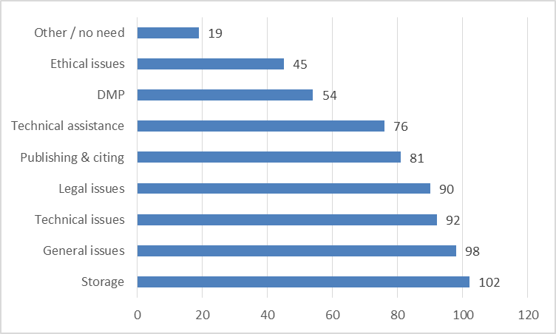

Figure 5: Support and services needed (n=188)

The survey does not really identify one or two priorities. The answers rather reflect a set of needs, some more important (storage space, general advice for data management), others a little bit less (technical and legal issues, publishing and citing). One third mentioned ethical issues and help for the preparation of data management plans (DMP).

### Open access

We also tried to measure the colleagues’ general willingness to deposit and share their data. Are they motivated? Which kind of data would they deposit? Would they publish their data along with articles? Which data repository would they prefer?

About 40% of the respondents express a positive opinion about data sharing. Either they have already deposited their data in a repository (16%) or they intend to do so in the future (25%). 30% admit that they were not aware of this possibility (figure 6).

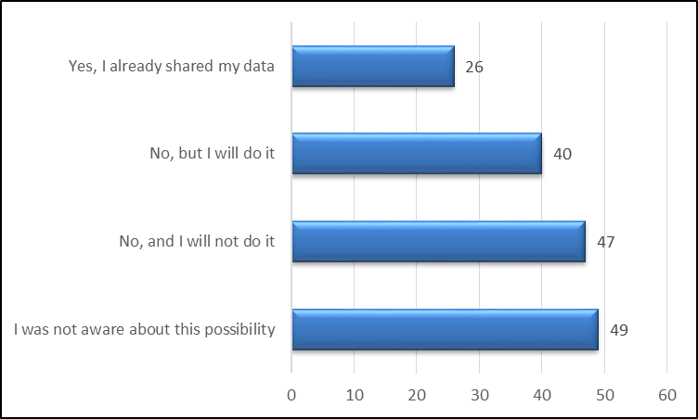

Figure 6: Deposit of research data in a data repository (n=162)

Another third (29%) clearly say that they never deposited their research data in the past and that they have no intention of doing so in the future. A deposit in a data repository is no option for five reasons: sensitive and confidential data, risk of plagiarism, workload, data illegibility (“nobody would understand my raw data”) and intellectual property (“these are MY data”).

This rejection of data sharing significantly decreases when it comes to the question of publishing data along with an article, i.e. when data sharing is incentive or obligatory (figure 7). Here, only 7% declare that they never shared their data in the past and that they will not share them in the future.

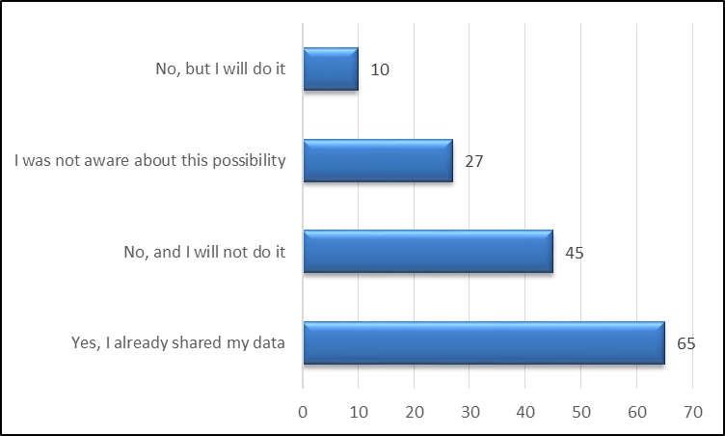

Figure 7: Data publishing (n=147)

44% of the respondents state that they have already published data together with an article, and 31% announce that they intend to do so in the future while 18% admit that they simply did not know about this possibility.

We also asked when and which kind of data they would share. Again, only 12% clearly state that they will not deposit or share their research results in this way (figure 8).

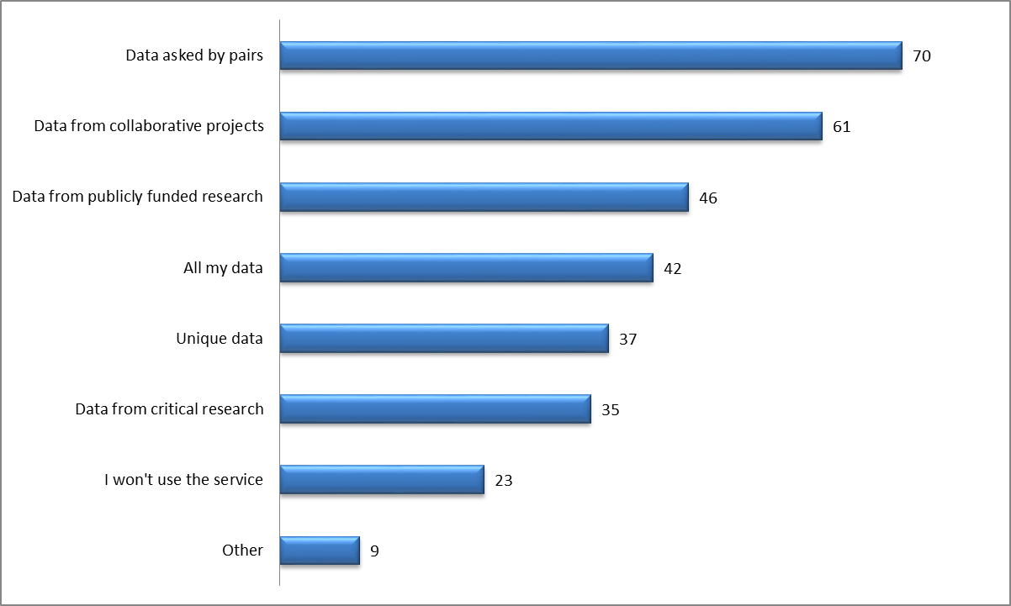

Figure 8: Data deposit (n=187)

37% underline that they would share those data asked for by their peers while others say that they would deposit data produced in collaborative research projects (33%) or with public funding (25%). The last question was about the kind of repository they would prefer for the deposit and sharing of their research data (figure 9). Even without a clear preference (many respondents mark more than one answer), we can identify a ranking of preferred options.

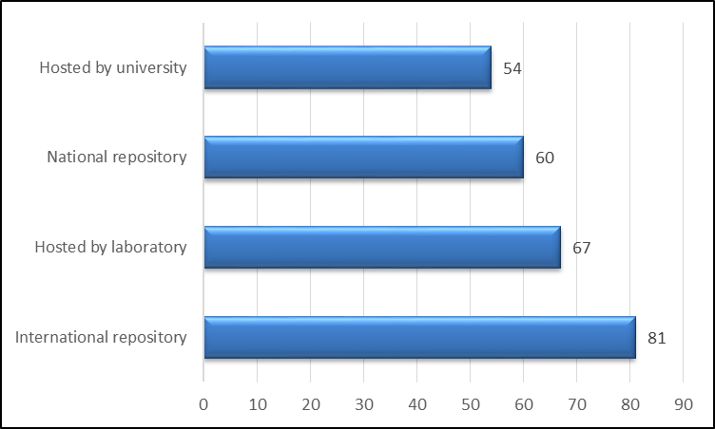

Figure 9: Preferred data repository (n=173)

International data repositories (47%) are at the top of the ranking, followed by local servers hosted by the laboratory, i.e. the research institute (39%). National (35%) or campus-wide platforms (31%) are less preferred. In other words, this sample is more interested in impact and visibility (international repository) and disciplinary specificity (laboratory) than in a multidisciplinary, national or institutional solution. Yet, no alternative is really rejected, and the differences do not seem to be very significant.

## Discussion

The response rate of this study – 15% - is globally satisfying, compared with other surveys in the same field where the rate is partially unknown (Tenopir et al. 2011 and 2015, Averkamp et al. 2014) or varying from 7% (Rege 2015) and 9% (Bauer et al. 2015) to 24% (Simukovic et al. 2013 and 2014). We received more answers from PhD students (33%) than in other surveys[1]. However, the rather small sample of 270 respondents should induce caution, especially when comparing sub-samples. Therefore, the following discussion will report tendencies rather than representative and reliable results.

Another reason for a prudent interpretation is the response rate per question. While questions about data management received an average response rate of 78%, the response rate for questions about data sharing fell to 49%. This low response rate may reflect a lack in a mix of experience, knowledge, motivation and awareness. But in all cases, it reduces still further the reliability of the replies.

As a whole, our sample does not confirm the 60-40 rule from the European PARSE.insight project which states that “60% like to get data from others but 40% have problems to give their own” (Reilly et al. 2011, p.12). In the Lille survey, only 46% (and not 60%) like to get data from others, and only 29% have problems giving their own away, with 30% others who have not made up their minds so far, for lack of information and/or awareness. On the whole, the scientists, scholars and PhD students seem rather pragmatic and realistic on a social sciences, humanities and arts campus with an extensive education program and a rather low budget for research.

### Status and discipline

To most of the survey questions, the professors, senior lecturers and PhD students replied in a consistent and comparable way, without any significant differences. The survey confirms that PhD students have less experience with research data management and sharing and are less aware of data-related aspects. But they also show a higher motivation to deposit and share their data in the future (63%) than professors and senior lecturers who seem more reluctant to deposit (45%). Professors are also twice more reluctant (28%) than PhD students (13%) to reuse the research data produced by other scientists. But all agree that they would prefer international data repositories to local solutions.

Our survey also reveals some differences between scientific communities (disciplines) on the campus. For instance, scholars in psychology and education seem less aware of data management and sharing than those in history, information sciences and modern languages and literature. Yet, statistically speaking, these are tendencies rather than significant differences, and as a whole, our sample shows a rather homogeneous community of scholars and scientists in social sciences and humanities, at least regarding research data management. Disciplinary differences exist but they should not be over-interpreted.

### Clusters

On the whole, we can distinguish four groups in our sample but they are not related to status or discipline. According to the answers on data management practice and motivation to share research data, we can identify four “clusters” of scholars and scientists (in brackets, the estimated part of the whole sample):

* The pioneers (20-25%): These respondents have more experience with data management and deposit and are more inclined to future data sharing than their colleagues.
* The motivated (25-30%): A second group of scholars and scientists with less or no experience are nevertheless highly motivated to engage in data sharing in the future.
* The unaware (30%): About one third of the sample admit that they are not really aware of research data management, of the opportunities for sharing their results with others or of the possibility to reuse the data of other scientists.
* The reluctant (5-10%): A small group did not deposit or share their data up to now and state that they will not do so in the future either.

Of course, the boundaries between these clusters are not always evident, in particular between the “pioneers” and the “motivated”. Also, because of the small size of the sub-samples, we did not try to characterize these clusters with regards to job status and discipline. More important for us is (1) the empirical evidence of different groups, a fact that calls for a differential approach on the campus, and (2) the relative part of each cluster, in particular the relatively small size of the “reluctant group”.

### Comparison with other surveys

Compared to the results of other surveys[2], we can highlight three aspects:

* Data management: less experience and a more personal (private) practice, especially regarding the way data are stored and backed up. At the University of Iowa, 69% store their data on their private computers but 72% (also) on a shared drive or institutional server. Austrian scientists mainly use their work computers (71%) and external storage devices (64%), while only 54% store the data on their private computers.
* Data sharing: a lower percentage of respondents already share data (34%), compared to the Berlin (50%), LIBER (58%) or NSF follow-up (75%) surveys. The Austrian scientists reported that they grant access to their data on request (57%) or to members of their own institution (53%). However, only 28% made their data available to the scientific community and only 10% to a wider public. These figures are more in line with our own results, such as the first NSF survey where only 36% scientists stated that they made their data easily accessible (Tenopir et al. 2011).
* Attitude towards data sharing: less favourable (40%) than the Berlin survey (60%), yet not more reluctant (12% compared to 15% in Berlin or 10% in Austria). The first NSF survey revealed that nearly half of the respondents would not share their data with others (46%) but the follow-up study shows that this percentage is decreasing.

One reason for these differences may be the fact that the Lille 3 survey puts the focus on social sciences and humanities. Other aspects are consistent with the cited surveys, such as the mainly personal responsibility for data management (93% “myself” in the Austria survey) and the preference for international and decentralized institutional data repositories (47% and 37%, Austria survey). The NSF follow-up study confirmed that scientists in psychology and education are in average less interested in data sharing, probably because of the often non-anonymous character of their results.

## Conclusion

The Lille survey provides a photography of a dynamic situation. Tenopir et al. (2015) described this situation as a “complex shift, with varying cultures among scientists that dictate the norms surrounding data sharing and reuse (and) still perceived risks and barriers that may be slowing the data sharing movement”. However, our study also showed that the continued barriers affect only a small part of the scientists, scholars and PhD students and that most of them are not opposed to data sharing but may need more information about conditions and opportunities.

The survey results helped us to improve the information about data management, deposit and sharing and to launch a training program for PhD students, as part of their doctoral education, as we are convinced that “the best possible point at which to intervene with guidance and training is very early on in a researcher’s career” (Ward et al. 2011, p.268). The survey itself also raised awareness on the issue of data management and data sharing and on the data policy on the Lille 3 campus[3]. The next step will be the project of a Lille data repository, either for all disciplines or limited to social sciences and humanities, in the framework of the French data infrastructure in digital humanities[4]. All these actions (figure 10) are coordinated and supported by the academic library, the graduate school in social sciences and humanities, the GERiiCO research laboratory, the University’s research management and the European Institute for Social Sciences and Humanities[5] at Lille.



Figure 10: Research data support services

The academic library plays a central part in particular in education, advice and assistance. The library will also be partner to a series of in-depth interviews with a smaller sample of scientists (n=30-50) in order to learn more about data behaviour, best practices and data-related needs. And the academic librarians’ contribution is expected and necessary also for the development of infrastructures and tools.

*Acknowledgments: The study was supported by the Department of International Relations of the University of Lille 3 and the European Institute for Social Sciences and Humanities at Lille. We would like to thank all colleagues who contributed to the success of the survey, in particular Peter Schirmbacher, Maxi Kindling and Elena Simukovic (Berlin), Isabelle Westeel, Cécile Malleret and Stéphane Chaudiron (Lille).*

## References

Averkamp, S., Gu, X., Rogers, B., 2014. *Data management at the University of Iowa: A university libraries report on campus research data needs*. University of Iowa. <http://ir.uiowa.edu/lib_pubs/153/>

Bauer, B., Ferus, A., Gorraiz, J., Gumpenberger, C., Gründhammer, V., Maly, N., Mühlegger, J. M., Preza, J. L., Sánchez Solís, B., Schmidt, N., Steineder, C., 2015. *Researchers and their data. Results of an Austrian survey - report 2015*. e-infrastructures austria, Vienna. <http://e-infrastructures.at/das-projekt/deliverables/>

Chaudiron, S., Maignant, C., Schöpfel, J., Westeel, I., 2015. *Livre blanc sur les données de la recherche dans les thèses de doctorat*. Université de Lille 3, Villeneuve d'Ascq. <http://hal.univ-lille3.fr/hal-01192930>

Herb, U., 2015. *Open Science in der Soziologie. Eine interdisziplinäre Bestandsaufnahme zur offenen Wissenschaft und eine Untersuchung ihrer Verbreitung in der Soziologie*. vwh Verlag Werner Hülsbusch, Glückstadt.

Kuipers, T., van der Hoeven, J., 2009. *Insight into digital preservation of research output in Europe. Survey report.* PARSE insight, European Commission, Brussels. <http://www.parse-insight.eu/downloads/PARSE-Insight_D3-4_SurveyReport_final_hq.pdf>

Neuroth, H., Strathmann, S., Oßwald, A., Ludwig, J. (Eds.), 2013. *Digital curation of research data. Experiences of a baseline study in Germany*. vwh Verlag Werner Hülsbusch, Glückstadt. <http://www.nestor.sub.uni-goettingen.de/bestandsaufnahme/Digital_Curation.pdf>

Prost, H., Schöpfel, J., 2015. *Les données de la recherche en SHS. Une enquête à l'Université de Lille 3.* Rapport final. Université de Lille 3, Villeneuve d'Ascq. <http://hal.univ-lille3.fr/hal-01198379v1>

Ramjoué, C., 2015. Towards Open Science: The vision of the European Commission. *Information Services & Use 35* (3), 167-170. <http://dx.doi.org/10.3233/isu-150777>

Rebouillat, V., 2015. *Archives ouvertes de la connaissance : Valoriser et diffuser les données de recherche*. Master's thesis, ENSSIB, Villeurbanne. <http://cataloguebib.enssib.fr/cgi-bin/koha/opac-detail.pl?biblionumber=1903>

Rege, A., 2015. Retour sur l'enquête sur les pratiques de publication scientifique et de production de données de la recherche. In: *Université de Strasbourg, Projet AOC*, COPIL 27 mars 2015.

Reilly, S., Schallier, W., Schrimpf, S., Smit, E., Wilkinson, M., 2011. *Report on integration of data and publications*. ODE Opportunities for Data Exchange, The Hague. <http://www.stm-assoc.org/2011_12_5_ODE_Report_On_Integration_of_Data_and_Publications.pdf>

Simukovic, E., Kindling, M., Schirmbacher, P., 2013. *Umfrage zum Umgang mit digitalen Forschungsdaten an der Humboldt-Universität zu Berlin.* Report, Humboldt-Universität zu Berlin, Zentraleinrichtung Computer- und Medienservice (Rechenzentrum), Berlin. <http://edoc.hu-berlin.de/docviews/abstract.php?id=40341>

Simukovic, E., Kindling, M., Schirmbacher, P., 2014. Unveiling research data stocks: A case of Humboldt-Universität zu Berlin. In: *iConference*, 4-7 March 2014, Berlin. pp. 742-748. <https://www.ideals.illinois.edu/handle/2142/47259>

Tenopir, C., Allard, S., Douglass, K., Aydinoglu, A. U., Wu, L., Read, E., Manoff, M., Frame, M., 2011. Data sharing by scientists: Practices and perceptions. *PLoS ONE* 6 (6), e21101+. <http://dx.doi.org/10.1371/journal.pone.0021101>

Tenopir, C., Dalton, E. D., Allard, S., Frame, M., Pjesivac, I., Birch, B., Pollock, D., Dorsett, K., 2015. Changes in data sharing and data reuse practices and perceptions among scientists worldwide. *PLoS ONE* 10 (8), e0134826+. <http://dx.doi.org/10.1371/journal.pone.0134826>

Ward, C., Freiman, L., Jones, S., Molloy, L., Snow, K., Jul. 2011. Making sense: Talking data management with researchers. *International Journal of Digital Curation* 6 (2), 265-273. <http://dx.doi.org/10.2218/ijdc.v6i2.202>

## Further readings

Chaudiron, S., Maignant, C., Schöpfel, J., Westeel, I., 2015. *Livre blanc sur les données de la recherche dans les thèses de doctorat.* Université de Lille 3, Villeneuve d'Ascq. <http://hal.univ-lille3.fr/hal-01192930>

Prost, H., Malleret, C., Schöpfel, J., 2015. Hidden treasures. Opening data in PhD dissertations in social sciences and humanities. *Journal of Librarianship and Scholarly Communication* 3 (2), eP1230+. <http://dx.doi.org/10.7710/2162-3309.1230>

Schöpfel, J., Chaudiron, S., Jacquemin, B., Prost, H., Severo, M., Thiault, F., 2014. Open access to research data in electronic theses and dissertations: An overview. *Library Hi Tech* 32 (4), 612-627. <http://www.emeraldinsight.com/doi/abs/10.1108/LHT-06-2014-0058>

Schöpfel, J., Prost, H., Malleret, C., 2015a. Making data in PhD dissertations reusable for research. In: *8th Conference on Grey Literature and Repositories*, National Library of Technology (NTK), 21 October 2015, Prague, Czech Republic. <http://hal.univ-lille3.fr/hal-01248979/document>

Schöpfel, J., Juznic, P., Prost, H., Malleret, C., Cesarek, A., Koler-Povh, T., 2015b. Dissertations and data (keynote address). In: *GL17 International Conference on Grey Literature*, 1-2 December 2015, Amsterdam. <http://hal.univ-lille3.fr/hal-01285304>

Joachim Schöpfel is Lecturer of Library and Information Sciences at the University of Lille 3 (France), Director of the French Digitization Centre for PhD theses (ANRT) and member of the GERiiCO research laboratory. He was Manager of the INIST (CNRS) scientific library from 1999 to 2008. He teaches Library Marketing, Auditing, Intellectual Property and Information Science. His research interests are scientific information and communication, particularly open access, research data and grey literature.

Hélène Prost is an information professional at the Institute of Scientific and Technical Information (CNRS) and associate member of the GERiiCO research laboratory (University of Lille 3). She is interested in empirical library and information sciences and statistical data analysis. She participates in research projects on the evaluation of collections, document delivery, usage analysis, grey fliterature and open access, and she is the author of several publications.

1. Berlin 23% (Simukovic et al. 2013), Strasbourg 10% (Rege 2015), international NSF survey 13.5% (Tenopir et al. 2011)
2. Berlin n=499 (Simukovic et al. 2013, 2014) ; Strasbourg n=644 (Rege 2015, Rebouillat 2015) ; LIBER n=1840 (Reilly et al. 2011, Kuipers & van der Hoeven 2009, cf. also Herb 2015) ; Iowa n=784 (Averkamp et al. 2014) ; Austria n=3,026 (Bauer et al. 2015) ; international NSF survey n=1,315 (Tenopir et al. 2011) and follow-up n=1,015 (Tenopir et al. 2015)
3. For instance, we published a white paper on data in dissertations (Chaudiron et al. 2015), we organize an international conference on electronic dissertations and research data (ETD2016) and we develop our library based service on research data, also in collaboration with the UK JISC.
4. <http://www.huma-num.fr/>
5. <http://www.meshs.fr/>