**Journal hijacking: challenges for the scientific community and recommendations for journals**

**from Anna Abalkina**

Hijacked journals (also known as cloned journals) are a type of cybercrime. They copy the title, ISSN, and other metadata of legitimate journals and claim to be the authentic journal in order to attract authors and publish their papers in exchange for article processing charges (Abalkina, 2021; Jalalian & Dadkhah, 2015; Moussa, 2021). This phenomenon was first documented around 2011 (Jalalian & Dadkhah, 2015). Since then, hundreds of journals have been hijacked.

There are two methods of journal hijacking. First, fraudulent publishers create an alternative website for an existing journal, claiming that it is the genuine one (see Figure 1). This type of hijacking can be successful because they target print-only journals, and the fake website becomes the only visible online presence of the journal. They also clone journals published in local languages. This strategy has been especially effective with Chinese journals.

**Figure 1**

**Chinese Journal of Evidence-Based Medicine: authentic and cloned websites**

**Authentic journal**

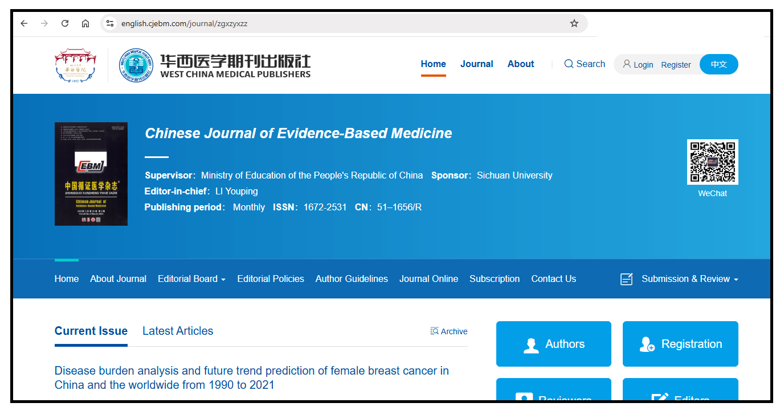  
(Source: https://english.cjebm.com/journal/zgxzyxzz)

**Hijacked journal**

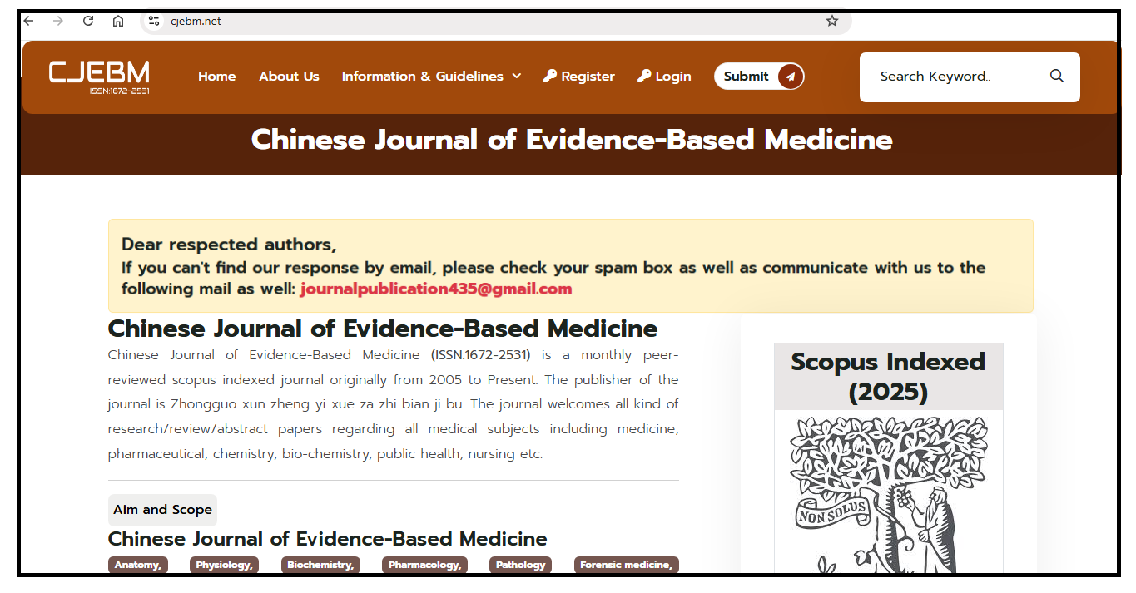  
(Source: https://www.cjebm.net/)

Another method is to register the expired web domain of an existing journal (Bohannon, 2015). This can happen when a journal ceases publication or when the original publisher fails to renew the domain registration. For example, the Russian Law Journal ceased publication, a fraudulent publisher registered its expired domain and created a journal website of the *Russian Law Journal* and accepted hundreds of papers in different disciplines, which were subsequently indexed in Web of Science (Abalkina, 2023b) (see Figure 2).

**Figure 2**

***Russian Law Journal*: authentic and hijacked websites**

**Authentic journal (2019)**

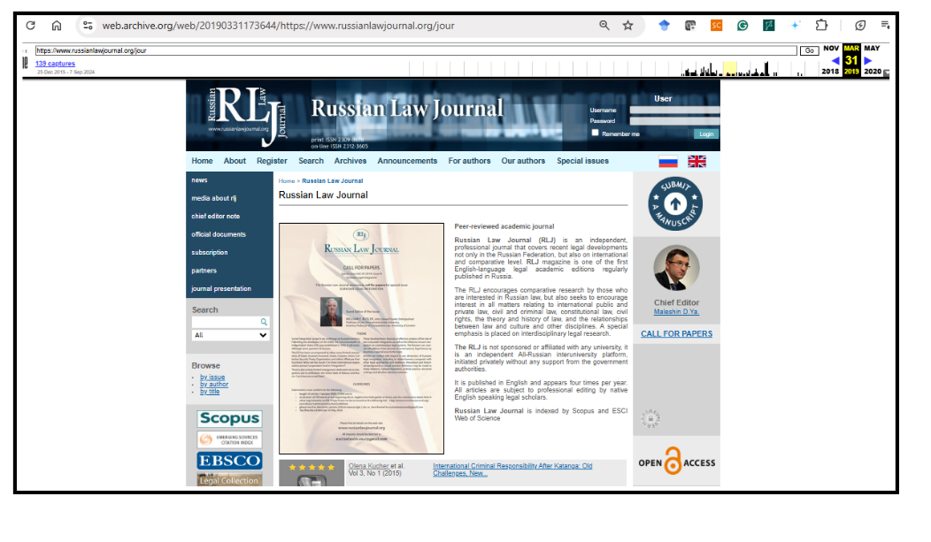(Source: <https://web.archive.org/web/20190331173644/https://www.russianlawjournal.org/jour>)

**Hijacked journal (2025)**

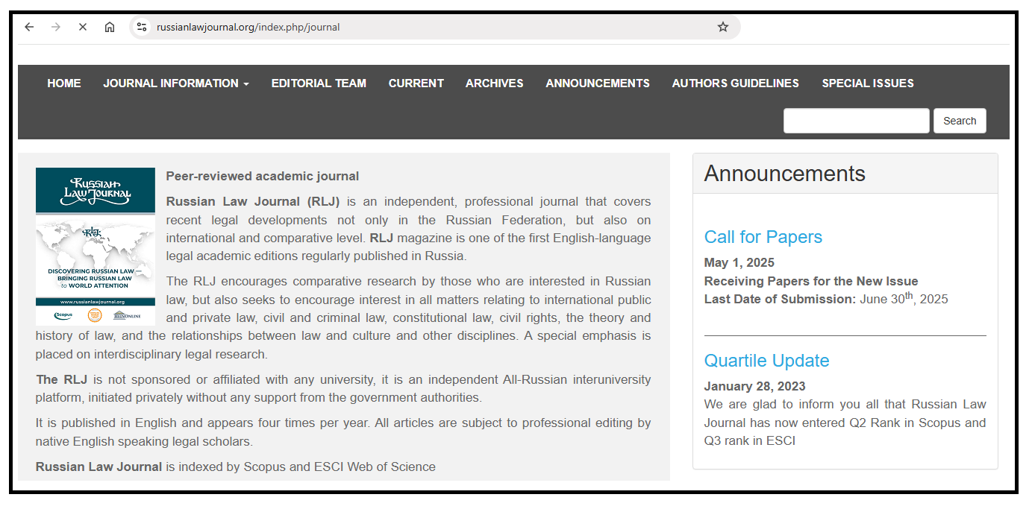(Source: <https://www.russianlawjournal.org/index.php/journal>)

More than 400 cases of hijacked journals have been documented since 2012 across different lists. The first list was created by the US-American librarian Jeffrey Beall, but he stopped updating it in 2017. Cabell’s, a paywalled database of journals, also includes hijacked journals as part of its criteria in Predatory Reports*,* which evaluates journals based on deceptive, fraudulent, or predatory practices. Another list has been compiled by UGC CARE in India[1], which includes Cloned List Ifor local hijacked journals and Cloned List II for those indexed in international databases. However, UGC CARE is discontinuing its journal list used for research evaluation purposes (The Economic Times, 2025). It is unclear whether the lists of cloned journals will continue to be updated. Another list is the Retraction Watch Hijacked Journal Checker[2], created in May 2022 and regularly updated. As of May 2025, the list includes more than 350 entries of hijacked journals.

The majority of original journals have been hijacked once, though some are associated with two cloned websites. The case of the Seybold Journal is notable, with five cloned websites (Abalkina, 2023a). Such multiple cloning of journals by different fraudulent publishers can be explained by the fact that certain types of legitimate journals are particularly targeted, for example, trade journals, small, niche and print-only journals, or journals published in local languages (Jalalian & Mahboobi, 2014; Shahri et al., 2018). Hijackers normally don’t clone journals by major publishers, though individual cases have been reported. For instance, in 2024 a fraudulent publisher cloned 13 journals published by Elsevier, Springer, etc. (Abalkina, 2024a). A striking detail is that the cloned webpages were identical to the authentic journals, the only difference was the web domain address, which was slightly different from the original.

Hijacked journals are not as numerous as predatory journals, but their proliferation also poses a significant challenge to the scientific community. They threaten scientific integrity by offering rapid publication without peer review, distorting international database indexes, and serving as repositories for low-quality papers and research involving misconduct. Such papers are nonetheless cited in reputable journals and indexed in various bibliographic databases.

There is evidence that unreviewed papers published in hijacked journals can be indexed in Scopus or Web of Science. A study by Abalkina (2024b) identified 67 hijacked journals that have penetrated Scopus since 2013, of which 33 have indexed unauthorized content, 23 compromised the journal’s homepage link in Scopus, and 11 did both. There is also evidence of hijacked journals penetrating Web of Science (Abalkina, 2023b; Butler, 2013). Hijacked journals are indexed in Google Scholar as well, and scholars should be cautious when retrieving data or conducting literature searches through this platform.

**Features of hijacked journals**

Hijacked journals present themselves as multidisciplinary journals. The topics of the papers they accept are usually from various disciplines and often do not correspond to the title of the journal. This happens because hijacked journals aim to accept as many papers as possible to maximize their profit. Low article processing charges (APCs) are another potential “red flag” of a fraudulent journal. Bhasker and Solomon (2025) note that low APCs of $25 per article are a specific diagnostic indicator of pseudo-journals. Such low fees can be explained by the limited payment capacity in countries where most authors publishing in hijacked journals are based, for example India, Indonesia, Uzbekistan, etc.

Hijacked journals publish papers within a matter of days, which is problematic because a genuine publication process requires both editorial assessment of the manuscript and a peer review process, both of which take time.

Hijacked journals may assign fake DOIs starting with numbers such as 12, 16 or 20 (see Figure 3), although a legitimate DOI always begins with 10. Sometimes, fraudulent publishers register real DOIs for hijacked journals. In such cases, it is possible to identify that the publisher is not the original one by cross-checking the information in the ISSN Portal or Crossref.

**Figure 3**

**A cloned version of gis.Science: Die Zeitschrift für Geoinformatik**

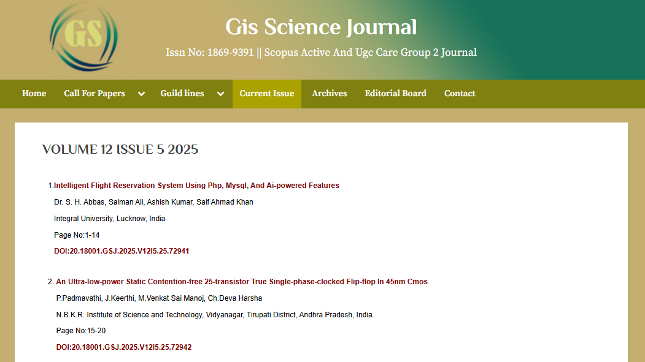  
(Source: <https://gisscience.net/volume-12-issue-5-2025/>)

Some hijacked journals provide fake editorial boards or copy them from other journals. They may also present fabricated journal metrics and incorrect impact factor values (Dadkhah et al., 2016) and claim indexation in different bibliographic databases, such as Scopus or Web of Science.

One of the red flags of hijacked journals is an anonymously registered and recently created domain, which can be verified using a WHOIS service. A recent registration makes it difficult for a hijacked journal to demonstrate a history of regular publication or the availability of an archive, which potential authors expect to see in a legitimate journal. For this reason, hijacked journals may create a fake archive filled with articles copied from other hijacked journals or generated by AI (Abalkina, 2021). Often the texts of these archived papers are not accessible due to paywall, likely because they do not exist. However, an archive is an important feature of a journal, as it indicates the continuous publication of journal issues (Dony et al., 2020).

**What Can Be Done? Recommendations for Journals**

Authentic journals that are hijacked face several challenges. They experience an increased editorial workload due to letters from authors who have fallen victim to the hijacked versions. Editors must take additional measures to prevent further damage to the journal, neutralize the hijacked version, and take steps to restore accurate information in bibliographic databases if the hijacked journal has led to the indexing of unauthorized content. Müller & Sæbø (2023) discuss such challenges in the case of the hijacking of their journal, Scandinavian Journal of Information Systems.

These challenges highlight the need for a proactive response from journals and editors in case of hijacking. The following measures can help journals to prevent hijacking, protect the journal and potential authors, as well as mitigate the negative effects caused by hijacking:

* Ensure the security of the journal's website and renew the domain registration in a timely manner. Passwords and access credentials should be stored securely. It is also important to plan for situations in which a colleague who holds the access credentials leaves the job and there should always be an alternative means of access to data storage. There have been cases where journals lost their web domains because they were unable to regain access.
* Journals should improve their search engine optimization (SEO), as hijacked journals actively promote fraudulent websites that often appear among the top search results in different search engines.

In case of hijacking:

* Submit a complaint to the domain registrar and hosting provider. Provide all available evidence of the illegitimate use of the journal’s title, ISSN, and other metadata. Include the details of the hijacked journal and any known contact information.
* You may consider contacting Visa, MasterCard, PayPal, etc., to disrupt the payment process of the hijacked journal if it is receiving payments for publications.
* Publish information about the journal hijacking on the homepage of the legitimate journal's website to inform authors about the fraudulent site. If the website is in a language other than English, consider adding the message in English as well, since the main victims of journal hijacking are often authors from East, South, and Central Asia.
* Inform the Retraction Watch Hijacked Journal Checker about the hijacking case by filling out the form[3]. Please also indicate the original website. If the case is confirmed, the database will be updated accordingly.
* If the journal has lost its web domain, inform indexing databases (e. g., Scopus, Web of Science, Scimago, DOAJ) about the case. Fraudulent publishers may use the domain to host a fake journal and index unreviewed papers in various bibliographic databases.
* Fraudulent publishers may also register a new DOI prefix for the hijacked journal. This can be checked via the Crossref title list[4]. If this has occurred, provide all available evidence of hijacking to Crossref. This may lead to the exclusion of the member from Crossref like in the case of a suspicious “Springer Global Publications” which had cloned the website of journals published by Springer, Elsevier, and other major publishers (Kincaid, 2024).

**Conclusions**

Hijacked journals are a type of fraudulent journal that poses a significant challenge to academic publishing by exploiting the reputation of legitimate journals. The proliferation of hijacked journals highlights vulnerabilities in the scholarly communication infrastructure, insufficient verification processes in indexing databases, limited awareness of the problem, and the use of publications in hijacked journals for research evaluation.

Tackling the problem of hijacked journals requires a coordinated and proactive response from multiple stakeholders. This includes stronger verification and response mechanisms from indexing databases, increased awareness of the issue, educating scholars on how to recognize hijacked journals to avoid submitting papers to or citing from them, and preventive actions by legitimate journals to protect themselves from being hijacked.

**Conflict of interest**

Anna Abalkina is a co-founder of the Retraction Watch Hijacked Journal Checker.

**References**

Abalkina, A. (2021). Detecting a network of hijacked journals by its archive. Scientometrics, 126, 7123–7148. <https://doi.org/10.1007/s11192-021-04056-0>.

Abalkina, A. (2023a). How many times can a journal be hijacked? Retraction Watch, 24 February 2023. <https://retractionwatch.com/2023/02/24/how-many-times-can-a-journal-be-hijacked/>.

Abalkina, A. (2023b). Three journals’ web domains expired. Then major indexes pointed to hijacked versions. Retraction Watch, 26 May 2023. <https://retractionwatch.com/2023/05/26/three-journals-web-domains-expired-then-major-indexes-pointed-to-hijacked-versions/>.

Abalkina, A. (2024a). New hijacking scam targets Elsevier, Springer Nature, and other major publishers. Retraction Watch, 25 November 2024. <https://retractionwatch.com/2024/11/25/exclusive-new-hijacking-scam-targets-elsevier-springer-nature-and-other-major-publishers/>.

Abalkina, A. (2024b). Challenges posed by hijacked journals in Scopus. Journal of the Association for Information Science and Technology, 75(4), 395–422. <https://doi.org/10.1002/asi.24855>.

Bhasker, J., & Vijay Solomon, R. (2025). The cost of deception: pseudo-journals and exploitative article processing charges. Research Evaluation, 34, rvaf017. <https://doi.org/10.1093/reseval/rvaf017>.

Bohannon, J. (2015). How to hijack a journal. Science, 350(6263), 903–905. <https://doi.org/10.1126/science.aad7463>.

Butler, D. (2013). Sham journals scam authors. Nature, 495, 421–422. <https://doi.org/10.1038/495421a>.

Dadkhah, M., Maliszewski, T., & Teixeira da Silva, J. A. (2016). Hijacked journals, hijacked web-sites, journal phishing, misleading metrics, and predatory publishing: Actual and potential threats to academic integrity and publishing ethics. Forensic Science, Medicine, and Pathology, 12, 353–362. <https://doi.org/10.1007/s12024-016-9785-x>.

Dony, C., Raskinet, M., Renaville, F., Simon, S., Thirion, P. (2020). How reliable and useful is Cabell’s blacklist? A Data-Driven Analysis. LIBER Quarterly, 30, 1–38. <https://doi.org/10.18352/lq.10339>.

Jalalian, M., & Dadkhah, M. (2015). The full story of 90 hijacked journals from August 2011 to June 2015. Geographica Pannonica, 19(2), 73–87. <https://doi.org/10.18421/GP19.02-06>.

Jalalian, M., & Mahboobi, J. (2014). Hijacked journals and predatory publishers Is there a need to re-think how to assess the quality of academic research. Walailak Journal of Science and Technology, 11(5), 389–394. <https://doi.org/10.14456/WJST.2014.16>.

Kincaid, E. (2024). Crossref suspends company’s membership after Retraction Watch report. Retraction Watch. 2 December 2024. <https://retractionwatch.com/2024/12/02/crossref-suspends-companys-membership-after-retraction-watch-report/>.

Moussa, S. (2021b). Journal hijacking: Challenges and potential solutions. Learned Publishing, 34(4), 688–695. <https://doi.org/10.1002/leap.1412>.

Müller, S. D., & Sæbø, J. I. (2023). The “hijacking” of the Scandinavian Journal of Information Systems: Implications for the information systems community. Information Systems Journal, 2023, 1–20. <https://doi.org/10.1111/isj.12481>.

Shahri, et al. (2018). Detecting Hijacked journals by using classification algorithms. Science and Engineering Ethics, 24, 655–668. <https://doi.org/10.1007/s11948-017-9914-2>.

The Economic Times. (2025). UGC discontinues CARE List journals, switches to decentralised journal evaluation. The Economic Times, 11 February 2025. <https://economictimes.indiatimes.com/industry/services/education/ugc-discontinues-care-list-journals-switches-to-decentralised-journal-evaluation/articleshow/118150336.cms?from=mdr>.

1. The Indian University Grants Commission (UGC) first introduced the UGC Consortium for Academic and Research Ethics (UGC-CARE) list in 2018, listing quality academic journals.
2. Retraction Watch Hijacked Journal Checker: <https://retractionwatch.com/the-retraction-watch-hijacked-journal-checker/>
3. Retraction Watch Hijacked Journal Checker form: <https://docs.google.com/forms/d/e/1FAIpQLScOZ6qj8ZwpkGh8IH7Z43xnxgY8B9wPHUKXnK50ikVv3HC-Dg/viewform>
4. Crossref title list:  <https://www.crossref.org/titleList/>