LibreOffice Technology, the only software platform
for personal productivity on the desktop, mobile and cloud
LibreOffice Technology is the result of ten years of intensive activity on the source code, coordinated by the Engineering Steering Committee and carried out by developers, software engineering and security experts, and interface and user experience specialists.
The goal of this evolution process has been to create a single software platform for individual productivity on desktop, mobile and cloud: the only approach able to offer users the interoperability features that enable transparent sharing of all content and independence from commercial choices and vendor lock-in strategies.
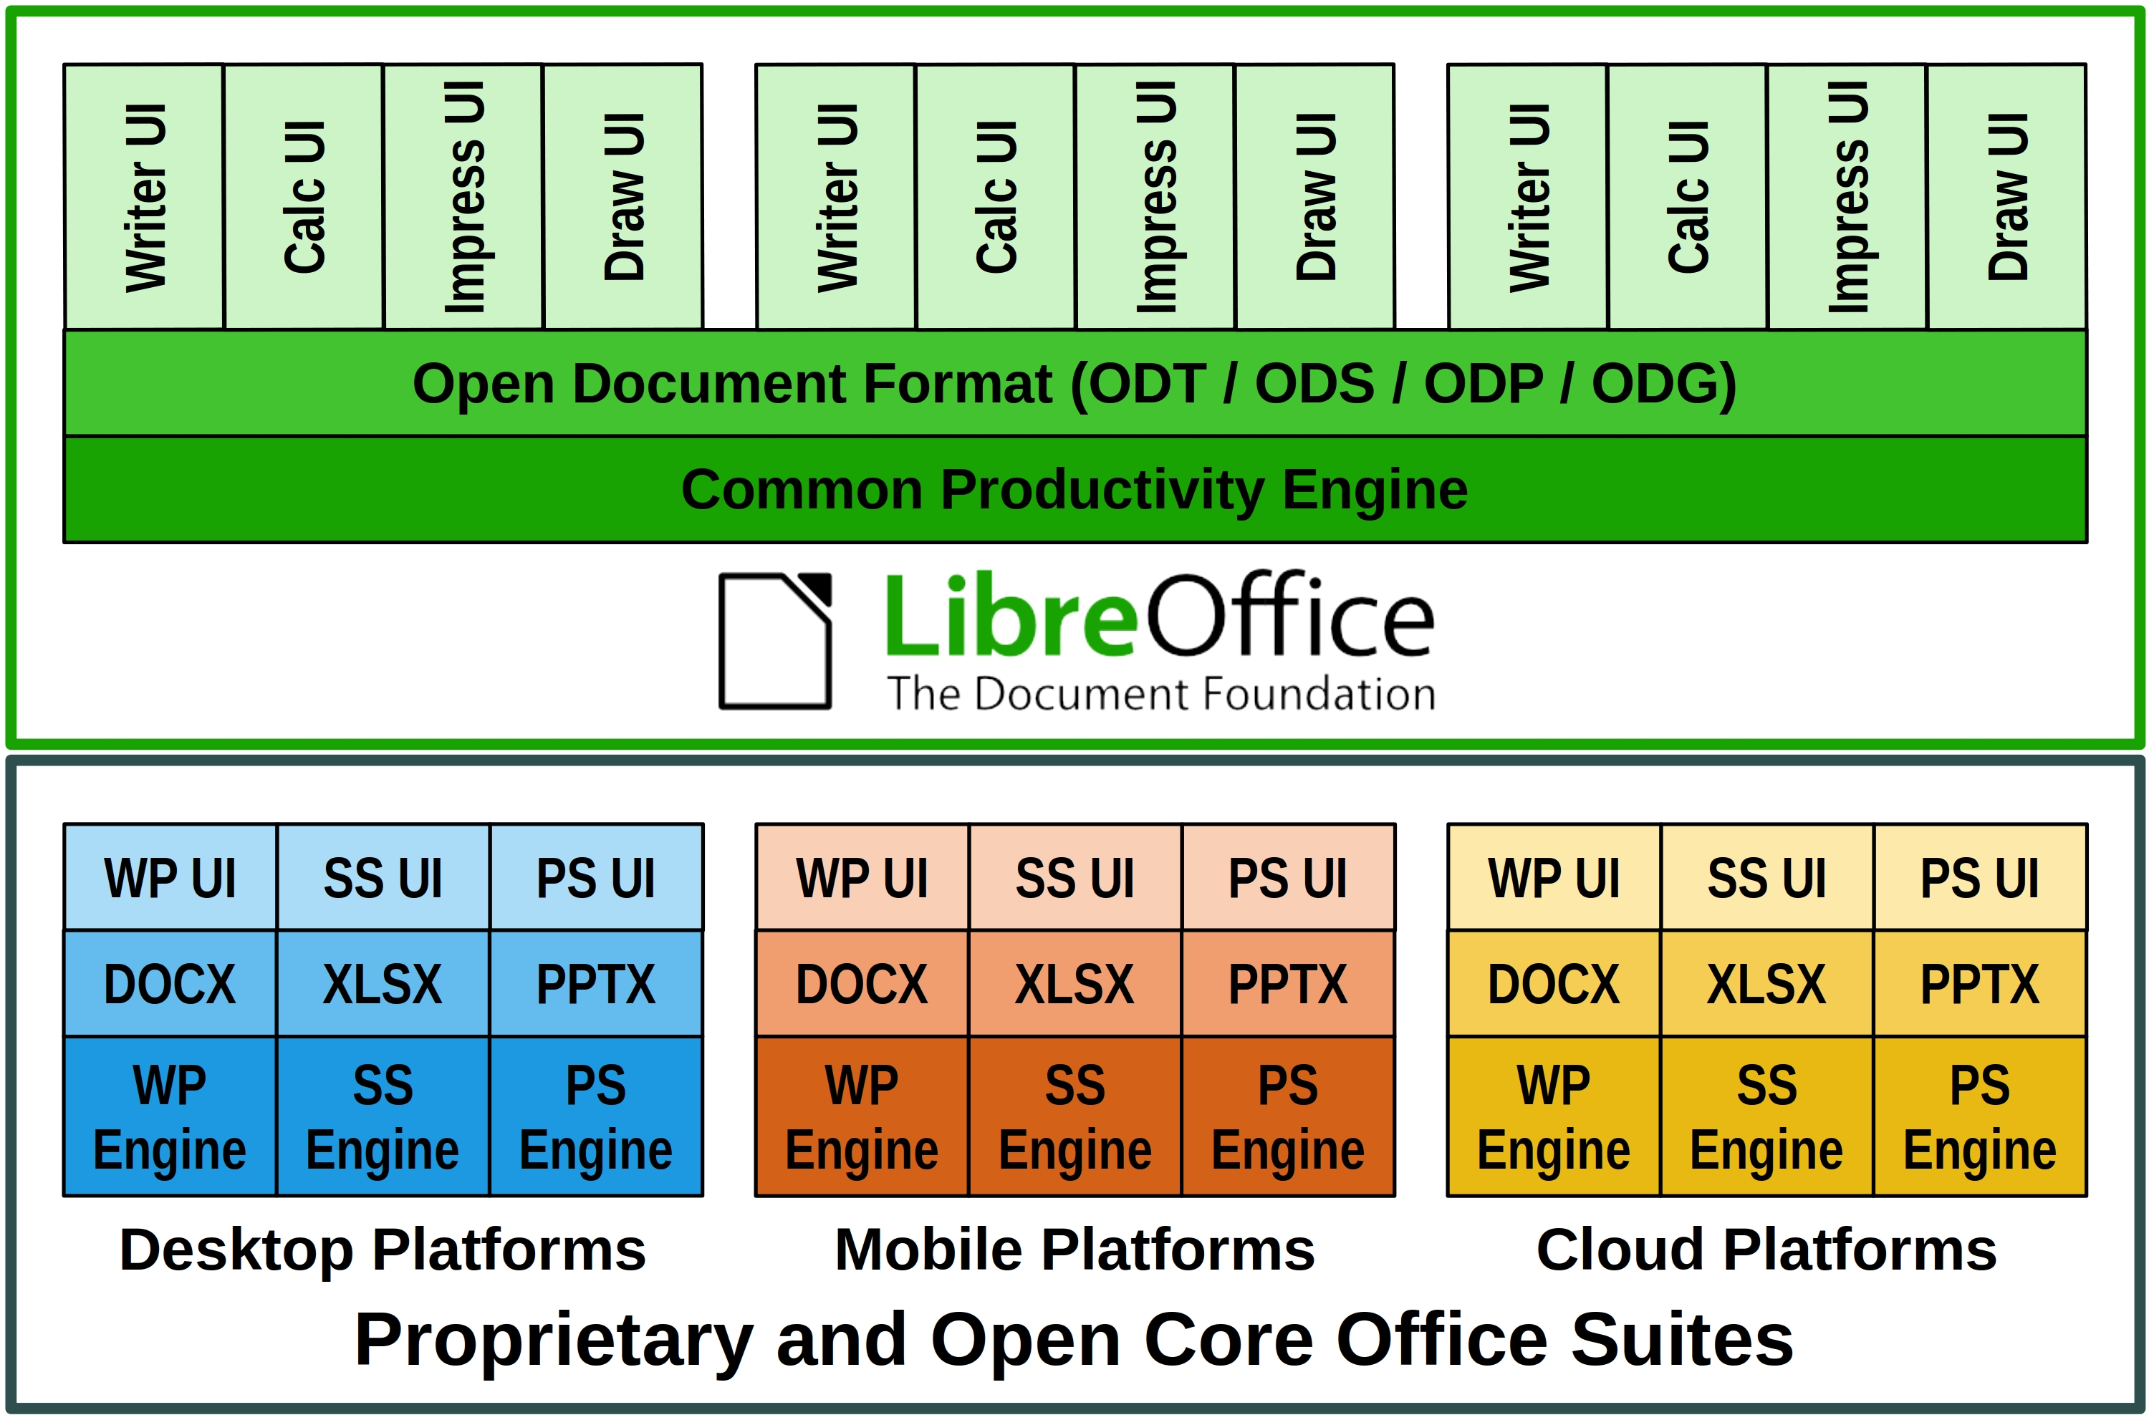
This is the opposite to all other proprietary and open core office suites, which have developed a different version for each platform trying to replicate the functionality, but only succeeding in part, so that – for example – the internal structure of documents (which is not visible to users) is different for each application.
The evolution process from product to platform
The source code inherited from OpenOffice was too complex for the average developer, also because the build environment was difficult to create and manage. It was therefore mandatory to mentor new developers to reduce the learning curve and speed up the process.
To help newcomers, senior developers have invented the "easy hacks": simple tasks for people with little or no knowledge of the source code, with the twofold objective of easing the learning curve and have a number of problems solved without spending their precious time.
Thanks to easy hacks, the project managed to attract new code contributors, create a strong base of new developers, increase the number of core developers, and also involve several new "star" contributors capable of challenging code cleaning and refactoring tasks.
In a short time, under the stewardship of LibreOffice Engineering Steering Committee, developers managed to reduce the software footprint, undertake a long awaited source code renovation with the removal of tens of thousands lines of dead code and a large number of deprecated libraries, and translate the majority of German comments to English.
To support the process, the development infrastructure was enhanced with the integration of several components and the update or replacement of existing ones. Today, the process is based as much as possible on automation, including tests, to free developers' time for more demanding tasks.
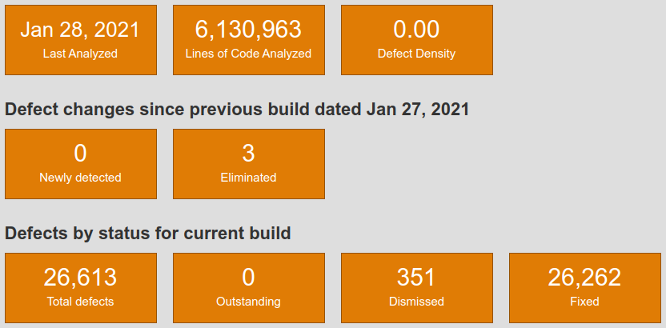
The result is a source code characterised by one of the lowest defect densities in the market, confirmed by static analysis tools such as Coverity Scan. The density inherited from OpenOffice – 1.1 errors per 1000 lines of code – has dropped to 0.001, against an average of 0.71 for projects of the same size.
Once the bulk of the source code renovation process has been completed, developers and UI designers have worked at improving the user experience. They have reorganized several menus, created new icon sets for Windows and macOS, improved existing icon sets, and extended the user interface options by adding a NotebookBar, with Tabbed, Grouped and Contextual variants.
Performances have also improved, especially when reading and writing large documents created using the OOXML Transitional proprietary file format, which represents the absolute majority of existing DOCX, XLSX and PPTX files. These document formats are supported by LibreOffice, and the compatibility is further improved with every new release, thanks to the activity of several developers with a specific competence on both document formats: ODF and OOXML.
Several OOXML documents are opened with LibreOffice, edited and saved back to the original format to check for consistency, until all issues are solved and the result is the same, independently from the software used.
Last, but not least, LibreOffice – thanks to a huge community of volunteers active in localization – is the software for personal productivity available in more native language versions than any other application. Today, the software is released in 119 language versions, with other 26 in development.
New LibreOffice APIs and Scripting Libraries
LibreOffice API (Application Programming Interface) are known for their steep learning curve, which were considered an obstacle for the development of macros within LibreOffice, and for integration projects on mobile and cloud platforms. To solve this issue, developers have created the more accessible LibreOffice Kit APIs and ScriptForge scripting libraries.
LibreOfficeKit is a thin API for LibreOffice that allows to access LibreOffice functionality through C/C++ or write external apps without having to compile or link to LibreOffice, and learn UNO – Universal Network Objects, the office suite component model – or other complex languages. The Kit allow fast rendering of documents for any application.
ScriptForge is an extensible and robust collection of macro scripting resources for LibreOffice which can be invoked from user Basic or Python scripts. They help to overcome LibreOffice API steep learning curve, as they offer easy access to and management of windows and documents, automation on Calc sheets, cells and ranges of cells, management of dialogs and their controls, as well as access to data contained in databases.
Open Document Format, the true document standard
LibreOffice Technology is the best platform for interoperability thanks to ODF, or Open Document Format, the native file format inherited from OpenOffice. ODF is maintained and further developed thanks to The Document Foundation, which has established the COSM – Community of ODF Specification Maintainers – project to hold funds and retain editors for ODF 1.3 and other future versions.
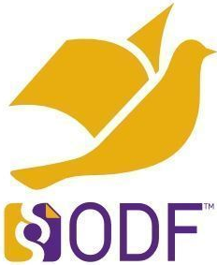
The ODF standard document format was designed in a "vendor neutral" manner from the ground up using existing standards wherever possible, to achieve a level of interoperability which is still unrivaled. ODF is robust and solid, is consistent across operating systems, and is predictable (i.e. a document will always generate the same XML code, even if created with a different version of the software, on a different hardware platform and with a different operating system).
Products based on LibreOffice Technology
Today, there is a large family of products based on LibreOffice Technology, for the desktop, with community and enterprise optimized versions, for the cloud, for Android & iOS, and for Chrome OS. These products are released by different organizations and have different brand names, but share the same common engine to offer users the same unique advantages in term of interoperability, resiliency, robustness and security.

