
Writer 6.0 Guide

Chapter 3
Working with Text: Advanced

Copyright
This document is Copyright © 2018 by the LibreOffice Documentation Team. Contributors are listed below. You may distribute it and/or modify it under the terms of either the GNU General Public License (http://www.gnu.org/licenses/gpl.html), version 3 or later, or the Creative Commons Attribution License (http://creativecommons.org/licenses/by/4.0/), version 4.0 or later.
All trademarks within this guide belong to their legitimate owners.

Contributors
Jean Hollis Weber | Bruce Byfield | Gillian Pollack

Acknowledgments
This chapter is updated from previous versions of the LibreOffice Writer Guide. Contributors to earlier versions are:
Jean Hollis Weber | John A. Smith | Hazel Russman
John M. Długosz | Ron Faile Jr.
This chapter is adapted from part of Chapter 3 of the OpenOffice.org 3.3 Writer Guide. The contributors to that chapter are:
Jean Hollis Weber | Agnes Belzunce | Daniel Carrera
Laurent Duperval | Katharina Greif | Peter Hillier-Brook
Michael Kotsarinis | Peter Kupfer | Iain Roberts
Gary Schnabl | Barbara M. Tobias | Michele Zarri
Sharon Whiston

Feedback
Please direct any comments or suggestions about this document to the Documentation Team’s mailing list: documentation@global.libreoffice.org
- Note
Everything you send to a mailing list, including your email address and any other personal information that is written in the message, is publicly archived and cannot be deleted.

Publication date and software version
Published July 2018. Based on LibreOffice 6.0.

Note for macOS users
Some keystrokes and menu items are different on macOS from those used in Windows and Linux. The table below gives some common substitutions for the instructions in this book. For a more detailed list, see the application Help.
Windows or Linux | macOS equivalent | Effect
Tools > Options menu selection | LibreOffice > Preferences | Access setup options
Right-click | Control+click and/or right-click depending on computer setup | Open a context menu
Ctrl (Control) | ⌘ (Command) | Used with other keys
F5 | Shift+⌘+F5 | Open the Navigator
F11 | ⌘+T | Open the sidebar Styles and Formatting deck

Contents
Copyright 2
Contributors 2
Acknowledgments 2
Feedback 2
Publication date and software version 2
Note for macOS users 2
Introduction 4
Using built-in language tools 4
Using paragraph and character styles 4
Using Tools > Language 5
Using language settings in Options 5
Using the status bar 6
Advanced find and replace techniques 6
Find and replace text attributes and formatting 7
Find and replace paragraph styles 7
Use similarity search 8
Use wildcards and regular expressions 8
Tracking changes to a document 9
Preparing a document for review 10
Recording changes 10
Accepting or rejecting changes 11
Comparing documents 12
Merging modified documents 12
Adding other comments 13
Using footnotes and endnotes 14
Inserting footnotes and endnotes 14
Defining the format of footnotes/endnotes 15
Linking to another part of a document 15
Using cross-references 16
Using bookmarks 16
Using hyperlinks 16
Inserting hyperlinks using the Navigator 16
Inserting hyperlinks using a dialog 17
Editing hyperlinks 18
Line numbering 18

Introduction
This chapter covers the more advanced tools for working with text in Writer:
- The built-in language tools
- Advanced find-and-replace techniques, including wildcards
- Track changes and insert comments
- Footnotes and endnotes
- Linking to other parts of a document
- Line numbering
This chapter assumes that you are familiar with the basic text techniques described in Chapter 2, Working with Text: Basics. We recommend that you also display formatting aids, such as end-of-paragraph marks, tabs, breaks, and other items in Tools > Options > LibreOffice Writer > Formatting Aids.
For information on formatting text (characters, paragraphs, lists), see Chapter 4.

Using built-in language tools
Writer provides some tools that make your work easier if you mix multiple languages within the same document or if you write documents in various languages:
- Paragraph and character styles
- The functions in Tools > Language
- Language settings in Options
- The functions available on the status bar
The main advantage of changing the language for a text selection is that you can then use the correct dictionaries to check spelling and apply the localized versions of AutoCorrect replacement tables, thesaurus, and hyphenation rules. A grammar checking dictionary may also be available for the selected language.
You can also set the language for a paragraph or a group of characters as None (Do not check spelling). This option is especially useful when you insert text such as web addresses or programming language snippets that you do not want to check for spelling.

Using paragraph and character styles
Changing the language on the Font tab of the Paragraph Styles dialog (Figure 1) will change the language for all paragraphs that use that paragraph style. If you will have whole paragraphs in different languages in a single document, you can use a different paragraph style for each language. For example, you might define Text Body-EN and Text Body-FR in a document containing paragraphs in both English and French
You can also set certain paragraphs to be checked in a language that is different from the language of the rest of the document by putting the cursor in the paragraph and changing the language on the Task Bar.
See Chapter 9, Working with Styles, for information on how to manage the language settings of a style.
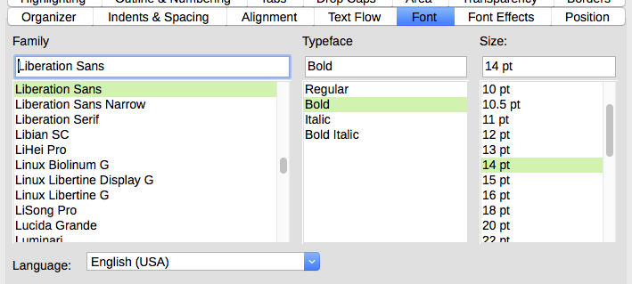
Figure 1: Setting the language for a paragraph style

Using Tools > Language
You can set the language for the whole document, for individual paragraphs, or even for individual words and characters, from Tools > Language on the Menu bar.
- For Selection applies a specified language to the selected text. If the language you wish to apply is not listed in the submenu, choose More... to open the Character dialog.
- For Paragraph applies the specified language to the paragraph where the cursor is located. If the language you wish to apply is not listed in the submenu, choose More...
- For all Text applies the specified language to all of the document, including text inserted after making the change. If the language you wish to apply is not listed in the submenu, choose More...
- More... opens the Character dialog, where you can select the required language on the Font tab. After a language has been applied to a selection or paragraph in the document, that language appears on the submenus for selections, paragraphs, and all text.
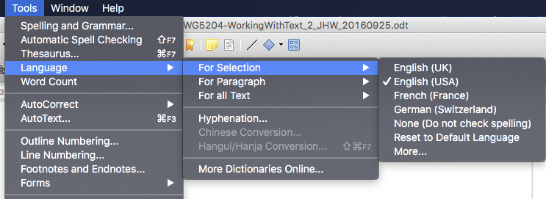
The Reset to Default Language option on the submenu is the fastest way to return a selection, paragraph, or all text to the default language set in Tools > Options (described below).

Using language settings in Options
Another way to change the language of a whole document is to use Tools > Options > Language Settings > Languages. In the Default languages for documents section (Figure 2), you can choose a different language for all the text that is not explicitly marked as a different language.
- Caution
A change in the default language from the Options dialog is a general change of settings of LibreOffice and will therefore apply to all the documents created in the future. If you want to change the language for the current document only, be sure to select the For the current document only option (see Figure 2).
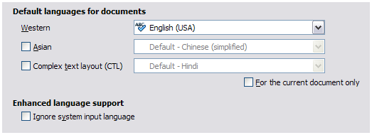
Figure 2: Options available in the Languages settings
- Note
The spelling checker works only for those languages in the list that have a checkmark symbol next to them. If you do not see this symbol next to your preferred language, you can install the dictionary using Tools > Language > More dictionaries online.

Using the status bar
The language used for checking spelling is also shown in the status bar, next to the page style in use. You can change the language for the paragraph or the entire document; click the language in the status bar to pop up a menu of choices.
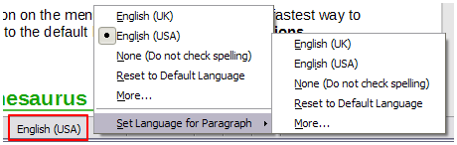
Figure 3: Language choices on the status bar
The Reset to Default Language option on the menu and submenu is the fastest way to return a paragraph or the entire document to the default language set in Tools > Options (described above).

Advanced find and replace techniques
In addition to finding and replacing words and phrases (described in Chapter 2), you can use Writer’s Find & Replace dialog to find and replace text attributes, formatting, and paragraph styles.

Find and replace text attributes and formatting
A powerful use of Find & Replace takes advantage of the Attributes and Format options. For example, you might want to replace underlined words with italics.
To find specific text attributes such as alignment, background, font color, line spacing that have been changed from the default:
- On the Find & Replace dialog (with Other Options displayed), click the Attributes button.
- Select the attribute you wish to search for from the list in the Attributes dialog and click OK. The names of the selected attributes appear under the Find: box. For example, to search for text that has been changed from the default font color, select the Font Color attribute.
- Click Find Next or Find All to search the document.
To find specific formatting such as bold, italic, font size:
- Open the Find & Replace dialog with Other Options displayed.
- To find text with specific formatting, enter the text in the Find: box. To search for specific formatting only, delete any text in the Find: box.
- Click Format to display the Text Format (Search) dialog. The tabs on this dialog are similar to those on the Paragraph and Paragraph Style dialogs.
- Choose the formats you want to search for and then click OK. The names of the selected formats appear under the Find: box. For example, you might search for all text in 14-point bold Times New Roman. The option Paragraph Styles changes to Including Styles.
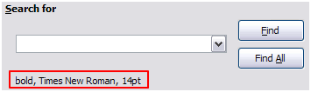
- To replace the format, click in the Replace: box, choose the format to use, and then click OK. The format selected will be displayed below this text box. To replace text as well as formatting, type the replacement text in the Replace: box.
To remove specific character formatting, click Format, select the Font tab, then select the opposite format (for example, No Bold). The No Format button on the Find & Replace dialog clears all previously selected formats.
- Click Find Next, Find All, Replace, or Replace All.
- Caution
Unless you plan to search for other text using those same attributes, click No Format to remove the attributes after completing your search. Without this, the next search may fail to find words you know are in the document.

Find and replace paragraph styles
Combining material from several sources may result in unwanted paragraph styles in your document. To quickly change all the paragraphs from one (unwanted) style to another (preferred) style:
- On the expanded Find & Replace dialog, select Paragraph Styles. The Find: and Replace: boxes now contain a list of styles in use in the document.
If you have attributes specified, this option is labeled Including Styles. Select No Format to remove any attributes and return the option to Paragraph Styles.
- Select the styles you want to search for and replace.
- Click Find, Find All, Replace, or Replace All.
Repeat steps 2 and 3 for each style that you want to replace.

Use similarity search
Find terms that are similar to the Find: text. For example, a similarity search can find words that differ from the Find: text by two characters.
Select Similarity search and click the Similarities button to open a dialog in which you can modify the text search by length and number of characters different from the search term (see Figure 4).
Exchange characters
Enter the number of characters in the search term that can be exchanged. For example, if you specify 2 exchanged characters, "black" and "crack" are considered similar.
Add characters
Enter the maximum number of characters by which a word can exceed the number of characters in the search term.
Remove characters
Enter the number of characters by which a word can be shorter than the search term.
Combine
Searches for a term that matches any combination of the similarity search settings.
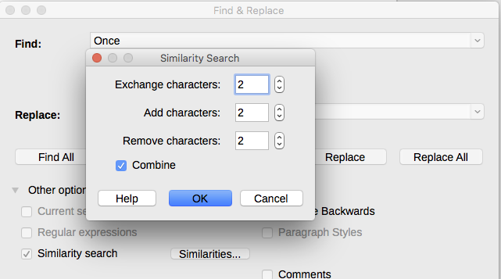
Figure 4: Similarity search dialog

Use wildcards and regular expressions
A wildcard is a special character that represents one or more unspecified characters. Wildcards make text searches more powerful but often less specific. LibreOffice enables you to use combinations of characters known as regular expressions which are more specific than simple wildcards but less so than a literal string. Regular expressions are very powerful but not very intuitive. They can save time and effort by combining multiple finds into one.
Table 1 shows a few of the regular expressions used by LibreOffice.
- Tip
The online help describes many more regular expressions and their uses.
To use wildcards and regular expressions when searching and replacing:
- On the Find & Replace dialog, click Other Options to see more choices. On this expanded dialog, select the Regular expressions option.
- Type the search text, including the wildcards, in the Search for box and the replacement text (if any) in the Replace with box. Not all regular expressions work as replacement characters; the line break (\n) is one that does work.
- Click Find, Find All, Replace, or Replace All (not recommended).
- Note
To search for a character that is defined as a wildcard, type a backslash (\) before the character to indicate that you are using it literally. For example, to find the text $5.00, you would conduct a search using \$5\.00.
Table 1: Examples of search wildcards (regular expressions)
To find | Use this expression | Examples and comments
Any single character | . (a period or full stop) | b.d finds bad, bud, bid, and bed.
One of the specified characters | [xyz] | b[iu]n finds bin and bun.
Any single character in this range | [x-y] | [r-t]eed finds reed, seed, and teed; ranges must be in alphabetically ascending order.
Any single character except the characters inside the brackets | [^x] | p[^a]st finds post and pest, but not past.
The beginning of a word | \<start | \<log finds logbook and logistics, but not catalog.
The end of a word | end\> | log\> finds catalog, but not logistics.
A paragraph marker | $ | Does not work as a replacement character. Use \n instead.
A line break | \n | Finds a line break that was inserted with Shift+Enter. When used as a replacement character, it inserts a paragraph marker.

Tracking changes to a document
You can use several methods to keep track of changes made to a document.
- Make your changes to a copy of the document (stored in a different folder, under a different name, or both), then use Writer to compare the two files and show the changes you made. This technique is particularly useful if you are the only person working on the document, as it avoids the increase in file size and complexity caused by the other methods.
- Save versions that are stored as part of the original file. However, this method can cause problems with large or complex documents, especially if you save a lot of versions. Avoid this method if you can.
- Use Writer’s change marks (often called “redlines” or “revision marks”) to show added or deleted material or changed formatting. Later, you or another person can review and accept or reject each change.
- Note
Not all changes are recorded. For example, changing a tab stop from align left to align right and changes in formulas (equations) or linked graphics are not recorded.

Preparing a document for review
When you send a document to someone else to review or edit, you may want to prepare it first so that the editor or reviewer does not have to remember to turn on the revision marks. After you have protected the document, any subsequent user must enter the correct password in order to turn off protection or accept or reject changes.
- Open the document. Check whether it contains multiple versions by clicking File > Versions. If multiple versions are listed, save the current version as a separate document with a different name and use this new document as the review copy.
- With the review copy open, make sure that change recording is turned on. The Edit > Track Changes > Record Changes menu item has a check mark next to it when recording is turned on.
- Click Edit > Track Changes > Protect Changes. On the Enter Password dialog, type a password (twice) and click OK.
- Tip
An alternative to steps 2 and 3 above is to choose File > Properties > Security tab, select the Record changes option, then click Protect and enter the password.

Recording changes
See Chapter 20, Setting up Writer, for instructions on setting up how changes will be displayed, if you don’t like the default settings.
- To begin tracking (recording) changes, click Edit > Track Changes > Record Changes. To show or hide the display of changes, click Edit > Track Changes > Show Changes.
- Tip
Hold the mouse pointer over a marked change; you will see a Help Tip showing the type of change, the author, date, and time of day for the change. If Extended Tips are enabled, you will also see any comments recorded for this change.
- To enter a comment on a marked change, place the cursor in the area of the change and then click Edit > Track Changes > Comment on Change.
In addition to being displayed as an extended tip, the comment is also shown in the list in the Manage Changes dialog (Figure 6).
To move from one marked change to the next, use the arrow buttons. If no comment has been recorded for a change, the Text field is blank.
- To stop recording changes, click Edit > Track Changes > Record Changes again.
- Tip
See also “Adding other comments” on page 13 for a way to annotate text that is not associated with a recorded change.
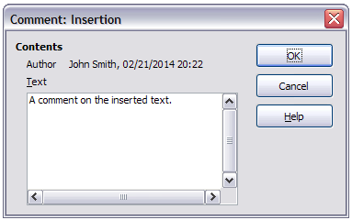
Figure 5: Inserting a comment during change recording

Accepting or rejecting changes
To accept or reject recorded changes, use any of these tools:
- Changes toolbar
- Right-click (context) menu
- Manage Changes dialog
- Manage Changes pane in the Sidebar (experimental)
The results of accepting or rejecting a change are as follows:
- Accept: incorporates the alteration into the document and removes the change indication marking.
- Reject: reverts the document to its original state and removes the change indication marking.
Changes toolbar
For quick and easy accepting and rejecting of changes, you can use the Changes toolbar, which includes buttons for the same functions as appear on the Edit > Track Changes submenu. To enable the Changes toolbar, click View > Toolbars > Changes on the Menu bar. You can dock this toolbar in a convenient place or leave it floating.
Right-click (context) menu
- If recorded changes are not showing, click Edit > Track Changes > Show Changes.
- Hover the mouse pointer over a recorded change. A box appears with information about the type of change, who made it, and the date and time.
- Right-click the changed text. In the context menu, choose Accept Change or Reject Change.
Manage Changes dialog
- Click Edit > Track Changes > Manage Changes. The Manage Changes dialog (Figure 6) opens, showing changes that have not yet been accepted or rejected.
- When you select a change in the dialog, the change itself is highlighted in the document, so you can see what the editor changed.
- Click Accept or Reject to accept or reject the selected change. You can also click Accept All or Reject All if you do not want to review the changes individually.
To show only the changes of certain people or only the changes on specific days or various other restrictions, use the Filter page (Figure 7) on the Accept or Reject Changes dialog. After specifying the filter criteria, return to the List page to see those changes that meet your criteria.
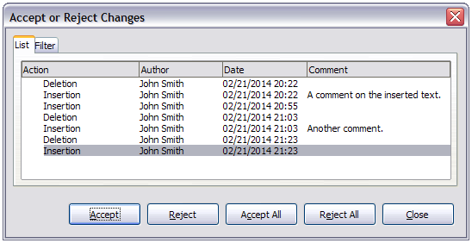
Figure 6: The List tab of the Manage Changes dialog
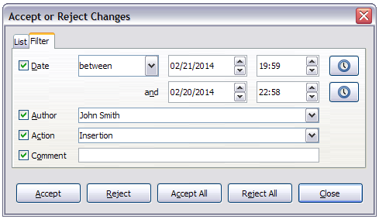
Figure 7: The Filter page of the Manage Changes dialog
Manage Changes pane in the Sidebar
The Manage Changes pane in the Sidebar shows the same information as in the Manage Changes dialog described above.

Comparing documents
Sometimes reviewers may forget to record the changes they make. You can find the changes if you compare the original document and the one that is edited. To compare them:
- Open the edited document. Select Edit > Track Changes > Compare Document.
- The Insert dialog appears. Select the original document and click Insert.
Writer finds and marks the changes and displays the Manage Changes dialog. From this point, you can go through and accept or reject changes procedure as described earlier.

Merging modified documents
The processes discussed to this point are effective when you have one reviewer at a time. Sometimes, however, multiple reviewers all return edited versions of a document. In this case, it may be quicker to review all of these changes at once, rather than one review at a time. For this purpose, you can merge documents in Writer.
To merge documents, all of the edited documents need to have recorded changes in them.
- Open one copy.
- Click Edit > Track Changes > Merge Document and select and insert another copy of the document to be merged with the first.
- After the documents merge, the Manage Changes dialog opens, as in Figure 6, showing changes by more than one reviewer. If you want to merge more documents, close the dialog and then repeat step 2.
- Repeat until all copies are merged.
All recorded changes are now included in the open copy. Save this file under another name.

Adding other comments
Writer provides another type of comments, which authors and reviewers use to exchange ideas, ask for suggestions, or mark items needing attention.
You can select a block of text, including multiple paragraphs, to be highlighted for a comment, or you can insert a comment at a single point. To insert a comment, select the text, or place the cursor in the place the comment refers to, and choose Insert > Comment or press Ctrl+Alt+C.
The anchor point of the comment is connected by a dotted line to a box on the right-hand side of the page where you can type the text of the comment. A Comments button is also added to the right of the horizontal ruler (see Figure 8); you can click this button to toggle the display of the comments.
Writer automatically adds the author’s name and a time stamp indicating when the comment was created. Select Tools > Options > LibreOffice > User Data to configure the name you want to appear in the Author field of the comment, or to change it.
Click somewhere on the page to finish your comment. Otherwise, you will not be able to move away from this location.
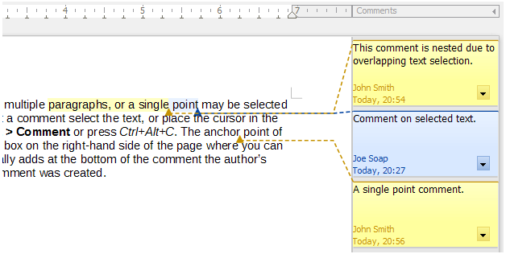
Figure 8: Comments in LibreOffice
If more than one person edits the document, each author is automatically allocated a different background color. Figure 8 shows an example of text with comments from two different authors. If an author selects text that overlaps another author’s comments, then the comments from the second author are nested with those of the first author.
Right-click a comment to open a context menu where you can delete the current comment, all the comments from the same author, or all the comments in the document. From this menu, you can also open a dialog to apply some basic formatting to the text of the comment. You can also change font type, size, and alignment from the Menu bar.
To navigate from one comment to another, open the Navigator (F5), expand the Comments section, and click the comment text to move the cursor to the anchor point of the comment in the document. Right-click the comment to quickly edit or delete it.
You can also navigate the comments using the keyboard. Use Ctrl+Alt+Page Down to move to the next comment and Ctrl+Alt+Page Up to move to the previous comment.
Comments can be printed next to the text in the right margin as they appear on screen. Each page is scaled down in order to make space for the comments to fit on the underlying paper size.

Using footnotes and endnotes
Footnotes appear at the bottom of the page on which they are referenced. Endnotes are collected at the end of a document.
To work effectively with footnotes and endnotes, you need to:
- Insert footnotes and define their format
- Define the location of footnotes on the page, and the color and line styles for separator lines, if the defaults do not meet your needs (see Chapter 5, Formatting Pages: Basics).

Inserting footnotes and endnotes
To insert a footnote or an endnote, put the cursor where you want the footnote or endnote marker to appear. Then select Insert > Footnote and Endnote from the Menu bar and choose Footnote or Endnote, or click the Insert Footnote or Insert Endnote button on the Standard toolbar.
A footnote or endnote marker is inserted in the text and, depending on your choice, the cursor is relocated either to the footnote area at the bottom of the page or to the endnote area at the end of the document. Type the footnote or endnote content in this area.
You can also choose use Insert > Footnote and Endnote > Footnote or Endnote to open the Insert Footnote/Endnote dialog (Figure 9), where you can choose whether to use the automatic numbering sequence specified in the footnote settings and whether to insert the item as a footnote or an endnote.
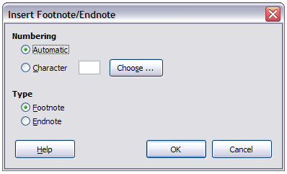
Figure 9: Inserting a footnote/endnote
If you use Insert Footnote or Insert Endnote, the footnote or endnote automatically takes on the attributes previously defined in the Footnote Settings dialog.
You can edit an existing footnote or endnote the same way you edit any other text.
To delete a footnote or endnote, delete the footnote marker. The contents of the footnote or endnote are deleted automatically, and the numbering of other footnotes or endnotes is adjusted automatically.

Defining the format of footnotes/endnotes
To format the footnotes themselves, click Tools > Footnotes and Endnotes. On the Footnotes/Endnotes Settings dialog (Figure 10), choose settings as required.
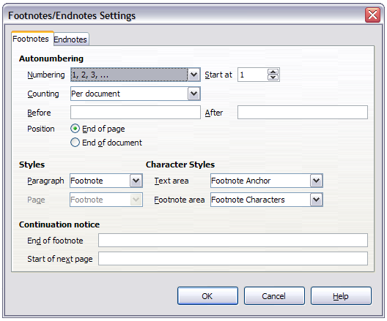
Figure 10: Defining footnote formatting

Linking to another part of a document
If you type in cross-references to other parts of the document, those references can easily get out of date if you reorganize the order of topics, add or remove material, or reword a heading. Writer provides two ways to ensure that references are up to date, by inserting links to other parts of the same document or to a different document: hyperlinks and cross-references.
The two methods have the same result: if you Ctrl+click the link when the document is open in Writer, you are taken directly to the cross-referenced item. However, they also have major differences:
- The text in a hyperlink does not automatically update if you change the text of the linked item (although you can change it manually), but changed text does automatically update in a cross-reference.
- When using a hyperlink, you do not have a choice of the content of the link (for example text or page number), but when using a cross-reference, you have several choices, including bookmarks.
- To hyperlink to an object such as a graphic, and have the hyperlink show useful text such as Figure 6, either give such an object a useful name instead of leaving it as the default name (“Graphics6”) or use the Hyperlink dialog to modify the visible text. In contrast, cross-references to figures with captions automatically show useful text, and you have a choice of several variations of the name.
- If you save a Writer document to HTML, hyperlinks remain active but cross-references do not. (Both remain active when the document is exported to PDF.)

Using cross-references
To ensure that references update if you reword a heading, caption, or other linked item, use automatic cross-references. For details, see “Using automatic cross-references” in Chapter 17, Fields.

Using bookmarks
Bookmarks are listed in the Navigator and can be accessed directly from there with a single mouse click. In HTML documents, bookmarks are converted to anchors that you can jump to by hyperlink. For more about bookmarks, see “Using bookmarks” in Chapter 17, Fields.

Using hyperlinks
When you type text (such as website addresses or URL) that can be used as a hyperlink, and then press the spacebar or the Enter key, Writer automatically creates the hyperlink and applies formatting to the text (usually a color and underlining).
If this does not happen, you can enable this feature using Tools > AutoCorrect Options > Options and selecting the URL Recognition option.
If you do not want Writer to convert a specific URL to a hyperlink, choose Edit > Undo Insert from the Menu bar or press Ctrl+Z immediately after the formatting has been applied.
You can also insert hyperlinks using the Navigator and the Hyperlink dialog, and you can modify all hyperlinks using the Hyperlink dialog, as described in this section.
- Note
Hyperlinks between documents can be set as relative or absolute, using the Save URLs relative to option in Tools > Options > Load/Save > General.
Relative linking is only possible when the document you are working on and the link destination are on the same drive, and you need to create the same directory structure on your hard disk as will apply on the destination website.
LibreOffice uses absolute path names internally, so when you move your mouse cursor over a hyperlink, the tooltip displays the absolute reference even when it is set to be a relative link.

Inserting hyperlinks using the Navigator
The easiest way to insert a hyperlink to another part of the same document is by using the Navigator:
- Open the document containing the items you want to cross-reference.
- Open the Navigator (by clicking its icon, choosing View > Navigator, pressing F5, or selecting the Navigator Tab on the open Sidebar).
- Click the arrow next to the Drag Mode icon, and select Insert as Hyperlink.
- In the list at the bottom of the Navigator, select the document containing the item that you want to cross-reference.
- In the Navigator list, select the item that you want to insert as a hyperlink.
- Drag the item to where you want to insert the hyperlink in the document. The name of the item is inserted in the document as an active hyperlink.
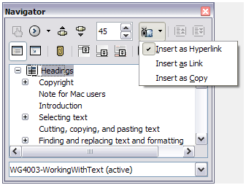
Figure 11: Inserting a hyperlink using the Navigator

Inserting hyperlinks using a dialog
To display the Hyperlink dialog (Figure 12), click the Hyperlink icon on the Standard Toolbar or choose Insert > Hyperlink from the Menu bar. To turn existing text into a link, select it before opening the dialog.
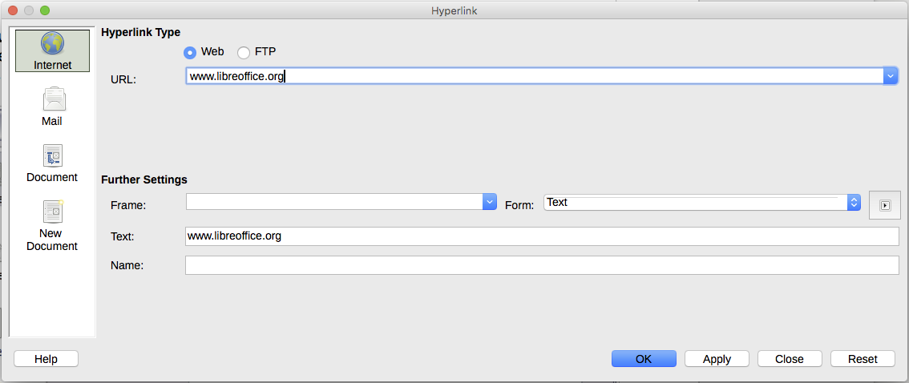
Figure 12: Hyperlink dialog showing details for Internet links
On the left hand side, select one of the four types of hyperlink:
- Internet: a web address, normally starting with http://
- Mail: an email address.
- Document: another document or to another place in the presentation.
- New document: the hyperlink creates a new document.www.libreoffice.org
The top right part of the dialog changes according to your choice for the hyperlink type. A full description of all the choices, and their interactions, is beyond the scope of this chapter. The most common choices used in Writer documents are as follows.
For an Internet hyperlink, choose the type of hyperlink (choose between Web, FTP or Telnet), and enter the required web address (URL).
For a Mail hyperlink, specify the receiver address and the subject.
For a Document hyperlink, specify the document path (the Open File button opens a file browser); leave this blank if you want to link to a target in the same presentation. Optionally specify the target in the document (for example a specific slide). Click the Target icon to open the Navigator where you can select the target, or if you know the name of the target, you can type it into the box.
For a New Document hyperlink, specify whether to edit the newly created document immediately or just create it (Edit later) and the type of document to create (text, spreadsheet, and so on). For a text document, Edit now is the more likely choice. The Select Path button opens a folder picker.
The Further settings section in the bottom right part of the dialog is common to all the hyperlink types, although some choices are more relevant to some types of links.
- Set the value of Frame to determine how the hyperlink will open. This applies to documents that open in a Web browser.
- Form specifies if the link is to be presented as text or as a button.
- Text specifies the text that will be visible to the user.
- Name is applicable to HTML documents. It specifies text that will be added as a NAME attribute in the HTML code behind the hyperlink.
- Event button: this button will be activated to allow LibreOffice to react to events for which the user has written some code (macro). This function is not covered in this book.

Editing hyperlinks
To edit a hyperlink, click anywhere in the link text and then open the Hyperlink dialog by clicking the Hyperlink icon on the Standard Toolbar or choosing Edit > Hyperlink from the Menu bar. Make your changes and click Apply. If you need to edit several hyperlinks, you can leave the Hyperlink dialog open until you have edited all of them. Be sure to click Apply after each one. When you are finished, click Close.
The standard (default) behavior for activating hyperlinks within LibreOffice is to use Ctrl+click. This behavior can be changed in Tools > Options > LibreOffice > Security > Options, by deselecting the option Ctrl-click required to follow hyperlinks. If clicking in your links activates them, check that page to see if the option has been deselected.
To change the color of hyperlinks, go to Tools > Options > LibreOffice > Appearance, scroll to Unvisited links and/or Visited links, select those options, pick the new colors and click OK. Caution: this will change the color for all hyperlinks in all components of LibreOffice—this may not be what you want.
In Writer and Calc (but not Draw or Impress), you can also change the Internet link character style or define and apply new styles to selected links.

Line numbering
Line numbering puts line numbers in the margin. It is often used in legal documents, poetry, and lists of programming code. Writer can insert line numbers in an entire document or in selected paragraphs. Line numbers are included when you print the document. You can also add a separator between line numbers. Figure 13 shows an example with numbering on every line.
You can choose how many lines are numbered (for example, every line or every tenth line), the numbering type, and whether numbers restart on each page. In addition, a text separator (any text you choose) can be set on a different numbering scheme (one every 12 lines, for example).
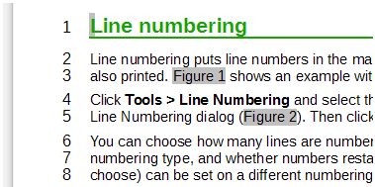
Figure 13: Line numbering example
To add line numbers to an entire document:
- Click Tools > Line Numbering and select the Show numbering option in the top left corner of the Line Numbering dialog (Figure 14).
- Then select any options you want and click OK.
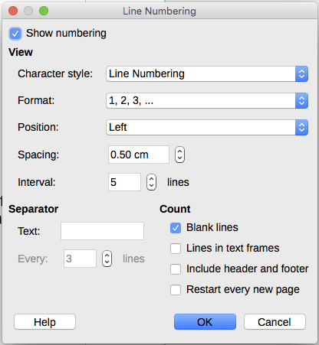
Figure 14: The Line Numbering dialog
To add line numbers to specific paragraphs, first disable the feature for the document and then enable it for specific paragraphs or paragraph styles.
To disable line numbering for the document, edit the Default Style paragraph style (because all paragraph styles are based on the Default Style):
- In the Sidebar, go to the Styles and Formatting pane and click the Paragraph Styles icon.
- Right-click the Default Style paragraph style and choose Modify.
- Click the Outline & Numbering tab (see Figure 15).
- In the Line Numbering area, clear the Include this paragraph in line numbering checkbox.
- Click OK.
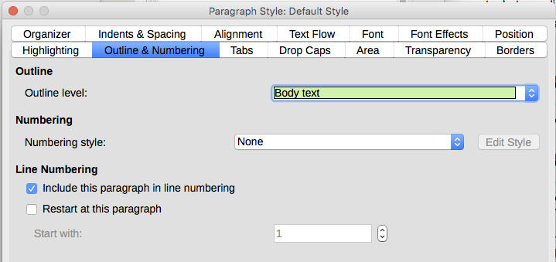
Figure 15: Disabling line numbering for a document
To enable line numbering for specific paragraphs:
- Select the paragraphs where you want to add the line numbers.
- Choose Format > Paragraph, and then click the Outline & Numbering tab.
- Select Include this paragraph in line numbering.
- Click OK.
You can also create a paragraph style that includes line numbering, and apply it to the paragraphs that you want to add line numbers to. For example, to number the lines of example code in a document, you will probably want to use a font or indentation that is different from normal text.
To specify the starting line number:
- Click in the paragraph and choose Format > Paragraph.
- On the Outline & Numbering tab, make sure Include this paragraph in line numbering is selected.
- Select Restart at this paragraph and enter a line number in the Start with box.
- Click OK.

