
Writer 6.0 Guide

Chapter 7
Printing, Exporting, E-mailing

Copyright
This document is Copyright © 2018 by the LibreOffice Documentation Team. Contributors are listed below. You may distribute it and/or modify it under the terms of either the GNU General Public License (http://www.gnu.org/licenses/gpl.html), version 3 or later, or the Creative Commons Attribution License (http://creativecommons.org/licenses/by/4.0/), version 4.0 or later.
All trademarks within this guide belong to their legitimate owners.

Contributors
Jean Hollis Weber | Bruce Byfield | Gillian Pollack

Acknowledgments
This chapter is updated from previous versions in the LibreOffice Writer Guide. Contributors to earlier versions are:
Jean Hollis Weber | John A Smith | Ron Faile Jr.
This chapter is adapted from Chapter 5 of the OpenOffice.org 3.3 Writer Guide. The contributors to that chapter are:
Jean Hollis Weber | Michele Zarri | Agnes Belzunce
Peter Kupfer | Robert Scott | Janet M. Swisher

Feedback
Please direct any comments or suggestions about this document to the Documentation Team’s mailing list: documentation@global.libreoffice.org
- Note
Everything you send to a mailing list, including your email address and any other personal information that is written in the message, is publicly archived and cannot be deleted.

Publication date and software version
Published July 2018. Based on LibreOffice 6.0.

Note for macOS users
Some keystrokes and menu items are different on macOS from those used in Windows and Linux. The table below gives some common substitutions for the instructions in this book. For a more detailed list, see the application Help.
Windows or Linux | macOS equivalent | Effect
Tools > Options menu selection | LibreOffice > Preferences | Access setup options
Right-click | Control+click and/or right-click depending on computer setup | Open a context menu
Ctrl (Control) | ⌘ (Command) | Used with other keys
F5 | Shift+⌘+F5 | Open the Navigator
F11 | ⌘+T | Open the sidebar Styles and Formatting deck

Contents
Copyright 2
Contributors 2
Acknowledgments 2
Feedback 2
Publication date and software version 2
Note for macOS users 2
Introduction 4
Quick printing 4
Controlling printing 4
Selecting general printing options 5
Printing multiple pages on a single sheet of paper 5
Selecting what to print 6
Printing a brochure 7
Printing in black and white (on a color printer) 8
Previewing pages before printing 9
Printing envelopes 9
Printing labels 12
Exporting to PDF 12
Quick export to PDF 12
Controlling PDF content and quality 12
General page of PDF Options dialog 13
Initial View page of PDF Options dialog 14
User Interface page of PDF Options dialog 15
Links page of PDF Options dialog 16
Security page of PDF Options dialog 16
Digital Signatures page of PDF Options dialog 18
Exporting to ePub 19
Exporting to other formats 19
E-mailing Writer documents 19
E-mailing a document to several recipients 20
Sending a fax 22
Digital signing of documents 22
Signing multiple times with same signature 23
Removing personal data 24

Introduction
This chapter describes several ways to print or export documents from Writer in paper or electronic form and the options for each of them.

Quick printing
Click the Print icon to send the entire document to the default printer defined for your computer.
- Note
You can change the action of the Print icon to send the document to the printer defined for the document instead of the default printer for the computer. Go to Tools > Options > Load/Save > General and select Load printer settings with the document.

Controlling printing
For more control over printing, use the Print dialog (File > Print or Ctrl+P).
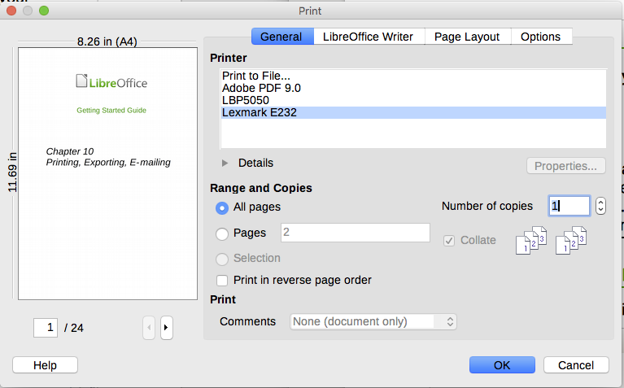
Figure 1: The Print dialog
- Note
The options selected on the Print dialog apply to this printing of this document only.
To specify default printing settings for LibreOffice, go to Tools > Options > LibreOffice > Print and Tools > Options > LibreOffice Writer > Print. See Chapter 20, Setting Up Writer, for more details.
The Print dialog has four pages, from which you can choose a range of options, as described in the following sections.

Selecting general printing options
On the General page of the Print dialog, you can choose:
- The printer (from the list of printers available).
- Which pages to print, the number of copies to print, and whether to collate multiple copies (Range and copies section).
- Whether to print in reverse page order (useful on some printers to make the pages come out in page order).
- Whether to print any comments that are in the document, and where to print the comments.
If the document contains no comments, the Print Comments drop-down list does not work.
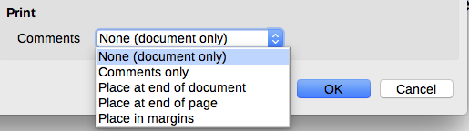
Figure 2: Choosing whether and where to print comments
Click the Properties button to display the selected printer’s properties dialog, where you can choose portrait (vertical) or landscape (horizontal) orientation, which paper tray to use, and the paper size to print on.
On the Options page of the Print dialog, you can choose other options for printing.
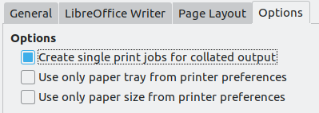
Figure 3: General print options

Printing multiple pages on a single sheet of paper
You can print multiple pages of a document on one sheet of paper. To do this:
- In the Print dialog, select the Page Layout page (Figure 4).
- In the Layout section, select from the drop-down list the number of pages to print per sheet. The preview panel on the left of the Print dialog shows how the printed document will look.
- When printing more than two pages per sheet, you can choose the order in which they are printed across and down the paper. Figure 5 shows the difference.
- In the Page sides section, select whether to print all pages or only some pages.
- Click OK.
- Tip
To print two pages per sheet in “facing pages” (book layout) style, print from Print Preview instead. See page 9.
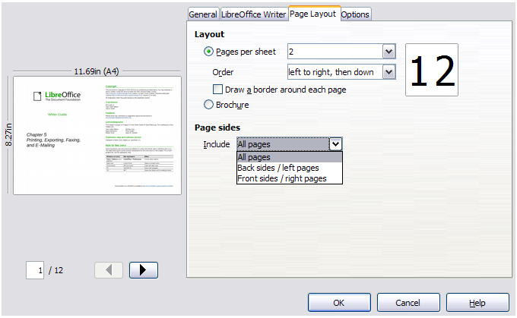
Figure 4: Printing multiple page per sheet of paper
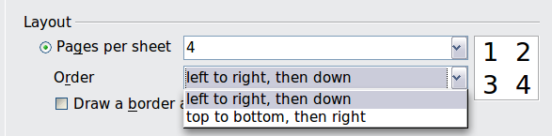
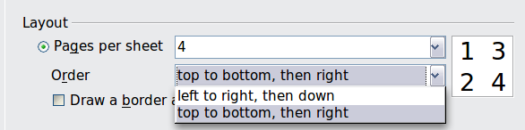
Figure 5: Choosing the order in which to print multiple pages

Selecting what to print
In addition to printing a full document, you can choose to print individual pages, ranges of pages, or a selection of a document, as described in this section.
Printing an individual page:
- Choose File > Print from the Menu bar, or press Ctrl+P.
- On the Print dialog, select the page to print.
- In the Range and copies section of the General page, select the Pages option.
- Enter the sequence number of the page you want to print. The preview box changes to show the selected page.
- Click OK.
Printing a range of pages:
- Choose File > Print from the Menu bar, or press Ctrl+P.
- On the Print dialog, select the range of pages to print.
- In the Ranges and copies section of the General page, select the Pages option.
- Enter the sequence numbers of the pages to print (for example, 1–4 or 1,3,7,11, or a combination like 3–6,8,12).
- Click OK.
Printing a selection of text:
- In the document, select the material (text and images) to print.
- Choose File > Print from the Menu bar, or press Ctrl+P.
- The Ranges and copies section of the Print dialog now includes a Selection option and the preview box shows the selected material. See Figure 6.
- Click OK.
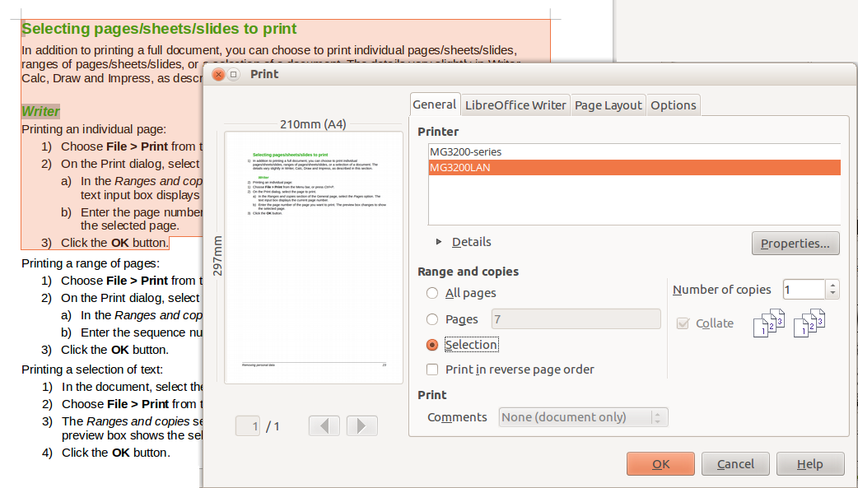
Figure 6: Printing a selection of text

Printing a brochure
In Writer, you can print a document with two pages on each side of a sheet of paper, arranged so that when the printed pages are folded in half, the pages are in the correct order to form a booklet or brochure.
- Tip
Plan your document so it will look good when printed half size; choose appropriate margins, font sizes, and so on. You may need to experiment.
To print a brochure on a single-sided printer:
- Choose File > Print, or press Ctrl+P.
- On the General page of the Print dialog, click Properties.
- Check that the printer is set to the same orientation (portrait or landscape) as specified in the page setup for your document. Usually the orientation does not matter, but it does for brochures. Click OK to return to the Print dialog.
- Select the Page layout page in the Print dialog.
- Select the Brochure option.
- In the Page sides section, select Back sides / left pages from the Include drop-down list. (See Figure 7.) Click OK.
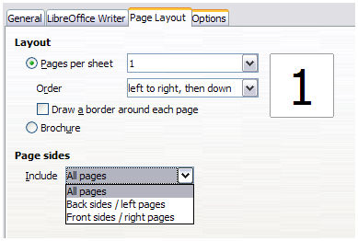
Figure 7: Selecting which pages to print
- Take the printed pages out of the printer, turn the pages over, and put them back into the printer in the correct orientation to print on the blank side. You may need to experiment a bit to find out what the correct arrangement is for your printer.
- On the Print dialog, in the Page sides section, select Front sides / right pages from the Include drop-down box. Click OK.
- Tip
If your printer can print double-sided automatically, choose All pages.

Printing in black and white (on a color printer)
You may wish to print documents in black and white on a color printer. Several choices are available.
- Note
Some color printers may print in color regardless of the settings you choose.
Change the printer settings to print in black and white or grayscale:
- Choose File > Print, or press Ctrl+P, to open the Print dialog.
- Click Properties to open the Properties dialog for the printer. The available choices vary from one printer to another, but you should find options for the Color settings. See your printer’s help or user manual for more information.
- The choices for color might include black and white or grayscale. Choose the required setting.
- Click OK to confirm your choice and return to the Print dialog,
- Click OK to print the document.
- Tip
Grayscale is better than black-and-white if you have images in the document.
Change the LibreOffice settings to print all color text and images as grayscale:
- Choose Tools > Options > LibreOffice > Print.
- Select the Convert colors to grayscale option. Click OK to save the change.
- Open the Print dialog (File > Print or press Ctrl+P).
- Click OK to print the document.
Change the LibreOffice Writer settings to print all color text as black, and all images as grayscale:
- Choose Tools > Options > LibreOffice Writer > Print.
- Under Contents, select the Print text in black option. Click OK to save the change.
- Open the Print dialog (File > Print), or press Ctrl+P.
- Click OK to print the document.

Previewing pages before printing
The normal page view in Writer shows what each page will look like when printed; you can edit the pages in that view. If you are designing a document to be printed double-sided, you may want to see what facing pages look like. Writer provides two ways to do this:
- View Layout (editable view): use the Facing Pages (Book View) button on the status bar and (usually) zoom out.
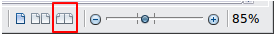
- Print Preview (read-only view).
To use Print Preview:
- Choose File > Print Preview (or click the Print Preview icon on the Standard toolbar). Writer now displays the Print Preview toolbar instead of the Formatting toolbar.
- Select the required preview icon: Two Pages, Book Preview, or Multiple Pages.
- To print the document from this view, click the Print icon to open the Print dialog.
- Choose the print options and click OK.

Printing envelopes
Printing envelopes involves two steps: setup and printing.
To set up an envelope to be printed by itself or with a document:
- Click Insert > Envelope from the Menu bar.
- In the Envelope dialog, start with the Envelope page. Verify, add, or edit the information in the Addressee and Sender (the “from” on the envelope) boxes.
You can type information directly into the Addressee and Sender boxes, or use the right-hand drop-down lists to select the database or table from which you can draw the envelope information, if desired. See Chapter 14, Mail Merge, for details on how to print envelopes from a database.
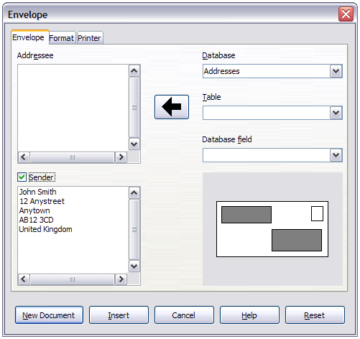
Figure 8: Choosing addressee and sender information for an envelope
- On the Format page (Figure 9), verify or edit the positioning of the addressee and the sender information. The preview area on the lower right illustrates your choices.
- To format the text of these blocks, click the Edit icon to the right. In the drop-down list you have two choices for each button: Character and Paragraph.
- Select Character to open a Character dialog, similar to the standard Character dialog, but omitting Borders, where you can set the formatting of the text.
- Select Paragraph to open a Paragraph dialog, similar to the standard Paragraph dialog, but omitting Outline & Numbering, where you to can set the paragraph's attributes.
- In the lower left of this page, the Size section, choose the envelope format from the drop-down list. The width and height of the selected envelope then show in the boxes below the selected format. If you chose a pre-existing format, just verify these sizes. If you chose User defined in the Format list, then you can edit the sizes.
- Tip
At this stage it is only possible to vary the position of the origin points (upper left corners) of the frames that will hold the Sender and Addressee information, but once the envelope has been created, full adjustment of size and position becomes possible.
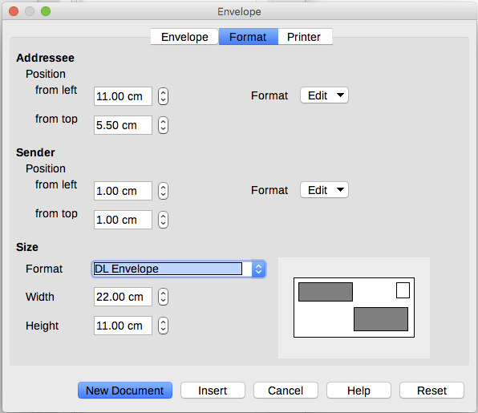
Figure 9: Choosing positioning and size of elements for an envelope
- After formatting, go to the Printer page (Figure 10) to choose the printer to use, its setup—for example, specification of the tray holding envelopes—and other printer options such as envelope orientation and shifting. You may need to experiment to see what options work best for your printer, as well as how the envelopes need to be positioned in the printer.
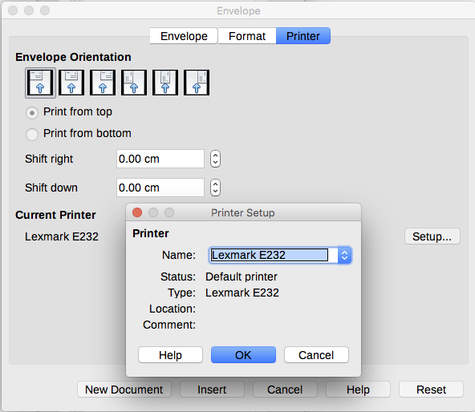
Figure 10: Choosing printer options for an envelope
- When you have finished formatting and are ready to print, click either the New Document or Insert button to finish. New Document makes only an envelope or starts a new document with the envelope. Insert puts the envelope into your existing document as page 1.
To not proceed with this envelope, click Cancel or press the Esc key. To remove your changes and return to the original settings when the dialog opened. click Reset.
The document now has the envelope in the same file as the document. Save this file before you do anything else.
To print the envelope:
- Choose File > Print from the Menu bar.
- On the Print dialog, under Print range, choose Pages and type 1 in the box. Click OK to print.

Printing labels
Labels are commonly used for printing address lists (where each label shows a different address), but they can also be used for making multiple copies of one label only, for example return-address stickers, or labels for CDs/DVDs or other items.
Printing labels, like printing envelopes, has two steps: setup and printing. This topic is covered in detail in Chapter 14, Mail Merge.

Exporting to PDF
LibreOffice can export documents to PDF (Portable Document Format). This standard file format is ideal for sending the file to someone else to view using Adobe Reader or other PDF viewers.
- Tip
Unlike Save As, the Export command writes a copy of the current document in a new file with the chosen format, but keeps the current document and format open in your session.

Quick export to PDF
Click the Export as PDF icon to export the entire document using the PDF settings you most recently selected in the PDF Options dialog. You are asked to enter the file name and location for the PDF, but you do not get a chance to choose a page range, the image compression, or other options.

Controlling PDF content and quality
For more control over the content and quality of the resulting PDF, use File > Export as PDF. The PDF Options dialog opens. This dialog has six pages (General, Initial View, User Interface, Links, Security, and Digital Signatures). Select the appropriate settings, and then click Export. Then you are asked to enter the location and file name of the PDF to be created, and click Export.
- Note
Another choice is to use File > Export. This opens the Export dialog. Select the PDF file format, file name and location, and click Export. This then opens the PDF Options dialog. Click Export when all the selections have been made. The only difference between the two export methods is the sequence in which steps occur.

General page of PDF Options dialog
On the General page (Figure 13), you can choose which pages to include in the PDF, the type of compression to use for images (which affects the quality of images in the PDF), and other options.
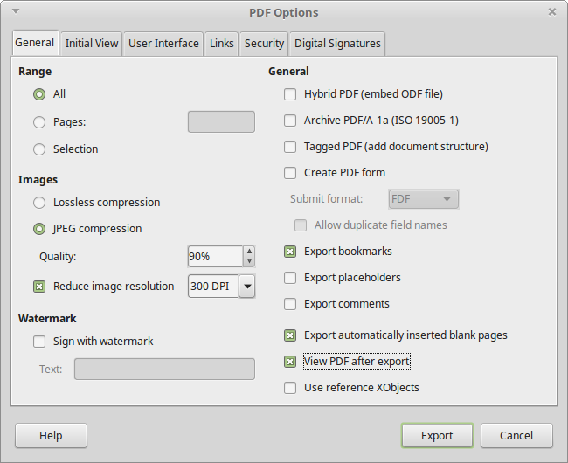
Figure 11: General page of PDF Options dialog
Range section
- All: Exports the entire document.
- Pages: Exports a subset of pages, for example 1–4, or 1,3,7,11, or 3–6,8,12.
- Selection: Exports whatever material is selected.
Images section
- Lossless compression: Images are stored without any loss of quality. Tends to make large files when used with photographs. Recommended for other kinds of images or graphics.
- JPEG compression: Allows for varying degrees of quality. A setting of 90% works well with photographs (small file size, little perceptible loss of quality).
- Reduce image resolution: Lower-DPI (dots per inch) images have lower quality. For viewing on a computer screen generally a resolution of 72dpi (for Windows) or 96dpi (GNU/Linux) is sufficient, while for printing it is generally preferable to use at least 300 or 600 dpi, depending on the capability of the printer. Higher dpi settings increase the size of the exported file.
- Note
EPS (Encapsulated PostScript) images with embedded previews are exported only as previews. EPS images without embedded previews are exported as empty placeholders.
Watermark section
- Sign with Watermark: When this option is selected, a transparent overlay of the text you enter into the Watermark Text box will appear on each page of the PDF.
General section
- Hybrid PDF (embed ODF file): Use this setting to export the document as a PDF file containing two file formats: PDF and ODF. In PDF viewers it behaves like a normal PDF file, and it remains fully editable in LibreOffice.
- Archive PDF/A-1a (ISO 19005-1): PDF/A is an ISO standard for long-term preservation of documents, by embedding all the information necessary for faithful reproduction (such as fonts) while forbidding other elements (including forms, security, and encryption). PDF tags are written. If you select PDF/A-1a, the forbidden elements are grayed-out (not available).
- Tagged PDF: Tagged PDF contains information about the structure of the document’s contents. This can help to display the document on devices with different screens, and when using screen reader software. Some tags that are exported are table of contents, hyperlinks, and controls. This option can increase file sizes significantly.
- Create PDF form – Submit format: Choose the format of submitting forms from within the PDF file. This setting overrides the control’s URL property that you set in the document. There is only one common setting valid for the whole PDF document: PDF (sends the whole document), FDF (sends the control contents), HTML, and XML. Most often you will choose the PDF format.
Allow duplicate field names: If enabled, the same field name can be used for multiple fields in the generated PDF file. With this option enabled, you can enter data in the first occurrence of the named field in the PDF document and all fields with the same name will carry your entry. If disabled, field names will be exported using generated unique names.
- Export bookmarks: Creates PDF bookmarks (a table of contents list displayed by most PDF viewers, including Adobe Reader) for all headings in the document.
- Export placeholders: Exports placeholder text instead of a blank placeholder.
- Export comments: Exports comments as PDF notes. You may not want this!
- Export automatically inserted blank pages: If selected, automatically inserted blank pages are exported to the PDF. This is best if you are printing the PDF double-sided. For example, books usually have chapters set to always start on an odd-numbered (right-hand) page. When the previous chapter ends on an odd page, Writer inserts a blank page between the two odd pages. This option controls whether to export that blank page.
- View PDF after export: Your default PDF viewer will open and display the newly exported PDF immediately after it is generated.

Initial View page of PDF Options dialog
On the Initial View page, you can choose how the PDF opens by default in a PDF viewer. The selections should be self-explanatory.
If you have Complex Text Layout enabled (in Tools > Options > Language settings > Languages), an additional selection is available under Continuous facing: First page is left (normally, the first page is on the right when using the Continuous facing option).
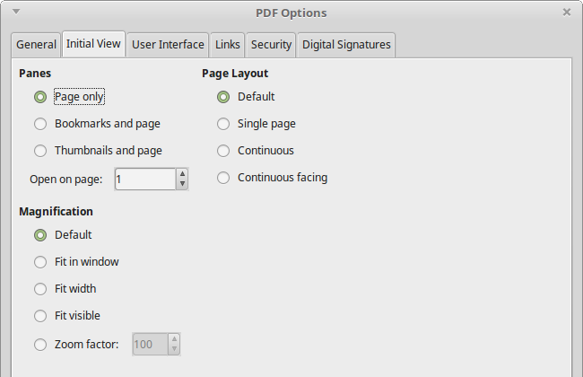
Figure 12: Initial View page of PDF Options dialog

User Interface page of PDF Options dialog
On the User Interface page, you can choose more settings to control how a PDF viewer displays the file. Some of these choices are particularly useful when you are creating a PDF to be used as a presentation or a kiosk-type display.
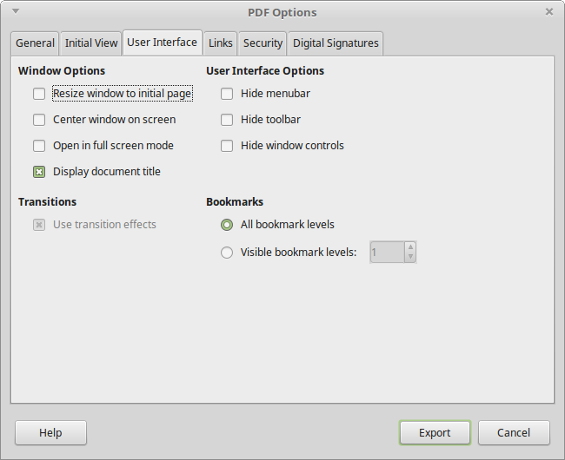
Figure 13: User Interface page of PDF Options dialog
Window options section
- Resize window to initial page. Causes the PDF viewer window to resize to fit the first page of the PDF.
- Center window on screen. Causes the PDF viewer window to be centered on the computer screen.
- Open in full screen mode. Causes the PDF viewer to open full-screen instead of in a smaller window.
- Display document title. Causes the PDF viewer to display the document’s title in the title bar.
User interface options section
- Hide menubar. Causes the PDF viewer to hide the Menu bar.
- Hide toolbar. Causes the PDF viewer to hide the toolbar.
- Hide window controls. Causes the PDF viewer to hide other window controls.
Bookmarks
Select how many heading levels are displayed as bookmarks, if Export bookmarks is selected on the General page.

Links page of PDF Options dialog
On the Links page, you can choose how links in documents are exported to PDF.
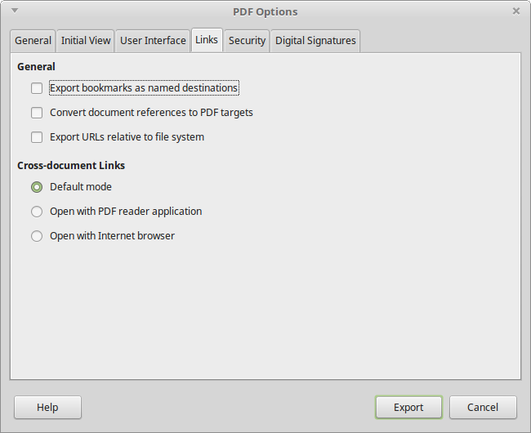
Figure 14: Links page of PDF Options dialog
Export bookmarks as named destinations
If you have defined Writer bookmarks, this option exports them as “named destinations” to which Web pages and PDF documents can link.
Convert document references to PDF targets
If you have defined links to other documents with OpenDocument extensions (such as .odt, .ods, and .odp), this option converts the files names to .pdf in the exported PDF document.
Export URLs relative to the file system
If you have defined relative links in a document, this option exports those links to the PDF.
Cross-document links
Set up the behavior of the PDF links to other files. Select one among the following alternatives:
- Default mode: The PDF links will be handled as specified in your operating system.
- Open with PDF reader application: Use the same application used to display the PDF document to open linked PDF documents.
- Open with Internet browser: Use the default Internet browser to display linked PDF documents.

Security page of PDF Options dialog
PDF export includes options to encrypt the PDF (so it cannot be opened without a password) and apply some digital rights management (DRM) features.
- With an open password set, the PDF can only be opened with the password. Once opened, there are no restrictions on what the user can do with the document (for example, print, copy, or change it).
- With a permissions password set, the PDF can be opened by anyone, but its permissions can be restricted. See Figure 15. After you set a password for permissions, the other choices on the Security page become available.
- With both the open password and permission password set, the PDF can only be opened with the correct password, and its permissions can be restricted.
- Note
Permissions settings are effective only if the user’s PDF viewer respects the settings.
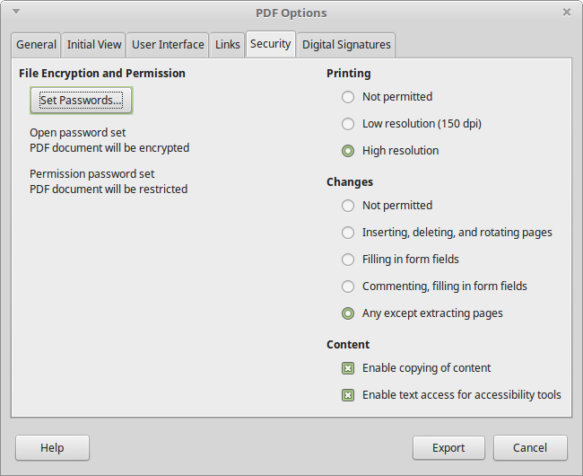
Figure 15: Security page of PDF Options dialog with passwords set
Figure 16 shows the pop-up dialog displayed when you click the Set passwords button on the Security page of the PDF Options dialog.
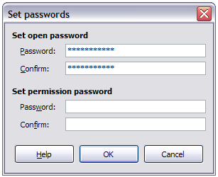
Figure 16: Setting a password to encrypt a PDF

Digital Signatures page of PDF Options dialog
The Digital Signatures page contains the options related to exporting a digitally signed PDF.
Digital signatures are used to ensure that the PDF was really created by the original author (that is, you), and that the document has not been modified since it was signed.
The signed PDF export uses the keys and X.509 certificates already stored in your default key store location or on a smartcard. The key store to be used can be selected under Tools > Options > LibreOffice > Security > Certificate Path. When using a smartcard, it must already be configured for use by your key store. This is usually done during installation of the smartcard software. Details about using these features is outside the scope of this chapter.
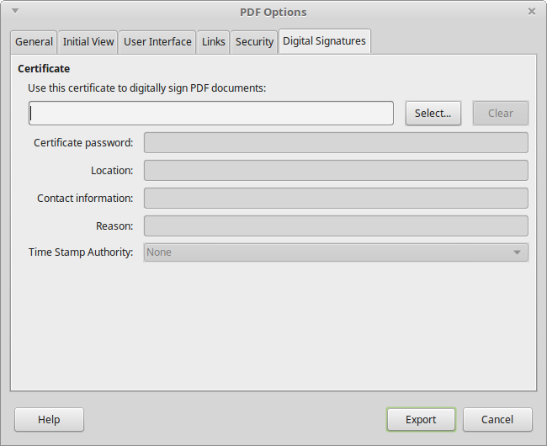
Figure 17: Digital Signatures page of PDF Options dialog
- Use this certificate to digitally sign PDF documents: Click Select to open the Select Certificate dialog, where all certificates found in your selected key store are displayed. If the key store is protected by a password, you are prompted for it. When using a smartcard that is protected by a PIN, you are also prompted for that.
Select the certificate to use for digitally signing the exported PDF, then click OK. All other fields on the Digital Signatures page are accessible only after a certificate has been selected.
- Certificate password: Enter the password used for protecting the private key associated with the selected certificate. Usually this is the key store password. If the key store password has already been entered in the Select Certificate dialog, the key store may already be unlocked and not require the password again.
When using a smartcard, enter the PIN here. Some smartcard software will prompt you for the PIN again before signing.
- Location, Contact information, Reason: Optionally enter additional information about the digital signature that will be applied to the PDF. This information will be embedded in the appropriate PDF fields and will be visible to anyone viewing the PDF. Any or all of the three fields may be left blank.
- Time Stamp Authority: Optionally select a Time Stamping Authority (TSA) URL. During the PDF signing process, the TSA will be used to obtain a digitally signed timestamp that is then embedded in the signature. Anyone viewing the PDF can use this timestamp to verify when the document was signed.
The list of TSA URLs that can be selected is maintained under Tools > Options > LibreOffice > Security > TSAs. If no TSA URL is selected (the default), the signature will not be timestamped, but will use the current time from your local computer.

Exporting to ePub
ePub is an e-book file format that can be downloaded and read on devices like smartphones, tablets, computers, or e-readers. It is the most widely supported vendor-independent XML-based (as opposed to PDF) e-book format.
Export to ePub is limited in LibreOffice 6.0. A text-only document generally exports well, but some contents (such as illustrations, tables, and cross references) may not export correctly. These functions are expected to be added or greatly improved in later releases of LibreOffice.
Use File > Export As > Export as EPUB to start the process.
- Tip
Other ways to export to ePub from Writer (.odt) files include Calibre, an open-source e-book manager that runs on Windows, macOS, and Linux. Calibre provides many e-book conversion facilities and allows editing of the result. https://calibre-ebook.com/

Exporting to other formats
LibreOffice uses the term “export” for some file operations involving a change of file type. Writer can export files to XHTML, ePub and other formats, as shown in Figure 18.
Choose File > Export. On the Export dialog, specify a file name for the exported document, then select the required file format and click Export.
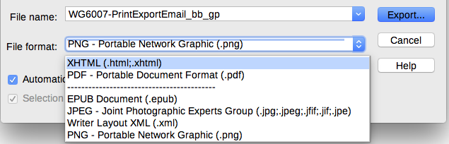
Figure 18: Export file formats

E-mailing Writer documents
LibreOffice provides several ways to quickly and easily send a Writer document as an e-mail attachment in one of three formats: .odt (OpenDocument Text, Writer’s default format), .doc (Microsoft Word format), or .pdf.
To send the current document in .odt format, choose:
- File > Send > E-mail Document, or File > Send > E-mail as OpenDocument Text. Writer opens your default e-mail program. The document is attached.
- In your e-mail program, enter the recipient, subject, and any text you want to add, then send the e-mail.
If you choose E-mail as Microsoft Word, Writer first creates a .doc file and then opens your e-mail program with the .doc file attached. Similarly, if you choose E-mail as PDF, Writer opens the PDF Options dialog where you can select the settings you want, then creates a PDF, and then opens your email program with the .pdf file attached.

E-mailing a document to several recipients
To e-mail a document to several recipients, you can use the features in your e-mail program or you can use Writer’s mail merge facilities to extract email addresses from an address book.
You can use Writer’s mail merge to send e-mail in two ways:
- Use the Mail Merge Wizard to create the document and send it. See Chapter 14, Mail Merge, for details.
- Create the document in Writer without using the Wizard, then use the Wizard to send it. This method is described here.
To use the Mail Merge Wizard to send a previously-created Writer document:
- Open the document in Writer. Click Tools > Mail Merge Wizard. On the first page of the wizard, select Use the current document and click Next.
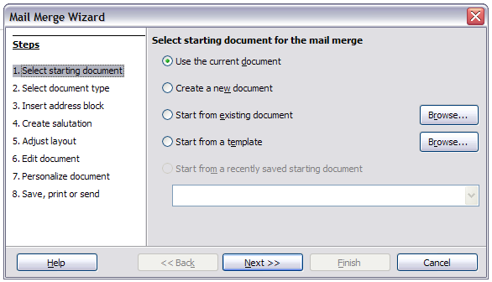
Figure 19: Select starting document
- On the second page, select E-mail message and click Next.
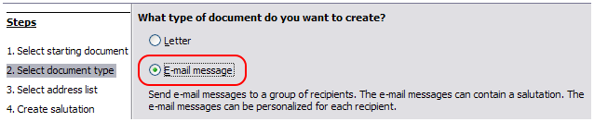
Figure 20: Select document type
- On the third page, click the Select Address List button. Select the required address list (even if only one is shown) and then click OK. (If the address list you need is not shown here, you can click Add to find and add it to the list.)

Figure 21: Selecting an address list
- Back on the Select address list page, click Next. On the Create salutation page, deselect the checkbox by This document should contain a salutation.
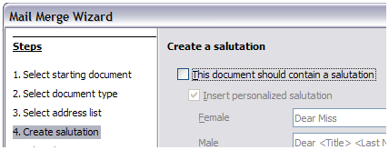
Figure 22: Deselecting a salutation
- In the left-hand list, click Step 8. Save, print or send. Writer displays a “Creating documents” message and then displays the Save, print or send page of the Wizard (Figure 23).
- Select Send merged document as E-Mail. The lower part of the page changes to show e-mail settings choices.
- Type a subject for your email and click Send documents. Writer sends the e-mails.

Figure 23: Sending a document as an email message

Sending a fax
To send a fax directly from Writer, you need a fax modem and a fax driver that allows applications to communicate with the fax modem.
- Open the Print dialog (Figure 1) by choosing File > Print (or Ctrl+P) and select the fax driver in the Printer list.
- Click OK to open the dialog for your fax driver, where you can select the fax recipient.
You can set up a toolbar button so that a single click sends the current document as a fax. To add a button for this purpose to a toolbar, see Chapter 21, Customizing Writer.

Digital signing of documents
To sign a document digitally, you need a personal key, also known as a certificate. A personal key is stored on your computer as a combination of a private key, which must be kept secret, and a public key, which you add to your documents when you sign them. You can get a certificate from a certification authority, which may be a private company or a governmental institution.
When you apply a digital signature to a document, a kind of checksum is computed from the document’s content plus your personal key. The checksum and your public key are stored together with the document.
When someone later opens the document on any computer with a recent version of LibreOffice, the program will compute the checksum again and compare it with the stored checksum. If both are the same, the program will signal that you see the original, unchanged document. In addition, the program can show you the public key information from the certificate. You can compare the public key with the public key that is published on the web site of the certificate authority. Whenever someone changes something in the document, this change breaks the digital signature.
On Windows operating systems, the Windows features of validating a signature are used. On Linux systems, files that are supplied by Thunderbird, Mozilla, or Firefox are used. For a more detailed description of how to get and manage a certificate, and signature validation, see “About Digital Signatures” and “Applying Digital Signatures” in the LibreOffice Help.
To sign a document:
- Choose File > Digital Signatures > Digital Signatures. If you have set LibreOffice to warn you when the document contains notes (comments) or recorded changes, you may see a message box asking whether you want to continue signing the document.
- If you have not saved the document since the last change, a message box appears. Click Yes to save the file.
- The Digital Signatures dialog opens. Click Sign Document to add a public key to the document.
- In the Select Certificate dialog, select your certificate and click OK to return to the Digital Signatures dialog.
- The certificate used is displayed in the dialog with an icon next to its name.
This icon indicates the status of the digital signature.
- An icon with a red seal indicates that the document was signed and the certificate was validated.
- An icon with a yellow caution triangle overlaying the red seal indicates that the document is signed but that the certificate could not be validated.
- An icon of a yellow caution triangle indicates an invalid digital signature.
- Click Close to apply the digital signature.
A signed document shows an icon in the status bar. You can double-click the icon to view the certificate. More than one signature can be added to a document.

Signing multiple times with same signature
In the past, LibreOffice prohibited multiple signatures by the same author on a document, but a signature description is now provided, so an author can now sign a document more than once.
When you select File > Digital Signatures, the dialog (Figure 24) lists existing signatures together with their description (if they have any).
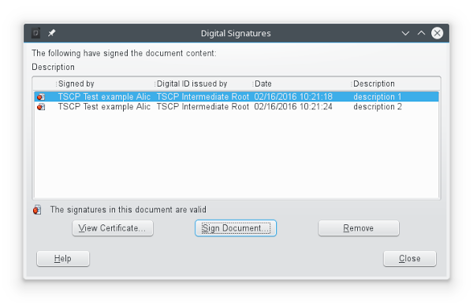
Figure 24: Signatures of the document
When you click the Sign Document button, the dialog (Figure 25) for certificate selection also asks for an optional description.
Changing an existing description invalidates the signature.
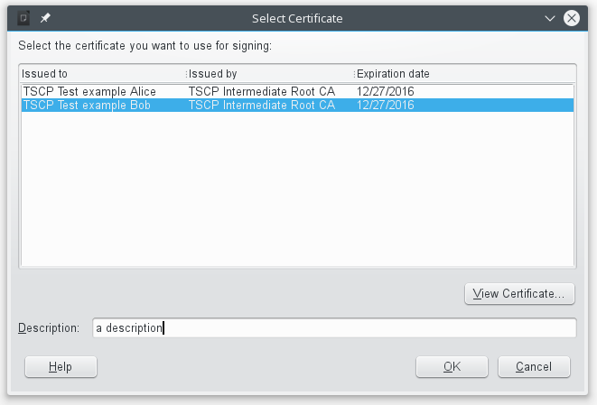
Figure 25: Signatures can now have a description

Removing personal data
You may wish to ensure that personal data, versions, comments, hidden information, or recorded changes are removed from files before you send them to other people or create PDFs from them.
In Tools > Options > LibreOffice > Security > Options, you can set LibreOffice to remind (warn) you automatically when saving files containing certain information and optionally remove personal information.
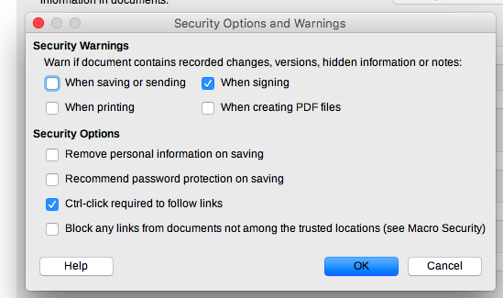
Figure 26: Set security warnings and options
To remove personal and some other data from a file, go to File > Properties. On the General page, uncheck Apply user data and click the Reset Properties button. This removes any names in the created and modified fields, deletes the modification and printing dates, and resets the editing time to zero, the creation date to the current date and time, and the version number to 1.
To remove version information, either (a) go to File > Versions, select the versions from the list and click Delete, or (b) use Save As and save the file with a different name.

