
Writer 6.0 Guide

Chapter 10
Working with Templates

Copyright
This document is Copyright © 2018 by the LibreOffice Documentation Team. Contributors are listed below. You may distribute it and/or modify it under the terms of either the GNU General Public License (http://www.gnu.org/licenses/gpl.html), version 3 or later, or the Creative Commons Attribution License (http://creativecommons.org/licenses/by/4.0/), version 4.0 or later.
All trademarks within this guide belong to their legitimate owners.

Contributors
Jean Hollis Weber | Bruce Byfield | Gillian Pollack

Acknowledgments
This chapter is updated from previous versions of the LibreOffice Writer Guide. Contributors to earlier versions are:
Jean Hollis Weber | John A Smith | Ron Faile Jr.
Barbara Duprey | Hazel Russman | Gary Schnabl
This chapter is adapted from Chapter 10 of the OpenOffice.org 3.3 Writer Guide. The contributors to that chapter are:
Alan Madden | Paul Miller | Catherine Waterman
Jean Hollis Weber | Michele Zarri

Feedback
Please direct any comments or suggestions about this document to the Documentation Team’s mailing list: documentation@global.libreoffice.org
- Note
Everything you send to a mailing list, including your email address and any other personal information that is written in the message, is publicly archived and cannot be deleted.

Publication date and software version
Published July 2018. Based on LibreOffice 6.0.

Note for macOS users
Some keystrokes and menu items are different on macOS from those used in Windows and Linux. The table below gives some common substitutions for the instructions in this book. For a more detailed list, see the application Help.
Windows or Linux | macOS equivalent | Effect
Tools > Options menu selection | LibreOffice > Preferences | Access setup options
Right-click | Control+click and/or right-click depending on computer setup | Open a context menu
Ctrl (Control) | ⌘ (Command) | Used with other keys
F5 | Shift+⌘+F5 | Open the Navigator
F11 | ⌘+T | Open the sidebar Styles and Formatting deck

Contents
Copyright 2
Contributors 2
Acknowledgments 2
Feedback 2
Publication date and software version 2
Note for macOS users 2
Introduction 4
Using a template to create a document 4
Creating a document from the Templates dialog 4
Creating a document from a template in the Start Center 5
Creating a template 5
Creating a template from a document 5
Creating a template using a wizard 6
Editing a template 6
Updating a document from a changed template 7
Adding templates obtained from other sources 7
Installing individual templates 7
Installing collections of templates 8
Setting a default template 8
Setting a template as the default 8
Resetting Writer’s default template as the default 9
Associating a document with a different template 9
Organizing templates 10
Creating a template category 10
Deleting a template category 10
Moving a template 11
Deleting a template 11
Importing a template 11
Exporting a template 11

Introduction
A template is a document model that you use to create other documents. For example, you can create a template for business reports that has your company’s logo on the first page. New documents created from this template will all have your company’s logo on the first page.
Templates can contain anything that regular documents can contain, such as text, graphics, a set of styles, and user-specific setup information such as measurement units, language, the default printer, and toolbar and menu customization.
All documents in LibreOffice are based on templates. If you do not specify a template when you start a new Writer document, then the document is based on the default template for text documents. If you have not specified a default template, Writer uses the blank template for text documents that is installed with LibreOffice. See “Setting a default template” on page 8.
LibreOffice supplies only a few user-selectable templates. You can add templates from other sources (see page 7) as well as creating your own templates (see page 5).

Using a template to create a document

Creating a document from the Templates dialog
To use a template to create a document:
- From the Menu bar, choose File > New > Templates, or click the small arrow next to the New icon on the Standard toolbar and select Templates.
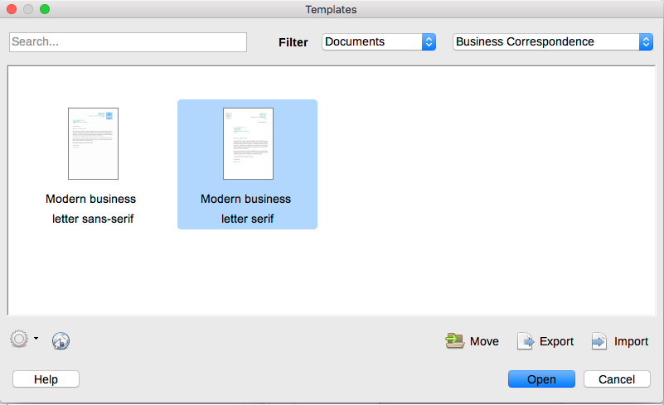
Figure 1: Templates dialog
- From the Filters list at the top of the Templates dialog, optionally select a category.
- Find and double-click the required template. A new document based on the selected template opens in Writer. You can then edit and save the new document just as you would any other document.
The template the document is based upon is listed in File > Properties > General.
- Note
The connection between a template and a document remains until the template is modified and, the next time that the document is opened, you choose not to update it to match the template.
If you copy or move the document to a different computer, which does not have a copy of that template installed, the connection is broken, even though it continues to be listed in the document’s properties. See “Associating a document with a different template” on page 9 for a way to reconnect a template to a document, if required.

Creating a document from a template in the Start Center
You can create a document from the template view of the Start Center, which is visible when no other document is open.
To open the Templates dialog from the Start Center, click the Templates icon in the left pane. The icon is also a drop-down list to select the templates of a given type of document. The Manage Templates option on the list opens the Templates dialog.

Creating a template
You can create templates in two ways: by saving a document as a template or by using a wizard.

Creating a template from a document
In addition to formatting, any settings that can be added to or modified in a document can be saved within a template. For example:
- Printer settings.
- General behaviors set from Tools > Options, such as Paths.
- Menu and toolbar customizations; see Chapter 21.
Templates can also contain predefined text, saving you from having to type it every time you create a new document. For example, a letter template may contain your name, address, and salutation.
- Tip
You can save a template from the usual Save dialog, but it won’t be listed with other templates. You might want to do this to share a template easily with others.
To create a template from a document and save it to My Templates:
- Open a new or existing document of the type you want to make into a template (text document, spreadsheet, drawing, or presentation).
- Add any content that you want to appear in any document you create from the new template, for example company logo, copyright statement, and so on.
- Create or modify any styles or other formatting, such as Autotext. that you want to use in the new template.
- From the Menu bar, choose File > Templates > Save as Template. The Save as Template dialog (Figure 2) displays the existing categories and a textbox to enter a name for the new template.
- Select the required category and click Save.
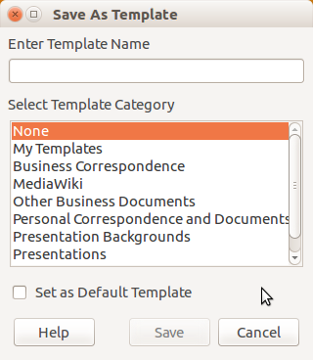
Figure 2: Save as Template dialog

Creating a template using a wizard
You can use wizards to create templates for letters, faxes, and agendas, and to create presentations and Web pages.
For example, the Fax Wizard guides you through the following choices:
- Type of fax (business or personal).
- Document elements like the date, subject line (business fax), salutation, and complimentary close.
- Options for sender and recipient information (business fax).
- Text to include in the footer (business fax).
To create a template using a wizard:
- From the Menu bar, choose File > Wizards > [type of template required].
- Follow the instructions on the pages of the wizard. This process is slightly different for each type of template, but the format is similar.
- In the last section of the wizard, you can specify the template name that will show in the Templates dialog, and also the name and location for saving the template. The two names can be different but this may later cause confusion. The default location is your user templates folder, but you can choose a different location.
- To set the file name or change the folder, select the Path icon (the three dots to the right of the location). On the Save As dialog, make your selections and click Save.
- Finally, you can choose whether to create a new document from the template immediately, or manually change the template, and then click Finish to save the template. For future documents, you can re-use the template created by the wizard, just like any other template.

Editing a template
You can edit a template’s styles and content, and then, if you wish, you can reapply the template’s styles to documents that were created from that template. You cannot reapply content.
To edit a template:
- From the Menu bar, choose File > Templates > Manage Templates or press Ctrl+Shift+N. The Templates dialog opens. You can also open the Templates dialog from the Start Center.
- Navigate to the template that you want to edit. Click once on it to activate the file handling controls. Right-click to open the context menu and click Edit. The template opens in LibreOffice.
- Edit the template as you would edit any other document. To save your changes, choose File > Save from the Menu bar.

Updating a document from a changed template
If you make any changes to a template and its styles, the next time you open a document that was created from the template before the changes, a confirmation message is displayed.
To update the document:
- Select Update Styles to apply the changed styles in the template to the document.
- Select Keep Old Styles if you do not want to apply the changed styles in the template to the document (but see the Caution notice below).
- Caution
If you choose Keep Old Styles, the document is no longer connected to the template, even though the template is still listed under File > Properties > General. To reconnect the document to the template, you will have to copy it into an empty document based on the template, as described in “Associating a document with a different template” on page 9.

Adding templates obtained from other sources
LibreOffice refers to sources for templates as repositories. A repository can be local (a directory on your computer to which you have downloaded templates) or remote (a URL from which you can download templates).
You can get to the official template repository by using the Browse online templates icon in the lower left of the Templates dialog, as shown in Figure 3, or by visting https://extensions.libreoffice.org/templates.
On other websites, you may find collections of templates that have been packaged into extension (.oxt) files. These are installed a little differently, as described below.
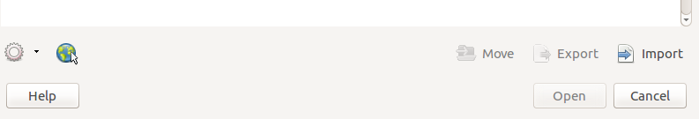
Figure 3: Getting more templates for LibreOffice

Installing individual templates
To install a template:
- Download the template and save it anywhere on your computer.
- Import the template into a template folder by following the instructions in “Importing a template” on page 11.
- Tip
(For advanced users) You can manually copy new templates into the template folders. The location varies with your computer’s operating system. To learn where the template folders are stored on your computer, go to Tools > Options > LibreOffice > Paths.

Installing collections of templates
The Extension Manager provides an easy way to install collections of templates that have been packaged as extensions. Follow these steps:
- Download the extension package (.oxt or .zip file) and save it anywhere on your computer.
- In LibreOffice, select Tools > Extension Manager from the Menu bar. In the Extension Manager dialog, click Add to open a file browser window.
- Find and select the package of templates you want to install and click Open. The package begins installing. You may be asked to accept a license agreement.
- When the package installation is complete, the templates are available for use through File > Templates > Manage Templates and File > New > Templates and the extension is listed in the Extension Manager.
See Chapter 21, Customizing Writer, for more about the Extension Manager.

Setting a default template
If you create a document by choosing File > New > Text Document from the Menu bar, Writer creates the document from the default template for text documents. You can, however, set a custom template to be the default. You can reset the default later, if you choose.
- Note for Microsoft Word users
You may know that Microsoft Word employs a normal.dot or normal.dotx file for its default template and how to regenerate it.
LibreOffice does not have a similar default template file; the “factory defaults” are embedded within the software.

Setting a template as the default
Most default settings, such as page size and page margins, can be changed in Tools > Options, but those changes apply only to the document you are working on. To make those changes the default settings for that document type, you need to replace the default template with a new one.
You can set any template in the Templates dialog to be the default for that document type:
- From the Menu bar, choose File > Templates > Manage Templates.
- In the Templates dialog, open the category containing the template that you want to set as the default, then select the template.
- Right-click the selected template and select Set as default from the context menu (see Figure 4).
The next time that you create a document of that type by choosing File > New, the document will be created from this template.
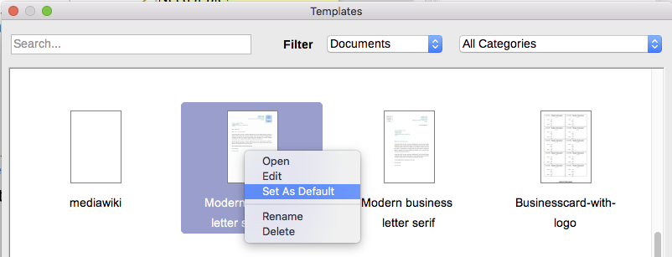
Figure 4: Setting a template as the default template for documents

Resetting Writer’s default template as the default
To re-enable Writer’s original default template as the default:
- From the Menu bar, choose File > Templates > Manage Templates.
- In the Templates dialog (Figure 5), click the Settings icon on the bottom left.
- Point to Reset Default Template on the drop-down menu, and click Text Document.
This choice does not appear unless a custom template had been set as the default, as described in the previous section.
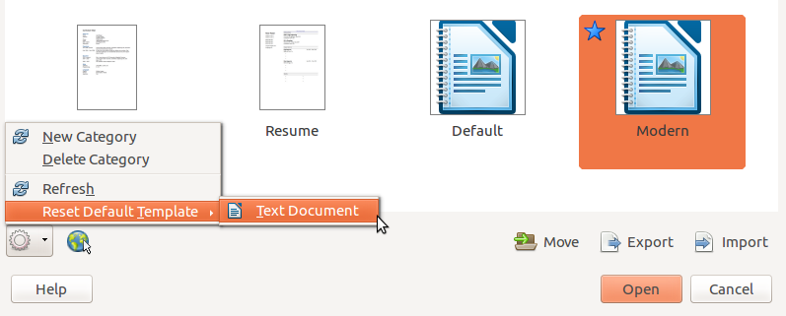
Figure 5: Resetting the default template for text documents
The next time that you create a document by choosing File > New > Text Document, the document will be created from Writer’s default template.

Associating a document with a different template
At times you might want to associate a document with a different template, or perhaps you’re working with a document that did not start from a template.
One of the major advantages of using templates is the ease of updating styles in more than one document, as described in Chapter 9, Working with Styles. If you update styles in a document by loading a new set of styles from a different template (as described in Chapter 9), the document has no association with the template from which the styles were loaded. Instead, you need to associate the document with the different template.
For best results, the names of styles should be the same in the existing document and the new template. If they are not, you need to use Edit > Find & Replace to replace old styles with new ones. See Chapter 2, Working with Text: Basics, for more about replacing styles.
- Use File > New > Templates. In the Templates dialog, double-click the template you want to use. A new document opens, containing any text or graphics that were in the template.
- Delete any unwanted text or graphics from this new document.
- Open the document you want to change. (It opens in a new window.)
- Use Edit > Select All, or press Ctrl+A, to select everything in the document.
- Use Edit > Copy, or press Ctrl+C, to copy the contents of the document to the clipboard.
- Click in the blank document created in step 1. Use Edit > Paste, or press Ctrl+V, to paste the contents from the old document into the new one.
- Update the table of contents, if there is one. Close the old file without saving. Use File > Save As to save this new file with the name of the file from which content was taken. When asked, confirm you wish to overwrite the old file. Or, you may prefer to save the new file under a new name and preserve the old file under its original name.
- Caution
Any changes recorded (tracked) in the document will be lost during this process. The resulting document will contain only the changed text.

Organizing templates
Writer can only lists templates that are in LibreOffice template categories. You can create new template categories and use them to organize your templates. For example, you might have one category for report templates and another for letter templates. You can also import and export templates.
To begin, choose File > Templates > Manage Templates to open the Templates dialog.

Creating a template category
To create a template category:
- Click the Settings icon on the Templates dialog.
- Click New category on the context menu (see Figure 6).
- In the pop-up dialog, type a name for the new category and click OK.
- Note
You cannot create a sub-category inside a template category in LibreOffice.
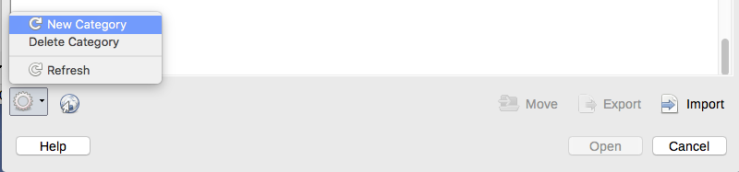
Figure 6: Creating a new category

Deleting a template category
To delete a category, click the Settings icon select the catgory from the pop-up Category list, and then click OK. When a message box appears asking you to confirm the deletion, click Yes.

Moving a template
To move a template from one template category to another, select it in the Templates dialog, and click the Move icon in the bottom center of the dialog (see Figure 7). In the popup dialog, select the required category and click OK.
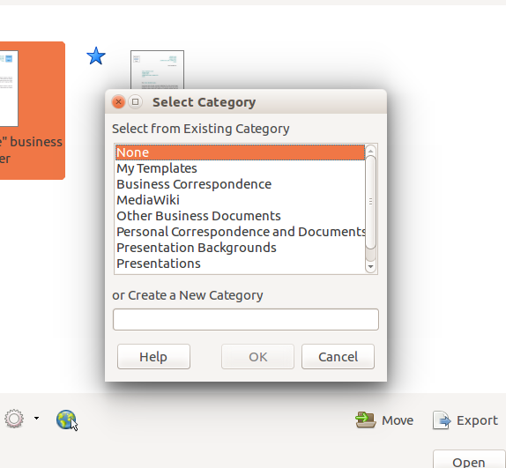
Figure 7: Moving templates to another category

Deleting a template
To delete a template:
- In the Templates dialog, select the category that contains the template you want to delete.
- Select the template to delete.
- Right-click to open the context menu of the template and click Delete. A message box appears and asks you to confirm the deletion. Click Yes.

Importing a template
Before you can use a template in LibreOffice, it must be in one of the folders listed for the Template path in Tools > Options > LibreOffice > Paths:
- In the Templates dialog, click the Import icon on the bottom right. The Select Category dialog appears.
- Find and select the category where you want to import the template and click OK. A standard file browser window opens.
- Find and select the template that you want to import and click Open. The file browser window closes and the template appears in the selected category.

Exporting a template
To export a template to another location in your computer or network:
- In the Templates dialog, locate the category that contains the template to export.
- Select the template that you want to export.
- Click the Export icon in the bottom right of the dialog. The Save As window opens.
- Find the folder into which you want to export the template and select Save.

