
Writer 6.0 Guide

Chapter 11
Images and Graphics
Pictures, Drawing Tools, Gallery, Fontwork

Copyright
This document is Copyright © 2018 by the LibreOffice Documentation Team. Contributors are listed below. You may distribute it and/or modify it under the terms of either the GNU General Public License (http://www.gnu.org/licenses/gpl.html), version 3 or later, or the Creative Commons Attribution License (http://creativecommons.org/licenses/by/4.0/), version 4.0 or later.
All trademarks within this guide belong to their legitimate owners.

Contributors
Jean Hollis Weber | Bruce Byfield | Gillian Pollack

Acknowledgments
This chapter is updated from previous versions of the LibreOffice Writer Guide. Contributors to earlier versions are:
John A Smith | Jean Hollis Weber | Ron Faile Jr.
Barbara Duprey | Jamie Eby
An earlier version appeared in the OpenOffice 3.3 Writer Guide. The contributors were:
Agnes Belzunce | John Kane | Vincenzo Ponzi
Gary Schnabl | Barbara M. Tobias | Jean Hollis Weber
Michele Zarri

Feedback
Please direct any comments or suggestions about this document to the Documentation Team’s mailing list: documentation@global.libreoffice.org
- Note
Everything you send to a mailing list, including your email address and any other personal information that is written in the message, is publicly archived and cannot be deleted.

Publication date and software version
Published July 2018. Based on LibreOffice 6.0.

Note for macOS users
Some keystrokes and menu items are different on macOS from those used in Windows and Linux. The table below gives some common substitutions for the instructions in this book. For a more detailed list, see the application Help.
Windows or Linux | macOS equivalent | Effect
Tools > Options menu selection | LibreOffice > Preferences | Access setup options
Right-click | Control+click and/or right-click depending on computer setup | Open a context menu
Ctrl (Control) | ⌘ (Command) | Used with other keys
F5 | Shift+⌘+F5 | Open the Navigator
F11 | ⌘+T | Open the sidebar Styles and Formatting deck

Contents
Copyright 2
Contributors 2
Acknowledgments 2
Feedback 2
Publication date and software version 2
Note for macOS users 2
Images (graphics) in Writer 5
Creating and editing images 5
Preparing images for black-and-white printing 5
Adding images to a document 6
Inserting an image file 6
Drag and drop 6
Insert Image dialog 6
Copy and paste 7
Linking an image file 7
Embedding linked images 8
Scanning 9
Inserting an image from the Gallery 9
Inserting an image as a background 9
Modifying, handling, and positioning images 10
Using the Picture toolbar 10
Image mode 10
Transparency 11
Color 11
Flip vertically, horizontally or in 90° rotations 11
Image filters 11
Using the Formatting toolbar and Image dialog 11
Cropping images 11
Using the Crop tool 12
Using the Crop page of the Image dialog 12
Resizing an image 13
Rotating or flipping an image 14
Other settings 14
Deleting an image 15
Exporting images 15
Compressing images 15
Saving modified images 15
Using Writer’s drawing tools 16
Creating drawing objects 16
Setting or changing properties for drawing objects 17
Resizing a drawing object 17
Grouping drawing objects 17
Rotating drawing objects 18
Positioning images within the text 18
Arranging images 19
Anchoring images 20
Aligning images 20
Wrapping text around images 21
Editing the contour 22
Example 1: Page wrapping 23
Example 2: Simple contour wrapping in action 24
Example 3: Wrap Through and In Background 25
Adding captions to images 25
Adding captions automatically 25
Adding captions using the Caption dialog 26
Numbering images by chapter 26
Adding captions manually 27
Place the graphic and its caption in separate paragraphs 28
Use a table 28
Creating an image map 28
Managing the LibreOffice Gallery 30
Adding objects to the Gallery 30
Deleting images from the Gallery 31
Adding a new theme to the Gallery 31
Deleting a theme from the Gallery 32
Location of the Gallery and the objects in it 32
Using Fontwork 32
Creating a Fontwork object 32
Editing a Fontwork object 33
Using the Fontwork toolbar 33
Using the Formatting toolbar 34
Using menu options 34
Using the 3D-Settings toolbar 35
Moving and resizing Fontwork objects 35

Images (graphics) in Writer
You can add graphic and image files, including photos, drawings, and scanned images, to Writer documents. Writer can import various vector (line drawing) and raster (bitmap) file formats.
Images in Writer are of these basic types:
- Image files, such as photos, drawings, and scanned images
- Diagrams created using LibreOffice’s drawing tools
- Artwork created using clip art or Fontwork
- Charts created using LibreOffice’s Chart facility
This chapter covers images, diagrams, and artwork. Instructions on how to create charts are given in Chapter 19, Spreadsheets, Charts, other Objects. For more detailed descriptions on working with drawing tools, see the Draw Guide.

Creating and editing images
You might create images (also called ‘pictures’ in LibreOffice) using a graphics program, scan them, or download them from the Internet (make sure you have permission to use them), or use photos taken with a digital camera. Writer can import various vector (line drawing) images, and can rotate and flip such images. Writer also supports raster (bitmap) file formats, the most common of which are GIF, JPG, PNG, and BMP. See the Help for a full list.
Writer can also import SmartArt images from Microsoft Office files. For example, Writer can open a Microsoft Word file that contains SmartArt, and you can use Writer to edit the images.
Some things to consider when choosing or creating pictures include image quality and whether the picture will be printed in color or black and white (grayscale).
To edit photos and other bitmap images, use a bitmap editor. To edit line drawings, use a vector drawing program. You do not need to buy expensive programs. For many graphics, LibreOffice Draw is sufficient. Open-source (and usually no-cost) tools such as GIMP (bitmap editor) and Inkscape (vector drawing program) are excellent. These and many other programs work on Windows, MacOS, and Linux.
For best results:
- Create images that have the exact dimensions required for the document, or use an appropriate graphics package to scale photographs and large drawings to the required dimensions. Do not scale images with Writer, even though Writer has tools for doing this, because the results might not be as clear as you would like.
- Do any other required image manipulation (brightness and contrast, color balance, cropping, conversion to grayscale, and so on) in a graphics package, not in Writer, even though Writer has the tools to do a lot of these things too.
- If the document is meant for screen use only, there is no need to use high resolution images of 300 or more dpi (dots per inch). Most computer monitors work at between 72 and 96 dpi; reducing the resolution (and the file size) has no negative impact on what is displayed.

Preparing images for black-and-white printing
If color images are to be printed in grayscale, check that any adjacent colors have good contrast and print dark enough. Test by printing on a black-and-white printer using a grayscale setting. Better still: change the “mode” of the image to grayscale, either in a photo editor or in Writer itself (see “Image mode” on page 10).
For example, the following diagram looks good in color. The circle is dark red and the square is dark blue. In grayscale, the difference between the two is not so clear. A third element in the diagram is a yellow arrow, which is almost invisible in grayscale.
Original drawing in color |   Drawing printed in grayscale
Changing the colors of the circle and the arrow improves the contrast and visibility of the resulting grayscale image.
  Original drawing in color |   Drawing printed in grayscale
If the document will be available in black-and-white print only, a better result can often be obtained by choosing grayscale fills, not color fills.

Adding images to a document
Images can be added to a document in several ways: by inserting an image file stored on your computer, directly from a graphics program or a scanner, by dragging them from the clip art internal gallery, or by copying and pasting from a source being viewed on your computer.

Inserting an image file
When the image is in a file stored on the computer, you can insert it into a LibreOffice document using any of the following methods.

Drag and drop
- Open a file browser window and locate the image you want to insert.
- Drag the image into the Writer document and drop it where you want it to appear. A faint vertical line marks where the image will be dropped.
This method embeds (saves a copy of) the image file in the Writer document. To link the file instead of embedding it, hold down the Ctrl+Shift keys while dragging the image.

Insert Image dialog
- Click in the LibreOffice document where you want the image to appear.
- Choose Insert > Image from the Menu bar.
- On the Insert Image dialog, navigate to the file to be inserted, and select it.
At the bottom of the dialog (Figure 1) are one or two options. See “Linking an image file” on page 7 for the use of Link. Select Preview (not available on all installations) to view a thumbnail of the selected image on the right (as shown in the example).
- Click Open.
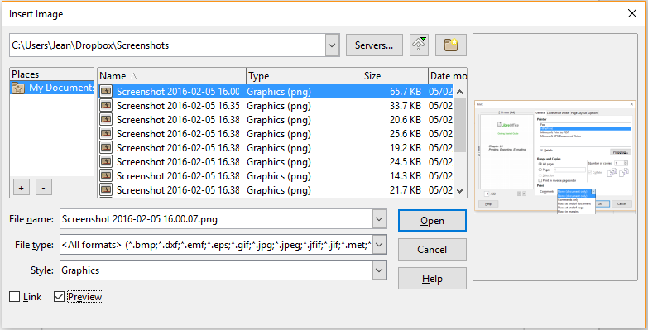
Figure 1: Insert Image dialog
- Note
If you choose the Link option, a message box appears when you click Open. It asks if you want to embed the graphic instead. Choose Keep Link if you want the link, or Embed Graphic if you do not. To prevent this message from appearing again, deselect the option Ask when linking a graphic at the bottom of the message.

Copy and paste
Using the clipboard, you can copy images into a LibreOffice document from another LibreOffice document and from other programs. To do this:
- Open both the source document and the target document.
- In the source document, select the image to be copied.
- Press Ctrl+C (or right-click and select Copy from the context menu) to copy the image to the clipboard.
- Switch to the target document.
- Click to place the cursor where the image is to be inserted.
- Press Ctrl+V (or right-click and select Paste from the context menu) to insert the image.
- Caution
If the application from which the image was copied is closed before the image is pasted into the target, the image stored on the clipboard could be lost.

Linking an image file
If the Link option in the Insert Image dialog is selected, Writer creates a link to the file containing the image instead of saving a copy of the image in the document. The result is that the image is displayed in the document, but when the document is saved, it contains only a reference to the image file, not the image itself. The document and the image remain as two separate files, and they are merged together only when you open the document again.
Linking an image has two advantages and one disadvantage:
- Advantage – You can modify the image file separately without changing the document because the link to the file remains valid, and the modified image will appear when you next open the document. This can be a big advantage if you (or someone else, perhaps a graphic artist) is updating images.
- Advantage – Linking can reduce the size of the document when it is saved, because the image file itself is not included. File size is usually not a problem on a modern computer with a reasonable amount of memory, unless the document includes many large images files; LibreOffice can handle quite large files.
- Disadvantage – If you send the document to someone else, or move it to a different computer, you must also include the image files, or the recipient will not be able to see the linked images. You need to keep track of the location of the images and make sure the recipient knows where to put them on another machine, so the document can find them. For example, you might keep images in a subfolder named Images (under the folder containing the document); the recipient of the file needs to put the images in a subfolder with the same name and in the same place relative to the document.
- Note
When inserting the same image several times in a document, LibreOffice embeds only one copy of the image file.

Embedding linked images
If you originally linked the images, you can easily embed one or more of them later if you wish. To do so:
- Open the document in LibreOffice and choose Edit > Links.
- The Edit Links dialog shows all the linked files. In the Source file list, select the files you want to change from linked to embedded.
- Click the Break Link button.
- Note
Going the other way, from embedded to linked, is not so easy—you must delete and reinsert each image, one at a time, selecting the Link option when you do so.

Figure 2: The Edit Links dialog

Scanning
If a scanner is connected to your computer, Writer can call the scanning application and insert the scanned item into your document as an image. To start this procedure, click where you want the image to be inserted and choose Insert > Media > Scan > Select Source.
Select the scan source from the list of available devices, then choose Insert > Media > Scan > Request to open the imaging software where you can adjust settings for picture quality, size, and other attributes. This practice is quick and easy, but may not result in a high-quality image of the correct size. You may get better results by scanning material into a graphics program and cleaning it up there before inserting the resulting image into Writer.

Inserting an image from the Gallery
The Gallery (Figure 3) provides a convenient way to group reusable objects such as graphics and sounds that you can insert into your documents. The Gallery is available in all components of LibreOffice. See “Managing the LibreOffice Gallery” on page 30. You can copy or link an object from the Gallery into a document.
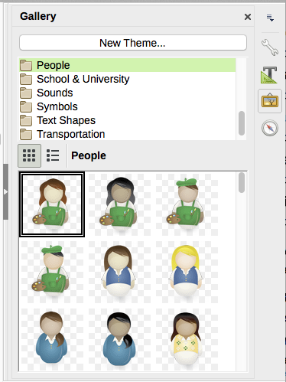
Figure 3: The Gallery in the Sidebar
To insert an object:
- Click the Gallery icon in the Sidebar.
- Select a theme.
- Select an object with a single click.
- Drag and drop the image into the document, or right-click the object and choose Insert.
To insert an object as a link, hold down the Shift and Ctrl keys and drag and drop the object into the document.

Inserting an image as a background
To insert an image as the background to a page or paragraph, right-click the image in the Gallery and choose Insert as Background > Page or > Paragraph.

Modifying, handling, and positioning images
When you insert a new image, you may need to modify it to suit the document. The placement of the picture relative to the text is discussed in “Positioning images within the text” on page 18. This section describes the use of the Picture toolbar, resizing, cropping, and rotating an image.
Writer provides many tools for working with images. These tools are sufficient for most people’s everyday requirements. However, for professional results it is generally better to use an image manipulation program such as GIMP to modify images (for example, to crop, resize, rotate, and change color values) and then insert the result into Writer.

Using the Picture toolbar
When you insert an image or select one already present in the document, the Picture toolbar appears. You can set it to always be present (View > Toolbars > Picture) and choose whether to float or dock it. Two other toolbars can be opened from this one: the Image Filter toolbar, which can be torn off and placed elsewhere on the window, and the Color toolbar, which opens as a separate floating toolbar.
From these three toolbars, you can apply small corrections to the image or obtain special effects. Picture control buttons from the Picture toolbar can also be added to the Standard toolbar. See Chapter 21, Customizing Writer, for more information.
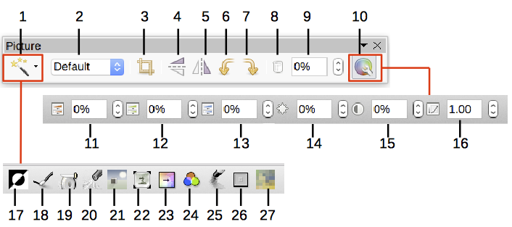
1 | Filter | 10 | Color | 19 | Sharpen
2 | Image mode | 11 | Red | 20 | Remove Noise
3 | Crop | 12 | Green | 21 | Solarization
4 | Flip Vertically | 13 | Blue | 22 | Aging
5 | Flip Horizontally | 14 | Brightness | 23 | Posterize
6 | Rotate 90° Left | 15 | Contrast | 24 | Pop Art
7 | Rotate 90° Right | 16 | Gamma | 25 | Charcoal Sketch
8 | Frame Properties | 17 | Invert | 26 | Relief
9 | Transparency | 18 | Smooth | 27 | Mosaic
Figure 4: Picture toolbar plus Color toolbar and Image Filter toolbar

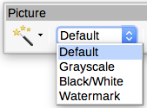
Image mode
You can change color images to grayscale, to black and white, or to a watermark by selecting the image and then selecting the relevant item from the Image Mode list.

Transparency
Modify the percentage value in the Transparency box on the Picture toolbar to make the image more transparent. This is particularly useful when creating a watermark or when placing the image in the background.

Color
Use this toolbar to modify the individual RGB color components of the image (red, green, blue) as well as the brightness, contrast, and gamma of the image. If the result is not satisfactory, you can press Ctrl+Z to restore the default values.

Flip vertically, horizontally or in 90° rotations
To flip an image vertically horizontally or rotate it by ninety degrees, select the image, and then click the relevant button.

Image filters
Table 1 provides a short description of the available filters. The best way to understand them is to see them in action. Experiment with the different filters and filter settings, remembering that you can undo all the changes by pressing Ctrl+Z or Alt+Backspace or by selecting Edit > Undo.
Table 1: Image filters and their effects
Name | Effect
Invert | Inverts the color values of a color image or the brightness values of a grayscale image.
Smooth | Softens the contrast of an image.
Sharpen | Increases the contrast of an image.
Remove noise | Removes single pixels from an image.
Solarization | Mimics the effects of too much light in a picture. A further dialog opens to adjust the parameters.
Aging | Simulates the effects of time on a picture. Can be applied several times. A further dialog opens to adjust the aging level.
Posterize | Makes a picture appear like a painting by reducing the number of colors used.
Pop Art | Modifies the picture dramatically.
Charcoal Sketch | Displays the image as a charcoal sketch.
Relief | A dialog is displayed to adjust the light source that will create the shadow and, hence, the relief effect.
Mosaic | Joins groups of pixels into a single area of one color.

Using the Formatting toolbar and Image dialog
When an image is selected, you can customize some aspects of its appearance using the tools available on the Formatting toolbar and in the dialog opened by right-clicking on the image and selecting Properties. You can, for example, create a border around the image, selecting style and color; or you can (on the Borders page of the Image dialog) add a shadow to the image.

Cropping images
When you are only interested in a section of the image for the purpose of your document, you may wish to crop (cut off) parts of it. Writer provides two ways to crop an image: the Crop tool and the Crop page of the Image dialog. The Crop tool provides a quick and easy way to crop an image; but for more control, use the Image dialog.
- Note
If you crop an image in Writer, the image itself is not changed. Writer hides, not cuts off, part of the image. If you export the document to HTML, the original image is exported, not the cropped image. For export, crop images in an external editor.

Using the Crop tool
To use the Crop tool, right-click the image and select Crop from the context menu. Cropping handles appear at the corners and mid-points of the sides of the image (see Figure 5). Drag a handle to cut off part of the image. Click outside the image to turn off cropping mode.
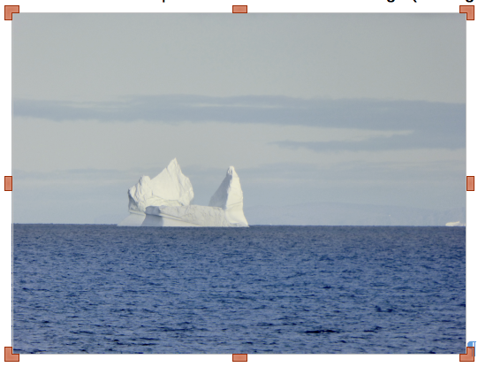
Figure 5: Cropping handles on an image

Using the Crop page of the Image dialog
To use the Image dialog, right-click the image and select Properties from the context menu, then select the Crop page of the Image dialog.
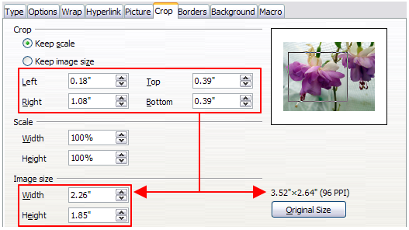
Figure 6: Result on image size of cropping using Keep scale option
The units of measurement shown on the Crop page are those set in Tools > Options > LibreOffice Writer > General.
Two options are available in the crop section for cropping an image: Keep scale and Keep image size. Keep scale maintains the proportions of the image; Keep image size may result in distortion of the image.
As the values for Left, Right, Top, and Bottom are altered, the boundaries of the image in the preview box change to show the crop area on the image, and the Width and Height fields under either Scale or Image size change. This results in either an image size change (Figure 6), or a scale change for a fixed image size (Figure 7).
The original image size is indicated above the Original Size button.
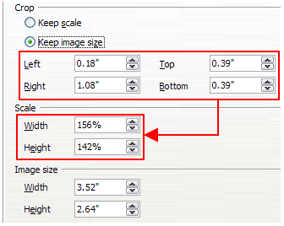
Figure 7: Result using Keep image scale option

Resizing an image
To perfectly fit the image into your document, you may have to resize it. There are a number of options available in Writer to do this.
A quick and easy way to resize is by dragging the image’s sizing handles:
- Click the image, if necessary, to show the green sizing handles.
- Position the pointer over one of the green sizing handles. The pointer changes shape, giving a graphical representation of the direction of the resizing.
- Click and drag to resize the image.
- Release the mouse button when satisfied with the new size.
- Tip
The corner handles resize both the width and the height of the image simultaneously, while the other four handles resize only one dimension at a time. To retain the original proportions of the image, hold down the Shift key while dragging one of these handles.
For more accurate resizing of images, use either the Crop page (Figure 6) or the Type page of the Image dialog.
On the Crop page you can adjust the following settings:
- Scale Width and Height: specify in percentages the scaling of the image. The size of the image changes accordingly. For a symmetrical resizing, both values need to be identical.
- Image size: specify the size of the image in your preferred unit of measurement. The image enlarges or shrinks accordingly.
- Original size button: when clicked, restores the image to its original size. This will be the size resulting after any cropping was carried out.
On the Type page of the Image dialog, select the Relative option to toggle between percentage and actual dimension. For a symmetrical resizing, select the Keep ratio option. Clicking on the Original Size button restores the original image size, but the scale dimensions are altered if the image has been cropped.

Rotating or flipping an image
To quickly rotate an image 90 or 180 degrees, or flip it vertically or horizontally, right-click the image and select Rotate or Flip on the context menu, then choose the desired result.
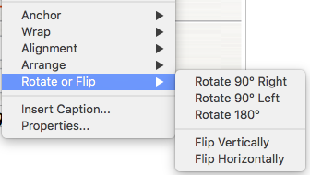
Figure 8: Quickly rotating or flipping an image
Previous versions of Writer did not provide a way to use other rotation angles. With version 6, you can rotate images at any required angle, using either of these methods:
- Interactively. Select the image and click the Rotate icon on the Image toolbar. Rotation handles appear around the object. Hover the mouse cursor over a handle; when the cursor changes shape, click and drag it to the required angle.
- Properties dialog. Right-click the image and select Properties. On the Image dialog, select the Image page. In the Rotation Angle field, specify the rotation required.

Other settings
The Image dialog (Figure 6) consists of ten pages. The Crop page was described on page 11; the Type and Wrap pages are explained in “Positioning images within the text” on page 18. The other pages serve the following purposes:
- Options: give the image a descriptive name (as you want it to appear in the Navigator), display alternative text when the mouse hovers over the image in a web browser, protect some of the image settings from accidental changes, and prevent the image from being printed.
- Borders: create borders around the image. The Borders dialog is the same as the one used for defining table or paragraph borders. You can also add a shadow to the image if so desired.
- Area: change the background color of the image. This setting produces the desired results only for images with a transparent color.
- Hyperlink: associate a hyperlink to the image, or create an image map (see page 28).
- Image: flip or rotate the image, and display the original location of the file in case the image is linked rather than embedded.
- Transparency: set the transparency options for the image.
- Macro: associate a macro to the image. You can choose among the predefined macros or write your own.

Deleting an image
To delete an image, click it to show the green resizing handles, then press the Delete key.

Exporting images
To make complex adjustments to the image, or to save it for use in another document, you can export it directly from the document. Right-click the image to select it and open the context menu. Then choose Save to open the Image Export dialog. Depending on the original format of the image, Writer will let you save the picture in many different formats. Give a name to the image, select the desired image format in the Filter list, and click Save.

Compressing images
If you insert a large image in your document and resize it to fit into the layout of the page, the complete original image is stored in the document file to preserve its content, resulting in a large document file to store or send by mail.
If you can accept some loss of quality of the image rendering, you can compress or resize the image object to reduce its data volume while preserving its display in the page layout. You probably don’t want to compress something that will be professionally printed.
Right-click to select the image and open the context menu. Then choose Compress to open the Compress Image dialog (Figure 9). Note that the Calculate button updates the image information on the dialog on each parameter set you change. Click OK to apply the compression settings. If the resulting image is not acceptable, press Ctrl+Z to undo and choose another compression setting. For more information, see the Help.
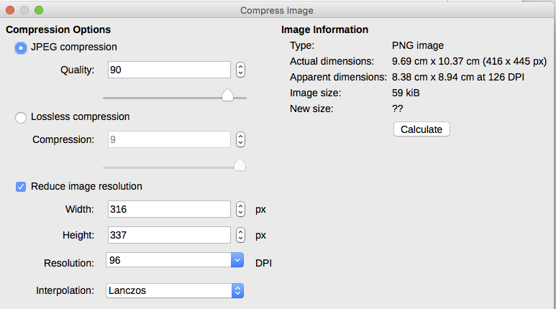
Figure 9: Compressing an image

Saving modified images
In previous versions of LibreOffice, if you saved an embedded image (by right-clicking and choosing Save on the context menu), the saved image was the original one; modifications like rotations, cropping, and color effects were not included in the saved image.
Starting from LibreOffice 6, you can choose whether to save the original image or the modified image through a dialog that pops up when you choose Save.

Using Writer’s drawing tools
You can use Writer’s drawing tools to create graphics such as simple diagrams using rectangles, circles, lines, text, and other predefined shapes. You can also group several drawing objects to make sure they maintain their relative position and proportion.
You can place the drawing objects directly on a page in the document or insert them into a frame.
You can also use the drawing tools to annotate photographs, screen captures, or other illustrations produced by other programs, but this is not recommended because:
- You cannot include images in a group with drawing objects, so they may get out of alignment in your document.
- If you convert a Writer document to another format, such as HTML, the drawing objects and the images will not remain associated; they are saved separately.
In general, if you need to create complex drawings, it is recommended you use LibreOffice Draw, which includes many more features such as layers and styles.

Creating drawing objects
To begin using the drawing tools, display the Drawing toolbar (Figure 10) by clicking View > Toolbars > Drawing or by clicking on the Show Draw Functions icon on the standard toolbar.
The Drawing toolbar may appear at the bottom or left side of the workspace. You can move it to another location and dock it, or float it and move it to a convenient place on the screen.
1 2 3 4 5 6 7 8 9 10 11 12 13 14 15 16 17 18
1 | Select | 6 | Polygon | 11 | Stars | 15 | Text Box
2 | Insert Line | 7 | Quick Shapes | 12 | Callouts | 16 | Fontwork
3 | Lines & Arrows | 8 | Basic Shapes | 13 | Flowcharts | 17 | Points
4 | Curve/Freeform Line | 9 | Symbols | 14 | Callouts | 18 | Toggle Extrusion
5 | Curve | 10 | Arrows
Figure 10: The Drawing toolbar
To use a drawing tool:
- Click in the document where you want the drawing to be anchored. You can change the anchor later, if necessary.
- Select the tool from the Drawing toolbar (Figure 10). The mouse pointer changes to a drawing-functions pointer and the normal Formatting toolbar changes to the Drawing Object Properties toolbar (Figure 11).
- Move the cross-hair pointer to the place in the document where you want the image to appear and then click-and-drag to create the drawing object. Release the mouse button. The selected drawing function remains active, so that you can draw another object of the same type.
- To cancel the selected drawing function, press the Esc key or click the Select icon (the arrow) on the Drawing toolbar.
- You can now change the properties (fill color, line type and weight, anchoring, and others) of the drawing object using either the Drawing Object Properties toolbar (Figure 11) or the choices and dialog reached by right-clicking on the drawing object.

Setting or changing properties for drawing objects
To set the properties for a drawing object before you draw it:
- On the Drawing toolbar (Figure 10), click the Select tool.
- On the Drawing Object Properties toolbar (Figure 11), click the icon for each property and select the value you want for that property.
- For more control, or to define new attributes, you can click the Area or Line icons on the toolbar to display detailed dialogs.
The default you set applies to the current document and session. It is not retained when you close the document or close Writer, and it does not apply to any other document you open. The defaults apply to all the drawing objects except text objects.
To change the properties for an existing drawing object, select the object, then continue as described above.
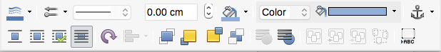
1 2 3 4 5 6 7
8 9 10 11 12 13
1 | Line Color | 4 | Line Width | 7 | Anchor | 10 | Align
2 | Arrow Style | 5 | Area Color | 8 | Wrap | 11 | Arrange
3 | Line Style | 6 | Area Style / Filling | 9 | Rotate | 12 | Group
 |  |  |  |  |  | 13 | Insert Caption
Figure 11: Drawing Object Properties toolbar
You can also specify the position and size, rotation, and slant and corner radius properties of the drawing object: right-click the drawing object and select Position and Size from the context menu. Choose any properties, as required.

Resizing a drawing object
An object is resized in a similar way to an image. Select the object, click one of the eight handles around it and drag it to its new size. The object will be scaled up or down.
When you grab the corner handle of an object and drag it, LibreOffice will resize proportionately. If you also press the Shift key, the resizing will not keep object proportions. Conversely, if you grab one of the edges, LibreOffice will scale unproportionally in the direction perpendicular to the edge; if you also press the Shift key, LibreOffice will scale proportionately.
For more sophisticated control of the size of the object, choose Format > Frame and Object > Properties from the Menu bar. Use the Type tab to set the position and size independently. If the Keep ratio option is selected, then the two dimensions change so that the proportion is maintained, resulting in a scaled resizing.

Grouping drawing objects
Grouping drawing objects makes it easier to handle several objects as a single entity, while preserving their relative sizes and positions. When objects are grouped, any editing operations carried out on that group are applied to all members of the group. If you click on one member of the group, the whole group is selected.
To group drawing objects:
- Select one object, then hold down the Shift key and select the others you want to include in the group. The bounding box expands to include all the selected objects.
- With the objects selected, hover the mouse pointer over one of the objects and choose Format > Group > Group from the Menu bar or right-click and choose Group > Group from the context menu.
- Note
You cannot include an embedded or linked image in a group with drawing objects.
You can edit an individual member of a group without ungrouping or breaking the group. Select the group and go to Format > Group > Enter Group on the Menu bar, or right-click and select Group > Enter Group from the context menu. When you have finished editing an individual member of a group, go to Format > Group > Exit Group on the Menu bar, or right-click and select Group > Exit Group from the context menu.
To ungroup or break apart a group of objects, select the group then go to Format > Group > Ungroup on the Menu bar, or right-click and select Group > Ungroup from the context menu.

Rotating drawing objects
You can rotate a drawing object in a similar way to rotating images (page 14). To rotate a drawing object to any required angle, use either of these methods:
- Interactively. Select the drawing object and click the Rotate icon on the Drawing Object Properties toolbar. Rotation handles appear around the object. Hover the mouse cursor over a handle; when the cursor changes shape, click and drag it to the required angle.
- Position and Size dialog. Right-click the object and select Position and Size. On the dialog, select the Rotation page. In the Rotation Angle field, specify the rotation required. By default, rotation is around the center of the object, but you can choose a different pivot point.
- Tip
Of particular interest to Writer is the Text drawing object. Ordinary text can only be rotated to 90, 180, or 270 degrees, as described in Chapter 9, but a Text object can be rotated to any desired angle.

Positioning images within the text
When you add an image to a text document, you need to choose how to position it with respect to the text and other images. The positioning of images is often rather time-consuming and may be very frustrating for both inexperienced and experienced users. As Writer is a word processor rather than a desktop publishing program, there are some limitations to the flexibility in positioning images and it takes time to get things exactly as you would like them.
Positioning of an image is controlled by four settings:
- Arrangement refers to the placement of an image on an imaginary vertical axis. Arrangement controls how images are stacked upon each other or relative to the text.
- Alignment refers to the vertical or horizontal placement of an image in relation to the chosen anchor point.
- Anchoring refers to the reference point for the images. This point could be the page, or frame where the object is, a paragraph, or even a character. An image always has an anchor point.
- Text wrapping refers to the relation of images to the surrounding text, which may wrap around the graphic on one or both sides, be overprinted behind or in front of the graphic, or treat the graphic as a separate paragraph or character.
The settings can be accessed in a number of ways, depending on the nature of the images:
- From the Format menu, where you can find Anchor, Wrap, and Arrange (both for images and drawing objects).
- From the context menu displayed when you right-click the graphic; this menu also includes Alignment.
- For images, from the Type and Wrap pages of the Image dialog. Note that you cannot control the arrangement using the dialog. To open the Image dialog, click the image to select it and then choose Format > Image > Properties or right-click the image and choose Properties on the context menu.
- For drawing objects, from the Position and Size page of the Position and Size dialog. To open the dialog, right-click the drawing object and choose Position and Size on the context menu.
- For an embedded object (such as a Calc spreadsheet or Draw document), from the OLE-Object toolbar.
- Note
While all the positioning techniques discussed in this section apply equally to frames, contour wrapping is not possible for frames.

Arranging images
Arranging an image means to determine its position relative to other images or text. Arranging is only relevant when objects are overlapping. You can choose between four common settings, plus a fifth special setting for drawing objects:
Bring to Front
Places the image on top of any other images or text.
Forward One
Brings the image one level up in the stack. Depending on the number of overlapping objects, you may need to apply this option several times to obtain the desired result.
Back One
Sends the image one level down in the object stack.
Send to Back
Sends the image to the bottom of the stack.
To Background / To Foreground
Only available for drawing objects; moves the drawing object behind or in front of the text respectively.
- Tip
To select an object that is covered by other objects, press the Tab key to move through the objects until you reach the object you want.

Anchoring images
You can anchor images as a character or to a page, paragraph, or character. You can also place images in a frame and anchor the frame to a page, paragraph, or character. Which method you choose depends on what you are trying to achieve.
To Page
The graphic keeps the same position in relation to the page margins. It does not move as you add or delete text or other images. This method is useful when the graphic does not need to be visually associated with a particular piece of text. It is often used when producing newsletters or other documents that are very layout intensive, or for placing logos in letterheads.
- Caution
If you plan to use a document within a master document, do not anchor images To Page because the images will disappear from the master document. See Chapter 16, Master Documents, for more information.
To Paragraph
The graphic is associated with a paragraph and moves with the paragraph. It may be placed in the margin or another location. This method is useful as an alternative to a table for placing icons beside paragraphs.
To Character
The graphic is associated with a character but is not in the text sequence. It moves with the paragraph but may be placed in the margin or another location. This method is similar to anchoring to a paragraph but cannot be used with drawing objects.
As Character
The graphic is placed in the document like any other character and, therefore, affects the height of the text line and the line break. The graphic moves with the paragraph as you add or delete text before the paragraph. This method is useful for keeping screen-shots in sequence in a procedure (by anchoring them as a character in a blank paragraph) or for adding a small (inline) icon in sequence in a sentence.
To Frame
If the graphic has been placed in a frame, you can anchor the graphic in a fixed position inside the frame. The frame can then be anchored to the page, a paragraph, or a character, as required.

Aligning images
Once you have established the anchor point of the graphic, you can decide the position of the graphic relative to this anchor: this is called aligning the images. Choose from six options: three for aligning the graphic horizontally (left, center, right) and three for aligning the graphic vertically (top, center, bottom). Horizontal alignment is not available for images anchored As Character.
For finer control of the alignment, use the Position options on the Type page of the Image dialog, shown in Figure 12.
For both the horizontal and vertical position, start by picking the reference point in the right hand side drop-down menu, then select in the first drop-down menu among Left, Right, or Center. If you select the value From left (or From top for the vertical positioning), you can specify the amount in your selected unit of measurement. In the example in Figure 12, the upper-left corner of the image will be placed at 3 cm from the left margin of the page horizontally and on the top margin vertically.
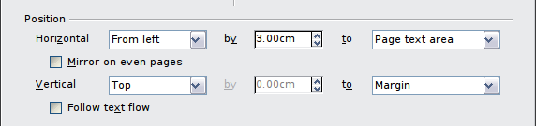
Figure 12: Fine tuning the alignment
A visual representation of the area to which the image is anchored is shown in the preview pane to the right of the page, indicated by a red bordered area. The graphic position is indicated by a green bordered area.

Wrapping text around images
The Wrap setting determines the relation between the text and the graphic. Several choices are available from the context menu:
No Wrap
With this option the text is placed above and below the image but not to either side of it. This is the wrapping type used for most of the figures in this guide. The advantage of No Wrap is that it doesn’t need much tweaking.
Page Wrap or Optimal Page Wrap
The text flows around the image. Moving the image around the page causes the text to be rearranged to fill the space to the left and right of it. Optimal Page Wrap prevents text from being placed to the side of the image if the spacing between the image and the margin is less than 2 cm.
Wrap Through
Superimposes the image on the text. That is, the image is in front of the text. This option must be used in conjunction with the image-transparency setting in order to make the text under the picture visible.
In Background
Similar to Wrap Through, but the image is placed behind the text so there may be no need to change the transparency to make the text visible. Best used only for images without a lot of contrast or different colors.
- Note
The No Wrap option found in the context menu of a picture is equivalent to the Wrap Off menu item in the Format > Wrap menu.
The wrap format is normally selected after anchoring and alignment of the image. To set the position of an image to the desired wrap format, right-click the image to display the context menu and move the mouse pointer to Wrap to display the available wrap formats. Alternatively, select Format > Wrap from the Menu bar. Select the desired wrap format.
- Note
When anchoring an image as character, you can only adjust the distance between the image and the text, but no wrapping option is displayed.
To fine-tune the wrapping options, open the Image dialog and select the Wrap page.
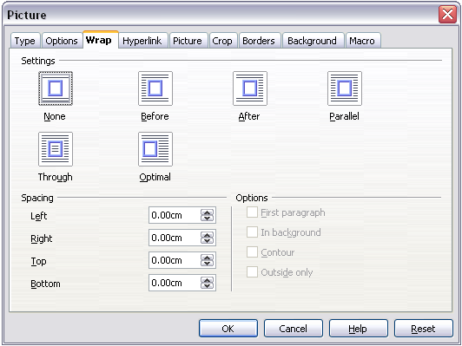
Figure 13: The advanced wrap format options
For images, you can open this dialog by selecting Format > Image > Properties from the Menu bar or right-click and select Properties from the context menu. For drawing objects, you can access the Wrap page by selecting Format > Wrap > Edit in the Menu bar or right-click and select Wrap > Edit from the context menu.
This page is divided into three sections. In the top part you can select from the wrap types mentioned above, plus two additional wrap formats that prevent the text from filling the area to the left (After) or to the right (Before) of the picture. Use the Spacing section of the page to adjust the spacing between the image and the text. The contents of the Options section of the page may change depending on the selected wrap format.
First paragraph
Select this box if you want LibreOffice to start a new paragraph after the image even if it could still wrap around the image.
In background
This option becomes available if Through Wrap is selected; it moves the image to the background.
Contour
Wraps the text around a custom contour rather than around the edge of the picture. This option is only available for Page or Optimal Page Wrap.
Outside only
Forces the text to wrap on the outside of the image, even if the contour contains open areas within the shape.

Editing the contour
If you select wrapping around a drawing object, LibreOffice automatically creates a contour. The Edit Contour option is only available for image wrapping. To create a contour, right-click the image and select Edit Contour from the context menu, or access the Contour Editor by selecting Format > Wrap > Contour.
The dialog shown in Figure 14 opens with the image loaded in the main window. Use the tools to draw the region of the image you do not want to be covered by the text; this area will be shaded.
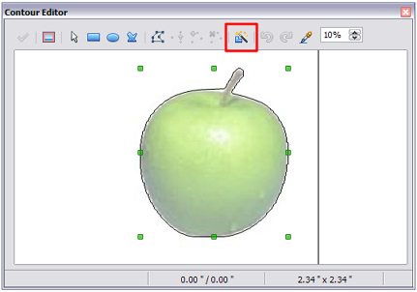Figure 14: The Contour Editor in action with AutoContour
Four tools are available in the Contour Editor window: Rectangle, Ellipse, Polygon, and AutoContour. Some familiarity with drawing tools is required to create complex contours; however, in most circumstances there is no need for high accuracy. Figure 14 shows the actual contour used for “Example 2: Simple contour wrapping in action” on page 24 when using AutoContour; the shape of the line around the edge of the apple is quite acceptable.
When you are done, click the Apply button to save the contour. If you are not satisfied with the result, you can select the contour line and press the Delete key to restart, or click the Workspace icon and then click inside the contour. You can also undo the previous steps or you can select the Edit Points button and adjust the contour shape point by point. Be aware that any of the graphic outside the contour line is not shown in the document.

Example 1: Page wrapping
Figure 15 shows an example of page wrapping in action.
To achieve this:
- Insert the image into the document, then anchor it to the paragraph of your choice. To move the anchor, select the image or the anchor, and move it until the anchor symbol is at the beginning of the chosen paragraph.
- Align the image so that the left margin of the image is where you want it to be. This can be done with the mouse or using the advanced settings. The taskbar shows the location of the upper left corner and the image size.
- Change the wrap to Page Wrap. We now wish to increase the space between the image and the text. To do this, access the Wrap page of the Picture dialog and set the gap between the image and text to 0.1” in all the boxes.
- The last touch is to change the position so that the image has our chosen number of lines of the paragraph above it. Again, you can use the mouse to drag the image or use the advanced settings, which require a bit of trial and error. Moving with the mouse is the simplest method.
- Tip
When adjusting white space in a wrap, consider also the white space in the image.
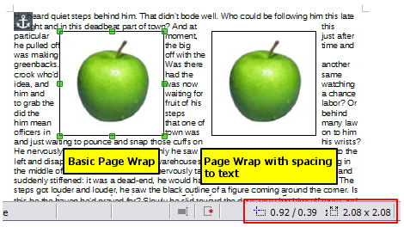
Figure 15: Example of image with Page Wrap formatting

Example 2: Simple contour wrapping in action
In this example we again apply page wrapping as in Example 1, enabling this time the contour option. We will work on an image and on a drawing object as the contour option works slightly differently in each case.
The example in Figure 16 was created following the steps below.
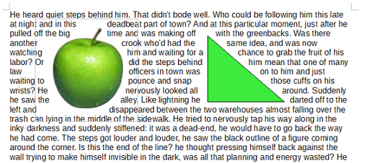
Figure 16: Image and drawing objects with contour wrapping
- Create some text.
- Insert an image of your choice and anchor it to the first paragraph. Adjust the alignment as desired, then change the wrap type to Page Wrap. Right-click the picture and select Wrap > Edit Contour from the context menu.
- Use the technique discussed in “Editing the contour” on page 22 to create a custom contour and click Apply. If needed, adjust the spacing between the edge of the image and the text using the Wrap page of the Image dialog.
- Insert an AutoShape of your choice (a triangle in the example) and proceed as in step 2 above.
- Enable the contour wrap by selecting Format > Wrap > Contour from the Menu bar. As discussed previously, LibreOffice automatically generates the contour. You may need to adjust the distance between the drawing object and the text using Format > Wrap > Edit.

Example 3: Wrap Through and In Background
This example shows how to use an image as a watermark by wrapping the text through it and adjusting the transparency. This is not the best way to create watermarks and it is presented here only for illustration purposes. If you need to create a watermark, it is best to use a Fontworks object wrapped in the background and, if possible, add it to a page style.
Selecting the Wrap Through option for an inserted image causes the image to overlap the text, which as a result will be hidden. To make the text appear, change the transparency of the picture; although the words under the image become visible, they may be difficult to read and will appear lighter than the rest of the text.
To reproduce the example in Figure 17, create some dummy text, then insert the image of your choice. Anchor the image (to the page in the example) and select the wrap through option from the Format > Wrap menu or right-click the image and select Wrap > Wrap Through from the context menu. Move the image into the desired position. The Picture toolbar should be displayed when the image is selected. Change the transparency to a suitable value (40% in the example) so that the text can be read.
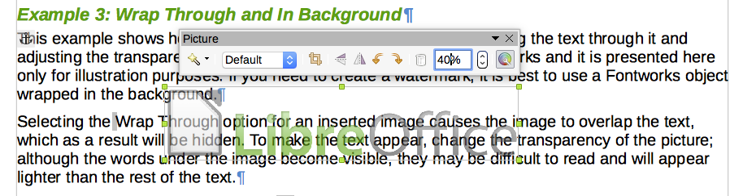
Figure 17: Transparent image added over the text
You can obtain a better result if you set an image’s wrap to In Background. With this selection all the text will be clearly readable, with all characters having the same intensity, as long as the background is not too dark. You may still need to adjust the transparency of the image.

Adding captions to images
You can add captions to images in three ways: automatically, by using the Caption dialog, or manually.

Adding captions automatically
You can set up LibreOffice to add captions automatically whenever you insert an image, a table, or other objects into a document. You can choose which objects are captioned automatically, what the sequence name is for each caption (for example, Table or Figure), and the position of the caption.
To set up automatic captions, choose Tools > Options > LibreOffice Writer > AutoCaption. At the right of the dialog, choose which objects you want to be automatically captioned and specify the characteristics of the captions.
When you insert an image, if automatic captioning is enabled, the graphic is placed in a frame along with a caption containing the default sequence name for images: Illustration. Position the cursor in the caption area and type the text for the caption. You can change the sequence name by selecting one from the drop-down Category list or typing in your own.
A common sequence name—Figure—is not one of the names provided: <None>, Drawing, Illustration, Table, and Text. If you want the name “Figure” or any other custom name for your images, do the following:
- Open the AutoCaption dialog, as described above.
- In the Add captions automatically when inserting section, select LibreOffice Writer Image. This activates the Caption area in the dialog for images.
- Under the Category drop-down list, enter the name that you want added (say, Figure), by overwriting any sequence name in the list. (Overwriting a term does not delete it from the drop-down list.) You can also set some options for the number style and for a separator between the name and the number, if desired. Click OK to save the changes.

Adding captions using the Caption dialog
To add captions using the Caption dialog:
- Insert the graphic, then either right-click it and select Insert Caption from the context menu, or select it and choose Insert > Caption from the Menu bar.
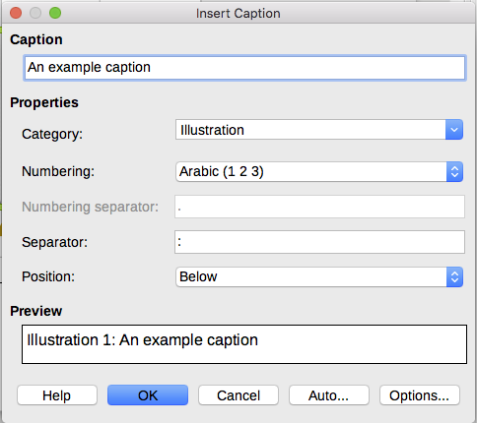
Figure 18: Defining the caption for an illustration
- Under Properties on the Caption dialog (Figure 18), make your selections for the Category, Numbering, and Separator fields [Illustration, Arabic (1 2 3), and a colon (:), respectively, for the example in Figure 18] and type your caption text in the Caption text box at the top. Whatever text you enter for the caption appears in the box at the bottom, after the sequence name, number, and separator.
- Click OK. The graphic and its caption are placed in a frame.
- Tip
In the Category box, you can type any name you want (for example, Figure) if the drop-down list does not include it. Writer will create a numbering sequence using that name, as it does when using the AutoCaption feature.

Numbering images by chapter
Additional options for numbering captions are available under the Options button in the Captions dialog (Figure 19). Some of these settings, which refer to the outline level, will have an effect only if you are using outline level paragraph styles on the chapter headings within your document.
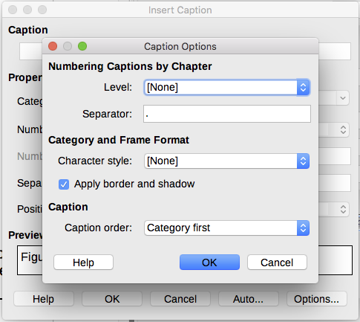
Figure 19: Options for numbering figures
When chapter numbering is set up, Writer will restart the caption numbering for each chapter it encounters. For example, if the last figure caption you create in chapter 1 is Figure 1.15, and the next figure caption you create is in chapter 2, the numbering will start over at Figure 2.1.
Options available to chapter numbering for captions include the following:
- Use Level to specify the outline level that triggers a restart of the numbering as well as how many levels of outline numbering are shown before the table number. For example, if the document uses Heading 1 style for chapters and Heading 2 style for sub-headings, if you want all the tables in a chapter (that is, between two Heading 1 paragraphs) to be numbered sequentially independently of the sub-heading they are under, select 1 as Level. If instead you want to restart the numbering at each sub-heading, select level 2.
- Use the Separator field to establish the separator between the chapter number and figure number.
- Use Character style to set a character style for the caption. This is useful if the separator of your choice is not a symbol included in the default font type of your document or if you want the caption to have a special color, size and so on.
- The Apply border and shadow option does not apply to table captions. LibreOffice normally wraps the objects you can add a caption to in a frame, but not for tables.
- Use Caption order to specify whether you want the category or numbering to appear first in the caption.

Adding captions manually
If you save as *.docx files or export in other formats, you may find that captions applied as described above (either automatically or using the Caption dialog) are lost during the export.
To avoid export problems, or as another way to put captions above pictures or below them (the usual case), you can add a caption manually, in either of two ways:
- Place the graphic and its caption in separate paragraphs.
- Use a table.

Place the graphic and its caption in separate paragraphs
Insert the graphic and anchor it to its paragraph as a character. Press Enter to create a new paragraph for the caption.
- In the caption paragraph, type, for example, Figure and add a space.
- To insert the figure number automatically, click Insert > Fields > Other (Ctrl+F2) and select the Variables tab.
- Select Number range in the Type list. Select Figure in the Selection list and choose, for example, Arabic (1 2 3) in the Format drop-down list. Click the Insert button.
- A number will appear after the word “Figure” in the caption. Now, type the text of the caption.
- Tip
If you are manually adding captions to a lot of figures using this method, you might want to make an AutoText entry containing, for example, Figure and a space, the figure-number field, and an optional separator and a space after it.
To ensure the picture and its caption stay together on the page, create a new paragraph style, for example Figure. If the picture is going above the caption, define the text flow of the Figure paragraph style as Keep with next paragraph and the next style as Caption. Conversely, if the caption is going above, define the Caption paragraph style as Keep with next paragraph and the next style as Figure.

Use a table
Create a one-column, two-row table. Place the picture in one row and type the caption in the other row—or use two or more rows for the caption and other text. This method can be especially useful for pictures with numbered legends, such as Figure 10 on page 16.

Creating an image map
An image map defines areas of an image (called hotspots) with hyperlinks to web addresses, other files on the computer, or parts of the same document. Hotspots are the graphic equivalent of text hyperlinks. Clicking on a hotspot causes LibreOffice to open the linked page in the appropriate program (for example, the default browser for an HTML page; LibreOffice Calc for a ODS file; a PDF viewer for a PDF file). You can create hotspots of various shapes and include several hotspots in the same image.
To use the image map editor (Figure 20):
- In the Writer document, select the image in which you want to define the hotspots.
- Choose Edit > ImageMap from the Menu bar. The ImageMap Editor (Figure 20) opens.
- Use the tools and fields in the dialog (described below) to define the hotspots and links necessary.
- Click the Apply icon to apply the settings.
- When done, click the Save icon to save the image map to a file, then close the dialog.
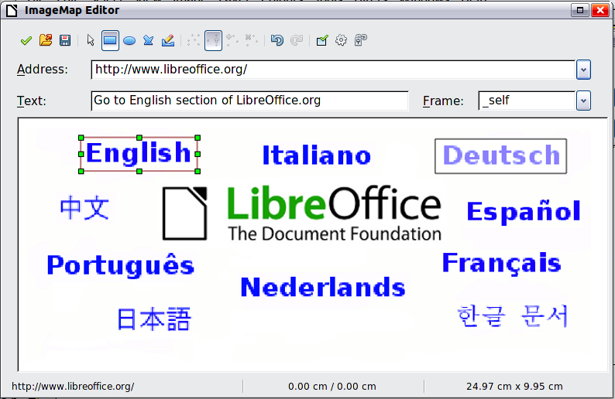
Figure 20: The dialog to create or edit an image map
The main part of the dialog shows the image on which the hotspots are defined. A hotspot is identified by a line indicating its shape.
The toolbar at the top of the dialog contains the following tools:
- Apply icon: applies the changes.
- Open, Save, and Select icons.
- Tools for drawing a hotspot shape: these tools work in exactly the same way as the corresponding tools in the Drawing toolbar.
- Edit, Move, Insert, Delete Points: advanced editing tools to manipulate the shape of a polygon hotspot. Select the Edit Points tool to activate the other tools.
- Active icon: toggles the status of a selected hotspot between active and inactive.
- Macro: associates a macro with the hotspot instead of just associating a hyperlink.
- Properties: sets the hyperlink properties and adds the Name attribute to the hyperlink.
Below the toolbar, specify for the selected hotspot:
- Address: the address pointed by the hyperlink. You can also point to an anchor in a document; to do this, write the address in this format: file:///<path>/document_name#anchor_name
- Text: type the text that you want to be displayed when the mouse pointer is moved over the hotspot.
- Frame: where the target of the hyperlink will open: pick among _blank (opens in a new browser window), _self (opens in the active browser window), _top or _parent.
- Tip
The value _self for the target frame will work in the vast majority of occasions. It is therefore not recommended to use the other choices unless absolutely necessary.

Managing the LibreOffice Gallery
Graphics in the Gallery are grouped by themes, such as Arrows, Diagrams, and People. You can create other groups or themes and add your own pictures or find extensions containing more graphics. Click a theme to see its contents displayed in the Gallery window.
You can display the Gallery in Icon View (Figure 2) or Detailed View (Figure 21), and you can hide or show the Gallery by clicking on the Sidebar’s Hide button.
- Note
In some installations, only the My themes theme is customizable, although new themes can be added as explained in “Adding a new theme to the Gallery” on page 31. The locked themes are easily recognizable by right-clicking on them; the only available option in the context menu is Properties.
By default, the Gallery is opened in the Sidebar. You can float the Gallery as you can other Sidebar panes; see Chapter 1, Introducing Writer, for more information.
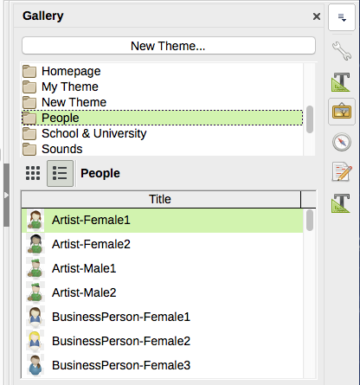
Figure 21: Gallery in Detailed View

Adding objects to the Gallery
You may wish to add to the My Theme folder in the Gallery any images that you use frequently, for example, a company logo. You can then easily insert these graphics into a document later.
- Right-click the My Theme folder and select Properties from the context menu.
- In the theme’s Properties dialog, click the Files tab (Figure 22).
To add a single file:
- In the Properties of My Theme dialog, click Add to open the Gallery dialog.
- Use the navigation controls to locate the image to add to the theme. Select it and then click Open to add it to the theme.
- Click OK on the Properties dialog to close it.
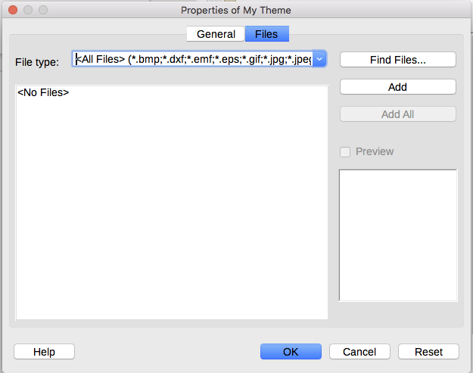
Figure 22: Gallery Properties dialog
To add several files at once:
- In the Properties of My Theme dialog, click the Find Files button.
- The Select path dialog (not shown) opens. You can enter the path for the file’s folder in the Path text box, or you can navigate to locate the file’s directory.
- Click the Select button to start the search. A list of graphic files is then displayed in the Properties dialog. You can use the File type drop-down list to limit the files displayed.To add all of the files shown in the list, click Add All. Otherwise, select the files to add and then click Add (hold down either the Shift key or the Ctrl key while clicking on the files).
- Click OK on the Properties dialog to close it.

Deleting images from the Gallery
To delete an image from a theme:
- Right-click the name of the image file or its thumbnail in the Gallery.
- Click Delete in the context menu. A confirmation message appears; click Yes.
- Note
Deleting the name of a file from the list in the Gallery does not delete the file from the hard disk or other location.

Adding a new theme to the Gallery
To add a new theme to the Gallery:
- Click the New Theme button above the list of themes (Figure 21).
- In the Properties of New Theme dialog, click the General tab and type a name for the new theme.
- Click the Files tab and add images to the theme, as described earlier.

Deleting a theme from the Gallery
To delete a theme from the Gallery:
- Go to Insert > Media > Gallery.
- Select from the list of themes the theme you wish to delete.
- Right-click the theme, then click Delete on the context menu.

Location of the Gallery and the objects in it
Graphics and other objects shown in the Gallery can be located anywhere on your computer’s hard disk, on a network drive, or other removable media. When you add graphics to the Gallery, the files are not moved or copied; the location of each new object is simply added as a reference.
In a workgroup, you may have access to a shared Gallery (where you cannot change the contents unless authorized to do so) and a user Gallery, where you can add, change, or delete objects.
The location of the user Gallery is specified in Tools > Options > LibreOffice > Paths. You can change this location, and you can copy your gallery files (SDV) to other computers.
Gallery contents provided with LibreOffice are stored in a different location. You cannot change this location.
- Note
Gallery themes can be packed for distribution through the LibreOffice extensions framework. In that case, the location of the graphic files is determined by the extension settings. To get more gallery themes, visit the LibreOffice extensions website at http://extensions.libreoffice.org.

Using Fontwork
With Fontwork you can create graphical text art objects to make your work more attractive. There are many different settings for text art objects (line, area, position, size, and more), so you have a large choice.
Fontwork is available with each component of LibreOffice, but you will notice small differences in the way that each component displays it.

Creating a Fontwork object
- Choose Insert > FontWork from the Menu bar. Or, click the Fontwork Gallery icon  on the Fontwork toolbar (View > Toolbars > Fontwork) or the Drawing toolbar (View > Toolbars > Drawing).
- In the Fontwork Gallery (Figure 23), select a Fontwork style, then click OK. The Fontwork object will appear in your document.
- Notice the colored squares around the edge (indicating that the object is selected) and the yellow dot; these are discussed in “Moving and resizing Fontwork objects” on page 35.
Resize the object using one of the corner handles (hold down the Shift key to keep the sides proportional), or right-click and choose Position and Size from the context menu for more precise sizing.
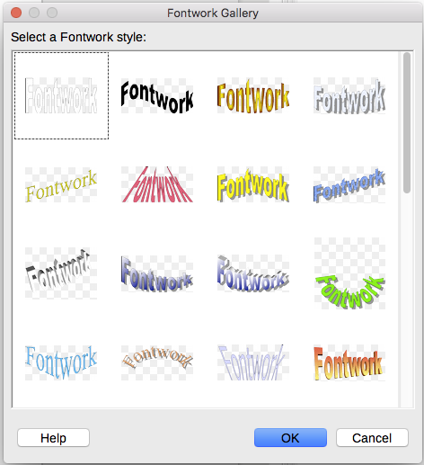
Figure 23: The Fontwork Gallery
- Double-click the object to edit the Fontwork text (see Figure 24). Select the text and type your own text in place of the black Fontwork text that appears over the object.

Figure 24: Editing Fontwork text
- Click anywhere in a free space or press Esc to apply your changes.

Editing a Fontwork object
Now that the Fontwork object is created, you can edit some of its attributes. To do this, you can use the Fontwork toolbar, the Formatting toolbar, or menu options as described in this section. If the selected Fontwork object is a 3-D object, you can also use the 3D-Settings toolbar.

Using the Fontwork toolbar
Make sure that the Fontwork toolbar, shown in Figure 25, is visible. If you do not see it, go to View > Toolbars > Fontwork. Click the different icons to edit Fontwork objects.
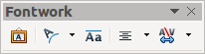
Figure 25: The floating Fontwork toolbar
 | Fontwork Shape: Edits the shape of the selected object. You can choose from a palette of shapes. | 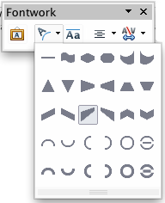  Figure 26: Fontwork toolbar showing palette of shapes
 | Fontwork Same Letter Heights: Changes the height of characters in the object. Toggles between normal height (some characters taller than others, for example capital letters, d, h, l and others) and all letters the same height.

Figure 27: Left: normal letters; right: same letter heights
 | Fontwork Alignment: Changes the alignment of characters. Choices are left align, center, right align, word justify, and stretch justify. The effects of the text alignment can only be seen if the text spans over two or more lines. In the stretch justify mode, all the lines are filled completely. | 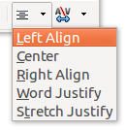
 | Fontwork Character Spacing: Changes the character spacing and kerning in the object. Select from the choices in the drop-down list. | 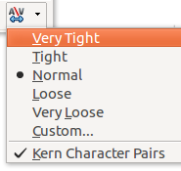

Using the Formatting toolbar
You can customize the Fontwork object with several more attributes. Click on the object; the Formatting toolbar changes to show the options for customizing the object. These choices are the same as the ones for other drawing objects, described earlier in this chapter. See also the Draw Guide for details.

Using menu options
You can use some the choices on the Format menu to anchor, align, arrange, and group selected Fontwork objects, wrap text around them, and flip them horizontally and vertically.
You can also right-click a Fontwork object and choose many of the same options from the context menu. The context menu also provides quick access to the Line, Area, Text, and Position and Size dialogs. For more information on all of these menu options, see the Draw Guide.

Using the 3D-Settings toolbar
If the selected Fontwork object is a 3-D object, you can also use the options on the 3D-Settings toolbar. You can also change a 2-D Fontwork object into a 3-D object (or change a 3-D object into a 2-D object) by clicking the Extrusion On/Off icon on the 3D-Settings toolbar. For more information, see the Draw Guide.
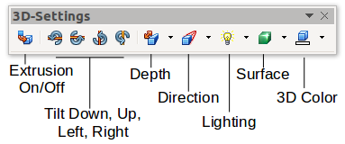

Moving and resizing Fontwork objects
When you select a Fontwork object, eight colored squares (known as handles) appear around the edge of the object, as shown below. You can drag these handles to resize the object.
A yellow dot also appears on the object. This dot may be along an edge of the object, or it may be somewhere else; in the example on the right. If you hover the pointer over this yellow dot, the pointer turns into a hand symbol. You can drag the dot in different directions to distort the object.  Hovering the pointer over other parts of the object turns the pointer into the usual symbol for dragging the object to another part of the page. | 
For precise control of the location and size of the object, use the Position and Size areas of the Type tab in the Properties dialog.

