
Writer 6.0 Guide

Chapter 15
Tables of Contents, Indexes, Bibliographies

Copyright
This document is Copyright © 2018 by the LibreOffice Documentation Team. Contributors are listed below. You may distribute it and/or modify it under the terms of either the GNU General Public License (http://www.gnu.org/licenses/gpl.html), version 3 or later, or the Creative Commons Attribution License (http://creativecommons.org/licenses/by/4.0/), version 4.0 or later.
All trademarks within this guide belong to their legitimate owners.

Contributors
Jean Hollis Weber | Bruce Byfield | Gillian Pollack

Acknowledgments
This chapter is updated from previous versions of the LibreOffice Writer Guide. Contributors to earlier versions are:
Jean Hollis Weber | John A Smith | Ron Faile Jr.
An earlier version appeared in the OpenOffice 3.3 Writer Guide. The contributors were:
Martin Fox | John Kane | Rachel Kartch
Sigrid Kronenberger | Peter Kupfer | Paul Miller
Iain Roberts | Gary Schnabl | Rob Scott
Janet Swisher | Catherine Waterman | Jean Hollis Weber
Claire Wood | Michele Zarri

Feedback
Please direct any comments or suggestions about this document to the Documentation Team’s mailing list: documentation@global.libreoffice.org
- Note
Everything you send to a mailing list, including your email address and any other personal information that is written in the message, is publicly archived and cannot be deleted.

Publication date and software version
Published July 2018. Based on LibreOffice 6.0.

Note for macOS users
Some keystrokes and menu items are different on macOS from those used in Windows and Linux. The table below gives some common substitutions for the instructions in this book. For a more detailed list, see the application Help.
Windows or Linux | macOS equivalent | Effect
Tools > Options menu selection | LibreOffice > Preferences | Access setup options
Right-click | Control+click and/or right-click depending on computer setup | Open a context menu
Ctrl (Control) | ⌘ (Command) | Used with other keys
F5 | Shift+⌘+F5 | Open the Navigator
F11 | ⌘+T | Open the sidebar Styles and Formatting deck

Contents
Copyright 2
Contributors 2
Acknowledgments 2
Feedback 2
Publication date and software version 2
Note for macOS users 2
Introduction 5
Tables of contents 5
Creating a table of contents quickly 5
Customizing a table of contents 6
Type page 7
Entries page 8
Styles page 10
Columns page 11
Background page 11
Editing a table of contents 12
Updating a table of contents 13
Deleting a table of contents 13
Alphabetic indexes 14
Adding index entries 14
Example of using an index key 15
Creating a concordance 16
Creating an alphabetic index quickly 16
Customizing an index 17
Type page 17
Entries page 18
Styles, Columns, and Background pages 20
Columns page 20
Maintaining an index 21
Viewing and editing existing index entries 21
Other types of indexes 21
Example: Creating an index of figures 22
Bibliographies 23
Creating a bibliographic database 23
Filtering records 24
Changing the data source 24
Adding entries to the database 25
Maintaining entries in the database 25
Advanced: Modifying the bibliographic database 25
Column details 25
Field details 26
Adding references (citations) into a document 27
Entering references from a database 28
Entering references from documents 28
Editing a reference 29
Creating the bibliography 29
Index/Table page 29
Entries page 30
Styles, Columns and Background pages 31
Defining the paragraph style for the bibliography 31
Updating, editing, and deleting an existing bibliography 33

Introduction
This chapter describes how to create and maintain a table of contents, an index, and a bibliography for a text document using LibreOffice Writer. Other types of index are mentioned briefly. To understand the instructions, you need a basic familiarity with Writer and styles (see Chapters 8 and 9). Some common usage examples are given.

Tables of contents
Writer’s table of contents (TOC) feature lets you build an automated TOC from the headings in a document. Whenever changes are made to the text of a heading in the body of the document or the page on which the heading appears, those changes automatically appear in the table of contents when it is next updated.
Before you start, make sure that the headings are styled consistently. For example, you can use the Heading 1 style for chapter titles and the Heading 2 and Heading 3 styles for chapter subheadings.
This section shows you how to:
- Create a table of contents quickly, using the defaults.
- Customize a table of contents.
- Note
You can use any style you want for the different levels to appear in the table of contents; for simplicity, most of this chapter uses the default Heading [x] styles.
You can specify other text in addition to headings to appear in the TOC, as described later in this chapter.

Creating a table of contents quickly
Most of the time you will probably find the default table of contents (TOC) to be what you need, although the formatting may be inelegant. To insert a default TOC:
- When you create a document, use the following paragraph styles for different heading levels (such as chapter and section headings): Heading 1, Heading 2, and Heading 3. These are what will appear in your TOC. Writer can evaluate up to ten levels of headings.
- Click in the document where you want the TOC to appear.
- Choose Insert > Table of Contents and Index > Table of Contents, Index or Bibliography.
- Click OK. The result will be a typical table of contents with the entries generated as hyperlinks.
- Tips
- If some of your headings do not show up in the table of contents, check that the headings have been tagged with the correct paragraph style. If a whole level of headings does not show up, check the settings in Tools > Chapter Numbering. See “Defining a hierarchy of headings” in Chapter 8, Introduction to Styles, for more information.
- The TOC appears with a gray background. This background is there to remind you that the TOC is a field; the text you see is generated automatically. The background is not printed and does not appear if the document is converted to a PDF. To turn off this gray background, go to Tools > Options > LibreOffice > Application Colors, then scroll down to the Text Document section and deselect the option for Index and table shadings.
This change may leave a gray background showing behind the dots between the headings and the page numbers, because the dots are part of a tab. To turn that shading off, go to Tools > Options > LibreOffice Writer > Formatting Aids and deselect the option for Tabs.
- If you cannot place the cursor in the TOC, choose Tools > Options > LibreOffice Writer > Formatting Aids, and then select Enable cursor in the Protected Areas section.
- If you add or delete text (so that headings move to different pages) or you add, delete, or change headings, you need to update the table of contents. To do this: Right-click anywhere in the TOC and select Update Index from the context menu.
- Caution
If you have Edit > Track Changes > Show enabled when editing a document and you update the TOC, then errors may occur, as the TOC will still include any deleted headings and you may find that deleted text causes page numbering in the TOC to be wrong. To avoid this problem, be sure this option is deselected before updating a TOC.

Customizing a table of contents
Almost every aspect of the table of contents can be customized to suit the style and requirements of your document. However, with this flexibility also comes some complexity, so it is good to have in mind the desired end result.
Start by clicking in the document where you want the table of contents to appear and choose Insert > Table of Contents and Index > Table of Contents, Index or Bibliography to open the Table of Contents, Index or Bibliography dialog shown in Figure 1.
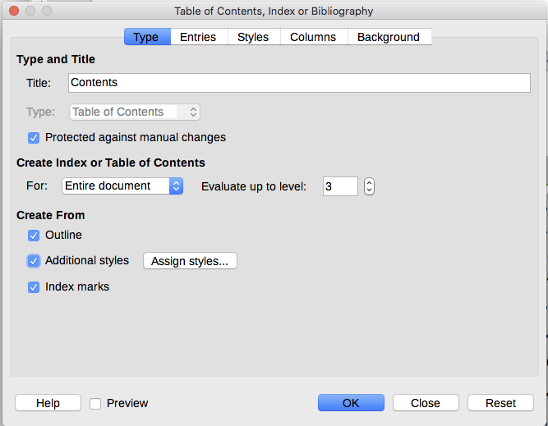
Figure 1: Type page of Table of Contents, Index or Bibliography dialog
You can also access this dialog at any time by right-clicking anywhere in an existing table of contents and choosing Edit Index from the context menu.
The Table of Contents, Index or Bibliography dialog has five pages. Each of them covers a different aspect of the TOC structure and appearance:
- Use the Type page to set the attributes of the TOC.
- Use the Entries and Styles pages to format the entries in the TOC.
- Use the Columns page to put the TOC into more than one column.
- Use the Background page to add color or an image to the background of the TOC.
You can display a preview box, located on the left-hand side of each page, to show as you work how the TOC will look: select the Preview option in the lower left-hand corner of the dialog. The illustrations in this chapter show the dialog as it appears with the preview box hidden.
- Note
The preview box shows the appearance from settings made on the Type, Entries, and Styles pages. It does not show changes made on the Columns and Background pages.
After making all your changes, click OK to apply them. To revert to the default settings for the Columns and Background pages, select each page in turn and click the Reset button. The settings on the Entries and Styles pages must be reset manually; the Reset button has no effect.

Type page
Use the Type page, pictured in Figure 1, to set the attributes of the TOC.
Changing the title
To give the table of contents a different title, type it in the Title field. To delete the title, clear the Title field.
Setting the type
Be sure the Type is set to Table of Contents. See “Alphabetic indexes” on page 15 and “Other types of indexes” on page 22 for more about creating other types of indexes.
- Caution
You can change the type of index only when you first create it. Once you define an index type (for example, make a table of contents) you cannot change the type.
Protecting against manual changes
By default, to prevent the TOC from being changed accidentally, the Protected against manual changes option is selected; the TOC can only be changed by using the right-click menu or the dialog. If the option is not selected, the TOC can be changed directly on the document page, just like other text. However, any manual changes will be lost when you update the TOC, so they should be avoided.
Choosing the scope of the table of contents
In the For drop-down list in the Create from area, you can select whether the TOC will cover all the headings of the document (Entire document) or just the headings of the chapter where it is inserted. Writer identifies a “chapter” as all the headings between two first level outline headings (normally Heading 1).
Changing the number of levels included
Writer uses 10 levels of headings when it builds the table of contents (or the number of levels used in the document, whichever is smaller). To change the number of levels included, enter the required number in the Evaluate up to level box. For example, the TOC in this book includes only the first four heading levels.
Creating a table of contents from an outline
The third section of the Type page determines what Writer should use to create the TOC. The choices (not mutually exclusive) are:
- Outline
- Additional styles
- Index marks
By default Writer uses the outline levels; that is, paragraphs formatted with the paragraph styles associated with outline levels in Tools > Chapter Numbering.
You can change the paragraph styles included in the outline as described in “Using paragraph styles to define a hierarchy of headings” in Chapter 8, Introduction to Styles, and you can include other paragraph styles in the TOC by assigning an outline level to those styles. To do this, modify the paragraph style definition: go to the Outline & Numbering page for the style, and select the required outline level. Click OK to save the change.
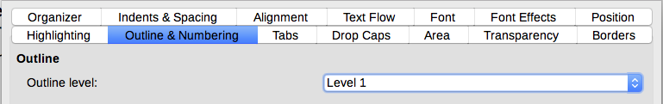
Figure 2: Specifying an outline level on Outline & Numbering page for a paragraph style
Creating from additional styles
By selecting the Additional Styles option on the Type page, you can add more paragraph styles to the TOC. This can be useful when you want to include in the TOC the heading of an annex (appendix). If the Outline option is also selected, the additional styles will be included in the table of contents together with the ones defined in the outline numbering.
Creating from index marks
This selection adds any index entries that you have inserted into the document by using Insert > Indexes and Tables > Entry. Normally you would not use this selection for a table of contents. However, if you do wish to use it, be sure to select Table of Contents from the drop-down list in the Insert Index Entry dialog (see Figure 8) when you are entering the index entries for use in a TOC, so that Writer can distinguish between them and any index entries intended for inclusion in an alphabetic index.

Entries page
Use the Entries page (see Figure 3) to define and format the entries in the TOC. Each outline level can be styled independently from the other levels by adding and deleting elements.
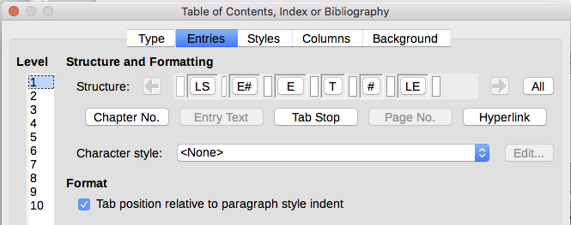
Figure 3: Entries page of Insert Index/Table dialog
Click a number in the Level column to select the outline level whose elements you want to format. The Structure line contains the elements included in the entries for that level. Elements that can be added to the structure line are displayed just below the structure line, and are grayed out if they cannot be included:
- The E# icon represents the “chapter number”, which means the heading number value assigned in Tools > Chapter Numbering to a heading style, not just for chapters but also for other levels of headings. See “Setting up heading numbering” in Chapter 8, Introduction to Styles.
- The E icon represents the chapter (or sub-chapter) text: That is the text formatted with the paragraph style used for each level. In Figure 3, Heading 1 is used for Level 1, Heading 2 for Level 2.
- The T icon represents a tab stop.
- The # icon represents the page number.
- The LS icon represents the start of a hyperlink.
- The LE icon represents the end of a hyperlink.
- Each white field on the Structure line represents a blank space where you can add custom text or another element.
- Caution
In the Chapter Numbering dialog (covered in Chapter 8), if you have included any text in the Separator Before or After boxes for any given level, then that text will be part of the E# field for that level. Take care when building the structure line not to create any unwanted effects in the appearance of the TOC.

Adding elements
To add an element to the Structure line:
- Click in the white field where you want to insert the element.
- Click one of the active buttons just below the Structure line. For example, to add a tab, click the Tab Stop button. An icon representing the new element appears on the Structure line.
- To add custom text, such as the word Chapter, type the text in the white field. Don't forget a trailing space.

Changing elements
To change an element in the Structure line, click the icon representing that element and then click a non-grayed out element in the row of buttons just below the Structure line. For example, to change a chapter number to a tab stop, click the E# icon on the Structure line (it shows then as being pressed) and then click the Tab stop button in the row of available elements. To cancel before swapping an element, click in one of the white spaces.

Applying changes to all outline levels
To apply the displayed structure and formatting to all outline levels, click the All button on the right.

Deleting elements
To delete an element from the Structure line, click the button representing that element and then press the Delete key on your keyboard. For example, to delete the default hyperlink setting, click the LS icon and then press the Delete key. Repeat this for the LE icon.

Applying character styles
You might want an element to be a bit different from the rest of the line. For example, you might want the page number to be bold. To apply a character style to an element:
- Be sure you have previously defined a suitable character style.
- On the Structure line, click the button representing the element to which you want to apply a style.
- From the Character Style drop-down list, select the desired style.
To view or edit the attributes of a character style, select the style from the Character Style drop-down list and then click the Edit button.
- Tip
The default character style for hyperlinks is Internet Link (such as those inserted by Insert > Hyperlink), which by default is underlined and shown in blue.
The default hyperlinks of TOC entries are set to the Index Link character style, which may be different in appearance from the Internet Link style. If you want them to appear the same as internet links, you can select the LS icon on the Structure line and change the character style selection for TOC entries to Internet Link.
You can also change the attributes for Index Link to what you want.

Tab parameters
Click the Tab stop icon on the structure line to bring up these controls:
- Fill character: select the tab character you wish to use; the first choice is none (blank).
- Tab stop position: specify the distance to leave between the left page margin and the tab stop. Optionally, select Align right for the tab stop; this selection inactivates the distance.

Tab position relative to paragraph style indent
When this option is selected, entries are indented according to the settings of their individual formats. Where a paragraph style specifies an indent on the left, tab stops are relative to this indent. If this option is not selected, tab stops are relative to the left margin position.

Styles page
Use the Styles page (Figure 4) to change which paragraph style is assigned to display the text of each level in the table of contents. In most cases, the best strategy is to keep the assigned styles but change their settings as needed to make the TOC appear the way you want.
To apply a custom paragraph style to an outline level:
- In the Levels list, select the outline level.
- In the Paragraph Styles list, click the desired paragraph style.
- Click the < button to apply the selected paragraph style to the selected outline level.
The style assigned to each level appears in square brackets in the Levels list.
To remove paragraph styling from an outline level, select the outline level in the Levels list, and then click the Default button.
To view or edit the attributes of a paragraph style, click the style in the Paragraph Styles list, and then click the Edit button.
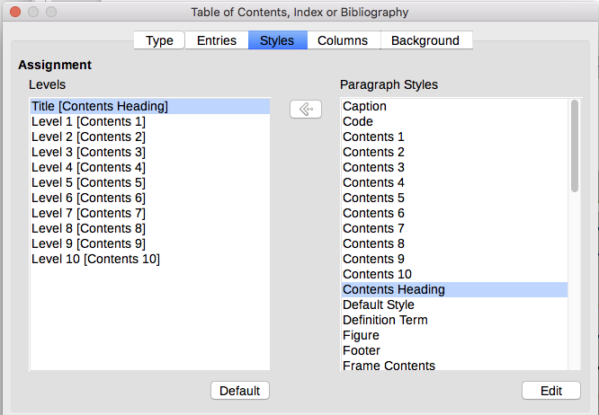
Figure 4: Styles page of the Table of Contents, Index or Bibliography dialog
- Note
Changes to a paragraph style will affect any text in the document that is formatted using this style, not just the format of the table of contents.

Columns page
Use the Columns page to change the number of columns for the TOC. Multiple columns are more likely to be used in an index than in a TOC, so this page is described in the section on indexes. See Figure 12.

Background page
Use the Background page (Figure 5) to add color or an image to the background of the TOC.
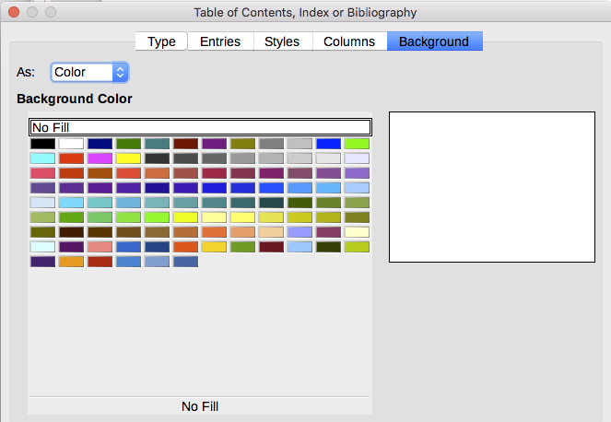
Figure 5: Background page, showing Color choices

Adding color
To add color to the background of the table of contents, select from the color grid.

Adding an image
To add an image to the background of the table of contents:
- From the As drop-down list, select Image. The Background page now displays the image options, as shown in Figure 6.
- Click the Browse button. The Find images dialog opens.
- Find the image file you want and then click the Open button. The selected image appears in the preview box. (If you do not see the image, select the Preview option.)
- To embed the image in your document, clear the Link option. To link the image to the document but not embed it, select the Link option.
- In the Type area, choose how you want the background image to appear:
- To position the image in a specific location, select Position and then click the desired location in the position grid.
- To stretch the image to fill the entire background area, select Area.
- To repeat the image across the entire background area, select Tile.
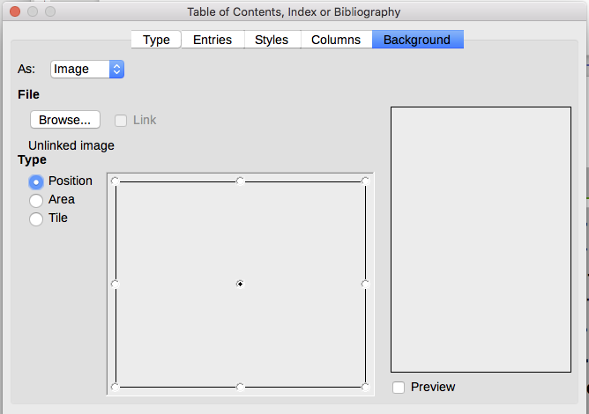
Figure 6: Image options on the Background page

Deleting a color or an image
To delete color or an image from the table background:
- From the As drop-down list, select Color.
- Click No Fill on the color grid.

Editing a table of contents
To edit an existing TOC:
- Right-click anywhere in the TOC.
- From the context menu, choose Edit Index. The Table of Contents, Index or Bibliography dialog (Figure 1 on page 6) opens. You can edit and save the TOC as described in the previous section.
- Tip
If you cannot click in the TOC, it is probably protected. To disable this protection, choose Tools > Options > LibreOffice Writer > Formatting Aids, and then select Enable Cursor in the Protected areas section. If you wish to edit the TOC without enabling the cursor, you can access it from the Navigator as described below.
To access the Table of Contents, Index or Bibliography dialog from the Navigator:
- Open the Navigator (press F5).
- Click the expansion symbol (+ sign or triangle) next to Indexes.
- Right-click Table of Contents1 and choose Index > Edit.
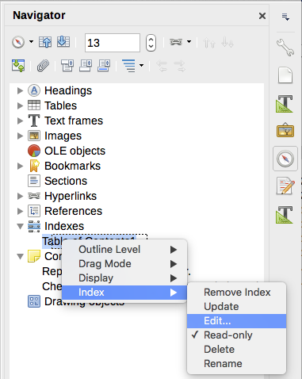
Figure 7: Access a TOC from the Navigator

Updating a table of contents
Writer does not update the TOC automatically, so after any changes to the headings, you need to update it manually. Right-click anywhere in the TOC; from the context menu, choose Update Index.
You can also update the index from the Navigator by expanding Indexes, right-clicking on Table of Contents1, and choosing Index > Update.

Deleting a table of contents
To delete the TOC from a document, right-click anywhere in the TOC and choose Delete Index from the context menu. You can also delete the index from the Navigator by choosing Index > Delete from the menu shown in Figure 7. Writer will not prompt you to confirm the deletion.

Alphabetic indexes
An alphabetical index (referred to as an index) is a list of keywords or phrases used throughout a document that, if listed in order with page numbers, may help the reader find information quickly. Generally an index is found in the back of a book or document.
This section describes how to:
- Add index entries manually.
- Use a concordance file.
- Create an alphabetic index quickly.
- Customize the display of index entries.
- Customize the appearance of the index.
- View and edit existing index entries.

Adding index entries
Before you can create an index, you must create some index entries, either manually or by using a concordance (see page 17). To create index entries manually:
- To add a word to the index, place the cursor anywhere in that word. To add multiple words as one entry, select the entire phrase.
- Choose Insert > Table of Contents and Index > Index Entry to display a dialog similar to that shown in Figure 8. When the dialog opens, the selected text appears in the Entry text input box. You can accept the word or phrase shown, or change it to whatever you want.
- Click Insert to create the entry.
- Note
A cursor placed immediately before the first character of a word, or immediately after the last character of a word if it is followed by a space, counts as being in that word.
You can create multiple entries without closing the dialog. For each one:
- Click at the location in the document that you want to index.
- Click again on the dialog.
- Change the entry if needed, and click Insert.
- Repeat steps 1–3 until you have finished with the entries, then click Close.
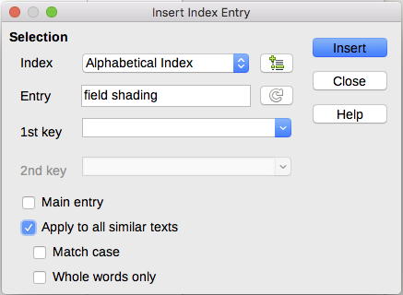
Figure 8: Inserting an index entry
Below is a brief explanation of the fields in the Insert Index Entry dialog and how to use them.
Index
The type of index this entry is for. The default is Alphabetical Index, but you can use this field to create extra entries for a table of contents or user-defined indexes or lists of almost anything. For example, you might want an index containing only the scientific names of species mentioned in the text, and a separate index containing only the common names of species. See “Other types of indexes” on page 22.
Entry
The word or phrase to be added to the selected index. This word or phrase does not need to be in the document itself; you can add synonyms and other terms that you want to appear in the index.
1st key
An index key is an entry that has no associated page number and has several subentries that do have page numbers. Using keys is a useful way of grouping related topics. (See “Example of using an index key” below.)
2nd key
You can have up to a three-level index, where some of the first-level keys have level-2 entries that are also keys (without page numbers). This degree of index complexity is not often necessary.
Main entry
When the same term is indexed on several pages, often one of those pages has more important or detailed information on that topic, so you want it to be the main entry. To make the page number for the main, or most important, entry stand out, select this option and then define the character style for the page number of a main index entry to be bold, for example.
Apply to all similar texts
Select this option to have Writer automatically identify and mark any other word or phrase that matches the current selection. The Match case and Whole words only options become available if this option is selected. Use this option with care, as it may result in many unwanted page numbers (for minor uses of a word) being listed in the index.

Example of using an index key
An index key is a primary entry under which subentries are grouped. For example, you might want to create a grouping similar to this:
LibreOffice
Calc, 10
Impress, 15
Writer, 5
In this example, LibreOffice is the 1st key. The subentries (with the page numbers showing) are the indexed entries. To insert an index entry for the topic Writer, on the Insert Index Entry dialog (Figure 8 on page ), type Writer in the Entry box and LibreOffice in the 1st key box.
- Note
If field shading is active (Tools > Options > LibreOffice > Application Colors > Text Document > Field shadings), when a selected word or phrase has been added to the index, it is shown in the text with a gray background. If the text of an index entry has been changed from the text of the word selected, the index entry is marked by a small gray rectangle at the start of that word.
- Tip
You can also open the Insert Index Entry dialog by clicking the Entry icon on the Insert toolbar, as shown in Figure 9.
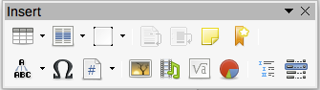
Figure 9: Index Entry icon on Insert toolbar

Creating a concordance
A concordance is a plain text file that lists words to add to the index. It has one word or phrase defined on each line. Each line has a strict structure, consisting of seven fields, separated by semicolons:
Search term;Alternative entry;1st key;2nd key;Match case;Word only
No space is entered between the semicolon and a field’s contents. A key is a higher level heading that a search term is placed beneath.
If you choose not to have an alternative entry, a first key or a second key, leave those fields blank, so that one semi-colon immediately follows another.
The last two fields are structured somewhat differently. If you want only entries that have the same upper or lower case letters as your entries, enter 1 in the second to last field. Similarly, entering 1 in the last field sets the index to only include instances where the entry is a whole word, and not part of a larger one. You can also leave the last two fields blank, as you can with any of the others.
For example, entering:
Macaw;Ara;Parrots;;0;0
Would produce an entry for macaw with
- A listing under macaw.
- An alternate listing under ara (the scientific name).
- A listing of Parrots, Macaw.
- No second key (notice the two semi-colons).
- Inclusion of instances that start with a lower or upper case letter (both “macaw” and “Macaw”).
- Inclusion of instances in which the term is a whole word or part of a longer word.
Whether creating a concordance is faster than adding entries manually is debatable, buta concordance is certainly more systematic. The disadvantage of a concordance is that it can produce an index that includes instances of common words that are irrelevant for your purposes. In many cases, a useful index may require a combination of manual entries and a concordance.

Creating an alphabetic index quickly
Now that you have some index entries, you can create the index.
Although indexes can be customized extensively in Writer, most of the time you need to make only a few choices.
To create an index quickly:
- Click in the document where you want to add the index and click Insert > Table of Contents and Index > Table of Contents, Index or Bibliography to open the Table of Contents, Index or Bibliography dialog.
- In the Type box on the Type page (Figure 10), select Alphabetical Index.
- In the Options section, you may want to deselect Case sensitive (so that capitalized and lower-case words are treated as the same word) and Combine identical entries with p or pp.
- If you are using a concordance, select Concordance file In the Options section, then click the File button and select the concordance file you created.
- Click OK. The result will be a typical index.

Customizing an index
To customize an existing index, right-click anywhere in the index and choose Edit Index/Entry from the context menu.
The Table of Contents, Index or Bibliography dialog (Figure 10) has five pages. Any or all of them can be used to customize the index.
- Use the Type page to set the attributes of the index.
- Use the Entries and Styles pages to format the entries in the index.
- Use the Columns page to put the index into more than one column.
- Use the Background page to add color or an image to the background of the index.
After making your changes, click OK to save the index so it appears in your document.

Type page
Use the Type page (Figure 10) to set the basic attributes of the index.
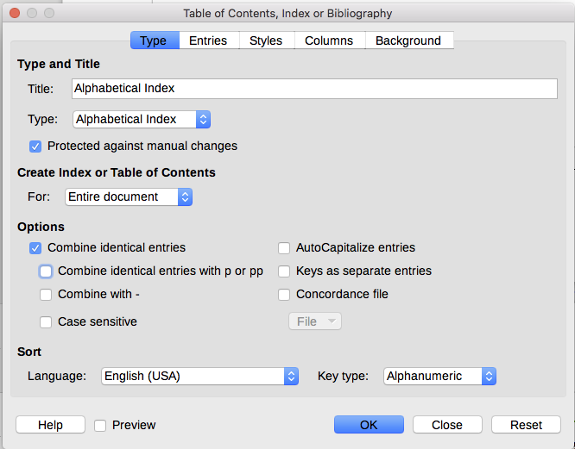
Figure 10: Type page for an alphabetic index
To give the index a different title, edit the Title field. To delete the title, clear the Title field.
Be sure the type of index is set to Alphabetical Index.
To prevent the index from being changed accidentally, select Protected against manual changes. The index can then only be changed using the right-click menu or the Table of Contents, Index or Bibliography dialog. If the option is not selected, the index can be edited directly on the document page, just like other text. However, any manual changes to an index are lost when you update it, so they should be avoided.
From the drop-down list in the Create Index or Table of Contents section, select Entire document. You can also choose to create an index for just the current chapter.
Other options determine how the index handles entries:
Combine identical entries
Defines how identical entries are dealt with. Normally each page number of an indexed word or phrase will be shown in the index; however, these can be combined using the Combine identical entries with p or pp. If you want a page range displayed, select Combine with – (which will produce something similar to 23–31). If you want different entries based on what letters are capitalized, select Case sensitive.
AutoCapitalize entries
Automatically capitalizes the first letter of each entry regardless of how they show within the document itself.
Keys as separate entries
For the keys to have their own page numbers, select this option.
Concordance file
Choose the file to be used, if any. See page 17 for more information.
Sort
Defines how the entries are sorted when displayed. The only option is alphanumeric, but you can define which language alphabet will be used.

Entries page
Use the Entries page to set exactly how and what will be displayed for each of the entries. The page is similar to Figure 11.
- Note
Hyperlinking from the index to the location of entries in the text is not available.
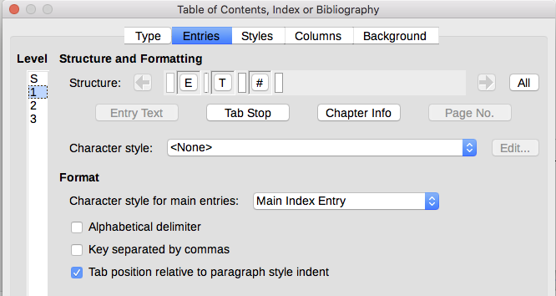
Figure 11: Entries page for an alphabetical index
To begin, in the Level column select the index level whose elements you want to format. Level “S” refers to the single letter headings that divide the index entries alphabetically when the Alphabetical delimiter option is selected in the Format section. (You will be able to apply your changes to all index levels later.) The Structure line displays the elements for entries in that level. Each button on the Structure line represents one element:
- The E icon represents the entry text.
- The T icon represents a tab stop.
- The # icon represents the page number.
- The CI icon represents chapter information. This is not present by default, but can be added by selecting the Chapter info button.
Each white field on the Structure line represents a blank space. You can add, change, or delete elements as described on page 9 for a table of contents.

Chapter Info
The Chapter Info button inserts chapter information, such as the chapter heading and number. The information to be displayed is selected from the Chapter entry list that appears when this option is selected. This data is determined in the Chapter Numbering dialog (Tools > Chapter Numbering).

Applying character styles
Each of the elements on the Structure line may be given additional formatting. For example, you may want the page number to be a different size from the rest of the index text. To do this, apply a character style to one of the elements in the Structure line, as for a table of contents; see page 10.

Formatting entries
Apply additional formatting using the options in the Format section.
- Alphabetical delimiter. This separates the index entries into blocks that start with the same first letter, using that letter as a header. For example, if your index begins:
apple, 4
author, 10
break, 2
bus, 4
Then selecting this option will give you:
A
apple, 4
author, 10
B
break, 2
bus, 4
- Key separated by commas. Arranges the entries in the index on the same line but separated by commas.
- Tab position relative to Paragraph Style indent. When selected, entries are indented according to the settings of their individual formats. Where a paragraph style with an indent on the left is in use, tab stops will be relative to this indent. If this option is not selected, tab stops will be relative to the left margin position.

Styles, Columns, and Background pages
Use the Styles page to change which paragraph style is assigned to display the text of each level in the index. In most cases, the best strategy is to keep the assigned styles but change their settings as needed to make the index appear the way you want.
The Background page is the same as for TOCs. Refer to “Styles page” on page 11 and “Background page” on page 12 for detailed information on these pages.

Columns page
Use the Columns page (Figure 12) to change the number of columns for the index.
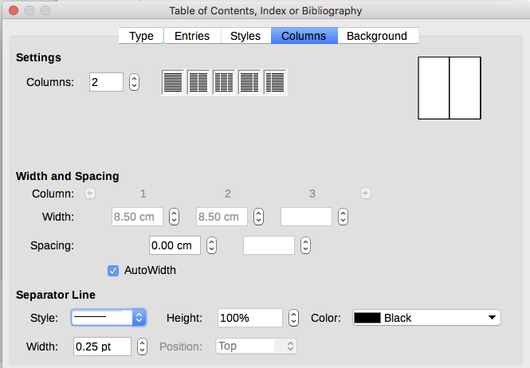
Figure 12: Columns page of the Insert Index/Table dialog

Adding multiple columns
To display the index in more than one column:
- Either enter the number of columns desired in the box labeled Columns or select the icon representing the number of columns.
- To evenly distribute the columns according to the page width, select the AutoWidth box. If it is unchecked, you can manually set each of the following:
- Width of each of the columns
- Spacing between the columns
- You can choose to have a separator line between the columns:
- Style: The default is None, or select from three choices of line style.
- Width: The width (thickness) of the line. The default is 0.25pt.
- Height: The height of the line, as a percentage of the full column height. The default is 100%
- Position: Position of the line relative to the columns (top, centered, or bottom) if the height is less than 100%.
- Color: Allows the color of the separator line to be set.

Maintaining an index
To modify the appearance of an index, right-click anywhere in the index and choose Edit Index from the context menu. The Table of Contents, Index or Bibliography dialog opens and you can edit and save the index using the five tabs described in the previous section.
To update or delete an index, right-click anywhere in the index and select Update Index or Delete Index.

Viewing and editing existing index entries
Once you have added the initial entries, you can make some amendments. You can view and edit these using the following steps:
- Ensure that field shading is active (View > Field Shadings or Ctrl+F8), so you can locate index entries more easily.
- Place the cursor in the field shading of an existing index entry in the body of the document, right-click, and select Index Entry from the content menu. In the case of a changed-text entry, the field shading is immediately before the word. Placing the cursor immediately before a word marked as a text entry will satisfy both selection criteria.
- A dialog similar to Figure 13 appears. You can move through the various index entries using the forward and back arrow buttons. If there is more than one entry for a single word or phrase, a second row of buttons with a vertical bar at the point of the arrow head is displayed allowing you to scroll through each of these entries.
- Make the necessary modifications or additions to the index entries, and then click OK.
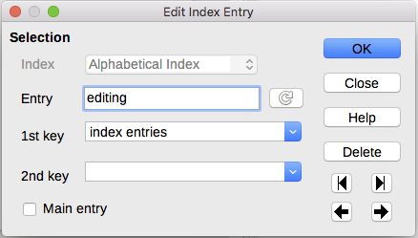
Figure 13: Viewing and editing index entries

Other types of indexes
An alphabetical index is not the only type of index that you can build with Writer. Other types of indexes supplied with Writer include those for illustrations, tables, and objects, and you can even create a user-defined index. This chapter does not give examples of all the possibilities.
To create other indexes:
- Place the cursor where you want the index created.
- Select Insert > Table of Contents and Index > Table of Contents, Index or Bibliography from the Menu bar.
- On the Table of Contents, Index or Bibliography dialog, in the Type drop-down list, select the index wanted.
- Modify the various pages, which are similar to those discussed in previous sections.
- Select OK when everything has been set.

Example: Creating an index of figures
Creating an index (list) of figures or tables is easy if the figure captions were created using Insert > Caption or manually using a number range variable as described in Chapter 17, Fields.
- On the Table of Contents, Index or Bibliography dialog, in the Type drop-down list, choose Illustration Index. You can change the title of the index to something else; we have used Table of Figures as our title.
- Be sure Captions is selected in the Create from section, and choose the category of caption. The default for Category is Illustration; in our example we have used Figure for the figure captions.
(The category Figure is not supplied with LibreOffice; however, if you have defined it when creating a caption in your document, it will appear on this list. See Chapter 11, Images and Graphics, for more about creating captions.)
- Under Display, you can choose References (to include the category, number, and caption text), Category and Number, or Caption Text. We have chosen References.
- The other pages of this dialog are similar to those described for tables of contents.
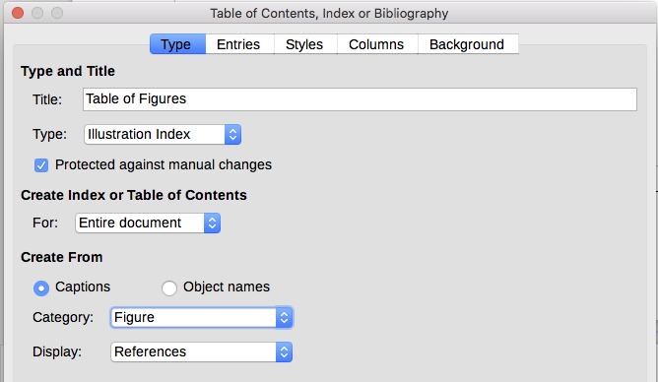
Figure 14: Creating other types of indexes
- Click OK. The result is shown below.
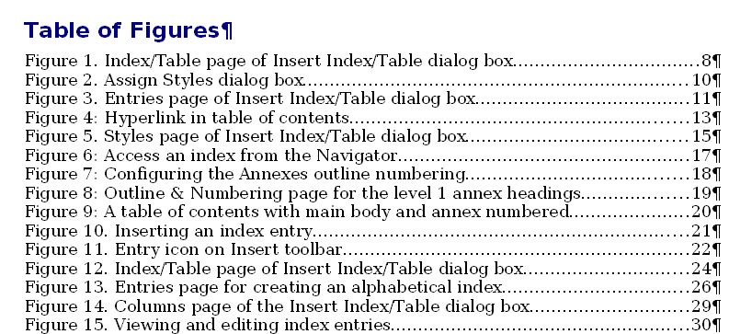
Figure 15: Resulting index of illustrations

Bibliographies
A bibliography is a list of references used in a document. The references can be stored in a bibliographic database or within the document itself.
This section shows you how to:
- Create a bibliographic database; add and maintain entries.
- Add a reference (citation) into a document.
- Format the bibliography.
- Update and edit an existing bibliography.
Citations within the text require entries in different fields in the bibliography database, and different presentations in the text. Before creating a list of references, determine which citation style you need for a document. The five main styles are:
- APA (American Psychological Association): Psychology, education, and other social sciences.
- MLA (Modern Languages Association): Literature, art, and humanities.
- Chicago: History and specific publications.
- Turabian: A variation of the Chicago style for general use by university students.
- AMA (American Medical Association): Medicine, Health, and Biology.
All citations use the Identifier field (first on the left) to set the format for a citation in the document. In this column, you can add the citation in the correct form for the citation style. All necessary information, including the Identifier field, should be entered before any citation is created in the document. The Identifer column in the table (Figure 16) and the Short Name field below the table are the same field.
The bibliography database is the source for citations in the text, no matter what citation style you use.
- Tip
Writer has a single bibliography database for all documents. Since formatting entries can be tedious, consider creating a template with citations for each type of source material.

Creating a bibliographic database
Although you can create references within the document itself, creating a bibliographic database allows reuse in other documents and saves a lot of time.
For most of this section, the database table used is the sample one that comes with Writer. For information on creating a new table in the bibliographic database, see Chapter 8, Getting Started with Base, in the Getting Started Guide.
The bibliography database has to cover many different media and circumstances, which is why it contains so many fields. It also includes fields such as ISBN that no citation style uses, but might be useful to you as you do research.
- Note
Any single entry in the bibliography needs only about half a dozen fields filled in, no matter what citation format you use. What differs is the fields needed for each type of source material and the order of the fields in each citation style.
Select Tools > Bibliography Database. The Bibliography Database window, similar to that in Figure 16, opens. The upper part of the page shows all of the records, in a table layout similar to that of a spreadsheet. The lower part of the page shows all the fields of the selected record.
- Caution
The sample entries in the sample database for both the Identifer column and the Short Name field are meaningless. Replace them with the proper format for the citation style you are using.
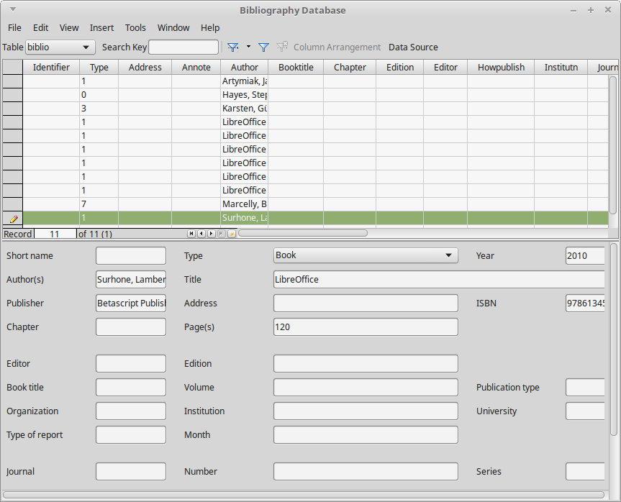
Figure 16: Bibliography Database main window

Filtering records
To set up a filter for specific records within the bibliographic database, select Tools > Filter from the Bibliographic Database Menu bar, or click the Standard Filter button on the toolbar near the top of the window. On the Standard Filter dialog (Figure 17), choose the fields, conditions, and values for the filter and click OK.

Changing the data source
To change the data source in use (for example, if you have more than one bibliographic database for different purposes), select Edit > Choose Data Source from the Menu bar, or click the Data Source button on the toolbar near the top of the window. On the Choose Data Source dialog, select a data source and click OK.
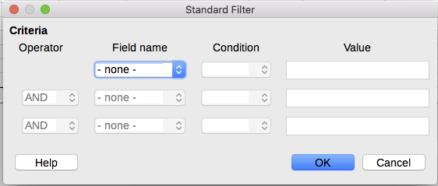
Figure 17: Setting up a filter for the bibliographic database

Adding entries to the database
Use the Bibliography Database dialog (Tools > Bibliography Database) to add entries to the database:
- You can add records directly into the database using the fields in the lower section of the dialog shown in Figure 16 on page .
- Select Insert > Record from the Menu bar of the Bibliography Database dialog, or click the Insert Record icon to the left of the horizontal scroll bar.
- Enter a name for the entry in the Short Name box. Complete other fields as required. Use the Tab key to move between fields.
It is best to use a unique name in the Short name field. This field is used when inserting entries into documents.
- To complete the entry, move to the last field and press Tab once more.
If your document requires [Author, date] style citations, use the Short name field of the database to record the information in the required format.

Maintaining entries in the database
To maintain entries in the database, use the Bibliography Database dialog (Tools > Bibliography Database). Click the appropriate record and modify the fields as appropriate.
Modified entries are saved automatically to the database when the cursor moves off the record.

Advanced: Modifying the bibliographic database
You can modify the bibliography database in several ways, as summarized below.
- Note
For more information on how to use LibreOffice’s database features, see Chapter 8, Getting Started with Base, in the Getting Started Guide.

Column details
To change the details of columns in the bibliographic database, select Edit > Column Arrangement from the Menu bar, or click the Column Arrangement button on the tolbar near the top of the window (see Figure 16). On the Column Layout for Table biblio dialog (Figure 18), you can change which fields are allocated to which columns. As an example, you can select to have Author data go into the Identifier column, by changing the destination in the drop-down list. The Short name data column destination sets to None automatically, as you can't set duplicate destinations for data.
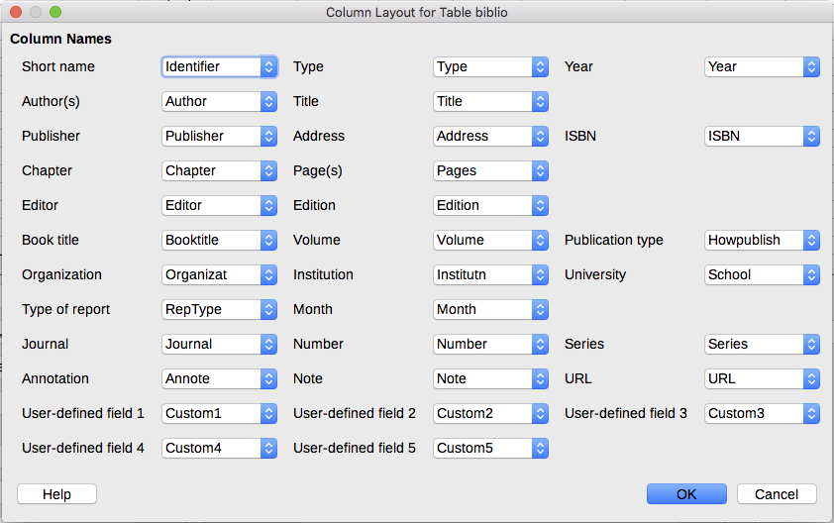
Figure 18: Changing column layout for bibliographic database

Field details
You can make changes to the bibliography database (for example, rename fields or change the length of fields) by doing the following:
- In the main document (not the Bibliography Database window), press F4 or click View > Data Sources to open the data source window, similar to Figure 19.
- Make sure that the Bibliography database is selected as well as the correct table. You may have to expand some levels to be able to select the correct ones.
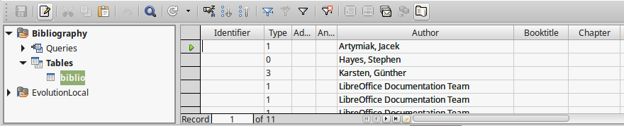
Figure 19: Data Source view of Bibliography database
- Right-click the table entry (biblio in the example) and select Edit Database File from the context menu. This opens a window similar to Figure 20, which is the main menu for Base, the database component of LibreOffice.
- If Tables (in the Database section on the left) is not selected, select it now.
- Right-click the biblio table name in the Tables section and select Edit from the context menu to display a window similar to that shown in Figure 21.
- You can now select each of the fields. Select the text in the Field Name cell and change the entry as required. Click in the Field Type cell to open a selection menu to change the data type in that cell. In the Field Properties section, you can modify the data properties. For each field selected, a description of that field appears to the right of the section.
- When finished, you will be asked to confirm that you want the changes saved.
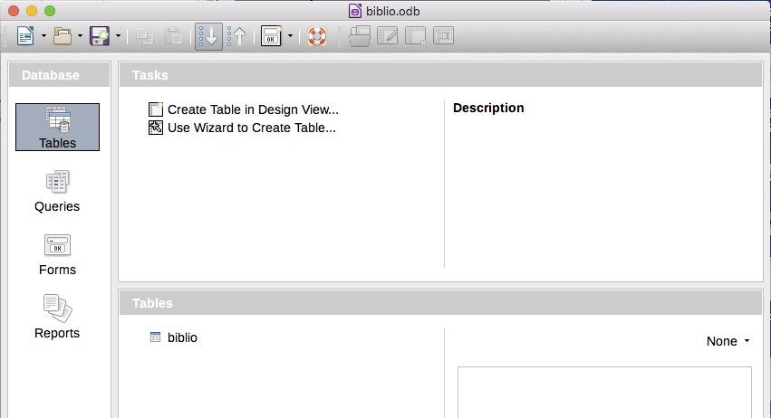
Figure 20: Main window for working with databases
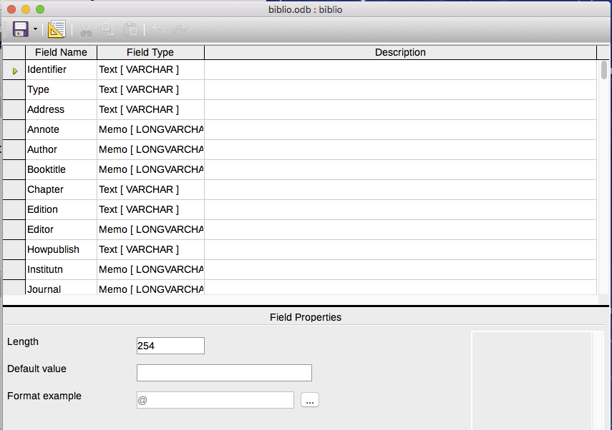
Figure 21: Modify table properties window

Adding references (citations) into a document
Writer supports two methods of adding references to your document:
- From a bibliography database, such as the one built into Writer.
- Directly from the keyboard.

Entering references from a database
To add references from the bibliographic database into a document:
- Place the cursor where you want the reference to appear.
- From the main menu, choose Insert > Table of Contents and Index > Bibliography Entry.
- In the Insert Bibliographic Entry dialog (Figure 22), choose From bibliography database at the top of the dialog.
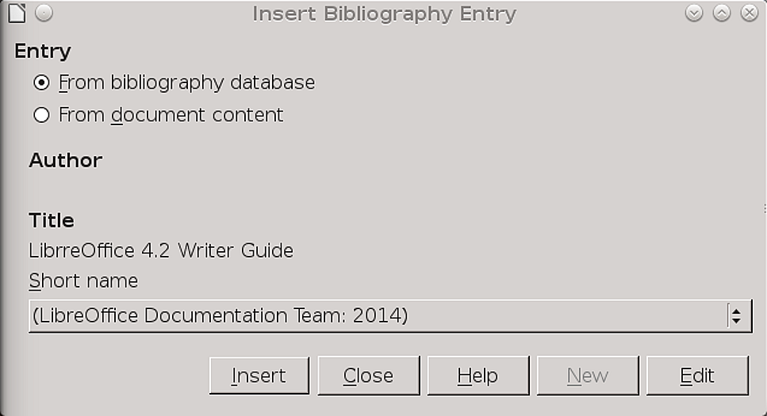
Figure 22: Inserting bibliographic entries into a document
- Select the reference from the Short name drop-down list near the bottom of the dialog. The Author and Title of the selected reference are shown in the middle of the dialog, to help you verify that it is the reference you want.
- To insert the reference into the document, click Insert.
- You can keep the dialog open and insert another reference into the document; you don’t need to close and reopen it.
- When you have finished inserting all the references, click Close.

Entering references from documents
You may choose to enter your bibliographic entries directly into the document, instead of from an external database. For example, you may not be working on your own computer.
Click in the document where you want to add the entry.
- Select Insert > Table of Contents and Index > Bibliography Entry.
- In the dialog that opens, select the From document content option.
  - Select New.
  - In the Define Bibliography Entry dialog, complete all the fields which are relevant to your entry. Type a unique name in the Short name text entry box, because the Insert Bibliography Entry dialog uses this entry for the citation.
  - Select a choice from the menu in the Type box to enable the OK button.
  - Click OK when all the fields wanted are completed.
  - Click Insert to add the Short name field to the document
  - Click in each location you wish to add an entry and repeat this sequence
- Click Close.
To re-use an entry in your document, restart the sequence above, and then select the Short name required from the current list of entries, instead of selecting to add a new entry.

Editing a reference
To edit a reference:
- Right-click the entry (the cursor then displays to the left of the entry).
- From the context menu, select Bibliography Entry. The Edit Bibliography Entry dialog (similar to the Insert Bibliography Entry dialog) opens.
- To quickly edit only the Short name, click the text box, edit the entry and then click Apply.
- To edit more of the entry, click Edit to open the Define Bibliography Entry dialog.
Make any changes required and then click OK to return to the Edit Bibliography Entry dialog.
- Click Apply to accept the changes and exit the dialog.
- Note
Whatever the source of the citation, the modified references are stored only in the document. If the source is a bibliography database, that database remains unmodified.

Creating the bibliography
- Place the cursor at the point where you wish to insert the bibliography.
- Select Insert > Table of Contents and Index > Table of Contents, Index or Bibliography and change the Type to Bibliography, to display a dialog similar to that shown in Figure 23.
The Table of Contents, Index or Bibliography dialog has five pages.

Index/Table page
Writer supports two ways of displaying references (citations) in the text of a document:
- Using the text recorded in the Short name field of each bibliographic entry, for example (Smith, 2001) depending on citation style.
- By numbering the referenced documents in the sequence they occur in the text, for example [1].
- Tip
To specify which citation style is used in the document, use the Type page on the Table of Contents, Index or Bibliography dialog (Figure 23).
Formatting the bibliography involves choices made in two places:
- Table of Contents, Index or Bibliography dialog, covered in this section.
- Bibliography 1 paragraph style (see page 32).
The basic settings are selected on this page.
- To give the bibliography a title, enter it in the Title field. (A title is not required.)
- You can protect the bibliography from being changed accidentally, by selecting Protected against manual changes. If this option is selected, the bibliography can only be changed using the right-click menu or the Table of Contents, Index or Bibliography dialog. If the option is not selected, the bibliography can be changed directly on the document page, just like other text, but any manual changes will be lost when you update the bibliography.
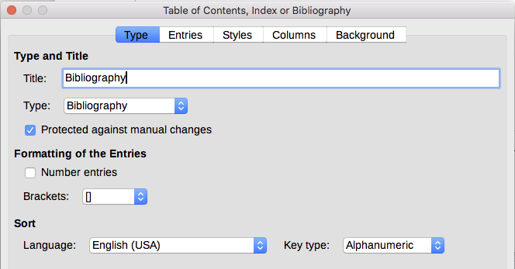
Figure 23: Inserting a bibliography
- To have the bibliographic entries (citations) numbered within the body of the document (for example, [1], [2]...), select Number entries. If, however, you wish to have the Short name field contents (from the database) appear in the document, deselect this option.
- Select the type of brackets that you want for the referenced entries shown within the body of the document.
- Define the sorting you require. Currently only alphanumeric sorting is supported. Sorting by the sequence that entries appear in the text is done on the Entries page.

Entries page
The structure of this page (see Figure 24) is similar to that for tables of contents and for indexes.
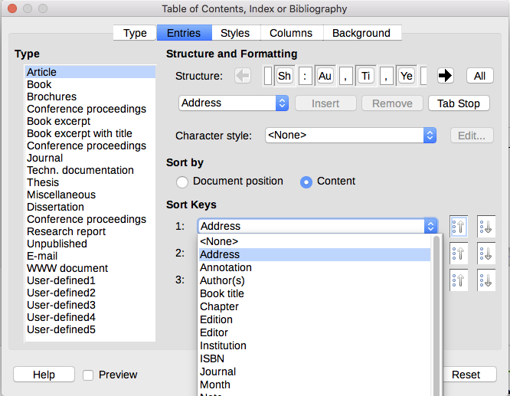
Figure 24: Entries page for bibliographies
The Type refers to the kind of source, such as a periodical or a web page. Each entry in the Type list has a default structure format. You can define how the entry will appear, based on its source, by selecting from the Type list of entries, or simply apply the same format to all entries by selecting the All button.
The Structure of the entry is based on the fields available in the bibliographic database. Consult the citation style required for your document and modify the Structure line as needed.
To remove elements from the Structure line, click the element then click the Remove button.
To add an element, click in the Structure line where it is to be inserted. Select either the Tab stop, or an element in the drop-down list to the left of the Insert button, and then click Insert. The elements in the drop-down list are those fields found in the Bibliography Database.
All the elements on the Structure line can be formatted using the Character Style selection list. For example, you can define a character style so that book and journal titles are in italics or bold.
To determine how entries are sorted, modify the Sort by options. To sort by the sequence that entries appear in the text, choose Document position. In most modern citation styles, you will want Content (alphabetical descending order). Use Sort keys to group similar references.

Styles, Columns and Background pages
Refer to “Styles page” on page 11, “Columns page” on page 21 and “Background page” on page 12 for detailed information on these pages.

Defining the paragraph style for the bibliography
You can modify the Bibliography 1 paragraph style to suit your requirements. For example, to number the entries in the bibliography list, you need to define a numbering style and link that numbering style to the Bibliography 1 paragraph style. To do this:
- On the Styles and Formatting window, click the List Styles icon. You can either define a new list style or modify one of those supplied. In this example, we will modify the Numbering 5 style. Right-click Numbering 5 and choose Modify from the context menu.
- On the Numbering Style dialog, go to the Customize page. In our example we want to have the numbers enclosed in square brackets. To do this, type [ in the Before box and ] in the After box, as shown in Figure 25.
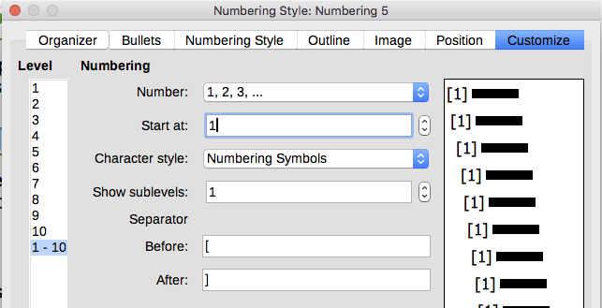
Figure 25: Specifying square brackets before and after the number in a list
- Now go to the Position page of the Numbering style dialog (Figure 26). In the Spacing to text box, specify how much indentation you want for the second and following lines of any item in the bibliography list of your document. Often you will need to experiment a bit to see what is the best setting. In our example, we have chosen 1 cm.
- Click OK to save these settings and close the Numbering Style dialog. Return to the Styles and Formatting window, click the Paragraph Styles icon, choose All Styles from the list at the bottom of that window, then right-click Bibliography 1 and choose Modify.
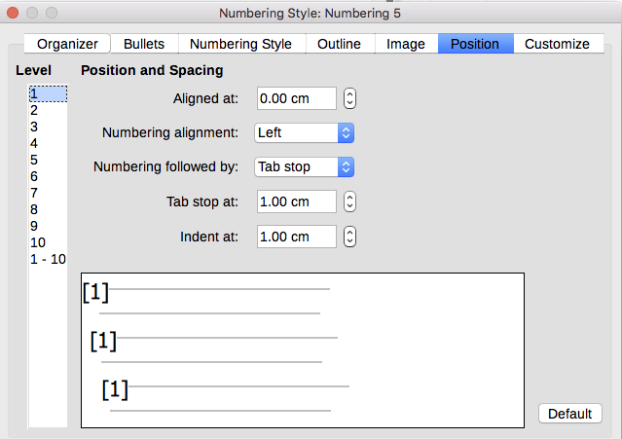
Figure 26: Setting the spacing between the margin and the text
- On the Paragraph Style dialog, go to the Outline & Numbering tab and select Numbering 5 from the drop-down list. (See Figure 27.) Click OK to save this change to the Bibliography 1 paragraph style.
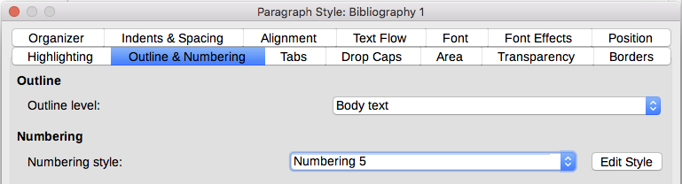
Figure 27: Applying a numbering style to a paragraph style
Now when you generate the bibliography, the list will look something like the one shown in Figure 28 for a book after removing elements from the structure line (the Short name and colon, for example).

Figure 28: Result of changing settings for Bibliography 1 paragraph style

Updating, editing, and deleting an existing bibliography
Right-click anywhere in the bibliography. From the context menu, select:
- Update Index to update the bibliography.
- Edit Index to open the Table of Contents, Index or Bibliography dialog so you can edit and save the bibliography.
- Delete Index to delete the bibliography without a confirmation request.
- Tip
If you find Writer’s bibliography feature too limited, you may wish to try Zotero, which is free and open source, available for Mac, Windows, and Linux. It is reported to work well with Writer (http://www.zotero.org/).

