
Writer 6.0 Guide

Chapter 16
Master Documents

Copyright
This document is Copyright © 2018 by the LibreOffice Documentation Team. Contributors are listed below. You may distribute it and/or modify it under the terms of either the GNU General Public License (http://www.gnu.org/licenses/gpl.html), version 3 or later, or the Creative Commons Attribution License (http://creativecommons.org/licenses/by/4.0/), version 4.0 or later.
All trademarks within this guide belong to their legitimate owners.

Contributors
Jean Hollis Weber | Bruce Byfield | Gillian Pollack

Acknowledgments
This chapter is updated from previous versions of the LibreOffice Writer Guide. Contributors to earlier versions are:
Jean Hollis Weber | Barbara Duprey | Ron Faile Jr.
David Blymire | John A Smith | Klaus-Jürgen Weghorn
An earlier version appeared in the OpenOffice 3.3 Writer Guide. The contributors were:
Jean Hollis Weber | Michele Zarri | Daniel Carrera
Ian Laurenson | Scott Rhoades | Janet M. Swisher
Sharon Whiston

Feedback
Please direct any comments or suggestions about this document to the Documentation Team’s mailing list: documentation@global.libreoffice.org
- Note
Everything you send to a mailing list, including your email address and any other personal information that is written in the message, is publicly archived and cannot be deleted.

Publication date and software version
Published July 2018. Based on LibreOffice 6.0.

Note for macOS users
Some keystrokes and menu items are different on macOS from those used in Windows and Linux. The table below gives some common substitutions for the instructions in this book. For a more detailed list, see the application Help.
Windows or Linux | macOS equivalent | Effect
Tools > Options menu selection | LibreOffice > Preferences | Access setup options
Right-click | Control+click and/or right-click depending on computer setup | Open a context menu
Ctrl (Control) | ⌘ (Command) | Used with other keys
F5 | Shift+⌘+F5 | Open the Navigator
F11 | ⌘+T | Open the sidebar Styles and Formatting deck

Contents
Copyright 2
Contributors 2
Acknowledgments 2
Feedback 2
Publication date and software version 2
Note for macOS users 2
Why use a master document? 4
Using the master document Navigator 4
Styles in master documents and subdocuments 5
Creating a master document: scenarios 5
Starting with no existing documents 5
Step 1. Plan the project 6
Step 2. Create a template 6
Step 3. Create the master document 7
Step 4. Create subdocuments 7
Step 5. Add some pages to the master document 7
Step 6. Insert the subdocuments into the master document 8
Step 7. Add table of contents, bibliography, index 9
Combining several documents into a master document 10
Splitting a document into master and subdocuments 12
Restarting page numbering 13
Editing a master document 14
Changing the appearance of the master document 14
Editing subdocuments 14
Adding, deleting, or renaming subdocuments 15
Cross-referencing between subdocuments 15
Preparing items as targets for cross-referencing 15
Using bookmarks 15
Setting references 16
Inserting the cross-references 17
Creating a master document template 19
Creating one file from a master document and its subdocuments 19
Anchoring images 20

Why use a master document?
A master document (.odm) is a container that joins separate text documents (.odt) into one larger document, and unifies the formatting, table of contents (TOC), bibliography, index, and other material. Master documents are typically used for producing long documents such as a book, a thesis, or a long report.
A master document is especially useful in these situations:
- When the file size or number of pages is quite large; writing, reviewing, and editing may be easier when done on subsets of the full document.
- When different people are writing different chapters or other parts of the full document.
- When files will be published as stand-alone documents as well as becoming part of a larger document. The chapters of this Writer Guide are an example of this usage.
- When subdocuments are used in more than one final document.
- To change templates for a document: add it to a master document with a different template. To work, this technique needs both the document and the master document to have styles of the same name.
You can use several methods to create master documents. Each method has its advantages and disadvantages. Which method you choose depends on what you are trying to accomplish. The different methods are described in this chapter, along with suggestions on when to use each one.
- Tip
A master document is not always the best method to use in any of the situations given above. You may find that using one big file, or an ordinary document (.odt) containing sections linked to other files, may do the job just as well. For more about using sections to combine files, see Chapter 6, Formatting Pages: Advanced.

Using the master document Navigator
In Writer, the Navigator has two forms: one is used in ordinary text documents and the other in master documents.
In an ordinary text document, the Navigator displays lists of the graphics, tables, index entries, hyperlinks, references, and other items in the document, as shown on the left in Figure 1.
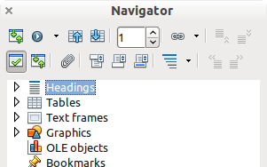 | 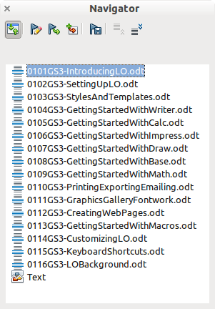
Figure 1: The Navigator for a text document (left) and for a master document (right)
In a master document, you can toggle between the regular and master views by clicking on the Toggle icon at the upper left. In the master view, the Navigator lists the subdocuments and text sections, as shown on the right in Figure 1. The use of the Navigator in a master document is covered in more detail later in this chapter (see “Step 6. Insert the subdocuments into the master document” on page 8 and “Cross-referencing between subdocuments” on page 15).

Styles in master documents and subdocuments
A stand-alone document becomes a subdocument when it is linked into a master document. A document can be used as a subdocument in several master documents. Each master document may have different style definitions (font, type size, color, page size, margins, and so on), which affect the appearance of the final document, but the individual documents retain their original characteristics.
The relationship between styles in a master document and its subdocuments is as follows:
- Custom styles used in subdocuments, such as paragraph styles, are automatically imported into the master document.
- If more than one subdocument uses a custom style with the same name (for example, myBodyText), then only the one in the first subdocument to be linked is imported into the master document.
- If a style with the same name exists in the master document and in the subdocuments (for example, Default Style), then the style is applied as defined in the master document.
- The styles in the subdocuments are only changed in the master document, so when a subdocument is opened for editing the original styles are not affected.
- Tip
If you use the same document template for the master document and its subdocuments, the subdocuments will look the same when they are loaded into the master document as they do when viewed as individual files. When you modify or create a style, be sure to make the change in the template (not in the master document or any of the subdocuments). Then when you reopen the master document or a subdocument, the styles will update from the template.

Creating a master document: scenarios
Which method you choose from the three most common methods for creating a master document depends on the current state of your document:
- You have no existing documents but intend to write a long book containing several chapters, possibly by multiple authors.
- You have several existing documents (chapters) by one or more authors that you want to combine into one book, controlled by the master document.
- You have one existing document (a book) that you want to split into several subdocuments (chapters) that will be controlled by the master document.
We will look at each of these scenarios in turn.

Starting with no existing documents
When you start with no existing documents, you can set up everything the way you want from the beginning. Follow these steps, in the order given. Each step is explained in detail in the following subsections.
Step 1. Plan the project
Step 2. Create a template
Step 3. Create the master document
Step 4. Create subdocuments
Step 5. Add some pages to the master document
Step 6. Insert the subdocuments into the master document
Step 7. Add table of contents, bibliography, index

Step 1. Plan the project
Although you can make changes at most steps in this process, the more you can plan before you start, the less work you will have to do to correct any problems later. Here are some things you need to plan.
Parts of book or report required. What pages will be in the master document and what will be in the subdocuments?
Consider as an example a book with the parts given in the table below.
Part | Location
Title (cover) page | In master document
Copyright page | In master document
Table of contents (TOC) | In master document
Preface (Foreword) | Subdocument
Chapters 1 to 7 | Subdocuments
Index | In master document
Page, paragraph, character, frame, and numbering styles. Determine the styles you wish to use. See Chapter 8, Introduction to Styles, and Chapter 9, Working with Styles, for instructions on how to create or modify styles and examples of the use of styles in book design. Pay particular attention to setting up headings using styles, as described in “Using paragraph styles to define a hierarchy of headings” in Chapter 8.
Fields and AutoText entries, as required. See Chapter 2, Working with Text: Basics, and Chapter 17, Fields, for ideas.
One or more templates for master and subdocuments. If you are starting a new project, create the master document and all the subdocuments from the same template. Not using the same template can create style inconsistencies that could cause your document not to look as you expect. For example, if two subdocuments have a style with the same name that is formatted differently in each document, the master document will use the formatting from the first subdocument that was added.
Page numbering. In our example, the pages are numbered sequentially from the title page. (The title page style can be defined not to show the page number, but it will still count as page 1.) Therefore the first chapter begins on a higher number page, for example page 5. To create a book in which the page numbering restarts at 1 for the first chapter, you need to do some additional work. See “Restarting page numbering” on page 13.

Step 2. Create a template
You can create a template from an existing document or template that contains some or all of the page, paragraph, character, and other styles you want for this document, or you can create the template from a blank document. For more about templates, see Chapter 10, Working with Templates. Be sure to use File > Save As Template when creating the template.
- Tip
You can also create master document templates; see page 19.

Step 3. Create the master document
It does not matter in what order you create the master and subdocuments, and you do not have to create all the subdocuments at the same time, when you are starting the project. You can add new subdocuments at any time, as you need them.
Follow this process to create the master document:
- Open a new document from the template you created in Step 2, by choosing File > New > Templates, then selecting the template you created. Be sure the first page of this new document is set to the page style you want for the first page of the final document; if it is not, change it. In our example, the style for the first page is Title page.
- If any text or page breaks came into this document from the template, delete the text. (The TOC, index, and any fields in headers and footers can stay.)
- Click File > Send > Create Master Document. Save the master document in the folder for this project. We will return to this master document later. For now, you can either leave it open or close it.
- Note
Using File > New > Master Document will create a master document file (.odm) associated with the default template. If your document is, or will be, based on a custom template, use the method described above.
- Tip
You can also create a master document directly from a master document template.

Step 4. Create subdocuments
A subdocument is no different from any other text document. It becomes a subdocument only when it is linked into a master document and opened from within the master document. It can still be used as a stand-alone document. Some settings in the master document will override the settings in a subdocument, but only when the document is being viewed, manipulated, or printed through the master document.
Create a subdocument in the same way as you create any ordinary document:
- Open a blank document based on the project template (very important) by choosing File > New > Templates, then selecting the required template.
- Delete any unwanted text or other material that was brought in from the template, and set the first page to the page style you specified for the first page of a chapter.
- Click File > Save As. Give the document a suitable name and save it in the folder for this project.
If you already have some of the chapters written, the files may not be based on the template you just created for this project. If you want to change the template attached to the existing files, use the technique described in “Associating a document with a different template” in Chapter 10, Working with Templates.

Step 5. Add some pages to the master document
To assist you, do the following:
- Make sure paragraph marks are showing. You can set them in Tools > Options > LibreOffice Writer > Formatting Aids, or click the Fomatting Marks icon on the Standard toolbar, or press Ctrl+F10.
- Show text boundaries, table boundaries, and section boundaries (Tools > Options > LibreOffice > Application Colors).
If your master document does not contain any required “front matter” such as a title page, copyright page, or TOC page, add them now. The example in this section uses the sequence of page styles given in “Step 1. Plan the project” on page 6.
- Type the contents of the title page (or leave placeholders and fill in later). With the insertion point in the last blank paragraph on the page, click Insert > Manual Break. On the Insert Break dialog, select Page break and the page style for the second page (Copyright Page in our example), and leave the Change page number option deselected. Click OK.
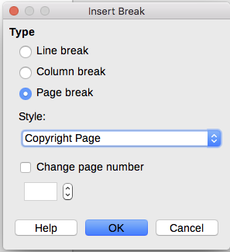
Figure 2: Inserting a page break between the title page and the copyright page
- Type the contents of the copyright page (or leave placeholders). With the insertion point in the last blank paragraph on the page, insert another manual page break, this time setting the page style to Table of Contents page.
- On the Table of Contents page, leave a blank paragraph or two or insert a TOC (Insert > Table of Contents and Index > Table of Contents, Index or Bibliography). The TOC will not have any contents until you add the subdocuments, but a gray mark or box indicates its location. For more about inserting and formatting TOCs, see Chapter 15, Tables of Contents, Indexes, Bibliographies.
- Note
Depending on the style definitions for the first paragraph (usually a heading) on the Copyright and TOC pages, you may not need to insert manual page breaks.

Step 6. Insert the subdocuments into the master document
Now we are ready to add the subdocuments.
- Tip
Subdocuments are inserted into a master document before the item highlighted in the Navigator. If you insert the last subdocument first, and then insert the other subdocuments before the last one, they will end up in the correct sequence without the necessity of moving them up or down in the list.
- Display the Navigator (click View > Navigator, or press F5, or click the Navigator icon on the Sidebar).
- Be sure the Navigator is showing the Master View (see “Using the master document Navigator” on page 4). If necessary, click the Toggle icon at the upper left to switch between regular and master views.
- On the Navigator, select Text, then click Insert > File.
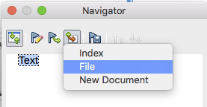
Figure 3: Inserting a subdocument into a master document using the Navigator
A standard file browser dialog opens. Select the required file (which you created in Step 4) and click Insert. This example uses seven chapters; we will load Chapter 7 first, as suggested in the Tip above.
The inserted file is listed in the Navigator before the Text item, as shown in Figure 4.
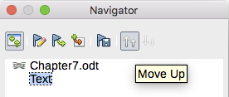
Figure 4: Navigator after inserting one subdocument
- Because the Text section contains the title page and other material, highlight it and click the Move Up icon to move it to the top of the list.
- Highlight the subdocument you just inserted (Chapter 7), then click Insert > File to insert the first subdocument; in this example, Chapter 1. Chapter 7 remains highlighted. Repeat with Chapter 1, Chapter 2, and so on until all the subdocuments have been added to the list. The Navigator will now look something like Figure 5.
- Save the master document again.
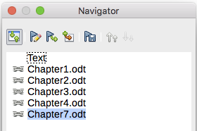
Figure 5: The Navigator showing a series of files in a master document

Step 7. Add table of contents, bibliography, index
You can generate a table of contents, bibliography, or index for the book, using the master document. You must insert these items into a text section in the master document. For more about these document elements, see Chapter 15, Tables of Contents, Indexes, Bibliographies.
Put the insertion point on the page in the first text section where the table of contents is to go and choose Insert > Table of Contents and Index > Table of Contents, Index or Bibliography to create the table of contents.
If you do not have a Text section at the end of the master document, insert one before the last subdocument, then move it down so it is after the last subdocument. Now, if you have included bibliographic entries in your subdocuments, you can put the insertion point on the page in this last text section where the bibliography is to go and create the bibliography.
If you have included index entries in your subdocuments, put the insertion point on the page in the last text section where the index is to go and create the index.
Figure 6 shows the Navigator after addition of a TOC and index.
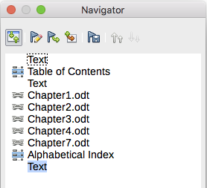
Figure 6: Navigator showing subdocuments, table of contents, and index in a master document

Combining several documents into a master document
When you have several existing documents, you can combine them into one document controlled by a master document.
This method works best when all of the documents were created from the same template, but you can also use it when the documents have been created from different templates. This method is especially useful when the subdocuments are created or maintained by multiple writers. For example, you might be creating an anthology of short stories, a book of symposium papers, or a set of engineering test results with a standard company title page.
We will use a book of engineering test results as an example.
- Tip
You could create a master document template (see page 19) and use it as the starting point for this method. In that case, skip steps 1 and 2 and start with step 3.
- Open the title page document that you plan to use as the master document. To avoid creating too many subdocuments when this document is converted to a master document, have only one level 1 heading present. If there are more, temporarily change them to lower level headings and note which they are (add, for example, an asterisk at the end of each heading to remind you which have to revert to level 1 headings later).
- Select File > Send > Create Master Document, name and save this master document (see “How to do it:” on page 12).
Let us assume our original document was named FrontPage with a single Level 1 heading, and that when we created the master document (.odm file) we named it TestFile.
In this case, the master document is a blank file containing only one section. Also created at the same time was a subdocument named TestFile1, which is a .odt file containing the text from the FrontPage file. When opening the .odm file and clicking Yes to update all links, this file is linked in to the master document to provide the original content.
The original FrontPage file is left intact in its folder.
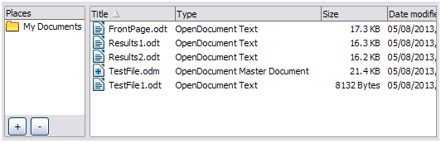
Figure 7: TestFile documents created from FrontPage
- Open the master document and click Yes to update links. The master document opens with the Navigator open by default (see “Using the master document Navigator“ on page 4 and “Step 6. Insert the subdocuments into the master document“ on page 8 for more detailed information).
- Click Insert > File and release the button.
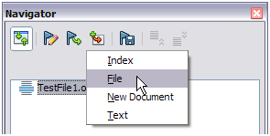
Figure 8: Adding files to the master document
- Navigate to the location of the test results files (Results1.odt, Results2.odt, and so on). Select the first file to insert, Results1.odt for example, and click Insert. The file is inserted above the existing entry.
- Click the Move Up icon to have the TestFile1 text above the Results1 text (file contents are inserted above the selected file in the master document).
- Repeat from step 4 as often as required. It does not matter which file is highlighted in the master document when you insert the next one, just select the inserted file and use the Move Up or Move Down icons to position it as required.
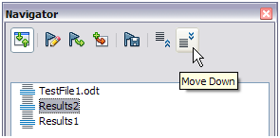
Figure 9: Moving subdocuments
- To edit the master document, to perhaps add a widget serial number and a client's name, in the master document right-click TestFile1 and select Edit from the context menu. Add the required content to the file which opens, save and close the file (see “Editing a master document” on page 14 for more detailed information).
- Select Tools > Update > Links from the Menu bar, or click Update > Links in the Navigator. All the edits in the master document will now show.

Splitting a document into master and subdocuments
When you have one existing document that you want to split into a master document and several subdocuments, you can have Writer split the document automatically at headings with an outline level of your choice.
Although this method is quick and easy, some cleanup work may be necessary:
- The automatically generated file names for the subdocuments are maindocnameX.odt, where X is 1, 2, 3, and so on. If you have a Preface or other “chapter” starting with a Heading 1 before Chapter 1, the file names will not directly correspond to the chapter numbers. You may wish to rename the subdocuments; see “Adding, deleting, or renaming subdocuments” on page 15.
- If the original document is associated with a template, the master document (.odm) will also be associated with that template, but the subdocuments will not. The subdocuments will inherit the styles in the original document, but their association with the template is lost.
How to do it:
- Open the document and choose File > Send > Create Master Document.
- On the Name and Path of Master Document dialog (Figure 10):
  - Navigate to the folder where you want to save the master document and its subdocuments (or create a new folder).
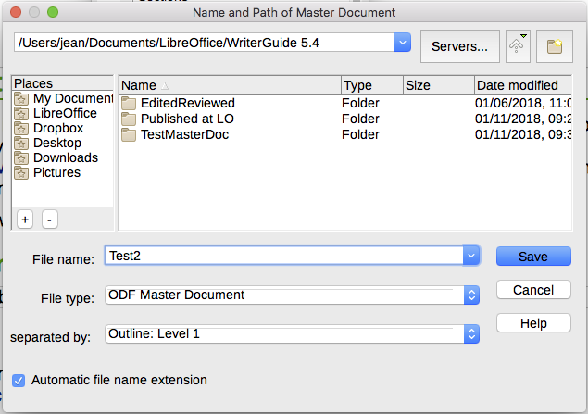
Figure 10: Splitting a document into master and subdocuments
  - Type a name for the master document in the File name box.
  - In the separated by: list, choose the outline level where the file should be split into subdocuments. Usually this is Outline: Level 1 for a chapter heading, but your document may be structured differently. For more information about outline levels, see “Using paragraph styles to define a hierarchy of headings” in Chapter 8, Introduction to Styles.
  - Leave the Automatic file name extension option selected, and click Save to split the document into subdocuments and create the master document.
If you selected Outline: Level 1 and the paragraph style at that level is Heading 1, each of the subdocuments begins with a Heading 1 paragraph.

Restarting page numbering
The examples in the previous sections showed a very basic collection of files with sequential page numbering. This is useful for many documents, including e-books, but a typical printed book has the following sequence of page numbers:
- No page numbers on cover page or copyright page.
- Lower-case roman numerals in the front matter, starting with i.
- Arabic numerals in the body of the document, starting with 1.
- Page numbering sequential through the rest of the book.
To set up a master document to produce such a book, you need to define a different paragraph style for the heading of the first chapter and assign two special characteristics to it.
Example
Each chapter may start with a Heading 1 paragraph, set up on the Text Flow page of the Paragraph Style dialog to start on a new page (Figure 11). The Page number is set to 0, with the effect that numbering continues from the number of the previous page.
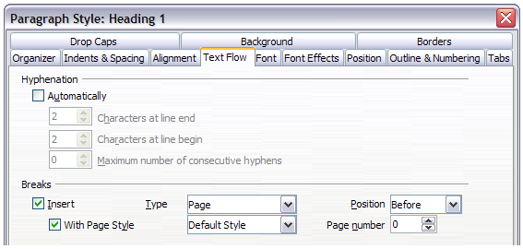
Figure 11: Text Flow tab of Paragraph Style dialog for Heading 1
Look on the Outline & Numbering tab (Figure 12) of this dialog to see what outline level Heading 1 is assigned to. Usually this will be Outline Level 1. The level cannot be changed here because it has been set in Tools > Chapter Numbering.
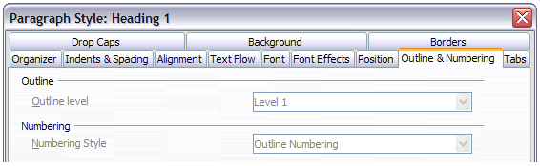
Figure 12: Outline & Numbering tab of Paragraph Style dialog for Heading 1
Only one paragraph style can be assigned to Outline Level 1 through Tools > Chapter Numbering. However, you can assign additional paragraph styles to any outline level by using the Outline & Numbering tab on the Paragraph Style dialog.
Therefore, you want to define a style called Heading 1 Chapter 1 that is identical in appearance to Heading 1 but has one essential difference:
- Right-click Heading 1 in the Paragraph Styles section of the Styles and Formatting tab in the Sidebar, and select New. On the Organizer page of the Paragraph Style dialog, name the new style, select the next style, and be sure Inherit from shows Heading 1.
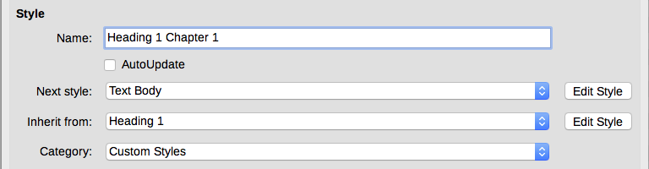
Figure 13: Organizer page for the new style
- On the Text Flow tab, in the Breaks section, select Insert, Page, Before, With Page Style, and Page number 1 (Figure 15).
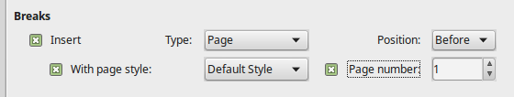
Figure 14: Set the page number to restart at 1 for this heading style
- On the Outline & Numbering tab, set the Outline level to Level 1 (Figure 15). This ensures that the heading will appear in the Table of Contents along with the other chapter headings. (The Numbering Style for this heading is None, as it was not assigned an outline level through the Outline Numbering dialog.)
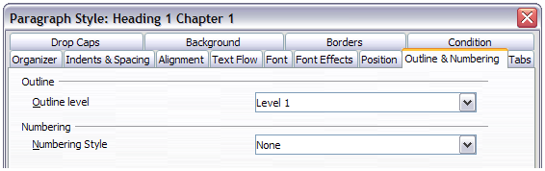
Figure 15: Assign the style to outline level
- Now, assign the new style to the first paragraph of Chapter 1, and you’re done.

Editing a master document
After creating a master document, you may want to change its appearance or contents.

Changing the appearance of the master document
You can change the styles in the template as your project develops. Do not make changes to styles in the master document or in any of the subdocuments; make those changes in the template.
To update the master document (and all of the subdocuments) with changes to the template, open the master document. You will get two messages: first, to ask if you want to update all links; and second, if you want to apply the changed styles. Answer Yes to both of these messages.

Editing subdocuments
You cannot edit a subdocument from within the master document. Instead, you must open the subdocument, either by double-clicking on it in the master document’s Navigator, or by opening it from outside the master document. Then you can edit it just as you would edit any other document.
If, while editing a subdocument, you want to make changes to the styles that apply to the master document, follow the recommendations in “Changing the appearance of the master document” above.
If you change the contents of any subdocument, you need to manually update the table of contents, bibliography, and index from within the master document.

Adding, deleting, or renaming subdocuments
To add a subdocument, follow the method described in “Step 6. Insert the subdocuments into the master document“ on page 8.
To delete a subdocument, right-click its file name in the Navigator and choose Delete.
If you rename a subdocument by changing its file name, the next time you update links in the master document, that subdocument will show up as a broken link (shown in red). To fix this:
- Right-click the broken link in the Navigator and choose Edit link.
- In the Edit Sections dialog (Figure 16), select the renamed file, and edit the name of the section (which is the name shown in the Navigator).
- Click OK to save the changes.
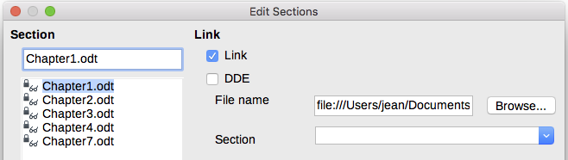
Figure 16: Editing a link in a master document

Cross-referencing between subdocuments
The methods described earlier in this chapter are all most writers will need when using master documents. However, you might want to include automatically updated cross-references between subdocuments. This section describes how to do this.
The process to create cross-references between subdocuments is time consuming, but it works.
- Caution
The method described does not work well if the subdocuments will be used standalone as well as within a master document. As noted on page 18, the cross-reference will show as an error in a standalone document, but it will show correctly in the master document.

Preparing items as targets for cross-referencing
Before you can insert a cross-reference to anything that is not automatically shown on the Cross-references tab of the Fields dialog, such as a heading, you must prepare that heading as an item to be referenced. To do this, you can either use bookmarks or set references.

Using bookmarks
Bookmarks are listed in the Navigator and can be accessed directly from there.
To insert a bookmark:
- Select the text you want to bookmark. Click Insert > Bookmark.
- On the Insert Bookmark dialog, the larger box lists any previously defined bookmarks. Type a name for the new bookmark in the top box. Click Insert.
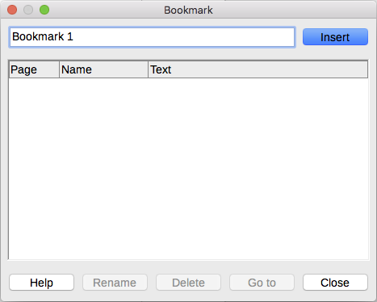
Figure 17: Inserting a bookmark

Setting references
When you set references, be sure to select the entire text you want to use as the reference, such as a heading or figure number. Keep a list of your names for the reference fields, and be sure each name is unique. One way to keep track of this information is to save it in a separate file.
The field names are case-sensitive. You can check the field name by holding the cursor over the referenced item. In our example (Figure 18), the heading has the field name word count.
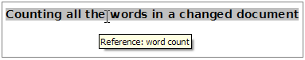
Figure 18: Finding the field name for a heading
Open the subdocument in which you want to set references.
- Click Insert > Cross-reference.
- On the Cross-references page of the Fields dialog (Figure 19), click Set Reference in the Type list. The Selection list now shows any references that have been defined. You can leave this page open while you set many headings as references.
- Click in the document and highlight the text of the first heading to be used as a target for a cross-reference. Click on the Fields dialog. The text of the heading will appear in the Value box in the lower right of the dialog. In the Name box, type some text by which you can identify this heading.
- Click Insert. The text you typed in the Name box now appears in the Selection list.
- Repeat steps 3 and 4 as often as required, keeping a note of your references as needed.
- Repeat for other subdocuments if wanted. Save and close.
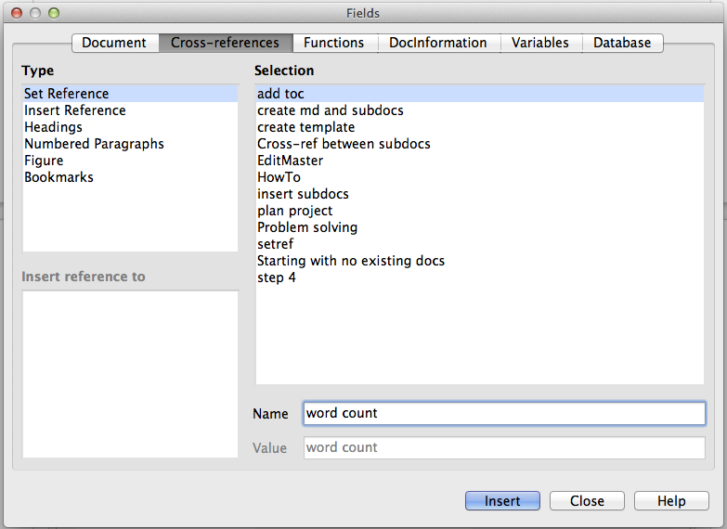
Figure 19: Setting text to be used as a target for a cross-reference

Inserting the cross-references
- Open the master document. In the Navigator, select a subdocument, right-click and choose Edit from the context menu. The subdocument opens for editing.
- In the subdocument, place the cursor where you want the cross-reference to appear. Click Insert > Cross Reference.
- On the Cross-references page of the Fields dialog (Figure 20), select Insert Reference in the Type list on the left. The Selection list on the right shows only the reference field names for the subdocument you are using, so ignore that list and check the list you created manually in “Setting references” above. Select Reference in the Insert reference to list.
- In the Name field in the lower right, type the name of the reference you set in the subdocument you are referring to. In our example, the name of the reference is word count.
- Click Insert, type any text you want to appear between the reference and page number (such as “on page”), and then insert another reference with Page from the Insert reference to list. The cross-references will show an error as shown in Figure 21. When you hover the mouse pointer over one of these fields, you will see the field name.
(You can turn on the display of field codes by clicking View > Field Names. The two error fields shown in Figure 21 now look like Figure 22.)
- After you have inserted all the cross-references required in the subdocument, save and close it and return to the master document window.
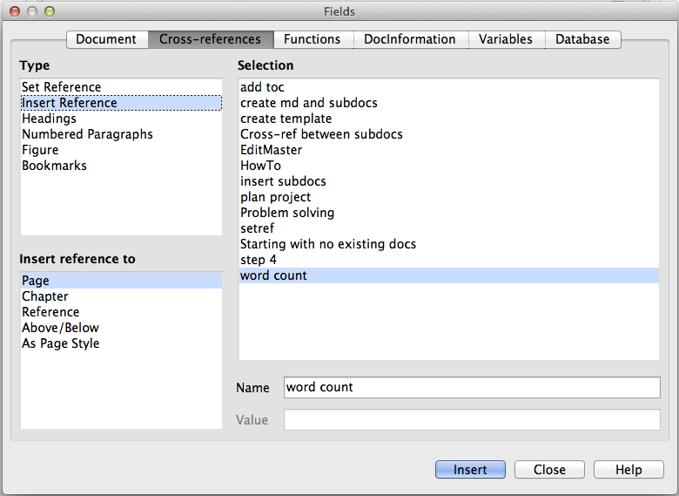
Figure 20: Fields dialog showing manual entry of field name
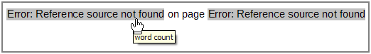
Figure 21: Viewing the field name
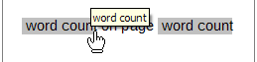
Figure 22: Displaying field codes
Select Tools > Update > Links from the Menu bar, or click Update > Links in the Navigator. All the edits in the master document will now show. Within the master document, navigate to the page of the subdocument on which you inserted the cross-reference field. You should now see the text of the cross-reference appear in the spot where you inserted it. If it does not work, save the master document, close it, and open it again, updating the links.
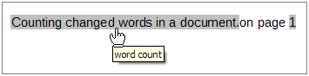
Figure 23: Field contents visible
This technique also works if you open a subdocument directly in step 2 (that is, not from within the master document) and insert a cross-reference field.

Creating a master document template
A master document template is created in much the same way as any other template:
- First, create the master document using File > Send > Create Master Document, as described in earlier sections of this chapter.
- Then, use File > Templates > Save as Template to create the template (.otm), which will then be listed in the Templates dialog along with other templates.
- Tip
Include in the name you give a master document template some indication that it’s not an ordinary template.

Creating one file from a master document and its subdocuments
Master documents are .odm files containing linked subdocuments, which are in .odt format. Although linked files are very useful when writing and editing a large document such as a book, sometimes you might need to have a copy of the entire book in one file, for example when sending it to a publisher.
To export a master document to a .odt file (without affecting the original .odm file):
- Open the master document and update all links. Choose File > Export from the Menu bar.
- On the Export dialog (Figure 24), type a name for the exported .odt file and choose ODF Text Document (.odt) from the File format list (it should be the default choice). Click Export. This step creates from a write-protected .odt file, with each subdocument in a separate section.
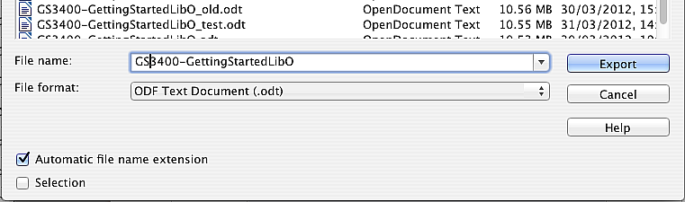
Figure 24: Exporting a master document to an Open Document Text (.odt) file
- Close the master document and open the new .odt file, updating all links.
- To break the links and remove the write protection, go to Format > Sections, select the first item in the Section list, then press Shift+click the last item in the list in order to select all the items in the list. Deselect both Link in the Link section and Protected in the Write protection section.
- Click OK.
- If you wish to eliminate some or all of the sections to have a plain text document, select the sections you wish to remove, and click Remove. The contents of those sections remain in the document; only the section markers are removed. Click OK.

Anchoring images
An image (graphic) anchored “to page” in a subdocument is not displayed in the master document although it always appears correctly in the subdocument.
Because the master document reorganizes the page flow, page numbers, and cross-references when it collates all the subdocuments together, the absolute reference to a page X in a subdocument is lost in the master document. The image loses its anchor reference and simply disappears.
To avoid this problem but keep images positioned precisely on a particular page, anchor the pictures as follows:
- Right-click the image and choose Properties from the context menu.
- On the Type page of the Image dialog (Figure 25), set the anchor to To character or To paragraph.
- Under Position, choose suitable horizontal and vertical references to the page. Click OK to save the changes.
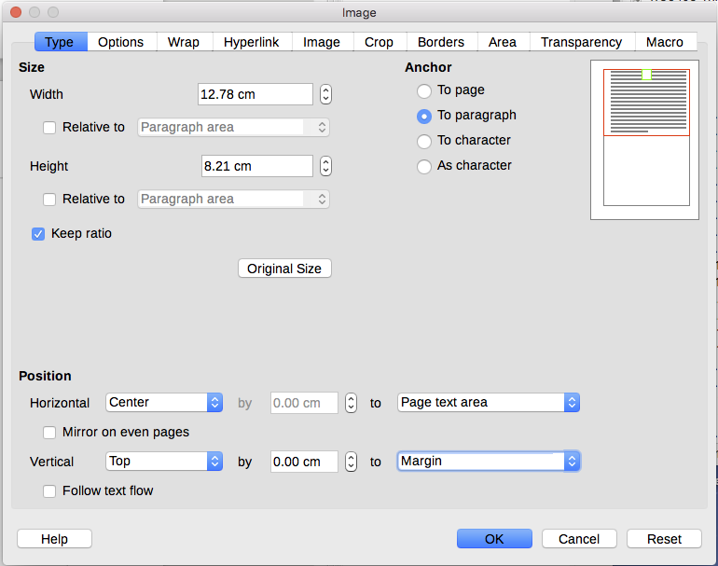
Figure 25: Anchoring a graphic and setting its position on a page

