
Writer 6.0 Guide

Chapter 17
Fields

Copyright
This document is Copyright © 2018 by the LibreOffice Documentation Team. Contributors are listed below. You may distribute it and/or modify it under the terms of either the GNU General Public License (http://www.gnu.org/licenses/gpl.html), version 3 or later, or the Creative Commons Attribution License (http://creativecommons.org/licenses/by/4.0/), version 4.0 or later.
All trademarks within this guide belong to their legitimate owners.

Contributors
Jean Hollis Weber | Bruce Byfield | Gillian Pollack
Barbara Duprey

Acknowledgments
This chapter is updated from previous versions of the LibreOffice Writer Guide. Contributors to earlier versions are:
Jean Hollis Weber | John A Smith | Ron Faile Jr.
Barbara Duprey
An earlier version appeared in the OpenOffice 3.3 Writer Guide. The contributors were:
Agnes Belzunce | John Kane | Gary Schnabl
Barbara M. Tobias | Jean Hollis Weber | Michele Zarri

Feedback
Please direct any comments or suggestions about this document to the Documentation Team’s mailing list: documentation@global.libreoffice.org
- Note
Everything you send to a mailing list, including your email address and any other personal information that is written in the message, is publicly archived and cannot be deleted.

Publication date and software version
Published July 2018. Based on LibreOffice 6.0.

Note for macOS users
Some keystrokes and menu items are different on macOS from those used in Windows and Linux. The table below gives some common substitutions for the instructions in this book. For a more detailed list, see the application Help.
Windows or Linux | macOS equivalent | Effect
Tools > Options menu selection | LibreOffice > Preferences | Access setup options
Right-click | Control+click and/or right-click depending on computer setup | Open a context menu
Ctrl (Control) | ⌘ (Command) | Used with other keys
F5 | Shift+⌘+F5 | Open the Navigator
F11 | ⌘+T | Open the sidebar Styles and Formatting deck

Contents
Copyright 2
Contributors 2
Acknowledgments 2
Feedback 2
Publication date and software version 2
Note for macOS users 2
Introduction to fields 4
Keyboard shortcuts for fields 4
Quick and easy field entry 4
Using document properties to hold metadata and information that changes 4
Using other fields to hold information that changes 6
Using AutoText to insert often-used fields 7
Defining your own numbering sequences 7
Create a number range variable 8
Use AutoText to insert a number range field 9
Using automatic cross-references 10
Inserting cross-references 11
Available formats 11
Preparing items as targets for cross-referencing 12
Using bookmarks 12
Setting references 12
Using fields in headers and footers 13
Developing conditional content 14
Choose the types of conditional content to use 14
Plan your conditional content 15
Choose or define a variable 15
Define a logical expression (condition) involving the variable 15
Create the variable 15
DocInformation fields 15
User-defined variable field 16
Apply the condition to the content 16
Conditional text 17
Hidden text 17
Hidden paragraphs 18
Hidden sections 18
Change the value of the variable 20
Using placeholder fields 20
Using other fields 21

Introduction to fields
Fields are used for a variety of purposes: for example, data that changes (such as the current date or the total number of pages) or might change (the name of a product or book under development), user-defined numbering sequences, automatic cross-references, and conditional content (words or paragraphs that are visible or printed in some conditions but not others). Index entries are also fields.
This chapter describes some common uses of fields. A full discussion of fields and their use is beyond the scope of this book. Power users can find more details in the application Help.
- Tip
Fields have a gray background when viewed on screen, unless you have deselected the Field shadings option or changed the color of field shadings in Tools > Options > LibreOffice > Application Colors. This gray background does not show when you print the file or export to PDF.

Keyboard shortcuts for fields
Here are some handy keyboard shortcuts to use when working with fields:
Ctrl+F2 Open the Fields dialog.
Ctrl+F8 Turn field shadings on or off.
Ctrl+F9 Show or hide field names.
F9 Update fields.

Quick and easy field entry
To quickly insert common fields into your document, choose Insert > Page Number or Insert > Field from the Menu bar and selecting the required field from the list.
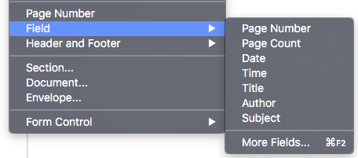
Figure 1: Inserting common fields

Using document properties to hold metadata and information that changes
The Properties dialog (File > Properties) for a document has seven tabs. The information on the General page and the Statistics page is generated by the program. Some information (the name of the person on the Created and Modified lines of the General page) is derived from the User Data page in Tools > Options > LibreOffice. The options on the Font and Security pages are discussed elsewhere in this book. CMIS Properties are outside the scope of this book.
Use the Description and Custom Properties pages to hold:
- Metadata to assist in classifying, sorting, storing, and retrieving documents. Some of this metadata is exported to the closest equivalent in HTML and PDF; some fields have no equivalent and are not exported.
- Information that changes. You can store data for use in fields in your document; for example, the title of the document, contact information for a project participant, or the name of a product might change during the course of a project.
This dialog can be used in a template, where the field names can serve as reminders to writers of information they need to include. (Placeholders can serve a similar function within the text; see page 20.)
You can return to this dialog at any time and change the information you entered. When you do so, all of the references to that information will change wherever they appear in the document. For example, on the Description page (Figure 2) you might need to change the contents of the Title field from the draft title to the production title.
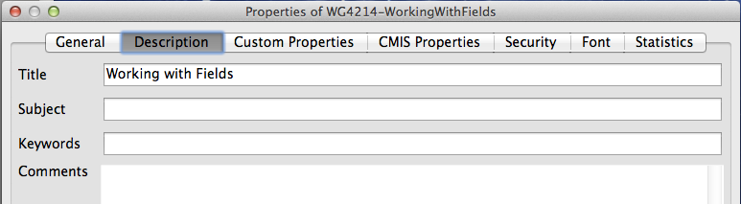
Figure 2: The Description page of the document’s Properties dialog
Use the Custom Properties page (Figure 3) to store information that does not fit into the fields supplied on the other pages of this dialog.
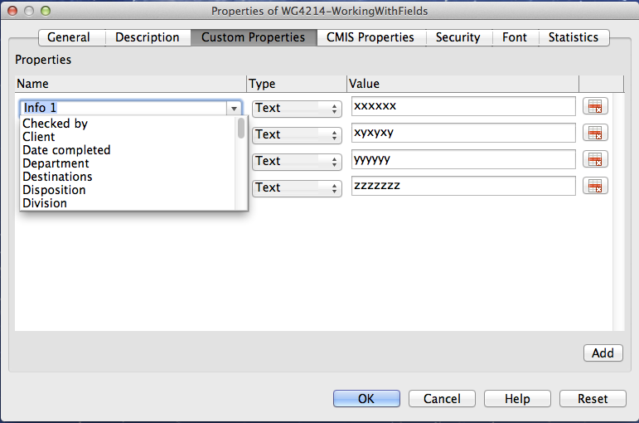
Figure 3: Custom Properties page, showing drop-down lists of names and types
When the Custom Properties page is first opened in a new document, it may be blank. If the new document is based on a template, this page may contain fields.
Click the Add Property button in the lower right of the page (not shown in illustration) to insert a row of boxes where you can enter your custom properties.
- The Name box includes a drop-down list of typical choices; scroll down to see all the choices. If none of the choices meet your needs, you can type a new name into the box.
- In the Type column, you can choose from Text, Date+Time, Date, Duration, Number, or Yes/no for each field. You cannot create new types.
- In the Value column, type or select what you want to appear in the document where this field is used. Choices may be limited to specific data types depending on the selection in the Type column; for example, if the Type selection is Date, the Value for that property is limited to a date.
To remove a custom property, click the button at the end of the row.
- Tip
To change the format of the Date value, go to Tools > Options > Language Settings > Languages and change the Locale setting.

Using other fields to hold information that changes
One way that people use fields is to hold information that is likely to change during the course of a project. For example, the name of a manager, a product, or even your entire company may change. If you have inserted the changeable information as fields, you can change the information in one place, and it will automatically change in all the places where that field occurs.
Writer provides several places where you can store the information referred to by a field. We will look at some of them here.
Seven document properties (Date, Time, Page Number, Page Count, Subject, Title, and Author) are on the Insert > Field menu (Figure 1). To insert one of these fields, click it in the menu. Some of these fields get their information from the Document Properties dialog (Figure 2.)
Other document properties are on the DocInformation and Document pages of the Fields dialog (Figures 4 and 5), reached by choosing Insert > Field > More Fields or pressing Ctrl+F2. The Custom item in the Type list on the DocInformation page is derived from the Custom Properties page of the Document Properties dialog (Figure 3); it does not appear on the list if no custom properties have been defined.
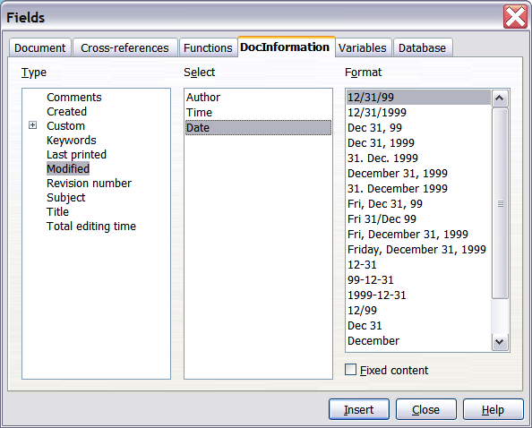
Figure 4: Inserting a Date Modified field using the DocInformation page of the Fields dialog
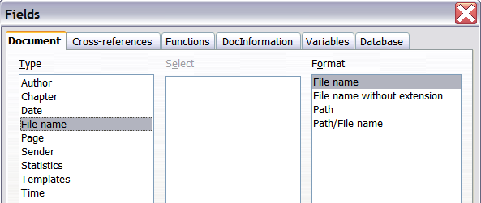
Figure 5: Inserting a File name field using the Document page of the Fields dialog
Some of these items are picked up from the User Data page of the Tools > Options > LibreOffice dialog, so make sure the information on that page is correct.
To insert one of these fields, select it in the Type list and then select from the Select and Format lists if choices appear. Finally, click Insert.
- Tip
Although these fields are often used to hold information that changes, you can make the content unchangeable by selecting the Fixed content option (visible in Figure 4, lower right) when inserting the field. If necessary, you can come back to this dialog later and deselect this option to make the field variable again. For example, if you use a field to insert the creation date of a document, you do not want that date to change.

Using AutoText to insert often-used fields
If you use the same fields often, you can use AutoText as a quick and easy way to insert them. To define an AutoText entry for a field:
- Insert a field into your document, as described previously.
- Select the field you inserted, and then choose Tools > AutoText (or press Ctrl+F3).
- On the AutoText dialog (Figure 6), choose the group where this new entry will be stored (in this example, My AutoText), type a name for the entry, and change the suggested shortcut if you wish.
- Click the AutoText button and click New to have the entry inserted as a field. Do not choose New (text only) because the AutoText entry will be plain text, not a field. (The New selections do not appear until you have selected a group and typed a name for the entry.)
- Click Close to close the AutoText dialog.
When you want to insert this field at the cursor position, type the shortcut and press F3.

Defining your own numbering sequences
You may want to define your own numbering sequences to use in situations where you do not always want the number at the start of the paragraph, or where you want more control than the built-in numbering choices give you, or where list styles don’t do what you want.
This topic describes how to create and use a numbering sequence, using a number range variable field. The example would be better done with a list style, but it illustrates the technique.
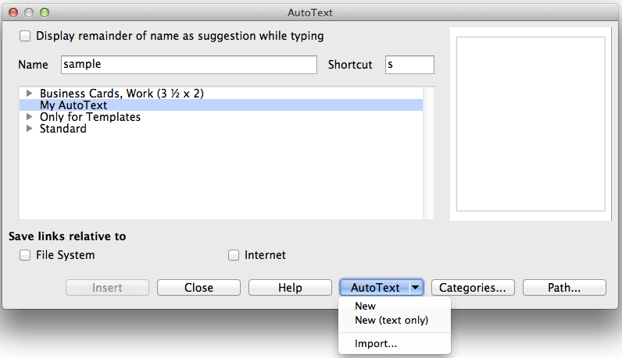
Figure 6: Creating a new AutoText entry

Create a number range variable
To create a number range variable using Arabic (1 2 3) numbers:
- Place the insertion point in a blank paragraph in your document.
- Choose Insert > Field > More Fields or press Ctrl+F2, then select the Variables page (Figure 7).
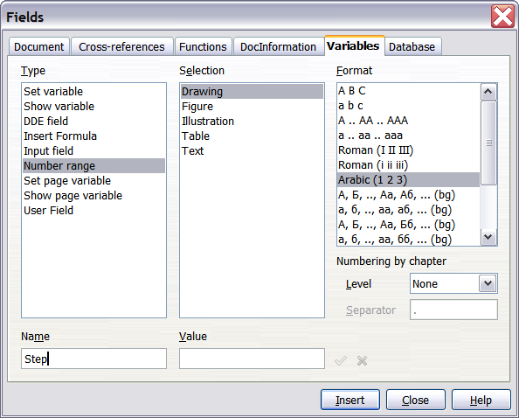
Figure 7: Defining a number range variable
- In the Type list, select Number range. In the Format list, select Arabic (1 2 3). Type whatever you want in the Name field. (We have used Step in this example.)
- Click Insert. The name of the variable (Step) now appears in the Selection list, and a number field (showing 1) appears at the insertion point in your document. The Fields dialog remains open.
- If you click several more times on the Insert button in the Fields dialog, the numbers 2, 3, 4, and so on will appear in the document.
Now you may want to change the Step sequence to a different number, greater or less than the current value, so you can use the same sequence name more than once in your document (for example, to begin each set of instructions). To do that, you need to insert a new field of the same name, while instructing LibreOffice to force the value to the new choice.
- Open the Fields dialog to the Variables page. Make sure the variable name Step appears in the Name box.
- In the Value box, type 1 (we will illustrate a numbering restart here, but any number will work), as shown in Figure 8. Click Insert.
- To continue with the normal sequence (that is, to have the next Step value be 2), you need to delete the contents of the Value box after inserting at step 2.
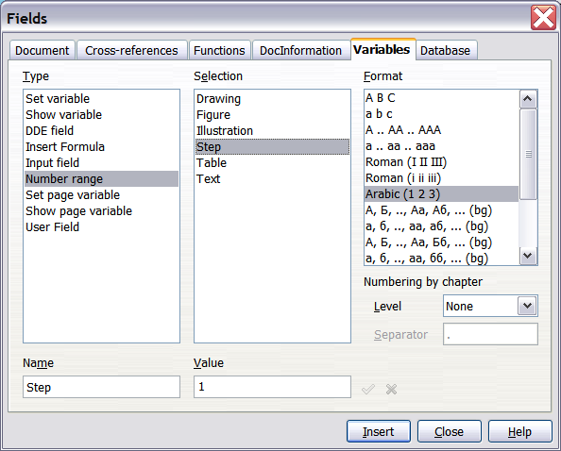
Figure 8: Defining a field to restart a number range variable

Use AutoText to insert a number range field
To avoid doing all of that every time you want to put in a Step number, create two AutoText entries, one for the Step (Value=1) field (call it Step1, for example) and one for the Step = Step+1 field (StepNext). Then insert the fields in the same way you would insert any other AutoText. See “Using AutoText to insert often-used fields” on page 7.
You can create similar fields for substeps or other sequences that you want to be numbered with letters (a, b, c), Roman numerals (i, ii, iii), or some other sequence. In the Fields dialog, choose the required format in the Format list when creating the field codes.
- Tip
If a user-defined variable is not in use in the document, the X icon next to the Value box is active. You can delete the variable by clicking this icon. To remove a variable that is used in the current document, first delete from the document all fields using that variable, and then remove the variable from the list.

Using automatic cross-references
If you type in cross-references to other parts of the document, those references can easily get out of date if you reword a heading, add or remove figures, or reorganize topics. Replace any typed cross-references with automatic ones and, when you update fields, all the references will update automatically to show the current wording or page numbers.
- Tip
Some people use Writer’s Hyperlink feature for cross-references. However, the visible text of the hyperlink does not change if you change the text of the item to which it links. For that reason, you are advised to use cross-references in most situations. The exception is when the document is to be saved as HTML; cross-references do not become hyperlinks in an HTML document, so you need to use hyperlinks in the Writer document.
The Cross-references page of the Fields dialog (Figure 9) lists some items, such as headings, numbered paragraphs, and bookmarks. If figure captions, table captions, user-defined number range variables, and some other items have been defined in a document, that type also appears in the list.
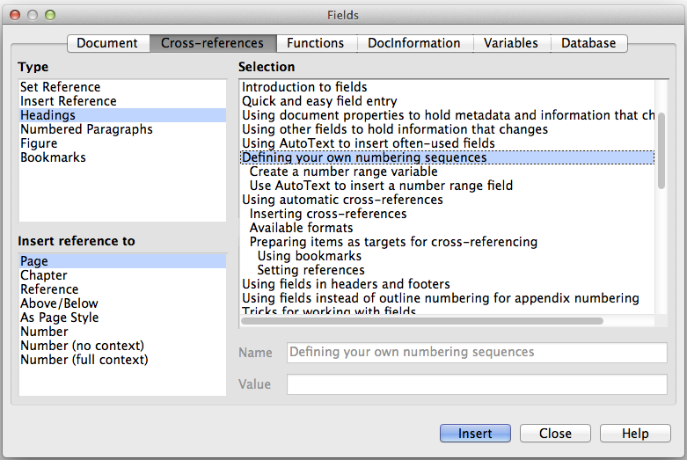
Figure 9: The Cross-references page of the Fields dialog

Inserting cross-references
To insert a cross-reference to a heading, figure, or other item shown on the Cross-references page:
- Place the cursor where you want the cross-reference to appear in the document.
- If the Fields dialog is not open, choose Insert > Cross Reference or press Ctrl+F2. On the Cross-references page (Figure 9), in the Type list, click the type of item you are referencing (for example, Heading or Figure).
- You can leave this page open while you insert many cross-references.
- Click the required item in the Selection list, which shows both automatically created entries (for example Headings) as well as user-defined references (for example bookmarks).
- In the Insert reference to list, choose the type of reference required. The choices vary with the item being referenced.
For headings, usually you will choose Reference (to insert the full text of the heading) or Page (to insert the number of the page the heading is on).
For figures, you will usually choose Category and Number (to insert the word “Figure” and its number), Reference (to insert the word “Figure” with its number and the full text of the caption), Page (to insert the number of the page the figure is on), or Numbering (to insert only the figure number).
- Click Insert.
For a full list of the reference formats available, and their use, consult the Help.

Available formats
For all types of reference, you can select from the following formats:
- Page: the page number of the target.
- Chapter: the number of the chapter where the referenced target is located.
- Reference: the full text set as reference.
- Above/Below: the word above or below depending on the position of the field relative to the referenced target.
- As Page Style: similar to Page, the page number where the reference is, but using the formatting specified in the page style. This is very useful when putting a reference to a page in the front matter where roman numerals are usually employed.
For headings or numbered paragraphs, two additional options are available:
- Number (no context): inserts only the number of the heading or of the numbered paragraph. For example, if referencing a numbered item 2.4, it inserts 4.
- Number (full context): inserts the full number including higher hierarchical levels. For example, if referencing a numbered item 2.4, the full numbering (2.4) is inserted.
For objects inserted with captions such as a table or a figure, you can choose:
- Category and Number: inserts both the category and number of the referenced object (for example, Figure 6). This is the most used formatting for figures and tables.
- Caption Text: inserts the full caption of the referenced object. For example, Figure 6: This is an example figure.
- Numbering: inserts the sequential number of the referenced object, without the category (for example, if referencing Table 2, the field will contain only the number 2).

Preparing items as targets for cross-referencing
Occasionally you might want to insert a cross-reference to something that is not automatically shown on the Cross-references page: an illustration without a caption or an item in a bullet list, for example. Before you can insert a cross-reference to such an item, you must prepare the item as a target to be referenced. To do this, you can either use bookmarks or set references.
After a target has been defined, you can cross-reference to it as described on page 11.

Using bookmarks
Bookmarks are listed in the Navigator and can be accessed directly from there. In HTML documents, bookmarks are converted to anchors that you can jump to using a hyperlink.
- Select the text you want to bookmark, or click in the required place in the text. Choose Insert > Bookmark.
- On the Insert Bookmark dialog, the larger box lists any previously defined bookmarks. Type a name for this bookmark in the top box. Click OK.

Setting references
- Choose Insert > Cross reference or press Ctrl+F2.
- On the Cross-references page of the Fields dialog (Figure 10), select Set Reference in the Type list. The Selection list shows any references that have been defined. This dialog can remain open while you set several items as references.
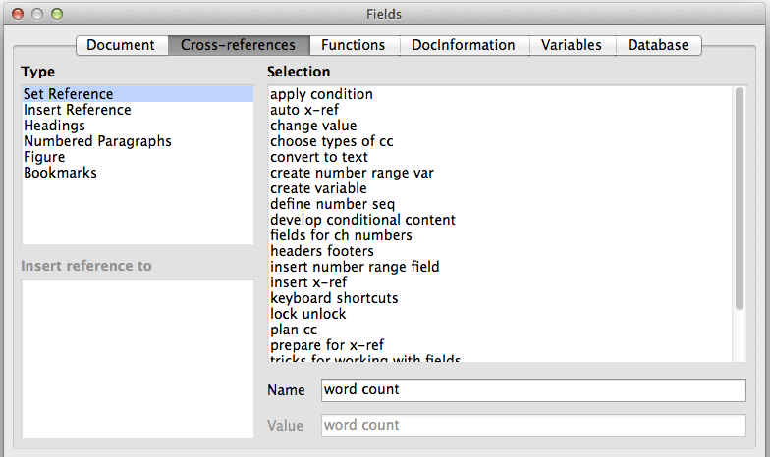
Figure 10: Setting text to be used as a target for a cross-reference
- Click in the document and highlight the text of the first item to set as a target for a cross-reference. Click on the Fields dialog. The text of the item will appear in the Value box in the lower right. In the Name box, type some text by which you can identify this item.
- Click Insert. The text you typed in the Name box now appears in the Selection list.
- Tip
See Chapter 16 for how to create cross-references to other subdocuments in a master document.

Using fields in headers and footers
You may want to use fields like statistics while writing, and replace them with others like Chapter when the document is ready for use.
You can insert fields into headers or footers, using techniques described earlier in this chapter:
- To insert a page number, document title, author, creation date and time, current date and time, or total page count field, use Document Properties (see page 4) or choose Insert > Field > [item] from the Menu bar.
- To insert a cross-reference to a bookmark, heading, or other item, use Insert > Field > More Fields > Cross-references.
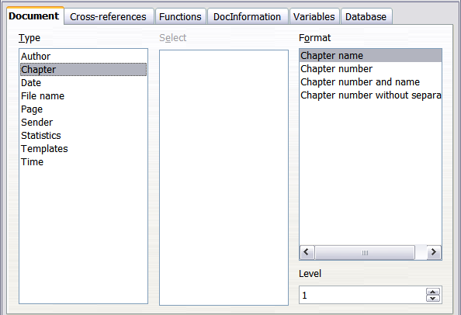
Figure 11: Inserting the current chapter name and number into your document
- If you have used Heading 1 for your chapter titles, you can use a Document field to insert the current chapter title, so the header or footer contents change from one chapter to the next. See Figure 11. (Writer calls chapter titles Chapter names.) If you have used outline numbering on your Heading 1, you can choose whether to include these numbers in the field (Chapter number and name). Use Insert > Field > More Fields > Document.
- You can insert cross-references to other heading levels by specifying a value in the Level box in the lower right of the Document page of the Fields dialog (Figure 11). That is, Level 1 = Heading 1, Level 2 = Heading 2, and so on.
- Note
A cross-reference field in the header of a page picks up the first heading of that level on the page, and a field in the footer picks up the last heading of that level on the page.
- To include the chapter number with the page number, position the cursor just before the Page field you inserted. On the Document page of the Fields dialog, select Chapter in the Type column and Chapter number without separator in the Format column. Click Insert.
Go to the header or footer where you inserted this field and type the character you want to appear between the chapter number and the page number; for example, a period or a dash.
The table of contents will not automatically pick up these chapter numbers, so you need to make a change on the Entries page of the Table of Contents, Index or Bibliography dialog, as described in Chapter 15.
- You can add a page count to the footer; for example, Page 9 of 12. Type the word Page and a space in front of the Page field. Type a space, the word of, and a space after the Page field. Then choose Insert > Field > Page Count.

Developing conditional content
Conditional content is text and graphics that are included or excluded from a document depending on a condition you specify.
A simple example is a reminder letter for an overdue account. The first and second reminders might have a subject line of “Reminder Notice”, but the third reminder letter might have the subject “Final Notice” and a different final paragraph.
A more complex example is a software manual for a product that comes in two versions, Pro and Lite. Both product versions have much in common, but the Pro version includes some features that are not in the Lite version. If you use conditional content, you can maintain one file containing information for both versions and print (or create online help) customized for each version. You do not have to maintain two sets of the information that is the same for both versions, so you will not forget to update both versions when something changes.
- Tip
In some cases, the same effect can be obtained by hiding a paragraph or character style; see Chapter 9, Working with Styles.

Choose the types of conditional content to use
This section describes several Writer features that can help you design and maintain conditional content. You can use one or any combination of these features in the same document.
Conditional text
With conditional text, you can have two alternative texts (a word, phrase, or sentence). One text will be displayed and printed if the condition you specify is met, and the other will be displayed and printed if the condition is not met. You cannot include graphics or edit the text except in the field dialog (not in the body of the document). You also cannot format part of the text (for example, bolding one word but not the others), but you can format the field to affect all of the field contents (for example, bolding all of the words). You cannot include a cross-reference or other field in the text.
Hidden text
With hidden text (a word, phrase, or sentence), you have only two choices: show or hide. If the condition you specify is met, the text is hidden; if the condition is not met, the text is displayed. The disadvantages are the same as for conditional text: you cannot include graphics, edit the text in the body of the document, format part of the text, or include a field.
Hidden paragraphs
Hidden paragraphs are like any other paragraphs, but you can specify a condition under which the paragraph is not displayed or printed. A blank paragraph can also be hidden, for example if a database field has no content for the current record. This is very useful when merging an address into a letter: if you allow two lines for the street address and the database record uses only one line, you can prevent the blank line from appearing in your document. You can include graphics, edit the text in the body of the document, format any part of the text, and include fields.
Hidden sections
Hidden sections are like hidden paragraphs, but they can include more than one paragraph, for example, a heading plus one or more paragraphs. However, a section cannot contain less than a paragraph, so you cannot use this method for single words or phrases. The contents of a hidden section behave just like the contents of any other part of the document, but you can specify a condition under which the section is not displayed or printed. In addition, you can password protect a section.

Plan your conditional content
Conditions are what programmers call logical expressions. You must formulate a logical expression for each condition because a condition is always either true (met) or false (not met). You can use the same condition in many places in your document, for different types of conditional content.
To make conditional content work, you need to:
- Choose or define a variable.
- Define a logical expression (condition) involving the selected variable.

Choose or define a variable
You can use the following variables in your condition:
- User-defined variables.
- Predefined LibreOffice variables, which use statistical values from the document properties.
- User data.
- Database field contents—for example from your address book.
You cannot use internal variables (for example, page number, or chapter name) to formulate conditions.
The examples in this chapter use user-defined variables.

Define a logical expression (condition) involving the variable
The condition compares a specified fixed value with the contents of a variable or database field.
To formulate a condition, use the same elements as you would to create a formula: operators, mathematical and statistical functions, number formats, variables, and constants. The possible operators, and many examples of use, are given in the Help; look in the index under Defining Conditions and conditional. You can define quite complex expressions, but in most cases a simple condition will do the job.

Create the variable
To create the variable, you can use choices found on the DocInformation, Variables, and Database pages of the Fields dialog.

DocInformation fields
“Using document properties to hold metadata and information that changes” on page 4 described how to set up a custom document property. You can use that document property as the variable in your condition statement.

User-defined variable field
To set up a variable or user field:
- Place the cursor where you want the field to be inserted.
- On the Fields dialog, select the Variables page.
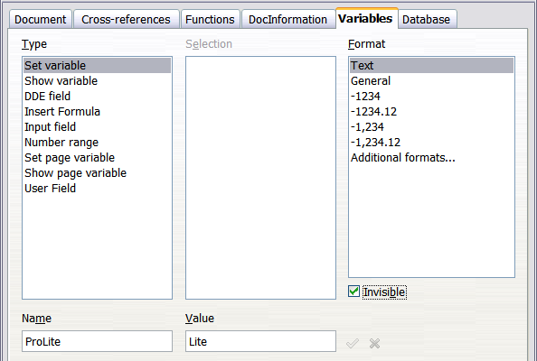
Figure 12: Defining a variable to use with conditional content
- Select Set variable in the Type list and Text in the Format list. Type a name for the variable in the Name box, and a value in the Value box. I have chosen ProLite for the name (to remind me that this variable is related to the two product versions), and I set the value as Lite because I can remember “If it is the Lite version, then this text should be hidden.”
- Select Invisible so the field does not show in the document. Click Insert, then click Close.
- A small gray mark will appear where you inserted the field. We will come back to this later.
- Tip
Because the gray mark is so small, you may have trouble finding it again, especially if you have other fields in the document. You may prefer to leave the variable field visible while you work, and change it to invisible just before you create final copy.
At any time, you can place the insertion point just before the field and choose Edit > Fields or right-click the field and choose Fields on the context menu. On the Edit Fields dialog (Figure 17), select or deselect Invisible.

Apply the condition to the content
Now that you have defined the variable, you can use it in a condition statement. This topic describes some of the possibilities.

Conditional text
First, let us set up some conditional text that will insert the words Great Product Lite into the Lite version and Great Product Pro into the Pro version of the manual. You would use this field whenever you want to mention the name of the product.
- Place the cursor where you want one of these phrases to appear. (You can move or delete it later, if you wish.)
- On the Functions page of the Fields dialog, select Conditional text in the Type list.
- As shown in Figure 13, type ProLite EQ "Lite" in the Condition box, Great Product Lite in the Then box, and Great Product Pro in the Else box.
- Note
These fields are case-sensitive, and quotation marks are required around a text value such as Lite.
- Click Insert to insert the field, then click Close. You should see Great Product Lite in the text.
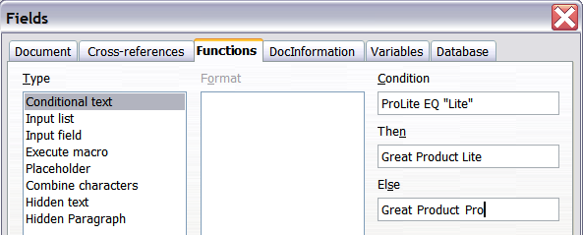
Figure 13: Inserting conditional text
- Tip
If you want to insert this field into your text in many places (as you probably would for a product name), create an AutoText entry for it. See “Using AutoText to insert often-used fields” on page 7 for instructions.

Hidden text
You might use hidden text for words or short phrases that describe features of Great Product Pro that are not found in the Lite version. You can reuse the same field in several places in the document—for example, by copying and pasting it.
To create a hidden text field:
- On the Functions page of the Fields dialog, select Hidden text in the Type list, as shown in Figure 14.
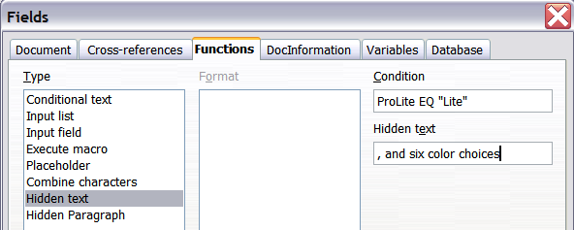
Figure 14: Creating a condition for hidden text
- Type ProLite EQ "Lite" in the Condition box and type the required text in the Hidden text box. Remember, this is the text that is hidden if the condition is true.
- Click Insert to create and insert the field.

Hidden paragraphs
A conditional paragraph is hidden if the condition is true. To hide a paragraph:
- Click in the paragraph to be hidden.
- On the Functions page (Figure 15) of the Fields dialog, select Hidden paragraph in the Type list.
- For this example, type ProLite EQ "Lite" in the Condition box.
- Click Insert to create and insert the field. If an extra paragraph mark appears, delete it.
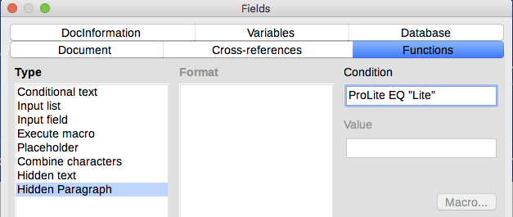
Figure 15: Creating a condition for a a hidden paragraph
To show all hidden paragraphs so you can edit them, do one of the following:
- Choose View > Hidden Paragraphs from the menu bar, so it is checked.
- On the Tools > Options > LibreOffice Writer > Formatting Aids page, select the Fields: Hidden paragraphs option.
- Double-click in front of the variable that you used to define the condition for hiding the paragraph, and enter a different value for the variable.

Hidden sections
A conditional section is hidden if the condition is true. To create a conditional section:
- Select the text that you want to be included in the conditional section. (You can edit this text later, just as you can edit any other text.)
- Choose Insert > Section. On the Insert Section dialog (Figure 16), select the Section tab, then select Hide and enter the condition in the With Condition box. You can also give the section a name, if you wish. This is strongly recommended, so you can find it again easily if you have several sections in your document.
- Click Insert to insert the section into your document.
To show a hidden section so you can edit it:
- Choose Format > Sections.
- On the Edit Sections dialog (similar to the Insert Section dialog), select the section from the list.
- Deselect Hide, and then click OK. You can now edit the contents of the section. Afterwards, you can choose Format > Sections and select Hide to hide the section again.
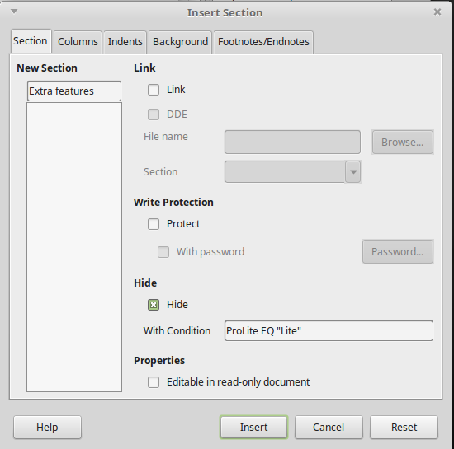
Figure 16: Creating a section to be hidden when a specified condition is met
To make the hidden section a normal part of the document (that is, to remove the section markers, but not the contents of the section):
- Show the hidden section, as described above.
- On the Edit Sections dialog, select the section from the list.
- Click Remove. The contents of the section are now a normal part of the document.

Change the value of the variable
To change the value of the variable between Lite and Pro:
- Find the variable field you created in “Choose or define a variable” on page 15.
- Click once just in front of this field, then right-click and click Fields on the context menu.
- On the Edit Fields dialog (Figure 17), change the value of the variable to Pro.
- If you have set fields to update automatically, all of the conditional and hidden text that uses this variable as a condition will change.
- Tip
Conditional text and hidden text can only be edited in the Edit Fields dialog.
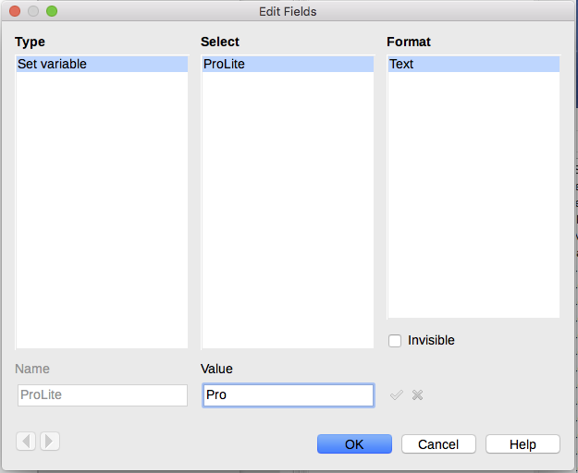
Figure 17: Changing the value of the variable
- Tip
To turn on automatic updating of fields, choose Tools > Options > LibreOffice Writer > General, and select Fields under Update: Automatically. Lite

Using placeholder fields
A placeholder field prompts you to enter something (text, a table, a frame, an image, or an object).
To insert a placeholder field into a document:
- On the Functions page of the Fields dialog, select Placeholder in the Type column and select what the placeholder is for in the Format column.
- In the Placeholder box, type the text that you want to appear in the placeholder field.
- In the Reference box, type the text that you want to display as a help tip when you rest the mouse pointer over the field.
Figure 18 shows the results of inserting a placeholder field for an image.
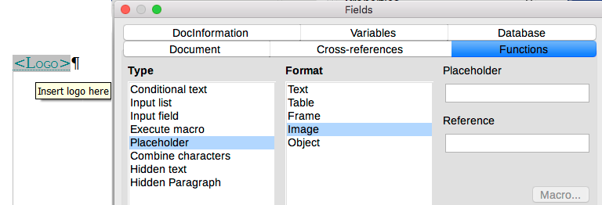
Figure 18: Inserting a placeholder field
Because the <Logo> field is an Image placeholder, when you click the field in the document, the Insert Image dialog opens, prompting you to select an image. When you select an image and click Open, the image replaces the field in the document.
Similarly, clicking on a Table placeholder field opens the Insert Table dialog, clicking on a Frame placeholder field opens the Frame dialog, and clicking on an Object placeholder field opens the Insert OLE Object dialog. The text placeholder field is different: you simply click it and type some text in the Placeholder box, which replaces the field.

Using other fields
Other uses of fields, including database fields, are described in various chapters of this book.
LibreOffice provides many other fields that you may find useful, but they are too specialized to cover in this book. Please refer to the Help system for details, instructions, and examples.

