
Writer 6.0 Guide

Chapter 20
Setting up Writer
Choosing options to suit the way you work

Copyright
This document is Copyright © 2018 by the LibreOffice Documentation Team. Contributors are listed below. You may distribute it and/or modify it under the terms of either the GNU General Public License (http://www.gnu.org/licenses/gpl.html), version 3 or later, or the Creative Commons Attribution License (http://creativecommons.org/licenses/by/4.0/), version 4.0 or later.
All trademarks within this guide belong to their legitimate owners.

Contributors
Jean Hollis Weber | Bruce Byfield | Gillian Pollack
Cathy Crumbley

Acknowledgments
This chapter is updated from previous versions of the LibreOffice Writer Guide. Contributors to earlier versions are:
John A Smith | Jean Hollis Weber | Ron Faile Jr.
John M. Długosz
An earlier version appeared in the OpenOffice 3.3 Writer Guide. The contributors were:
Jean Hollis Weber | Agnes Belzunce | Daniel Carrera
Peter Hillier-Brook | Stefan A. Keel | Gary Schnabl
Janet M. Swisher | Michele Zarri | Jared Kobos

Feedback
Please direct any comments or suggestions about this document to the Documentation Team’s mailing list: documentation@global.libreoffice.org
- Note
Everything you send to a mailing list, including your email address and any other personal information that is written in the message, is publicly archived and cannot be deleted.

Publication date and software version
Published July 2018. Based on LibreOffice 6.0.

Note for macOS users
Some keystrokes and menu items are different on macOS from those used in Windows and Linux. The table below gives some common substitutions for the instructions in this book. For a more detailed list, see the application Help.
Windows or Linux | macOS equivalent | Effect
Tools > Options menu selection | LibreOffice > Preferences | Access setup options
Right-click | Control+click and/or right-click depending on computer setup | Open a context menu
Ctrl (Control) | ⌘ (Command) | Used with other keys
F5 | Shift+⌘+F5 | Open the Navigator
F11 | ⌘+T | Open the sidebar Styles and Formatting deck

Contents
Copyright 2
Contributors 2
Acknowledgments 2
Feedback 2
Publication date and software version 2
Note for macOS users 2
Introduction 4
Choosing options that affect all LibreOffice components 4
User data 4
Memory options 4
View options 4
Print options 5
Paths options 5
Fonts options 5
Security options 6
Application colors 6
Choosing options for loading and saving documents 7
General 7
Microsoft Office 9
HTML compatibility 9
Choosing Writer-specific options 9
General options 9
View options 10
Formatting Aids options 11
Grid options 11
Print options 11
Table options 12
Changes options 13
Comparison options 13
Compatibility options 14
AutoCaption options 15
Mail Merge E-mail options 16
Choosing language settings 16
Install the required dictionaries 16
Change some locale and language settings 17
Sentence checking 17
Choose spelling and grammar options 18
English sentence checking 18

Introduction
This chapter briefly presents some of the setup options found under Tools > Options on the Menu bar. Additional options, and more details about the ones given here, are covered in the Help and in Chapter 2, Setting up LibreOffice, in the Getting Started Guide.
Several of the most relevant options are discussed in other chapters of this book, in the context of tasks where they are most applicable.
- Tip
Many options are intended for power users and programmers. If you don’t understand what an option does, it’s usually best to leave it on the default setting unless instructions in this book recommend changing the setting.

Choosing options that affect all LibreOffice components
This section covers some of the settings that apply to all the components of LibreOffice (Writer, Calc, Impress, Draw, Math, and Base) and that are particularly important when using Writer.
To navigate to options that govern all LibreOffice components, click Tools > Options and then click the marker (+ or triangle) by LibreOffice on the left-hand side. A list of pages drops down. Select an item in the list to display the relevant page on the right-hand side of the dialog.
- Tip
The Reset button (located in the lower right of any page of the Options dialog) resets the values on that page to the values that were in place when you opened the dialog.
If you are using a version of LibreOffice other than US English, some field labels may be different from those shown in the illustrations.

User data
Because Writer can use the name or initials stored in the LibreOffice – User Data page for several things, including document properties (‘created by’ and ‘last edited by’ information), the name of the author of comments and changes, and the sender address in mailing lists, you will want to ensure that the correct information appears here. If you do not want user data to be part of the document’s properties, deselect Use data for document properties.

Memory options
The options on the LibreOffice – Memory page control how LibreOffice uses your computer’s memory and how much memory it requires.
This page includes the option for enabling or disabling the Quickstarter, where this feature is available. It is not available on macOS or on systems where the Quickstarter module has not been installed. For more about Quickstarter, see Chapter 1.

View options
The options on the LibreOffice – View page affect how the document window looks and behaves. Set them to suit your personal preferences. For details, see the Help or Chapter 2, Setting up LibreOffice, in the Getting Started Guide.

Print options
On the LibreOffice – Print page, set the print options to suit your default printer and your most common printing method.
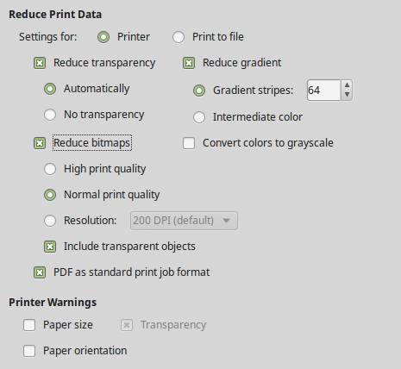
Figure 1: Choosing general printing options to apply to all LibreOffice components
In the Printer warnings section near the bottom of the page, you can choose whether to be warned if the paper size or orientation specified in your document does not match the paper size or orientation available for your printer. Having these warnings turned on can be quite helpful, particularly if you work with documents produced by people in other countries where the standard paper size is different from yours.
- Tip
If your printouts are incorrectly placed on the page or chopped off at the top, bottom, or sides, or the printer is refusing to print, a likely cause is incorrect page size in printer settings.

Paths options
On the LibreOffice – Paths page, you can change the location of files associated with, or used by, LibreOffice to suit your needs. For example, you might want to store documents by default somewhere other than My Documents. Multiple paths are possible.

Fonts options
If you receive a document containing fonts that you do not have on your system, LibreOffice will use substitute fonts for those it does not find. On the LibreOffice – Fonts page, you can specify a font different from the one the program chooses.
- Tip
Liberation fonts (Serif, Sans, and Mono) are often good choices to substitute for Times, Arial, and Courier.
- Note
The Font Options choices do not affect the default fonts for your documents. To change them, you need to create a new default template for Writer documents, as described in Chapter 10, Working with Templates.

Security options
Use the LibreOffice – Security page to choose security options for saving documents and for opening documents that contain macros. For information on the options not mentioned here, refer to the Help or to the Getting Started Guide.
Security options and warnings
If you record changes, save multiple versions, or include hidden information or notes in your documents, and you do not want some recipients to see that information, you can set warnings to remind you to remove it, or you can have LibreOffice remove some of it automatically. Note that unless the information is removed, much of it is retained even when the file has been saved to other formats, including PDF.
Click the Options button to open a separate dialog with several options, including:
Remove personal information on saving
Select this option to always remove user data from the file properties when saving the file. To save personal information with documents and still be able to manually remove personal information only from specific documents, do not select this option.
Ctrl-click required to follow hyperlinks
The default behavior in LibreOffice is that using Ctrl+click a hyperlink opens the linked document or website. This is because many people find writing and editing documents easier when accidental clicks on links do not activate the links. To set LibreOffice to activate hyperlinks using just an ordinary click, deselect this option.

Application colors
Writing, editing, and (especially) page layout are often easier when you can see the page margins (text boundaries), the boundaries of tables and sections, grid lines, and other features. In addition, you might prefer to use colors that are different from LibreOffice’s defaults.
On the LibreOffice – Application colors page (Figure 2), you can specify which user interface elements are visible and the colors used to display them.
- To show or hide items such as text boundaries, select or deselect the boxes in the On column next to the names of the elements.
- To change the default colors for a specific element, click the down-arrow in the Color setting column by the name of the element and select a color from the drop-down list.
- To save your color changes as a color scheme, click Save, type a name in the Scheme box, and then click OK.
- Note
To change the color settings used in Track Changes mode, go to Tools > Options > LibreOffice Writer > Changes.
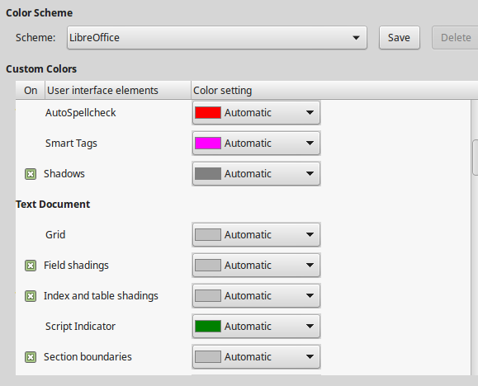
Figure 2: Showing or hiding text, object, and table boundaries

Choosing options for loading and saving documents
You can set the options for loading and saving documents to suit the way you work.
If the Options dialog is not already open, click Tools > Options. Click the expansion symbol (+ or triangle) to the left of Load/Save.

General
Most of the choices on the Load/Save – General page (Figure 3) are familiar to users of other office suites. Some items of interest are described below.
Load user-specific settings with the document
When a LibreOffice document is saved, certain settings from the user's system are saved with it. When the document is opened on another user’s system, it will use the settings saved from the previous user’s system. Deselecting this option causes the current user’s settings to override the settings previously saved with the document.
Even if you deselect this option, some settings are always loaded with the document:
- Settings available in File > Print > Options.
- Name of Fax.
- Spacing options for paragraphs before text tables.
- Information about automatic updating for links, field functions, and charts.
- Information about working with Asian character formats.
- Note
The settings for any data sources linked to a document are always loaded with the document, whether or not Load user-specific settings with the document is selected.
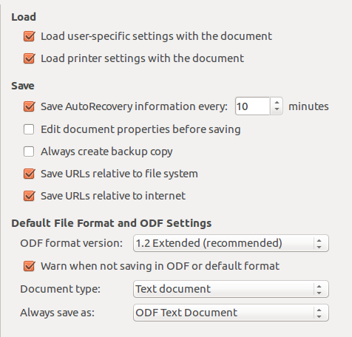
Figure 3: Choosing Load and Save options
Load printer settings with the document
If this option is enabled, the printer settings of the previous user will be loaded with the document. In an office setting, this may cause a document to be printed on a distant network printer unless the printer is manually changed in the Print dialog. If disabled, the current user’s default printer will be used to print the document. The current printer settings will be stored with the document whether or not this option is selected.
Save AutoRecovery information every __ minutes
Choose whether to enable AutoRecovery and how often to save the information used by the AutoRecovery process. AutoRecovery in LibreOffice saves the information needed to restore all open documents in case of a crash. If you have this option set, recovering your document after a system crash will be easier.
Edit document properties before saving
If this option is selected, the document’s Properties dialog pops up to prompt you to enter relevant information the first time you save a new document (or whenever you use Save As).
Always create backup copy
Saves the previously-saved version of a document as a backup copy in a separate folder whenever you save a document. When LibreOffice creates a new backup copy, the previous backup copy is replaced. To see or change the backup folder, go to Tools > Options > LibreOffice > Paths. When opening a backup file, you will be prompted to specify the program to open it with; choose LibreOffice.
- Tip
Authors whose work may be very lengthy should always consider enabling LibreOffice to create an automatic backup copy.
Save URLs relative to file system / to internet
Use these options to select the default for relative addressing of URLs in the file system and on the Internet. For details, see Chapter 2, Setting up LibreOffice, in the Getting Started Guide.
Default file format and ODF settings
ODF format version: LibreOffice by default saves documents in OpenDocument Format (ODF) version 1.2 Extended. You will rarely need to change this for compatibility when exchanging files with other people.
Document type: If you routinely share documents with users of Microsoft Word, you might want to change the Always save as option to one of the Word formats. However, you can choose a Word format when you save any individual file.

Microsoft Office
On the Load/Save – Microsoft Office page, you can choose what to do when importing and exporting Microsoft Office OLE objects (linked or embedded objects or documents such as equations or spreadsheets): convert them into or from the corresponding LibreOffice OLE object or load and save them in their original format.

HTML compatibility
Choices made on the Load/Save – HTML Compatibility page (not shown) affect HTML pages imported into LibreOffice and those exported from LibreOffice. See HTML documents; HTML import and export in the Help, and Chapter 2 in the Getting Started Guide, for more information.

Choosing Writer-specific options
Settings chosen in the LibreOffice Writer section of the Options dialog determine how Writer documents look and behave while you are working on them.
If the Options dialog is not already open, choose Tools > Options. Click the marker (+ or triangle) by LibreOffice Writer on the left side of the dialog.

General options
The choices on the LibreOffice Writer – General page affect the updating of links and fields, the units used for rulers and other measurements, and the default tab stop positions.
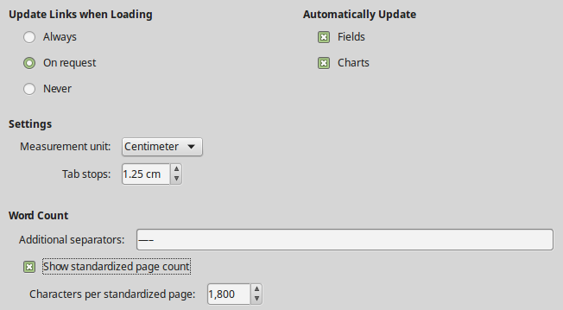
Figure 4: Choosing general options for Writer
Update Links when Loading
Depending on your work patterns, you may not want links to be updated when you load a document. For example, if your file links to other files on a network, you won’t want those links to try to update when you are not connected to the network.
Automatically Update [Fields and Charts]
You may not want fields or charts to update automatically while you are working, because that slows down performance. Alternatively, you may want automatic updates if you are referring to information in the fields or charts.
Settings – Measurement unit
Document designers recommend using points as the default measurement because you can easily relate things like font size to things like indents and tabs.
Settings – Tab stops
The Tab stops setting specifies the distance the cursor travels for each press of the Tab key. This setting is also used for the indent distance applied by the Increase Indent and Decrease Indent buttons on the Formatting Toolbar, which affect the indentation of entire paragraphs.
- Tip
To avoid unwanted changes, do not rely on default tab settings. Rather, define your own tabs in paragraph styles or individual paragraphs (see “Defining your own tab stops and indents” in Chapter 4, Formatting Text).
Word Count – Additional separators
For counting words, specifies the characters that are considered to separate words, in addition to spaces, tabs, line breaks, and paragraph breaks.
Word Count – Show standardized page count
Editors and publishers often define a “standard” page as containing a specified number of characters or words; this field allows quick calculation of the number of these pages.

View options
Two pages of options set the defaults for viewing Writer documents: View (described here) and Formatting Aids (described below).
View is a good page to check if, for example, you cannot see graphics on the screen.
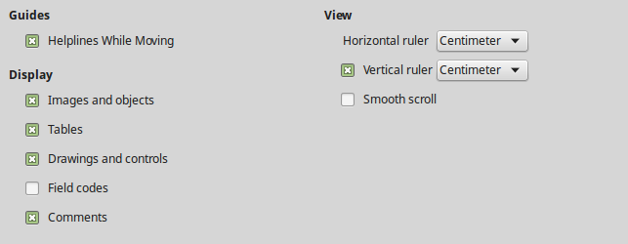
Figure 5: Choosing View options for Writer
Enabling Helplines While Moving helps to precisely position a drawing object on a page. When enabled, horizontal and vertical parallel lines appear that are the height and width of the object. These lines extend across the complete working area as the object is moved.
- Tip
If you have inserted a field but do not see the text or number you expect, uncheck Field codes here. Example: Date (fixed) appears on the screen when Field codes is enabled, while 21/07/17 appears when it is disabled.

Formatting Aids options
On the LibreOffice Writer – Formatting Aids page (Figure 6), select the desired options.
The Display of options determine which symbols show when you select View > Formatting Marks from the Menu bar or the Formatting Marks icon in the Standard toolbar. Symbols such as paragraph ends and tabs can help in writing, editing, and page layout. For example, they can show if there are any blank paragraphs or if any tables or graphics are too wide and intrude into the margins of the page.
- Note
Direct cursor lets you enter text, images, tables, frames, and other objects in any blank area in your document. Writer then inserts blank paragraphs, tabs, spaces and so on to position the text or objects. However, this feature can lead to many formatting oddities and is incompatible with rigorous use of styles, so it should be avoided.
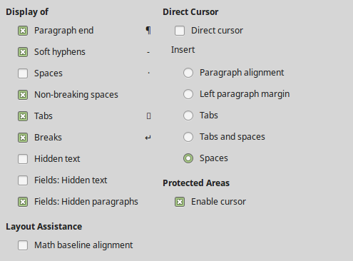
Figure 6: Choosing Formatting Aids options

Grid options
Snap to grid automatically moves an object to the nearest gridlines. This can be very helpful when you are trying to align several objects such as graphics or tables.
On the LibreOffice Writer – Grid page, you can choose whether to enable this feature and what grid intervals to use. If the grid intervals (subdivisions) are too large, you may find that you do not have enough control in placing the objects.

Print options
On the LibreOffice Writer – Print page, you can choose which items are printed with a Writer document by default. These options are in addition to the general options for all LibreOffice components on the LibreOffice – Print page (see page 5).
- Tip
You can override any of these defaults when printing a specific document. Click File > Print, then use the options on the various pages of the Print dialog.
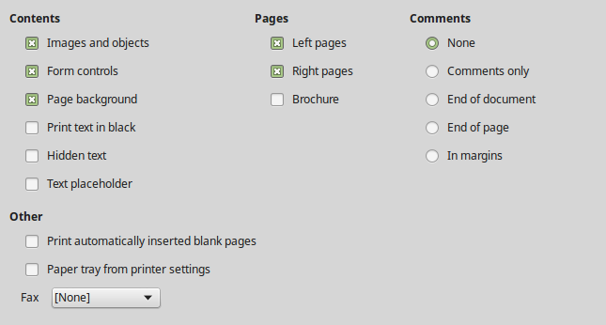
Figure 7: Choosing Print options for Writer
Some considerations:
- When you are working on drafts and you want to save printer ink or toner, you might want to deselect some of the items in the Contents section.
- The Print text in black option causes color text (but not graphics) to print as black on a color printer; on a black-and-white printer, this option causes color text to print as solid black instead of shades of gray (dithered).
- By comparison, the Convert colors to grayscale option on the Options – LibreOffice – Print page (Figure 1), prints all text and graphics as grayscale on color printers. (On black-and-white printers, color in graphics normally prints as grayscale.)
- If you are printing double-sided on a non-duplexing printer, you might choose to print only left or right pages, then turn the stack over and print the other pages.

Table options
On the LibreOffice Writer – Table page (Figure 8), you can specify the default behavior of tables. See the Help or Chapter 13, Tables of Data, for more information.
Some considerations:
- If most of your tables will require borders or headings, you may wish to select those options. If most of your tables are used for page layout, deselect Border and Heading.
- Select Do not split to prevent tables from being split across pages. Number recognition can be very useful if most of your tables contain numerical data. Writer will recognize dates or currency, for example, and format the numbers appropriately. However, if you want the numbers to remain as ordinary text, this feature can be quite irritating, so you may want to deselect it.
- The Keyboard handling section specifies the distances that cells move when you use keyboard shortcuts to move them and the size of rows and columns inserted using keyboard shortcuts. If you don’t use keyboard shortcuts for this purpose, you can ignore these settings. See the Help for more information.
- The Behavior of rows/columns section specifies the effects that changes to rows or columns have on adjacent rows or columns and the entire table. You might need to test these selections to fully understand the effects.
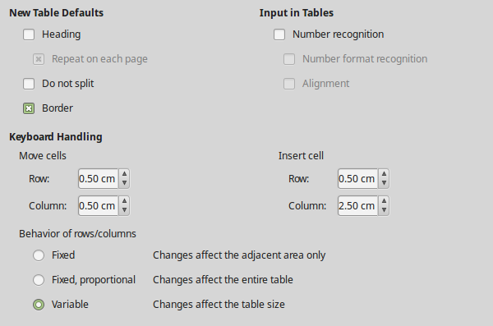
Figure 8: Choosing default Table options

Changes options
If you plan to use the change-tracking feature of Writer (described in Chapter 3, Working with Text: Advanced), use the LibreOffice Writer – Changes page to choose the way changes to text and formatting are marked. Change bars can show wherever a change has been made to a line of text and are formatted under Lines Changed.
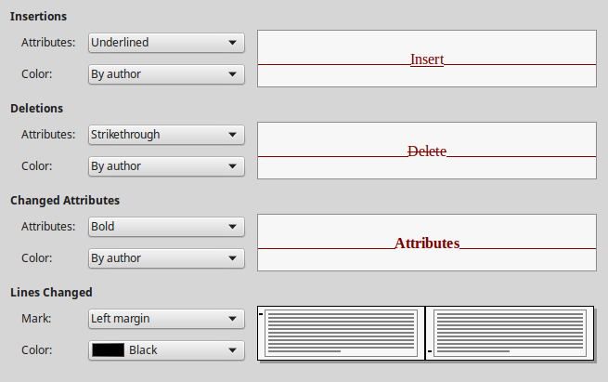
Figure 9: Choosing options for tracking changes

Comparison options
The options on the LibreOffice Writer – Comparison page determine the level of detail used by the Compare Document feature (Edit > Track Changes > Compare Document), described in Chapter 3, Working with Text: Advanced.
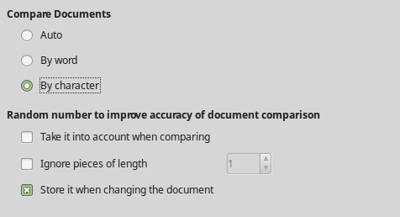
Figure 10: Options for comparing documents

Compatibility options
The settings on the LibreOffice Writer – Compatibility page (Figure 11) are used mainly when importing documents from Microsoft Word. If you are not sure about the effects of these settings, leave them as the defaults provided by LibreOffice. For information about settings that are not described below, see the Help. All settings selected will apply only to the current document, unless you select the Use as Default button at the bottom.
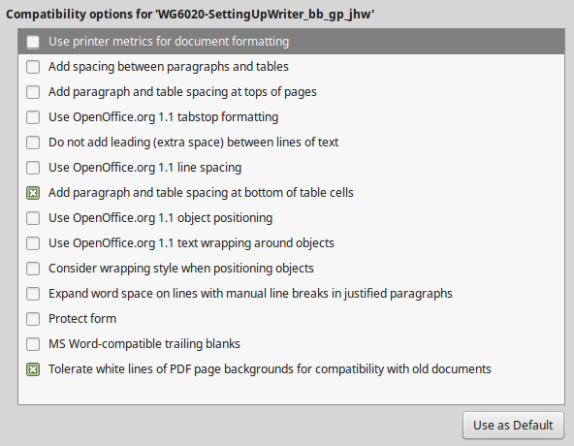
Figure 11: Choosing compatibility options
Use printer metrics for document formatting
If this option is selected, the printer specified for the document determines how the document is formatted for viewing on screen. The line breaks and paragraph breaks you see on screen match those that apply when the document is printed on that printer. If this option is not selected, a printer-independent layout will be used for screen display and printing.
This setting can be useful when several people are reviewing a document that will eventually be printed on a specific printer or when the document is exported to PDF. It is most useful with PostScript printers.
Add spacing between paragraphs and tables (in current document)
Paragraph spacing is treated differently in LibreOffice Writer than it is in Microsoft Word. If you have defined spacing between paragraphs or tables in LibreOffice, this spacing is added to the spacing defined in Microsoft Word.
If this option is selected, Microsoft Word-compatible spacing is added between paragraphs and tables in LibreOffice Writer documents.
Add paragraph and table spacing at tops of pages (in current document)
You can define paragraphs and tables to have space appear before (above) them. If this option is selected, any space above a paragraph will also appear if the paragraph is at the beginning of a page or column, or if the paragraph is positioned on the first page of the document, or after a manual page break.
If you import a Microsoft Word document, the spaces are automatically added during the conversion.
Add paragraph and table spacing at bottom of table cells
Specifies that the bottom spacing is added to a paragraph, even when it is the last paragraph in a table cell.
Use as Default
Click this button to use the settings on this page as the default in Writer.

AutoCaption options
LibreOffice can automatically insert captions for tables, pictures, frames, and OLE objects in a Writer document. To set this up, use the options on the LibreOffice Writer > AutoCaption page. Select the object you want to be automatically captioned (LibreOffice Writer Image in Figure 12). With the item highlighted, specify the characteristics of the caption.
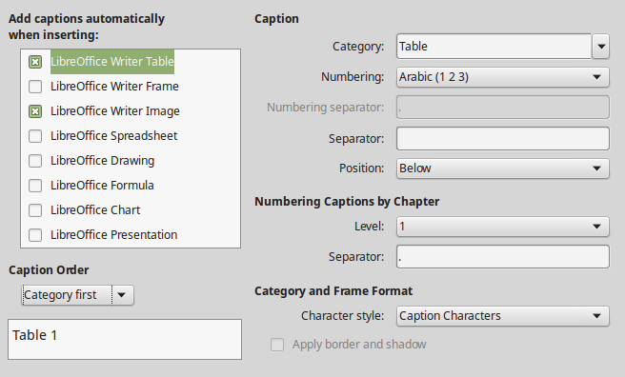
Figure 12: Setting up automatic captions
The categories supplied for captions are Drawing, Illustration, Table, and Text. To use another name (for example, Figure) for the caption label, type the required term in the Category box.
- Note
You may not want captions for every table, for example if you use tables for layout as well as for tables of data. You can always add captions to individual tables, graphics, or other objects (right-click > Insert Caption).
Information about numbering captions by chapter, character styles, frame styles, and other items on the AutoCaption page is given in other chapters in this book.

Mail Merge E-mail options
Using a data source such as an address book, Writer can insert personal, address, and other information into form letters. These documents can be printed for mailing or they can be e-mailed through Writer. (See Chapter 14, Mail Merge, for details.)
Use the LibreOffice Writer – Mail Merge E-mail page to set up the user and server information for sending form letters by e-mail. If you are not sure what information to put in any of the fields, consult your e-mail program or your internet service provider.
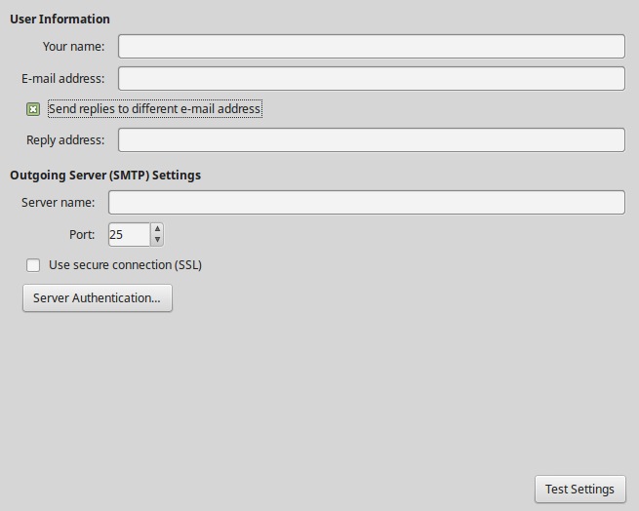
Figure 13: Specifying settings for use when emailing mail-merged form letters

Choosing language settings
You may need to do several things to get the language settings you want:
- Install the required dictionaries.
- Change some locale and language settings.
- Choose spelling and grammar options.

Install the required dictionaries
LibreOffice automatically installs many language modules with the program. A language module can contain up to three submodules: spelling dictionary, hyphenation dictionary, and thesaurus. These are usually referred to as “dictionaries” in Writer.
To add other dictionaries, be sure you are connected to the Internet, and then choose Tools > Language > More Dictionaries Online from the Menu bar. LibreOffice will open your default web browser to a page containing links to additional dictionaries that you can install. Follow the prompts to select and install the ones you want.

Change some locale and language settings
You can change some details of the locale and language settings that LibreOffice uses for all documents or for specific documents. See the Help for details on all these options.
In the Options dialog, click the expansion symbol (+ sign or triangle) by Language Settings and choose Languages.
On the right-hand side of the Language Settings – Languages page (Figure 14), change the settings as required. In the example, English (USA) has been chosen for all the appropriate settings, but you could choose a mixture of languages. For example, if you were working in Germany, you might prefer the user interface to be in English (USA), but German (Germany) for the Locale setting, which influences settings for numbering, currency, and units of measure.
If you want the language setting to apply to the current document only, instead of being the default for all new documents, select For the current document only.
Changes to the system input language/keyboard normally affect text typed into a document after the change. If you do not want this to happen, select Ignore system input language; new text will then continue to follow the language of the document or the paragraph, not the system language.
If necessary, select the options to enable support for Asian languages (Chinese, Japanese, Korean) and support for CTL (complex text layout) languages such as Hindi, Thai, Hebrew, and Arabic. If you choose either of these options, the next time you open the Options dialog, you will see some extra pages under Language Settings. These pages are not discussed here.
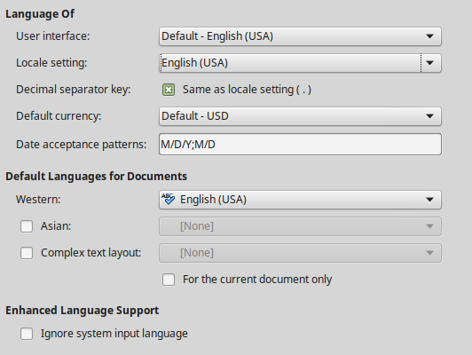
Figure 14: Choosing language options

Sentence checking
LibreOffice can check sentences in many languages. These checkers are enabled by default if the language is the computer’s default language, and others can be added using the Extension Manager (see Chapter 21, Customizing Writer). The set of rules available for the sentence checkers depends on the language.

Choose spelling and grammar options
To change the options for checking spelling and grammar, use the Language Settings > Writing Aids page (Figure 15). Some considerations:
- If you do not want spelling checked while you type, deselect Check spelling as you type. (You can over-ride this setting in a document using Tools > Automatic Spell Checking on the Menu bar or the Auto Spellcheck icon on the Standard toolbar.)
- If you want grammar to be checked as you type, you must have Check spelling as you type enabled too.
- Check special regions means that text in headers, footers, frames, and tables are also checked when checking spelling.
Here you can also select which of the user-defined (custom) dictionaries are active, add a new custom dictionary, edit dictionaries, and delete custom dictionaries. Dictionaries installed by the system cannot be deleted.
- Tip
When checking spelling, words marked “Add to Dictionary” are added by default to the Standard dictionary. Words marked “Ignore All” are added to the IgnoreAllList dictionary. See Chapter 2, Working with Text: Basics.
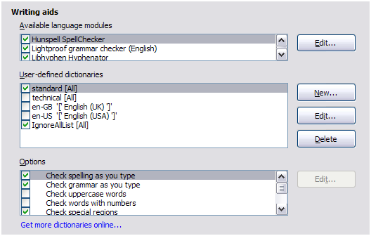
Figure 15: Choosing languages, dictionaries, and options for checking spelling

English sentence checking
On the Language Settings > English sentence checking page, you can choose which items are checked for, reported to you, or converted automatically. This menu is also found in the English dictionaries extension installed by default by LibreOffice (select Tools > Extension Manager, select English spelling dictionaries and click the Options button to reveal the menu). Select which of the optional features you wish to check. These are described in Chapter 2, Working with Text: Basics.
After selecting the additional grammar checks, you must restart LibreOffice, or reload the document, for them to take effect.

