
Writer 6.0 Guide

Chapter 18
Forms

Copyright
This document is Copyright © 2018 by the LibreOffice Documentation Team. Contributors are listed below. You may distribute it and/or modify it under the terms of either the GNU General Public License (http://www.gnu.org/licenses/gpl.html), version 3 or later, or the Creative Commons Attribution License (http://creativecommons.org/licenses/by/4.0/), version 4.0 or later.
All trademarks within this guide belong to their legitimate owners.

Contributors
Jean Hollis Weber | Bruce Byfield | Gillian Pollack

Acknowledgments
This chapter is updated from previous versions of the LibreOffice Writer Guide. Contributors to earlier versions are:
Jean Hollis Weber | John A Smith | Ron Faile Jr.
Barbara Duprey
An earlier version appeared in the OpenOffice 3.3 Writer Guide. The contributors were:
Iain Roberts | Tara Hess | Sigrid Kronenberger
Janet Swisher | Jean Hollis Weber | Claire Wood
Michele Zarri

Feedback
Please direct any comments or suggestions about this document to the Documentation Team’s mailing list: documentation@global.libreoffice.org
- Note
Everything you send to a mailing list, including your email address and any other personal information that is written in the message, is publicly archived and cannot be deleted.

Publication date and software version
Published July 2018. Based on LibreOffice 6.0.

Note for macOS users
Some keystrokes and menu items are different on macOS from those used in Windows and Linux. The table below gives some common substitutions for the instructions in this book. For a more detailed list, see the application Help.
Windows or Linux | macOS equivalent | Effect
Tools > Options menu selection | LibreOffice > Preferences | Access setup options
Right-click | Control+click and/or right-click depending on computer setup | Open a context menu
Ctrl (Control) | ⌘ (Command) | Used with other keys
F5 | Shift+⌘+F5 | Open the Navigator
F11 | ⌘+T | Open the sidebar Styles and Formatting deck

Contents
Copyright 2
Contributors 2
Acknowledgments 2
Feedback 2
Publication date and software version 2
Note for macOS users 2
Introduction 4
When to use forms 4
Alternatives to using forms in Writer 4
Creating a simple form 4
Create a document 5
Open the form toolbars 5
Activate design mode 5
Insert form controls 5
Configure controls 6
Use the form 6
Form controls reference 7
Example: a simple form 10
Create the document 10
Add form controls 10
Configure form controls 11
Finishing touches 13
Accessing data sources 13
Creating a database 14
Registering an existing data source 16
Deregistering a data source 16
Re-registering an existing data source 17
Creating a form for data entry 17
Entering data into a form 18
Advanced form customization 19
Linking a macro to a form control 19
Read-only documents 20
Fine-tuning database access permissions 20
Form control formatting options 21

Introduction
This chapter covers the use of interactive forms within Writer documents. A form has sections that are not to be edited, and other sections that are designed for the reader to make changes. For example, a questionnaire has an introduction and questions (which do not change) and spaces for the reader to enter answers.
Writer provides several ways to enter information into a form, including check boxes, option buttons, text boxes, pull-down lists, and other items, collectively known as form controls.
LibreOffice forms include a lot of features; not everything is described here. Notable omissions are using forms in HTML documents and writing macros to link to form controls.
LibreOffice Calc, Impress, and Draw also support forms in much the same way that Writer does.

When to use forms
Forms are used in three ways:
- To create a simple document for the recipient to complete, such as a questionnaire sent out to a group of people who fill it in and return it.
- To link into a database or data source and allow the user to enter information. Someone in a sales department might enter purchasers’ information into a database using a form.
- To view information held in a database or data source. A librarian might call up information about books.
Using forms to access a database offers a fast and easy way to build complex graphical front ends. Your form can include not only the fields that link to the data source, but also text, graphics, tables, drawings and other elements.
A typical way to use a simple form is:
- You design the form, then save it.
- You send the form to others (for example, by email).
- They fill in the form, save it, and send it back to you.
- You open the form and see what their answers are.
- Tip
By using a data source, or setting a form to update over the web, you can gather data automatically. However, those methods are more complex and are not covered in this book.

Alternatives to using forms in Writer
LibreOffice Base provides an alternative way to access a data source. There are a lot of similarities between forms in Base and Writer, but one may be better for a particular task than the other. Base is appropriate only if the form accesses a data source; you would not use it for simple forms.

Creating a simple form
This section explains how to create a simple form without any links to a data source or database and without advanced customization.

Create a document
There is nothing special to be done when creating a document to use as a form, though it’s a good idea to make sure that the grid is enabled (View > Grid and Helplines) so that controls can be positioned accurately.
Create a new Writer document with File > New > Text document.

Open the form toolbars
Two toolbars control form creation: Form Controls and Form Design. Select View > Toolbars > Form Controls and View > Toolbars > Form Design to show them both. The Form Controls toolbar has an icon for each of the most commonly used types of control.
You can also open the Form Design toolbar from the Form Controls toolbar. Some of the less commonly used controls are on a third toolbar (More Controls) also opened from the Form Controls toolbar.
- Tip
Many of these controls are also located on the Form menu.
You can dock these toolbars in different places on the Writer window, or leave them floating. Figure 1 shows the three toolbars floating. When they are floating, you can also change them from vertical to horizontal and change the number of tools on a row; to make these changes, drag a corner of the toolbar.
See “Form controls reference” on page 7 for descriptions of the tools on these toolbars.
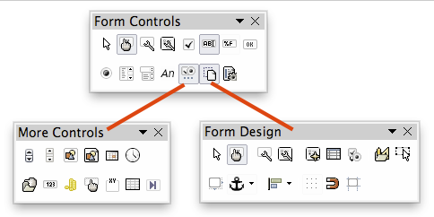
Figure 1: The Form Control, More Controls, and Form Design Toolbars

Activate design mode
Click the Design Mode On/Off icon on the Form Controls toolbar to turn design mode on. (Click it again to turn it off.) This activates or deactivates the icons for inserting form controls and selects controls for editing.
When design mode is off, the form behaves as it would for the end user. Buttons can be pressed, check boxes selected, list items selected, and so on.

Insert form controls
- To insert a form control into the document, click the control’s icon to select it. The mouse pointer changes to look like this:
- Click in the document where you want the control to appear. (You can move it later.)
- Hold the left mouse button down and drag the control to size it. Some controls have a fixed size symbol followed by the name of the control (for example, Check Box or Option Button).
- The control icon remains active, so you can insert several controls of the same type without needing to go back to the toolbar.
- To change to another tool, click its icon on the toolbar.
- To stop inserting controls, click the Select icon on the Form Controls toolbar, or click any of the controls you have just inserted. The mouse pointer changes back to its normal appearance.
- Tip
To make a form control square, hold down the Shift key when creating it. To keep the proportions of an existing control the same, hold down Shift when resizing it.

Configure controls
After inserting the controls, you need to configure them to look and behave as you want. Right-click a form control within the document and select Control from the context menu to open the Properties dialog for the selected control. Double-clicking on a form control also opens this dialog.
The Properties dialog has three pages: General, Data, and Events. For simple forms, only the General page is needed. Use this page to set the look and feel of the control. See “Configure form controls” on page 11 and “Form control formatting options” on page 21 for more information, and the descriptions in the Help for details. Configuration for use with a database is discussed in “Click OK to exit the Registered databases dialog.” on page 17.
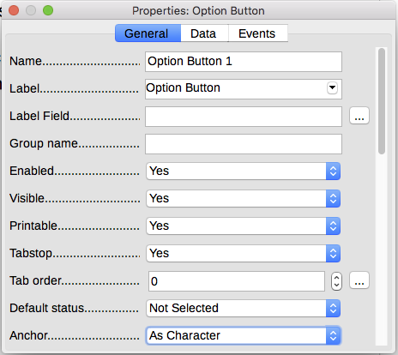
Figure 2: Example of the Properties dialog for a form control
The fields on this dialog vary with the type of control.
To see additional fields, use the scroll bar or enlarge the dialog.

Use the form
To use the form, leave design mode by clicking the Design Mode On/Off icon to deactivate it. Save the form document.

Form controls reference
The icons you see in Writer may differ from the ones shown here.
Form Control toolbar
 | Select | Selects a form control to perform some other action on it.
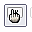 | Design mode on/off | Toggles between design mode on (to edit forms) and design mode off (to use forms).
 | Control | Launches form control properties dialog. This dialog can be kept open as different controls are selected.
 | Form | Launches form properties dialog, controlling properties for the form as a whole, such as which data source it connects to.
 | Check Box | A box that can be selected or deselected on the form. You can label the box.
 | Text Box | A control to create a box into which the form’s user can type any text.
 | Formatted Field | A control allowing numeric formatting options. For example, you can set maximum and minimum values for the number entered, or the number type (decimal places, scientific, currency).
 | Push Button | Creates a button that can be linked to a macro. The label is the name that appears on the button.
 | Option Button | Creates an option button (also known as a radio button). When multiple buttons are grouped together, only one can be selected at a time. The easiest way to group multiple buttons is to use the Group Box icon on the More Controls toolbar, with wizards enabled.
 | List Box | Creates a list of options as a pull-down menu that the user can choose from. If the form is linked to a data source and wizards are on, creating a list box launches the List Box Wizard.  If the form is not linked to a data source, turn wizards off and create an empty list box. Then in the List Entries field on the General tab, enter the options you want to appear on the list.
 | Combo Box | As with a List Box, you set up a list of choices. In addition, a panel at the top either displays the choice made or allows the form user to type in something else. This works the same as the List Box.
 | Label Field | A text label. The difference between this and just typing on the page is that, as a control, you can link a label field to macros so, for example, something happens when the mouse passes over it or clicks on it.
 | More Controls | Launches the More Controls toolbar.
 | Form Design | Launches the Form Design toolbar, which can also be opened with View > Toolbars > Form Design.
 | Wizards On/Off | Some form controls (List Box and Combo Box) have optional wizards. If you do not want the wizard to launch when you create one of these controls, use the Wizards On/Off icon to switch wizards off.
More Controls toolbar
 | Spin Button | Allows form users to choose a number by cycling through the list of numbers. You can specify maximum, minimum, default, and the step between numbers.  This control is not commonly used in Writer.
 | Scrollbar | Creates a scrollbar, with a number of options to define the exact appearance. This control is not commonly used in Writer.
 | Image Button | Behaves exactly like a push button, but displays as an image. Choose the image in the Graphics option on the General tab in the Control Properties dialog.
 | Image Control | Only useful when the form is connected to a data source and a field in the data source exists that can hold images. You can add new images to the database or retrieve and display images from it.
 | Date Field | Stores a date. You need to configure the earliest and latest dates the field will accept, the default date, and the date format. You can add a spinner.
 | Time Field | Works like a date field but specifies a time.
 | File Selection | Allows a user to select a file, either by typing the path and name directly or by clicking on a Browse button and choosing the file from a dialog.
 | Numeric Field | Displays a number. You need to specify formatting, maximum, minimum and default values. You can add a spinner.
 | Currency Field | Works like a numeric field; additionally you can add a currency symbol.
 | Pattern Field | Useful when the form links into a data source. Specify an Edit Mask to restrict what a user can enter into the field. Specify a Literal Mask to restrict which data is displayed from the data source.
 | Group Box | Group boxes have two different uses.  If wizards are on, creating a group box launches the Group Element wizard. This creates a group of options buttons (in which only one may be selected at a time). In most cases, using a group box is the best way to create a set of option buttons.  If wizards are off, a group box is simply a visual box to group together different controls. It has no effect on the way the controls operate.
 | Table Control | Table controls are only useful with a data source. If no data source is specified, you will be prompted to choose one in the Table Element Wizard. You then pick the fields to display and, when design mode is off, the data appears in the table. The table also includes controls to step through the records.  Records can be added, deleted, and modified in the table.
 | Navigation Bar | A navigation bar is the same as the Form Navigation toolbar (View > Toolbars > Form Navigation), but can be placed anywhere in the document and be resized.
Form Design toolbar
 | Select | Selects a form control to perform an action on it.
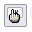 | Design mode on/off | Toggles between design mode on (to edit forms) and design mode off (to use forms).
 | Control | Launches form control properties dialog. This dialog can be kept open whiles different controls are selected.
 | Form | Launches form properties dialog, which controls properties for the form as a whole, such as which data source it connects to.
 | Form Navigator | Displays all the forms and controls in the current document and allows you to edit and delete them easily.  If you use the Form Navigator, give your controls names (in the properties dialog) you can tell which is which in the navigator.
 | Add Field | Useful only if you have specified a data source for the form. Otherwise, an empty box opens.  If you have specified a data source, Add Field opens a list of all the fields in the specified table, which you can then drag and drop onto the page. The fields are placed on the page with the name of the field before them.  This is a quick and easy way to create a form from a data source.
 | Activation Order | Allows you to specify the order in which focus shifts between controls. You can test the order by leaving design mode and using Tab to switch between the controls.
 | Open in Design Mode | Opens the current form in design mode (to edit the form rather than entering data into it).
 | Automatic Control Focus | If activated, focus is set to the first form control.
 | Position and Size | Launches the Position and Size dialog, where you can type precise values, rather than dragging the control. You can also lock the size or position, so they do not get changed accidentally. For some controls, you can rotate and set the slant and corner radius.
 | Change Anchor | Just as with a frame, any form control can be anchored to page, paragraph, or character and also anchored as a character (meaning that it behaves like any other character on the page).
 | Alignment | Disabled unless the control is anchored as a character. You can align a control in different ways, for example so the top of the control lines up with the top of the text or the bottom lines up with the bottom of the text.
 | Display Grid | Displays a grid of dots on the page, to help you line up controls.
 | Snap to Grid | When a control is brought close to a grid point or line, it will snap to the grid. This makes it is easier to line up controls.
 | Guides when Moving | When a control is being moved, lines extend from the control horizontally and vertically to help you position it accurately.

Example: a simple form

Create the document
Open a new document (File > New > Text Document). It is a good idea to sketch the final result to use as a guide when designing the form, although it can easily be changed later.
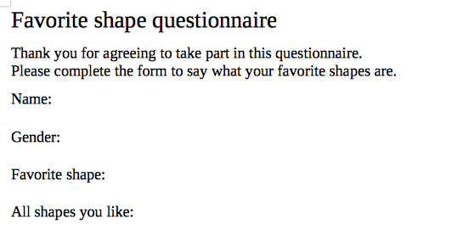
Figure 3: Initial document without form controls

Add form controls
The next step is to add the form controls to the document. We will have four controls:
- Name is a text box.
- Gender is three option buttons: male, female, or other; user can select one.
- Favorite shape is a list of options.
- All shapes you like is a series of check boxes.
To add these controls:
- Select View > Toolbars > Form Controls to open the Form Control toolbar.
- If the tools are not active, click the Design Mode On/Off icon to activate them.
- Click the Text Box icon, then click in the document and drag the shape of the Name text box to approximately the size you want. Drag it to line up with the Name: label.
- Make sure Wizards On/Off is off. Click the Option Button icon. Click and drag to create three option buttons near the Gender: label in the document. We will configure these in the next section.
- Click the List Box icon and draw a list box by Favourite Shape: in the document. This will just be an empty pane for now.
- Click the Check Box icon and create four check boxes by All shapes you like, side by side across the page.
Your document should now look something like Figure 4.
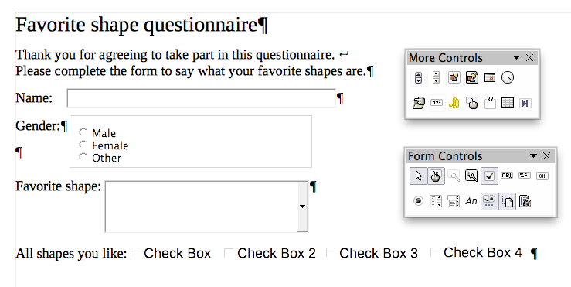
Figure 4: Document with form controls

Configure form controls
No further configuration is required for the Name field.
For the option buttons, do this:
- Be sure design mode is on. Right-click the first option button and click Control on the context menu. In the Properties dialog (Figure 5), on the General tab, type Male in the Label field and Gender in the Group name field.
- Repeat for the other two options, using Female and Other, respectively, for the Label and Gender for the Group name. (Grouping options allows only one to be selected at a time.)
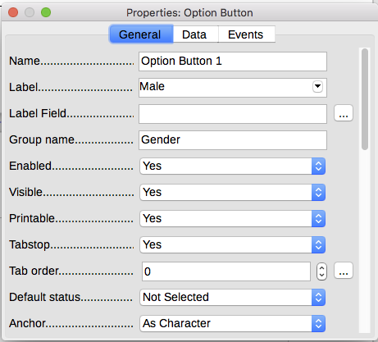
Figure 5: Specifying label and group names for an option button
To add the list of choices to the the list box, do this:
- Be sure Design Mode is on and Wizards are off. Double-click the List Box control to open the control’s Properties dialog (Figure 6). Select the General tab.
- Scroll down to find the List Entries text input box. Type the names of the shapes (Circle, Triangle, Square, Pentagon) one at a time. After each, press Shift+Enter. You should end up with a line saying "Circle";"Triangle";"Square";"Pentagon".
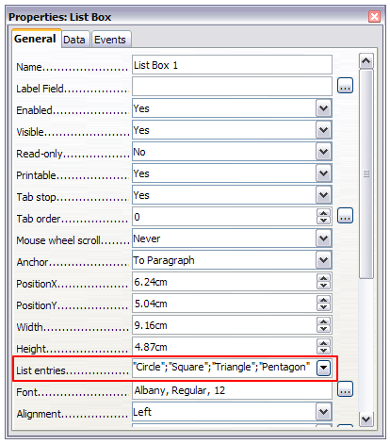
Figure 6: Properties dialog for a list box
To give the check boxes names (instead of Check Box, Check Box 2, and so forth):
- Double-click the first Check Box. The Properties dialog stays open but changes to show the properties for the check box.
- Change the text in the Label field to Circle and press Enter. The cursor moves to the next line, and the label on the check box in the document changes immediately.
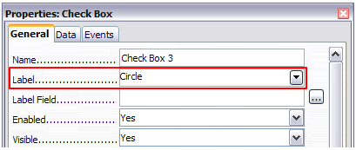
Figure 7: Top part of Properties dialog for a check box
- Click each of the other three check boxes in turn. Change the text in the Label text input box in the Properties dialog to Triangle, Square, and Pentagon in turn.
- Close the Properties dialog.
- Turn design mode off and close the two Controls toolbars.
You have now completed the form, which should look something like Figure 8.
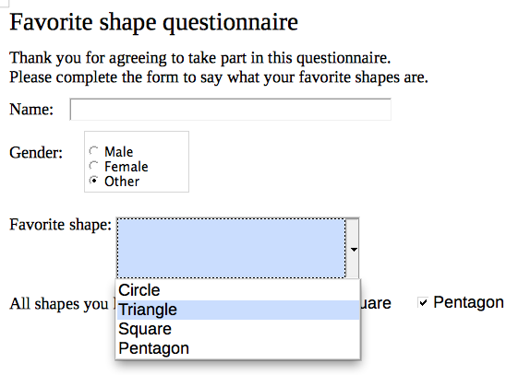
Figure 8: Completed form

Finishing touches
The form is complete, but you are free to make further changes to the document. If you plan to send this out to other people to complete, you probably want to make the document read-only so that users would be able to fill in the form but not make any other changes to the document.
To make the document read-only, select File > Properties, select the Security tab and enable Open file read-only.
- Note
If the document is read-only, anyone filling in the form will need to use File > Save as to save the document.

Accessing data sources
The most common use for a form is to input information into a database. For example, you can design a form that others can use to enter information into a contacts database. Because it is part of a Writer document, the form can contain graphics, formatting, tables, and other elements to make it look just the way you want. Modifying the form is as simple as editing a document.
LibreOffice can access numerous data sources. These include ODBC, MySQL, Oracle JDBC, spreadsheets and text files. As a general rule, databases can be accessed for reading and writing; other data sources (such as spreadsheets) are read-only.
- Tip
To see the list of supported data source types for your operating system, choose File > New > Database. On the first page of the Database Wizard (Figure 9), select Connect to an existing database and then open the drop-down list.

Creating a database
Chapter 8, Getting Started with Base, in the Getting Started Guide covers in more detail how to create a database. Below is a short guide to creating a very simple database.
- Select File > New > Database to start the Database Wizard.
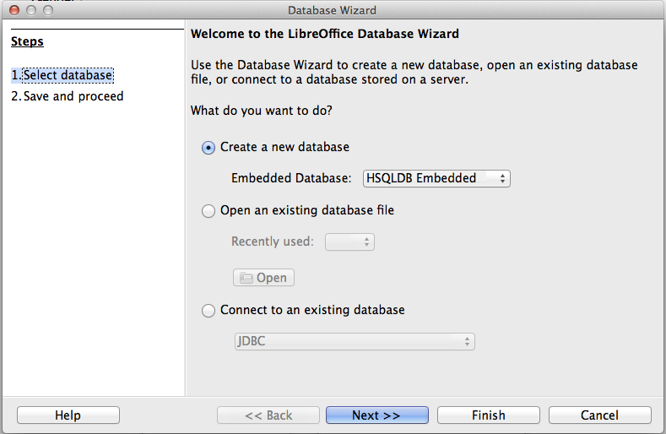
Figure 9: Database Wizard
- Select Create a new database and click Next >>.
- On the next page, select Yes, register the database for me and Open the database for editing. Registering the database means that it can be accessed from other LibreOffice components such as Writer and Calc. You need to do this if you want to link forms to it.
- Click Finish and save your new database, giving it a name. Unlike other documents in LibreOffice, databases must be saved when you first create them.
After saving the database, you should see the main Base window (Figure 10), which contains three panels. The left-hand panel is Database, with icons for Tables, Queries, Forms and Reports.
The next step is to create a table:
- Choose Tables in the left-hand column, then choose Create Table in Design View under Tasks.
- Use the Table Design window to tell Base which fields to create. We will have three input data fields: Name, Address, and Telephone.
- On the first line, enter under Field Name, ID, and set the Field Type to Integer [INTEGER]. In the box at the left of the line, right-click and select Primary Key, bringing up a key icon in the box. In the Field Properties at the bottom of the window is an Auto Value option; change this to Yes. Optionally, type Primary key in the Description column. See Figure 11.
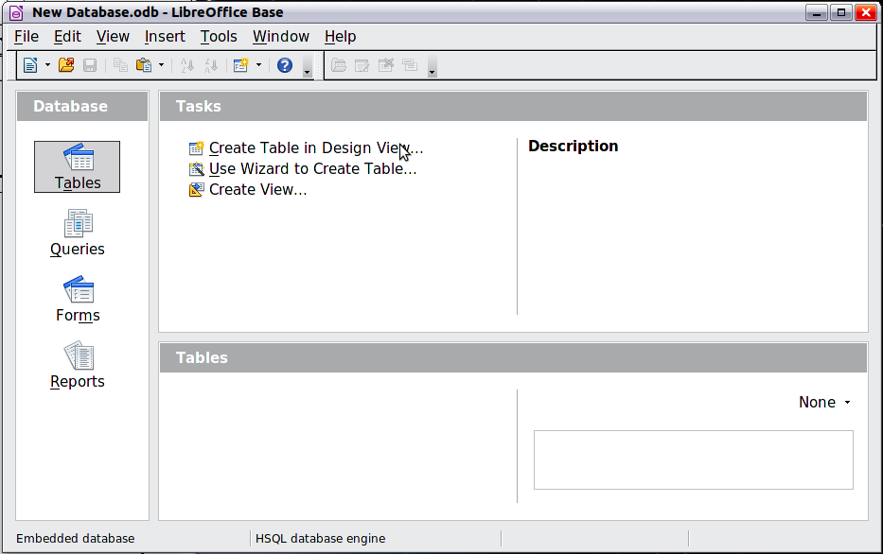
Figure 10: Main Base window
- Caution
Setting up the Primary Key field with Auto Value set to Yes is a critical step. If this is not done, the form you create later will be much trickier to use and may generate errors for the user. It could even prevent the user from saving the records in the form. Make sure you get this step right!
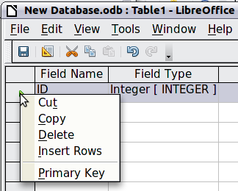
Figure 11: Setting a primary key
- On the next three lines, enter under Field Name Name, Address and Telephone. Accept the default Field Type of Text [VARCHAR] and leave Description blank.
- Save the table (File > Save). You will be prompted to name it. The name can be anything you like. Click OK.
- Finally, close the table design window to return to the main Base window. If File > Save is available, select it to save the whole database.
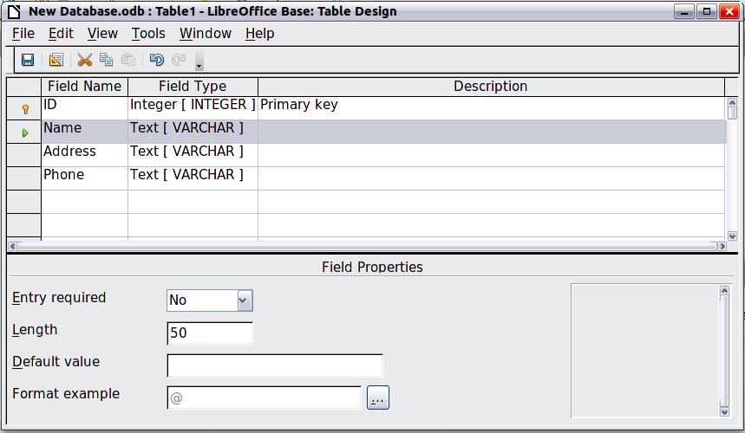
Figure 12: Database table design

Registering an existing data source
If you have an existing data source, such as a spreadsheet or database, you need to register it with LibreOffice. An example of registering a spreadsheet as a data source is given in Chapter 14, Mail Merge. To summarize:
- Select File > New > Database to launch the Database Wizard.
- Select Connect to an existing database and choose the type from the drop-down list.
- Click Next >> and follow the instructions to select the database to register. The exact process varies between different types of data source.
- In Step 3: Save and proceed, ensure that Yes, register the database for me is selected. Deselect Open the database for editing; you just need to register it, not edit it through Base.

Deregistering a data source
To remove a registered data source from LibreOffice so that it is no longer available for use, as for example an obsolete address list, do the following:
- Open the Data sources window (by selecting View > Data Sources from the Menu bar, or by pressing F4, or by selecting the Data Sources icon on the Standard toolbar).
- In the left pane, the Data source explorer, right-click a data source.
- Select Registered databases from the context menu.
- In the Registered databases dialog, select the data source to be removed.
- Click Delete, then click Yes in the confirmation box which opens.
- Repeat steps 4) and 5) as required.
- Click OK to close the Registered databases dialog.
This does not delete the database from your system. It can be registered again using the methods outlined below.

Re-registering an existing data source
To re-register an existing database file (.odt) of addresses, do the following:
- Open the Data sources window.
- In the left pane, the Data source explorer, right-click a data source.
- Select Registered databases from the context menu.
- In the Registered databases dialog, click the New button.
- In the Create Database Link dialog, click the Browse button, and navigate to the database file location and select it. Click Open to return to the Create Database Link dialog.
- Change the Registered name if required.
- Click OK to exit this dialog.
- Click OK to exit the Registered databases dialog.

Creating a form for data entry
Once a database is registered with LibreOffice, follow these steps to link a form to the data source:
- Create a new document in Writer (File > New > Text Document).
- Design your form, without putting in the actual fields (you can always change it later).
- Show the Form Controls toolbar (View > Toolbars > Form Controls).
- Click the Design Mode On/Off icon to put the document into design mode, if necessary. With design mode off, most of the toolbar buttons are grayed out. If the Design Mode icon is also grayed out, click the Select icon to activate it.
- Click the Text Box icon. Click in the document and drag to create a text box for the first form field (for example, Name, if you are linking to the database created above).
- Click the Text Box icon again and drag the mouse to draw another field. Additional fields, of any type, can be added in the same way (click and drag).
So far you have followed the same steps used before when creating your first form. To link the form with the data source you registered:
- Click the Form icon in the Form Controls toolbar, or right-click any of the fields you inserted and select Form, to open the Form Properties dialog (Figure 13).
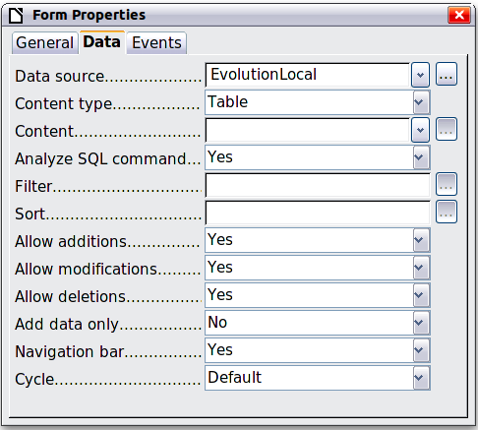
Figure 13: Form properties, connecting to a data source
- In the Form Properties dialog, choose the Data tab.
- Set Data Source to be the data source you registered.
- Set Content Type to be Table.
- Set Content to be the name of the table you want to access.
- Close the dialog.
- For each form control in turn, click the control to select it (small green boxes appear around it), then launch the Properties dialog: either right-click and select Control or click the Control icon on the Form Controls toolbar.
- In the Properties dialog, click the Data tab (Figure 14). If you set up the form correctly, the Data Field option will contain a list of the different fields in the data source (for example, Name, Address and Telephone). Select the field you want.
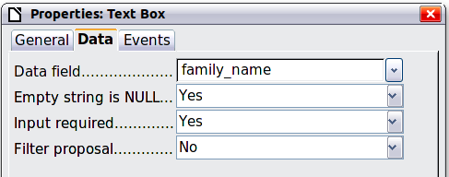
Figure 14: Form control properties, Data tab
- Repeat for each control in turn until every control that should be assigned to a field has been assigned.
- Caution
If you created a database in LibreOffice Base and your Primary Key field had Auto Value set to Yes, that field does not need to be part of the form. If Auto Value was set to No, you will have to include it and have your users enter a unique value into that field whenever they make a new entry—not something that is recommended.

Entering data into a form
Once you have created a form and tied it to a database, use it to enter data into the database or modify data already there:
- Make sure that the form is not in design mode. (In the Form Controls toolbar, click the Design Mode On/Off icon. If design mode is off, most of the buttons on the toolbar will be grayed out.)
- Make sure that the Form Navigation toolbar is on (View > Toolbars > Form Navigation). This toolbar normally appears at the bottom of the workspace.
Figure 15: Form Navigation toolbar
- If there is existing data in the data source, use the control buttons on the Form Navigation toolbar to look at different records. To amend data in a record, edit the values in the form. To submit the changes, press Enter with the cursor in the last field. The record is saved and the next record is displayed.
- If there is no data in the form, enter information by typing into the fields of the form. To submit the new record, press Enter with the cursor in the last field.
- Other functions can be performed from the Form Navigation toolbar, including deleting a record and adding a new record.
- Note
If a user tries to fill in the form and receives the error “Attempt to insert null into a non-nullable column”, then the form designer should go back to the database and confirm that the Primary Key field has the Auto Value set to Yes. This error will prevent the form user from saving the records.

Advanced form customization

Linking a macro to a form control
You can set any form control (for example, text box or button) to perform an action when triggered by some event.
To assign a macro to an event:
- Create the macro. See Chapter 13, Getting Started with Macros, in the Getting Started Guide.
- Be sure the form is in design mode. Right-click the form control, select Control and click the Events tab (Figure 16).
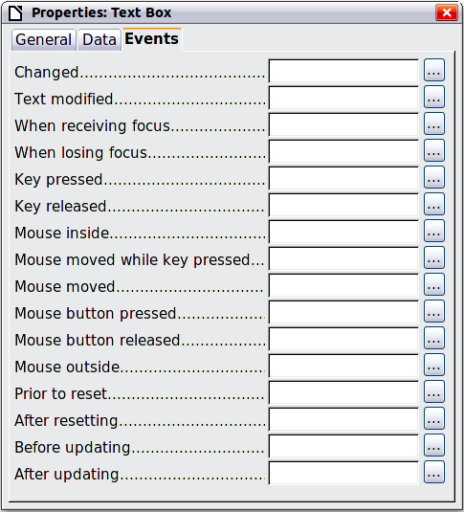
Figure 16: Control properties, Events tab
- Click the browse icon by any event to open the Assign action dialog (Figure 17).
- Click the Macro button and select the macro from the list in the Macro Selector dialog (not shown). You return to the Assign action dialog. Repeat as needed, then click OK to close the dialog.
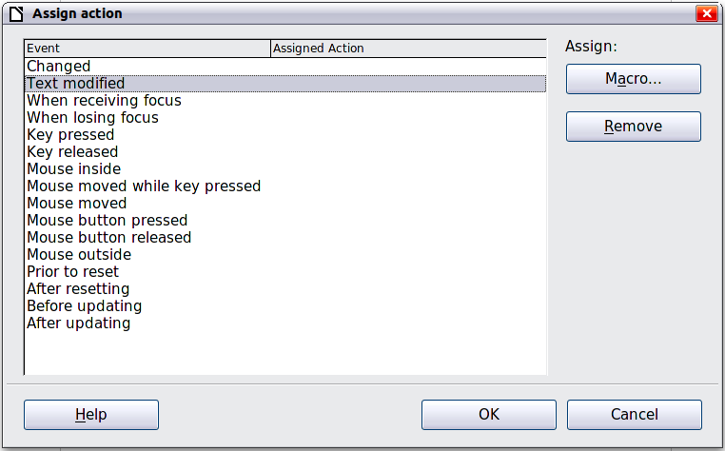
Figure 17: Assign action dialog
Macros can also be assigned to events relating to the form as a whole. To do this, right-click a form control in the document, select Form and click the Events tab.

Read-only documents
Having created your form, you want whoever is using it to be able to access the information stored in the database, or complete the form, without changing the layout. To do this, make the document read-only by choosing File > Properties > Security and selecting Open file read-only.

Fine-tuning database access permissions
By default, when a database is accessed from a form, any changes can be made to it: records can be added, deleted, and amended. You may not want that behavior. For example, you may want users to be able only to add new records or to be prohibited from deleting existing records.
In design mode, right-click a form control and select Form from the context menu. On the Data tab of the Form Properties dialog are a number of options: Allow additions, Allow deletions, Allow modifications and Add data only. Set each of these to Yes or No to control the access users have to the data source.
Individual fields can also be protected. This might be useful if you wanted a user to be able to modify some parts of a record but only view others, such as a stock list where item descriptions are fixed and quantities can be modified.
To make an individual field read-only, in design mode, right-click the form control within the document and select Control from the context menu. Select the General tab (Figure 18) and set Read-only to Yes.
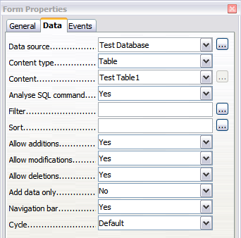
Figure 18: Data Properties of a form

Form control formatting options
You can customize the way form controls look and behave in a number of ways. These are all accessed in design mode. Right-click the form control, select Control from the context menu and select the General tab in the Properties dialog.
- Set a label for the control in the Label box (not to be confused with the box called Label Field). Some form controls, such as push buttons and option buttons, have visible labels that can be set. Others, such as text boxes, do not.
- Set whether the form control will print out if the document is printed with the Print option.
- Use the Font setting to set the font, typeface, and size for a field’s label or for text typed into a field. This setting does not affect the size of check boxes or option buttons.
- For a text box, you can set the maximum text length. This is very useful when adding records into a database. Every database text field has a maximum length and, if the data entered is too long, LibreOffice displays an error message. By setting the maximum text length of the form control to be the same as that of the database field, this error can be avoided.
- You can set the default option for a form control. By default, a control is blank, or has every option unselected. You can set the control to start with a particular option or list item selected.
- For controls where a password is being entered, setting the Password character (for example to *) displays only that character, but saves what the user really types.
- You can add additional information and help text for a form control.
- You can use other formatting controls such as background color, 3-D look, text formatting, scroll bars, and borders to further define how the control appears.

