
Writer 6.0 Guide

Chapter 21
Customizing Writer

Copyright
This document is Copyright © 2018 by the LibreOffice Documentation Team. Contributors are listed below. You may distribute it and/or modify it under the terms of either the GNU General Public License (http://www.gnu.org/licenses/gpl.html), version 3 or later, or the Creative Commons Attribution License (http://creativecommons.org/licenses/by/4.0/), version 4.0 or later.
All trademarks within this guide belong to their legitimate owners.

Contributors
Jean Hollis Weber | Bruce Byfield | Gillian Pollack

Acknowledgments
This chapter is updated from previous versions of the LibreOffice Writer Guide. Contributors to earlier versions are:
Jean Hollis Weber | John A Smith | Ron Faile Jr.
Barbara Duprey | Rafael Atias
An earlier version appeared in the OpenOffice 3.3 Writer Guide. The contributors were:
Jean Hollis Weber | Peter Hillier-Brook | Michele Zarri
Barbara M. Tobias

Feedback
Please direct any comments or suggestions about this document to the Documentation Team’s mailing list: documentation@global.libreoffice.org
- Note
Everything you send to a mailing list, including your email address and any other personal information that is written in the message, is publicly archived and cannot be deleted.

Publication date and software version
Published July 2018. Based on LibreOffice 6.0.

Note for macOS users
Some keystrokes and menu items are different on macOS from those used in Windows and Linux. The table below gives some common substitutions for the instructions in this book. For a more detailed list, see the application Help.
Windows or Linux | macOS equivalent | Effect
Tools > Options menu selection | LibreOffice > Preferences | Access setup options
Right-click | Control+click and/or right-click depending on computer setup | Open a context menu
Ctrl (Control) | ⌘ (Command) | Used with other keys
F5 | Shift+⌘+F5 | Open the Navigator
F11 | ⌘+T | Open the sidebar Styles and Formatting deck

Contents
Copyright 2
Contributors 2
Acknowledgments 2
Feedback 2
Publication date and software version 2
Note for macOS users 2
Introduction 4
Customizing menu content 4
Creating a new menu 5
Customizing toolbars 6
Choosing icons for toolbar commands 6
Assigning shortcut keys 7
Saving changes to a file 8
Loading a saved keyboard configuration 8
Assigning macros to events 8
Adding functionality with extensions 8
Installing extensions 9
Adding custom colors 10
Adding fonts 11
Finding free-licensed fonts 11

Introduction
This chapter describes some common customizations that you may wish to do, in addition to the options described in Chapter 20, Setting up Writer.
You can customize menus, toolbars, and keyboard shortcuts in LibreOffice, add new menus and toolbars, and assign macros to events.
Other customizations are made easy by extensions that you can install from the LibreOffice website or from other providers.
- Note
Customizations to menus and toolbars can be saved in a template. To do so, first save them in a document and then save the document as a template as described in Chapter 10, Working with Templates. If you work on more than one project, you may find that having different menus and toolbars can be useful.

Customizing menu content
You can add to and rearrange menus on the Menu bar, add commands to menus, and make other changes. You can also modify context (right-click) menus in a similar way.
To customize menus:
- Choose Tools > Customize.
- On the Customize dialog, go to the Menus page (Figure 1) or the Context Menus page.
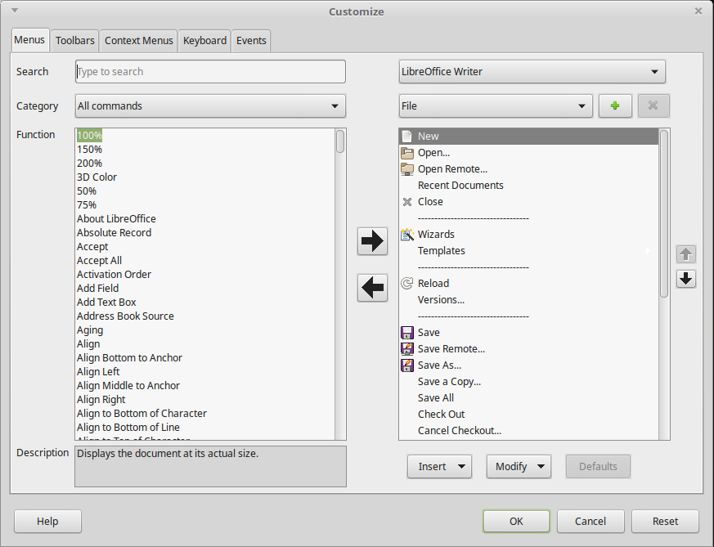
Figure 1: The Menus page of the Customize dialog
A
B
C
D
E
F
G
- On the right-hand side, select from the first drop-down list (A in the illustration) whether to apply the customized menu to all of LibreOffice Writer or only to a specific document.
- Select from the next drop-down list (B) the menu that you want to customize. The list includes the main menus and submenus. The commands contained in the selected menu are shown in the box (C) below.
- To add a command to the selected menu:
- Optionally select a command in box C under which the new item will be placed.
- Optionally filter the Function list by selecting a category (D) on the left, then select the required item from the Function list (E) and click the right-pointing arrow (F) between the lists.
- If necessary, use the up and down arrows on the far right (G) to move the selected command to a different position.
- To remove a menu item from the left-hand list, select it and click the left-pointing arrow between the lists.
- To add a separator line after the highlighted entry, click the Insert button and choose Insert Separator.
- To add a submenu after the highlighted entry, click the Insert button and choose Insert Submenu. In the pop-up dialog, type a name for the new submenu.
- When you have finished making all your changes, click OK to save them.

Creating a new menu
You might find a “Favorites” menu useful, or a menu collecting tools for a specific project. To create a new menu:
- On the Menus page of the Customize dialog, click the + sign next to the list of menus (B) to display the New Menu dialog (Figure 2). (Not available for context menus.)
- Type a name for the new menu in the Menu name box.
- Use the up and down arrow buttons to move the new menu into the required position on the Menu bar.
- Click OK to save.
The new menu now appears on the list of menus in the Customize dialog. (It will appear on the Menu bar itself after you save your customizations.)
After creating a new menu, you need to add some commands to it, as described above.
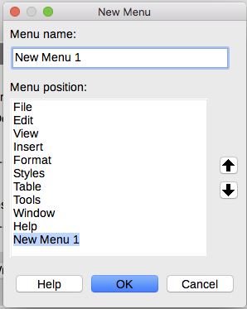
Figure 2: Adding a new menu
- Note
Changes to the menus are not immediately displayed. Changes saved to LibreOffice Writer's menu are displayed the next time Writer is opened. Changes saved to a document's menu are displayed the next time the document is opened.

Customizing toolbars
You can customize toolbars in several ways, including choosing which icons are visible, locking the position of a docked toolbar (as described in Chapter 1, Introducing Writer), and adding or deleting icons (commands) in the list of those available on a toolbar. You can also create new toolbars. The controls on the Toolbars page of the Customize dialog (Figure 3) are similar to those on the Menus page.
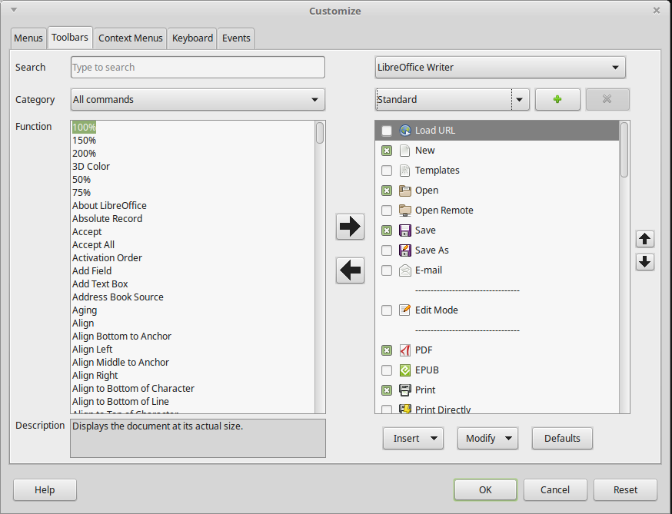
Figure 3: The Toolbars page of the Customize dialog
A

Choosing icons for toolbar commands
Toolbar buttons usually have icons, not words, on them, but not all of the commands have associated icons. If the command does not have an icon, you can choose an icon for it. To choose an icon, select the command in the list on the right (marked A in Figure 3), and click Modify > Change icon. On the Change Icon dialog, scroll through the available icons, select one, and click OK to assign it to the command.
To use a custom icon, create it in a graphics program and import it into LibreOffice by clicking the Import button on the Change Icon dialog (Figure 4). Custom icons should be 16×16 pixels in size.
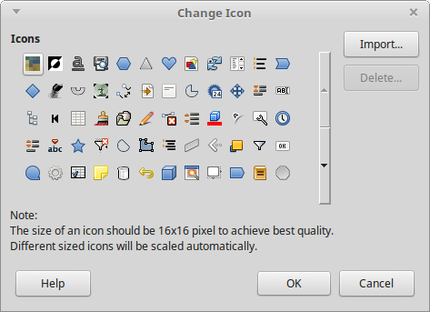
Figure 4: Change Icon dialog

Assigning shortcut keys
In addition to using the built-in keyboard shortcuts, you can define others. You can assign shortcuts to standard LibreOffice functions or your own macros and save them for use with Writer or with the entire LibreOffice suite.
To adapt shortcut keys to your needs, use the Keyboard page of the Customize dialog (Figure 5).
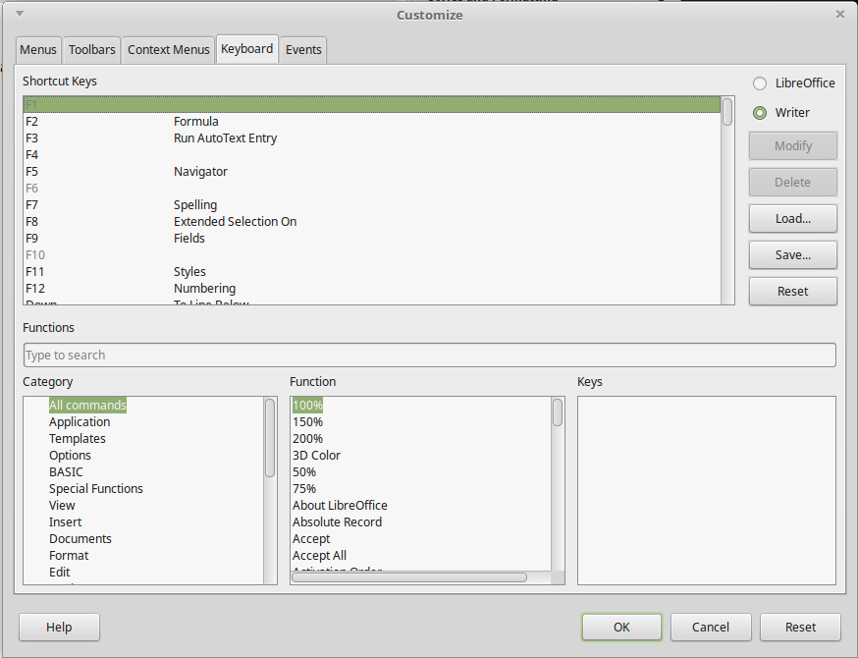
Figure 5: Defining keyboard shortcuts for applying styles
- Choose whether to have the shortcut key assignment available in all components of LibreOffice or only in Writer.
- Select the desired shortcut key in the Shortcut keys list at the top of the page.
- Select the required function from the Category and Function lists.
- Click the Modify button. The selection now appears in the Keys list on the lower right.
- Click OK to accept the change.
Repeat as required.
- Note
Shortcut keys that are grayed-out in the listing on the Customize dialog, such as F1 and F10, are not available for reassignment.

Saving changes to a file
Changes to the shortcut key assignments can be saved in a keyboard configuration file for use at a later time, so you can create and apply different configurations as needed. To save keyboard shortcuts to a file:
- After making keyboard shortcut assignments, click the Save button on the Keyboard page of the Customize dialog (Figure 5).
- In the Save Keyboard Configuration dialog, type a name for the keyboard configuration file in the File name box, or select an existing file from the list. Browse to the location where you want to save the file.
- Click Save. A confirmation dialog appears if you are about to overwrite an existing file, otherwise there will be no feedback and the file will be saved.

Loading a saved keyboard configuration
To load a saved keyboard configuration file and replace your existing configuration, click the Load button on the Customize dialog, and then select the configuration file from the Load Keyboard Configuration dialog.

Assigning macros to events
An “event” can be something like a document is opened, a key is pressed, or the mouse moved. You can associate a macro with an event, so the macro is run when the event occurs. For example, a common use is to assign the “open document” event to run a macro that performs certain setup tasks for the document.
To associate a macro with an event, use the Events page of the Customize dialog. For more information, see Chapter 13, Getting Started with Macros, in the Getting Started Guide.

Adding functionality with extensions
An extension is a package that can be installed into LibreOffice to add new functionality. They can add new top-level menus, submenus or toolbar icons. Extensions may also have their own settings, available from the extension manager.
Several extensions are shipped bundled with LibreOffice and are installed with the program. Others can be downloaded from various websites. The official extension repository is located at http://extensions.libreoffice.org/. These extensions are free of charge.
Some extensions from other sources are free of charge; others are available for a fee. Check the descriptions to see what licenses and fees apply to the ones that interest you.

Installing extensions
Extensions can be installed in these ways:
- From the *.oxt file in your system's file browser. Double-click the file.
- From the Extension Manager, as follows:
- In LibreOffice, select Tools > Extension Manager from the Menu bar.
- In the Extension Manager dialog (Figure 6), click Add.
- A file browser window opens. Find and select the extension you want to install and click Open.
- Users with administrator or root privileges will see a dialog where they can choose to install extensions "for all users" (shared) or "only for me" (user). Users without those privileges can install, remove, or modify extensions only for their own use.
- The extension begins installing.
In each case, during the process you may be asked to accept a license agreement. When the installation is complete, the extension is listed in the Extension Manager dialog.
- Tip
To get extensions that are listed in the repository, you can open the Extension Manager and click the Get more extensions online link. You do not need to download them separately.
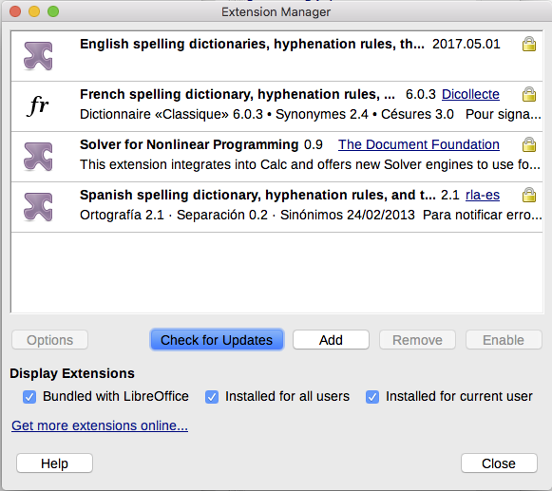
Figure 6: Using the Extension Manager

Adding custom colors
Versions of LibreOffice before 5.3 had a Colors page in Tools > Options, where you could add custom colors to a color palette, for example to exactly match a corporate color scheme. This page has been removed. The method for defining a custom color is now as follows:
- Insert any drawing object, such as a square, into any document.
- Right-click on the object and choose Area from the context menu.
- Go to the Color tab (Figure 7). Under Colors > Palette, choose which palette you wish to add the new color to. Under New, define the new color using RGB or Hex notation, or click the Pick button to select the color on the Pick a Color page (Figure 8).

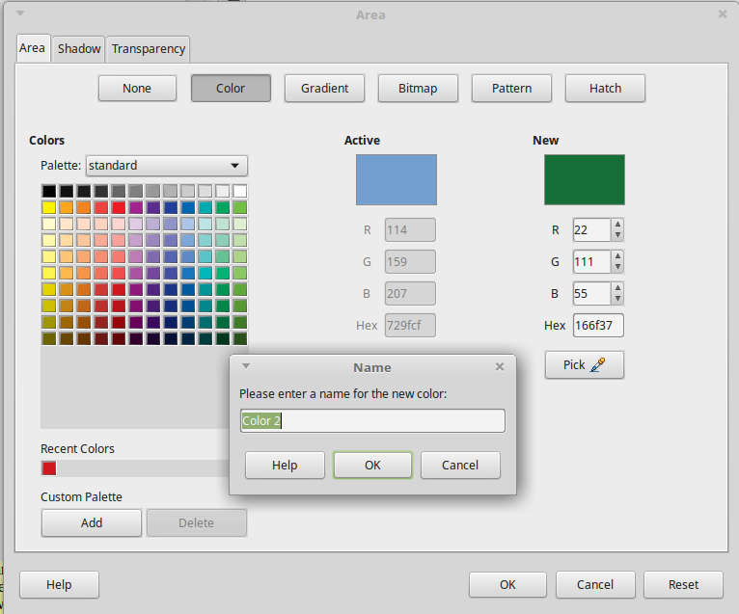
Figure 7: Defining a new color
- Click Add in the lower left corner, enter a name for the new color in the pop-up dialog, and click OK to save.
- Delete the drawing object from the document, if it is not needed.
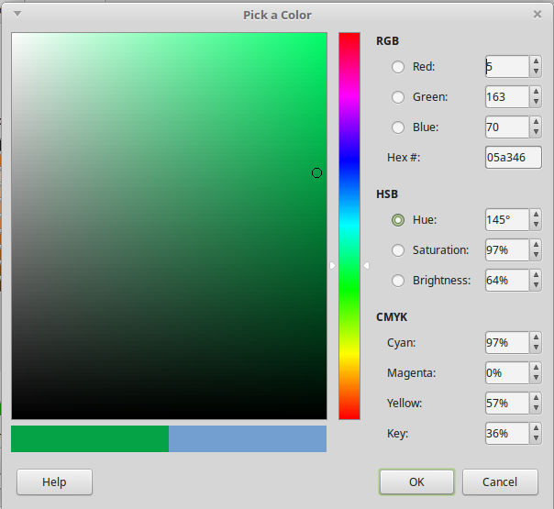
Figure 8: Defining a color by picking it from a color chart

Adding fonts
LibreOffice supports PostScript (.pfb), TrueType (.ttf), and OpenType (.otf) font file formats. Other font formats exist, and may be supported by your operating system, but these formats may be limited in selection and quality.
If you have administration privileges, you can install additional fonts through your operating system; they will then be available for use by LibreOffice and will appear in Writer’s font lists.

Finding free-licensed fonts
In addition to proprietary fonts from sources like Adobe, hundreds of free-licensed fonts are available. You can use, share, and edit free-licensed fonts as you please. Most are available at no cost. Many are clones or near-variations of classic fonts, but some are original fonts.
Many Linux distributions include a few free-licensed fonts in their package repositories. Other places where you can find free-licensed fonts include The League of Moveable Type (https://www.theleagueofmoveabletype.com/), Open Font Library (http://openfontlibrary.org/).

