
LibreOffice Tutorial

Chapter 1
Introduction to Writer
Writing a Conference Call Letter

Copyright
This document is Copyright © 2019 by the LibreOffice Documentation Team. Contributors are listed below. You may distribute it and/or modify it under the terms of either the GNU General Public License (http://www.gnu.org/licenses/gpl.html), version 3 or later, or the Creative Commons Attribution License (http://creativecommons.org/licenses/by/4.0/), version 4.0 or later.
All trademarks within this guide belong to their legitimate owners.

Contributors
This book is adapted and updated from LibreOffice Tutorial by Bernard Poole.

To this edition
Pulkit Krishna

To previous editions
Bernard Poole

Feedback
Please direct any comments or suggestions about this document to the Documentation Team’s mailing list: documentation@global.libreoffice.org
- Note:
Everything you send to a mailing list, including your email address and any other personal information that is written in the message, is publicly archived and cannot be deleted.

Publication date and software version
Published April 2020. Based on LibreOffice 6.4.
Contents
Copyright 2
Contributors 2
To this edition 2
To previous editions 2
Feedback 2
Publication date and software version 2
LEARNING OUTCOMES 4
BEFORE YOU BEGIN 4
OPENING, NAMING & SAVING A NEW WRITER DOCUMENT 6
Opening a new Writer document 6
Naming & Saving a new Writer document 8
Creating a new folder 10
SOME HELPFUL HINTS WHILE USING WRITER 11
Word processing is not the same as using a typewriter 11
Removing unwanted Returns (using the Show ¶ option) 12
Undoing unintended actions 13
Scrolling through a document 14
Shortcuts or quick keyboard commands 16
Renaming a document 16
CREATING AND SAVING A DOCUMENT 17
Typing the Conference Call Letter 18
UPDATING AND SIMPLE FORMATTING OF A DOCUMENT 18
Inserting the date 18
Adding text to an existing document 21
Removing text 21
Changing text 22
Selecting (highlighting) a block of text 23
Using the Writer Indent Markers 24
CHECKING THE DOCUMENT FOR SPELLING ERRORS 28
Accessing and using the spelling checker 28
PRINTING A FIRST DRAFT OF THE DOCUMENT 29
Removing your document from the printer 31
Always proofread your writing 31
RUNNING OFF A FINAL COPY 31
MAKING A BACKUP COPY OF THE DOCUMENT 31
LOOKING BACK 32
LOOKING FORWARD 32
SKILL CONSOLIDATION 32

LEARNING OUTCOMES
In this tutorial, along with some helpful hints to bear in mind when word processing, you will learn the steps required to produce a word-processed document from scratch and carry out basic formatting and editing functions. These include:

- opening and naming a new word processor document
- entering and saving a document
- updating and simple formatting of a document
- checking a document for spelling and grammar errors
- printing a document
- making a backup copy of a document

It is likely that you are not a beginner to word processing, so you may think you don't need to complete this tutorial. That would be a mistake. Most computer users learn no more than the minimum they think they need to know to use a program such as Writer, without taking the trouble to learn other useful features of the software. In other words, even if you have used a word processor for a while, there's a good chance that you will still benefit from completing this tutorial. So, with this in mind please conscientiously work your way through the tutorial with a view to learning new things. You'll be surprised what you’ll discover!

Before you begin
- Caution
You'll find it easiest to use this tutorial if you follow the directions carefully. On computers there are always other ways of doing things, but if you wander off on your own be sure you know your way back!
Chapter 1 makes the assumption that you are already familiar with computing environment, though you may not be an expert in its use. You'll also need to know:

- where to find the computer
- how to turn the computer on
- how to log on to the system (using your login name and password).

You also should be familiar with the Windows, Icons, Menus, and Pointers (the so-called WIMP interface) with which you interact with the computer. If not, your instructor will make this clear to you before you proceed with these tutorials.

Chapter 1 assumes that you have downloaded a zipped copy of the set of Work Files for LibreOffice that accompany these tutorials. You can download them from the same place you have downloaded this Tutorial (See Preface). These files, after they have been unzipped, should ideally be stored on your data drive (hard drive or USB drive, for example) in three folders named Base Files, Impress Files, and Miscellaneous Files. You also will need a fourth folder for the data files that you will be creating while working your way through the tutorials. This fourth folder will be called Data Files. If you do not have these four folders and files ready, prepare them now before proceeding with this tutorial. Here are the steps to do this:

First, after you have downloaded the zipped set of Work Files onto your computer, Unzip the file by double clicking on the File name (Work Files for LibreOffice.zip) and Extract them onto your hard drive or USB drive.

You should now have a folder called Work Files for LibreOffice on your Hard Drive or USB Drive.

Double click on the Work Files for LibreOffice folder to open it.

Inside the Work Files for LibreOffice folder you should see three folders named Base Files, Impress Files, and Miscellaneous Files. You need to create a new, fourth, folder called Data Files. Here’s how you do this.

In the Work Files for LibreOffice folder, right click in the white space below the list of the existing three folders then, in the drop down menu (called a Context Menu) that pops up, select New > Folder (Figure 1).

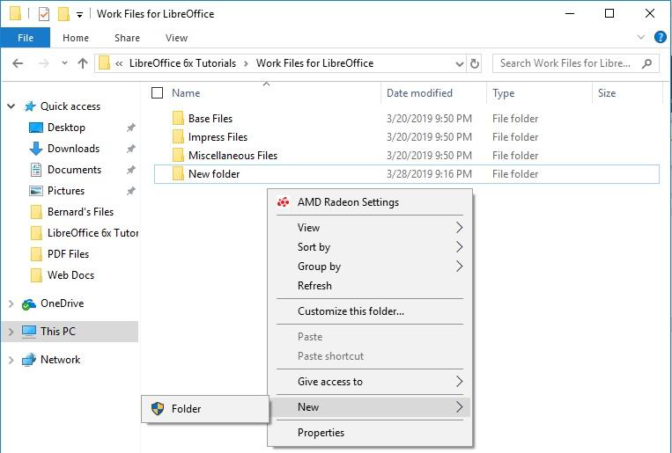Figure 1: Creating a New Folder

The system will create a new folder and you need to immediately give the folder the name Data Files (Figure 2 next page).

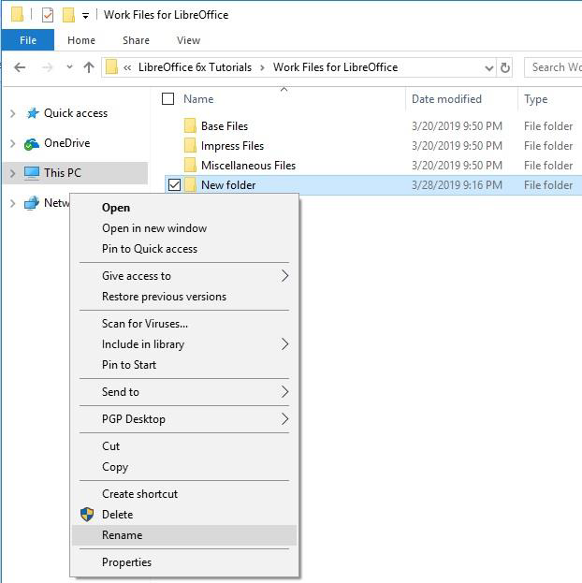Figure 2: Renaming the new folder

Type Data Files for the new folder name.

While you are working your way through these tutorials, you will be creating many files and storing them in appropriately named folders inside this Data Files folder.

OPENING, NAMING & SAVING A NEW WRITER DOCUMENT

Opening a new Writer document
Before you can use LibreOffice, you must have the program installed on your computer so that you can open the program. Figure 3 on the next page illustrates the window you will see when you open the LibreOffice program.
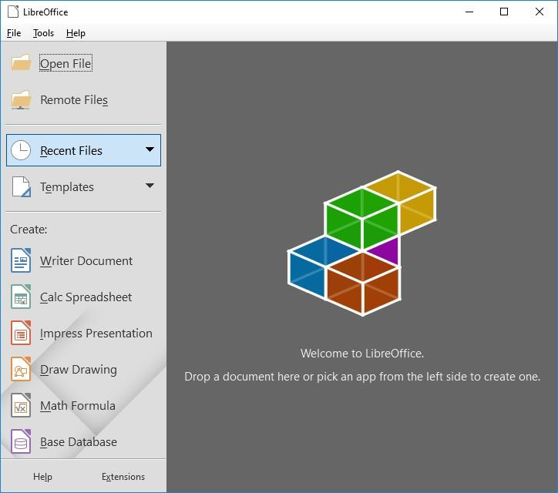Figure 3: LibreOffice opening dialog box
If this doesn’t look like the screen you got when you opened LibreOffice, every operating system is slightly different in the steps to open a program, so we’ll assume that you already have that figured out.

Here now are the steps to open a new Writer document. Figure 4 (next page) illustrates the screen you will see when you first open a new Writer document.

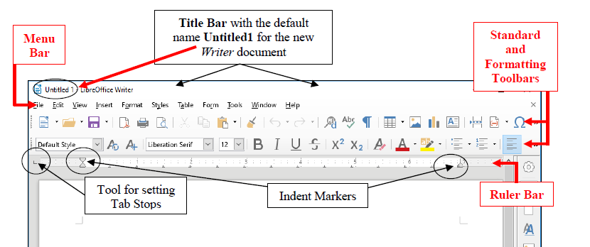Figure 4: New blank Writer document (annotated)

Notice the default title that Writer has given the document (Untitled1). You will be changing this shortly when you save the document for the first time.

Figure 4 illustrates the toolbars (Menu Bar, Standard Bar and Formatting Bar) that are available when you open any new Writer document.

Figure 4 above also illustrates the Ruler Bar, along with the tool for setting Tab Stops and the tools for setting Indents—called Indent Markers.

Many, if not most, users of Writer never figure out how to use these Tab Stops and Indent Markers. Many users do not even know they exist! You will be very familiar with these indent markers by the time you complete these tutorials.

Check out the tool for setting Tab Stops; it’s on the same line as the Ruler Bar, but at the left edge of the Writer window (see Figure 4 above)—it’s so small you could easily miss it (a lot of Writer users do!)

You’ll be practicing using this Tab Stop tool later in the tutorial; note where it is for now.

Make a mental note of the Indent Markers, too; they’re on the left and right sides of the Ruler bar (Figure 4 again)

Naming & Saving a new Writer document
In the following exercises, use your Data Files folder to save the files you’ll create.

Look at the new document’s default name (Untitled1) at the top left of the Writer window (see Figure 4 above)

The document is given this default name by LibreOffice because you haven't yet given it a name of your own.

It is ALWAYS a good idea to immediately—and thoughtfully—name a new document before you even begin to enter any data, and then save the document on the drive and in the folder of your choice. It’s not a bad idea to save a backup copy, too (you’ll have the opportunity to create backups at the end of each chapter of these tutorials).

There are two good reasons for naming and saving your files thoughtfully:

- If you give a document an appropriate descriptive name (such as Letter to Mom 3-8-04) you will be able to more easily identify the contents of a document. A thoughtful name will also help you find a document on the disk drives, because you can have the system search for it by the word(s) you expect to be in the name.

- If you carefully save a document (file) in a location of your choice you will more easily find the document at some later date. For example, if it’s a letter you’re saving, you’d want to save it in a folder called, say, Correspondence (which you would naturally need to create ahead of time).

Let’s get on with the task at hand (Naming and Saving a new Writer document).

From the File menu, select Save As.

Writer now displays the Save As dialog box (Figure 5).

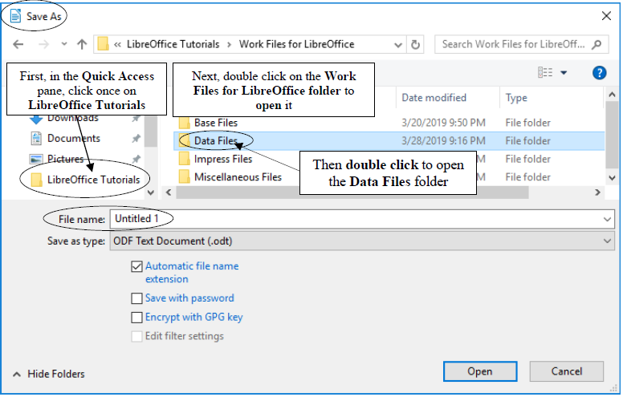Figure 5: The Save As dialog box
As you see in Figure 5, the Save As dialog box prompts you:

- to select the location where you want to save the new document (in this case, in your Work Files for LibreOffice > Data Files folder);

- to type a name for the document before clicking on the Save button.

In the left frame of the Save As dialog box (called the Quick Access pane), click once on LibreOffice Tutorials to open the folder (Figure 5 above) then, in the next window of the Save As dialog, double click on the Work Files for LibreOffice folder.

You should now see a list of four folders, including the Data Files folder you created when you prepared it for use with these tutorials (Figure 5 above).

Double click on the Data Files folder to open it (Figure 5 above)

You are going to create various types of Data files as you work your way through these tutorials, including Writer files, Calc files, Base files and Impress files. For now you’re going to create a new folder, called Writer Documents, just for your Writer files. You’ll later create the folders for the three other types of data files.

Creating a new folder
So, inside the Data Files folder you need to create a new folder to store all the documents you will create using Writer. You already learned to do this when you created the Data Files folder (see page 5 on the previous page).

Here are the steps if you still need help:

In the Work Files for LibreOffice > Data Files folder, click on the New Folder icon (Figure 6)

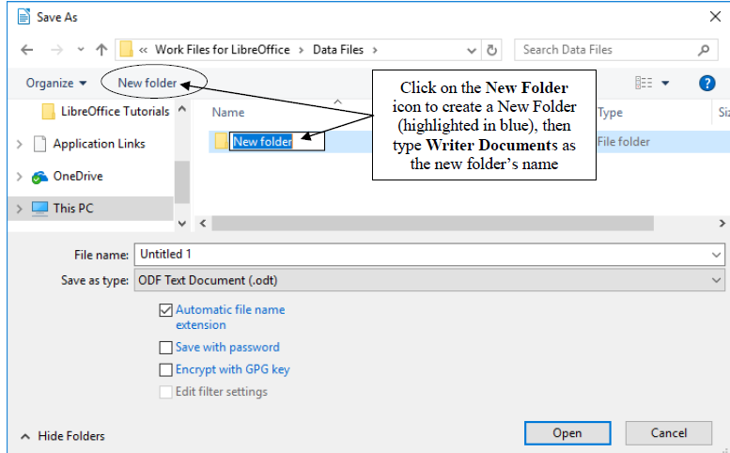Figure 6: The New Folder icon in the Save As dialog box
The system quickly creates a New Folder, with a default name highlighted in blue (Figure 6), inviting you to type a name for the New Folder.

For the new folder’s name, type Writer Documents, hit the Enter key, then double click on the new folder to Open it

Writer opens the new folder so that you can save inside it the new document you are about to create (Figure 7).

In the File name: data entry box (Figure 7), type Conference Call Letter to replace the default name (Untitled 1) and press Enter (or click on Save)

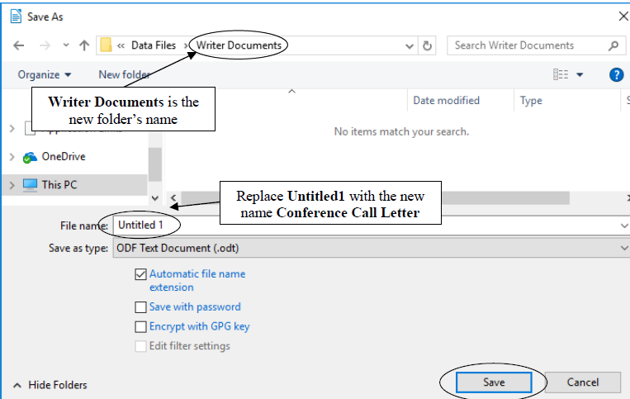Figure 7: Naming the Conference Call Letter
From now on, you do not need to select Save As to save the document unless you want to save a backup or save it in some other location. Whenever you simply Save this particular file, it will be saved with the name Conference Call Letter in this same folder (Writer Documents) on your disk drive.

SOME HELPFUL HINTS WHILE USING WRITER
You will shortly type the text of the Conference Call Letter. Before you begin, read the following helpful hints.

Word processing is not the same as using a typewriter
Next to no one uses a typewriter anymore. But if you happen to be one of those who have never yet used a computer, but you used to use a typewriter, read on.

As you type at the computer keyboard, the characters (letters of the alphabet, numbers, etc.) appear on the screen. When you use a typewriter, however, the letters appear directly on the paper in front of you. Also, when using a typewriter you have to move the carriage that holds the sheet of paper in place back at the end of every line so that you can start typing at the beginning of the next line on the page. This is called a carriage return.

When you use a word processor, however, the system takes care of the end of each line. As you type away in word processing, the program is aware that you are getting to the end of the line, and it will automatically move a word to the beginning of the next line if it doesn't fit completely on the end of a line. The technical term for this is “wrap around.” You don't have to worry about hyphenating words that are broken up over two lines—unless you want to, of course.

So, when you are using a computer, the only time you need to hit the Enter key is at the end of a paragraph, whether the paragraph be an empty line, just one word, one line, or several lines.

Type the following passage for practice—remember, don't press the Enter key until you get to the end of the paragraph.

And though he tried to look properly severe for his students, Fletcher Seagull suddenly saw them all as they really were, just for a moment, and he more than liked, he loved what he saw. No limits, Jonathan? he thought, and he smiled. His race to learn had begun.

Notice how the word processor wrapped around the text at the end of each line.

Removing unwanted Returns (using the Show ¶ option)
You can have Writer show you exactly where, in your document, you have hit the Enter or Return key (say, at the end of paragraphs). To do this you’ll click on the Show ¶ icon in the Standard Toolbar (Figure 8).

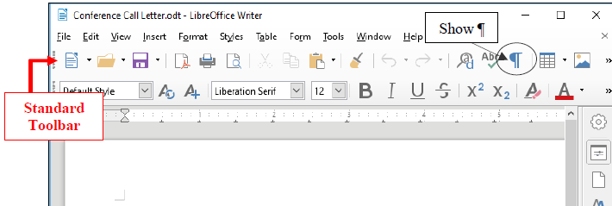Figure 8: The Show ¶ icon in the Standard toolbar
In the Standard Toolbar, click on the Show ¶ tool now (Figure 8 above)

The ¶ symbol is the standard mark used by editors to indicate the need for a paragraph break in running text. Right now you should see a ¶ symbol at the end of the paragraph you just typed and also on the empty line after the paragraph.

In the Conference Call Letter that you’ll be typing shortly, the ¶ symbol, if you have the ¶ option turned on, would appear wherever you hit Enter/Return at the end of each paragraph. Another ¶ symbol would appear on an empty line because, strictly speaking, the empty line is another paragraph break.

Notice also that the Show ¶ tool puts a dot wherever there is a space in the running text. You should see lots of dots throughout the Jonathan Livingstone Quote you just typed. This is useful, for example, so that you can see wherever you may have unintentionally typed extra spaces here and there that you may want to remove.

Let’s try this now.

Position the cursor immediately before the sentence that begins “No limits, Jonathan?…”, then hit the Enter key twice

Notice the ¶ symbols that show you where you hit the Enter key—one at the end of the previous line, and the other on the empty line ahead of the cursor.

Now remove the Paragraph marks you just entered by pressing the Backspace key twice

Finally, click on the Show ¶ icon in the Standard Toolbar to turn off the paragraph marks (¶) and all the dots between the words

Undoing unintended actions
If you do something you didn't intend, or if you make a mistake, you'll select Undo from the Standard toolbar which is located immediately below the Menu Bar (Figure 9). This is a lifesaver that you will use often!

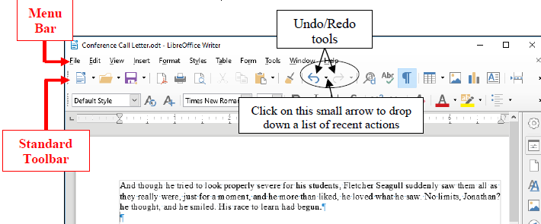Figure 9: Undo/Redo tools

In the Standard toolbar check out this Undo/Redo option now so you can see where to find it when you need it
A quicker way to Undo is to use the shortcut Ctrl+z on your keyboard. You can also undo any number of specific recent actions by clicking on the small arrow next to the Undo tool in the Standard toolbar (Figure 9 above), which will drop down a menu or list of the various actions you have taken since the last Undo. Be careful when you use this feature, however, because if you undo, say, 10 actions, all the actions you did prior to that will also be undone!

Scrolling through a document
We need to open a longer document so you can practice different ways of scrolling.

From the File menu select Open…, then navigate to the Work Files for LibreOffice > Miscellaneous Files > Practice folder

Among the various files in the Practice folder locate the document called Term Paper and double click on it to open it

Now, with the Term Paper document open on the screen, look at the scroll bars (Figure 10).

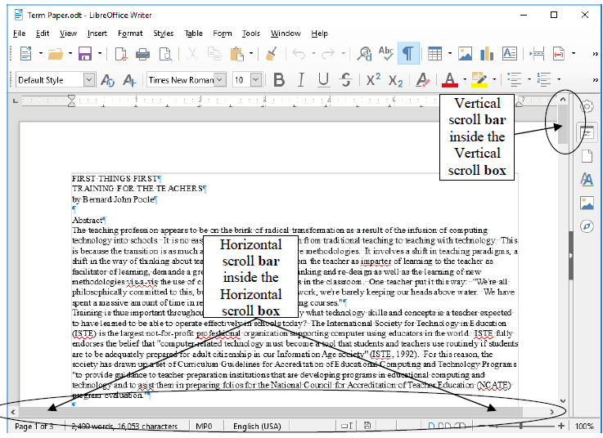Figure 10: The scroll boxes

On the right of the screen you have a vertical scroll bar and, inside it, the vertical scroll box. At the bottom of the screen you have a horizontal scroll bar and horizontal scroll box.

At either end of the scroll bars are arrows pointing in opposite directions (left and right, or up and down). As you might expect, clicking on these arrows will scroll a document left or right or up and down. Scrolling from left to right or right to left is simpler than scrolling up or down, since you only have the width of the page to deal with. But the process is the same for scrolling up and down, too.

Try scrolling now from side to side—left to right and back again—by clicking on the scroll arrows to move the scroll box in the horizontal scroll bar

Try scrolling up and down by clicking on the scroll arrows to move the scroll box in the vertical scroll bar

You can scroll a lot faster by positioning the mouse arrow on the scroll box itself, holding down the left mouse button, and dragging the box left or right, up or down, in the scroll bars.

Try this, too

If you click either side of the scroll box inside the horizontal or vertical scroll bars, this causes the document to scroll in jumps from side to side or up and down.

Try this as well

You also can scroll and position the cursor very precisely across a line of text, character by character, or up and down from line to line, by using the arrow keys on the lower right of the keyboard.

Try this as well

Finally, yet another vertical scrolling option is available if you have a mouse with a rubberized wheel between the buttons, as illustrated in Figure 11.

Figure 11: The scrolling wheel on the mouse
Try this, too

When you have finished experimenting with the scroll bars, close (File > Close) the Term Paper document

Shortcuts or quick keyboard commands
The quickest way to save your work is to press Ctrl+s on the keyboard.

The Ctrl (Control) key is in the lower left corner of the keyboard. Locate it now. You'll be using it a lot as you become more familiar with the LibreOffice programs. It is always used in combination with one or two other keys. Ctrl+s, for example, is executed by holding down the Ctrl key and, while holding the Ctrl key down, at the same time quickly hit the S key.

You'll learn more shortcuts as you work your way through the tutorials. The author (Bernard Poole) has prepared a chart that breaks down the most used Writer quick keyboard commands. You will find this chart handy when you are learning to use the software for the first time. The chart is available in the appendix.

For ready reference, you may want to print out the Quick Keyboards Commands sheet which lists the most frequently used LibreOffice shortcut keyboard commands.

You can also search the help files using the search string: ”General Shortcut Keys in LibreOffice”.

The official shortcut keys chart is also available on the LibreOffice documentation page for download.

Renaming a document
You will sometimes want to rename a document that you've already saved on your disk. One way you can do this is by navigating on the disk drive to the document you want to rename, and right-clicking on the icon for the document. Then, from the context menu that pops up, select the option to Rename…, which highlights the document’s name so that you can type a new name for it (Figure 12).
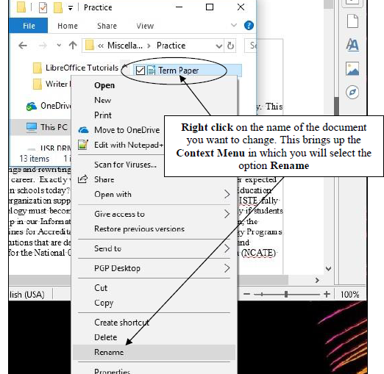Figure 12: Renaming an existing document or file
To rename a document which you already have open in Writer, or in any other LibreOffice application, you would choose Save As from the File menu. This will give you the opportunity to save the document with a new name of your choice. Bear in mind, however, that when you do this, the document with the original name will still be on your disk—a second copy, if you like. If you don't want to keep this copy, you should delete it right away so as to remove unwanted clutter from your disk drive.

CREATING AND SAVING A DOCUMENT
Practice makes perfect
Figure 13 has the contents of the Conference Call Letter you are going to create next.
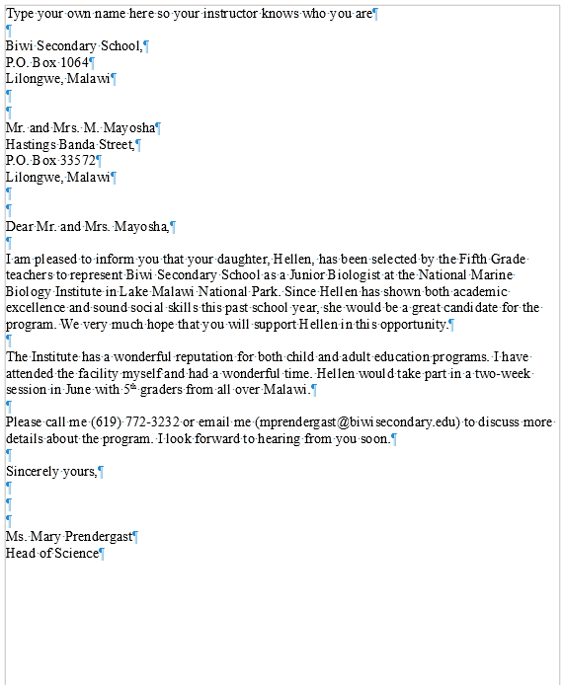Figure 13: First version of the Conference Call Letter
You still should have open on your desktop the document you already named Conference Call Letter, but it has the Jonathan Livingstone Seagull quote, which you need to clear the document. Here are the steps to quickly remove it.

In the Edit menu choose Select All then press the Backspace key or the Delete key once to remove the highlighted text from the document

You can also use the Quick Keyboard command Ctrl+a to Select All the content of a document, or you can use the mouse (or your finger if you have a touch screen) to drag to highlight the whole paragraph, or you can quadruple click on the paragraph.

Typing the Conference Call Letter
You should now have a blank page with the cursor waiting in the top left corner, ready for you to type in the Conference Call Letter. Figure 13 on the previous page has the full text of the Conference Call Letter. The Figure also shows where all the Paragraph marks (¶) are. This will help you remember to hit the Enter key only where necessary, not at the end of every line. There’s no need to show Paragraph marks in your version of the document, but feel free to do so if you wish.

Start by typing your own name at the top of the letter

As you type, Writer is programmed to warn you of any spelling, grammar or style errors it finds by underlining them in red (grammar or spelling) or blue (style) on your screen. This may occur as you type the contents of Figure 13.

Go ahead and type the letter now—hit Ctrl-S at the end of every paragraph to safely Save the document as you go along

Once you have typed in the whole document and saved it, you should go back and correct any errors you may have made, and then save the document again. Remember: when you save a document with the same name as before, you are replacing the earlier version. You won't be creating a second copy.

UPDATING AND SIMPLE FORMATTING OF A DOCUMENT
Now that your Conference Call Letter is saved on disk, you can make any revisions you want.

Word processing allows you to treat text like modeling clay. You can easily mold your words and ideas. You can change margins, put in underlines, italics, boldface, and so forth. You can correct errors, move text around, lay it out on the page—all at the touch of a few buttons.

In the next Chapter (Chapter Two) you will have an opportunity to become quite sophisticated in this regard. But let's keep it simple for now. Refer back to Figure 13 while you complete the next few sections of the tutorial.

Inserting the date
There is no date on the Conference Call Letter in Figure 13 above. A letter is incomplete without a date, so here (on the next page) are the steps to have Writer put today's date in the letter.
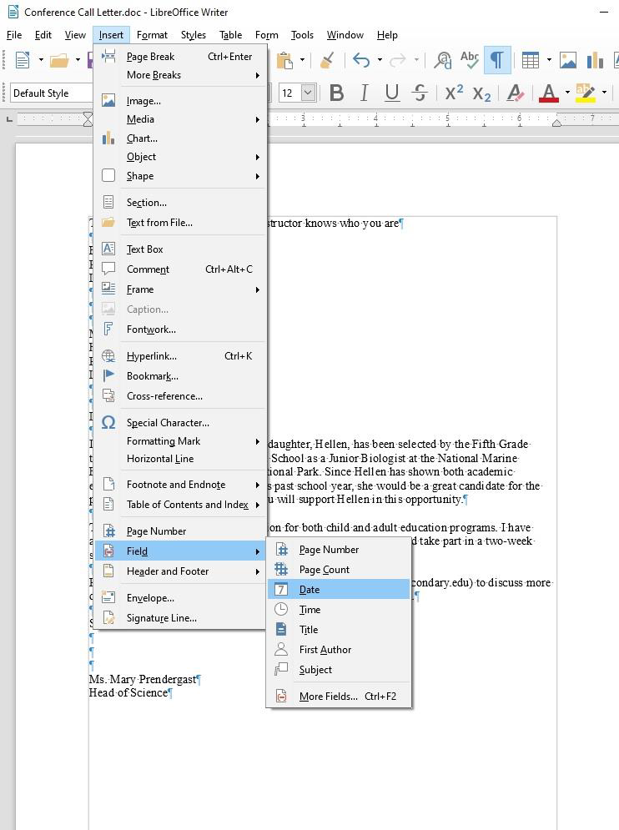Figure 14: Inserting the Date into a document

Click to position the insertion point cursor at the end of the Biwi Secondary School address at the top of the page (the first of the two addresses)—at the end of the last line, after “Malawi”—then press Enter

The cursor should now be waiting at the beginning of the next line.

In the Insert Menu > Field Menu click on the Date tool (Figure 14 above)

As soon as you click on the Date tool, Writer immediately inserts today’s date at the cursor.

There is, however, one problem with the all-numeric date format (all numeric)—it uses the USA style, with the month first and the day second. Elsewhere in the world, the date is shown with the day first and the month second. So, where you have 4/2/2019, for example, is that February 4, 2019, or April 2, 2019? You really can’t be sure.

Fortunately, LibreOffice has a quick way around that problem by allowing you to select another format for the date which spells out the month and thus can in no way be confused. Here’s what you need to do.

Use the mouse to right click on the date, and in the context menu that pops up, select Edit Fields…

The Edit Fields dialog box comes up, enabling you to select from a long list of possible date formats (Figure 15)

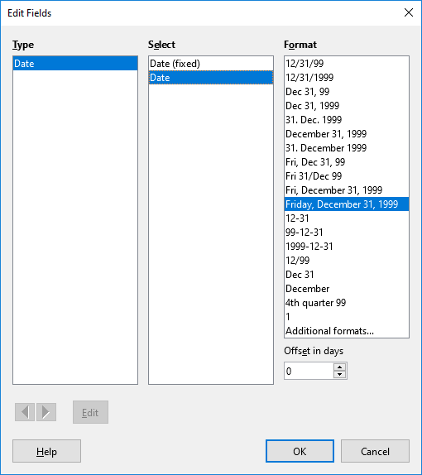Figure 15: Selecting an easily-recognized date format
In the Select column (second column), click on the second option Date—not the Date (fixed) option—then in the Format column select the date format Friday, December 31, 1999 and click on OK

Now check the new format for the date; there’s no question which date you’re referring to now, right? You’ll also appreciate the advantage of allowing Writer to insert the date for you as not fixed because it will be updating the date automatically when you save the letter as a template. Later, any time you use the template, or print another Conference Call Letter, the date will be adjusted automatically to reflect the current date on which you edit or reprint the document.

Adding text to an existing document
You will most always want to add text to an existing document—make revisions and so forth; it is an activity which is fundamental to the whole process of writing. On a typewriter, or if you write a document by hand, making any kind of change is usually messy, and often difficult to do. When you use the word processor, however, it is a simple task. Let's practice now.

There is no limit to the extra details that could be added to the letter, but for the sake of this exercise you will add just one sentence to the next to last paragraph to help the parents appreciate what Hellen will get out of the experience at the Institute.

Position the insertion point cursor so it is at the END of the paragraph which begins "The institute has a wonderful reputation..."—so after the phrase “…5th graders from all over Malawi.”—then press the space bar once and type the sentence:

She would thus be able to meet and make friends with others of her own age and academic ability.

Read over the sentence you just typed to check for errors. Correct any you may have made. Before you go on to the next section you should save what you have done so far.

Press Ctrl+s to save the changes you have made to the letter

Removing text
There are several ways of removing text. In a moment you'll learn how to highlight a block of text in order to move or delete larger sections of text. But if all you want to do is remove a few words, or a short sentence, the quickest way is to use the Backspace key.

You are going to remove the second sentence of the second paragraph. This second sentence begins "I have attended the facility myself...".

Position the insertion point cursor at the beginning of the third sentence of the second paragraph—the sentence that begins "Hellen would take part ..."

Press the Backspace key as many times as is necessary until the second sentence of this paragraph (the sentence that begins “I have attended the facility…”) is removed from the letter

You'll find the automatic repeat feature of the keyboard (activated by holding down a key such as the Backspace key) will come in handy for a delete operation like this.

Press Ctrl+s again to save the changes you just made

Changing text
It is often necessary to change a word or words here and there in a document. The Conference Call Letter overuses the word "program," for example. The word appears once in the first paragraph and then is used twice in the final paragraphs. To improve the letter, it would be better to rewrite the first sentence of the second paragraph to read: "The Institute has a wonderful reputation for its offerings for both children and adults."

Place the cursor between the period (full stop) and the "s” at the end of the first sentence in the second paragraph (right at the end of the word "programs" but before the period/full stop)

Use the Backspace key to remove the text “both child and adult programs”

Make sure there is still a space after the word “for”, then type the phrase “its offerings for both children and adults.”

Another change you need to make is to the telephone number in the first sentence of the last paragraph. A common error with numbers is called transposition, where one accidentally reverses the order of digits. The number is supposed to be 772–3223, not 3232.

Position the cursor just at the end of the telephone number, press the Backspace key 2 times, then type the digits "23", and press Ctrl+s

At this stage your Conference Call Letter should look much the same as Figure 16.
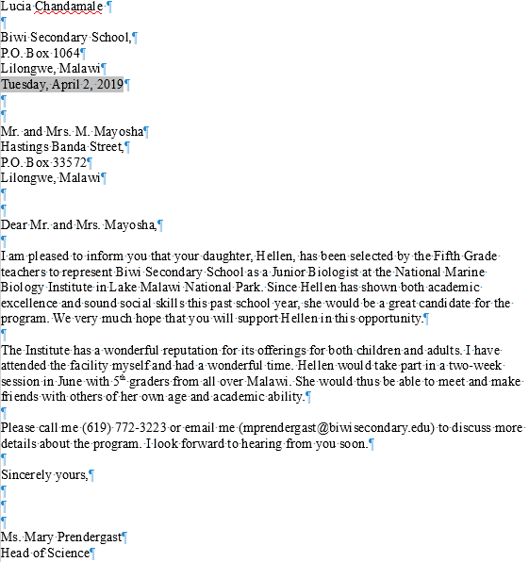Figure 16: Intermediate version of the Conference Call Letter

Selecting (highlighting) a block of text
Let’s take a few minutes to learn about highlighting text in a Writer document. Highlighted text is text that stands out from the rest of the document because, in the case of LibreOffice, the background of the highlighted text becomes a block of light blue color (Figure 17).
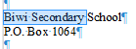Figure 17: Highlighted text
When you highlight text, you can do things to it (delete it, move it, copy it, change the margins set for it, change the font, the text style or color, and so on) without affecting the rest of your document.

You can highlight a single character...

Use the mouse to position the cursor so it is immediately before the "B" in “Biwi” in the address at the top of the letter

Hold down the left mouse button and keep it down as you carefully drag across just the "B" at the beginning of the word so that it becomes highlighted

This latter operation is tricky the first few times you try it. If you drag across more than just the "B", keep your finger on the left mouse button and drag back until you have just what you want highlighted. You can select as much or as little of the text as you want. Remember, you're in control.

Let go of the left mouse button when just the "B" is highlighted

Now click anywhere in the text to remove the highlighting (i.e. to deselect the selected text)

Try this a few times on different letters anywhere in the document

Double clicking to highlight a single word...

Position the I–beam cursor anywhere over the word "Secondary" in the first line of the address at the top of the letter and double click the left mouse button

The single word "Secondary" should be highlighted on the screen.

Click anywhere in the text to remove the highlighting

Try this on a few more words anywhere in the document till you're comfortable with the action

Triple clicking to quickly highlight a sentence...
Position the cursor anywhere in the middle of the first paragraph in the body of the letter paragraph and triple click on the left mouse button

Click anywhere in the text to remove the highlight, then try this again on other sentences elsewhere in the document till you're comfortable with the action

Quadruple clicking to quickly highlight an entire paragraph...

Position the cursor anywhere in the middle of a paragraph and quadruple click on the left mouse button

Click anywhere in the text to remove the highlight, then try this again on another paragraph elsewhere in the document till you're comfortable with the action

You can highlight an extended area (or block) of text...

Place the cursor right at the start of the first paragraph of the letter (before the sentence that reads: I am pleased to inform you… )

Now, while you hold down the Shift key, click at the end of the last paragraph (after the sentence that reads: I look forward to hearing from you soon. and notice that the whole paragraph is highlighted

Click anywhere in the text to remove the highlighting

You can quickly highlight an entire document...

You should be getting the hang of this highlighting by now. You can drag the mouse to highlight several paragraphs or even an entire document of several pages. However, dragging through a 50-page document would quickly become tedious. So, Writer provides a short cut to select an entire document—you may recall using this feature earlier in the tutorial.

Press Ctrl+a (or in the Edit menu choose Select All), then click anywhere in the text to remove the highlighting

Using the Writer Indent Markers
The letter is nearly ready to be printed. There are just a couple more changes you need to make.

- For example, one style for letter–writing is to use a ½” indent for the first line of every paragraph.

- Another is to position the first address (the address of the sender) along with the date so that they appear at the top right of the first page, instead of on the left. In this case, the closing signature could also be aligned on the right side of the page at the end of the letter.

Put your thinking cap on now, because what follows can be tricky for some. Figure 18 illustrates these final changes you are going to make to the Conference Call Letter.

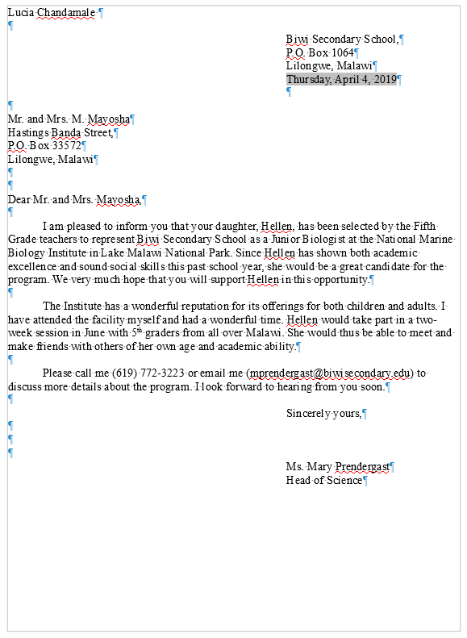Figure 18: The final version of the Conference Call Letter
- Note
Moving small indent markers is a delicate operation; be sure to position the very of the mouse pointer (Figure 19) on an indent marker as you complete the following exercises.
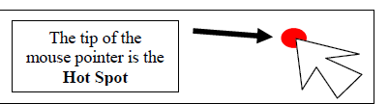Figure 19: the Tip of the mouse pointer is the Hot Spot!
Indent Markers are used to adjust the first line margin, and the left and right margins, of paragraphs—including a paragraph that has only one line.

On the left side of the ruler, at the 0" hash mark, you can see the two indent markers that are used to set the First Line Indent and the Left Indent for paragraphs (Figure 20). On the right side of the ruler you can see the Right Indent marker (Figure 20 again).
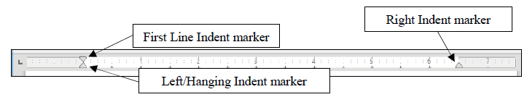Figure 20: The Indent Markers
In this exercise you will practice using just the First Line Indent marker and the Left Indent marker. In Chapter 2 you will have plenty of opportunity to learn about the Hanging Indent marker and the Right Indent marker.

Let’s learn how to use the First Line Indent marker now.

Click to put the cursor anywhere within the first paragraph of the letter (this tells Writer which paragraph of text to reformat)

In the Ruler bar, place the tip of the mouse pointer on the First Line Indent marker (see Figure 20 above), and use the mouse to drag the First Line Indent marker across ½” to the right (to the ½” hash mark on the ruler)

Notice that the First Line Indent marker (the upper triangular marker) and the Left/Hanging Indent marker (the lower triangular marker) moved independently and that only the first line of the paragraph has moved to the right half an inch (½”).

Next you are going to set the First Line Indent marker for both the second and third paragraphs in the body of the letter.

First, make sure you can see the whole letter in the window (maximize the window if necessary), then click to position the cursor before the first word of the second paragraph (before “The Institute…”)

While holding down the Shift key, click at the end of the third (last) paragraph (after the words “…from you soon.”)

Both the second and third paragraphs of the letter should be highlighted.

Now position the tip of the mouse arrow on the First Line Indent marker and slide it to the right to the ½” hash mark on the ruler bar

Notice that the first line margin of each paragraph is now set at ½" and the rest of each paragraph is set at 0”.
Practice makes perfect
If this is the first time you've used these markers you may still feel uncomfortable working with them, if only because they’re rather small and may be difficult for you to grab with the mouse pointer. More practice will cure that.

Next you are going to use the Left Indent marker to adjust the left margin for the First Address and the Date at the top of the letter, and then do the same to the left margin for the sign off at the end of the letter. Follow these steps carefully.

Drag to select (highlight) the First Address and Date lines at the top of the letter (the first four lines of text after your name)

Point at the Left Indent marker (the small marker at the bottom of the indent markers on the left of the Ruler bar), hold down the left mouse button and drag both the First and Left indent markers together over to the 4" hash mark on the ruler

Let go of the mouse button, then click anywhere in the text to de-select the highlighted text

The address and date should now be lined up on the new 4" margin. Figure 21 illustrates the change this makes to your letter.
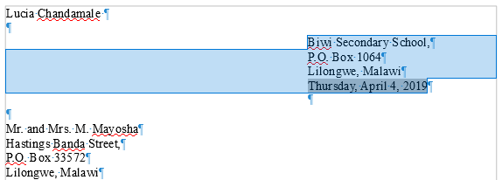Figure 21: First address after changing the indent markers
If you weren't successful the first time, just go through the steps again to get the hang of it.

Next scroll down to the end of the letter if it doesn't show on the screen

Select the lines that begin: "Sincerely yours," and that conclude with "Ms. Mary Prendergast" and “Head of Science” (including all three of the blank lines in between)

With these lines highlighted, again point at the Left Indent marker, hold down the left mouse button and drag both the indent markers together over to the 4" hash mark on the ruler

Press Ctrl+a to save this (almost final) version of the document

CHECKING THE DOCUMENT FOR SPELLING ERRORS
LibreOffice comes with a spelling checker. No matter how good you might think your spelling is you would do well to take advantage of this fast, effective tool for catching spelling errors or typos.

You Should use a spelling checker when you are proofing your word-processed work. The system will highlight any words that it cannot find in its dictionary and may make suggestions for words or spellings the student intended. It can thus help your students become better spellers, and broaden their vocabulary if they are curious enough to check out the meanings of the words they may never have come across before.

However, it cannot spell for them—yet! Nor can it correct errors such as the misuse of "to", "too", and "two"! A spelling checker is not an alternative to proofreading. Tell your students they should always proofread their work on the printed page (in hard copy form) after they have run it through the spelling checker. It also would be a good idea to have another student proofread papers for them. Assessing a classmate’s work is a valuable collaborative learning experience.

Accessing and using the spelling checker
First use the mouse to position the cursor at the very top of the Conference Call Letter, right before your name

In the Standard Toolbar click on the icon for Spelling and Grammar (Figure 22)
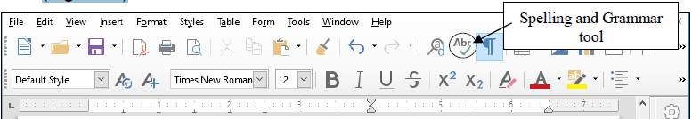Figure 22: The Spelling and Grammar tool in the Standard toolbar
This will bring up the dialog box shown in Figure 23.
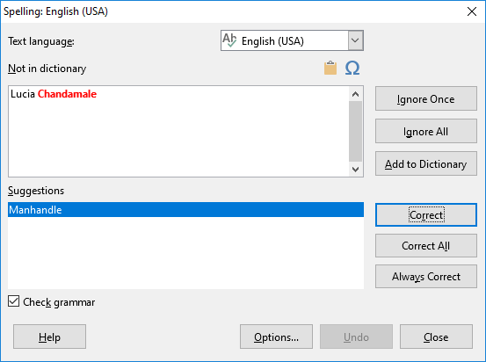Figure 23: Spelling and Grammar dialog box

If Writer highlights a word or phrase, this does not necessarily mean there is anything wrong with it. You still have to be able to tell if you have made an error and you also need to know what, if anything, to change. Sometimes you’ll ignore the spelling/grammar checker.

The Writer spelling and grammar checker is already working for you if those functions are in automatic mode, and you should see strange looking red or blue underlines under some of the words you typed.

Remember, the computer is just a dumb machine—it is a tool to assist your intelligence, not replace it!

If you tell the Spelling Checker to check your document, and it has "No suggestions" for a word highlighted, the dialog box gives you the option to have the Spelling Checker Ignore it (because the word is correct as is); or Ignore All occurrences of the same word in your document (because you don’t want the Checker to stop for them again); or Add the word to the custom dictionary (so it won’t be flagged in future documents you work on). This is generally useful for proper names.

In the example in Figure 23 above, the word “Chandamale” is a proper name and has been highlighted in red (it’s likely your own name has been, too). As you can see, the spelling checker doesn’t recognize it and draws it to your attention. The spelling checker also suggests what it thinks is the correct spelling (manhandle), even though this is incorrect! To fix the problem, you just click on the Ignore All button, and Writer will fix it on the spot. Then click on the Add to Dictionary button because you want the Spell Checker to ignore this proper name any time it might occur in other documents you prepare.

At one time or another you will find all these features useful, so you should take the time to check them out. For the most part the Spelling Checker is intuitive, and one of the best things you can do at this time is take a few minutes to browse through the various selections until you get a feel for what the Spelling Checker can do.

Using the Spelling and Grammar... option in the Standard Toolbar, work your way through the Conference Call Letter and correct any spelling or typing errors you may have made, then Save your work.

In Chapter 2 you will make more extensive use of the Writer Spelling Checker.

PRINTING A FIRST DRAFT OF THE DOCUMENT
It is always useful to preview your work on screen before sending it to the printer. In LibreOffice, you will be able to preview your work in the Print dialog box before you send it to the printer. Let’s see how this works.

From the File menu select Print (or press Ctrl+p) and in the dialog box that pops up (Figure 24) click on the General tab

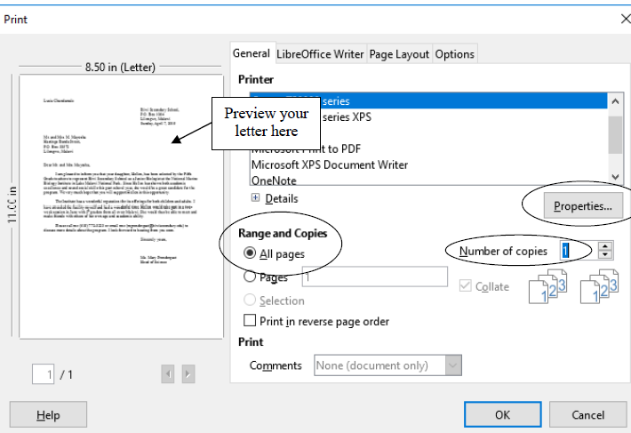Figure 24: Typical Writer Print dialog box
What kind of printer are you using?
If you have a laser printer, the quality is invariably "Best." But if you have an inkjet printer, for example, you can choose the quality of output you require. You select the print quality by clicking on the Properties button in the Print dialog box (Figure 24 above).

Printing a range of pages
With regard to Page Range, the Print All Pages option is selected by default. The Conference Call Letter is only one page long, so you will by default want to print the entire document. Should you want to print a subset of the pages of a long document, say from page 3 to page 6, you would click the radio button next to Pages (see Figure 24) and enter the numbers of the range of pages in the data entry box (ex. 1,3,5-12).

Setting the number of copies Writer also asks you how many copies you want to print. As you can see (Figure 24 on the previous page), the number 1 is already selected by default, and for a draft copy that is certainly as many as you would normally want.
- Tip
Save the environment
A useful environmental tip, for your draft copies, is to reuse paper that has one side blank. Keep a box near the printer where others who use the printer can deposit used paper that is clean on one side. Only use new paper for a final copy of a document.

You are now ready to print the document.

Click on OK in the Print dialog box

If all is well with your printer connections, your printer is turned on, and you have paper correctly set up in your printer, the printer will now go ahead and produce a hard copy of your document.

Removing your document from the printer
If you are using a laser printer or an ink jet printer, removing the paper from the printer is simply a matter of picking it out of the paper tray.

Always proofread your writing
Now you should take the time once again to carefully read over what you have typed.

If you used the Spell Checker, remember that it will not necessarily pick up all errors. If you type "me" when you meant to type "he," the checker won't mind in the least, since both words are in the dictionary.

As we noted earlier, the golden rule here is: A Spelling Checker is only as good as you are! You should never rely blindly on the feedback from the Spelling Checker. So always proofread your writing—and tell your students to do the same.

You might also have your friends or someone else proofread your papers. You should also check the overall page layout to see that the document looks good on the page. If there are problems, now is the time to fix them. Make all necessary changes on the computer and save the document again on your disk drive. If all is well, you are ready to go ahead and print the final version, the one that you will send in the mail to the parents. Later, in Chapter 6, you will have the opportunity to learn how to use Mail Merge to send individualized copies of a letter to a large number of addresses.

RUNNING OFF A FINAL COPY
Follow the steps you learned above to run off a final copy of your document.

Most printers today will accept single sheets of paper. So, if you wanted to use your school's or business letterhead, this would be no problem. You would, of course, need to remove the sender's address from the top of your Conference Call Letter since this address would already be included on the letterhead paper.

MAKING A BACKUP COPY OF THE DOCUMENT
Your last task before completing this session at the computer should be to make a backup of your document. For the sake of convenience, you’ll make the backup in the same folder (the Data Files folder) as the rest of the data files you will create using these tutorials.

The Conference Call Letter is still open in Writer. It is also saved in your Work Files for LibreOffice folder, since that is where you have been saving it all along.

From the File menu select Save As and in the Save As dialog box make sure you navigate to the Data Files folder, then change the file name to Conference Call Letter. Backup and click on the Save button.

Wait while the file is being saved, then close Writer (File > Close).

LOOKING BACK
In this tutorial you have learned the basics of the LibreOffice Writer word processor. You now know how to enter text, save it, revise it, set margins, check it for spelling, and print it on paper in draft, standard, or letter quality. You also learned one way to make a backup copy of your documents.

Many computer users learn no more than has been covered in this chapter. Under–utilization is a common fact of life for most computer users; they never discover the wide range of useful things the computer can help them do. Ideally, however, this tutorial should have made you keen to learn more about Writer. Remember what you learned in chapter 1. You may need to refer back to some of the details spelled out here when you are using the word processor on your own.

Above all, keep an open mind. It is almost impossible to know everything about the computer, so there is always a lot to learn, even when you think you know it all!

LOOKING FORWARD
This has been a good introduction to the LibreOffice word processor. Chapter 2 will give you an opportunity to further advance your skills.

Many of the word processing skills that you have learned will transfer across to other word processors. The more you use the computer as a tool for writing, the more natural it will become and the more you will improve your writing ability. The ease with which you can make changes will have a significant impact on your willingness to generate quality written communication. Needless to say, word processing will have the same effect on your students, so the sooner you can get them using the computer for all their writing assignments the better.

SKILL CONSOLIDATION
Complete these exercises to reinforce what you have learned in Chapter 1. This will help you appreciate the usefulness of the word processor for all your writing tasks.

- Use Writer to write a letter to someone in your family or to a friend using the same layout as the Conference Call Letter. There must be at least four paragraphs in the body of the letter. Print out a draft copy of the story, proof read it, correct any errors, then print out a final copy of the story.

- Write a letter to a school district superintendent explaining the details of a field trip that you are planning for your class. Print out a draft copy of the story, proof read it, correct any errors, then print out a final copy of the story.

- Write a short story of at least four paragraphs using Writer. Set the right and left margins at 1.5 inches. Print out a draft copy of the story, proof read it, correct any errors, then print out a final copy of the story.

- Use Writer to type up a paper of your choice. Print out a draft copy of the paper, proof read it, correct any errors, and then print out a final copy of the paper.

- Using Writer, type a paper of at least four paragraphs explaining what you have learned so far in tutorial 1. Print out a draft copy of the paper, proof read it, correct any errors, and then print out a final copy of the paper.

- Open Writer to create a new document. Name the document “A Day at the Beach” and type at least four paragraphs on this topic. Practice adding and deleting words, phrases, and whole sentences. Print out a draft copy of the paper, proof read it, correct any errors, and then print out a final copy of the paper.

- Open the document named Conference Call Letter. Change the date so that it is the current date, save the updated document. Remove all the first line indents from the paragraphs. Add a paragraph explaining that if Hellen cannot attend the Institute this year, the offer will be open again next year. Save the updated document. Print out a draft copy of the letter, proof read it, correct any errors, then print out a final copy of the letter.

The lines on your screen may be longer or shorter.
From the book "Jonathan Livingston Seagull: a story" by Richard Bach. New York, NY: Avon, 1970. And yes, the grammar is correct, so don’t worry if it seems odd to you here and there!
If you are new to word processing, the secret here is: don't panic! No matter how much you might think to the contrary, when you're working with computers you are in control—as long as you know what you're doing. The computer is just a dumb machine designed to serve your information processing needs. These tutorials will help you make this dumb machine your friend.

