XEngine Message Queue Docment

目录

XEngine Message Queue Docment 1

Preface 4

Reader 4

Overview 4

Associate Module 4

一 Technical structure 4

1.1 TCP 4

1.2 HTTP 4

二 Configure Env 5

2.1 WINDOWS 5

2.1.1 Configure Environment 5

2.1.2 complie and run 5

2.2 LINUX 6

2.2.1 Evnironment Configure 6

2.2.2 Complie and Run 6

2.3 Version Requirements 7

2.3.1 System Version 7

2.3.2 Software Version 7

三 Interface Protocol 7

3.1 TCP 7

3.1.1 Post Protocol 7

3.1.2 Get Protocol 9

3.1.3 Delete Protocol 10

3.1.4 Create Topic 11

3.1.5 Delete Topic 12

3.1.6 Subscribe Topic 13

3.1.7 Notification Message 14

3.2 HTTP 15

3.2.1 请求 15

3.2.2 回复 15

四 Configure Description 16

4.1 Service Configure 16

4.1.1 basic configure 16

4.1.2 Max Configure 16

4.1.3 Time Configure 16

4.1.4 Log Configure 17

4.1.5 Database Configure 17

五 Advanced configuration 17

appendix 17

Appendix 1 Type Define 17

Appendix 2 Protocol Define 17

Appendix 3 Transformation Definition 17

Appendix 4 update log 17

|  |  |  |  |
| --- | --- | --- | --- |
| File Status：  [ ] Draft  [√] Release | File Name： | XEngine Message Queue Service Docment | |
| Be A Version： | V1.2 | |
| Released： | 2021-07-16 | |
| Writer： qyt | | |

# Preface

## Reader

Development ,test

## **Overview**

This document contains related technical descriptions and interface definitions for storage services!

## Associate Module

The service used XEngine as Network Toolki.if you want to use code,you have to installed XEngine

And This service used library for jsoncpp

# 一 Technical structure

Used to http and tcp protocol though basic protocol,tcp and http are different.

Should be bind two port when Start service.these are tcp message port and http message port

## TCP

Tcp is fast and more futures.

## HTTP

Send Message through post,and recv message through get

# 二 Configure Env

## 2.1 WINDOWS

Need to download XEngine.

Complie and run and debug by vs2019.

Download address:https://gitee.com/xengine/libxengine

### 2.1.1 Configure Environment

After Download XEngine,if you download is zip file.you have to uncompress for xengine and add user environment value.

You need add to follow two user environment in your system

* XEngine_Include  XEngine is header path
* XEngine_Library  XEngine is library path

比如:



You need jsoncpp env.you can install through vcpkg

And you can download for youself:https://github.com/open-source-parsers/jsoncpp/

If you download for youself,you need install and complie by youself and configure project attributes vc++ path in your vs2019

### 2.1.2 complie and run

When you complete with configuration.you can come in code path.open XEngine_MQServiceApp.sln by vs2019.and choice x86(debug or release) or x86(just release) complie.

If environment not have error.complie is succesed.contrain 4 module and 1 exe program

And you need copy file under XEngine_Release to your complied dir.next step copy file under XEngine depend Module and jsoncpp module to your complied dir.

If not have error,you can see follow the infomation

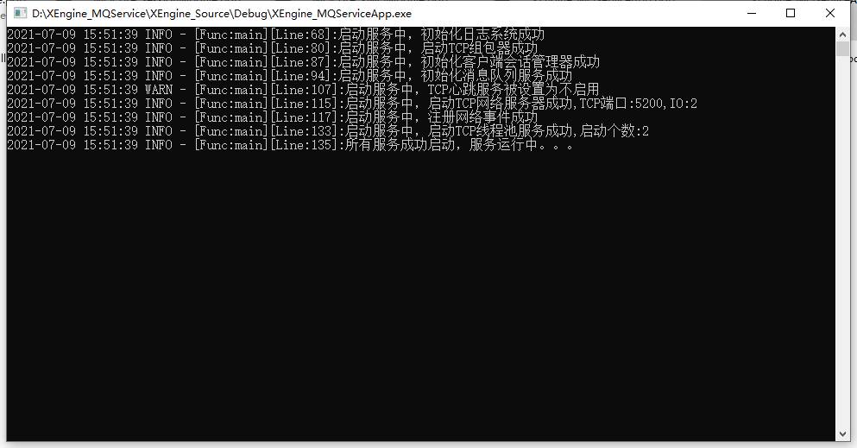

Note: You can run the program directly, the system will prompt you what you need, you can directly enter the XEngine directory to search.

## 2.2 LINUX

### 2.2.1 Evnironment Configure

If you use linux.you must running on ubuntu(20.04) or centos(8.x)...

After download complete.you can install xengine it by the shell file.

Execute command:sudo XEngine_RunEnv.sh -i 3

of course,and need install jsoncpp environment to your system.

Ubuntu:sudo apt install libjsoncpp-devel -y

Centos:sudo dnf install jsoncpp-devel -y

### 2.2.2 Complie and Run

Configure complete.you can complie it.open terminal in you xengine_storage dir and execute command.

complie:make

install:make FLAGS=InstallAll

clean:make FLAGS=CleanAll

If there is no error.you can see complied XEngine_MQServiceApp file in XEngine_Release

You can running at terminal.if there is no error,you can infomation:

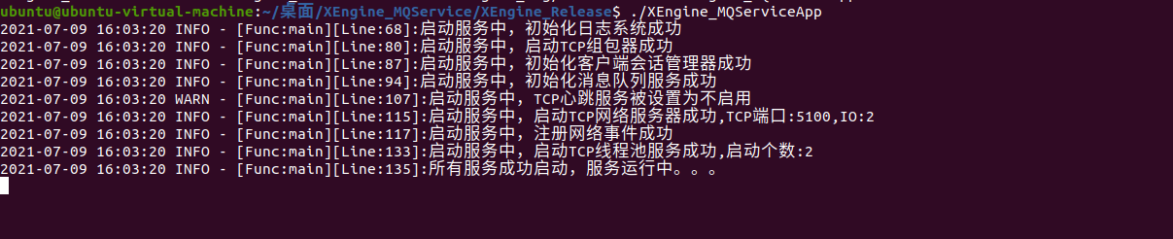

## 2.3 Version Requirements

### 2.3.1 System Version

Minimum version requirements:

WINDOWS: win7 sp1

Ubuntu:20.04

Centos:8.x

### 2.3.2 Software Version

Minimum version requirements:

XEngine:V7.14

JsonCpp:V1.9.2

# 三 Interface Protocol

## 3.1 TCP

Please Note:The wReserver field of the protocol header will be used as the server reply processing result. 0 means the processing is successful, other values mean failure  
 whether protocol load is general protocol or HTTP protocol,they can be load json data.

### 3.1.1 Post Protocol

To use the message queue, you need to deliver a packet to the message queue server first, so that other programs can get a packet from the message queue service.

#### 3.1.1.1 Request

Protocol Header:

wHeader = XENGIEN_COMMUNICATION_PACKET_PROTOCOL_HEADER

xhToken = 0

unOperatorType = ENUM_XENGINE_COMMUNICATION_PROTOCOL_TYPE_XMQ

unOperatorCode = XENGINE_COMMUNICATION_PROTOCOL_OPERATOR_CODE_MQ_REQPOST

unPacketSize = sizeof(XENGINE_PROTOCOL_XMQ) + MSGLEN

byVersion = 1

byIsReply = TRUE

wReserve = 0

wPacketSerial = 0

wTail = XENGIEN_COMMUNICATION_PACKET_PROTOCOL_TAIL

Protocol Body:

typedef struct tag_XEngine_ProtocolXmq

{

*TCHAR* tszMQKey[256];

_int64x nSerial;

int nKeepTime;

int nGetTimer;

}XENGINE_PROTOCOL_XMQ, *LPXENGINE_PROTOCOL_XMQ;

DATA in tail

#### 3.1.1.2 Reply

Protocol Header:

wHeader = XENGIEN_COMMUNICATION_PACKET_PROTOCOL_HEADER

xhToken = 0

unOperatorType = ENUM_XENGINE_COMMUNICATION_PROTOCOL_TYPE_XMQ

unOperatorCode = XENGINE_COMMUNICATION_PROTOCOL_OPERATOR_CODE_MQ_REPPOST

unPacketSize = sizeof(XENGINE_PROTOCOL_XMQ)

byVersion = 1

byIsReply = FALSE

wReserve = 0

wPacketSerial = 0

wTail = XENGIEN_COMMUNICATION_PACKET_PROTOCOL_TAIL

Protocol Body:

typedef struct tag_XEngine_ProtocolXmq

{

*TCHAR* tszMQKey[256];

_int64x nSerial;

int nKeepTime;

int nGetTimer;

}XENGINE_PROTOCOL_XMQ, *LPXENGINE_PROTOCOL_XMQ;

### 3.1.2 Get Protocol

#### 3.1.2.1 Requestion

Protocol Header:

wHeader = XENGIEN_COMMUNICATION_PACKET_PROTOCOL_HEADER

xhToken = 0

unOperatorType = ENUM_XENGINE_COMMUNICATION_PROTOCOL_TYPE_XMQ

unOperatorCode = XENGINE_COMMUNICATION_PROTOCOL_OPERATOR_CODE_MQ_REQGET

unPacketSize = sizeof(XENGINE_PROTOCOL_XMQ)

byVersion = 1

byIsReply = TRUE

wReserve = 0

wPacketSerial = 0

wTail = XENGIEN_COMMUNICATION_PACKET_PROTOCOL_TAIL

Protocol Body:

typedef struct tag_XEngine_ProtocolXmq

{

*TCHAR* tszMQKey[256];

_int64x nSerial;

int nKeepTime;

int nGetTimer;

}XENGINE_PROTOCOL_XMQ, *LPXENGINE_PROTOCOL_XMQ;

#### 3.1.2.2 Reply

Protocol Header:

wHeader = XENGIEN_COMMUNICATION_PACKET_PROTOCOL_HEADER

xhToken = 0

unOperatorType = ENUM_XENGINE_COMMUNICATION_PROTOCOL_TYPE_XMQ

unOperatorCode = XENGINE_COMMUNICATION_PROTOCOL_OPERATOR_CODE_MQ_REPGET

unPacketSize = sizeof(XENGINE_PROTOCOL_XMQ) + MSGLEN

byVersion = 1

byIsReply = FALSE

wReserve = 0

wPacketSerial = 0

wTail = XENGIEN_COMMUNICATION_PACKET_PROTOCOL_TAIL

Protocol Body:

typedef struct tag_XEngine_ProtocolXmq

{

*TCHAR* tszMQKey[256];

_int64x nSerial;

int nKeepTime;

int nGetTimer;

}XENGINE_PROTOCOL_XMQ, *LPXENGINE_PROTOCOL_XMQ;

Protocol Body:if sucess,protocol follow get data

### 3.1.3 Delete Protocol

#### 3.1.3.1 Requestion

Protocol Header:

wHeader = XENGIEN_COMMUNICATION_PACKET_PROTOCOL_HEADER

xhToken = 0

unOperatorType = ENUM_XENGINE_COMMUNICATION_PROTOCOL_TYPE_XMQ

unOperatorCode = XENGINE_COMMUNICATION_PROTOCOL_OPERATOR_CODE_MQ_REQDEL

unPacketSize = sizeof(XENGINE_PROTOCOL_XMQ)

byVersion = 1

byIsReply = TRUE

wReserve = 0

wPacketSerial = 0

wTail = XENGIEN_COMMUNICATION_PACKET_PROTOCOL_TAIL

Protocol Body:

typedef struct tag_XEngine_ProtocolXmq

{

*TCHAR* tszMQKey[256];

_int64x nSerial;

int nKeepTime;

int nGetTimer;

}XENGINE_PROTOCOL_XMQ, *LPXENGINE_PROTOCOL_XMQ;

#### 3.1.3.2 Reply

Protocol Header:

wHeader = XENGIEN_COMMUNICATION_PACKET_PROTOCOL_HEADER

xhToken = 0

unOperatorType = ENUM_XENGINE_COMMUNICATION_PROTOCOL_TYPE_XMQ

unOperatorCode = XENGINE_COMMUNICATION_PROTOCOL_OPERATOR_CODE_MQ_REPDEL

unPacketSize = sizeof(XENGINE_PROTOCOL_XMQ)

byVersion = 1

byIsReply = FALSE

wReserve = 0

wPacketSerial = 0

wTail = XENGIEN_COMMUNICATION_PACKET_PROTOCOL_TAIL

Protocol Body:

typedef struct tag_XEngine_ProtocolXmq

{

*TCHAR* tszMQKey[256];

_int64x nSerial;

int nKeepTime;

int nGetTimer;

}XENGINE_PROTOCOL_XMQ, *LPXENGINE_PROTOCOL_XMQ;

### 3.1.4 Create Topic

Post a packet to message queue,you must create a topic,you have to set topic name,data can be enter the message queue

#### 3.1.4.1 Requestion

Protocol Header:

wHeader = XENGIEN_COMMUNICATION_PACKET_PROTOCOL_HEADER

xhToken = 0

unOperatorType = ENUM_XENGINE_COMMUNICATION_PROTOCOL_TYPE_XMQ

unOperatorCode = XENGINE_COMMUNICATION_PROTOCOL_OPERATOR_CODE_MQ_REQCREATE

unPacketSize = sizeof(XENGINE_PROTOCOL_XMQ)

byVersion = 1

byIsReply = TRUE

wReserve = 0

wPacketSerial = 0

wTail = XENGIEN_COMMUNICATION_PACKET_PROTOCOL_TAIL

Protocol Body:

typedef struct tag_XEngine_ProtocolXmq

{

*TCHAR* tszMQKey[256];

_int64x nSerial;

int nKeepTime;

int nGetTimer;

}XENGINE_PROTOCOL_XMQ, *LPXENGINE_PROTOCOL_XMQ;

#### 3.1.4.2 Reply

Protocol Header:

wHeader = XENGIEN_COMMUNICATION_PACKET_PROTOCOL_HEADER

xhToken = 0

unOperatorType = ENUM_XENGINE_COMMUNICATION_PROTOCOL_TYPE_XMQ

unOperatorCode = XENGINE_COMMUNICATION_PROTOCOL_OPERATOR_CODE_MQ_REPCREATE

unPacketSize = sizeof(XENGINE_PROTOCOL_XMQ)

byVersion = 1

byIsReply = FALSE

wReserve = 0

wPacketSerial = 0

wTail = XENGIEN_COMMUNICATION_PACKET_PROTOCOL_TAIL

Protocol Body:

typedef struct tag_XEngine_ProtocolXmq

{

*TCHAR* tszMQKey[256];

_int64x nSerial;

int nKeepTime;

int nGetTimer;

}XENGINE_PROTOCOL_XMQ, *LPXENGINE_PROTOCOL_XMQ;

### 3.1.5 Delete Topic

#### 3.1.5.1 Requestion

Protocol Header:

wHeader = XENGIEN_COMMUNICATION_PACKET_PROTOCOL_HEADER

xhToken = 0

unOperatorType = ENUM_XENGINE_COMMUNICATION_PROTOCOL_TYPE_XMQ

unOperatorCode = XENGINE_COMMUNICATION_PROTOCOL_OPERATOR_CODE_MQ_REQDELETE

unPacketSize = sizeof(XENGINE_PROTOCOL_XMQ)

byVersion = 1

byIsReply = TRUE

wReserve = 0

wPacketSerial = 0

wTail = XENGIEN_COMMUNICATION_PACKET_PROTOCOL_TAIL

Protocol Body:

typedef struct tag_XEngine_ProtocolXmq

{

*TCHAR* tszMQKey[256];

_int64x nSerial;

int nKeepTime;

int nGetTimer;

}XENGINE_PROTOCOL_XMQ, *LPXENGINE_PROTOCOL_XMQ;

#### 3.1.5.2 Reply

Protocol Header:

wHeader = XENGIEN_COMMUNICATION_PACKET_PROTOCOL_HEADER

xhToken = 0

unOperatorType = ENUM_XENGINE_COMMUNICATION_PROTOCOL_TYPE_XMQ

unOperatorCode = XENGINE_COMMUNICATION_PROTOCOL_OPERATOR_CODE_MQ_REPDELETE

unPacketSize = sizeof(XENGINE_PROTOCOL_XMQ)

byVersion = 1

byIsReply = FALSE

wReserve = 0

wPacketSerial = 0

wTail = XENGIEN_COMMUNICATION_PACKET_PROTOCOL_TAIL

Protocol Body:

typedef struct tag_XEngine_ProtocolXmq

{

*TCHAR* tszMQKey[256];

_int64x nSerial;

int nKeepTime;

int nGetTimer;

}XENGINE_PROTOCOL_XMQ, *LPXENGINE_PROTOCOL_XMQ;

### 3.1.6 Subscribe Topic

Subscribing to the topic allows the user to actively push a message to the subscribed client every time there is new content in the topic after the request is successfully subscribed

#### 3.1.6.1 Requestion

Protocol Header:

wHeader = XENGIEN_COMMUNICATION_PACKET_PROTOCOL_HEADER

xhToken = 0

unOperatorType = ENUM_XENGINE_COMMUNICATION_PROTOCOL_TYPE_XMQ

unOperatorCode = XENGINE_COMMUNICATION_PROTOCOL_OPERATOR_CODE_MQ_REQNOTIFY

unPacketSize = sizeof(XENGINE_PROTOCOL_XMQ)

byVersion = 1

byIsReply = FALSE

wReserve = 0

wPacketSerial = 0

wTail = XENGIEN_COMMUNICATION_PACKET_PROTOCOL_TAIL

Protocol Body:

typedef struct tag_XEngine_ProtocolXmq

{

*TCHAR* tszMQKey[256];

_int64x nSerial;

int nKeepTime;

int nGetTimer;

}XENGINE_PROTOCOL_XMQ, *LPXENGINE_PROTOCOL_XMQ;

#### 3.1.6.2 Reply

Protocol Header:

wHeader = XENGIEN_COMMUNICATION_PACKET_PROTOCOL_HEADER

xhToken = 0

unOperatorType = ENUM_XENGINE_COMMUNICATION_PROTOCOL_TYPE_XMQ

unOperatorCode = XENGINE_COMMUNICATION_PROTOCOL_OPERATOR_CODE_MQ_REPNOTIFY

unPacketSize = sizeof(XENGINE_PROTOCOL_XMQ)

byVersion = 1

byIsReply = FALSE

wReserve = 0

wPacketSerial = 0

wTail = XENGIEN_COMMUNICATION_PACKET_PROTOCOL_TAIL

Protocol Body:

typedef struct tag_XEngine_ProtocolXmq

{

*TCHAR* tszMQKey[256];

_int64x nSerial;

int nKeepTime;

int nGetTimer;

}XENGINE_PROTOCOL_XMQ, *LPXENGINE_PROTOCOL_XMQ;

### 3.1.7 Notification Message

Protocol Header:

wHeader = XENGIEN_COMMUNICATION_PACKET_PROTOCOL_HEADER

xhToken = 0

unOperatorType = ENUM_XENGINE_COMMUNICATION_PROTOCOL_TYPE_XMQ

unOperatorCode = XENGINE_COMMUNICATION_PROTOCOL_OPERATOR_CODE_MQ_MSGNOTIFY

unPacketSize = sizeof(XENGINE_PROTOCOL_XMQ) + message

byVersion = 1

byIsReply = FALSE

wReserve = 0

wPacketSerial = 0

wTail = XENGIEN_COMMUNICATION_PACKET_PROTOCOL_TAIL

Protocol Body:

typedef struct tag_XEngine_ProtocolXmq

{

*TCHAR* tszMQKey[256];

_int64x nSerial;

int nKeepTime;

int nGetTimer;

}XENGINE_PROTOCOL_XMQ, *LPXENGINE_PROTOCOL_XMQ;

...body

## 3.2 HTTP

HTTP support post requestion now.make sure event through json

Content of Requestion and reply same to tcp protocol

st_Payload mean is load data.nPayType is 0 mean it is string,is 1 as base64 codec,if the value is 1, Then you need base64 decoding

If no have payload,,st_Payload can not be exist.

Serial can not be empty When you get the message

### 3.2.1 请求

{  
    **"unOperatorType"**:**7**,  
    **"unOperatorCode"**:**7001**,  
    **"byIsReply"**:**0**,  
    **"st_MQProtocol"**:{  
        **"tszMQKey"**:**"主题名"**,  
        **"nSerial"**:**0**,  
        **"nKeepTime"**:**0**,  
        **"nGetTimer"**:**0**  
    },  
    **"st_Payload"**:{  
        **"nPayType"**:**0**,  
        **"nPayLen"**:**6**,  
        **"tszPayData"**:**"123456"**  
    }  
}

### 3.2.2 回复

{  
    **"unOperatorType"**:**7**,  
    **"unOperatorCode"**:**7001**,  
    **"wReserve"**:**0**,  
    **"st_MQProtocol"**:{  
        **"tszMQKey"**:**"主题名"**,  
        **"nSerial"**:**0**,  
        **"nKeepTime"**:**0**,  
        **"nGetTimer"**:**0**  
    },  
    **"st_Payload"**:{  
        **"nPayType"**:**0**,  
        **"nPayLen"**:**6**,  
        **"tszPayData"**:**"123456"**  
    }  
}

# 四 Configure Description

## 4.1 Service Configure

Basic Configure File:XEngine_Config.json

### 4.1.1 basic configure

* bDeamon: 1 deamon process run 0 is terminal run
* tszTopic:Default Topic Name
* nTCPPort:tcp port
* nHttpPort:http port

### 4.1.2 Max Configure

XMax Configure

* MaxClient Allow Max Client Count
* MaxQueue Allow Max Queue
* IOThread:network io process threads number
* nTCPThread:tcp handle threads number
* nHttpThread:http handle threads number

### 4.1.3 Time Configure

XTime Configure

* bHBTime,1 is enable heartbeat,0 disable
* nDBMonth:database save time,default month
* nTimeCheck:check time
* nTCPTimeOut:how time check once
* nHttpTimeOut:same nTCPTimeOut

### 4.1.4 Log Configure

XLog Configure

* MaxSize:Log file size
* MaxCount:Log File Number
* LogLeave:Allow save level

### 4.1.5 Database Configure

XSql Configure

# 五 Advanced configuration

# appendix

## Appendix 1 Type Define

reference file:XEngine_CommHdr.h

## Appendix 2 Protocol Define

reference file:XEngine_ProtocolHdr.h

## Appendix 3 Transformation Definition

reference file:XEngine_Types.h only LINUX

## Appendix 4 update log