XEngine Proxy Service Docment

目录

XEngine Proxy Service Docment 1

Preface 2

Reader 2

Overview 2

Associate Module 3

一 Technical structure 3

1.1 Directory Structure 3

1.2 Source Directory 3

二 Configure Env 3

2.1 WINDOWS 3

2.2 LINUX 4

2.3 Version Requirements 4

2.3.1 System Version 4

2.3.2 Software Version 5

三 Configure Description 5

3.1 Basic Configure 5

3.2 Max Configure 5

3.3 Time Configure 5

3.4 Log Configure 5

appendix 6

Appendix 1 Type Define 6

Appendix 2 Protocol Define 6

Appendix 3 Transformation Definition 6

|  |  |  |  |
| --- | --- | --- | --- |
| File Status：  [ ] Draft  [√] Release | File Name： | XEngine Proxy Service Docment | |
| Be A Version： | V1.1.0.1001 | |
| Released： | 2021-12-31 | |
| Writer： qyt | | |

# Preface

## Reader

Developer ,tester

## **Overview**

This document contains related technical descriptions and interface definitions

## Associate Module

The service used XEngine as Network Toolki.if you want to use code,you have to installed XEngine

Download Address:https://gitee.com/xyry/libxengine

<https://github.com/libxengine/xengine>

Please refer to the readme configuration environment

# 一 Technical structure

Used to tcp protocol though basic protoco

Should be bind two port when Start service

## Directory Structure

* XEngine_APPClient:example code path
* XEngine_Docment:docment path
* XEngine_Release:complie release path
* XEngine_Source:code path

## Source Directory

* XEngine_ModuleAuthorize:User authorize module
* XEngine_ModuleConfigure:configure file module
* XEngine_ServiceApp:service program

# 二 Configure Env

## 2.1 WINDOWS

When you complete with configuration.you can come in code path.open XEngine_MQServiceApp.sln by vs2019 and choice x86(debug or release) or x64(just release) complie.

If environment not have error.complie is succesed.contrain 2 module and 1 exe program

And you need copy file under XEngine_Release to your complied dir.next step copy file under XEngine depend Module and jsoncpp module to your complied dir.

If not have error,you can see follow the infomation

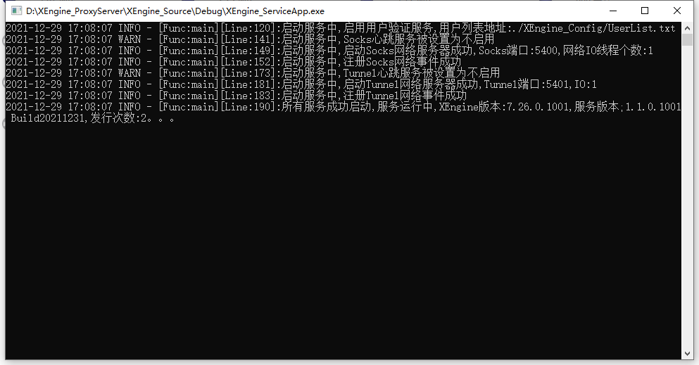

Note: You can run the program directly, the system will prompt you what you need, you can directly enter the XEngine directory to search.

## 2.2 LINUX

Configure complete.you can complie it.open terminal in you source dir and execute command.

complie:make

install:make FLAGS=InstallAll

clean:make FLAGS=CleanAll

If there is no error.you can see complied XEngine_ServiceApp file in XEngine_Release

You can running at terminal.if there is no error,you can infomation:

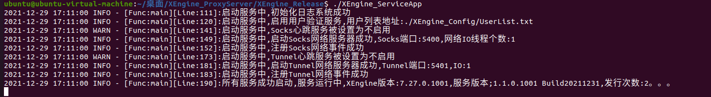

## 2.3 Version Requirements

### 2.3.1 System Version

Minimum version requirements:

WINDOWS: win7 sp1

Ubuntu:20.04

Centos:8.x

### 2.3.2 Software Version

Minimum version requirements:

XEngine:V7.27

# 三 Configure Description

Configure File:XEngine_Config.json

## 3.1 Basic Configure

* tszIPAddr:Service IP Address
* bDeamon:Is Deamon running
* nSocksPort:SOCKS Proxy Port
* nTunnelPort:HTTP Proxy Port

## 3.2 Max Configure

XMax Configure

* MaxClient Allow Max Client Count
* MaxQueue Allow Max Queue
* IOThread:network io process threads number

## 3.3 Time Configure

XTime Configure

* nTimeCheck:check time
* nSocksTimeOut:Socks Heartbeat timeout
* nTunnelTimeOut:Tunnel Heartbeat timeout

## 3.4 Log Configure

Configure Information:XLog

* nMaxSize:max log file size
* nMaxCount:file back number
* nLogLeave:log level
* tszLogFile:log save address

# appendix

## Appendix 1 Type Define

reference file:XEngine_CommHdr.h

## Appendix 2 Protocol Define

reference file:XEngine_ProtocolHdr.h

## Appendix 3 Transformation Definition

reference file:XEngine_Types.h only LINUX