XEngine Service Docment

目录

XEngine Service Docment 1

Preface 4

Reader 4

Overview 4

Associate Module 4

一 Technical structure 4

1.1 TCP 4

1.2 HTTP 4

二 Configure Environment 4

2.1 XEngien Env 4

2.2 Windows 5

2.1.2 complie and run 5

2.2 LINUX 5

2.2.1 Evnironment Configure 5

2.2.2 Complie and Run 5

2.3 Version Requirements 6

2.3.1 System Version 6

2.3.2 Software Version 6

三 Interface Protocol 6

3.1 TCP 6

3.1.1 Example 6

3.2 HTTP 7

3.2.1 Request 7

3.2.2 Reply 7

四 Configure Description 7

4.1 Service Configure 7

4.1.1 basic configure 7

4.1.2 Max Configure 7

4.1.3 Time Configure 8

4.1.4 Log Configure 8

五 Advanced configuration 8

appendix 8

Appendix 1 Type Define 8

Appendix 2 Protocol Define 8

Appendix 3 Transformation Definition 8

Appendix 4 update log 8

|  |  |  |  |
| --- | --- | --- | --- |
| File Status：  [ ] Draft  [√] Release | File Name： | XEngine Service Docment | |
| Be A Version： | V1.0.0.1001 | |
| Released： | 2022-04-22 | |
| Writer： qyt | | |

# Preface

## Reader

Development ,tester,qa

## **Overview**

This document contains related technical descriptions and interface definitions

## Associate Module

The service used XEngine as Network Toolki.if you want to use code,you have to installed XEngine

# 一 Technical structure

The Service implemented through c/c++,protocol through tcp and http.

## TCP

The TCP protocol uses the standard protocol header of XEngine to realize message communication. The TCP protocol is faster and has more functions.

## HTTP

Send and recv Message through post and get method.

# 二 Configure Environment

## 2.1 XEngien Env

Need to download XEngine.

Download address:https://gitee.com/xyry/libxengine

<https://github.com/libxengine/xengine>

Configure the environment as described in the XEngine Readme file

### 2.2 Windows

### 2.1.2 complie and run

When you complete with configuration.you can come in code path.open XEngine.sln by vs

If environment not have error.complie is succesed

And you need copy file under XEngine_Release to your complied dir.next step copy file under XEngine depend module to your complied dir.

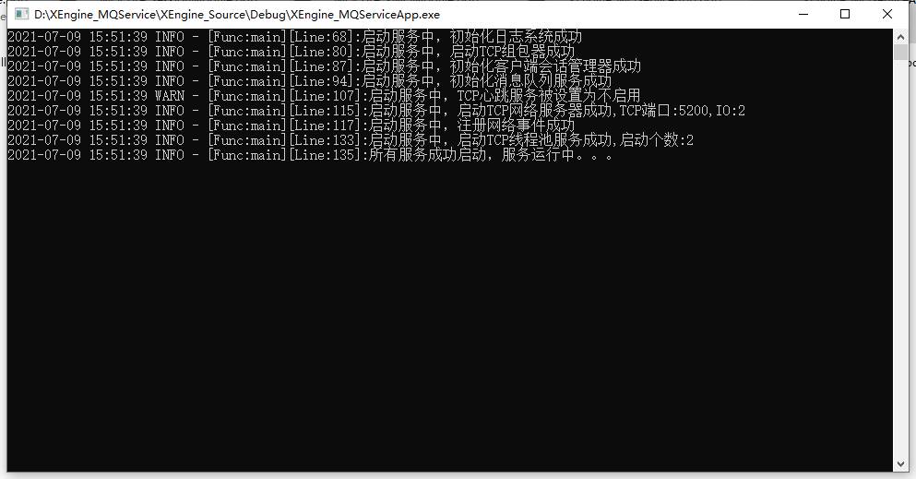

Note: You can run the program directly, the system will prompt you what you need, you can directly enter the XEngine directory to search,you can also use vscopy-*.bat to copy dependent module.

## 2.2 LINUX

### 2.2.1 Evnironment Configure

If you use linux.you must running on ubuntu20.04 or centos8.x(Compatible with Centos-like systems)...

### 2.2.2 Complie and Run

Configure complete.you can complie it.open terminal in you xengine_storage dir and execute command.

complie:make

install:make FLAGS=InstallAll

clean:make FLAGS=CleanAll

If there is no error.you can see complied XEngine_*App file in XEngine_Release

## 2.3 Version Requirements

### 2.3.1 System Version

Minimum version requirements:

WINDOWS: win7 sp1

Ubuntu:20.04

Centos:8.x

### 2.3.2 Software Version

Minimum version requirements:

XEngine:V7.30

# 三 Interface Protocol

## 3.1 TCP

Please Note:The wReserver field of the protocol header will be used as the server reply processing result. 0 means the processing is successful, other values mean failure  
 whether protocol load is general protocol or HTTP protocol,they can be load json data.

### 3.1.1 Example

#### 3.1.1.1 Request

Protocol Header:

Protocol Body:DATA in tail

#### 3.1.1.2 Reply

Protocol Header:

## 3.2 HTTP

### 3.2.1 Request

Method:

Address:

### 3.2.2 Reply

# 四 Configure Description

## 4.1 Service Configure

Basic Configure File:XEngine_Config.json

### 4.1.1 basic configure

* tszIPAddr: location ip address
* bDeamon: 1 deamon process run 0 is terminal run
* nCenterPort:tcp port
* nHttpPort:http port
* nHttp2Port:HTTP2 port
* nWSPort:websocket port

### 4.1.2 Max Configure

XMax Configure

* nMaxClient Allow Max Client Count
* nMaxQueue Allow Max Queue
* nIOThread:network io process threads number
* nCenterThread:tcp process threads number
* nHttpThread:http process threads number
* nHttp2Thread:http2 process threads number
* nWSThread:websocket process threads number

### 4.1.3 Time Configure

XTime Configure

* nTimeCheck:check time
* nCenterTimeOut:how time check once
* nHttpTimeOut:same nTCPTimeOut
* nHttp2TimeOut:HTTP2 client timeout
* nWSTimeOut:websocket client timeout

### 4.1.4 Log Configure

XLog Configure

* MaxSize:Log file size
* MaxCount:Log File Number
* LogLeave:Allow save level

# 五 Advanced configuration

# appendix

## Appendix 1 Type Define

reference file:XEngine_CommHdr.h

## Appendix 2 Protocol Define

reference file:XEngine_ProtocolHdr.h

## Appendix 3 Transformation Definition

reference file:XEngine_Types.h only LINUX

## Appendix 4 update log