- WebContent\moduleIndex.html
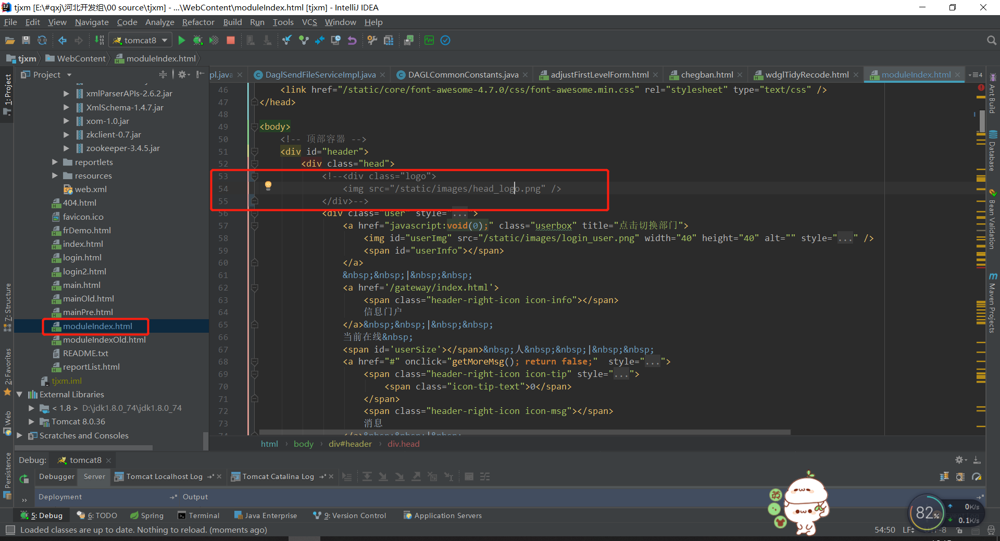
- WebContent\main.html
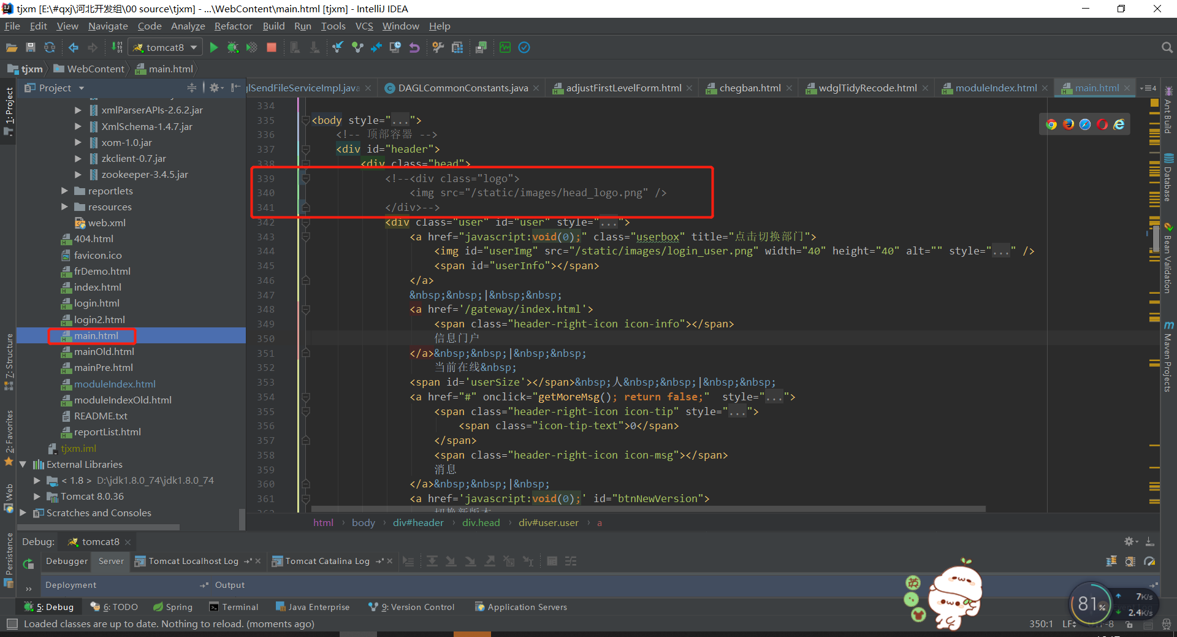
- WebContent\gateway\index.html
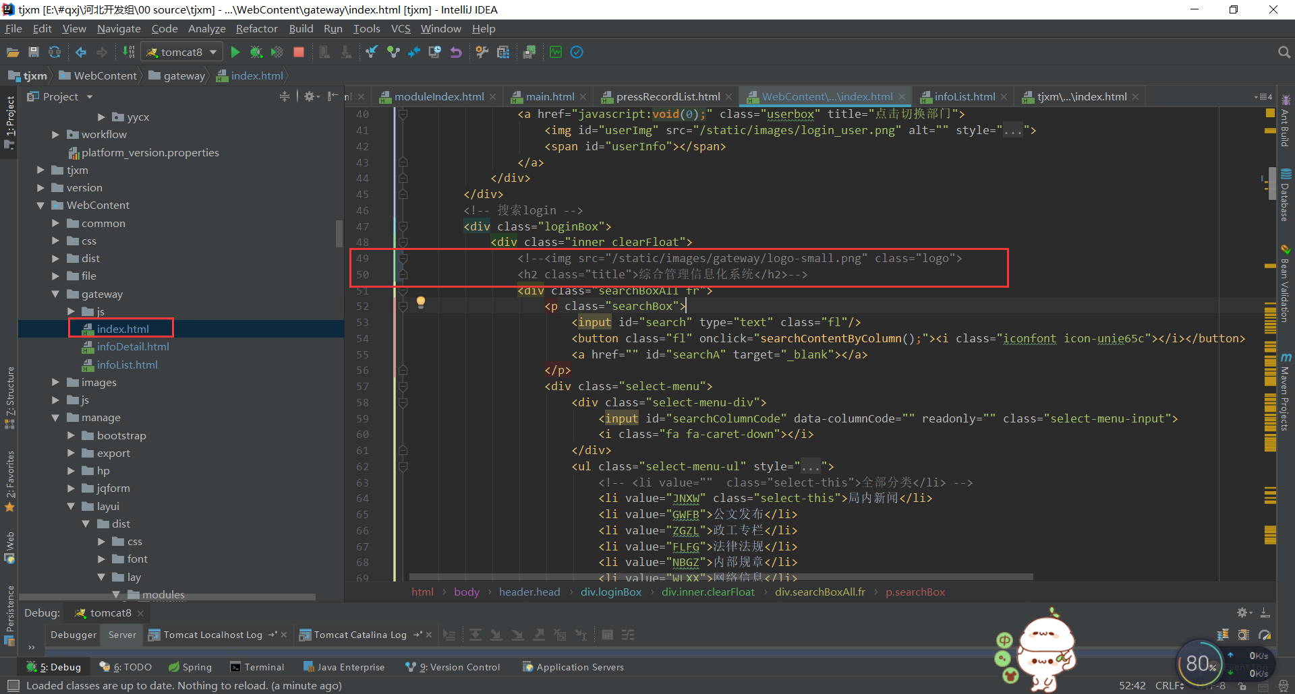
- WebContent\gateway\infoDetail.html
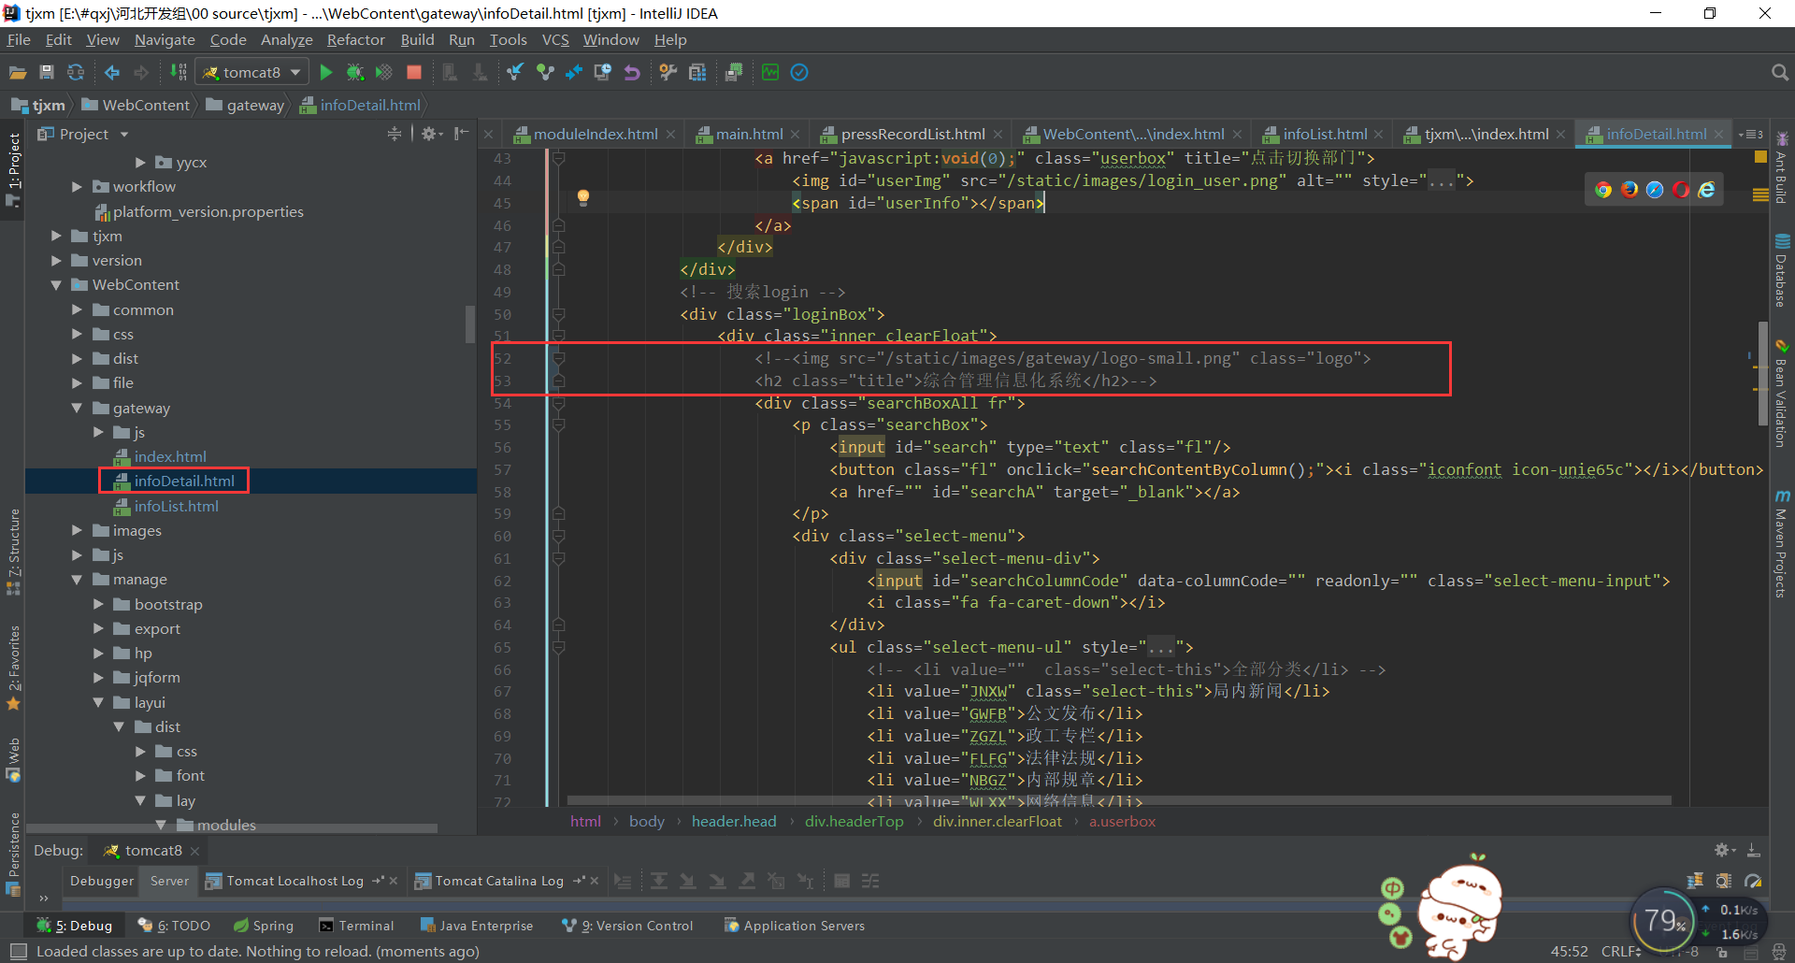
- WebContent\gateway\infoList.html
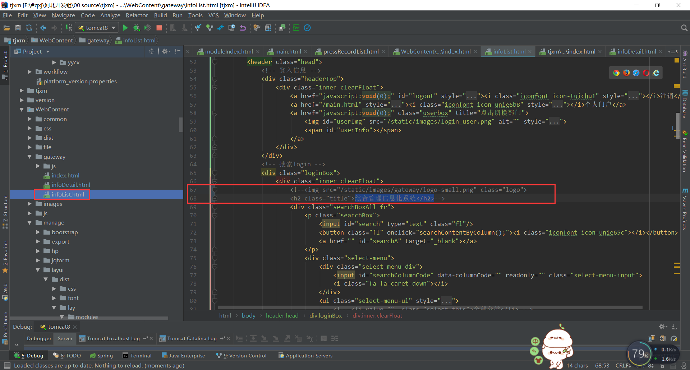
- WebContent\modules\video\index.html
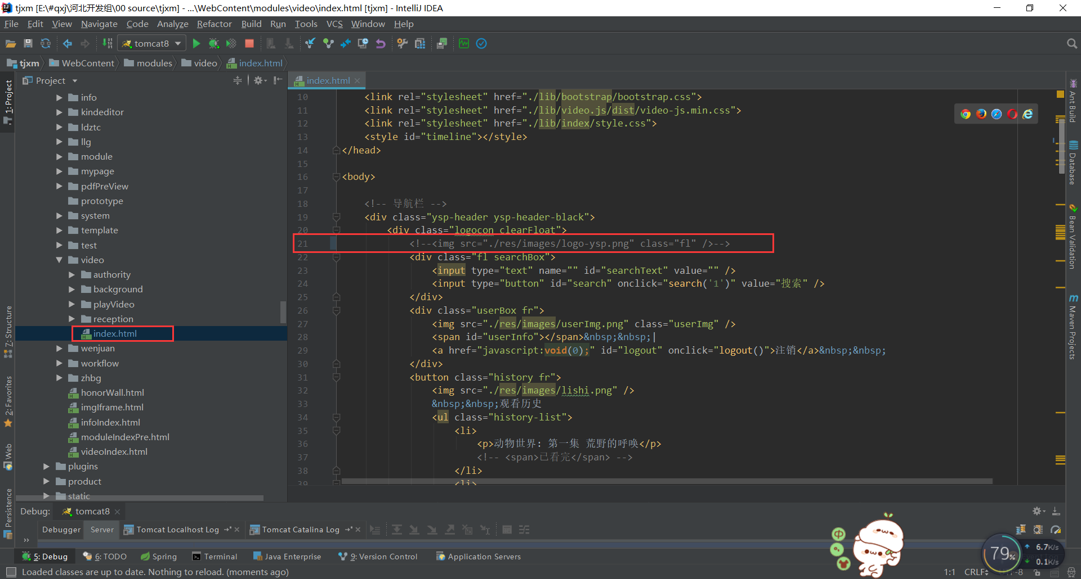
- WebContent\modules\video\reception\videoHomePage.html
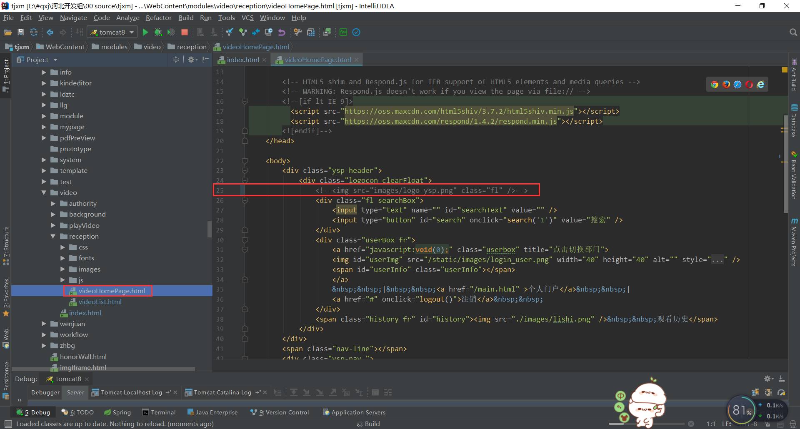
- WebContent\modules\video\reception\videoList.html
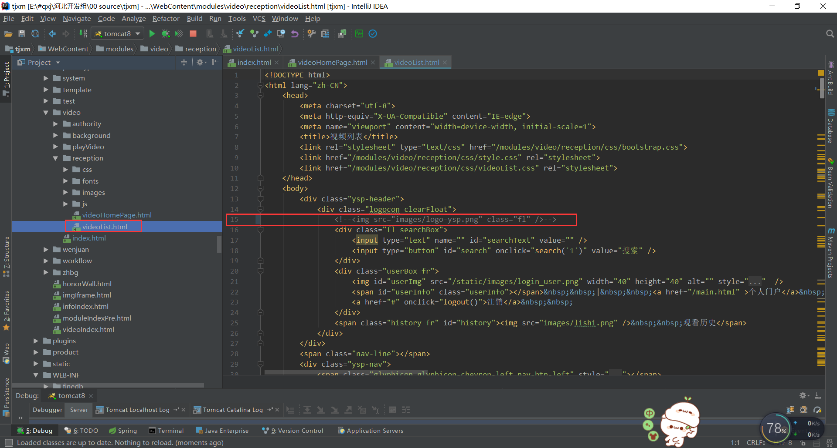
- WebContent\modules\video\playVideo\index.html
