实验3 JSP技术应用
班级：20物联网工程 | 姓名：李欣 | 成绩：

一、实验目的

（1）掌握JSP页面中的各种语法元素。

（2）掌握JSP页面中的隐式对象的使用。
- 掌握JSP页面与Servlet的数据交互。

二、实验内容及要求
编写jsp文件login.jsp，exam.jsp.jsp，result.jsp， 分别完成登录、考试、显示考试结果，Servlet文件ExamServlet完成考试处理。要求：
- 在考试页面中显示谁进入考试。
- 显示结果页面中显示谁考试多少分。
登录页面如图3-1所示。
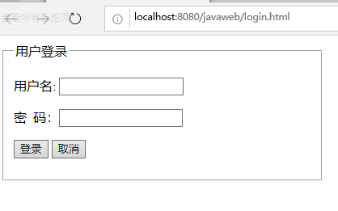
图3-1登录页面
考试页面如图3-2所示。
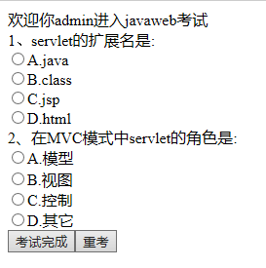
图3-2考试页面
考试结果页面如图3-3所示。
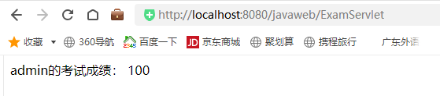
图3-3考试结果页面

三、实验代码
Login.jsp
<%--
Created by IntelliJ IDEA.
User: Administrator
Date: 2023/5/11
Time: 10:43
To change this template use File | Settings | File Templates.
--%>
<%@ page contentType="text/html;charset=UTF-8" language="java" %>
<html>
<head>
<title>Title</title>
</head>
<body>
<fieldset>
<table width="500" height="150" align="left">
<legend>用户登录</legend>
<form action="loginServlet" method="post">
<tr>
<td align="left">
用户名：<input type="text" name="name">
</td>
</tr>
<tr>
<td align="left">
密&nbsp;&nbsp;&nbsp;&nbsp;码：<input type="password" name="pwd">
</td>
</tr>
<tr>
<td>
<input type="submit" value="登录"><input type="reset" value="取消">
</td>
</tr>
</form>
</table>
</fieldset>
</body>
</html>

example.jsp
<%@ page import="javax.swing.*" %><%--
Created by IntelliJ IDEA.
User: Administrator
Date: 2023/5/11
Time: 11:09
To change this template use File | Settings | File Templates.
--%>
<%@ page contentType="text/html;charset=UTF-8" language="java" %>
<html>
<head>
<title>Title</title>
</head>
<body>
<%
Object name = session.getAttribute("name");
if(name == null){
JOptionPane.showMessageDialog(null,"请先登录");
RequestDispatcher rd = request.getRequestDispatcher("login.jsp");
rd.forward(request,response);
}
else {
String sname = name.toString();
out.write("欢迎你"+sname +"进入javaweb考试");
}
%>
<form action="exampleServlet" method="post">
<table>
<tr>
<td>1.servlet的扩展名是:</td>
</tr>
<tr>
<td><input type="radio" name="1" value="1">A.java</td>
</tr>
<tr>
<td><input type="radio" name="1" value="2">B.class</td>
</tr>
<tr>
<td><input type="radio" name="1" value="3">C.jsp</td>
</tr>
<tr>
<td><input type="radio" name="1" value="4">D.html</td>
</tr>
<tr>
<td>2.在MVC模式中servlet的角色是:</td>
</tr>
<tr>
<td><input type="radio" name="2" value="1">A.模型</td>
</tr>
<tr>
<td><input type="radio" name="2" value="2">B.视图</td>
</tr>
<tr>
<td><input type="radio" name="2" value="3">C.控制</td>
</tr>
<tr>
<td><input type="radio" name="2" value="4">D.其他</td>
</tr>
<tr>
<td><input type="submit" value="考试完成"><input type="reset" value="重考"></td>
</tr>
</table>
</form>
</body>
</html>

result.jsp
<%--
Created by IntelliJ IDEA.
User: Administrator
Date: 2023/5/11
Time: 11:28
To change this template use File | Settings | File Templates.
--%>
<%@ page contentType="text/html;charset=UTF-8" language="java" %>
<html>
<head>
<title>Title</title>
</head>
<body>
<%
String name = session.getAttribute("name").toString();
String result = session.getAttribute("result").toString();
out.write(name+"的考试成绩:"+result);
%>
</body>
</html>

exampleServlet
package javaclass.c3_text;
import javax.servlet.RequestDispatcher;
import javax.servlet.ServletException;
import javax.servlet.annotation.WebServlet;
import javax.servlet.http.HttpServlet;
import javax.servlet.http.HttpServletRequest;
import javax.servlet.http.HttpServletResponse;
import javax.servlet.http.HttpSession;
import java.io.IOException;
@WebServlet(name = "exampleServlet",urlPatterns = "/javaclass/c3_text/exampleServlet")
public class exampleServlet extends HttpServlet {
protected void doPost(HttpServletRequest request, HttpServletResponse response) throws ServletException, IOException {
String ans1 = request.getParameter("1");
String ans2 = request.getParameter("2");
int k = 0;//答题正确数
if(ans1.equalsIgnoreCase("1")){
k++;
}
if(ans2.equalsIgnoreCase("3")){
k++;
}
int score = k*50;
HttpSession session = request.getSession();
session.setAttribute("result",score);
RequestDispatcher rd = request.getRequestDispatcher("result.jsp");
rd.forward(request,response);
}
protected void doGet(HttpServletRequest request, HttpServletResponse response) throws ServletException, IOException {
}
}

loginServlet
package javaclass.c3_text;
import javax.servlet.RequestDispatcher;
import javax.servlet.ServletException;
import javax.servlet.annotation.WebServlet;
import javax.servlet.http.HttpServlet;
import javax.servlet.http.HttpServletRequest;
import javax.servlet.http.HttpServletResponse;
import javax.servlet.http.HttpSession;
import javax.swing.*;
import java.io.IOException;
@WebServlet(name = "loginServlet", urlPatterns = "/javaclass/c3_text/loginServlet")
public class loginServlet extends HttpServlet {
protected void doPost(HttpServletRequest request, HttpServletResponse response) throws ServletException, IOException {
request.setCharacterEncoding("utf-8"); //设置用户提交信息的编码
String name = request.getParameter("name");
String pwd = request.getParameter("pwd");
if (name.equalsIgnoreCase("admin") &&pwd.equalsIgnoreCase("123")){
HttpSession session = request.getSession();
session.setAttribute("name",name);
RequestDispatcher rd = request.getRequestDispatcher("example.jsp");
rd.forward(request,response);
}
else {
JOptionPane.showMessageDialog(null,"登录"+"信息有误，请重新登陆");
RequestDispatcher rd = request.getRequestDispatcher("login.jsp");
rd.forward(request,response);
}
}
protected void doGet(HttpServletRequest request, HttpServletResponse response) throws ServletException, IOException {
}
}

四、实验运行截图
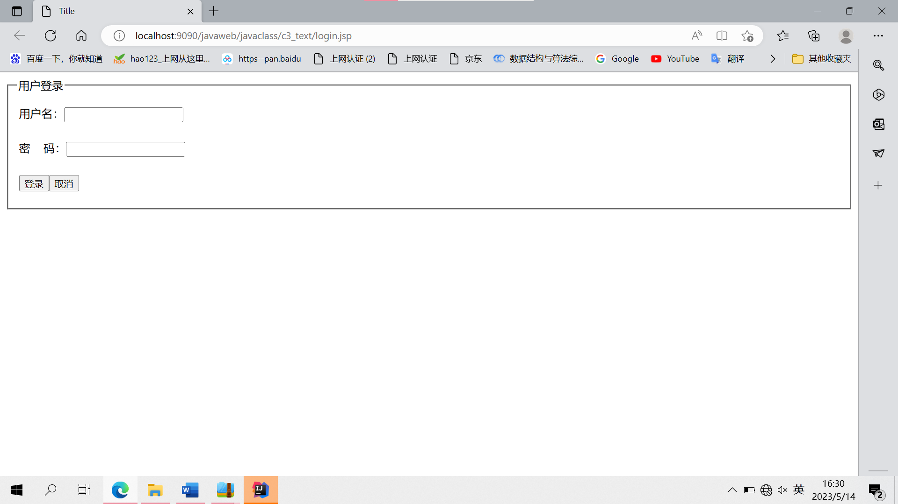
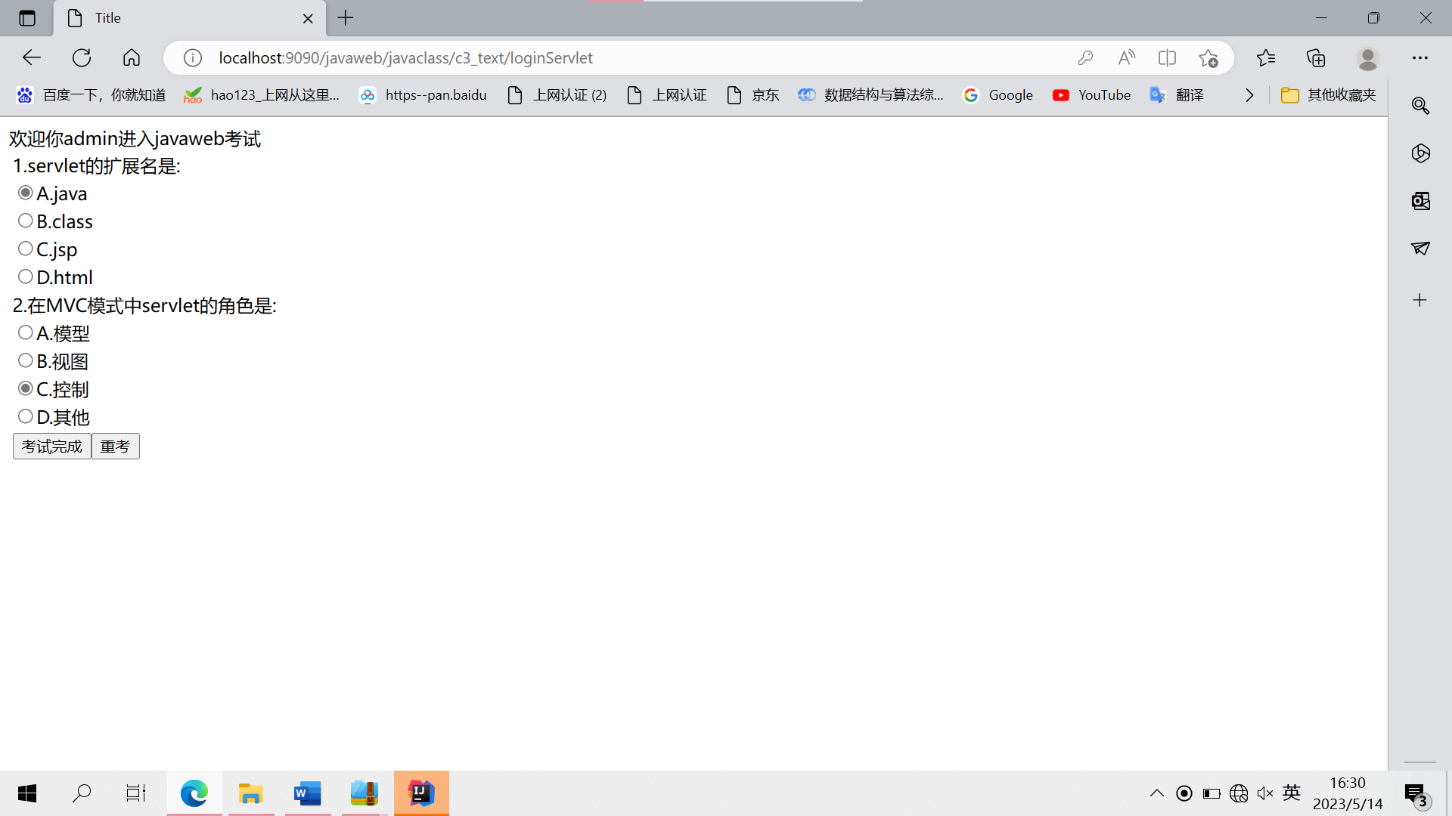
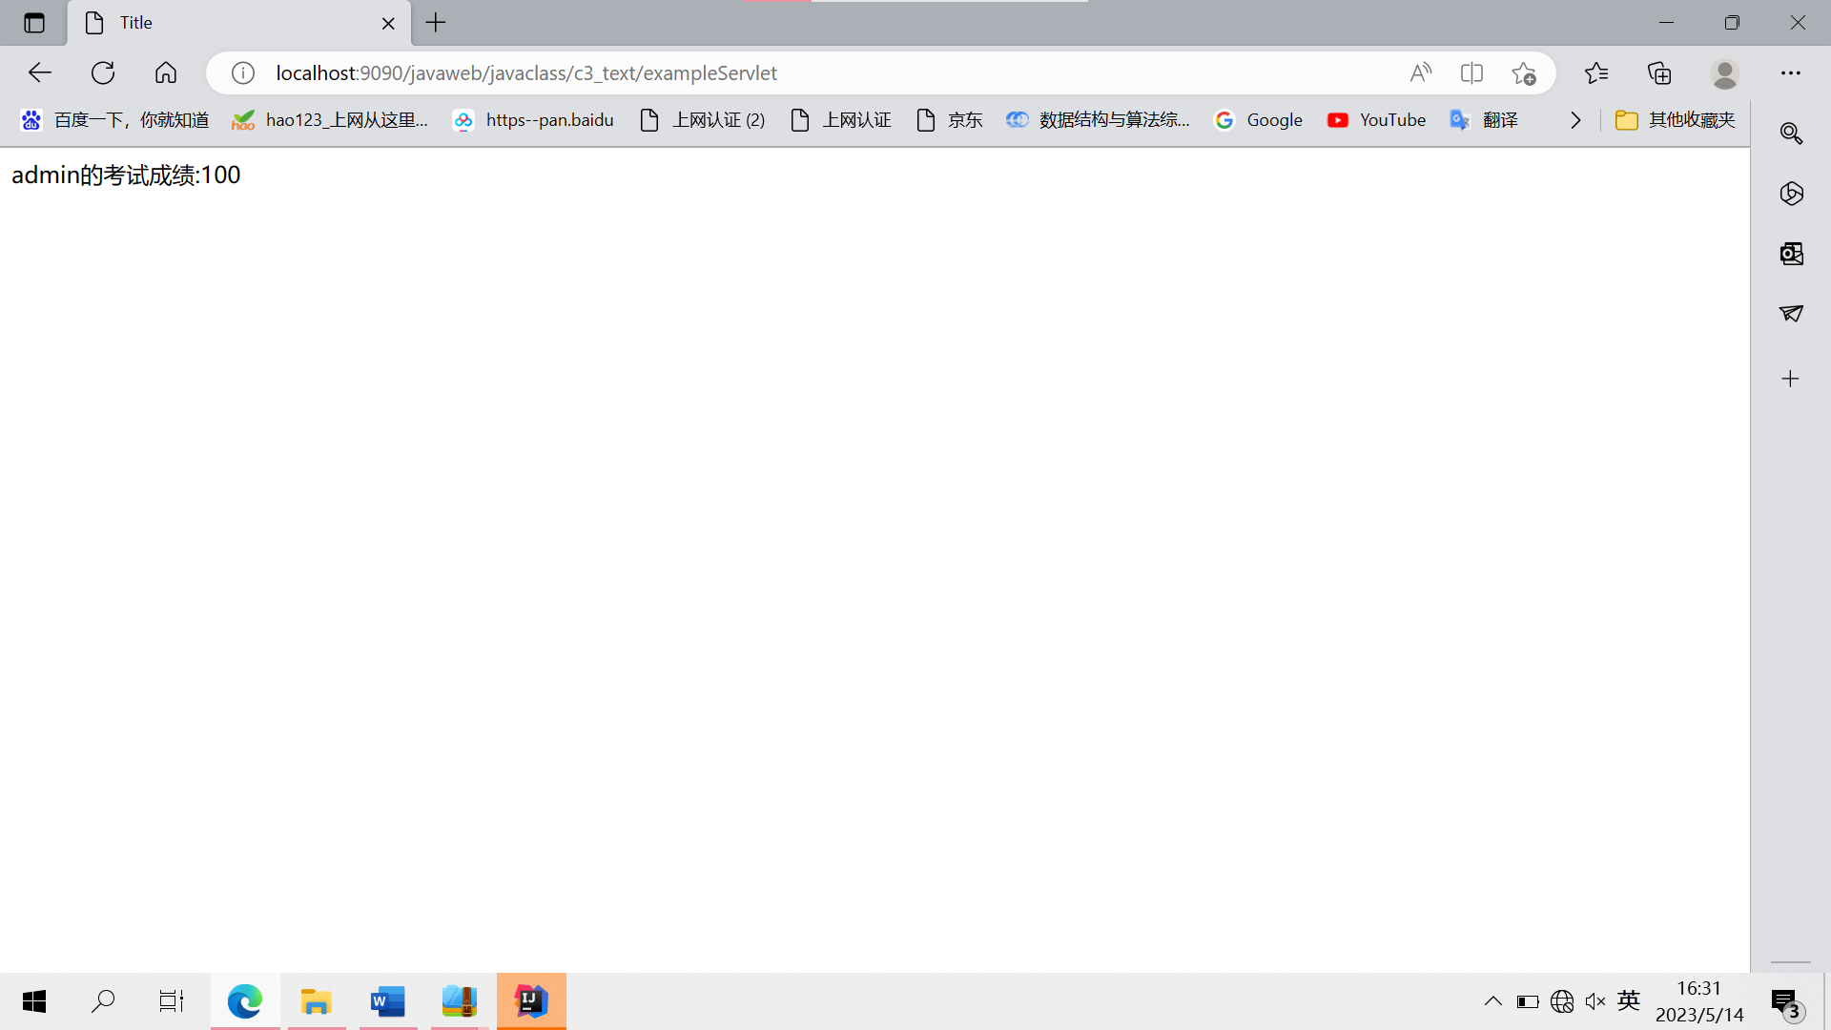

五、实验总结体会
Servle和jap的创建和运用，要积累很多知识点。通过这次实验，我对使用 IDEA开发jsp技术应用掌握地更加牢固了。

