**Project # 1: Spatial and Frequency Filtering**  
*CSC 391: Computer Vision*  
Caroline Li  
February 6, 2019

**3.2.1 Smoothing and denoising**

Below are the result of using the Gaussian and median filters of different sizes on the noisiest puppy image. As we can see, the larger the filter the smoother the image becomes so the less information we have about the subject for both filters. Comparing the 27 x 27 Gaussian filter with the 27 x 27 median filter, the Gaussian filter appears to make the whole image look equally blurry while the median filter appears smooth in areas of similar colors and intensities, and maintains sharp edges in areas such as where the white blanket touches the dark background, or where the puppy’s dark ear is next to its white fur. So the median filter appears to maintain sharp edges where there’s a clear distinction between different values, but only if these are large areas; if we look at where the puppy’s eyes are, it’s hard to see where exactly they are, which may be a result of the size of the filter.

|  |  |
| --- | --- |
| **Gaussian Filter** | **Median Filter** |
| 3 x 3 | 3 x 3 |
| 9 x 9 | 9 x 9 |
| 27 x 27 | 27 x 27 |

If we look at how running these filters on less noisy images and compare, we can see that the results from the Gaussian filter are pretty similar, whereas with the median filter on the less noisy image, we can see even more edges such as the top of the puppy’s head and in the puppy’s shadow, and edges that we see in the noisier image are even more sharp in the less noisy image.

|  |  |
| --- | --- |
| **27 x 27 Gaussian Filter** | **27 x 27 Median Filter** |
| 0.02 Noisy Image | 0.02 Noisy Image |
| 0.50 Noise Image | 0.50 Noisy Image |

**3.2.2 Edge detection**

Using the Canny edge detector with the non-noisy image, we can see outlines of the puppy’s ear, nose, coat, and the blanket. With the noisy image, however, edge detection appears to be random noise.

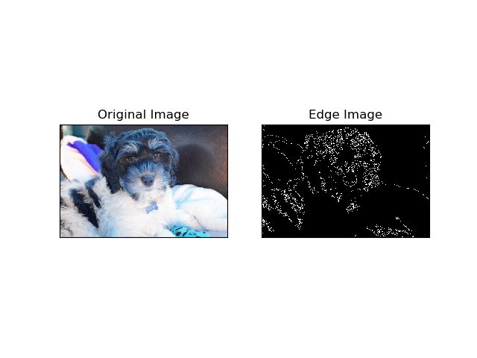

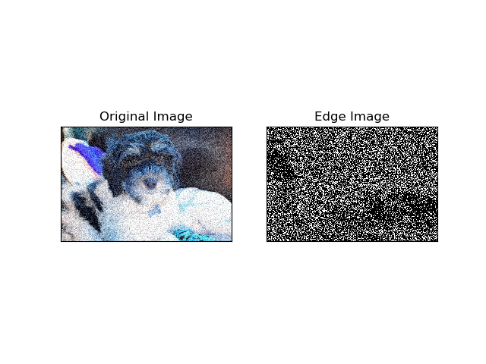

With the field images, while vegetation appears quite noisy, it is easy to distinguish where there is a body of water or a road.

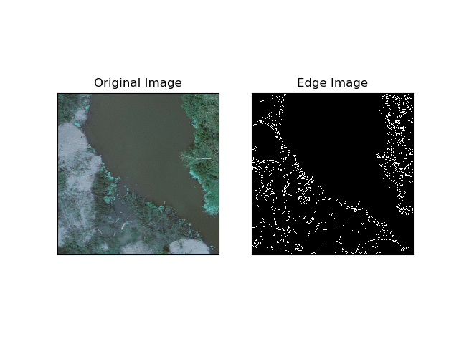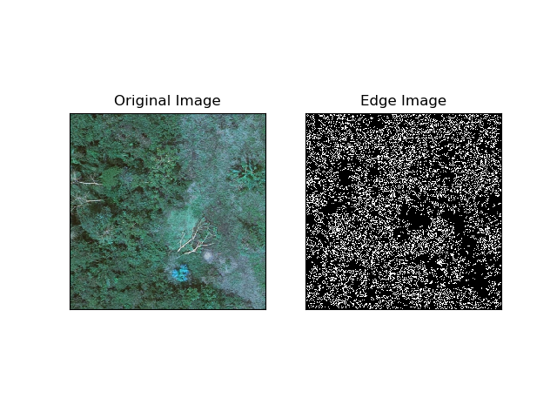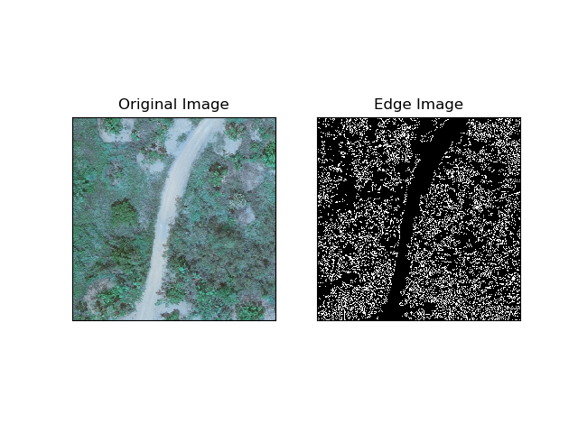

**4.2 Frequency Analysis**

Below is a comparison of the Fourier coefficients for the original and noisy image of the puppy. We can see that these images are fairly similar, though the noisy image has more values further away from zero which is likely because of the added noise. The difference doesn’t appear that great in these plots aside from some of the values being further away from the center in the noisy image.

|  |  |
| --- | --- |
|  |  |
| Original Image | Noisy Image |

Below are comparisons using the field images. We see that for the first two images, the Fourier coefficients show higher values around 0, probably because of the contrast between the foliage and sand, as well as the foliage and the dark body of water, in comparison to just foliage in the last picture shown.

|  |  |
| --- | --- |
| **Image** | **Fourier Coefficients** |
| window-00-02 |  |
| window-00-04 |  |
| window-00-06 |  |

When comparing the log plots of the magnitude of the Fourier coefficients between the original and noisy images of the puppy, we can see that the noisier the image is, the higher the values are away from the image. This is because of the added noise in the image, which disperses light and dark values all over the image, thus altering the magnitudes that we see.

|  |  |
| --- | --- |
|  |  |
| Original Image | Noisy Image |

The following images show the puppy image when lower frequencies are zeroed out and higher frequencies are zeroed out. With lower frequencies zeroed out, we can clearly see different edges in the image, which would be useful for edge detection. With the higher frequencies zeroed out, we can see that the image is smoother, however it does contain artifacts.

|  |  |
| --- | --- |
|  |  |
| Zeroed Low Frequencies  (Ideal High-Pass Filter) | Zeroed High Frequencies  (Ideal Low-Pass Filter) |

**5.2 Low-pass and High-pass Filtering**

When comparing high-pass versus low-pass filters, we see that high-pass filters detect edges while low-pass filters smooth the image. When comparing ideal versus Butterworth filters, we see that there’s some artifacts with the ideal filter while the Butterworth filters are sharp and exact, or equally smooth for high-pass and low-pass filters, respectively.

|  |  |
| --- | --- |
|  |  |
| Ideal High-Pass Filter on original image | Ideal Low-Pass Filter on original image |
|  |  |
| Butterworth High-Pass Filter on original image | Butterworth Low-Pass Filter on original image |

If we compare these same filters run on the noisy image, we can still see the same differences between the filters. With added noise, results from the low-pass filters look pretty similar to those of the original image, but with the high-pass filter, it is a little harder to see edges from the image.

|  |  |
| --- | --- |
|  |  |
| Ideal High-Pass Filter on noisy image | Ideal Low-Pass Filter on noisy image |
|  |  |
| Butterworth High-Pass Filter on noisy image | Butterworth Low-Pass Filter on noisy image |