Low Level Design

**Instant Chatters**

**Group - 1**

Vibhu Bhardwaj

Licency Patel

Sukanya Pradhan

Laxmi Kant Singh

Jangam Jonas Edward

Revision Number: 3.0

Last date of revision: 18-10-2022

**Contents**

1. **Introduction**
   1. Goals
2. **Data Flow Diagram**
3. **Modules**

**3.1 Server side modules**

3.1.1 Removing next line character

3.1.2 Clear output buffer

3.1.3 Adding all clients joined in queue

3.1.4 Removing clients from existing queue

3.1.5 Send messages to clients

3.1.6 Handling client communication

3.1.6.1 Validating client

**3.2 Client side modules**

3.2.1 Clear output buffer

3.2.2 Removing next line character

3.2.3 Receiving signal to interrupt

3.2.4 Sending messages to server

3.2.5 Receiving messages from server

**3.3 Search chat history**

# **Introduction**

* 1. **Goals**
  + The role of a server is to store, send and receive data. It provides services to the clients that get connected to it.
  + It has a structure sockaddr_in that stores the information about the server and a client_t structure that stores the client's information.
  + As usual, the server binds to a particular IP address and port no. and waits for connections from clients.
  + It accepts the request from the client that they want to get connected with and all of them get added up in a queue.
  + The server has a record of all the clients that are connected to it. If the client is a new user, the server sends a message for registration.
  + It provides two services to the user. A user can either have a private chat with another client or a large group depending on with whom he shares the Ip and port.
  + Here, Multithreading is used to handle multiple clients with the help of POSIX threads.
  + We declare a variable called tid, which is of type pthread_t, which is an integer used to identify the thread in the system. After declaring tid, we call the pthread_create() function to create a thread. The pthread_join() function for threads is the equivalent of wait() for processes.
  + A mechanism known as "thread synchronization" prevents two or more concurrent processes or threads from running a specific program segment known as a "critical section" at the same time. When the lock is set, no other thread can access the locked region of the code and release it when done with the execution.

**2. Dataflow diagram**

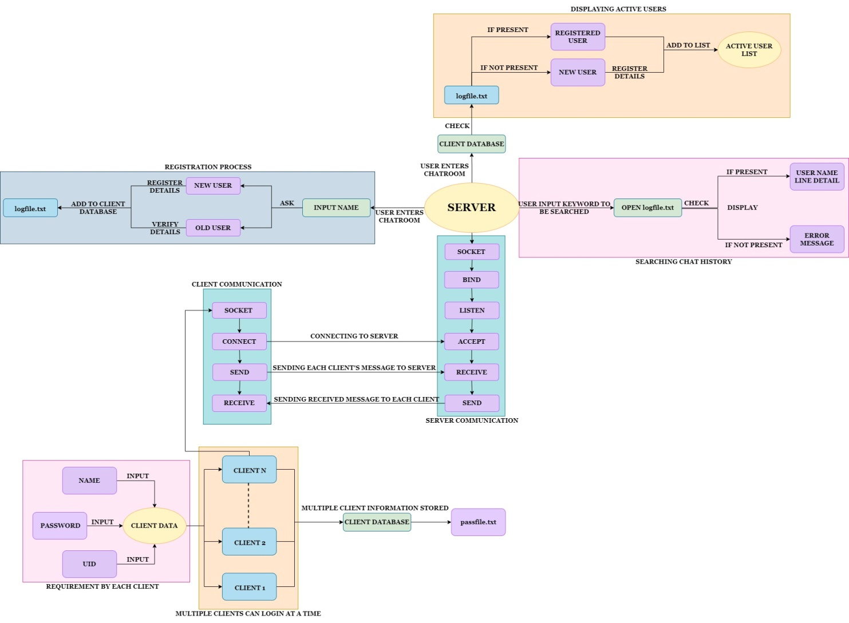

**3. Modules**

**3.1 SERVER SIDE MODULES:**

**3.1.1 Removing the next line character from the messages.**

| **Name** | str_trim_lf() | | |
| --- | --- | --- | --- |
| **Input** | **Parameters-**  Array, length | **Type-**  Character pointer,  Integer | **Comments-**The function takes an array and its length as an input |
| **Output** | Stores the string without the ‘\n’ character. | Void | Replaces ‘\n’ character with ‘\0’ |
| **Process** | This function is to trim the next line character from the buffer. | | |

* + 1. **Clear Output Buffer**

| **Name** | str_overwrite_stdout() | | |
| --- | --- | --- | --- |
| **Input** | Parameters- | Type- | Comments-  No input |
| **Output** |  | void | - |
| **Process** | Its purpose is to clear (or flush) the output buffer and move the buffered data to console or disk. | | |

* + 1. **Adding up all the clients joined in a queue.**

| **Name** | queue_add() | | |
| --- | --- | --- | --- |
| **Input** | Parameters-  Pointer of type client_t structure | Type-  Client_t | Comments-  This function takes a pointer of type client_t structure as an input. |
| **Output** | - | void | Updates all the clients according to the client_t structure. |
| **Process** | The function Add clients to clients array | | |

* + 1. **Removing the clients from the existing queue.**

| **Name** | queue_remove() | | |
| --- | --- | --- | --- |
| **Input** | Parameters-  Userid(uid) | Type-  integer | Comments-.  This function takes the user id as input. |
| **Output** | None | void | Comments- |
| **Process** | This function removes clients from the clients array. | | |

* + 1. **Send messages to the clients**

| **Name** | send_message() | | |
| --- | --- | --- | --- |
| **Input** | Parameters-  s(pointer)  uid  status | Type-  Character  Integer  character |  |
| **Output** | - | void | -Message gets sent to other clients having same status |
| **Process** | This function is used to send messages between clients who all have the same status  except the sender. | | |

* + 1. **Handling client communication**

| **Name** | handle_client() | | |
| --- | --- | --- | --- |
| **Input** | Parameters-  arg(client’s structure which is a structure pointer) | Type-  void |  |
| **Output** | None | - | - |
| **Process** | This function handles all client communication (sending and receiving messages and files) and also helps store chat history into a file. | | |

* + - 1. **Validating client**

| **Name** | handle_client() | | |
| --- | --- | --- | --- |
| **Input** | Parameters-  arg(client’s structure which is a structure pointer) | Type-  void |  |
| **Output** | None | - | - |
| **Process** | This function will ask the user whether the user is registered or not. If user is registered, open passfile.txt and search for the matching user name and password. If the match is found, user can enter the chatroom or else login denied. | | |

* 1. **CLIENT SIDE MODULES-**

**3.2.1 Clear Output Buffer**

| **Name** | str_overwrite_stdout() | | |
| --- | --- | --- | --- |
| **Input** | Parameters- | Type- | Comments-  No input |
| **Output** |  | void | - |
| **Process** | Its purpose is to clear (or flush) the output buffer and move the buffered data to console or disk. | | |

**3.2.2 Removing the next line character from the messages.**

| **Name** | str_trim_lf() | | |
| --- | --- | --- | --- |
| **Input** | **Parameters-**  Array, length | **Type-**  Character pointer,  Integer | **Comments-**The function takes an array and its length as an input |
| **Output** | Stores the string without the ‘\n’ character. | Void | Replaces ‘\n’ character with ‘\0’ |
| **Process** | This function is to trim the next line character from the buffer. | | |

**3.2.3 Receiving signal to interrupt**

| **Name** | catch_ctrl_and_exit() | | |
| --- | --- | --- | --- |
| **Input** | Parameters-  - | Type-  - | - |
| **Output** | - | void | - |
| **Process** | The function enables the client to log out from the session. | | |

**3.2.4 Sending messages to the server**

| **Name** | send_msg_handler() | | |
| --- | --- | --- | --- |
| **Input** | Parameters-  None | Type-  int | Comments- |
| **Output** | None | - | Makes use of the socket to send messages from the client to server after connection has been made |
| **Process** | This function is used to send messages to the server from the client. | | |

**3.2.5 Receive a message sent from the server**

| **Name** | receive_msg_handler() | | |
| --- | --- | --- | --- |
| **Input** | Parameters-  None | Type- | Comments |
| **Output** | No output by itself | void | Makes use of the socket to receive messages from the server after connection has been made |
| **Process** | This function enables the client to receive the message from the server. | | |

* 1. **SEARCH CHAT HISTORY**

| **Name** | main() | | |
| --- | --- | --- | --- |
| **Input** | Parameters-  None | Type- | Comments |
| **Output** | None | - | Makes use of the logfile.txt to search chat history when a user enter a keyword. |
| **Process** | This function will search the chat history file for a particular keyword entered by the user and if found, is displayed. | | |