尝试添加自定义组件
1.添加自定义组件至调色板界面
org.jbpm.gd.common.editor.GraphPage 是用来定义图形设计器diagram界面外观的，
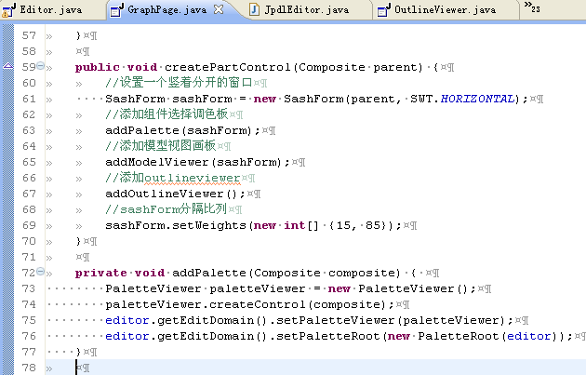

定义调色板是在paletteroot中，
public class PaletteRoot extends org.eclipse.gef.palette.PaletteRoot {
//所属的父editor
private Editor editor;
//存放类别
private List categoryList = new ArrayList();
//以类别名为键存放该类别的实体，实体list为值
private Map categoryMap = new HashMap();

public PaletteRoot(Editor editor) {
this.editor = editor;
addControls();
}

private void addControls() {
//添加默认组件（选择箭头 和 节点选择框）
add(createDefaultControls());
//从扩展点org.jbpm.gd.jpdl.palette 拿出配置元素
IConfigurationElement[] configurationElements =
Platform.getExtensionRegistry().getConfigurationElementsFor("org.jbpm.gd.jpdl.palette");
for (int i = 0; i < configurationElements.length; i++) {
String editorClass = configurationElements[i].getAttribute("editorClass");
//查看是否是匹配的编辑器
if (editorClass != null && editorClass.equals(editor.getClass().getName())) {
//添加元素至categoryList categoryMap
processPaletteContribution(configurationElements[i]);
}
}
for (int i = 0; i < categoryList.size(); i++) {
IConfigurationElement categoryElement = (IConfigurationElement)categoryList.get(i);
//把类别拼接上包名
String categoryName = categoryElement.getNamespaceIdentifier() + "." + categoryElement.getAttribute("id");
List entries = (List)categoryMap.get(categoryName);
if (entries != null && !entries.isEmpty()) {
//每个非空类别创建一个group
PaletteGroup paletteGroup = new PaletteGroup(categoryName);
for (int j = 0; j < entries.size(); j++) {
IConfigurationElement entryElement = (IConfigurationElement)entries.get(j);
String icon = entryElement.getAttribute("icon");
//实体名为包名+id
String entryName = entryElement.getNamespaceIdentifier() + "." + entryElement.getAttribute("id");
String label = entryElement.getAttribute("label");
boolean isNode = !"false".equals(entryElement.getAttribute("node"));
String object = entryElement.getAttribute("object");
String tooltip = entryElement.getAttribute("tooltip");
PaletteEntry entry;
//创建工厂 内部3个字段 elementId semanticElementFactory notationElementFactory
CreationFactory factory = new CreationFactory(object, editor.getSemanticElementFactory(), editor.getNotationElementFactory());
//只有transition不是节点
if (isNode) {
entry = new CreationToolEntry(label, tooltip, factory, getIconDescriptor(icon), null);
} else {
entry = new ConnectionCreationToolEntry(label, tooltip, factory, getIconDescriptor(icon), null);
}
entry.setId(entryName);
paletteGroup.add(entry);
}
add(paletteGroup);
}
}
}

private ImageDescriptor getIconDescriptor(String icon) {
return ImageDescriptor.createFromURL(Plugin.getDefault().getBundle().getEntry("/" + icon));
}

private void processPaletteContribution(IConfigurationElement configurationElement) {
IConfigurationElement[] elements;
//拿出类别子节点
elements = configurationElement.getChildren("category");
//添加至categoryList
for (int i = 0; i < elements.length; i++) {
categoryList.add(elements[i]);
}
//拿出实体子节点
elements = configurationElement.getChildren("entry");
for (int i = 0; i < elements.length; i++) {
//查看categoryMap中有没有实体所属该类别，categoryMap是【category，list】，list中存放的是具体的该类别的实体
//没有该实体所属类别的list就创建一个，并把该实体存入
List list = (List)categoryMap.get(elements[i].getAttribute("category"));
if (list == null) {
list = new ArrayList();
categoryMap.put(elements[i].getAttribute("category"), list);
}
list.add(elements[i]);
}
}

//NotationMapping帮助类
public class NotationMapping {

//【semanticElement，configurationElements】
private static Map NOTATION_MAPPINGS;
//【semanticElementId，notationElement】
private static HashMap NOTATION_ELEMENT_MAP = new HashMap();
//节点的图形面信息,没有定义的话为null
private static HashMap INITIAL_DIMENSION_MAP = new HashMap();
//是否 hide name，没有定义的话为false
private static HashMap HIDE_NAME_MAP = new HashMap();

private static Map getNotationMappings() {
if (NOTATION_MAPPINGS == null) {
initializeNotationMappings();
}
return NOTATION_MAPPINGS;
}

private static void initializeNotationMappings() {
NOTATION_MAPPINGS = new HashMap();
//拿到org.jbpm.gd.jpdl.notationMappings的元素
IConfigurationElement[] configurationElements =
Platform.getExtensionRegistry().getConfigurationElementsFor("org.jbpm.gd.jpdl.notationMappings");
for (int i = 0; i < configurationElements.length; i++) {
if (configurationElements[i].getName().equals("mapping")) {
NOTATION_MAPPINGS.put(
configurationElements[i].getAttribute("semanticElement"),
configurationElements[i]);
}
}
}

//【semanticElementId，notationElement】
public static String getNotationElementId(String semanticElementId) {
if (!NOTATION_ELEMENT_MAP.containsKey(semanticElementId)) {
IConfigurationElement element = (IConfigurationElement)getNotationMappings().get(semanticElementId);
NOTATION_ELEMENT_MAP.put(semanticElementId, element.getAttribute("notationElement"));
}
return (String)NOTATION_ELEMENT_MAP.get(semanticElementId);
}
//拿到图形信息
public static Dimension getInitialDimension(String semanticElementId) {
if (!INITIAL_DIMENSION_MAP.containsKey(semanticElementId)) {
processFigureElement(semanticElementId);
}
return (Dimension)INITIAL_DIMENSION_MAP.get(semanticElementId);
}

//存储该元素的figure相关信息
private static void processFigureElement(String semanticElementId) {
//拿到元素的figure子节点
IConfigurationElement[] children =
((IConfigurationElement)getNotationMappings().get(semanticElementId)).getChildren("figure");
Dimension dimension = null;
Boolean hideName = Boolean.FALSE;
//如果有该figure子节点得话 就赋值给 dimension hideName
if (children.length == 1) {
dimension =
new Dimension(
Integer.parseInt(children[0].getAttribute("width")),
Integer.parseInt(children[0].getAttribute("height")));
hideName = new Boolean(children[0].getAttribute("hideName") == null ? "false" : children[0].getAttribute("hideName"));
}
INITIAL_DIMENSION_MAP.put(semanticElementId, dimension);
HIDE_NAME_MAP.put(semanticElementId, hideName);
}

public static boolean hideName(String semanticElementId) {
if (!HIDE_NAME_MAP.containsKey(semanticElementId)) {
processFigureElement(semanticElementId);
}
return ((Boolean)HIDE_NAME_MAP.get(semanticElementId)).booleanValue();
}

}
自己也建一个调色板组件元素 myentry1，能成功显示出来
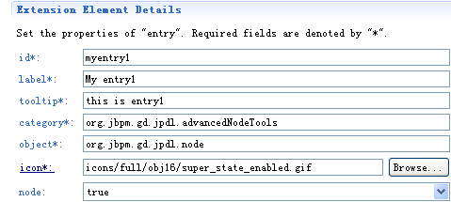

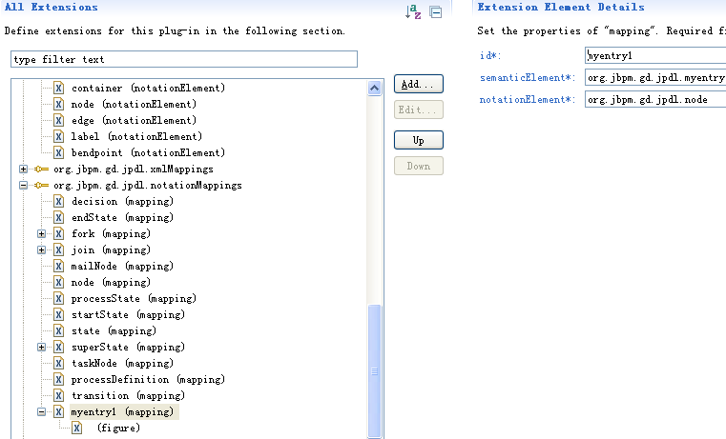

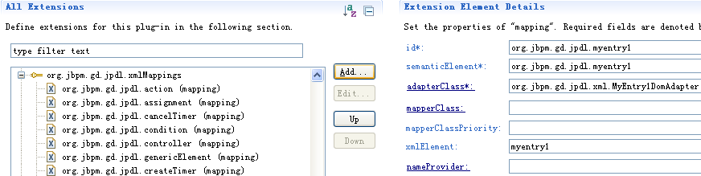

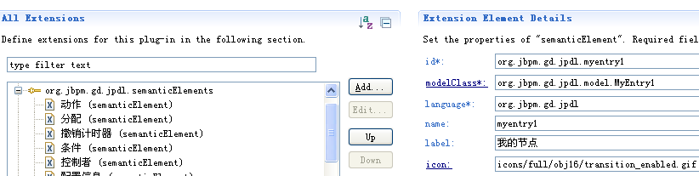

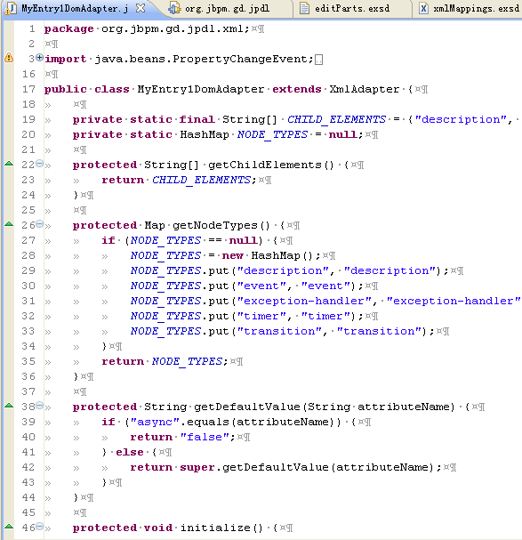

ProcessDefinitionDomAdapter
上面那个类，加些代码就可以保存了
CHILD_ELEMENTS？
getNodeTypes，doModelAdd，doModelRemove

runa产品，添加equox.app, work.compatily,添加required ，从80多变到95，成功

