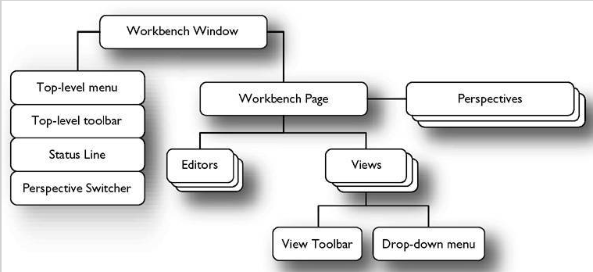
- 窗口属性的设置（自动生成）
org.eclipsercp.hyperbola/ApplicationWorkbenchWindowAdvisor
public class ApplicationWorkbenchWindowAdvisor extends
WorkbenchWindowAdvisor {

public ApplicationWorkbenchWindowAdvisor(
IWorkbenchWindowConfigurer configurer) {
super(configurer);
}

public ActionBarAdvisor createActionBarAdvisor(
IActionBarConfigurer configurer) {
return new ApplicationActionBarAdvisor(configurer);
}

public void preWindowOpen() {
IWorkbenchWindowConfigurer configurer = getWindowConfigurer();
configurer.setInitialSize(new Point(250, 350));
configurer.setShowCoolBar(false);
configurer.setShowStatusLine(false);
configurer.setTitle("Hyperbola");
}
}

- 保存窗口的设置
org.eclipsercp.hyperbola/ApplicationWorkbenchAdvisor
public void initialize(IWorkbenchConfigurer configurer) {
configurer.setSaveAndRestore(true);
}

public void postWindowCreate() {
super.postWindowCreate();
IStatusLineManager statusline = getWindowConfigurer().
getActionBarConfigurer().getStatusLineManager();
statusline.setMessage("this is for test, hello world");
// 设置打开时最大化窗口
getWindowConfigurer().getWindow().getShell().setMaximized(true);
}
- 创建一个view（可以用designer生成）ID最好和类的全名一样,icon属性可以在extendtion里面设
org.eclipsercp.hyperbola/ContactsView
public class ContactsView extends ViewPart {
public static final String ID =
"org.eclipsercp.hyperbola.views.contacts";

public ContactsView() {
super();
// TODO Auto-generated constructor stub
}

public void createPartControl(Composite parent) {
// TODO Auto-generated method stub
}

public void setFocus() {
// TODO Auto-generated method stub
}
}

- 把创建的view添加进窗口
org.eclipsercp.hyperbola/Perspective
public class Perspective implements IPerspectiveFactory {
public void createInitialLayout(IPageLayout layout) {
layout.setEditorAreaVisible(false);//设编辑区域设为不可视
layout.addView(ContactsView.ID, IPageLayout.LEFT,
1.0f, layout.getEditorArea());
}
}

在一个page中， 默认的editor占有整个page区域，view是在瓜分editor的区域，一个page可以有多个view，只有一个editor

五、如果只有一个view的话可以使用addStandaloneView
org.eclipsercp.hyperbola/Perspective
public class Perspective implements IPerspectiveFactory {
public void createInitialLayout(IPageLayout layout) {
layout.setEditorAreaVisible(false);
layout.addStandaloneView(ContactsView.ID, false,
IPageLayout.LEFT, 1.0f, layout.getEditorArea());
}
}
layout.getViewLayout(MyView.ID).setCloseable(false);设置窗口为不可关闭

编辑区域的打开可以用 IWorkbenchPage.setEditorArea Visible(boolean)
or org.eclipse.ui.workbench. ActionFactory.SHOW_EDITOR action.

清空以前的设置： 在run dialog中的main,选择clear workspace

- 在view中添加一个treeviewer
org.eclipsercp.hyperbola/ContactsView
public class ContactsView extends ViewPart {
public static final String ID =
"org.eclipsercp.hyperbola.views.contacts";
private TreeViewer treeViewer;
private Session session;

public ContactsView() {
super();
}

public void createPartControl(Composite parent) {
initializeSession(); // temporary tweak to build a fake model
treeViewer = new TreeViewer(parent,
SWT.BORDER | SWT.MULTI | SWT.V_SCROLL);
getSite().setSelectionProvider(treeViewer);
treeViewer.setLabelProvider(new WorkbenchLabelProvider());
treeViewer.setContentProvider(new BaseWorkbenchContentProvider());
treeViewer.setInput(session.getRoot());
session.getRoot().addContactsListener(new IContactsListener() {
public void contactsChanged(ContactsGroup contacts,
ContactsEntry entry) {
treeViewer.refresh();
}
});
}

private void initializeSession() {
session = new Session();
ContactsGroup root = session.getRoot();
ContactsGroup friendsGroup = new ContactsGroup(root, "Friends");
root.addEntry(friendsGroup);
friendsGroup.addEntry(new ContactsEntry(friendsGroup,
"Alize", "aliz", "localhost"));
friendsGroup.addEntry(new ContactsEntry(friendsGroup,
"Sydney", "syd", "localhost"));
ContactsGroup otherGroup = new ContactsGroup(root, "Other");
root.addEntry(otherGroup);
otherGroup.addEntry(new ContactsEntry(otherGroup,
"Nadine", "nad", "localhost"));
}

public void setFocus() {
treeViewer.getControl().setFocus();
}
}

TreeViewer是一个组件，为了使用它还必须提供the content provider and the label provider, Content provider提供的是树节点的实体，即model，label provider提供的是树节点显示的名称

七、 ITreeContentProvider
org.eclipse.jface/ITreeContentProvider
public interface ITreeContentProvider extends IStructuredContentProvider {
public Object[] getChildren(Object parentElement);
public Object getParent(Object element);
public boolean hasChildren(Object element);
}

ITreeContentProvider接口提供了treeViewer查找父节点 和 子节点的方法, 为了让treeviewer能够显示，应该让model继承ITreeContentProvider接口， 但这个接口是为了显示而设计的。让实体模型继承这个接口，会让实体与UI显示组件紧耦合。

所以这里使用了eclipse的adapter机制, adapter机制在rcp程序设计中有介绍

八、 显示菜单栏，工具栏
org.eclipsercp.hyperbola/ApplicationWorkbenchWindowAdvisor
public void preWindowOpen() {
IWorkbenchWindowConfigurer configurer = getWindowConfigurer();
configurer.setInitialSize(new Point(250, 350));
configurer.setShowMenuBar(true);
configurer.setShowCoolBar(true);
...
}

创建菜单项
org.eclipsercp.hyperbola/ApplicationActionBarAdvisor
public class ApplicationActionBarAdvisor extends ActionBarAdvisor {
private IWorkbenchAction exitAction;
private IWorkbenchAction aboutAction;
protected void makeActions(IWorkbenchWindow window) {
exitAction = ActionFactory.QUIT.create(window);
register(exitAction);
aboutAction = ActionFactory.ABOUT.create(window);
register(aboutAction);
}
protected void fillMenuBar(IMenuManager menuBar) {
MenuManager hyperbolaMenu = new MenuManager(
"&Hyperbola", "hyperbola");
hyperbolaMenu.add(exitAction);
MenuManager helpMenu = new MenuManager("&Help", "help");
helpMenu.add(aboutAction);
menuBar.add(hyperbolaMenu);
menuBar.add(helpMenu);
}
}
protected void fillCoolBar(ICoolBarManager coolBar) {
IToolBarManager toolbar = new ToolBarManager(coolBar.getStyle());
coolBar.add(toolbar);
toolbar.add(addContactAction);
}

在rcp中菜单项，工具栏项 都是实现了action的类提供

九、 注册窗口的选择事件
IWorkbenchWindow window
window.getSelectionService().addSelectionListener(new ISelectionListener(){
public void selectionChanged(IWorkbenchPart part, ISelection selection){

}
});

提供事件源
在viewPart的createPartControl(Composite parent)设置事件提供者

getSite().setSelectionProvider(treeViewer);

- 设置状态栏
org.eclipsercp.hyperbola/ApplicationWorkbenchWindowAdvisor
public void preWindowOpen() {
。。。。。。。。。。。
configurer.setShowStatusLine(true);
。。。。。。。。。。。。
}

org.eclipsercp.hyperbola/ApplicationWorkbenchWindowAdvisor
public void postWindowOpen() {
statusImage =
AbstractUIPlugin.imageDescriptorFromPlugin(
"org.eclipsercp.hyperbola",
IImageKeys.ONLINE).createImage();
IStatusLineManager statusline = getWindowConfigurer().
getActionBarConfigurer().getStatusLineManager();
statusline.setMessage(statusImage, "Online");
}
public void dispose() {
statusImage.dispose();
}

设置状态栏只能在状态栏的控制者被创建后设置，所以不能在ActionBarAdvisor. fillStatusLine()中设置状态栏，可以在postWindowOpen中设置，因为此时window已被创建

十一、设置系统托盘并设置事件
org.eclipsercp.hyperbola/ApplicationWorkbenchWindowAdvisor
public void postWindowOpen() {
initStatusLine();
final IWorkbenchWindow window = getWindowConfigurer().getWindow();
trayItem = initTaskItem(window);
if (trayItem != null) {
hookPopupMenu(window);
hookMinimize(window);
}
}

private void hookMinimize(final IWorkbenchWindow window) {
window.getShell().addShellListener(new ShellAdapter() {
public void shellIconified(ShellEvent e) {
window.getShell().setVisible(false);
}
});
trayItem.addListener(SWT.DefaultSelection, new Listener() {
public void handleEvent(Event event) {
Shell shell = window.getShell();
if (!shell.isVisible()) {
shell.setVisible(true);
window.getShell().setMinimized(false);
}
}
});
}

private void hookPopupMenu(final IWorkbenchWindow window) {
trayItem.addListener(SWT.MenuDetect, new Listener() {
public void handleEvent(Event event) {
MenuManager trayMenu = new MenuManager();
Menu menu = trayMenu.createContextMenu(window.getShell());
actionBarAdvisor.fillTrayItem(trayMenu);
menu.setVisible(true);
}
});
}

private TrayItem initTaskItem(IWorkbenchWindow window) {
final Tray tray = window.getShell().getDisplay().getSystemTray();
if (tray == null)
return null;
TrayItem trayItem = new TrayItem(tray, SWT.NONE);
trayImage = AbstractUIPlugin.imageDescriptorFromPlugin(
"org.eclipsercp.hyperbola", IImageKeys.ONLINE).createImage();
trayItem.setImage(trayImage);
trayItem.setToolTipText("Hyperbola");
return trayItem;
}

public void dispose() {
if (trayImage != null) {
trayImage.dispose();
trayItem.dispose();
}
}

因为ApplicationActionBarAdvisor中管理着所有的action，所以在该类中把action添加到trayItem中
org.eclipsercp.hyperbola/ApplicationActionBarAdvisor
protected void fillTrayItem(IMenuManager trayItem) {
trayItem.add(aboutAction);
trayItem.add(exitAction);
}

或者换一种写法{
public void postWindowOpen() {
IStatusLineManager statusline = getWindowConfigurer()
.getActionBarConfigurer().getStatusLineManager();
statusline.setMessage("this is for test, hello world " + new Date());
// 设置打开时最大化窗口
getWindowConfigurer().getWindow().getShell().setMaximized(true);
final IWorkbenchWindow window = getWindowConfigurer().getWindow();
// 拿到系统栏
final Tray tray = window.getShell().getDisplay().getSystemTray();
if (tray == null)
return;
// 在系统栏上放上一个图标项
trayItem = new TrayItem(tray, SWT.NONE);
trayImage = AbstractUIPlugin.imageDescriptorFromPlugin(
"com.joinbright.train", "icons/alt_about.gif").createImage();
trayItem.setImage(trayImage);
trayItem.setToolTipText("Hyperbola");
if (trayItem == null)
return;
// 设置弹出菜单
MenuManager trayMenu = new MenuManager();
final Menu menu = trayMenu.createContextMenu(window.getShell());
actionBarAdvisor.fillTrayItem(trayMenu);

// 设计窗口最小化的事件
window.getShell().addShellListener(new ShellAdapter() {
public void shellIconified(ShellEvent e) {
window.getShell().setVisible(false);
trayItem.setVisible(true);
}
});
// 设计图标的双击事件 --此处的listener是根据第一个参数来确定事件类型
// SWT.DefaultSelection，SWT.MenuDetect
trayItem.addListener(SWT.DefaultSelection, new Listener() {
public void handleEvent(Event event) {
Shell shell = window.getShell();
if (!shell.isVisible()) {
shell.setVisible(true);
window.getShell().setMinimized(false);// 因为window的隐身前的一个状态是最小化的
trayItem.setVisible(false);
}
}
});
// 设置图标项的动作
trayItem.addListener(SWT.MenuDetect, new Listener() {
public void handleEvent(Event event) {

menu.setVisible(true);
}
});
}
}

事件失效
event.doit=false;

设置焦点
public void setFocus() {
if (entry != null && !entry.isDisposed()) {
entry.setFocus();
}
}

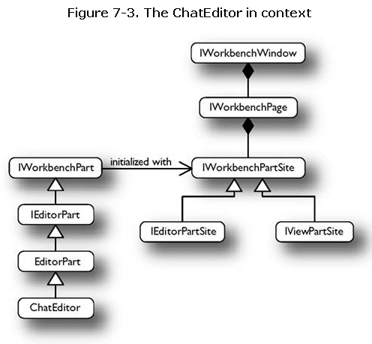

打开一个editor
IWorkbenchPage.openEditor(IEditorInput input, String editorId)

定义about界面的图片和说明，在产品文件的branding里面配置
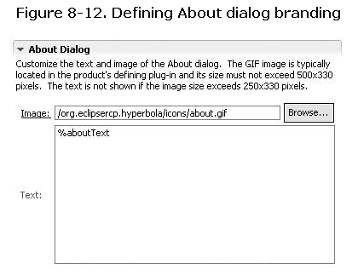

创建preferencePage
用designer创建一个preferencePage，然后在extensions中添加
preferencePage的层次关系靠每个page的 ID 和 category 来实现
一个page的category是另一个page的ID，即为他的子节点

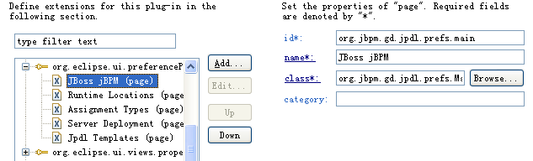

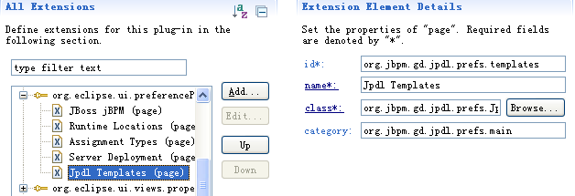
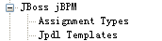

编辑器提供了主要的焦点，视图提供了支持的信息

编辑器在所有透视图中是共享的，在一个透视图中关闭它等于在所有透视图中也关闭了

编辑器与主要的菜单和工具栏相关， 视图与local的菜单和工具栏相关

忽略事件：
public void keyPressed(KeyEvent event) {
if (event.character == SWT.CR) {
sendMessage();
// ignore the CR and don't add to text control
event.doit = false;
}
}

注册快捷键
快捷键是和action相绑定的
绑定一个有ID域的action,
在构造方法里加上 setActionDefinitionId(ID);
这句话实际上是指定了相关联的command 的 id
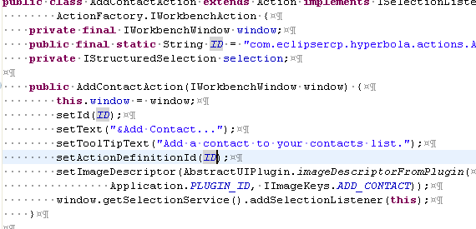
扩展commands
在commands扩展点新建一个category，一个command,一个keyBinding
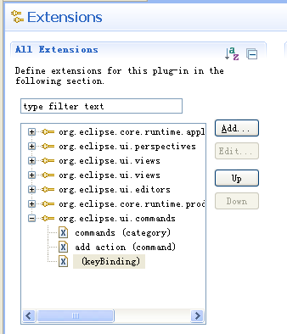

建立category 指定ID， name
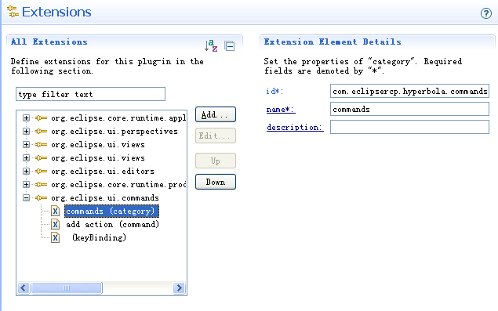

建立command，指定 command的ID， 所属分类的ID
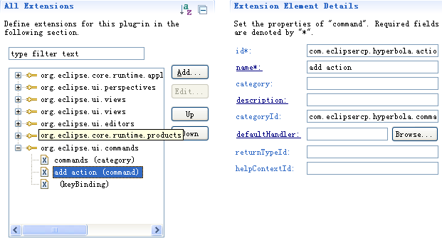

建立keyBinding，指定keyConfigurationID，可以用org.eclipse.ui.defaultAcceleratorConfiguration
指定keySequence,要绑定的按键
指定绑定的command ID , 就是说 action和command绑定，command和key绑定,但一个command和2个action绑定失效？

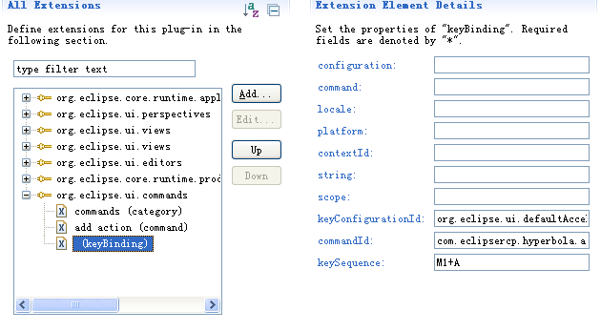

最后要调用ActionBarAdvisor. register(chatAction)

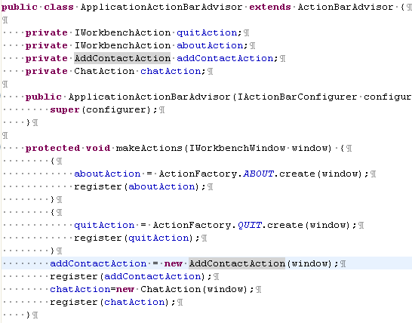

如何给系统默认定义好的action设置keybinding
系统创建的action有些是已经绑定好command ID的，可以通过方法
System.out.println("quitAction "+quitAction.getActionDefinitionId()); 来确认
所以要做的只是扩展一个keybinding把command ID 和 key binding起来，注意不要热键冲突,同样要register
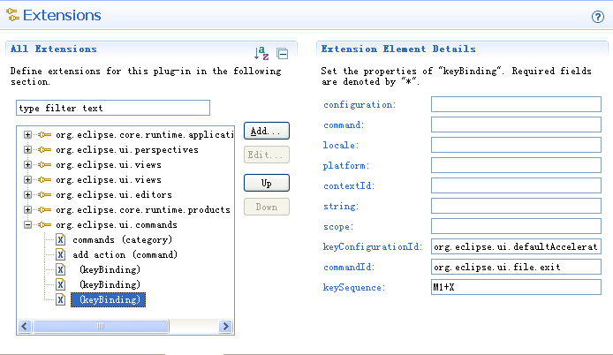

配置好的keybinding可以在 Window > Preferences... > General > Keys中显示出来
为了看到自己的配置，首先添加一个Preferences的action到menubar中,此时什么都没有，要显示keys配置页面，要扩展 org.eclipse.ui.preferencePages，
添加系统的keys页面设置
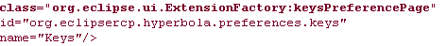
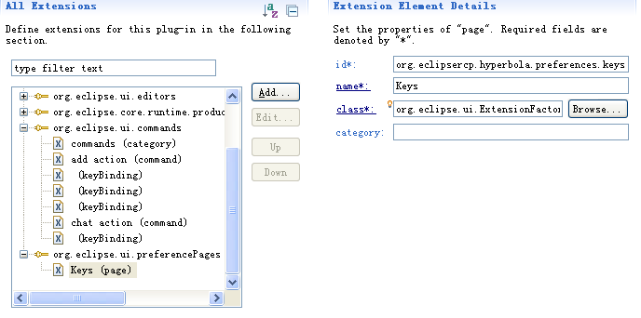
The new key configuration, called org.eclipsercp.hyperbola.keyConfig, is not enabled by default. To enable it, you must add an entry to your plug-in customization file as follows (see Section 13.5, "Adding Help Content," for how to create a preference customization file):
org.eclipse.ui/KEY_CONFIGURATION_ID=org.eclipsercp.hyperbola.keyConfig

添加3方插件 （帮助插件）
首先把要用的插件放到plugins目录下， 然后到Window > Preferences > Plug-in Development > Target Platform目录下，查看插件列表 ，点击reload刷新插件列表

添加help插件
首先把org.apache.lucene
org.eclipse.help.appserver
org.eclipse.help.base
org.eclipse.help.ui
org.eclipse.help.webapp
org.eclipse.tomcat
org.eclipse.ui.forms 添加到target platform插件列表

在产品的Configuration page点击add，添加org.eclipse.help.ui，然后点击Add Required Plug-ins， 自动添加org.apache.lucene, org.eclipse.help.appserver, and org.eclipse.help.base等， 再手动add org.eclipse.help.webapp and org.eclipse.tomcat插件， 点击save

环境设好了， 往菜单栏添加 HELP_CONTENTS action，OK ，启动，记得启动前, add Required Plug-ins, synchronize configuration

添加help内容
扩展模板
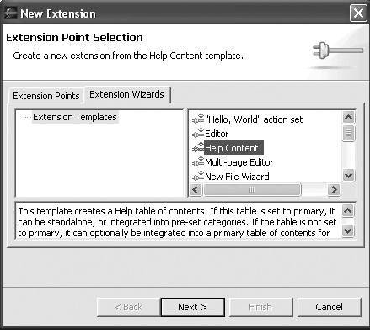

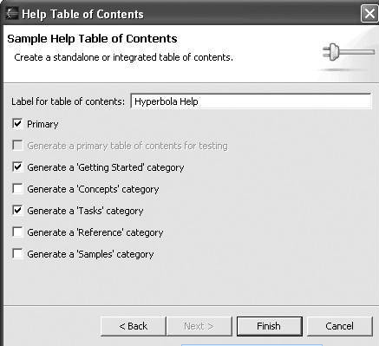
生成的帮助
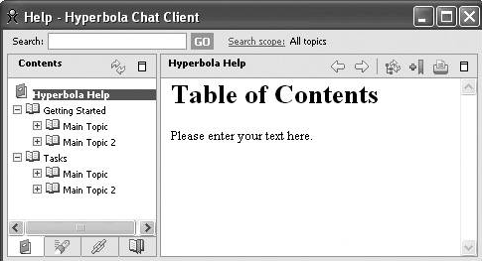

改变帮助内容

找到扩展页面， 找出配置文件

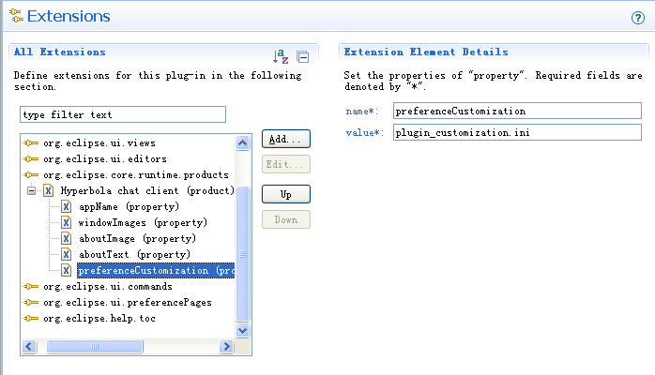
没有的话就创建配置文件
Open Hyperbola's plug-in editor and on the Extensions page, select Hyperbola Chat Client product extension to the org.eclipse.core.runtime.products extension point. Using its context menu, select New > property to add the preferenceCustomization property
org.eclipsercp.hyperbola/preferences.ini
org.eclipse.help.base/help_home=\
/org.eclipsercp.hyperbola/html/help_home.html
修改配置文件，添加org.eclipse.help.base/help_home=/com.eclipsercp.hyperbola/html/help_home.html
并在根目录下建立html/help_home.html， 此为help的主页(help_home)
帮助文档结构
默认生成了3个xml配置文件 其中primary为TRUE的是主文件或根结点，在它里面指定了其他的子节点ID。然后在去其他xml文件中找相应ID的配置信息
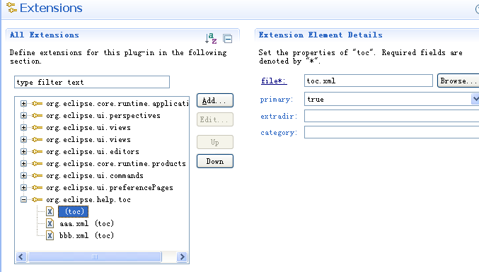

关联ContactsView 的F1帮助
首先 ContactsView. createPartControl(Composite):
org.eclipsercp.hyperbola/ContactsView
PlatformUI.getWorkbench().getHelpSystem().setHelp(
treeViewer.getTree(), "org.eclipsercp.hyperbola.contactsView");

然后扩展org.eclipsercp.hyperbola/plugin.xml
<extension point="org.eclipse.help.contexts">
<contexts file="contexts.xml"/>
</extension>

具体的页面
org.eclipsercp.hyperbola/contexts.xml
<contexts>
<context id="contactsView">
<description>This is Contacts View</description>
<topic
label="Managing Contacts"/>
href="html/tasks/managingContacts.html"
<topic
label="Grouping Contacts"/>
href="html/tasks/groupingContacts.html"
</context>
</contexts>

写相应的html页面
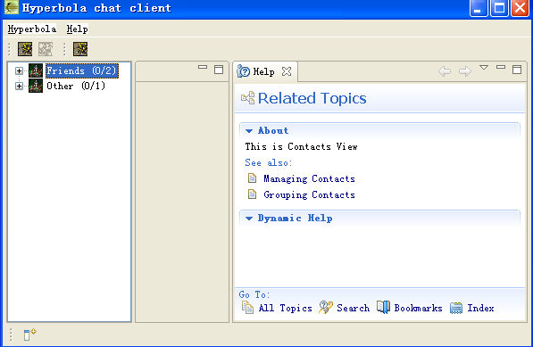

导出的时候记得把配置文件导出到build.properties
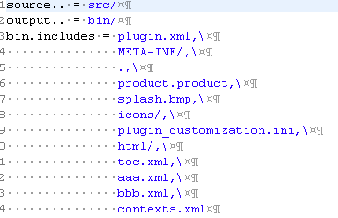
The Help actions used are supplied by the UI Workbench plug-in, which is already a prerequisite. The Hyperbola Help content is contributed via extensions to a Help plug-in extension point. Contributing extensions to a plug-in's extension point does not imply that you depend on the plug-in.

If you are looking for a class that you know exists and is in your target but you still cannot find it, it is likely that your plug-in dependencies are wrong.
So, when you are missing classes, hunt down the plug-in that contains them and add a direct dependency on it.

集成jpdl src
要在手动plugin.xml加上
<extension
id="jpdl"
point="org.eclipse.core.runtime.products">
<product
application="org.eclipse.ui.ide.workbench"
name="jpdldesigner">
<property
name="appName"
value="jpdldesigner">
</property>
</product>
</extension>
提供一个扩展product（ 用提示添加的方式添加不出来）
然后在product的configuration里面添加org.eclipse.ui.ide.applition, org.eclipse.ui.workbench.compatibility相关的插件，一般还需要添加jpdl依赖的插件，可以在designer下找到
这样就可以生成产品

2个不同的gef，draw2d版本会导致错误，com.ibm.ici/text

