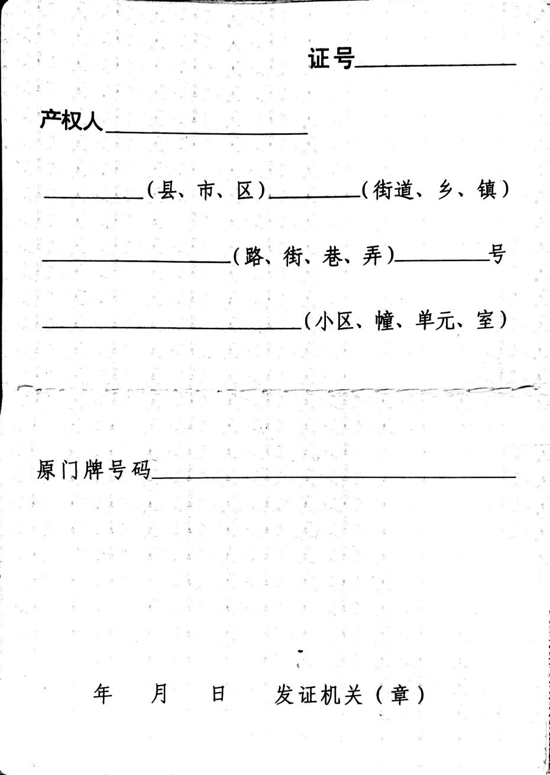

ResidenceName

NeighborhoodsName

CountyName

AddressCoding

Year

date

Month

OriginalMPAddress

PropertyOwner

MPNumber

RoadName

AddressCoding

AddressCoding

AddressCoding