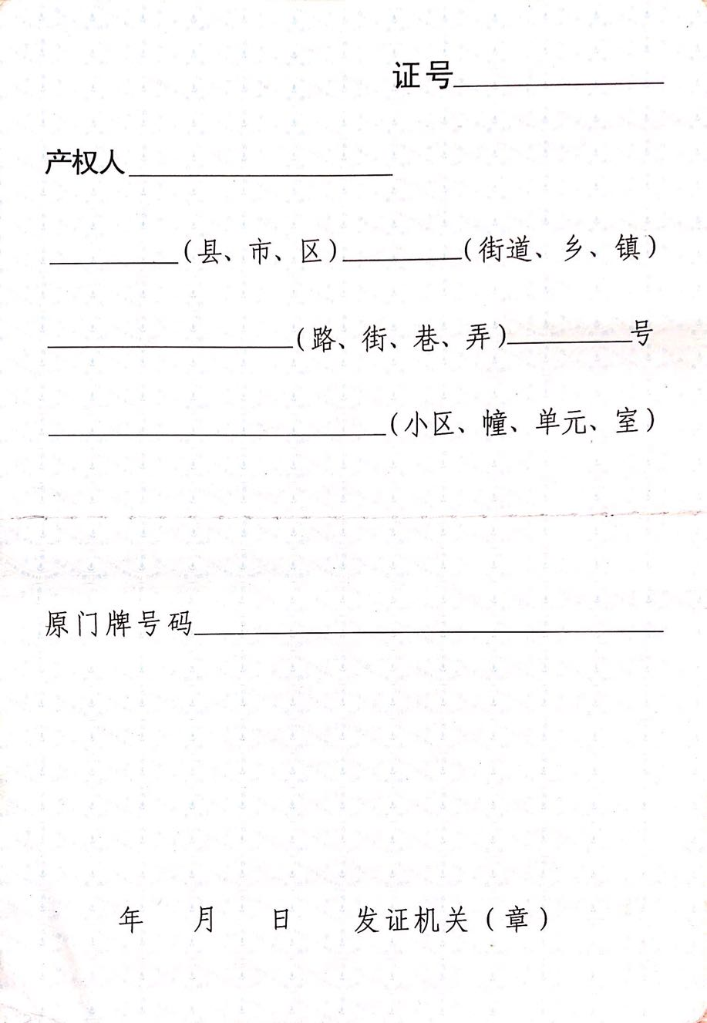

AddressCoding

PropertyOwner

CountyName NeighborhoodsName

RoadName MPNumber

ResidenceName

OriginalMPAddress

Year Month date