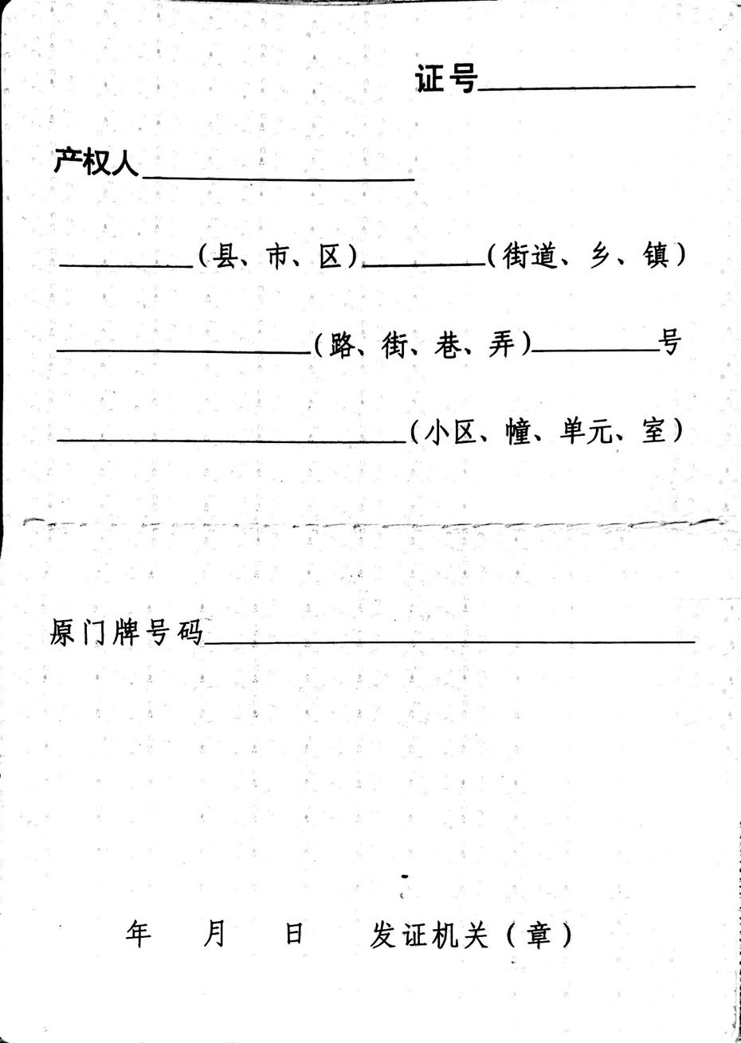

{Date}

{Month}

{Year}

{CountyName}

{NeighborhoodsName}

{ResidenceName}

{AddressCoding}

{OriginalMPAddress}

{PropertyOwner}

{MPNumber}

{RoadName}

AddressCoding

AddressCoding

AddressCoding