Tables
Table 1.
Sample Descriptive Statistics.
 | Twins & Full Siblings |  | Unrelated Individuals
Variable | Statistics | ICC | Statistics | p or chi sq
Number of individuals | 1,589 |  | 7,635
Number of families | 777
Age at Wave 1 | 16.10 (1.66) | 36.3% | 16.08 (1.72)
Female sex | 815 (51.3%) | 26.5% | 4,041 (52.9%)
Genetic ancestry |  | 100%ª
European | 987 (62.1%) |  | 4,741 (62.1%)
African | 281 (17.7%) |  | 1,695 (22.2%)
East Asian | 66 (4.2%) |  | 371 (4.9%)
Hispanic | 160 (10.1%) |  | 828 (10.8%)
Self-identified race/ethnicity ^{b}
White | 1,102 (69.4%) |  | 5,190 (68.0%)
Black/African | 296 (18.6%) |  | 1,680 (22.0%)
Native | 48 (3.0%) |  | 193 (2.5%)
Asian/Pacific Islander | 77 (4.8%) |  | 405 (5.3%)
Other | 130 (8.2%) |  | 426 (5.6%)
Hispanic | 194 (12.2%) |  | 817 (10.7%)
Annual household income | $47,741 ($59,568) | 100%ª | $46,179 ($44,273)
Parental education ^{c} |  | 100%ª
Never went to school | 2 (<0.1%) |  | 5 (<0.1%)
8th grade or less | 48 (3.0%) |  | 213 (2.7%)
Less than high school | 111 (7.0%) |  | 569 (7.5%)
High school graduate | 475 (29.9%) |  | 2,256 (29.5%)
Less than college | 348 (21.9%) |  | 1,582 (20.7%)
College graduate | 368 (23.2%) |  | 1,729 (22.6%)
More than college | 173 (10.9%) |  | 863 (11.3%)
PGS | -0.03 (0.99) | 57.0% | 0.00 (0.99)
Parental relationship
Parent report | -0.02 (1.01) | 50.0% | -0.01 (0.99)
Child report | 0.04 (0.98) | 27.7% | 0.00 (1.00)
Delinquent peer affiliation | 0.03 (0.99) | 38.6% | -0.01 (1.00)
School connectedness | 0.02 (1.00) | 27.0% | 0.00 (1.00)
Substance use behavior | -0.05 (0.99) | 39.0% | 0.01 (1.00)
Antisocial behavior | -0.07 (0.96) | 25.1% | 0.00 (1.00)
Note. Means are estimated for continuous variables with standard deviations in parentheses, while count and percentages are shown for categorical variables. ICC, intra-class correlation (proportion of between-family variance over total variance of the variable). ICC is estimated for dichotomous variables by dummy coding. Parental relationships, delinquent peer affiliation, school connectedness, antisocial behavior, and substance use behavior are measured as standardized factor scores estimated in the entire Add Health genotyped sample (i.e., population + related sample combined).
ª ICCs = 100% because these variables are the identical across siblings within a family.
^{b} Sum of frequencies and percentages larger than the total because individuals were allowed to endorse multiple racial-ethnic identities.
^{c} Parental education is measured as the higher of maternal and paternal education levels. In our analysis, ordinal categories of parental education were modeled as a continuous variable.

Figures
Figure 1.
Illustration of mechanisms of rGE with PGS.
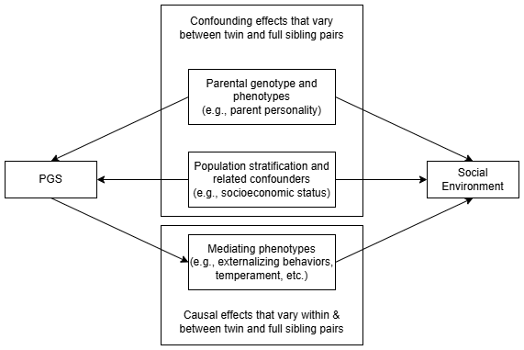
Note.

Figure 2.
Key Parameter Estimates from Main Analysis.
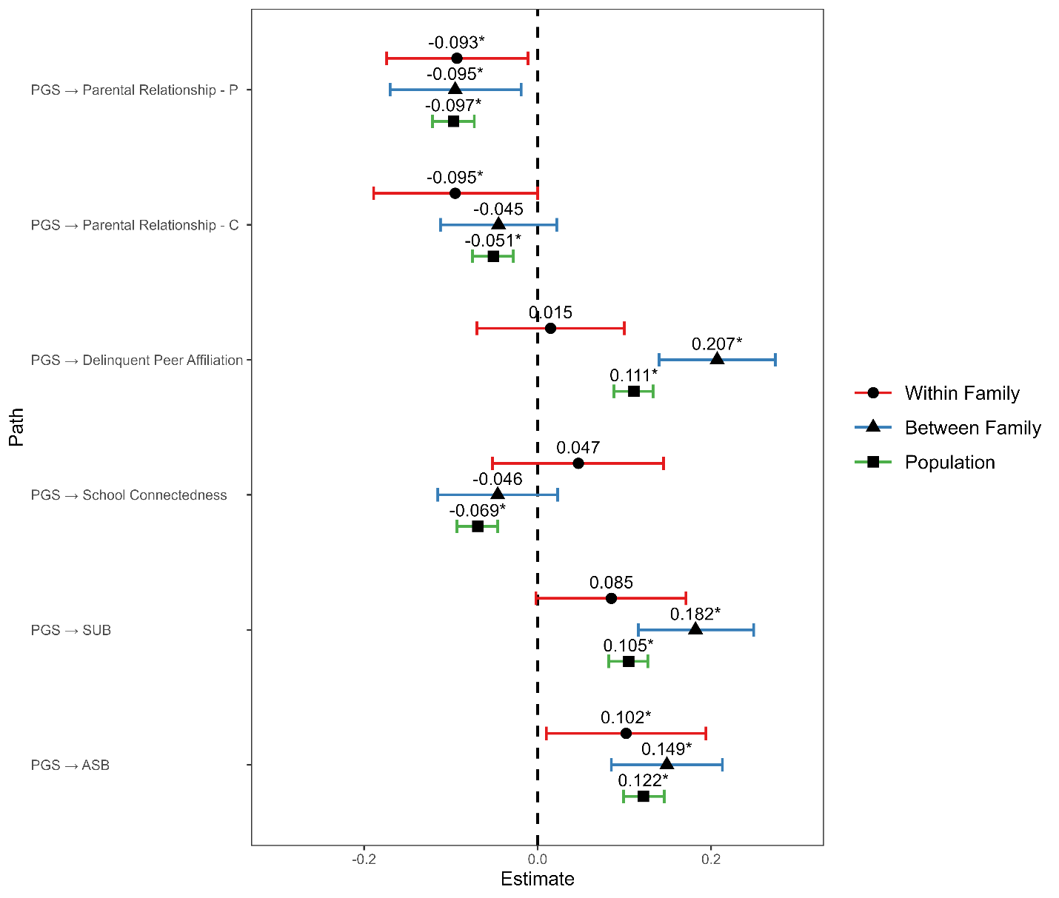
Note. Point estimates and 95% credible intervals of PGS effect on social environments. P, parent-report. C, child-report.
*, 95% credible interval does not contain the null, or statistically significant in the frequentist sense.

