Figures
Figure 1.
Explanations of rGE Between PGS and Social Environments.
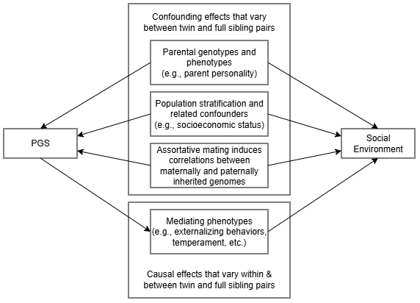
Note.

Figure 2.
Estimates of PGS Effects on Social Environments.
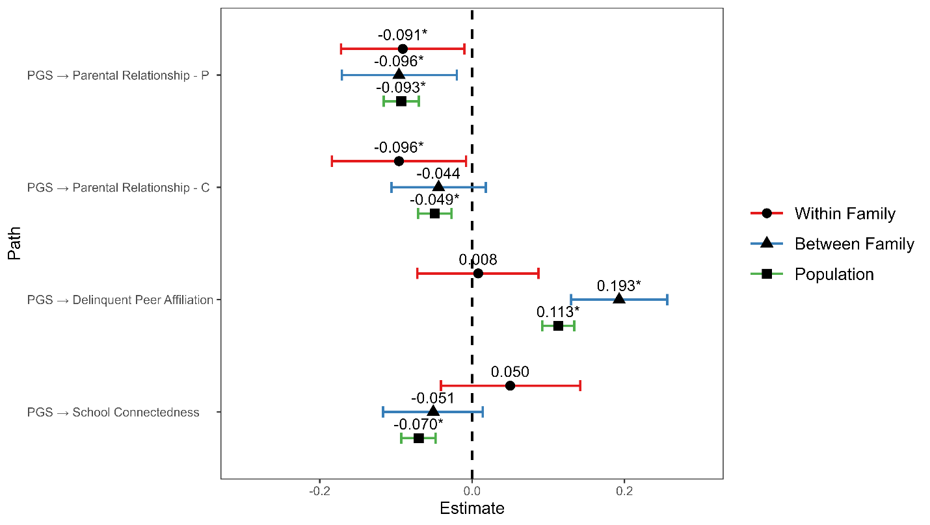
Note. Point estimates and 95% credible intervals at the within-family level, between-family level, and in the population (i.e., unrelated) sample were shown. P, parent reported. C, child reported.
*, 95% credible interval does not contain the null, or statistically significant in the frequentist sense.

