Tables
Table 1.
Sample Descriptive Statistics.
 | Twins & Full Siblings |  | Unrelated Individuals | Subsample Comparison
Variable | Statistics | ICC | Statistics | p-value
Number of individuals | 1,589 |  | 7,635
Number of families | 777
Age at Wave 1 | 16.10 (1.66) | 36.3% | 16.08 (1.72) | .783
Female sex | 815 (51.3%) | 26.5% | 4,041 (52.9%) | .097
Genetic ancestry |  | 100%ª
European | 987 (62.1%) |  | 4,741 (62.1%) | .118
African | 281 (17.7%) |  | 1,695 (22.2%)
East Asian | 66 (4.2%) |  | 371 (4.9%)
Hispanic | 160 (10.1%) |  | 828 (10.8%)
Self-identified race/ethnicity ^{b}
White | 1,102 (69.4%) |  | 5,190 (68.0%) | .179
Black/African | 296 (18.6%) |  | 1,680 (22.0%) | .033
Native | 48 (3.0%) |  | 193 (2.5%) | .346
Asian/Pacific Islander | 77 (4.8%) |  | 405 (5.3%) | .427
Other | 130 (8.2%) |  | 426 (5.6%) | .007
Hispanic | 194 (12.2%) |  | 817 (10.7%) | .159
Annual household income | $47,741 ($59,568) | 100%ª | $46,179 ($44,273) | .425
Parental education ^{c} |  | 100%ª
Never went to school | 2 (<0.1%) |  | 5 (<0.1%) | .975
8th grade or less | 48 (3.0%) |  | 213 (2.7%)
Less than high school | 111 (7.0%) |  | 569 (7.5%)
High school graduate | 475 (29.9%) |  | 2,256 (29.5%)
Less than college | 348 (21.9%) |  | 1,582 (20.7%)
College graduate | 368 (23.2%) |  | 1,729 (22.6%)
More than college | 173 (10.9%) |  | 863 (11.3%)
PGS | -0.03 (0.99) | 57.0% | 0.00 (0.99) | .462
Parental relationship
Parent report | -0.02 (1.01) | 50.0% | -0.01 (0.99) | .827
Child report | 0.04 (0.98) | 27.7% | 0.00 (1.00) | .871
Delinquent peer affiliation | 0.03 (0.99) | 38.6% | -0.01 (1.00) | .777
School connectedness | 0.02 (1.00) | 27.0% | 0.00 (1.00) | .656
Substance use behavior | -0.05 (0.99) | 39.0% | 0.01 (1.00) | .243
Antisocial behavior | -0.07 (0.96) | 25.1% | 0.00 (1.00) | .359
Note. Means are estimated for continuous variables with standard deviations in parentheses, while count and percentages are shown for categorical variables. ICC, intra-class correlation (i.e., proportion of between-family variance over total variance of the variable). ICC is estimated for dichotomous variables by dummy coding. Parental relationships, delinquent peer affiliation, school connectedness, antisocial behavior, and substance use behavior are measured as standardized factor scores estimated in the entire Add Health genotyped sample (i.e., population + related sample combined). Subsample comparison was performed by first randomly selecting one twin/sibling from each family and comparing these adolescents to the unrelated adolescents in the population sample. Continuous outcomes were compared using linear regression, binary outcomes using logistic regression, and categorical outcomes using chi-square test.
ª ICCs = 100% because these variables are the identical across siblings within a family.
^{b} Sum of frequencies and percentages larger than the total because individuals were allowed to endorse multiple racial-ethnic identities.
^{c} Parental education is measured as the higher of maternal and paternal education levels. In our analysis, ordinal categories of parental education were modeled as a continuous variable.
Figures
Figure 1.
Explanations of rGE Between PGS and Social Environments.
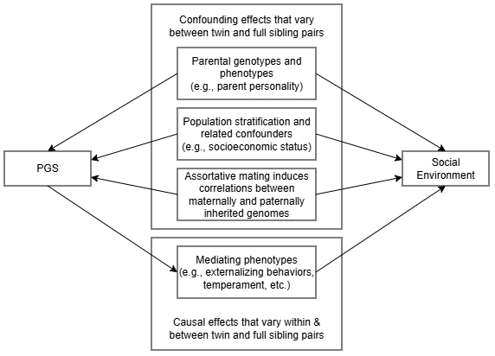
Note.

Figure 2.
Key Parameter Estimates from Main Analysis.
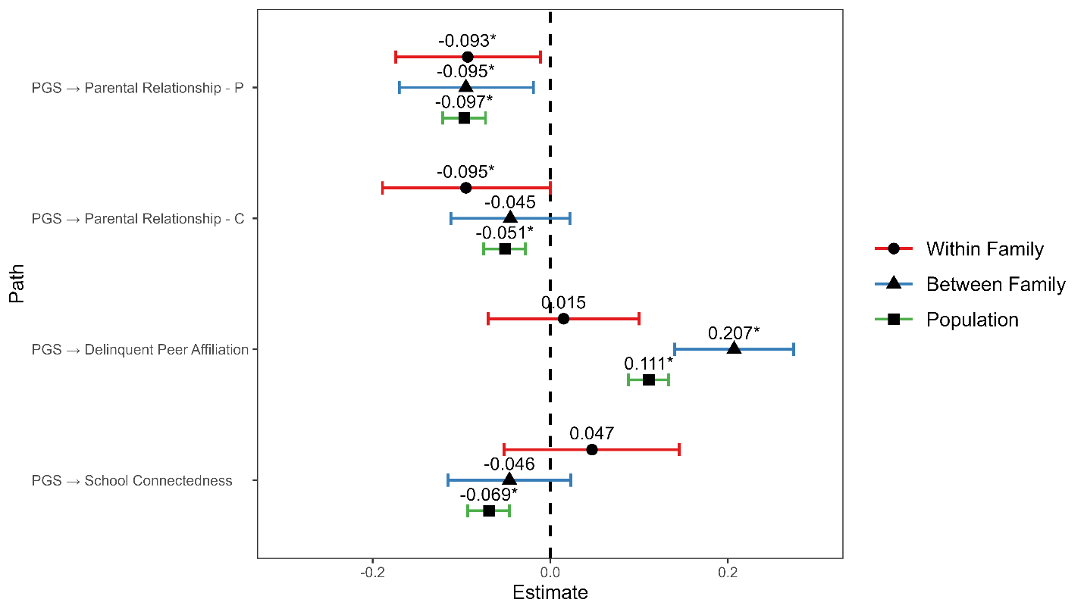
Note. Point estimates and 95% credible intervals of PGS effect on social environments. P, parent-report. C, child-report.
*, 95% credible interval does not contain the null, or statistically significant in the frequentist sense.

