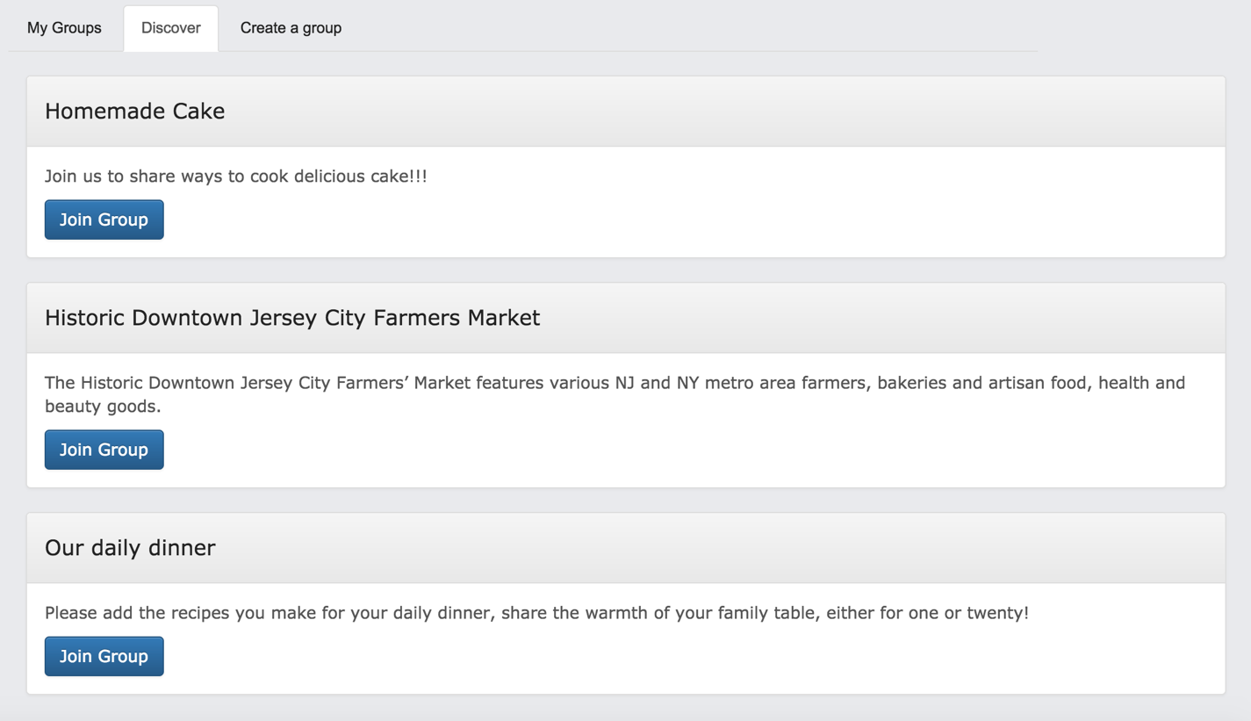**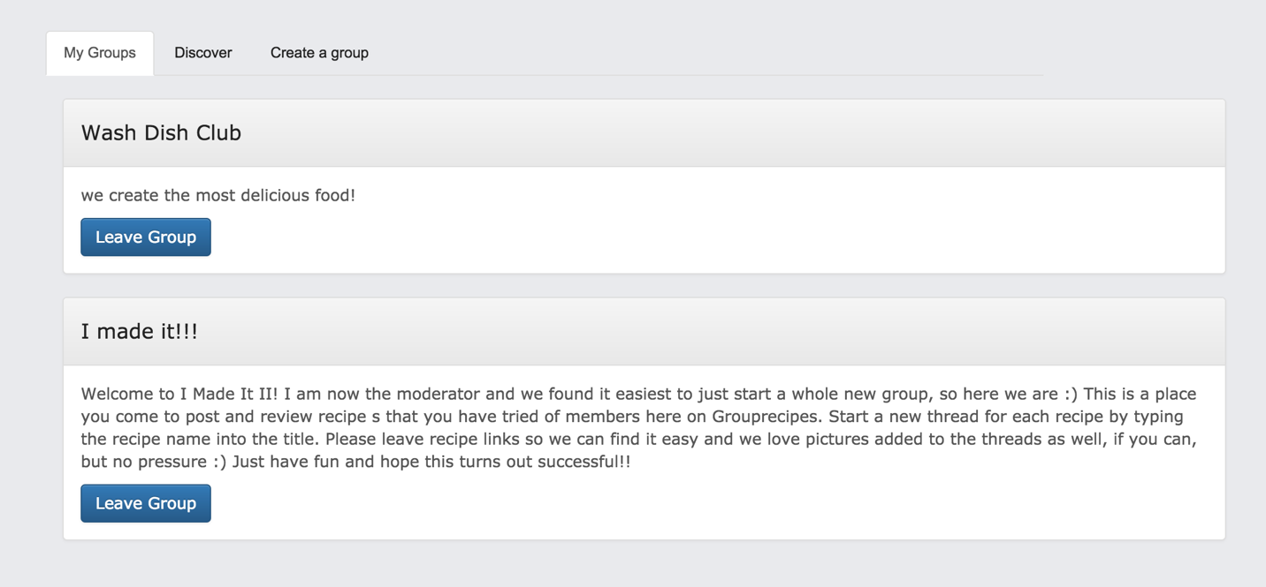Users can create and join groups and organize cooking events. In group page, there are three options, “My group” showing the groups user currently registered; “Discover” display all the Groups exist, use can join whatever groups they want; “Create Group” user can create new group to make friends, post events.**

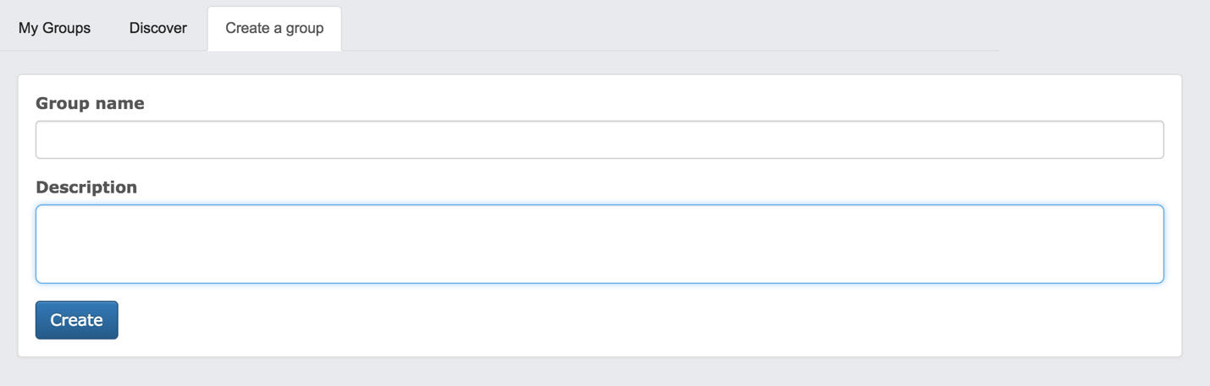

When user join one group, he or she can check all events that group posts, and RSVP for meetings. User can also posts reports with photos of the event where they can be read by members of the group but not by other users.

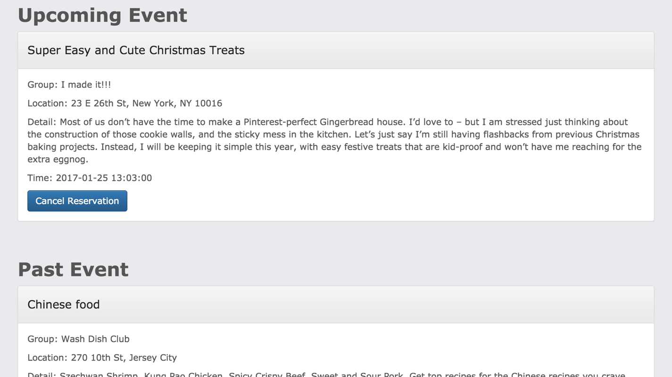“My Event” parts display upcoming events user have reserved and past event user have enrolled. User can cancel event. “Discover” shows all events hold by groups that user joined including upcoming events and past events. User can reserve events they like. “Create Event” user can create event including location, date, description and post to group members. User can also see the detail of event he or she reserved and post events report.

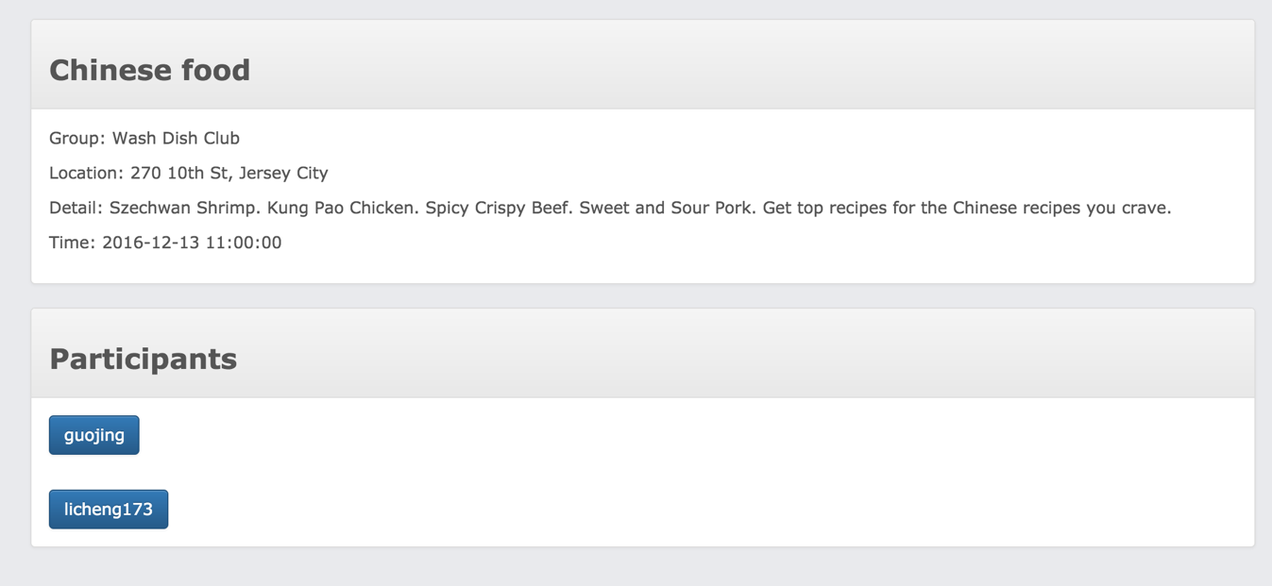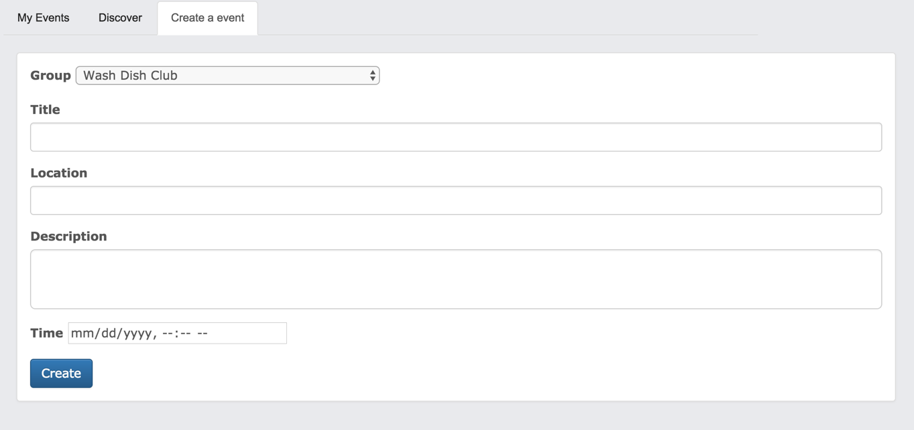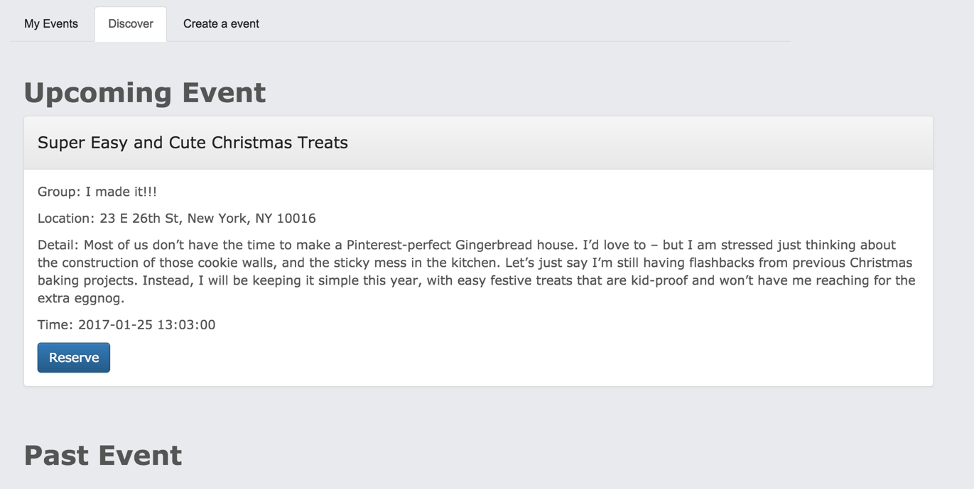

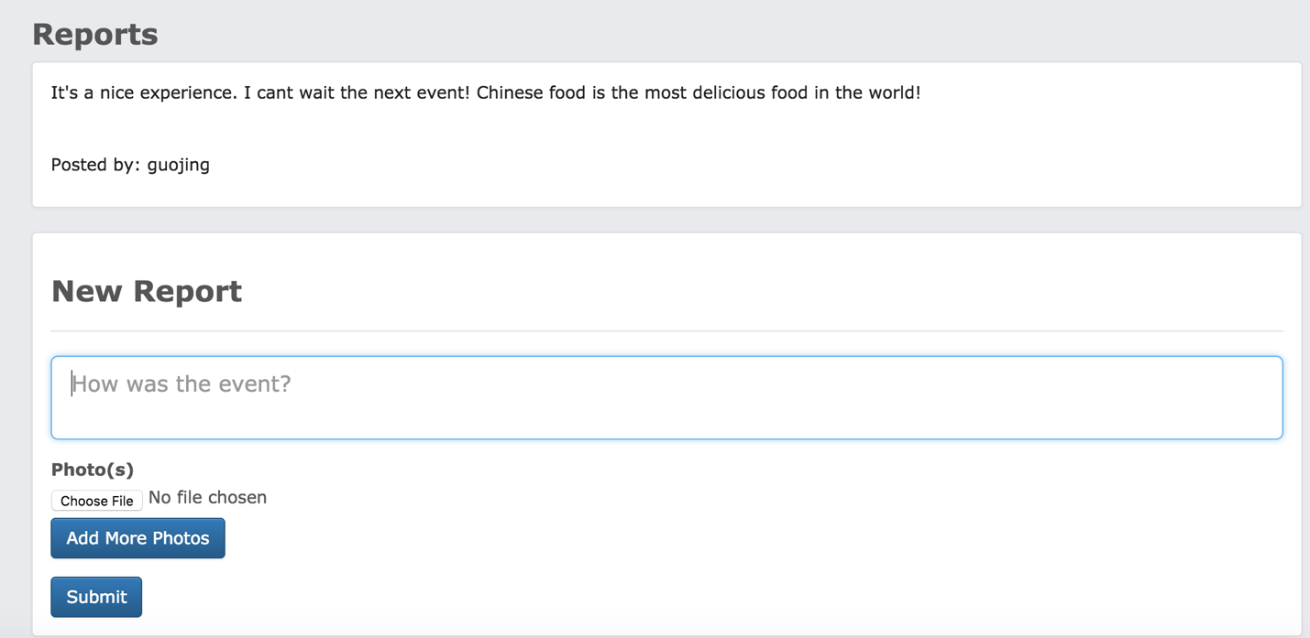

The last part is “History”. This part will display recipes the user has recently looked at, or to display recently clicked tags or recent searches, and in general to learn what kind of recipes the user is interested in. User can also click each record and check the detail of recipe he or she interested in.

