**Yiwei Liu N19884816 yl3791**

**Cheng Li N18250726 cl3570**

**CookZilla recipe sharing website**

1. **Introduction**

**This website is called “Cookzilla”. The purpose for this website is for users to share their recipes and form groups to communicate and hold events. The main functions are posting recipes, posting reviews and suggestions to reviews, forming groups, holding events, reserving events and posting meeting reports.**

1. **Explanation**

**To design the database, the first table to create is the "User" table. The "User" table is for storing the information of the users. This table should have a field of unique user id or name as primary key to represent each user. Here we choose using numeric user id as primary key because integer has better performance than string as primary key. Other than primary key, the table also has a field of "uname" which is unique for each id, and a password field, so as for users to use for login. The table also stores the real name and a profile for each user.**

**Each recipe should be posted by one user, therefore the "Recipe" table has a foreign key "uid" reference to the "uid" in the "User" table. The primary key of the "Recipe" table is "rid".**

**Because one recipe could link to one or more other recipes, we create a new table "Link_Recipe" to store the links between recipes.**

**Each recipe could have more than one ingredient, therefore create a new table "Ingredient". The primary keys are "rid" and "iname", means each recipe can not have ingredients with same name. Each ingredient should have a quantity, so add a field "iquantity" to the table.**

**Each recipe could have one or more pictures. Therefore, create a table "Recipe_Picture" to store the pictures. The "rid" is a foreign key reference to "Recipe".**

**The reviews are posted by users and are comments to the recipes. So the table "Review" has a foreign key "uid" reference to "User" and a foreign key "rid" reference to "Recipe". The primary key of the table is "r_id".**

**The "rate" field of "Review" can only have integer value 1 - 5, therefore create a restriction to the values by adding a table "Rate" as code book and set the field "rrate" in "Review" as foreign key.**

**One review could have more than one suggestions and more than one photo, therefore add two individual tables "Review_suggestion" and "Review_Photo", and set "r_id" as foreign keys in each table reference to table "Review".**

**The "GGroup" table stores the records of groups. "gid" is the primary key of the table. A group should have a creator, who is a registered user of the website, therefore the table has a field of “cuid” which references to the “User” table. A group also has a “gdescription” field to give a description of the group, which will be shown in the website to let users see the content.**

**Users could join one or more groups. These records are stored in the "Join_Group" table. The "uid" is a foreign key reference to the "uid" key in the "User" table. The "gid" is a foreign key reference to the "gid" key in the "GGroup" table.**

**The "Event" table stores the records of events. Because each event is held by a group, the "Event" table has a foreign key "gid" reference to the "gid" in the "GGroup". Each event should be created by a user, so that the user could cancel the event if schedule changes or nobody want to attend the event. It also has fields for the time, location and description of the event.**

**The "Reserve" table stores the records of users' reservations to events. Therefore it has a field “eid” referring to the “Event” table and a field “uid” referring to the “User” table.**

**After the events, the user could post reports of the events they attended. So the "Report" table has a foreign key "uid" reference to that in the "User" table and a foreign key "eid" reference to that in the "Event" table.**

**Each report could have one or more photos. These photos are stored in the "Report_Photo" table.**

1. **Diagram**
2. ER Diagram

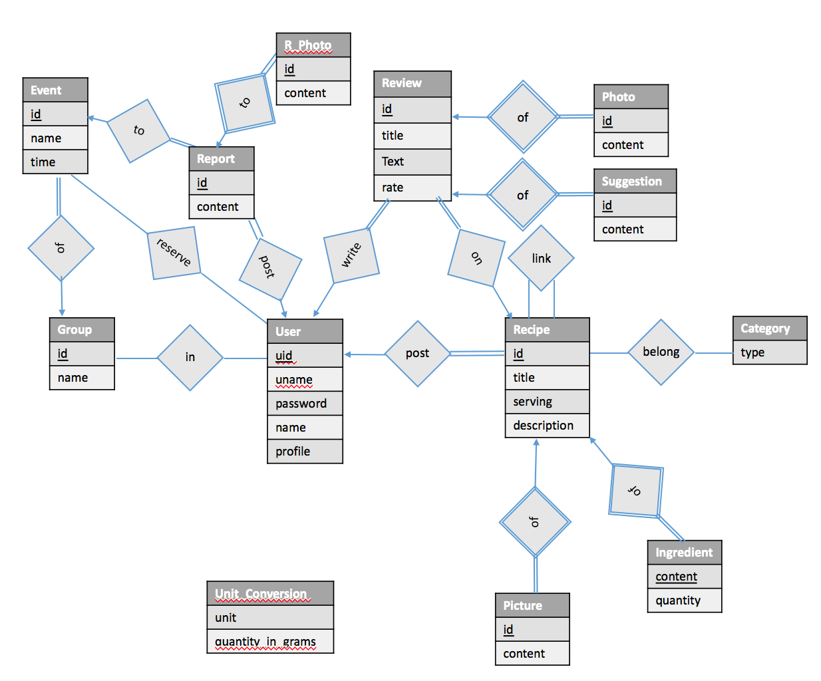

1. The final design of the table relations and contents.

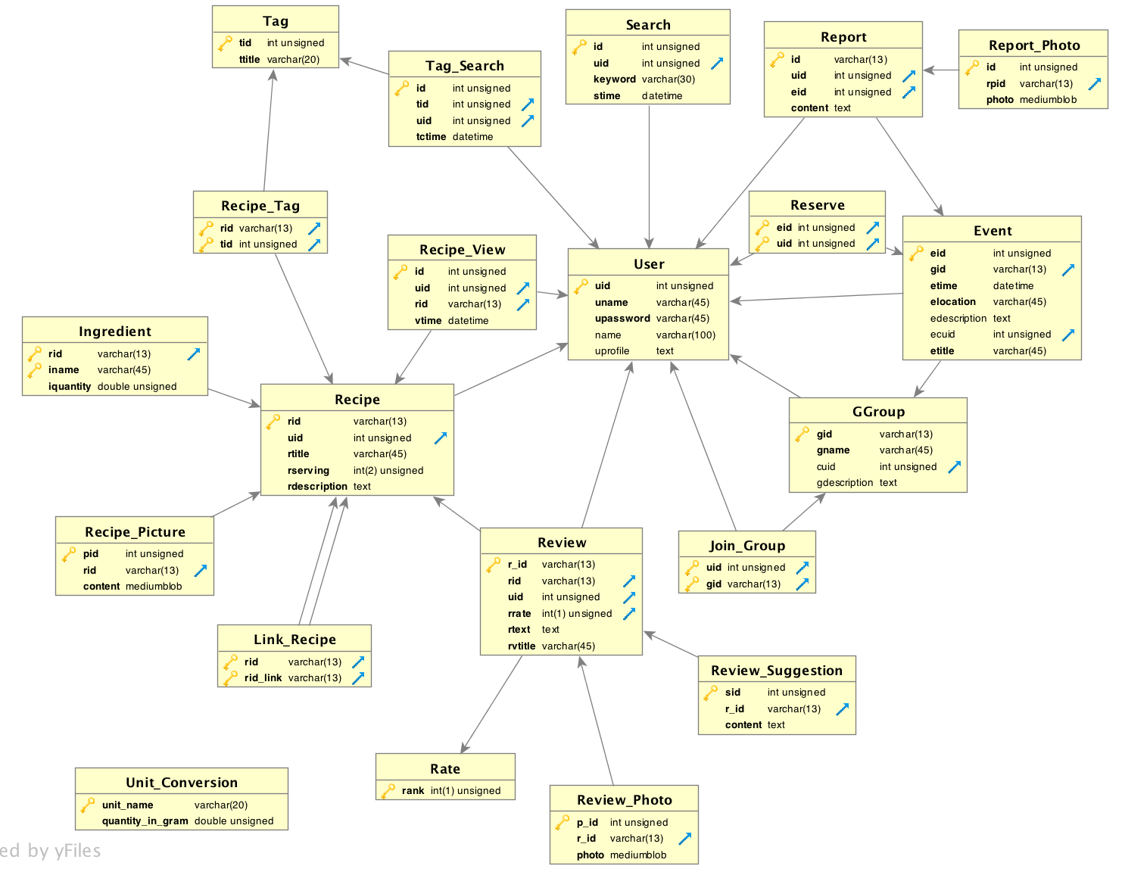

1. Instruction

To use the web site, the first step is register a user account.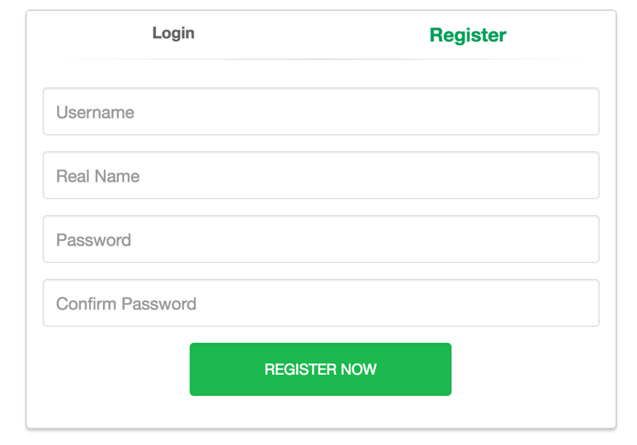

Input a unique username, a real name and the password twice. If the username has already been taken, it will report error.

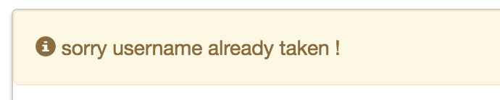

Then the user could login by inputting username and password. If input incorrect password, the page will report error.

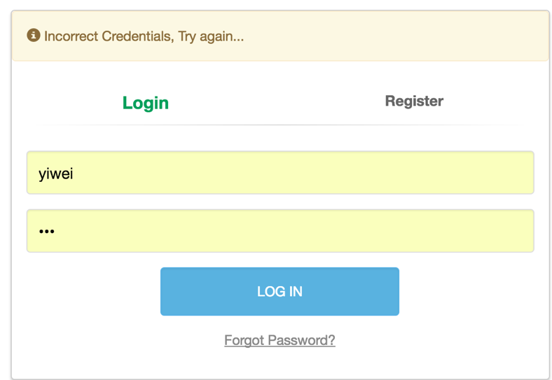

After login, the user could modify his/her profile and password by going to profile:

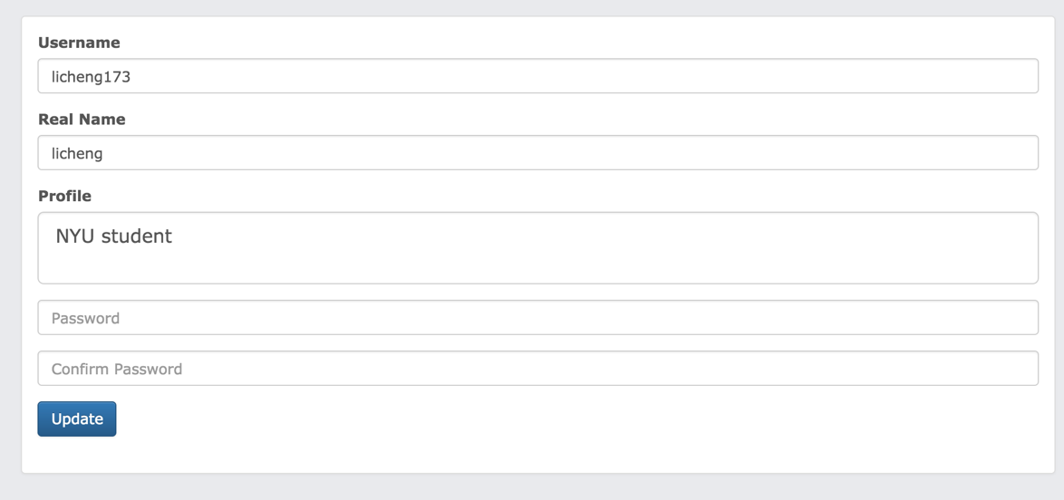

After login, the default page is the home page showing all the posted recipes by this user.

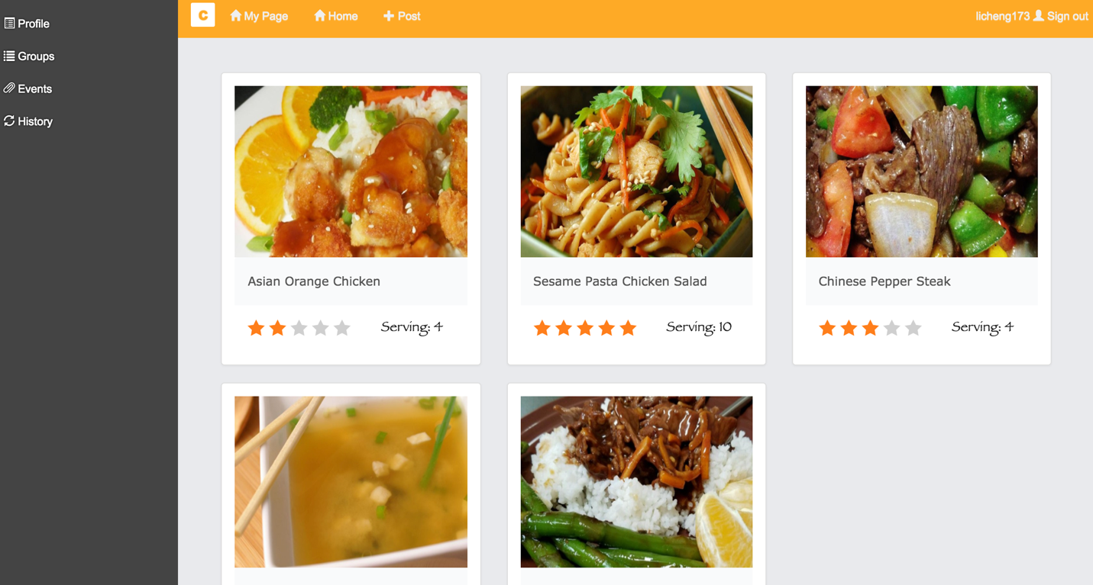

The recipes will have one picture, average review rating and serving number listed.

The left sidebar has options of “Profile”, “Groups”, “Events” and “History”. The topbar has the manu of choosing “My Page”, “Home”, “Post” and “Sign out”. The username of the user will be shown next to the “Sign out” button.

The “Home” page is almost same as the “My Page” except this page shows all the recipes posted by all users, and there is search function for search keywords and tags and ranks.

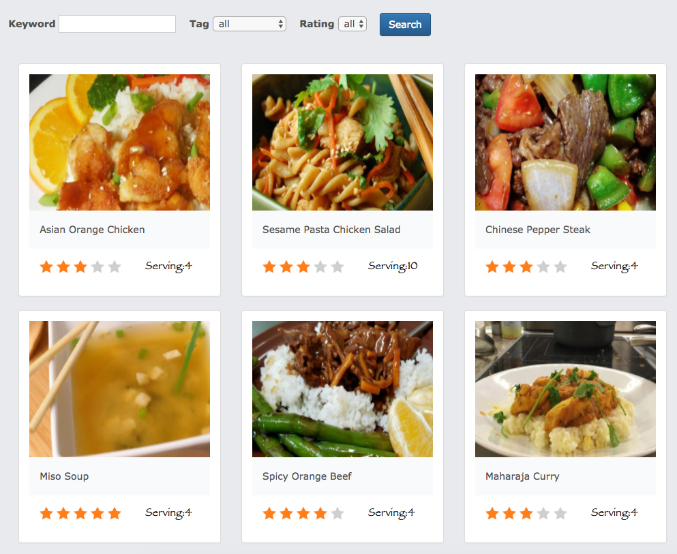

By pressing the “Post” button, the page will go to posting function:

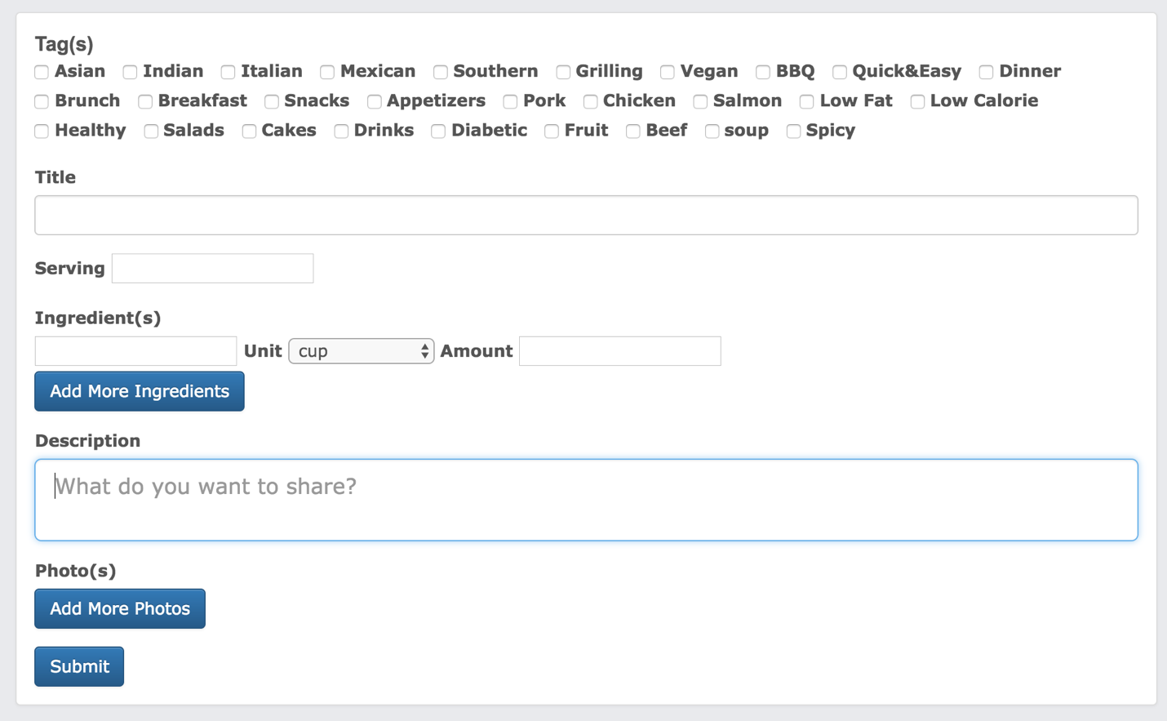

One can choose tags for the recipe, the tags items are fetched from the database, but not hard coded in the html. There are other columns, such as “Title” for the title of the recipe, “Serving” for showing the number of people the dish could serve, “Ingredient” for the composition of the recipe, “Description” for a detailed description of the dish, “Photo” to submit photos for the recipe.

After posting a new recipe, the recipe will be shown in the “My Page” and the “Home” page. To view the detail of the recipe, just click on the recipe.

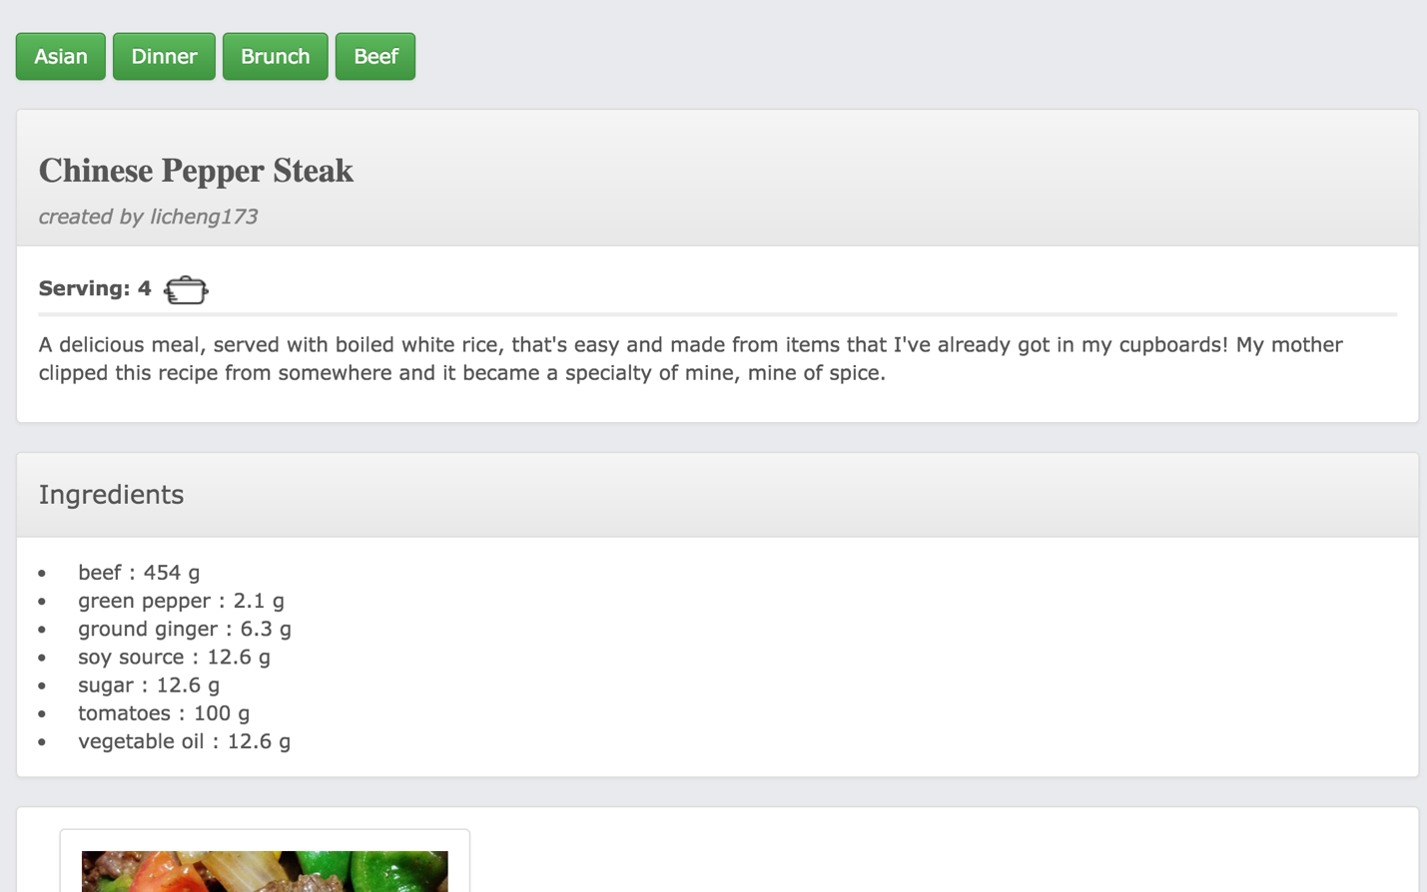

One can the detail of the ingredients, the description and all the pictures of the recipe.

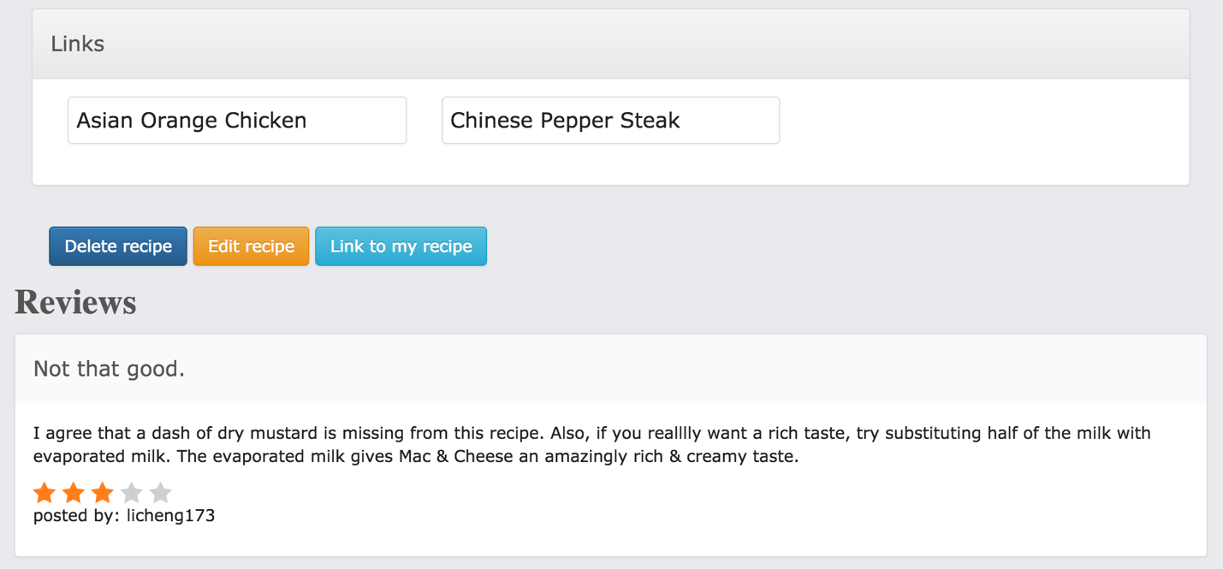

One can also see the other recipes the recipe linking to. There is a “Link to my recipe” button, by clicking which the user could link this recipe to one of his own recipe. If this recipe is posted by the user, there will be two more buttons: “Delete recipe” and “Edit recipe”. The delete button will delete the recipe together with the reviews. The “Edit recipe” button will lead to the edit page.

Following the recipe, there is the reviews to this recipe. And under all the reviews is the “New Review” panel.

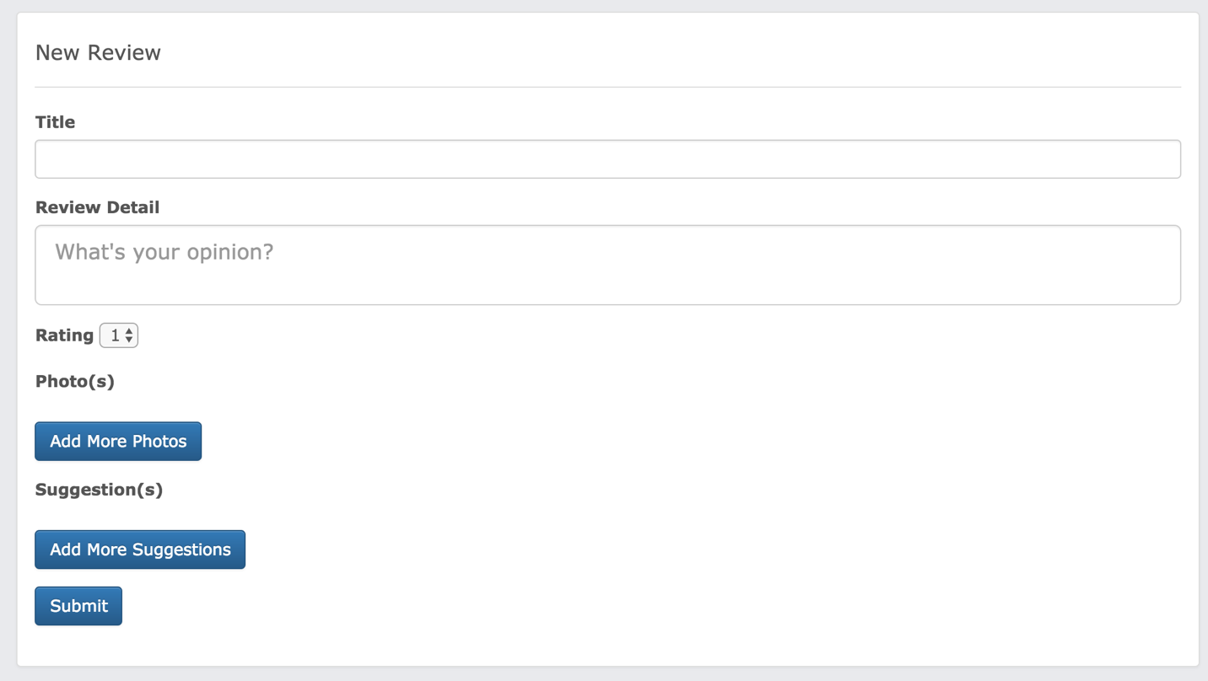

A review includes a title, a review, a rating, photos and suggestions. One can choose to post 0 to many photos and 0 to many suggestions.

Clicking the “Edit recipe” button will direct the user to the edit recipe page. In this page, one can remove the tags by clicking on the tags:

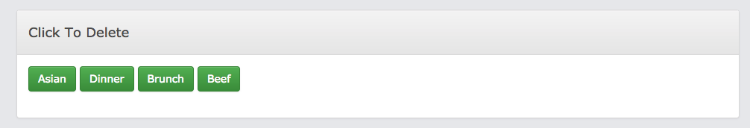

delete the ingredients:

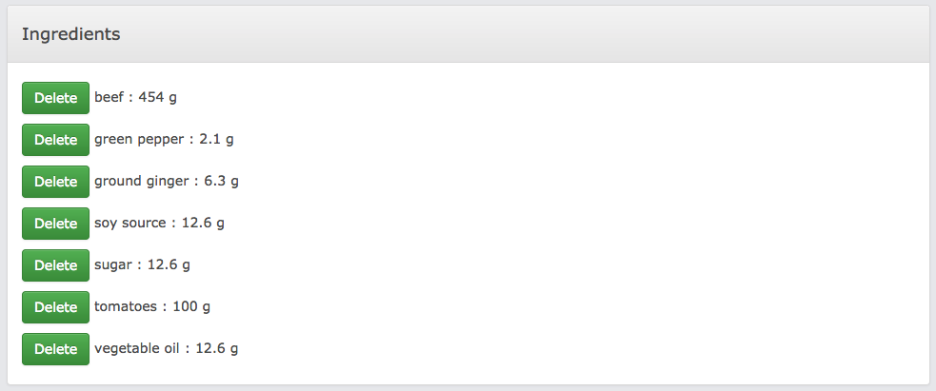

delete a photo:

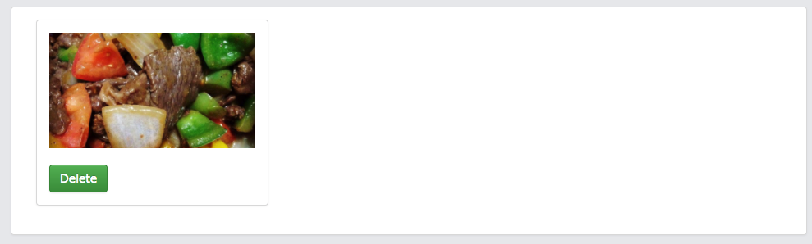

delete a link:

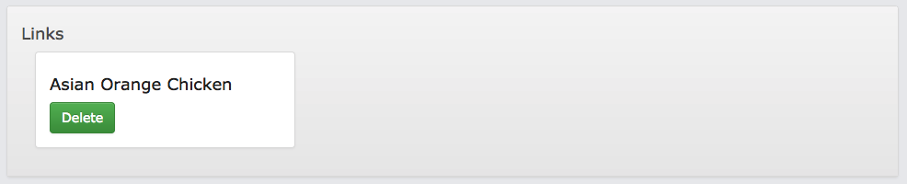

or revise the contents and add more tags, photos:

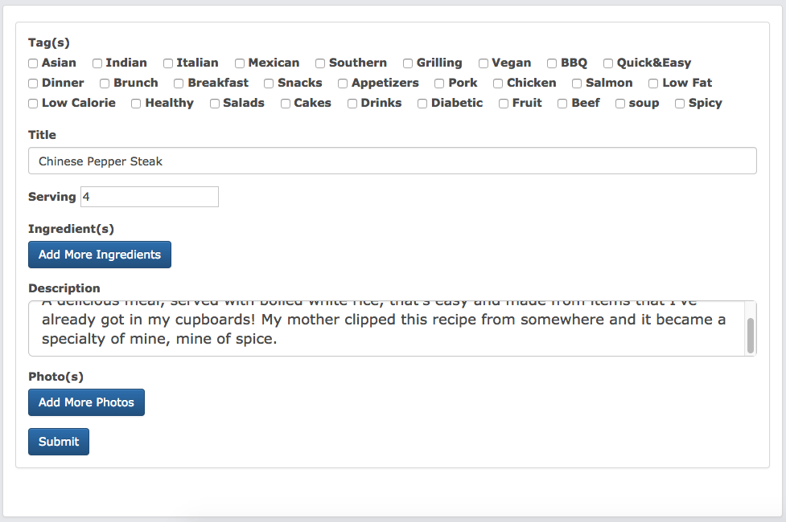

Go back to the recipe page, click on the reviews will lead to the review page:

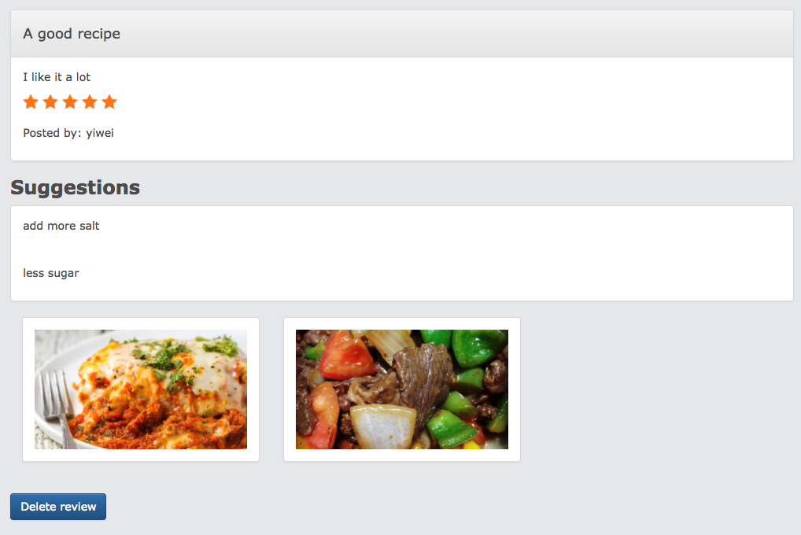

The details including photos and suggestions are shown here. If the review is posted by the logged in user, there is a “Delete review” button at the bottom. Clicking on this button could delete this review.

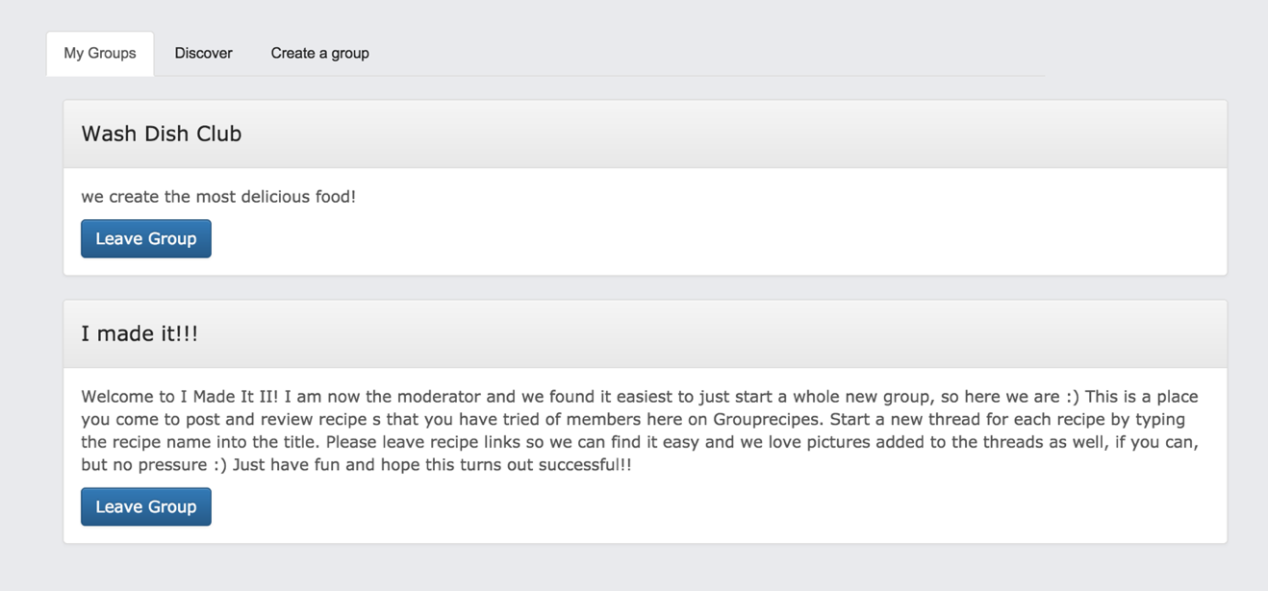Users can create and join groups and organize cooking events. In group page, there are three options, “My group” showing the groups user currently registered. User could leave the group by clicking on the “Leave Group” button.

“Discover” display all the other groups that the user is not in, use can join the groups by clicking “Join Group” buttom.

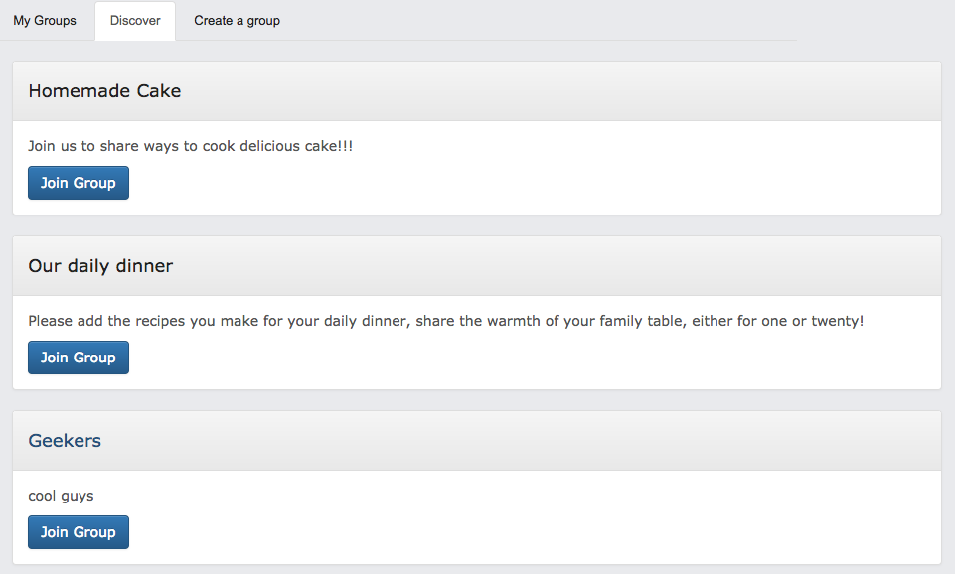

At “Create Group” page user can create new group.

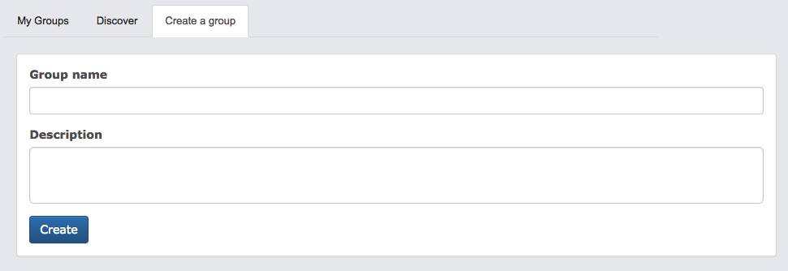

By clicking the “Event” button on the sidebar, user could find all the events he/she participated and reserved.

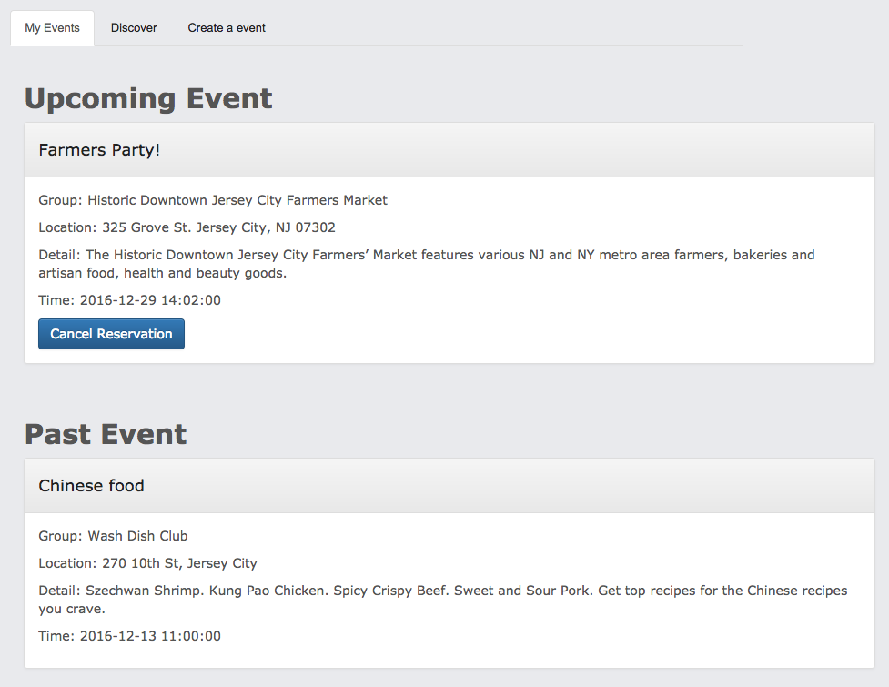

By clicking on the “Cancel Reservation” button, one could cancel the reservation to the event. All the past could not be cancelled.

The “Discover” tab shows all the other events held by the groups the user joined.

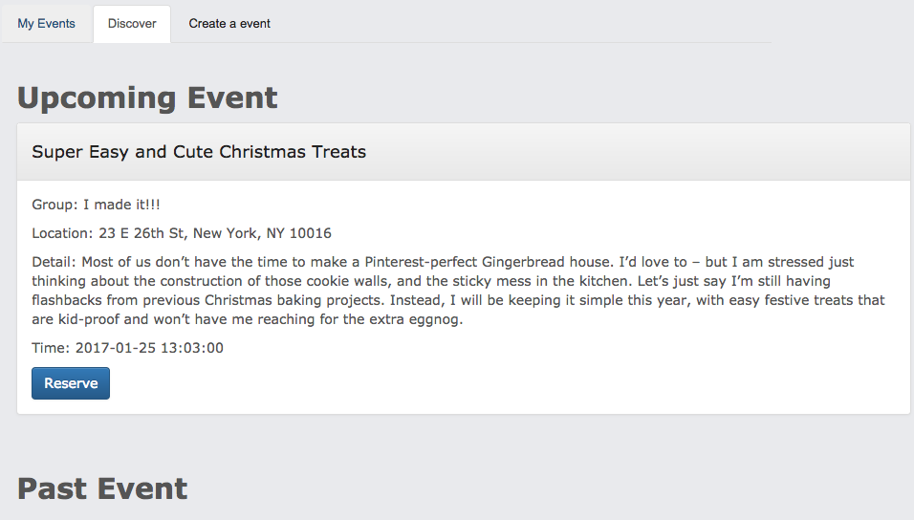

One can reserve the event by clicking on the “Reserve” button.

User can create an event at “Create an event” tab.

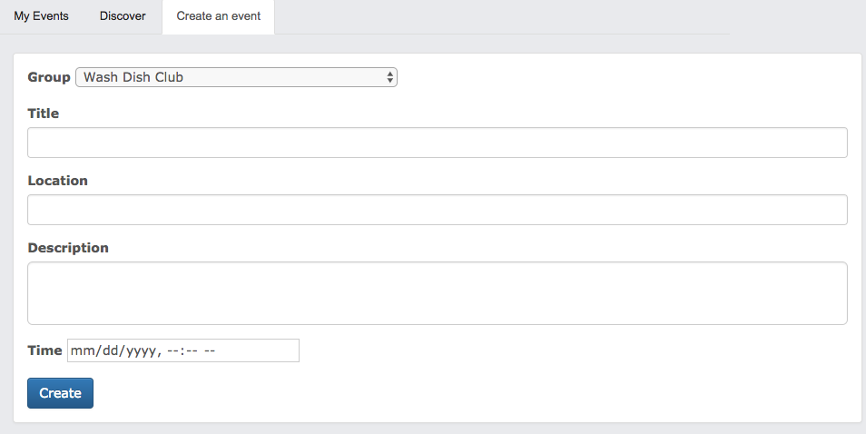

User can choose which group will this event belong to. The options are read from database that the user joined. Other fields include “Title”, “Location”, “Description” and “Time”.

Clicking on the event directs to the event detail page.

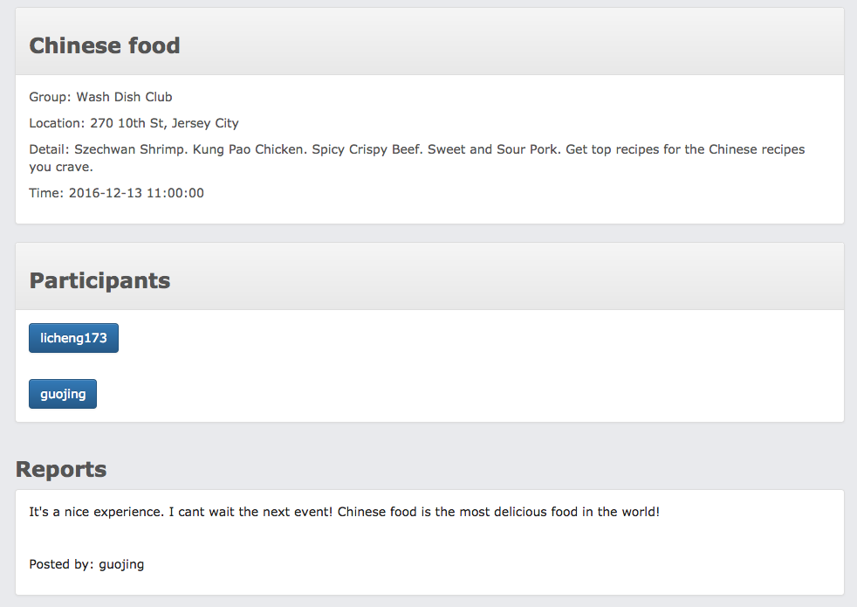

It shows the detail of the event, the participants and the reports posted by the participants. One can post a new review below. One can post a text report and several photos.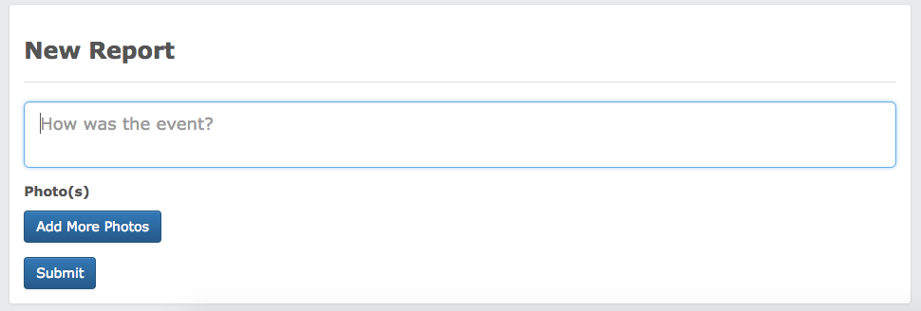

Clicking on the report leads to the report detail page.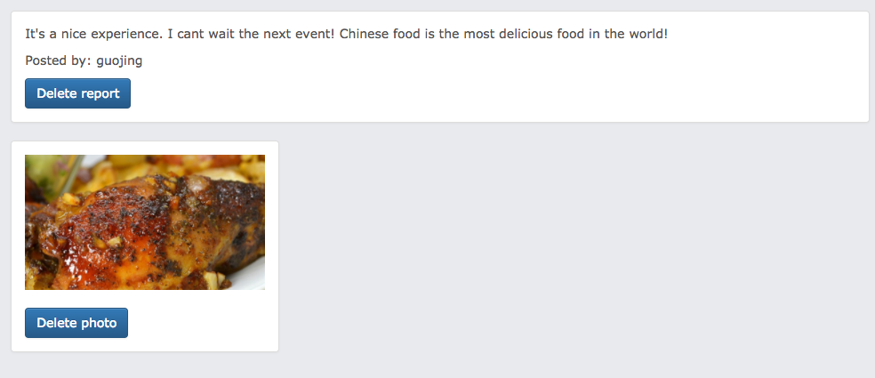

If the report is posted by the user, the user could delete the photos and report.

The last part is “History”. This part will display recipes the user has recently looked at, or to display recently clicked tags or recent searches, and in general to learn what kind of recipes the user is interested in. User can also click each record and check the detail of recipe he or she interested in.

