**Guidance on bias-correction of log-normal random effects and observations in state-space assessment models**

A simulation-estimation work for GoM haddock and GB yellowtail flounder, with 50 replicates. There can be different convergence rate across OM scenarios, to ensure that all scenarios had the same number of simulations, more iterations using new randomly generated numbers were run until results of 50 simulations were obtained (n = 50). Preliminary results showed that the convergence rate for different EMs within the same OM is very similar.

We have 6 x 4 (T/F BC on PE and OE) = 24 OMs, with increasing model complexity:

|  |  |  |  |
| --- | --- | --- | --- |
| **NAA Configuration** | **OM** | **PE** | **OE** |
| Rec (iid) | 1 | 1 | 1 |
|  | 2 | 0 | 1 |
|  | 3 | 1 | 0 |
|  | 4 | 0 | 0 |
| Rec+1 (iid) | 1 | 1 | 1 |
|  | 2 | 0 | 1 |
|  | 3 | 1 | 0 |
|  | 4 | 0 | 0 |
| Rec (ar1_y) | 1 | 1 | 1 |
|  | 2 | 0 | 1 |
|  | 3 | 1 | 0 |
|  | 4 | 0 | 0 |
| Rec+1 (ar1_y) | 1 | 1 | 1 |
|  | 2 | 0 | 1 |
|  | 3 | 1 | 0 |
|  | 4 | 0 | 0 |
| Rec+1 (ar1_a) | 1 | 1 | 1 |
|  | 2 | 0 | 1 |
|  | 3 | 1 | 0 |
|  | 4 | 0 | 0 |
| Rec+1 (2dar1) | 1 | 1 | 1 |
|  | 2 | 0 | 1 |
|  | 3 | 1 | 0 |
|  | 4 | 0 | 0 |

For each OM, we have 4 EMs with the same NAA configuration as the OM but with different BC option (T/F PE and T/F OE). For example:

|  |  |  |  |  |
| --- | --- | --- | --- | --- |
| **NAA Configuration** | **OM** | **EM** | **PE** | **OE** |
| Rec (iid) | 1 | 1 (correct EM) | 1 | 1 |
|  | **1** | 2 | 0 | 1 |
|  | 1 | 3 | 1 | 0 |
|  | **1** | 4 | 0 | 0 |

Model configuration for GoM haddock and GB yellowtail flounder

|  |  |  |
| --- | --- | --- |
| Parameter | Haddock | Yellowtail Flounder |
| Fleet Catch |  |  |
| Period | 1977-2018 | 1973-2022 |
| Selectivity form | Age-specific | Logistic |
| Likelihood for age comp. | Logistic-normal-miss0 | Dirichlet-miss0 |
| Survey Indices |  |  |
|  |  |  |
| Survey Indices |  |  |
| Period | 1. 1977-2018 | 1. 1973-2022 |
|  | 2. 1977-2018 | 2. 1973-2022 |
|  |  | 3. 1987-2022 |
| Selectivity form | Age-specific | Logistic |
| Likelihood for age comp. | Logistic-normal-miss0 | Dirichlet-miss0 |

**Note: we already know that in the OM with Rec RE (e.g. iid), mean rec estimated from an EM with bias correction on (BC ON) can be easily converted to the mean rec estimated from an EM with BC OFF [(mean rec1 – sigma^2/2) = mean rec2]. But this is not true when the OM has Rec+1 RE.**

The “random-effects” parameters for GB yellowtail flounder

|  |  |  |  |  |  |  |
| --- | --- | --- | --- | --- | --- | --- |
| **NAA Configuration** | **OM** | **Mean_Rec** | **Rec sigma** | **NAA sigma** | **Rho (ar1_y)** | **Rho (ar1_a)** |
| Rec (iid) | 1 | 45239.48 | 1.07 | NA | NA | NA |
|  | 2 | 25479.86 | 1.07 | NA | NA | NA |
|  | 3 | 44891.77 | 1.08 | NA | NA | NA |
|  | 4 | 25093.08 | 1.08 | NA | NA | NA |
| Rec+1 (iid) | 1 | 91247.16 | 1.23 | 0.55 | NA | NA |
|  | 2 | 25942.30 | 1.23 | 0.56 | NA | NA |
|  | 3 | 91014.06 | 1.24 | 0.55 | NA | NA |
|  | 4 | 25634.51 | 1.24 | 0.56 | NA | NA |
| Rec (ar1_y) | 1 | 48356.25 | 0.37 | NA | 0.96 | NA |
|  | 2 | 19730.91 | 0.37 | NA | 0.96 | NA |
|  | 3 | 48336.16 | 0.37 | NA | 0.96 | NA |
|  | 4 | 19369.80 | 0.37 | NA | 0.96 | NA |
| Rec+1 (ar1_y) | 1 | 25776.28 | 0.55 | 0.21 | 0.94 | NA |
|  | 2 | 5923.65 | 0.55 | 0.21 | 0.94 | NA |
|  | 3 | 25679.78 | 0.55 | 0.21 | 0.94 | NA |
|  | 4 | 5834.00 | 0.55 | 0.21 | 0.94 | NA |
| Rec+1 (ar1_a) | 1 | 89520.03 | 0.98 | 0.49 | NA | 0.53 |
|  | 2 | 28357.50 | 0.97 | 0.49 | NA | 0.55 |
|  | 3 | 88878.58 | 0.99 | 0.49 | NA | 0.53 |
|  | 4 | 27944.32 | 0.98 | 0.49 | NA | 0.55 |
| Rec+1 (2dar1) | 1 | 12667.86 | 0.52 | 0.2 | 0.94 | 0.25 |
|  | 2 | 4050.40 | 0.53 | 0.21 | 0.94 | 0.23 |
|  | 3 | 12568.81 | 0.52 | 0.2 | 0.94 | 0.25 |
|  | 4 | 3982.86 | 0.53 | 0.21 | 0.94 | 0.23 |

Linear regression didn’t show log(mean rec) was linearly related to any parameters shown here.

The “random-effects” parameters for GoM haddock

|  |  |  |  |  |  |  |
| --- | --- | --- | --- | --- | --- | --- |
| **NAA Configuration** | **OM** | **Mean_Rec** | **Rec sigma** | **NAA sigma** | **Rho (ar1_y)** | **Rho (ar1_a)** |
| Rec (iid) | 1 | 7615.01 | 1.57 | NA | NA | NA |
|  | 2 | 2215.09 | 1.57 | NA | NA | NA |
|  | 3 | 7798.86 | 1.59 | NA | NA | NA |
|  | 4 | 2215.49 | 1.59 | NA | NA | NA |
| Rec+1 (iid) | 1 | 8828.49 | 1.6 | 0.2 | NA | NA |
|  | 2 | 2214.08 | 1.6 | 0.2 | NA | NA |
|  | 3 | 9058.99 | 1.62 | 0.2 | NA | NA |
|  | 4 | 2210.97 | 1.62 | 0.2 | NA | NA |
| Rec (ar1_y) | 1 | 10291.91 | 1.16 | NA | 0.7 | NA |
|  | 2 | 2701.89 | 1.16 | NA | 0.7 | NA |
|  | 3 | 10655.62 | 1.17 | NA | 0.71 | NA |
|  | 4 | 2719.29 | 1.17 | NA | 0.71 | NA |
| Rec+1 (ar1_y) | 1 | 8192.65 | 1.18 | 0.16 | 0.6 | NA |
|  | 2 | 2500.65 | 1.18 | 0.16 | 0.6 | NA |
|  | 3 | 8439.07 | 1.18 | 0.17 | 0.61 | NA |
|  | 4 | 2505.25 | 1.18 | 0.16 | 0.61 | NA |
| Rec+1 (ar1_a) | 1 | 9303.82 | 1.55 | 0.2 | NA | -0.3 |
|  | 2 | 2206.69 | 1.56 | 0.2 | NA | -0.29 |
|  | 3 | 9529.18 | 1.57 | 0.2 | NA | -0.29 |
|  | 4 | 2204.79 | 1.58 | 0.2 | NA | -0.28 |
| Rec+1 (2dar1) | 1 | 8662.05 | 1.02 | 0.16 | 0.62 | -0.49 |
|  | 2 | 2542.59 | 1.02 | 0.16 | 0.62 | -0.49 |
|  | 3 | 8825.3 | 1.03 | 0.16 | 0.62 | -0.47 |
|  | 4 | 2542.65 | 1.03 | 0.16 | 0.62 | -0.48 |

Linear regression didn’t show log(mean rec) was linearly related to any parameters shown here.

**GB Yellowtail Flounder Simulation Results**

Simulated catch data (50 realizations for each OM)

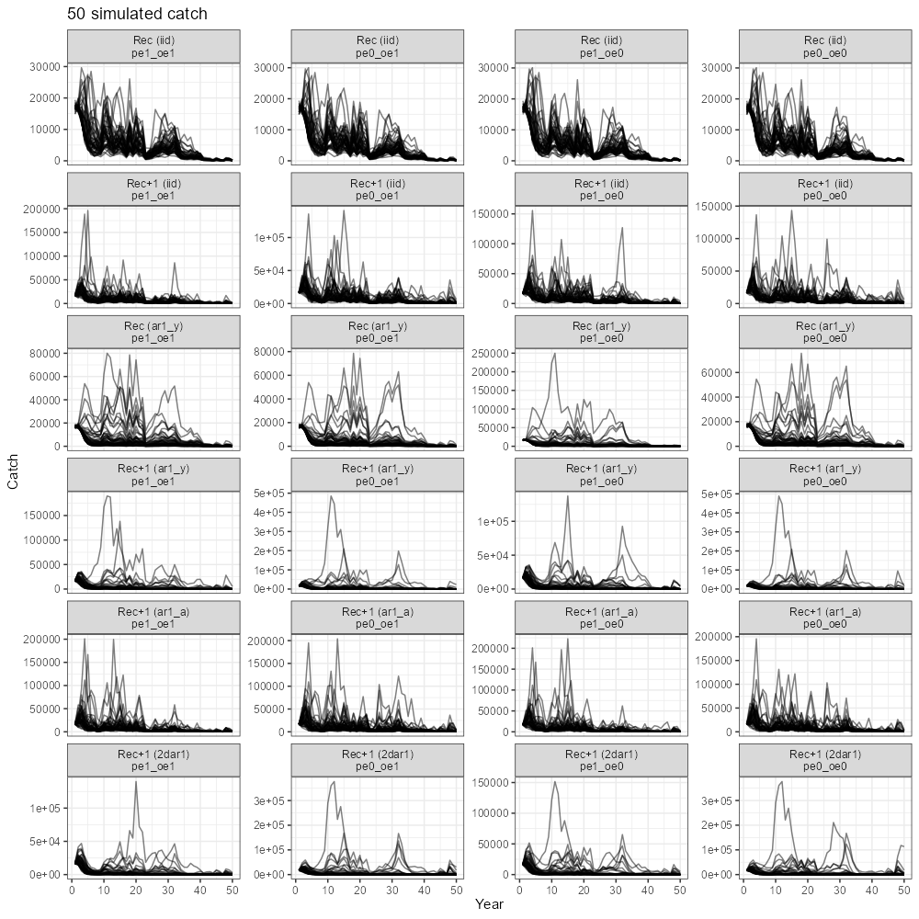

Compare Recruitment with the true recruitment (sim/true = 1 or not). Findings are below:

1. For OMs with Rec only (iid or ar1_y), EMs with/without BC produced similar estimates of Rec.
2. For OMs with Rec+1 (iid, ar1_y, ar1_a, 2dar1), when the OM had PE BC OFF, using EMs with PE BC ON induced large bias (e.g. 2nd column, EM1 and EM3 overestimated Rec in the OM with Rec+1); but when the OM had PE BC ON, using EMs with PE BC OFF only induced small bias.
3. For OMs with Rec+1 ar1_y or 2dar1, when the OM had PE BC ON, using wrong EMs with PE BC OFF produced more accurate estimates (e.g. 4th and 6th row, EM2 and EM4).
4. There is no indication that more bias in Rec was produced as NAA RE became more complex (e.g. 2dar1), although some extreme values was likely produced by EMs when the OM became complex.
5. Turn on/off BC for observation on the OM or EM side didn’t show strong influence on the Rec estimate (e.g. 1st column vs. 2nd column OR 3rd column vs. 4th column). (Probably because observation error is low for fleet catch?)
6. In most cases, EMs even the correct EMs tended to overestimate Rec.

Takeaways:

* In Rec only cases (iid, ar1_y), using an EM with BC either ON or OFF seems to be fine.
* In Rec+1 cases, OM-EM mismatch in PE BC can cause bias in Rec, using an EM with PE ON but the OM had PE OFF induced larger bias than using an EM with PE BC OFF but the OM had PE BC ON.
* In some cases an EM with PE BC OFF produces a less biased Rec than the correct EM with PE BC ON.
* OE BC ON or OFF doesn’t affect the Rec estimate.

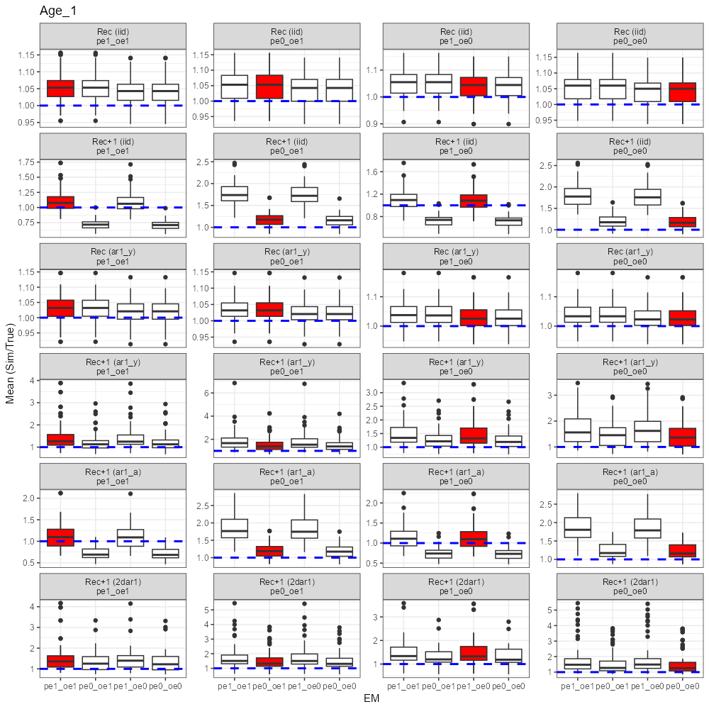

Compare NAA with the true NAA (sim/true = 1 or not). Findings are below:

1. For OMs with Rec only (iid or ar1_y), EMs with/without BC produced similar estimates of NAA (Ages 2+).
2. For OMs with Rec+1 (iid, ar1_y, ar1_a, 2dar1), when the OM had PE BC OFF, using EMs with PE BC ON induced large bias (e.g. 2nd column, EM1 and EM3 overestimated NAA in the OM with Rec+1); but when the OM had PE BC ON, using EMs with PE BC OFF only induced small bias.
3. For OMs with Rec+1 ar1_y or 2dar1, when the OM had PE BC ON, using wrong EMs with PE BC OFF produced more accurate estimates (e.g. 4th and 6th row, EM2 and EM4).
4. No indication that more bias in NAA was produced as Rec+1 became more complex (e.g. 2dar1).
5. Turn on/off BC for OE on the OM or EM side didn’t show strong influence on the NAA estimate. (Probably because observation error is low for fleet catch?)
6. In most cases, EMs tended to overestimate NAA, except for some EMs with BC OFF that underestimated the NAA (e.g. 5th row, 1st column).

Takeaways:

* In Rec only cases (iid, ar1_y), using an EM with BC either ON or OFF seems to be fine.
* In Rec+1 cases, OM-EM mismatch in PE BC can cause bias in NAA, using an EM with PE ON but the OM had PE OFF induced larger bias than using an EM with PE BC OFF but the OM had PE BC ON.
* In some cases an EM with PE BC OFF produces a less biased NAA than the correct EM with PE BC ON.
* OE BC ON or OFF doesn’t affect the NAA estimate.

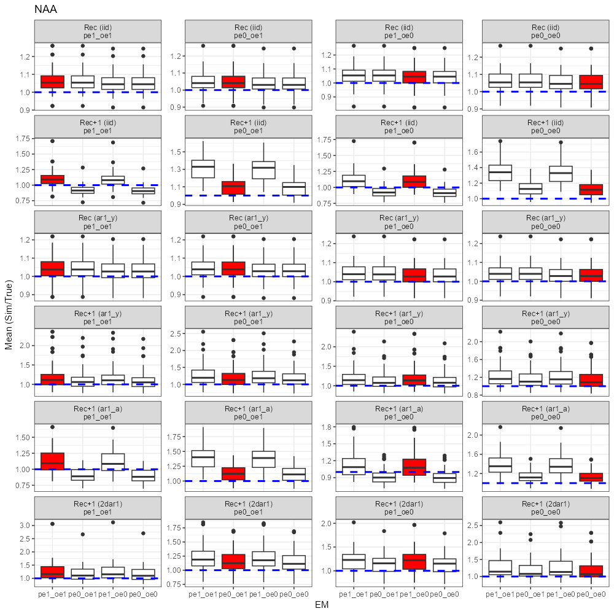

Compare catch with the true catch (sim/true = 1 or not). Findings are below:

1. The ratio (sim/true) was always very close to 1.
2. Patterns of the ratio appeared to be the same across OMs and EMs.

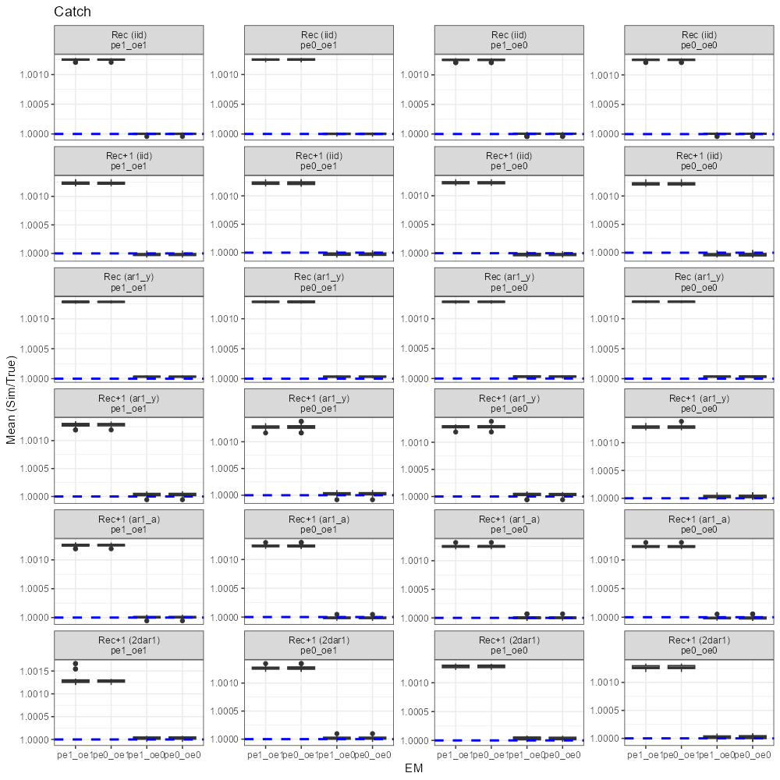

Compare Fmax with the true Fmax (sim/true = 1 or not). Findings are below:

1. The ratio (sim/true) for the OMs that had Rec only was close to 1, but for the OMs that had Rec+1, the ratio was 1 when the EM and OM had matched PE BC (e.g. iid and Rec+1 ar1_a), and in some cases the ratio was 1 even using wrong EMs (e.g. ar1_y and 2dar1).
2. More variable Fmax when OM had PE on NAA than Rec only.

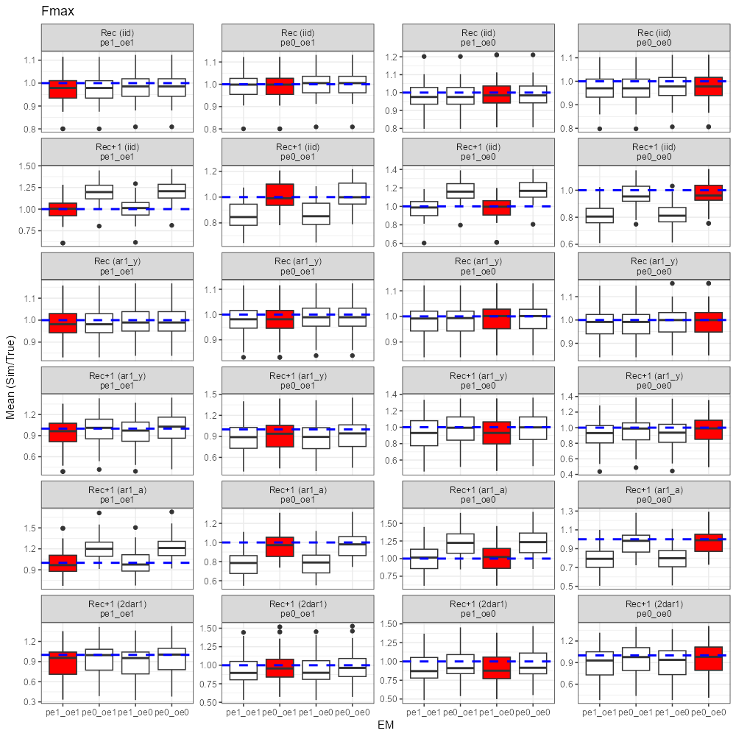

Compare index 1 with the true index 1 (sim/true = 1 or not). Note that there is no BC option for index observation. Findings are below:

1. The ratio (sim/true) was always higher for the EM with OE BC ON, regardless of which OM was used.
2. Large difference between EMs with OE BC ON and that with OE BC OFF (e.g. EM1 vs. EM3).
3. Patterns and magnitudes of the ratio were the same across OMs.
4. No EM captured the true index.
5. Findings are similar for index 2 and index 3.

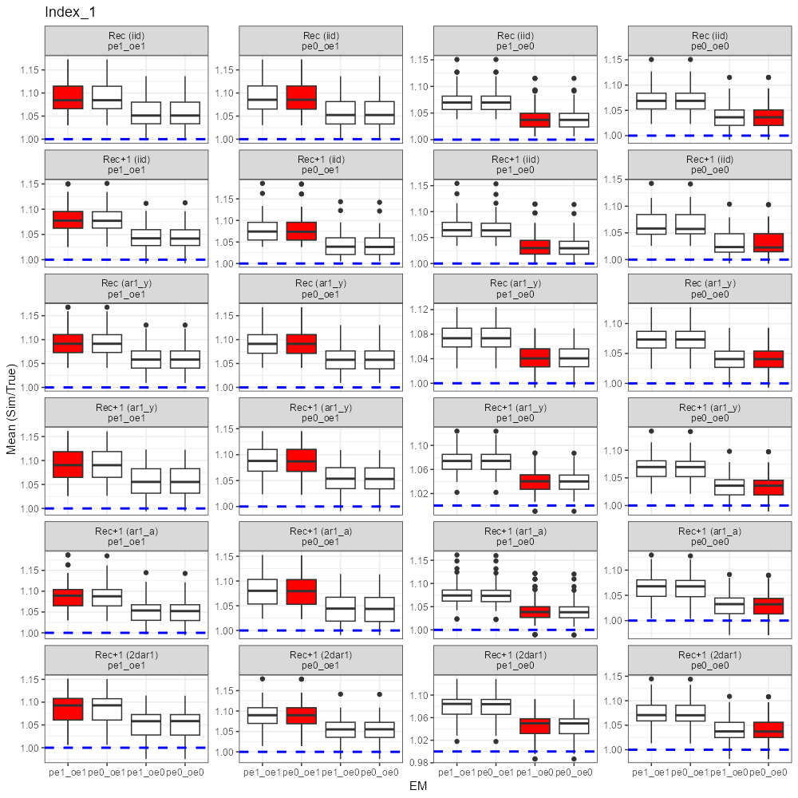

Compare catchability with the true catchability (sim/true = 1 or not). Findings are below:

1. Ratio (sim/true) was 1 for the correct EMs.
2. For Rec+1 iid and ar1_a, when the OM had OE BC ON, using EMs with OE BC OFF overestimated catchability; when the OM had OE BC OFF, using EMs with OE BC ON underestimated catchability
3. No evidence that the catchability estimates became more biased as model complexity increased.

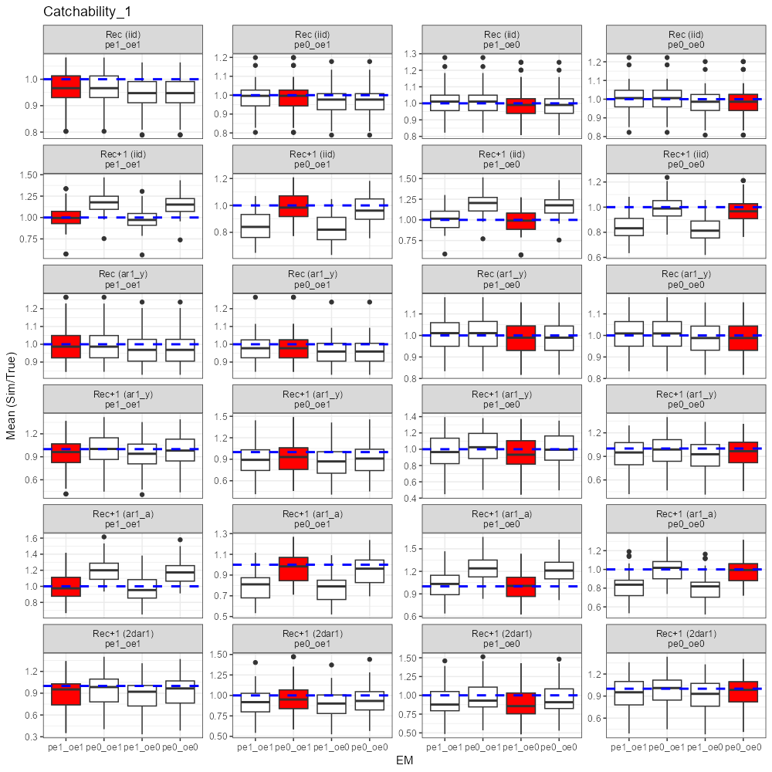

Compare dAIC. Findings are below:

1. dAIC tended to choose the correct EM.

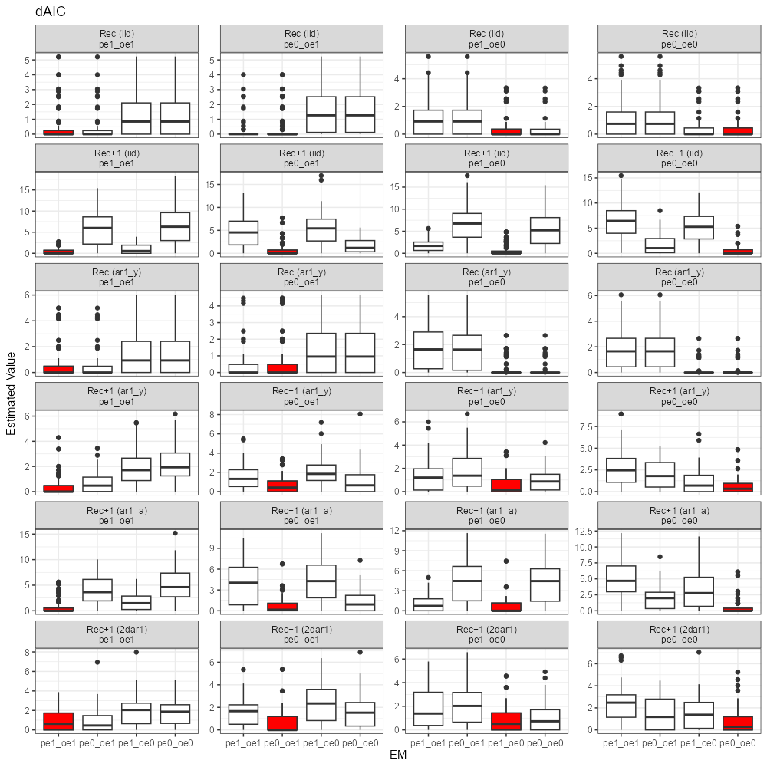

Compare Rec sigma. Findings are below:

1. Rec sigma was always comparable across EMs in each OM scenario.

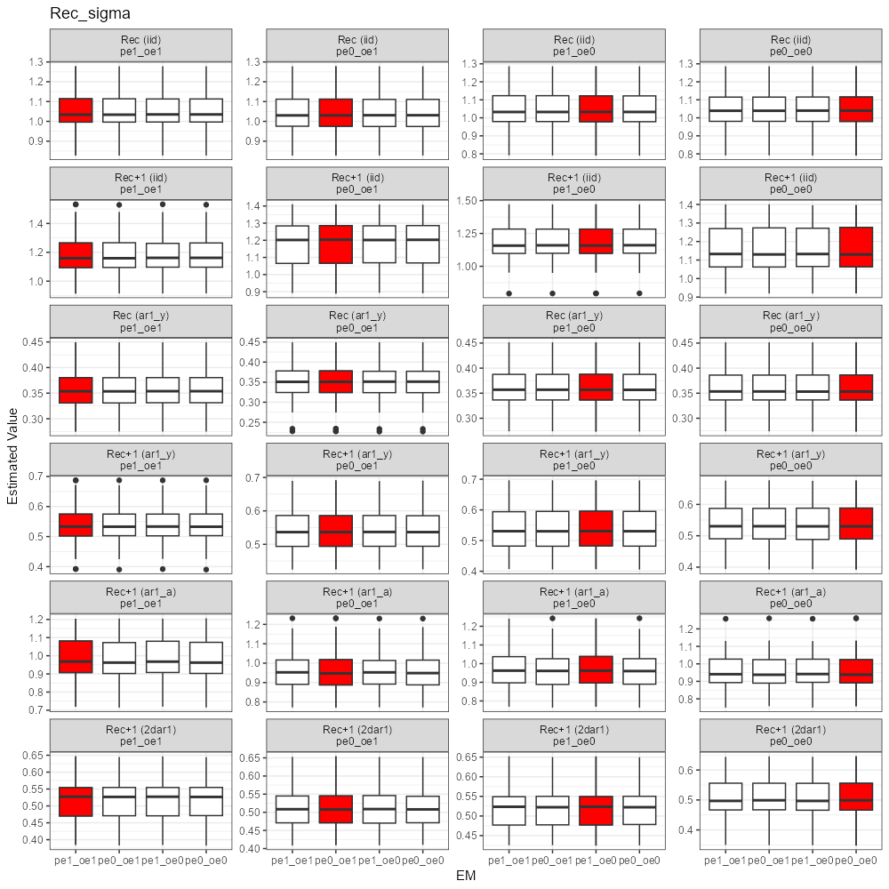

Compare NAA sigma. Findings are below:

1. NAA sigma was always comparable across EMs in each OM scenario.

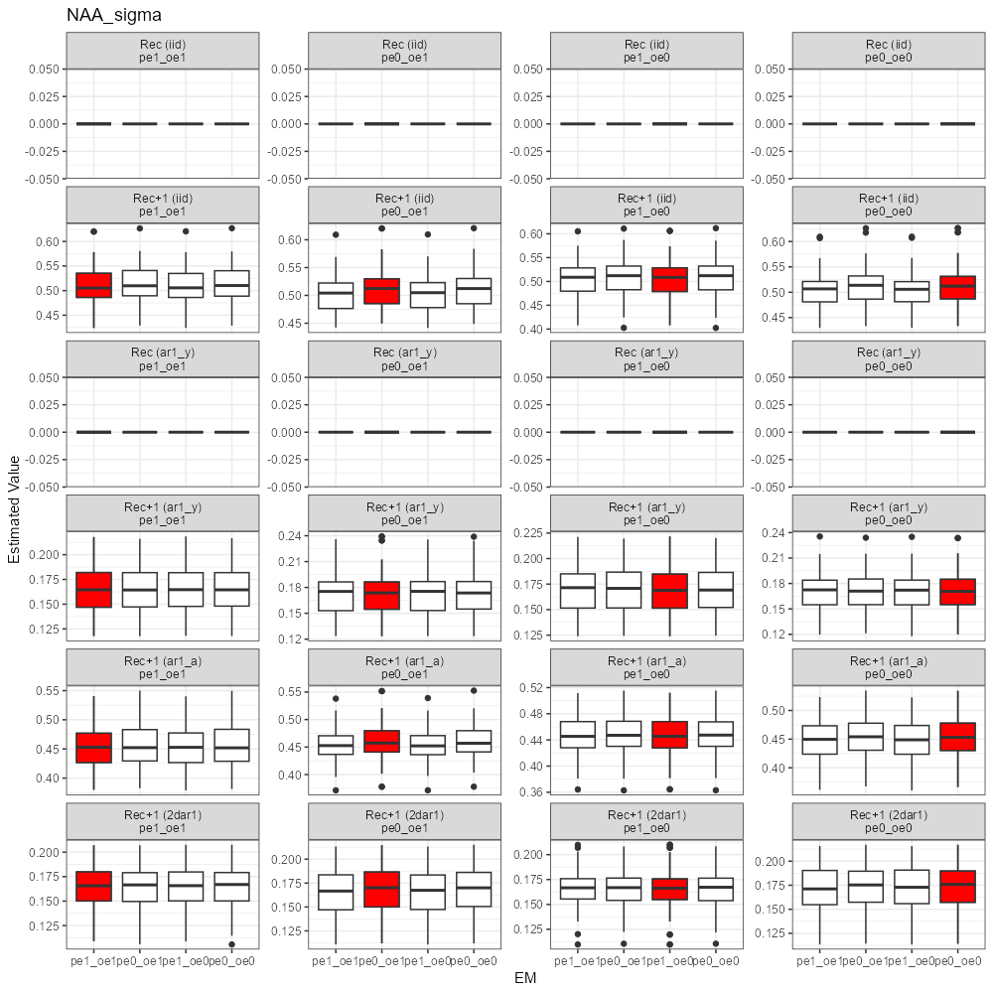

Compare rho_age. Findings are below:

1. Rho age was always comparable across EMs in each OM scenario.

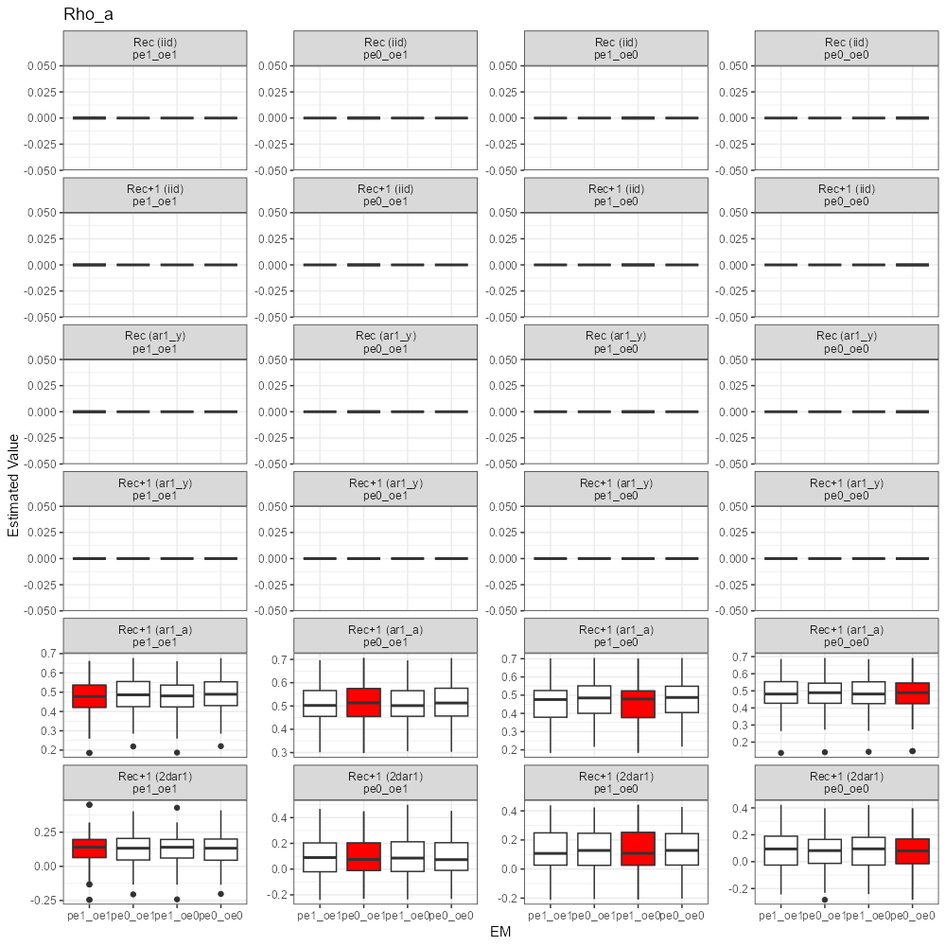

Compare rho_year. Findings are below:

1. Rho_year was always comparable across EMs in each OM scenario.

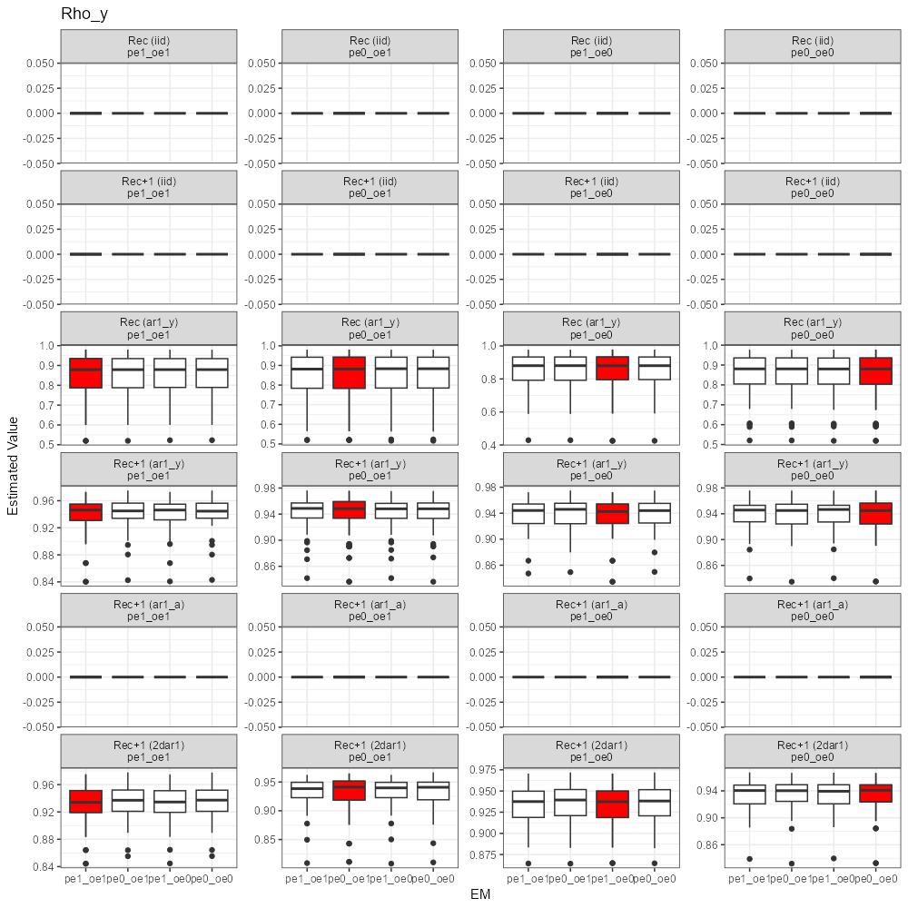

Compare the parameter associated with selfweighting likelihood. Findings are below:

1. Overdispersion parameter for catch age comp. was the same regardless of which EM was used.
2. Parameter value changed as OM changed.

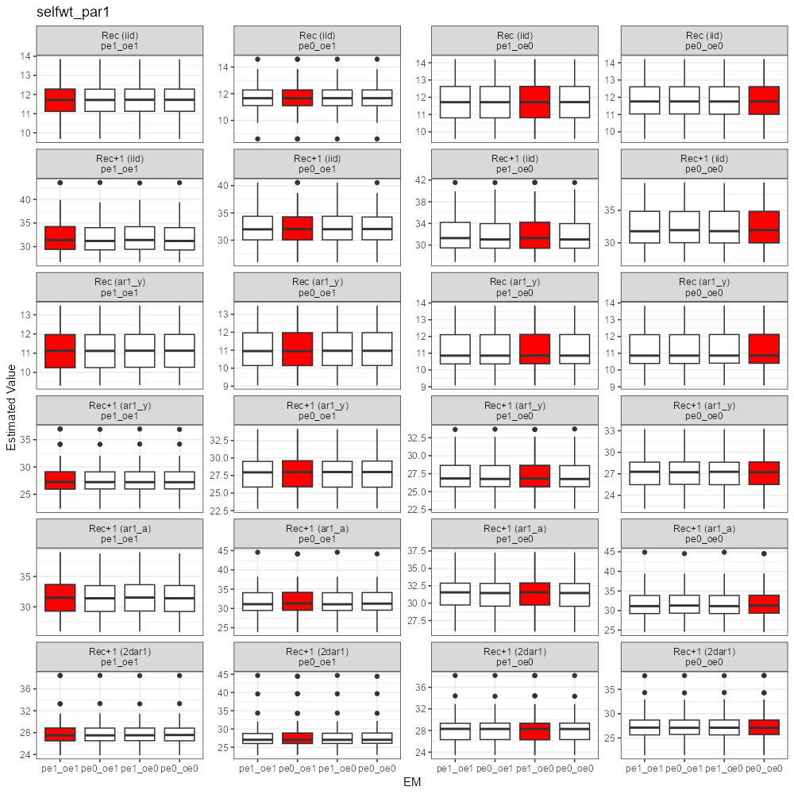

Compare the parameter associated with selfweighting likelihood. Findings are below:

1. Overdispersion parameter for index 1 age comp. was the same regardless of which EM was used.
2. Parameter value changed as OM changed.

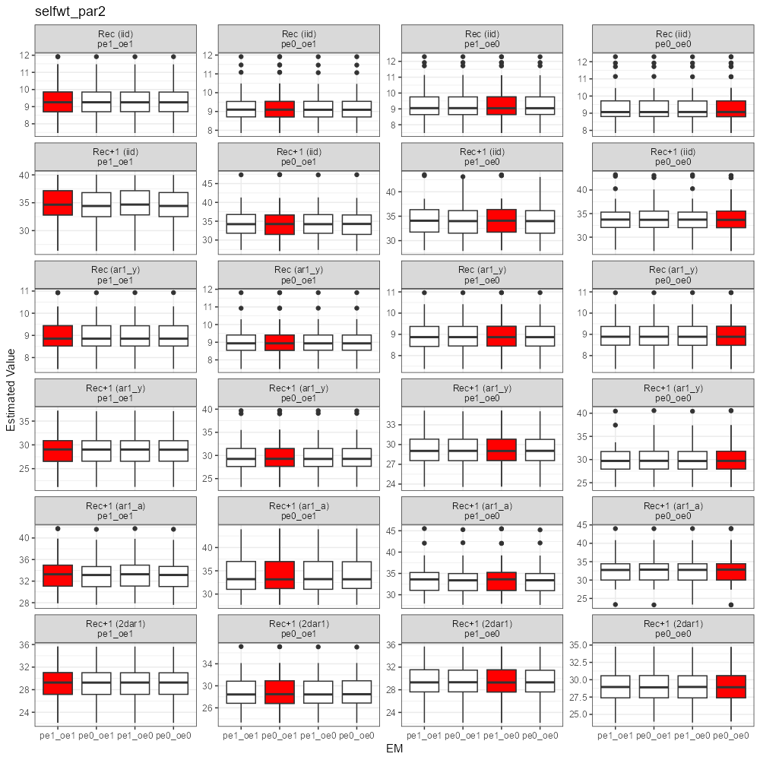

**GoM Haddock Simulation Results**

Simulated catch data (50 realizations for each OM)

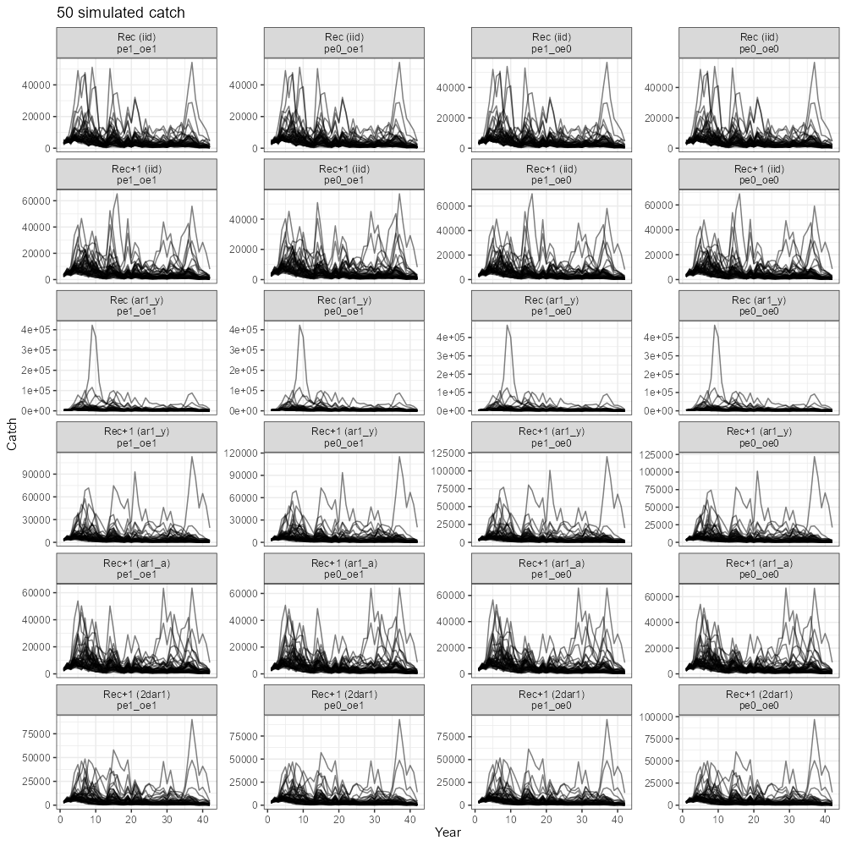

Compare Recruitment with the true recruitment (sim/true = 1 or not). Findings are below:

1. For OMs with Rec only (iid or ar1_y), EMs with/without BC produced similar estimates of Rec.
2. For OMs with Rec+1 (iid, ar1_y, ar1_a, 2dar1), when the OM had PE BC OFF, using EMs with PE BC ON induced large bias (e.g. 2nd column, EM1 and EM3 overestimated Rec in the OM with Rec+1); but when the OM had PE BC ON, using EMs with PE BC OFF only induced small bias.
3. For OMs with Rec+1 iid, ar1_y or ar1_a, when the OM had PE BC ON, using wrong EMs with PE BC OFF produced more accurate estimates (e.g. 2nd, 4th and 5th row, EM2 and EM4).
4. There is no indication that more bias in Rec was produced as NAA RE became more complex (e.g. 2dar1).
5. Turn on/off BC for observation on the OM or EM side didn’t show strong influence on the Rec estimate (e.g. 1st column vs. 2nd column OR 3rd column vs. 4th column). (Probably because observation error is low for fleet catch?)
6. In most cases, most EMs even the correct EMs tended to overestimate Rec.

Takeaways:

* In Rec only cases (iid, ar1_y), using an EM with BC either ON or OFF seems to be fine.
* In Rec+1 cases, OM-EM mismatch in PE BC can cause bias in Rec, using an EM with PE ON but the OM had PE OFF induced larger bias than using an EM with PE OFF but the OM had PE ON.
* In some cases an EM with PE BC OFF produces a less biased Rec than the correct EM with PE BC ON.
* OE BC ON or OFF doesn’t affect the Rec estimate.

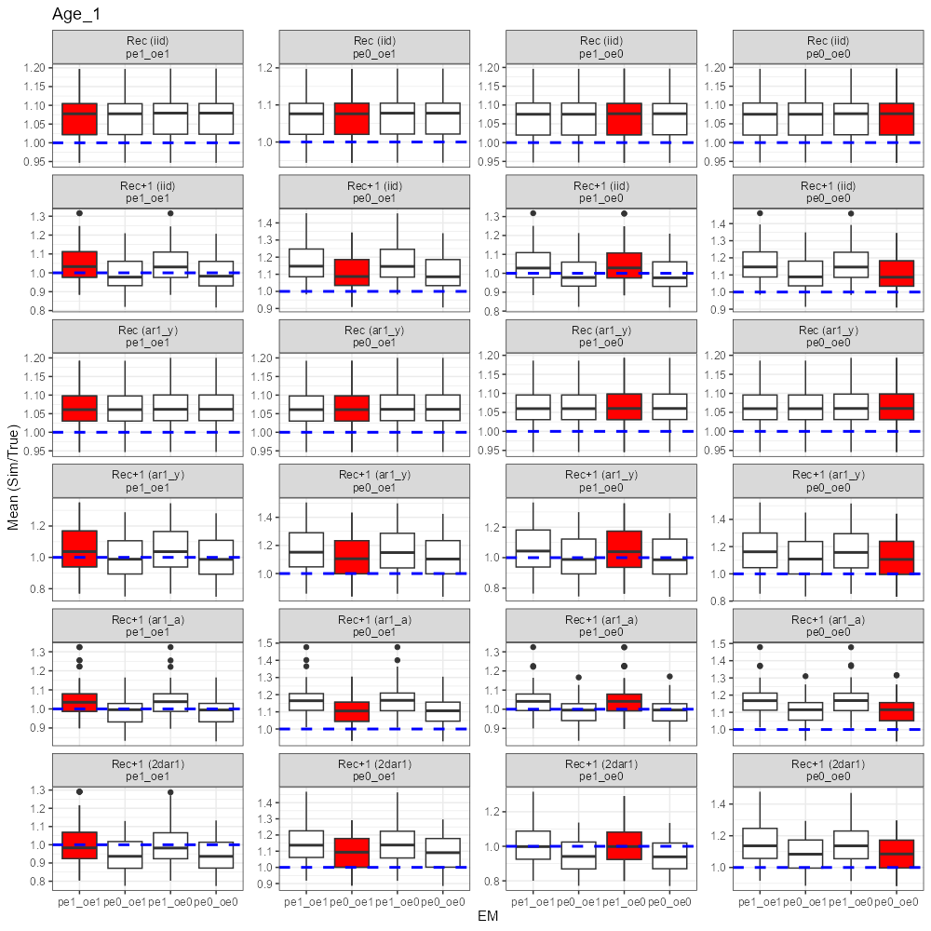

Compare NAA with the true NAA (sim/true = 1 or not). Findings are below:

1. For OMs with Rec only (iid or ar1_y), EMs with/without BC produced similar estimates of NAA (Ages 2+).
2. For OMs with Rec+1 (iid, ar1_y, ar1_a, 2dar1), when the OM had PE BC OFF, using EMs with PE BC ON induced large bias (e.g. 2nd column, EM1 and EM3 overestimated NAA in the OM with Rec+1); but when the OM had PE BC ON, using EMs with PE BC OFF only induced small bias.
3. For OMs with Rec+1 ar1_y, ar1_a, or 2dar1, when the OM had PE BC ON, using wrong EMs with PE BC OFF produced more accurate estimates (e.g. 4th, 5th, and 6th row, EM2 and EM4).
4. No indication that more bias in NAA was produced as Rec+1 became more complex (e.g. 2dar1).
5. Turn on/off BC for OE on the OM or EM side didn’t show strong influence on the NAA estimate. (Probably because observation error is low for fleet catch?)
6. In most cases, EMs tended to overestimate NAA.

Takeaways:

* In Rec only cases (iid, ar1_y), using an EM with BC either ON or OFF seems to be fine.
* In Rec+1 cases, OM-EM mismatch in PE BC can cause bias in NAA, using an EM with PE ON but the OM had PE OFF induced larger bias than using an EM with PE BC OFF but the OM had PE BC ON.
* In some cases an EM with PE BC OFF produces a less biased NAA than the correct EM with PE BC ON.
* OE BC ON or OFF doesn’t affect the NAA estimate.

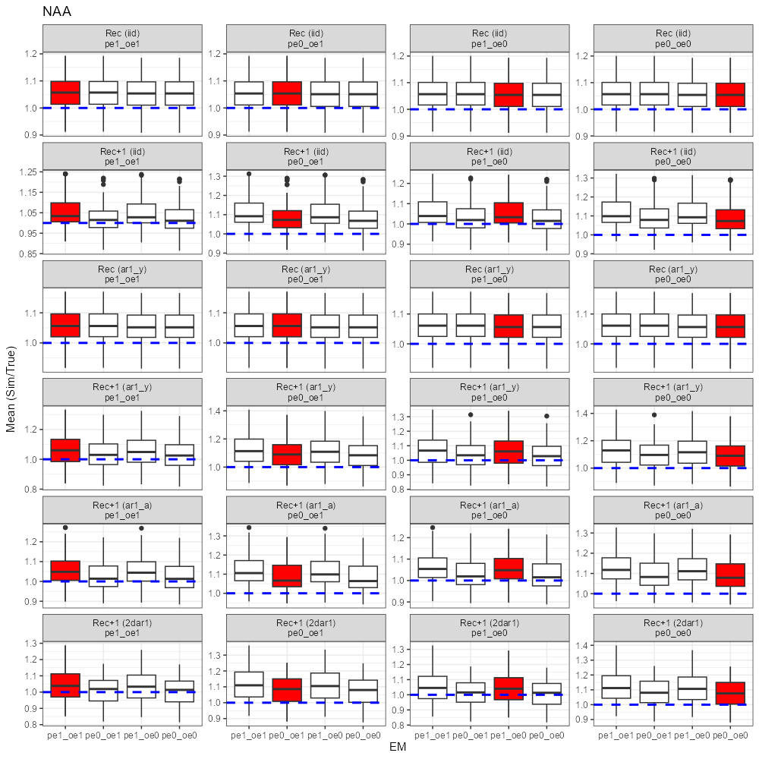

Compare catch with the true catch (sim/true = 1 or not). Findings are below:

1. The ratio (sim/true) was always very close to 1.
2. Patterns of the ratio appeared to be the same across OMs and EMs.

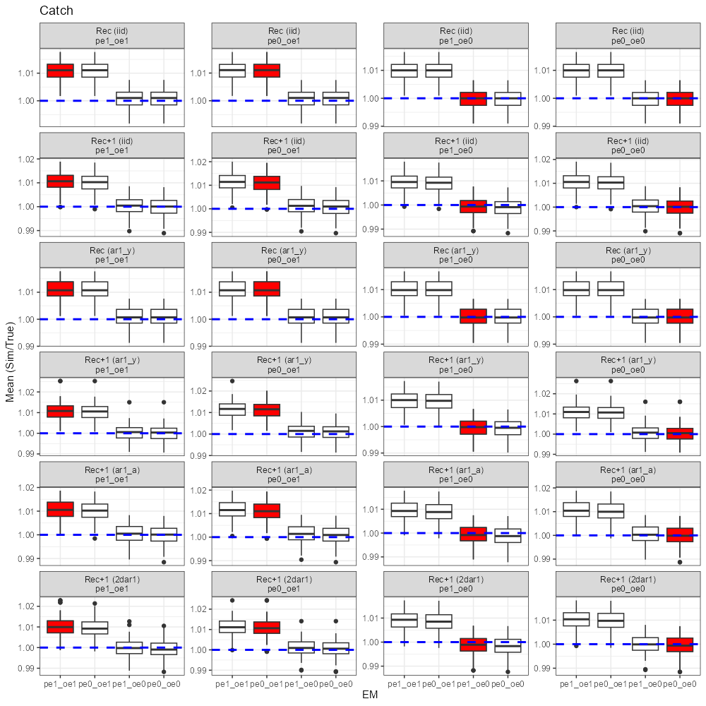

Compare Fmax with the true Fmax (sim/true = 1 or not). Findings are below:

1. The ratio (sim/true) for the OMs that had Rec only was close to 1, regardless of what EMs was used.
2. The ratio for the OMs that had Rec+1 was also close to 1 but more variable across EMs.

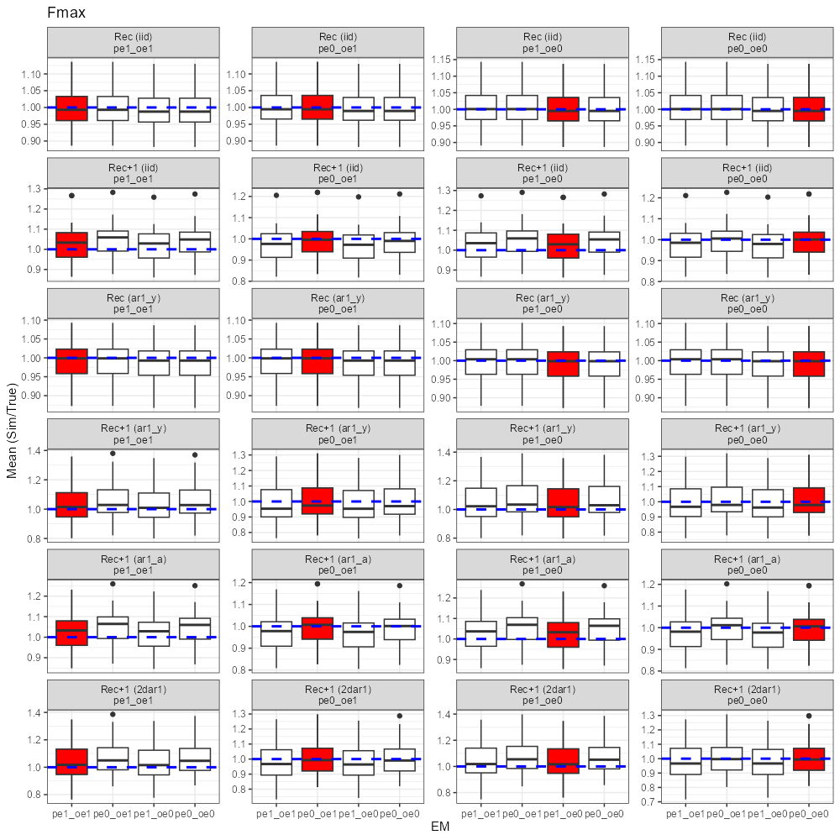

Compare index 1 with the true index 1 (sim/true = 1 or not). Note that there is no BC option for index observation. Findings are below:

1. The ratio (sim/true) was always higher for the EM with OE BC ON, regardless of which OM was used.
2. Large difference between EMs with OE BC ON and EMs with OE BC OFF (e.g. EM1 vs. EM3).
3. Patterns and magnitudes of the ratio were the same across OMs.
4. No EM captured the true index.
5. Findings are similar for index 2 and index 3.

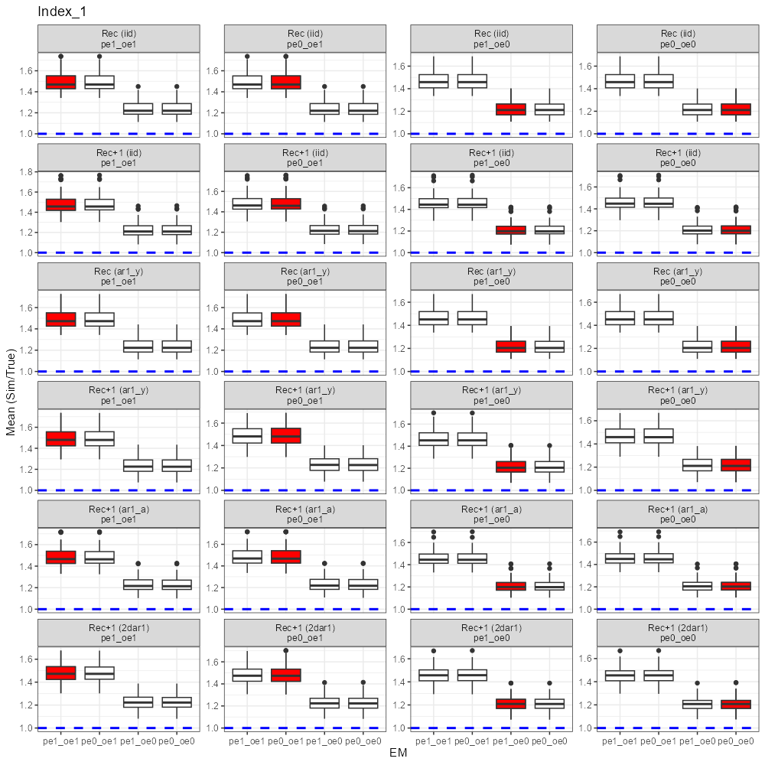

Compare catchability with the true catchability (sim/true = 1 or not). Findings are below:

1. Ratio (sim/true) was 1 for the correct EMs.
2. For Rec+1 iid and ar1_a, when the OM had OE BC ON, using EMs with OE BC OFF underestimated catchability; when the OM had OE BC OFF, using EMs with OE BC ON overestimated catchability
3. No evidence that the catchability estimates became more biased as model complexity increased.

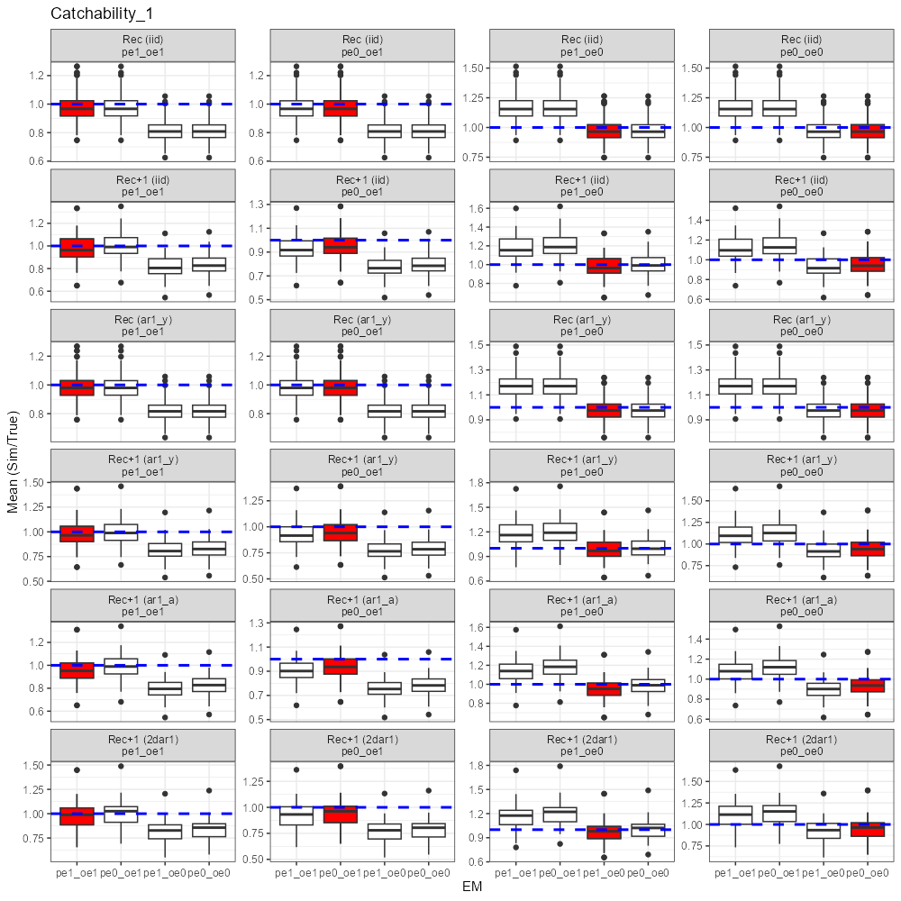

Compare dAIC. Findings are below:

1. dAIC tended to choose the correct EM in most cases.
2. dAIC is small (< 2).

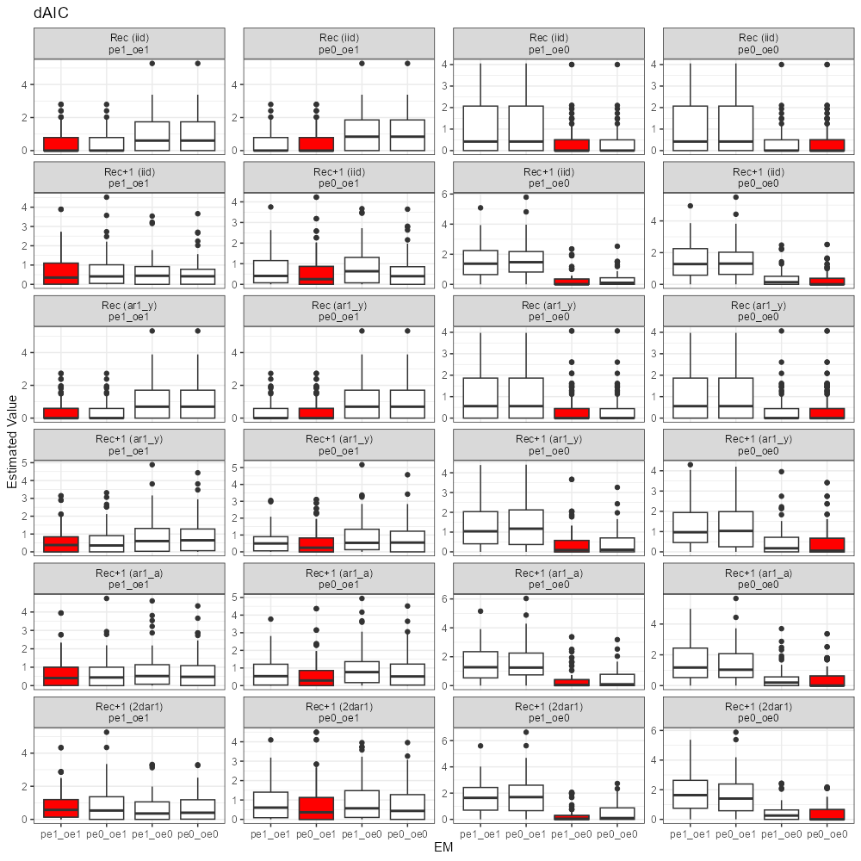

Compare Rec sigma. Findings are below:

1. Rec sigma was always comparable across EMs in each OM scenario.

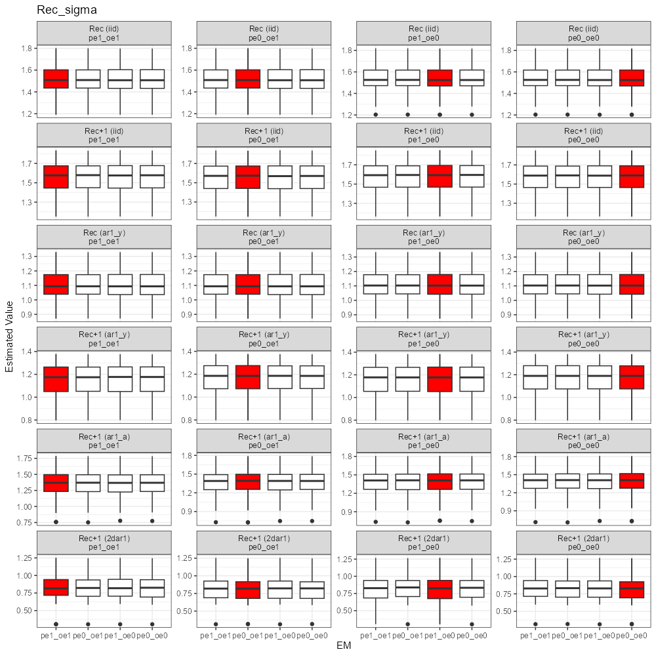

Compare NAA sigma. Findings are below:

1. NAA sigma was always comparable across EMs in each OM scenario.

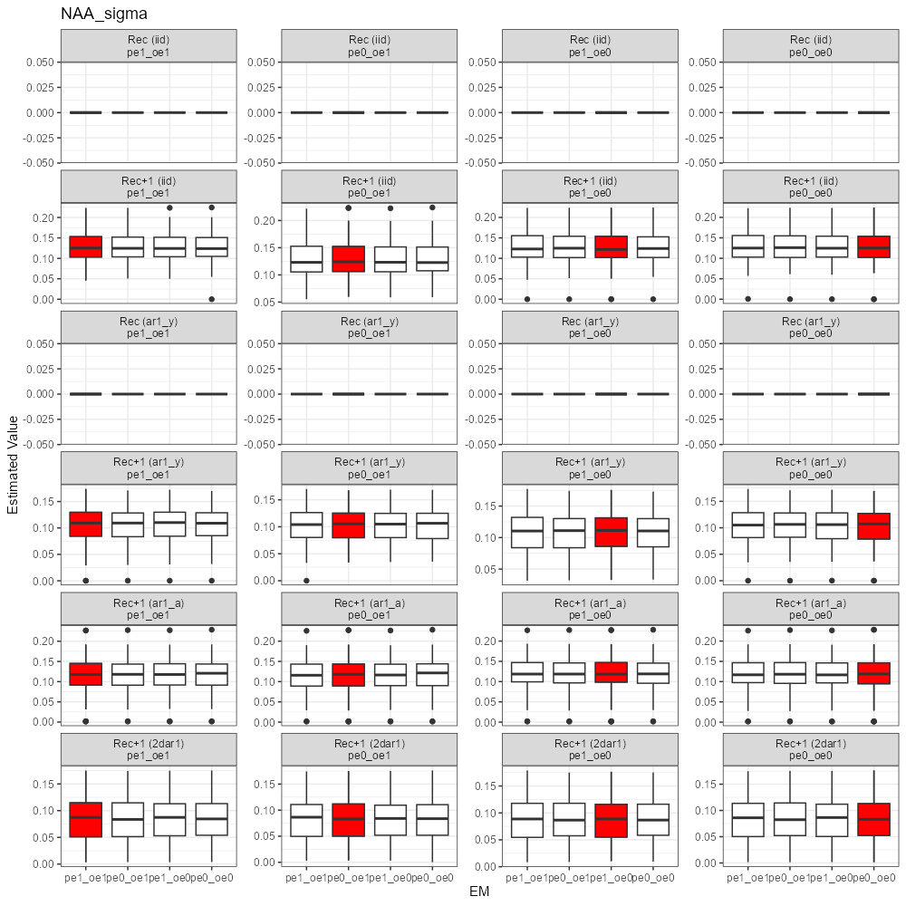

Compare rho_age. Findings are below:

1. Rho age was always comparable across EMs in each OM scenario.



Compare rho_year. Findings are below:

1. Rho_year was always comparable across EMs in each OM scenario.

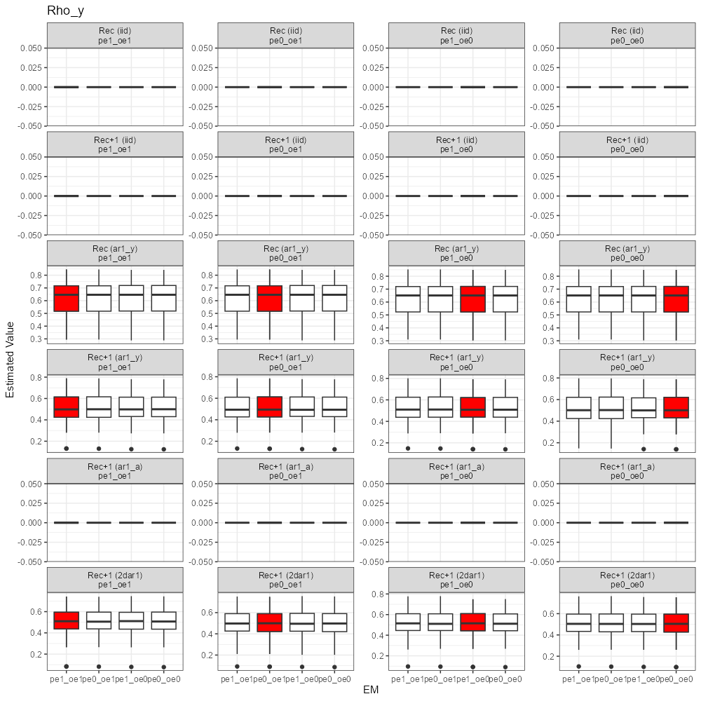

Compare the parameter associated with selfweighting likelihood. Findings are below:

1. Overdispersion parameter for catch age comp. was the same regardless of which EM was used.
2. Parameter value changed slightly as OM changed.

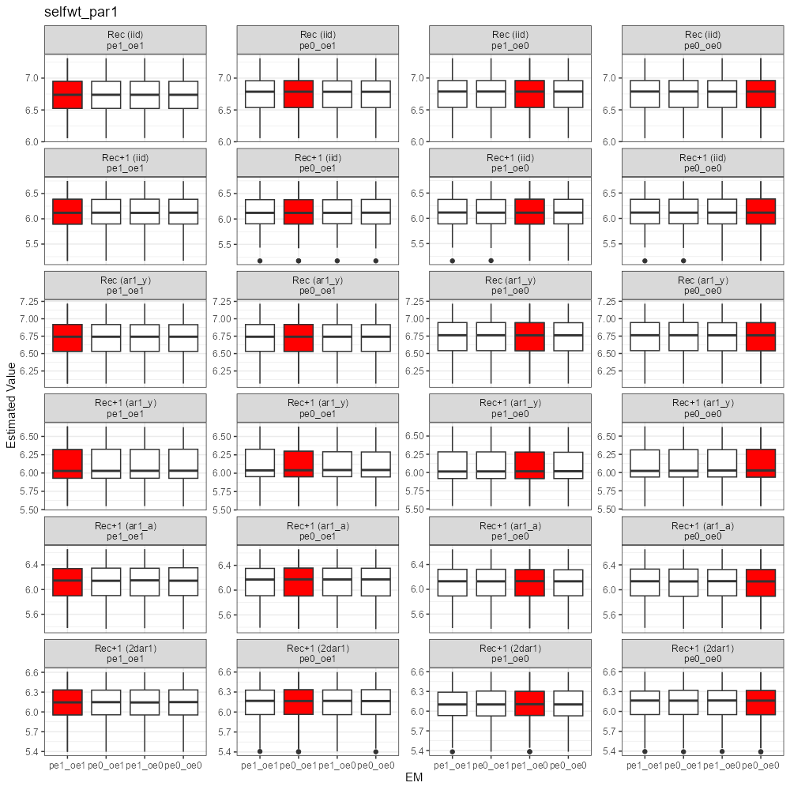

Compare the parameter associated with selfweighting likelihood. Findings are below:

1. Overdispersion parameter for index 1 age comp. was the same regardless of which EM was used.
2. Parameter value remained the same across OMs.

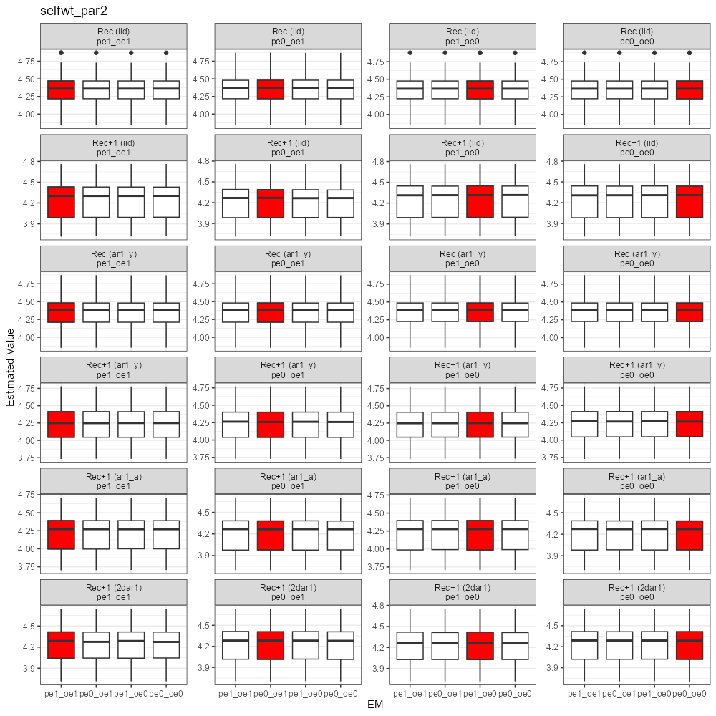

**Conclusions**

1. When only recruitment is treated as random effects (iid or ar1_y), there is no difference in the estimates of recruitment and NAA between EMs with/without bias correction.
2. When NAA is treated as random effects, there is difference in the estimates of recruitment and NAA between EMs with/without bias correction.
3. EMs with bias correction off, even the truth is on, produces small bias in Rec and NAA, while EMs with bias correction on when the truth is off can produce large bias in Rec and NAA.
4. Bias in estimated Rec and NAA doesn’t increase as the reality gets more and more complex (e.g. Rec+1 2dar1).
5. Bias correction on observation error shows no influence on estimates of population quantities and key parameters, except F (only for GB yellowtail flounder), index, and catchability.
6. Model diagnostics such as AIC performs relatively well in identifying the correct EM.

**Recommendations**

1. For assessment models that only have recruitment treated as random effects, the recruitment estimates as well as reference points should be the same (after adjustment using sigma^2/2) no matter bias correction is on or off.
2. For assessment models that have NAA treated as random effects, it is expected to see some discrepancy in recruitment and NAA between bias correction on and off.
3. Given the potential bias in population quantities and parameters, practitioners should calculate AIC for the models with and without bias correction to decide whether or not the bias correction should be used in the assessment model.
4. Turning off bias correction generally induces small bias even when the truth has bias correction.
5. Influences of bias correction on observation error may be overlooked in the present study, given relative small observation error in catch from groundfish stocks. Further explorations on pelagic stocks may be needed (ongoing simulations on mackerel).
6. Influences of bias correction on process error may be magnified in the present study as the variances in recruitment and NAA deviations are pretty large (worst case scenario).