Title: Can empirical catch allocation strategies based on single-region stock assessments provide adequate advice for managing spatially structured fish populations?
Running Title: Catch allocation for spatially structured populations
Authors:
Chengxue Li^{1,6,7}*, Jonathan J. Deroba¹, Daniel R. Goethel², Aaron M. Berger³, Amy M. Schueller⁴, Brian J. Langseth⁵, Emily M. Liljestrand¹, Dana H. Hanselman², Timothy J. Miller¹
Affiliations
¹ Northeast Fisheries Science Center, NMFS–NOAA, 166 Water St., Woods Hole, MA 02543, USA
² Alaska Fisheries Science Center, Auke Bay Laboratories, NMFS–NOAA, 17109 Point Lena Loop Road, Juneau, AK 99801, USA
³ Northwest Fisheries Science Center, Fisheries Resource and Monitoring Division, NMFS–NOAA, 2032 S.E. OSU Drive, Newport, OR 97365, USA
⁴ Southeast Fisheries Science Center, Beaufort Laboratory, NMFS–NOAA, 101 Pivers Island Road, Beaufort, NC 28516, USA
⁵ Northwest Fisheries Science Center, NMFS–NOAA, 2725 Montlake Blvd E, Seattle, WA 98112, USA
⁶ School of Marine and Atmospheric Sciences (SoMAS), Stony Brook University, Stony Brook, NY 11794, USA
⁷ Institute for Advanced Computational Science, Stony Brook University, Stony Brook, NY 11794, USA
* Corresponding author: Chengxue Li (chengxue.li@stonybrook.edu)
Target Journal: Fish and Fisheries

ORCID

Chengxue Li: 0000-0001-7518-7234

Aaron M. Berger: 0000-0002-1408-7122
Brian J. Langseth: 0000-0002-9901-6146

Daniel Goethel: 0000-0003-0066-431X

Timothy J. Miller: 0000-0003-1411-1206

Abstract
Spatial structure and movement are common features of marine fish populations, yet many fisheries management systems continue to rely on single-region stock assessments. When stock-level catch advice is generated at a broader spatial scale than management implementation, empirical catch allocation strategies provide a pragmatic way to distribute harvest among regions and fleets. However, the performance of spatial catch allocation approaches remains poorly understood in terms of their ability to achieve robust management outcomes, especially when confronted with uncertainty in underlying population structure, movement, and recruitment dynamics. Using a closed-loop management strategy evaluation (MSE) conditioned on a demersal fish population (western Atlantic black sea bass, Centropristis striata), we compared uniform, catch-based, survey-based, and catch-survey hybrid catch allocation strategies across operating model scenarios that varied in population structure, movement directionality and magnitude, and recruitment dynamics. Across scenarios, catch allocation strategy had limited influence on system-level outcomes but substantially redistributed catch, biomass, interannual variability in catch and spawning stock biomass (SSB), and depletion risk among regions. Differences among strategies were modest under bidirectional movement and recruitment varying around regional means, but stronger regional tradeoffs emerged when movement was unidirectional or recruitment declined in one population component. Landings-based strategies generally produced more stable catch outcomes, whereas survey-based strategies were more responsive to changes in regional biomass distribution but increased interannual variability in catch and SSB. No single strategy consistently outperformed others across metrics or spatial scales. These results indicate that empirical catch allocation can provide a useful bridge between spatially aggregated assessment advice and spatial management, but its performance is conditional on underlying spatial processes.

Keywords: catch allocation, spatial population structure, movement dynamics, black sea bass, management strategy evaluation

1 Introduction
Spatial structure and movement dynamics are fundamental features of many exploited marine fish populations, resulting in spatial heterogeneity in biological traits, size and age structure, phenology, and availability to fisheries and surveys (Ciannelli et al. 2013; Kerr et al. 2017; Cadrin 2020). Scientific advice for fisheries management is commonly developed using stock assessment models, which integrate available data to estimate stock status and inform catch advice (Hilborn and Walters 2013). However, assessment models often simplify spatial complexity by assuming a single homogenous population within fixed stock boundaries (Punt 2019). The ‘unit stock’ assumption has historically been used for pragmatic reasons, including limited spatially resolved data, historical catch reporting and allocation systems, governance constraints, and limits to practical model complexity (Cadrin et al. 2023). Despite mounting evidence for extensive spatial structure in many marine populations, routine application of spatially explicit assessment models remains rare (Kritzer and Liu 2014; Goethel et al. 2023). Thus, when spatial dynamics are recognized but not represented directly in the assessment model, fishery managers often rely on empirical catch allocation among spatial subunits to partially account for spatial heterogeneity (Cope and Punt 2011; Bailey et al. 2013; Bosley et al. 2019).
However, when spatial structure is not represented explicitly, mismatches arise among biological population structure (i.e., reproductively, demographically, or spatially distinct population components), assessment scale, and the spatial scale at which management actions are implemented. Spatial mismatches can bias estimates of stock status and productivity when regional population trends are aggregated into a single stock-level assessment, and they can also complicate the subsequent allocation of catch among spatial management units (Fu and Fanning 2004; Ying et al. 2011; Berger et al. 2017; Goethel and Berger 2017; Berger et al. 2021; Bosley et al. 2022). For instance, when managers recognize the need to address sub-stock spatial structure, stock-level catch advice from a spatially aggregated assessment must be allocated among smaller management units using empirical and/or ad hoc rules. Allocation rules may redistribute fishing mortality unevenly or unintentionally across population components, particularly when movement, productivity, selectivity, or recruitment dynamics vary among areas (Goethel and Berger 2017; Bosley et al. 2019; Berger et al. 2024). More broadly, failure to account for spatial structure can erode spatial biocomplexity through the loss or weakening of spawning components, destabilizing population dynamics and reducing resilience to exploitation and environmental variability (Kerr et al. 2017; Cadrin 2020). Thus, assessment scientists and fisheries managers must work together to identify robust solutions to managing spatially structured marine populations, particularly when data limitations prevent complex spatial assessments. One pragmatic response is to use spatial catch allocation rules that translate broader stock-level assessment outputs into finer-scale management limits.
Globally, a variety of approaches have been utilized to allocate catch spatially (Tokunaga et al. 2023; Free et al. 2025), and the rationale for catch allocation similarly varies (e.g., to avoid regional depletion, to protect biocomplexity, to maintain regional access, or to address socio-economic factors). In the U.S., several fisheries allocate catch from a broader stock-level assessment to finer spatial management units. In Alaska, sablefish (Anoplopoma fimbria) are assessed and managed as a single population, but catch is allocated to five management subregions based on a five-year rolling average of fishery-independent longline survey biomass proportions (Cheng et al. 2025). Catch allocation strategies for sablefish are meant to ensure regional harvest generally reflects the distribution of biomass in order to avoid localized depletion and ensure access to fishing opportunities across Alaska (Goethel et al. 2020). For similar reasons, most federally managed groundfish species in the Gulf of Alaska (e.g., rockfish) are allocated to management regions based on trawl survey biomass (NPFMC, 2024). In the northeast U.S., Atlantic herring (Clupea harengus) are assessed using a panmictic assessment due to an inability to allocate mixed stock catches to stock of origin. Catch advice is then allocated among three subregions to avoid overexploitation of any one stock based on historical tagging data and studies on larval drift that identified likely sub-stock structure. For black sea bass (Centropristis striata), the northern stock is assessed coastwide, but the commercial quota is distributed among states from Maine to North Carolina; after northward shifts created mismatches between local availability and fixed shares, the allocation was made spatially dynamic, with 75% of the quota distributed using historical landings-based default percentages and the remaining 25% allocated among states on the basis of regional biomass estimated by the most recent stock assessment (Free et al. 2025). In the northwest U.S., when management areas at scales finer than the population are used, catch advice from assessments are allocated either based on biomass estimates from a fishery independent trawl survey (e.g. Sablefish, Anoplopoma fimbria, Wetzel et al. 2025), or when occurrence in the survey is limited, on past catch percentages or percentages of habitat in each management area (e.g. Copper rockfish, Sebastes caurinus, Monk et al. 2023). Similar allocation challenges occur internationally and in transboundary fisheries. In South Africa, sardine (Sardinops sagax) are managed under a single resource-wide operational management procedure, but evidence for western and southern components separated near Cape Agulhas has led managers to use spatially explicit catch constraints to reduce risk to the western component (de Moor and Butterworth, 2015). In the Northeast Atlantic, ICES stock-level catch advice informs total allowable catch (TAC) setting under the European Union’s Common Fisheries Policy, after which quotas are allocated among member states through “relative stability,” a fixed allocation key based largely on historical catches during 1973-1978 (Symes, 1997; Hoefnagel et al. 2015). However, shifting stock distributions can create mismatches between fixed quota shares and current biomass distributions (Baudron et al. 2020), increasing interest in more spatially responsive approaches such as zonal attachment, where shares are based on the estimated proportion of stock biomass occurring within each jurisdiction (Hannesson, 2013; Fernandes and Fallon, 2020). In the U.S.-Canada Pacific hake (Merluccius productus) fishery, coastwide TAC is allocated between countries using fixed treaty shares based on historical catch, even though climate-mediated redistribution and changing movement can alter the spatial distribution of biomass and risk (Jacobsen et al. 2022). In transboundary tuna fisheries, allocation discussions commonly consider historical catch or effort, coastal-state rights, fishing dependence, development aspirations, and equity, although historical participation often remains dominant and can generate conflict between distant-water fishing states and coastal states (Bailey et al. 2013; Seto et al. 2021; Davis et al. 2022; Andriamahefazafy et al. 2024).
Although these examples show that catch allocation is widely used as a pragmatic response to spatial management problems, implementation is deceptively complex. In addition to choosing a data source as the basis of allocation among regions (e.g. based on historical catch, survey biomass, historical tagging, or equal among regions), managers must further distribute among fleets with distinct gear selectivity, spatial fishing patterns, access constraints, and socio-economic incentives (Cheng et al. 2024; Free et al. 2025). Fleet-specific processes can interact with spatial population structure, concentrating fishing mortality on vulnerable population components or leading to “less-efficient” harvest allocation (e.g., mismatches between where fish are available and where catch is allocated). Therefore, when spatial and fleet allocations are handled empirically, regional components may remain vulnerable even if system-level performance appears acceptable (Bosley et al. 2019, 2022).
Despite their widespread use in real-world management applications, empirical catch allocation strategies have not been widely tested via simulation. Bosley et al. (2019) present one of the few catch allocation simulations with operating models conditioned on Pacific hake (Merluccius productus) and Alaska sablefish. Results suggested that movement among areas led to flexibility in the combinations of spatial harvest rates that could achieve a large fraction of maximum system yield, where allocation based on survey biomass effectively approximated desirable system-level outcomes but regional depletion was still possible. Jacobsen et al. (2022) similarly evaluated Pacific hake using simulations to examine how climate-mediated movement interacts with harvest control rules and fixed total allowable catch allocations between the U.S. and Canada, showing that dynamic allocation based on survey biomass could reduce fishery risk under changing spatial distributions. Further simulations with Alaska sablefish (Cheng et al. 2026a) similarly suggest that spatially aggregated and spatially implicit fleets-as-areas assessments paired with survey-based regional allocation can provide adequate management advice under high-movement conditions, but it is recommended that regional depletion and spatial fishery dynamics be periodically evaluated with spatial models (Cheng et al. 2025). Although survey-based catch allocation appears robust based on the limited scope of existing simulation studies, the performance of catch allocation is likely conditional on population structure, movement directionality and magnitude, recruitment dynamics, fleet behavior, and the quality, spatial coverage, and representativeness of the spatial information used to distribute catch. Evaluations across these interacting processes remain limited, particularly for cases where single-region assessment advice is paired with spatially informed allocation rules, and alternatives to survey-based allocation need to be more thoroughly tested given that many fisheries globally do not have fishery-independent survey data.
Managing fisheries through spatial catch allocation has emerged as a pragmatic approach that allows spatial signals to influence harvest distribution when spatially explicit assessments are infeasible or not yet operational (Cadrin 2020; Goethel et al. 2023; Cadrin et al. 2023; Berger et al. 2024). Evaluating the management consequences of alternative catch allocation strategies requires a “closed-loop” simulation approach. Closed-loop feedback simulations directly link monitoring data, stock assessment, harvest decisions, management implementation, and population feedback responses to those procedures (Li et al. 2026a). Management strategy evaluation (MSE) provides the standard framework for testing this iterative end-to-end process under uncertainty and comparing performance relative to objectives (e.g., sustainability, stability, and risk) at regional and system-wide scales (Punt et al. 2016; Jacobsen et al. 2022; Li et al. 2026b). For example, South Africa has used MSE to test management procedures for multiple fisheries over several decades (de Moor et al. 2011; de Moor et al. 2022), and ecosystem-based MSE work has further illustrated how spatially relevant performance metrics, such as sardine biomass west of Cape Agulhas, can be incorporated when evaluating candidate management procedures (de Moor 2024). Recent guidance highlights MSE as a practical tool for identifying management procedures that remain effective when spatial processes are present but imperfectly represented in the assessment model (Goethel et al. 2023; Berger et al. 2024, Legault, 2026).
Using the U.S. Atlantic coast black sea bass (hereafter BSB) as a case study, we evaluated a deliberately simplified management system in which catch advice was generated from a single-region assessment and then distributed spatially through alternative allocation strategies. The overarching objective was to determine whether a single-region assessment, when paired with spatially explicit catch allocation, could provide reliable management advice for a spatially structured stock. Specifically, we addressed three questions: (1) How robust are alternative catch allocation strategies across contrasting spatial dynamics? (2) How do population structure, movement directionality and magnitude, and recruitment dynamics affect system-level and regional management performance? and (3) What tradeoffs arise among catch, spawning stock biomass (SSB), interannual variability in catch and SSB, and regional depletion risk under alternative catch allocation strategies? To address these questions, we implemented a conditioned MSE using a state-space spatial MSE platform (Li et al. 2026a) to compare alternative catch allocation strategies across a targeted range of operating-model scenarios. By quantifying tradeoffs among system-level and regional performance metrics, this study identified the conditions under which spatial catch allocation can approximate reliable management performance under a single-region assessment framework, and the conditions under which aggregated assessment advice may fail to maintain regional SSB or avoid localized depletion.

2 Methods
We implemented a closed-loop spatial MSE using the Spatial Processes and Stock Assessment Methods MSE package (SPASAM-MSE; Li et al. 2026a; https://lichengxue.github.io/SPASAM.MSE/). The Methods are organized around four linked components. First, the operating model (OM) simulates a spatially structured population, regional fisheries, survey indices, observation processes, and alternative movement and recruitment scenarios. Second, region-specific pseudo-data generated by the OM are processed into the aggregated data streams that would be available to a conventional single-region assessment. Third, a single-region estimation model (EM; i.e., the assessment model) is fit to those aggregated data and used with a harvest control rule (HCR) and short-term projection model to generate total catch advice. Finally, total catch advice is allocated among regions and fleets using alternative catch allocation strategies; the allocated catches are then applied in the OM to update the fishing mortality and population dynamics, and outcomes are evaluated with regional and system-level performance metrics. These metrics were then summarized across stochastic realizations to compare management procedures within each OM scenario and identify tradeoffs among allocation strategies.
Hereafter, we use “stock” to refer to the assessment and management unit for which aggregate status, reference points, and catch advice are generated. We use “population component” to refer to a biological or demographic component represented in the spatial OM, and “region” to refer to the spatial areas in which fish, fisheries, and surveys occur, and which catch is allocated to.

2.1 Case Study Species
The U.S. Atlantic coast BSB provides a useful case study for evaluating the management consequences of spatial population structure and catch allocation. The stock north of Cape Hatteras supports major commercial and recreational fisheries along the Atlantic coast of the U.S. and is managed jointly by the Mid-Atlantic Fishery Management Council and the Atlantic States Marine Fisheries Commission. Multiple lines of evidence indicate persistent spatial structure within this stock, commonly characterized by northern and southern components separated near Hudson Canyon, with differences in distribution, abundance, and population and fishery dynamics (NEFSC 2023; MAFMC 2024; NEFSC 2024a). Recent BSB assessment development has moved toward a spatially explicit Woods Hole Assessment Model (WHAM) framework with regions north and south of Hudson Canyon (Miller et al. 2025), providing a timely context for evaluating how catch allocation can affect management performance. The BSB case study enables a broader evaluation of when spatially informed catch allocation may provide adequate performance under simpler assessment frameworks, and when more explicit spatial modeling may be needed to evaluate risks to regional population components.

2.2 Model and MSE Platform Overview
SPASAM-MSE uses WHAM as the underlying age-structured, state-space population model for both the OM and EM, and provides the simulation framework needed to conduct closed-loop MSE. WHAM separates process variation in population and fishery dynamics from observation variation in fishery and survey data (Stock and Miller 2021; Miller et al. 2025), and has been widely applied in age-based stock assessments in the U.S. Northeast region (NEFSC 2023; NEFSC 2024a,b). SPASAM-MSE extends this assessment framework by linking spatial OMs, EMs, HCRs, catch allocation strategies, and management implementation error (i.e., cases where realized catches differ from intended catch allocations) within a closed-loop simulation environment.
The current spatial WHAM configuration (Miller et al. 2025) was initially developed for a BSB assessment (NEFSC, 2023) that addresses natal-homing dynamics, in which population components retain natal identity, may move among regions during the year, and return to natal spawning areas before spawning. Recent extensions implemented in SPASAM-MSE (Li et al. 2026a) allow additional population structures and movement dynamics, including metapopulation scenarios, so that assessment and management performance can be evaluated across a broader range of assumptions about spatial structure and connectivity.

2.3 Operating Model
The OM was conditioned to represent BSB-like population and fishery dynamics in two spatial regions corresponding to northern (Region 1) and southern (Region 2) components of the stock. The conditioned OM used biological, fishery, survey, and movement inputs derived from or informed by recent BSB assessments (Table 1; Figure 1), which also assumed natal homing population structure (alternatives such as metapopulation structure were explored in the simulation scenarios). This conditioned OM served as the baseline from which alternative OM scenarios were generated by modifying population structure, movement directionality and magnitude, movement pattern, and recruitment process (Figure 2).

2.3.1 Population Dynamics, Seasonality, and Movement
The OM tracks age-structured abundance for two population components across two regions over time. Fish retain population-component identity while contributing to regional biomass, catch, and survey availability according to the region they occupy. Full spatial WHAM population-dynamics equations are provided in Miller et al. (2025).
The annual population transition was divided into 11 seasonal intervals to represent within-year timing of fishing, movement, survey observation, and spawning. These intervals consisted of ten one-month intervals (1/12 of the year each) and one two-month interval representing the June-July spawning season (1/6 of the year). SSB was evaluated at midyear (1/2 of year; end of June), and regional fishery-independent survey indices sample observed abundance in April (at 1/4 of the year). Within each interval, fish experienced natural and fishing mortality, after which permitted movement transitions redistributed surviving fish among regions. Recruitment occurred annually (January 1st) as age-1 fish, and was assigned to the natal region of each population component. Although the OM retained within-year seasonality, the EM used the same assumed timing of spawning, fishing, and survey observations, but was fit to annual, spatially aggregated catch, survey-index, and age-composition data.
Natal-homing scenarios represent population components that retain natal identity and return to their natal spawning region before spawning. In these scenarios, seasonal movement can mix fish between regions, but SSB and recruitment remain tied to natal population identity. Metapopulation scenarios relax this natal-homing constraint by representing regional components linked by movement. In these scenarios, fish that move into another region can contribute to SSB in that region if present during the spawning season, and recruitment is assigned by region. Thus, movement can directly alter regional SSB and recruitment in metapopulation scenarios.
Movement transition probabilities were specified for each seasonal interval, with movement windows and probabilities summarized in Table 2. Within each interval, natural and fishing mortality were applied first, followed by movement transitions between regions for surviving fish; the same ordering was held constant across all OM scenarios and management procedures. Bidirectional scenarios allow exchange between regions during modeled movement periods, whereas unidirectional scenarios restrict exchange to a single direction during modeled movement periods. Low- and high-movement scenarios differ in the magnitude of seasonal movement probabilities. Additional scenarios allowed movement probabilities to vary among years or increase with age to represent ontogenetic movement (Table S1).

2.3.2 Recruitment, Survival, and Biological Inputs
In the baseline recruitment model, annual recruitment varied for each population component around its own mean, with independent and identically distributed (IID) lognormal deviations and standard deviation σ_{R} = 0.75. Transitions in numbers-at-age for age-2 and older fish, also referred to as survival deviations, were modeled with IID lognormal deviations and standard deviation σ_{N} = 0.20. Natural mortality was fixed at M = 0.4 for all ages. In density-dependent recruitment scenarios, recruitment followed a Beverton-Holt stock-recruitment relationship with lognormal deviations, whereas in the declining-recruitment scenarios, mean recruitment for population component 1 declined in log space at 0.016/yr during the feedback period (Table S1), reaching approximately 45% of its initial mean after 50 years.
Weight-at-age differed among fleets, survey indices, and population components, and maturity-at-age differed between population components. These inputs allow spatial differences in biomass, catch, and SSB to arise from both movement and regional biological heterogeneity (Table 1; Figure 1).

2.3.3 Fleets, Survey Indices, and Observation Model
The fishery was represented by two fleets in each region: a commercial fleet and a recreational fleet. Both fleets operated throughout the year and had fleet- and region-specific selectivity patterns (Table 1; Figure 1). Fishing mortality during the historical (conditioning) period followed the trajectory estimated from the BSB assessment. During the feedback (management procedure implementation) period, fishing mortality was determined from the catch advice generated by the EM, the spatial catch allocation strategy, and the regional abundance available to each fleet in the OM. Commercial and recreational catch observations from the OM were generated for each region and fleet using lognormal observation error with CVs of 0.05 for commercial catch and 0.15 for recreational catch. Age-composition observations were generated separately for each region, fleet, and year using multinomial sampling with effective sample size (ESS) = 50.
Regional survey-index catchability and selectivity were derived from the recent BSB research track assessment (NEFSC 2023; NEFSC 2024a). Survey indices in the OM were calculated from true regional numbers-at-age using survey selectivity and catchability, and a lognormal observation error with CV = 0.4 to generate regional survey-index pseudo-data. Age-composition observations were generated separately for each region, survey index, and year using multinomial sampling with ESS = 50.
2.3.4 Operating Model Scenarios
Scenario abbreviations combine population structure, movement, and recruitment features: N and M denote natal homing and metapopulation structure; B and U denote bidirectional and unidirectional movement; L and H denote low and high movement magnitude; I and O denote IID-year and ontogenetic movement; D and BH denote declining recruitment in population component 1 and Beverton-Holt density-dependent recruitment (Figure 2; Tables 2 and 3). These scenarios were designed to test whether catch allocation strategies remained robust across differences in biological structure, connectivity, and productivity. Natal-homing and metapopulation scenarios evaluated sensitivity to alternative assumptions about how movement affects spawning biomass and recruitment. Bidirectional, unidirectional, low-, and high-movement scenarios tested whether allocation performance depended on the direction and strength of spatial exchange. IID-year and ontogenetic movement scenarios evaluated whether temporal or age-dependent movement complexity altered management performance, while declining-recruitment and Beverton-Holt scenarios tested robustness to directional productivity change and density-dependent recruitment.

2.4 Data Processing for the Single-Region Estimation Model
The EM was designed to mimic a conventional single-region assessment that ignores spatial structure. Accordingly, the region-specific pseudo-data generated by the OM were aggregated before fitting the EM. To achieve this, observation uncertainty was applied first at the regional scale and the resulting observed regional data were then aggregated to the scale of the single-region EM.

2.4.1 Catch and Survey Index Aggregation
For each year, commercial and recreational catches from region 1 and region 2 were summed to produce aggregated commercial and recreational catch inputs for the EM. Thus, the EM retained separate commercial and recreational fleets but did not retain region-specific fleets. Regional survey abundance indices were similarly summed across regions to produce a single aggregate survey index for the EM. The aggregate catch and survey inputs were fit in the EM using the same lognormal observation error CVs as the corresponding regional observations: 0.05 for commercial catch, 0.15 for recreational catch, and 0.4 for the survey index.

2.4.2 Age-Composition Aggregation
For each year and fleet, observed age-specific catches from region 1 and region 2 were summed and divided by the total aggregated catch to obtain the proportion-at-age for the aggregated fleet. The same approach was applied to the survey age compositions, with age-specific survey abundance summed across regions and divided by the total aggregated survey abundance. Thus, the aggregated age compositions represented catch-weighted or survey-weighted mean proportions-at-age, with each region weighted by its contribution to the total catch or survey abundance in numbers. This procedure preserved each region’s contribution to the aggregate age structure while aggregating the data to the spatial scale of the single-region EM. The resulting aggregate commercial, recreational, and survey age compositions were provided to the EM with ESS = 50.

2.4.3 Biological Inputs for the Estimation Model
Biological inputs required by the EM, including weight-at-age and maturity-at-age, were aggregated to match the spatial scale of the single-region assessment. Annual fleet-specific weight-at-age was calculated as a catch-weighted average of the region-specific values for the corresponding fleet. Population-level weight-at-age was aggregated using commercial catch-based regional weights, because commercial catch observations were assumed to be less noisy than recreational catches. Maturity-at-age was similarly aggregated using regional catch proportions. These aggregated biological inputs represent the information that would be available to a panmictic assessment based on spatially aggregated data, and therefore intentionally simplify the spatially explicit biological structure represented in the OM.

2.5 Estimation Model
2.5.1 Model Configuration
The EM was a single-region WHAM assessment fit to the aggregated data inputs described in Section 2.4. It retained the broad age-structured, state-space form of the OM but omitted explicit region, movement, and population-component identity (Table S2). Recruitment and age-2+ numbers-at-age were specified using the same IID random-effect structure as in the OM, but at the aggregate single-region scale. Commercial selectivity was estimated for ages 1-3 and fixed at 1 for ages 4-8+; recreational selectivity was estimated for ages 1-4 and fixed at 1 for ages 5-8+; and survey selectivity was estimated for age 1 and fixed at 1 for ages 2-8+. The fixed fully selected ages were chosen based on prior sensitivity analyses that improved convergence of the EMs fit in the simulation loop and avoided weakly informed selectivity parameters. Initial numbers-at-age followed the equilibrium initialization approach of Stock and Miller (2021).
2.5.2. Biological Reference Point
At each assessment cycle, the F_{40%} reference point was calculated from the fitted single-region, multi-fleet EM using the static spawning-potential-ratio (SPR)-based approach described by Miller et al. (2025), with biological and fishery inputs averaged over the most recent five years, including weight-at-age, maturity-at-age, natural mortality, and selectivity. Aggregate fishery selectivity was derived from fleet-specific fishing mortality-at-age and therefore reflected the recent relative contribution of each fleet to total fishing mortality; thus the selectivity used for F_{40%} and projections (see Section 2.6.2) could vary among assessment cycles and catch allocation strategies (Miller et al. 2025). The weight-at-age and maturity-at-age inputs used for F_{40%} and projections were the aggregated single-region biological inputs calculated using the catch-weighting approach (described in Section 2.4); therefore, these quantities could also vary among assessment cycles and catch allocation strategies when the catch-based aggregation weights changed.
2.5.3 Convergence Criteria
EM convergence was evaluated for every assessment fit in every realization. An assessment fit was considered converged if the optimizer completed successfully and the Hessian matrix at the optimum was positive definite and invertible (Miller et al. 2026). No additional maximum-gradient threshold was applied.
2.6 Management Strategy Evaluation

2.6.1 Closed-Loop Simulation and Assessment Cycle
The closed-loop MSE linked the OM, observation model, data processing, EM, EM-based short-term projection, HCR, catch allocation strategy, and subsequent OM population dynamics. During each assessment cycle, the OM was updated sequentially by year, simulating the underlying population and fishery dynamics and generated region-specific pseudo-observations. The aggregated pseudo-data were fit by the EM, and the estimated F_{40%} was used to set quotas (see below). The fitted EM was then used to perform a short-term projection with the HCR to generate total catch advice for the next management cycle. Total catch advice was allocated among regions and fleets according to the specified catch allocation strategy and applied back in the OM, allowing management decisions to affect subsequent population dynamics, data generation, and future assessments.
The same sequence of random number seeds used to generate observation and process errors was used for each realization for all OM scenarios so that differences among strategies can be attributed to the management procedure rather than to different stochastic conditions. If any EM within any catch allocation strategy failed to converge in any assessment year for a given realization, that realization was removed from the analysis for all strategies and replaced with a new seed. For each OM scenario, the process was repeated until the same 100 converged realizations were retained for all EM-catch allocation strategies.
Each simulation consisted of a historical period followed by a 50-year management feedback period. The historical period covered 1989-2023 and was used to initialize population and fishery dynamics by conditioning on the outputs of the BSB assessment (NEFSC, 2023). The feedback period covered 2024-2073. The first assessment was conducted in 2023 using data through 2023 and produced catch advice for 2024 and 2025. Assessments were then conducted biennially, each using the full simulated data series available through the terminal year of the assessment and producing catch advice for the next two-year management cycle.

2.6.2 Catch Projection Model and Harvest Control Rule
The fitted EM outputs were used to calculate F_{40%}, conduct short-term projections, and generate catch advice under the HCR. The projection used EM terminal abundance, mean recruitment estimated across years up to the terminal assessment year, and five-year average values from the most recent assessment for selectivity-at-age, maturity-at-age, weight-at-age, and natural mortality to project the aggregate population forward over the two-year management cycle.
During the projection period, only recruitment random effects were allowed to continue, whereas age-2+ numbers-at-age process random effects were set to zero. Total catch advice was generated using a precautionary HCR, with target fishing mortality set at 75% of F_{40%}.
Total catch advice was then passed to the catch allocation step, where it was distributed among the four region-fleet combinations in the OM according to the strategy being evaluated. The allocated catches were converted to fleet- and region-specific fishing mortality rates, applied in the OM over the two-year management cycle, and used to generate the next set of pseudo-data. This closed-loop cycle was repeated throughout the feedback period, resulting in 25 biennial assessments in total for each MSE realization.

2.6.3 Catch Allocation Strategies
Five catch allocation strategies were evaluated (Table 4). Here, “gear” refers to the commercial and recreational fleets represented in the model, which differed in selectivity patterns and catch histories. For strategies that used empirical catch or survey information, allocation proportions were calculated from three-year mean catch or survey-index values to smooth annual variation in allocation weights. The ‘Equal’ catch allocation strategy (hereafter Equal) divided total catch advice equally among all four region-fleet combinations and served as the simplest spatial allocation rule. The ‘Gear-Equal' catch allocation strategy (hereafter Gear-Equal) first allocated total catch advice between commercial and recreational fleets according to historical catch shares and then divided each fleet allocation equally between regions. The ‘Fleet-Catch’ catch allocation strategy (hereafter Fleet-Catch) allocated catch in proportion to each region-fleet combination's historical catch share, preserving both regional and fleet-specific historical fishing patterns. The ‘Index-Equal’ catch allocation strategy (hereafter Index-Equal) allocated catch among regions according to historical regional survey indices and then divided each regional allocation equally between commercial and recreational fleets. The ‘Index-Gear’ catch allocation strategy (hereafter Index-Gear) allocated catch among regions according to historical survey indices and then allocated catch between fleets within each region according to historical fleet catch shares. These strategies span a gradient from allocation rules with no spatial or gear information to rules that incorporate historical fishing patterns, survey-based spatial signals, or both. The strategy set was chosen to represent commonly used empirical approaches for distributing stock-level catch advice when the assessment is conducted at a broader spatial scale than management implementation.
2.7 Performance Metrics
Management performance was evaluated using catch, SSB, average annual variation in catch and SSB, probability of overfishing, and probability of being overfished. Metrics were calculated at both regional and system levels, with regional metrics reported separately for regions 1 and 2. For probability of overfishing and probability of being overfished, the true spatially explicit reference points from the OM were used. After each MSE run, the saved output was reloaded and terminal-year static F_{40%} and SSB_{40%} reference points were recalculated post hoc for each OM scenario, realization, and allocation output using the approach of Miller et al. (2025) and Li et al. (2026a). Inputs were taken from the true OM, with biological and fishery quantities averaged over the final five feedback years. Global F_{40%} and SSB_{40%} were based on recruitment-weighted SPR and spawning biomass across regions using true mean recruitment averaged over all years. Short-term and long-term performance was summarized for catch and SSB over the first and final 10 years of the feedback period, respectively. Average annual variation in catch and SSB, probability of overfishing, and probability of being overfished were summarized across the full 50-year feedback period. Metrics were first computed within each simulation realization and then averaged across the 100 retained realizations for each OM scenario and catch allocation strategy (Table 5).
To summarize performance across metrics, each metric was converted to a 0-1 metric score within each OM scenario, spatial scale, and performance metric by min-max scaling across catch allocation strategies. For metrics where higher values indicate better outcomes, such as catch and SSB, the highest value among strategies received a score of 1 and the lowest received a score of 0. For metrics where lower values indicate better outcomes, such as variability and risk probabilities, the scaling was inverted so that higher scores consistently indicate more desirable outcomes. We then calculated an average scaled performance score by averaging the metric scores with equal weight across metrics. This score ranges from 0 to 1 and was used as a descriptive summary of multi-metric performance within each OM scenario and spatial scale.
Figure S1 shows one example realization for a natal-homing population with low bidirectional movement probability (NBL), illustrating the historical period, feedback period, and divergence among allocation strategies.

3 Results
To improve interpretability, we first present results for six OM scenarios that captured the dominant management-relevant contrasts across the full scenario set (Figures 3 and 4; Figures S2-S5): the BSB-conditioned baseline scenario with natal homing, low bidirectional movement, and recruitment varying around regional means (NBL); high bidirectional movement under metapopulation structure (MBH); low and high unidirectional movement under metapopulation structure (MUL and MUH); and declining-recruitment scenarios under natal homing with low bidirectional or low unidirectional movement (NBLD and NULD). These scenarios were selected to span key contrasts in the simulation design, including movement magnitude and directionality, population structure, and spatially asymmetric recruitment decline. Management outcomes from all 16 OM scenarios are summarized in Figures S6-S14.
Across the six representative OM scenarios, catch allocation strategy had stronger effects on regional outcomes than on system-level outcomes. System-level catch and SSB were often similar among strategies, whereas regional catch, regional SSB, variability, and depletion risk differed more clearly. The magnitude of these differences depended on the spatial process represented in the OM: Allocation effects were weakest when bidirectional movement and recruitment varying around regional means reduced persistent regional contrasts in productivity, and strongest when directional movement or declining mean recruitment in one region intensified those contrasts.

3.1 Baseline, Population Structure, and Movement Scenarios
Under the baseline scenario (NBL), allocation strategy had relatively small effects on system-level catch and SSB (Figures 3 and 4). Regional differences among strategies were present but moderate, suggesting that bidirectional exchange and the absence of a persistent recruitment trend limited strong spatial differences in productivity. Equal and Gear-Equal produced relatively stable catch outcomes, whereas Fleet-Catch and index-based strategies allowed catch allocations to respond to recent regional catch or survey signals, resulting in slightly greater catch variability (Figure S2).
The high-bidirectional metapopulation scenario (MBH) provided a contrast from the natal-homing baseline in which population structure and movement magnitude differed. Allocation strategy again had relatively small effects on both regional and system-level outcomes (Figures 3 and 4). Catch and SSB were broadly similar among strategies at the system level, and regional differences were modest. Fleet-Catch shifted some catch between regions relative to Equal and Gear-Equal, but this redistribution did not substantially alter system-level catch or SSB. Equal and Gear-Equal generally produced lower interannual catch variability, whereas index-based strategies produced slightly greater variability because allocation weights responded to recent survey signals (Figure S2).
Unidirectional movement produced stronger regional tradeoffs. In these metapopulation scenarios, recruitment still varied around regional means, but movement was constrained directionally. Under low unidirectional movement (MUL), Equal and Gear-Equal maintained higher catch in Region 1, whereas Fleet-Catch and the index-based strategies shifted catch toward Region 2 (Figure 3). This redistribution of fishing pressure increased SSB in Region 1 but reduced SSB in Region 2, with relatively small differences at the system level (Figure 4). Under high unidirectional movement (MUH), regional contrasts became more pronounced for catch and depletion risk, although system-level catch and SSB remained less sensitive to allocation strategy than regional metrics (Figures 3 and 4; Figure S5). In both unidirectional scenarios, Fleet-Catch and the index-based strategies reduced depletion risk in Region 1 relative to Equal and Gear-Equal, but this benefit came with lower Region 1 catch, higher Region 2 catch, and greater interannual catch variability (Figure 3; Figures S2 and S5).

3.2 Declining-Recruitment Scenarios
Declining-recruitment scenarios produced the clearest evidence that allocation strategy can influence regional depletion risk. In NBLD and NULD, recruitment continued to include stochastic annual deviations, but mean recruitment declined through time in population component 1, creating persistent spatial differences in productivity. Under these scenarios, Equal and Gear-Equal generally allowed higher catch in Region 1 but were associated with lower Region 1 SSB and elevated probabilities of being overfished (Figures 3 and 4; Figure S5). Fleet-Catch and the index-based strategies shifted catch away from Region 1 and reduced localized depletion risk, although they did not eliminate it (Figure 3; Figure S5).
The benefits of allocation based on recent catch or survey-index information were strongest under unidirectional movement with declining recruitment (NULD). In this scenario, Equal and Gear-Equal produced high Region 1 catch but low Region 1 SSB and high long-term depletion risk (Figures 3 and 4; Figure S5). Fleet-Catch and the index-based strategies reduced Region 1 catch and increased Region 1 SSB, indicating that allocation could partially compensate for the interaction between directional movement and declining regional productivity (Figures 3 and 4). However, these strategies also shifted fishing pressure toward Region 2 and increased catch variability, especially for the index-based allocation (Figure S2). Thus, allocation based on recent catch or survey-index information reduced risk in the vulnerable region but created tradeoffs in catch distribution and stability.

3.3 Tradeoffs Among Allocation Strategies
No single allocation strategy was the most robust across scenarios, regions, and performance metrics (Figures 5-7). Equal and Gear-Equal generally produced stable catch trajectories and low catch variability, and often performed similarly at the system level (Figures 3-5; Figure S2). However, because these strategies did not respond to regional biomass or catch patterns, they were less able to reduce localized depletion risk when movement was directional or recruitment declined in one region (Figure S5).
Fleet-Catch often provided an intermediate strategy. By allocating catch according to historical region-fleet catch patterns, it incorporated spatial and fleet information without relying directly on annual survey-based allocation weights. In several scenarios, Fleet-Catch reduced depletion risk in Region 1 relative to Equal and Gear-Equal while avoiding some of the higher variability associated with index-based strategies (Figures S2 and S5). However, its performance depended on whether historical catch patterns aligned with current spatial productivity and movement dynamics (Figures 5-7).
Index-Equal and Index-Gear responded most directly to regional survey signals, but also tended to produce higher interannual catch variability (Figure S2). These strategies were most useful for reducing localized depletion risk and increasing SSB in the vulnerable region when regional survey signals tracked persistent spatial differences in productivity, such as in the declining-recruitment scenarios (Figure S5). However, these regional SSB and depletion-risk benefits did not consistently translate into higher system-level performance and were accompanied by catch-related tradeoffs, including lower catch in the vulnerable region, higher catch in the other region, and greater interannual catch variability (Figures 5-7; Figure S2).
Average scaled performance scores provided a useful descriptive summary of these tradeoffs but did not identify a universally superior strategy (Figures 5-7). At the system level, the highest-scoring strategy varied among scenarios: Gear-Equal scored highest under NBL, Equal under MBH, MUH, and NULD, Fleet-Catch under MUL, and Index-Gear under NBLD (Figure 5). Regional scores showed stronger spatial contrast. Fleet-Catch most often scored highest in Region 1, particularly under NBL, MUL, MUH, and NULD, whereas Gear-Equal most often scored highest in Region 2, including under NBL, MBH, MUL, MUH, and NBLD (Figures 6 and 7). Thus, strategies with high scores in one region often had lower scores in the other region, especially under unidirectional movement and declining recruitment. System-level scores were generally less variable among strategies than regional scores, reinforcing that allocation effects were primarily regional (Figure 5).
Overall, the representative scenario results indicate that catch allocation matters most when spatial structure generates persistent spatial differences in productivity through directional movement, reduced connectivity, or a persistent trend in mean recruitment (Figures 3-7; Figures S2-S5). When movement produces bidirectional mixing and recruitment varies around regional means, simpler allocation strategies can approximate the performance of strategies that use regional catch or survey-index information. When regional components differ in productivity or are connected asymmetrically, spatially informed allocation can reduce localized depletion risk, but this benefit comes with tradeoffs in regional catch distribution and interannual variability.

3.4 Remaining operating model scenarios
Results from the remaining OM scenarios generally supported the patterns inferred from the six representative scenarios (Figures S6-S14). At the system level, Equal or Gear-Equal often had the highest average summed scaled performance in additional bidirectional scenarios with recruitment varying around regional means (NBH, MBL, NBLI, MBLI, NBLO, and MBLO; Figure S12). However, regional rankings were less aligned: Fleet-Catch most often scored highest in Region 1, whereas Gear-Equal most often scored highest in Region 2 (Figures S13 and S14). Thus, the full scenario set reinforced that stable aggregate performance can coexist with regional redistribution and divergent regional strategy rankings.
Temporal variation in movement and ontogenetic movement did not change the general conclusions. In NBLI and MBLI, as well as NBLO and MBLO, strategy rankings were similar to the corresponding low-bidirectional scenarios, with modest system-level differences but clearer regional separation (Figures S12-S14). These scenarios suggest that stochastic or age-dependent movement alone was less consequential for allocation performance than movement or recruitment processes that generated persistent spatial differences in productivity.
The additional natal-homing unidirectional scenarios (NUL and NUH) extended the pattern observed in the metapopulation unidirectional scenarios. Spatially differentiated strategies improved Region 1 scores by reducing depletion risk and increasing SSB, but this was associated with lower Region 1 catch, higher Region 2 catch, and weaker agreement between regional rankings (Figures S6, S7, S11, S13, and S14). The Beverton-Holt recruitment scenarios (NBH-BH and MBH-BH) further showed that density-dependent recruitment altered how allocation tradeoffs emerged at regional and system levels. Because recruitment depended on spawning biomass, allocation-induced changes in regional SSB could feed back into future productivity and change the relative performance of strategies. The clearest effect was a shift in which strategy ranked highest, especially under metapopulation structure (Figures S12-S14).

4 Discussion

4.1 Catch Allocation as a Spatial Bridge
This study evaluated whether empirical catch allocation can produce effective management advice despite an underlying mismatch between spatially aggregated assessment advice and spatially structured population dynamics. Allocation strategy had relatively small effects on system-level catch and SSB in many OM scenarios, but stronger effects on regional catch, SSB, interannual catch variability, and localized depletion risk (Figures 3 and 4; Figures S2-S5). This contrast occurred because allocation directly changed regional removals, while total catch advice remained constrained by the aggregate single-region assessment and HCR. In the closed-loop MSE, however, regional changes fed back through biomass, observations, EM estimates, and future catch advice, allowing detection of system-level effects in some scenarios that would be missed without feedback.
The consequences of spatial aggregation often emerge first at the scale of population components or management areas, not at the aggregate stock scale. Simulation studies have shown that managing spatially structured populations as a single unit can overfish vulnerable substocks or produce localized depletion even when aggregate management appears reasonable (Fu and Fanning 2004; Ying et al. 2011; Bosley et al. 2019). Our results build on this evidence by showing that the spatial distribution of catch advice can strongly influence regional outcomes and, through feedback, future aggregate advice (Figures 3 and 4; Figure S5). However, similar system-level outcomes from the various spatial catch allocation strategies should not be interpreted as evidence that the each assessment-management system adequately represents spatial dynamics, given that spatially-naive (e.g., Equal and Gear-Equal) management options had higher risk of localized depletion for certain OM scenarios.
A central conclusion of our study is that the performance of empirical catch allocation strategies depends on the biological processes connecting regional components. This finding is consistent with guidance emphasizing that the treatment of spatial structure should reflect population dynamics, management objectives, and the spatial scale of implementation (Cadrin 2020; Cadrin et al. 2023; Goethel et al. 2023). In this study, empirical catch allocation served as an implicit spatial mechanism by allowing regional information to influence harvest distribution, but it does not provide component-specific information on productivity or population-origin information given the reliance on a single-region assessment.

4.2 When Empirical Allocation Is Robust
Empirical allocation performed most consistently in scenarios with bidirectional movement and recruitment varying around regional means. In the BSB-conditioned baseline and high-bidirectional metapopulation scenarios, allocation strategies produced broadly similar system-level catch and SSB, even though regional differences remained (Figures 3 and 4; Figures S2-S5). Bidirectional exchange and the absence of a persistent recruitment decline reduced sustained regional contrasts, which limited the consequences of differences in spatial harvest distribution. This result is consistent with Bosley et al. (2019), who found that movement can create flexibility in spatial harvest rates that achieve generally similar system yields, which enables empirical catch allocation rules to approximate desirable outcomes under certain conditions. Cheng et al. (2025) similarly found that spatially aggregated management advice paired with index-based regional catch allocation may be adequate (in comparison to catch recommendations from a spatially explicit model) under relatively high movement for Alaska sablefish, provided that the assessment model captures the main dynamics needed to estimate aggregate productivity.
Operational examples also show why empirical allocation can be useful when allocation rules track the spatial distribution of the resource. Baudron et al. (2020) showed that all 19 northeast Atlantic species examined had shifted in distribution, with five shifting across management areas, illustrating how fixed historical quota shares under the European ‘relative stability’ system can become misaligned with current fish distribution and availability. A contrasting example is the U.S.-Canada transboundary allocation process for Eastern Georges Bank haddock (Melanogrammus aeglefinus), Atlantic cod (Gadus morhua), and yellowtail flounder (Pleuronectes ferruginea), where annual allocations combine historical landings with current resource distribution estimated from fishery-independent trawl surveys, with weights gradually shifted toward current distribution over time (Andrushchenko et al. 2022). This survey-informed approach illustrates how empirical allocation can balance responsiveness to distribution shifts with continuity in historical fishing access.
High or bidirectional movement should not, however, be interpreted as a general guarantee of robustness. Direction, seasonal timing, age dependence, spawning behavior, and regional productivity determine whether movement buffers or amplifies the consequences of spatial allocation choices, as illustrated by the contrast between bidirectional and unidirectional movement scenarios (Figures 3 and 4; Figure S5). Bosley et al. (2019) found that regional depletion could still occur under empirical catch allocation, while Goethel and Berger (2017) showed that misdiagnosing directional connectivity can strongly affect regional status and reference points. Movement magnitude alone is therefore likely less informative than the interaction between connectivity, productivity, and harvest distribution.
Even where allocation performance appeared most robust, regional differences among strategies persisted (Figures 3 and 4; Figure S5). Empirical catch allocation can therefore be considered robust under bidirectional movement and recruitment varying around regional means mainly because it preserved system-level performance, not because it eliminated regional tradeoffs. This distinction matters because spatial biocomplexity can contribute to population stability and resilience, but those benefits may be weakened if regional components are eroded while aggregate biomass remains acceptable (Ciannelli et al. 2013; Kerr et al. 2017).

4.3 When Allocation Redistributes Regional Risk
Allocation strategy became more important when directional movement or declining mean recruitment in one region generated persistent spatial differences in productivity. In the unidirectional movement scenarios, strategies that used recent catch or survey-index information changed regional SSB and depletion risk more strongly than system-level outcomes (Figures 3 and 4; Figure S5). In such cases, the problem is not only that a single-region assessment omits spatial structure, but also that stock-level catch advice must still be implemented spatially. If catch allocation rules do not align with the underlying movement process, they can concentrate fishing pressure on more vulnerable components or transfer risk from one region to another.
The declining-recruitment scenarios further illustrate this interaction. Mean recruitment declined in the initially higher-recruitment component, creating persistent spatial differences in productivity. This type of spatially asymmetric productivity change is relevant to climate-sensitive stocks because warming, habitat compression, or distribution shifts can reduce regional productivity or move production outside existing management boundaries (Baudron et al. 2020; Kerr et al. 2026). Non-spatial allocation strategies often maintained higher catch in the declining region, but at the cost of lower regional SSB and elevated localized depletion risk (Figures 3 and 4; Figure S5). Fleet-Catch and the index-based strategies reduced some of that risk by shifting catch away from the declining component, but they also increased catch variability and shifted fishing pressure elsewhere (Figure S2). Allocation can therefore redistribute fishing pressure in response to spatially asymmetric productivity change, but it cannot restore lost productivity or replace a HCR that responds appropriately to broader climate-driven change.
These results also highlight a distinction between regional occupancy and population contribution (Figures 3 and 4; Figure S5). Under natal homing, fish observed in a region outside the spawning period may not contribute to recruitment in that region. A regional abundance index may therefore describe where fish are available while incompletely representing which component sustains that abundance (Li et al. 2026b). Studies of connected populations have similarly shown that representing population structure can improve recruitment estimation, particularly for smaller components (Cadrin et al. 2019). For lake whitefish (Coregonus clupeaformis), Li et al. (2015) found that ignoring intermixing biased SSB estimates, whereas Li et al. (2018) found that incorporating spawning-origin information reduced bias in SSB and recruitment estimates, reinforcing that where fish are caught or observed may not identify the spawning component that sustains production. Vincent et al. (2017) also found that tagging data could help estimate movement and component abundance for natal-homing walleye (Sander vitreus) populations that intermix during harvest, demonstrating the value of information that links regional observations to spawning components and their underlying productivity. Empirical allocation can respond to regional abundance signals, but it cannot reconstruct biological information removed through aggregation.

4.4 Tradeoffs Among Allocation Strategies
Overall, allocation rules should be matched to management objectives. If the objective is stable catch, simple allocation rules may be attractive. If the objective is reducing localized depletion risk, allocation rules that use regional catch or survey-index information may be more appropriate. If both objectives matter, intermediate or constrained allocation rules may be needed. The main advantages, limitations, and management situations best suited for each strategy are summarized in Table 5.
The relative performance of the allocation strategies reflected the type of information each rule used (Figures 5-7). Both strategies produced relatively stable catch outcomes because they did not respond strongly to recent regional catch and survey-index signals (Figure S2). This stability was beneficial when movement was bidirectional and recruitment varied around regional means, but it limited their ability to respond when movement was directional or productivity declined (Figures 3 and 4; Figure S5). Stability should therefore be evaluated together with regional SSB and depletion risk rather than treated as an unqualified benefit.
Fleet-Catch provided an intermediate approach because it incorporated three-year mean region-fleet catch shares without relying directly on survey-index weights. Catch-based allocation integrates recent resource availability, fleet access, selectivity, and harvester behavior, which can make it both spatially differentiated and relatively stable. However, catch is an outcome of biology and management. It also reflects regulations, profitability, reporting, and traditional fishing patterns (Marchal et al. 2013). Catch shares can therefore become a poor guide if fleet distributions lag behind biological change or if regional productivity shifts through time, particularly under climate-driven changes in distribution or productivity (Baudron et al. 2020; Kerr et al. 2026). Their apparent stability should not be interpreted as biological robustness unless the relationship between catch and current regional productivity is periodically evaluated (Figures 3-7; Figure S5).
This issue also has social and institutional dimensions. Catch-history approaches are widely used in allocation because they provide continuity and recognize established fishing patterns, but they can preserve outdated access arrangements when resource distributions change (Bailey et al. 2013; Free et al. 2025). Adjustments to catch-based allocation may therefore need to balance biological responsiveness with stability and expectations about access among fleets and regions.
Index-Equal and Index-Gear responded most directly to regional survey information. Their advantage was the ability to shift catch away from regions with lower relative abundance, reducing localized depletion risk in some directional-movement and declining-recruitment scenarios (Figures 3 and 4; Figure S5). Their limitation was higher interannual catch variability (Figure S2). Responsiveness can improve tracking of spatial change, but it can also transmit observation uncertainty or short-term fluctuations into management decisions (Bosley et al. 2019; Fischer et al. 2022).
The timing and interpretation of the survey signal are also important. The regional indices in this study observed abundance at a single point in the annual cycle, whereas movement and fishing occurred across seasons. This timing matters because survey information is most directly linked to regional SSB when the survey overlaps the spawning period; mismatches between survey timing and spawning or movement periods can therefore affect management outcomes (Li et al. 2026b). Seasonal movement can alter fishery and survey availability (O'Boyle et al. 2016), and operational allocation systems may adjust survey information for timing, spatial coverage, habitat area, gear competition, or removals before using it to distribute catch (Webster and Stewart 2013). A spawning-season survey index should therefore not automatically be interpreted as annual exploitable biomass. The three-year averaging used here was a simple smoothing step; operational survey-based allocation may also require bounds on annual changes or combinations of survey and catch information when stability is an important objective.
4.5 Implications for Spatial Fisheries Management
Empirical catch allocation can provide a practical bridge between spatial biology and aggregate catch advice, but its adequacy should be evaluated against the dominant spatial risks for the stock. Spatially structured OMs can be useful even when management continues to rely on aggregate advice because they can identify processes that make allocation consequential, including directional movement, natal homing, regional productivity differences, and changes in fishery or survey availability. This diagnostic role is highlighted by Cheng et al. (2025), who showed that spatial models can be used alongside spatially aggregated assessments to evaluate regional depletion, recruitment, movement, and the robustness of survey-based catch apportionment.
Our results identify situations where empirical allocation alone may be insufficient. The clearest examples were the declining-recruitment scenarios, especially NULD and NBLD, where all allocation strategies left substantial Region 1 depletion risk despite differences in catch distribution. Separately, the high unidirectional movement scenarios, including MUH and NUH, also produced tradeoffs that no strategy fully resolved: reducing depletion risk in one region often required lower catch in that region, higher catch elsewhere, and greater interannual catch variability. In such cases, spatial benchmark evaluation, spatially informed reference points or HCRs, intermediate spatial assessment structures, or fully spatial assessments informed by movement or population-origin data may be warranted.
Spatial management responses should be viewed as a continuum rather than a choice between empirical allocation and a fully spatial assessment. Intermediate approaches, including fleet- or area-specific selectivity, time-varying selectivity, or state-space random effects, may partly accommodate spatial availability or unmodeled movement processes (Lee et al. 2017; Li et al. 2026b). Fully spatial assessments with movement can provide more direct estimates of regional biomass, depletion, connectivity, and spatial reference points, but require data that can support those processes (Goethel et al. 2023; Kapur et al. 2021). Longer-term progress will likely depend on data that link regional observations and catches to population components, such as tagging, spawning-origin information, genetics, otolith chemistry, or close-kin mark-recapture (Bravington et al. 2016; Kerr et al. 2017; Li et al. 2018; Punt 2019; Vincent et al. 2017).
In practice, aggregate advice could be paired with spatial safeguards: monitoring persistent regional differences in biomass, fishing mortality, movement, and fleet distributions; matching allocation indices to the biological quantity and season they are intended to represent; smoothing or bounding annual allocation changes; and triggering spatial review when regional divergence persists. These safeguards are consistent with recommendations for adaptive allocation policy and MSE practice, including defining measurable objectives, collecting indicators needed to evaluate them, phasing in changes, conducting regular reviews, and revisiting management procedures when monitoring indicates that the system has moved outside the range of conditions evaluated in the MSE (de Moor et al. 2022; de Moor 2024; Free et al. 2025). Regional depletion risk, regional catch stability, and divergence between regional and system-level outcomes should therefore remain part of performance evaluation even when catch advice is generated at the system level.

4.6 Limitations and Future Directions
Several limitations should be considered. In the present study, the EM was intentionally specified as a single-region assessment so that the analysis could isolate the consequences of pairing aggregate advice with spatial allocation. This study therefore did not compare empirical allocation directly with management based on a correctly specified spatial assessment. Future work could evaluate how alternative assessment structures interact with catch allocation strategies. For example, Li et al. (2026b) found that numbers-at-age random effects in state-space models can partially absorb unmodeled movement and improve assessment and management performance, but they did not fully capture movement dynamics, especially at high movement rates. Intermediate approaches such as fleet-as-area models, time-varying selectivity, or alternative state-space random-effects structures may therefore reduce some effects of spatial misspecification without replacing the need for spatial models when movement or population structure is a dominant process (Lee et al. 2017; Li et al. 2026b; O'Boyle et al. 2016).
The treatment of EM convergence was also simplified. If any EM failed to converge in any assessment year for a given realization, that realization was removed for all allocation strategies and replaced with a new seed. This approach maintained a balanced comparison among strategies, but it also conditioned the analysis on successful automated convergence. In an operational assessment, analysts would typically diagnose convergence problems and adjust model settings, starting values, data weighting, or model structure. Conversely, convergence failures may themselves indicate difficult data or model states, so excluding failed realizations could underrepresent the operational cost of assessment misspecification.
A limitation specific to black sea bass is that the OM did not represent protogynous hermaphroditism, sex-specific selectivity, sex-transition dynamics, or potential changes in sex ratio under fishing. This simplification could matter because allocation among fleets and regions can change size- and sex-specific removals. Fishing can alter size or age at sex change and sex ratios in hermaphroditic species, although responses vary among stocks (Provost and Jensen 2015; Robinson et al. 2017). For northern black sea bass, Blaylock and Shepherd (2016) found that atypical protogynous traits, including contributions from secondary males, may make the stock more resilient than a typical protogynous population, but they also emphasized uncertainty in sex change, secondary male spawning, and recruitment processes. Future BSB-specific MSEs could therefore evaluate whether sex-transition dynamics interact with fleet selectivity and spatial allocation.
Observation uncertainty is another important limitation. Survey-based strategies were more responsive but also produced more variable catch outcomes (Figure S2), suggesting that performance depends on survey precision, spatial coverage, and whether the survey observes the relevant biological component at the appropriate time of year. In populations with strong seasonal movement or natal homing, biomass during the survey period may differ from availability to fisheries in other seasons. Future simulations could compare alternative survey seasons, multiple seasonal indices, composite indices, stock-composition information in surveys or catches for natal-homing scenarios, and levels of smoothing across gradients of observation uncertainty.
Fleet behavior was also simplified. In real fisheries, vessels respond to regulations, markets, access, local abundance, and historical fishing patterns, so realized fishing mortality may differ from the allocation rule. Benson et al. (2015) showed that fleet profitability, fish availability, and assessment error could mediate or intensify conservation risks under aggregate harvest management of spatially structured herring. Guan et al. (2013) similarly found that assessment bias depended on the interaction between population spatial structure and spatially heterogeneous fishing removals, with management-area assessments overestimating SSB and underestimating fishing mortality when removals were spatially uneven. Incorporating incomplete quota uptake, effort displacement, fleet switching, and stakeholder constraints would help identify strategies that are both biologically robust and operationally feasible.
Regional reference points and status metrics remain difficult to define in connected populations because movement can decouple the region where fish are observed or harvested from the population component that contributes to spawning and recruitment (Goethel and Berger 2017; Kapur et al. 2021; Punt 2019). In this study, catch advice was generated from the single-region EM using a HCR informed by F_{40%}, whereas regional and system-level performance metrics were evaluated in the spatially explicit OM using the spatial F_{40%} framework described in Miller et al. 2025. Under this framework, regional F_{40%} values were calculated separately from component-specific SPRs, while global F_{40%} was defined as the single fully selected fishing mortality rate, applied across the combined regional and fleet selectivity patterns, that reduced the recruitment-weighted sum of component-specific SPRs to 40% of the unfished level. Because operational guidelines for spatial reference points remain less established, future studies should focus on developing robust approaches for estimating spatial reference points in connected populations (Reuchlin-Hugenholtz et al. 2016; Goethel et al. 2023; Cheng et al. 2026b).
The HCR was also simplified. Total catch advice was generated using a constant target fishing mortality of 75% of F_{40%}, without an explicit rebuilding rule if the stock or a regional component became overfished. Therefore, probabilities of being overfished were used as performance metrics but did not trigger additional reductions in catch advice. A biomass-based HCR or rebuilding plan could reduce depletion risk, change catch variability, and alter the relative performance of allocation strategies, particularly in scenarios with persistent regional productivity decline.
Finally, allocation decisions are not purely biological. They also reflect stability, equity among fleets or regions, and stakeholder acceptability. A rule that reduces localized depletion risk may shift catch away from historical fishing communities or increase interannual catch variability (Figure 3; Figures S2 and S5). MSE can quantify these tradeoffs and clarify the consequences of alternative allocation rules, but it cannot determine how managers should weight catch, stability, depletion risk, and equity; those weights require explicit management objectives and, where distributional tradeoffs are important, stakeholder input (Punt et al. 2016; Walter et al. 2023). Average scaled performance scores provide one way to visualize multi-metric performance across strategies, but their interpretation depends on how managers and stakeholders choose to weight competing objectives.

4.7 Conclusions
Empirical catch allocation strategies based on recent regional catch or survey-index signals are not inherently better, and simpler allocation rules are not inherently inadequate. Their performance depends on whether the information used to distribute catch reflects the spatial processes that generate risk. Allocation rules should therefore be treated as components of the management procedure, not simply as administrative steps after assessment, and evaluated at both regional and system levels. Closed-loop MSE provides a practical way to identify when empirical allocation is likely to meet management objectives, when smoothing or regional safeguards are needed, and when additional spatial assessment or management structure is warranted.

Acknowledgements
We thank the Northeast Fisheries Science Center (NEFSC), Alaska Fisheries Science Center (AFSC), and Northwest Fisheries Science Center (NWFSC) for providing financial support for this project. We also thank Aquatic Brewing in Falmouth, Massachusetts, for providing a fertile atmosphere for discussion. The scientific results and conclusions, as well as any views or opinions expressed herein, are those of the authors and do not necessarily reflect the views of NOAA or the U.S. Department of Commerce.

References
- Andriamahefazafy, M., Haas, B., Campling, L., Le Manach, F., Goodman, C., Adams, T. J. H., & Hanich, Q. (2024). Advancing tuna catch allocation negotiations: An analysis of sovereign rights and fisheries access arrangements. npj Ocean Sustainability, 3, 16. https://doi.org/10.1038/s44183-024-00055-9
- Andrushchenko, I. A., Brooks, E. N., & Way-Nee, E. (2022). Allocation shares for Canada and the USA of the transboundary resources of Atlantic cod, haddock, and yellowtail flounder on Georges Bank through fishing year 2023. Transboundary Resources Assessment Committee Status Report 2022/04. https://doi.org/10.25923/wbk4-pr08
- Bailey, M., Ishimura, G., Paisley, R., & Sumaila, U. R. (2013). Moving beyond catch in allocation approaches for internationally shared fish stocks. Marine Policy, 40, 124-136. https://doi.org/10.1016/j.marpol.2012.12.014
- Baudron, A. R., Brunel, T., Blanchet, M.-A., Hidalgo, M., Chust, G., Brown, E. J., Kleisner, K. M., Millar, C., MacKenzie, B. R., Nikolioudakis, N., Fernandes, J. A., & Fernandes, P. G. (2020). Changing fish distributions challenge the effective management of European fisheries. Ecography, 43, 494-505. https://doi.org/10.1111/ecog.04864
- Benson, A. J., Cox, S. P., & Cleary, J. S. (2015). Evaluating the conservation risks of aggregate harvest management in a spatially structured herring fishery. Fisheries Research, 167, 101-113. https://doi.org/10.1016/j.fishres.2015.02.003
- Berger, A. M., Barcelo, C., Goethel, D. R., Hoyle, S. D., Lynch, P. D., McKenzie, J., Dunn, A., Punt, A. E., Methot, R. D., Hampton, J., Porch, C. E., McGarvey, R., Thorson, J. T., A’mar, Z. T., Deroba, J. J., Elvarsson, B. T., Holmes, S. J., Howell, D., Langseth, B. J., ... Rasmussen, S. (2024). Synthesizing the spatial functionality of contemporary stock assessment software to identify future needs for next generation assessment platforms. Fisheries Research, 275, 107008. https://doi.org/10.1016/j.fishres.2024.107008
- Berger, A. M., Deroba, J. J., Bosley, K. M., Goethel, D. R., Langseth, B. J., Schueller, A. M., & Hanselman, D. H. (2021). Incoherent dimensionality in fisheries management: Consequences of misaligned stock assessment and population boundaries. ICES Journal of Marine Science, 78, 155-171. https://doi.org/10.1093/icesjms/fsaa203
- Berger, A. M., Goethel, D. R., Lynch, P. D., Quinn, T. J. II, Mormede, S., McKenzie, J., & Dunn, A. (2017). Space oddity: The mission for spatial integration. Canadian Journal of Fisheries and Aquatic Sciences, 74, 1698-1716. https://doi.org/10.1139/cjfas-2017-0150
- Blaylock, J., & Shepherd, G. R. (2016). Evaluating the vulnerability of an atypical protogynous hermaphrodite to fishery exploitation: Results from a population model for black sea bass (Centropristis striata). Fishery Bulletin, 114, 476-489. https://doi.org/10.7755/fb.114.4.9
- Bosley, K. M., Goethel, D. R., Berger, A. M., Deroba, J. J., Fenske, K. H., Hanselman, D. H., Langseth, B. J., & Schueller, A. M. (2019). Overcoming challenges of harvest quota allocation in spatially structured populations. Fisheries Research, 220, 105344. https://doi.org/10.1016/j.fishres.2019.105344
- Bosley, K. M., Schueller, A. M., Goethel, D. R., Hanselman, D. H., Fenske, K. H., Berger, A. M., Deroba, J. J., & Langseth, B. J. (2022). Finding the perfect mismatch: Evaluating misspecification of population structure within spatially explicit integrated population models. Fish and Fisheries, 23, 294-315. https://doi.org/10.1111/faf.12616
- Bravington, M. V., Grewe, P. M., & Davies, C. R. (2016). Absolute abundance of southern bluefin tuna estimated by close-kin mark-recapture. Nature Communications, 7, 13162. https://doi.org/10.1038/ncomms13162
- Cadrin, S. X. (2020). Defining spatial structure for fishery stock assessment. Fisheries Research, 221, 105397. https://doi.org/10.1016/j.fishres.2019.105397
- Cadrin, S. X., Goethel, D. R., Berger, A. M., & Jardim, E. (2023). Best practices for defining spatial boundaries and spatial structure in stock assessment. Fisheries Research, 262, 106650. https://doi.org/10.1016/j.fishres.2023.106650
- Cadrin, S. X., Goethel, D. R., Morse, M. R., Fay, G., & Kerr, L. A. (2019). “So, where do you come from?” The impact of assumed spatial population structure on estimates of recruitment. Fisheries Research, 217, 156-168. https://doi.org/10.1016/j.fishres.2018.11.030
- Cheng, M. L. H., Goethel, D. R., Hulson, P. J. F., & Cunningham, C. J. (2026a). Evaluating alternative assessment structures for Alaska sablefish under survey design changes via closed-loop simulation. NPFMC CIE Review. Available at: https://github.com/dgoethel-noaa/2026_Sablefish_CIE/blob/main/Documents%20for%20Review/Appendix_3E_Closed_Loop_Sim_Final.pdf
- Cheng, M. L. H., Miller, T. J., Goethel, D. R., & Cunningham, C. J. (2026b). Ensuring consistency in spatially-stratified stock assessment models: An analytical solution for equilibrium population structure with connectivity for age- and size-structured models. Fisheries Research, 300, 107800. https://doi.org/10.1016/j.fishres.2026.107800
- Cheng, M. L. H., Goethel, D. R., Hulson, P. J. F., & Cunningham, C. J. (2024). Confronting transitions in fishery fleet structure and selectivity: Practical recommendations for integrated age-structured stock assessments based on simulation analysis. Canadian Journal of Fisheries and Aquatic Sciences, 81, 1676-1696. https://doi.org/10.1139/cjfas-2024-0129
- Cheng, M. L. H., Marsh, C. A., Goethel, D. R., Hulson, P. J. F., Echave, K., Williams, B. C., Berger, A. M., & Cunningham, C. J. (2025). Panmictic panacea? Demonstrating good practices for developing spatial stock assessments through application to Alaska sablefish (Anoplopoma fimbria). Fish and Fisheries, 26, 825-847. https://doi.org/10.1111/faf.70002
- Ciannelli, L., Fisher, J. A. D., Skern-Mauritzen, M., Hunsicker, M. E., Hidalgo, M., Frank, K. T., & Bailey, K. M. (2013). Theory, consequences and evidence of eroding population spatial structure in harvested marine fishes: A review. Marine Ecology Progress Series, 480, 227-243. https://doi.org/10.3354/meps10067
- Cope, J. M., & Punt, A. E. (2011). Reconciling stock assessment and management scales under conditions of spatially varying catch histories. Fisheries Research, 107, 22-38. https://doi.org/10.1016/j.fishres.2010.10.002
- Davis, R. A., Hanich, Q., Haas, B., Cisneros-Montemayor, A. M., Azmi, K., Seto, K. L., Swartz, W., González-Espinosa, P. C., Colléter, M., & Adams, T. J. H. (2022). Who gets the catch? How conventional catch attribution frameworks undermine equity in transboundary fisheries. Frontiers in Marine Science, 9, 831868. https://doi.org/10.3389/fmars.2022.831868
- de Moor, C. L. (2024). Explicitly incorporating ecosystem-based fisheries management into management strategy evaluation, with a focus on small pelagics. Canadian Journal of Fisheries and Aquatic Sciences, 81, 1122-1134. https://doi.org/10.1139/cjfas-2023-0092
- de Moor, C. L., & Butterworth, D. S. (2015). Assessing the South African sardine resource: Two stocks rather than one? African Journal of Marine Science, 37, 41-51. https://doi.org/10.2989/1814232X.2015.1009166
- de Moor, C. L., Butterworth, D. S., & De Oliveira, J. A. A. (2011). Is the management procedure approach equipped to handle short-lived pelagic species with their boom and bust dynamics? The case of the South African fishery for sardine and anchovy. ICES Journal of Marine Science, 68, 2075-2085. https://doi.org/10.1093/icesjms/fsr165
- de Moor, C. L., Butterworth, D. S., & Johnston, S. (2022). Learning from three decades of management strategy evaluation in South Africa. ICES Journal of Marine Science, 79, 1843-1852. https://doi.org/10.1093/icesjms/fsac114
- Fernandes, P. G., & Fallon, N. G. (2020). Fish distributions reveal discrepancies between zonal attachment and quota allocations. Conservation Letters, 13, e12702. https://doi.org/10.1111/conl.12702
- Fischer, S. H., De Oliveira, J. A. A., Mumford, J. D., & Kell, L. T. (2022). Exploring a relative harvest rate strategy for moderately data-limited fisheries management. ICES Journal of Marine Science, 79, 1730-1741. https://doi.org/10.1093/icesjms/fsac103
- Free, C. M., Kitchel, Z. J., Seeley, M., & Shields, A. (2025). Quota allocation policies in U.S. federal fisheries management and implications for climate resilience. Fish and Fisheries, 26, 790-808. https://doi.org/10.1111/faf.70000
- Fu, C., & Fanning, L. P. (2004). Spatial considerations in the management of Atlantic cod off Nova Scotia, Canada. North American Journal of Fisheries Management, 24, 775-784. https://doi.org/10.1577/M03-134.1
- Goethel, D. R., & Berger, A. M. (2017). Accounting for spatial complexities in the calculation of biological reference points: Effects of misdiagnosing population structure for stock status indicators. Canadian Journal of Fisheries and Aquatic Sciences, 74, 1878-1894. https://doi.org/10.1139/cjfas-2016-0290
- Goethel, D. R., Hanselman, D. H., Rodgveller, C. J., et al. (2020). Assessment of the sablefish stock in Alaska. NPFMC SAFE Report. Available at: https://apps-afsc.fisheries.noaa.gov/refm/docs/2020/sablefish.pdf
- Goethel, D. R., Berger, A. M., & Cadrin, S. X. (2023). Spatial awareness: Good practices and pragmatic recommendations for developing spatially structured stock assessments. Fisheries Research, 264, 106703. https://doi.org/10.1016/j.fishres.2023.106703
- Guan, W., Cao, J., Chen, Y., & Cieri, M. (2013). Impacts of population and fishery spatial structures on fishery stock assessment. Canadian Journal of Fisheries and Aquatic Sciences, 70, 1178-1189. https://doi.org/10.1139/cjfas-2012-0364
- Hannesson, R. (2013). Zonal attachment of fish stocks and management cooperation. Fisheries Research, 140, 149-154. https://doi.org/10.1016/j.fishres.2013.01.001
- Hilborn, R., & Walters, C. J. (2013). Quantitative fisheries stock assessment: Choice, dynamics and uncertainty. Springer.
- Hoefnagel, E., de Vos, B., & Buisman, E. (2015). Quota swapping, relative stability, and transparency. Marine Policy, 57, 111-119. https://doi.org/10.1016/j.marpol.2015.03.012
- Hurtado-Ferro, F., Punt, A. E., & Hill, K. T. (2014). Use of multiple selectivity patterns as a proxy for spatial structure. Fisheries Research, 158, 102-115. https://doi.org/10.1016/j.fishres.2013.10.001
- Jacobsen, N. S., Marshall, K. N., Berger, A. M., Grandin, C., & Taylor, I. G. (2022). Climate-mediated stock redistribution causes increased risk and challenges for fisheries management. ICES Journal of Marine Science, 79, 1120-1132. https://doi.org/10.1093/icesjms/fsac029
- Kapur, M. S., Siple, M. C., Olmos, M., Privitera-Johnson, K. M., Adams, G., Best, J., Castillo-Jordán, C., Cronin-Fine, L., Havron, A. M., Lee, Q., Methot, R. D., & Punt, A. E. (2021). Equilibrium reference point calculations for the next generation of spatial assessments. Fisheries Research, 244, 106132. https://doi.org/10.1016/j.fishres.2021.106132
- Karp, M. A., Peterson, J. O., Lynch, P. D., Griffis, R. B., Adams, C. F., Arnold, W. S., Barnett, L. A. K., deReynier, Y., DiCosimo, J., Fenske, K. H., Gaichas, S. K., Hollowed, A., Holsman, K., Karnauskas, M., Kobayashi, D., Leising, A., Manderson, J. P., McClure, M., Morrison, W. E., Schnettler, E., Thompson, A., Thorson, J. T., Walter, J. F. III, Yau, A. J., Methot, R. D., & Link, J. S. (2019). Accounting for shifting distributions and changing productivity in the development of scientific advice for fishery management. ICES Journal of Marine Science, 76, 1305-1315. https://doi.org/10.1093/icesjms/fsz048
- Kerr, L. A., Behan, J. T., Cadrin, S. X., Hansell, A. C., Hart, A. R., Kittel, J. A., Large, S. I., Miller, T. J., & Tyrell, A. S. (2026). Climate attribution in fishery stock assessment: Case studies from the Northeast U.S. groundfish stocks. Fish and Fisheries. Advance online publication. https://doi.org/10.1111/faf.70102
- Kerr, L. A., Cadrin, S. X., & Kovach, A. I. (2014). Consequences of a mismatch between biological and management units on our perception of Atlantic cod off New England. ICES Journal of Marine Science, 71, 1366-1381. https://doi.org/10.1093/icesjms/fsu113
- Kerr, L. A., Hintzen, N. T., Cadrin, S. X., Clausen, L. W., Dickey-Collas, M., Goethel, D. R., Hatfield, E. M. C., Kritzer, J. P., & Nash, R. D. M. (2017). Lessons learned from practical approaches to reconcile mismatches between biological population structure and stock units of marine fish. ICES Journal of Marine Science, 74, 1708-1722. https://doi.org/10.1093/icesjms/fsw188
- Kritzer, J. P., & Liu, O. R. (2014). Fishery management strategies for addressing complex spatial structure in marine fish stocks. In S. X. Cadrin, L. A. Kerr, & S. Mariani (Eds.), Stock identification methods: Applications in fishery science (pp. 29-57). Academic Press. https://doi.org/10.1016/B978-0-12-397003-9.00003-5
- Lee, H. H., Piner, K. R., Maunder, M. N., Taylor, I. G., & Methot, R. D. Jr. (2017). Evaluation of alternative modelling approaches to account for spatial effects due to age-based movement. Canadian Journal of Fisheries and Aquatic Sciences, 74, 1832-1844. https://doi.org/10.1139/cjfas-2016-0294
- Legault, C. M. (2026). The evolution, current practices, and future opportunities of retrospective analysis in stock assessment. ICES Journal of Marine Science, 83(5), fsag079. https://doi.org/10.1093/icesjms/fsag079
- Li, C., Deroba, J. J., Goethel, D. R., Berger, A. M., Schueller, A. M., Langseth, B. J., Liljestrand, E., Hanselman, D. H., & Miller, T. J. (2026a). SPASAM-MSE: A generalized spatial management strategy evaluation framework for exploring the impacts of spatial structure on stock assessments and management outcomes. Canadian Journal of Fisheries and Aquatic Sciences, 83, 1-22. https://doi.org/10.1139/cjfas-2025-0283
- Li, C., Deroba, J. J., Berger, A. M., Goethel, D. R., Langseth, B. J., Schueller, A. M., & Miller, T. J. (2026b). Random effects on numbers-at-age transitions implicitly account for movement dynamics and improve stock assessment and management. Canadian Journal of Fisheries and Aquatic Sciences, 83, 1-18. https://doi.org/10.1139/cjfas-2025-0092
- Li, Y., Bence, J. R., & Brenden, T. O. (2015). An evaluation of alternative assessment approaches for intermixing fish populations: A case study with Great Lakes lake whitefish. ICES Journal of Marine Science, 72, 70-81. https://doi.org/10.1093/icesjms/fsu057
- Li, Y., Bence, J. R., & Brenden, T. O. (2018). Can spawning origin information of catch or a recruitment penalty improve assessment and fishery management performance for a spatially structured stock assessment model? Canadian Journal of Fisheries and Aquatic Sciences, 75, 2136-2148. https://doi.org/10.1139/cjfas-2017-0523
- Marchal, P., De Oliveira, J. A. A., Lorance, P., Baulier, L., & Pawlowski, L. (2013). What is the added value of including fleet dynamics processes in fisheries models? Canadian Journal of Fisheries and Aquatic Sciences, 70, 992-1010. https://doi.org/10.1139/cjfas-2012-0326
- Mid-Atlantic Fishery Management Council (MAFMC). (2024). Black Sea Bass management track assessment and fishery management plan updates. Mid-Atlantic Fishery Management Council.
- Miller, T. J., Curti, K. L., & Hansell, A. C. (2025). Space for WHAM: A multi-region, multi-stock generalization of the Woods Hole Assessment Model with an application to black sea bass. Canadian Journal of Fisheries and Aquatic Sciences, 82, 1-26. https://doi.org/10.1139/cjfas-2025-0097
- Miller, T. J., Britten, G. L., Brooks, E. N., Fay, G., Hansell, A. C., Legault, C. M., Li, C., Muffley, B., Stock, B. C., & Wiedenmann, J. (2026). An investigation of factors affecting inferences from and reliability of state-space age-structured assessment models. Canadian Journal of Fisheries and Aquatic Sciences, 83, 1-20. https://doi.org/10.1139/cjfas-2025-0149
- Monk, M.H., C.R. Wetzel, J. Coates. 2024. Status of copper rockfish (Sebastes caurinus) along the U.S. California coast north of Point Conception in 2023. Pacific Fishery Management Council, Portland, Oregon. 286p.
- Northeast Fisheries Science Center (NEFSC). (2023). Report of the black sea bass (Centropristis striata) research track stock assessment working group. Northeast Fisheries Science Center, U.S. Department of Commerce.
- Northeast Fisheries Science Center (NEFSC). (2024a). Black Sea Bass management track stock assessment report. Northeast Fisheries Science Center, U.S. Department of Commerce.
- Northeast Fisheries Science Center (NEFSC). (2024b). Yellowtail flounder research track assessment report. Northeast Fisheries Science Center, U.S. Department of Commerce.
- North Pacific Fishery Management Council (NPFMC). (2024). GOA rockfish spatial management discussion paper. In Council final report to the North Pacific Fishery Management Council, September 30-October 8, 2024. Available at: https://meetings.npfmc.org/CommentReview/DownloadFile?p=93c99820-ac11-4cf3-8809-4c2888ddddae.pdf&fileName=C3e%20GOA%20Rockfish%20Spatial%20Mgmt%20Discussion%20Paper.pdf
- O’Boyle, R., Dean, M., & Legault, C. M. (2016). The influence of seasonal migrations on fishery selectivity. ICES Journal of Marine Science, 73, 1774-1787. https://doi.org/10.1093/icesjms/fsw048
- Poos, J. J., Bogaards, J. A., Quirijns, F. J., Gillis, D. M., & Rijnsdorp, A. D. (2010). Individual quotas, fishing effort allocation, and over-quota discarding in mixed fisheries. ICES Journal of Marine Science, 67, 323-333. https://doi.org/10.1093/icesjms/fsp241
- Powers, J. E., & Abeare, S. M. (2009). Fishing effort redistribution in response to area closures. Fisheries Research, 99, 216-225. https://doi.org/10.1016/j.fishres.2009.06.011
- Provost, M. M., & Jensen, O. P. (2015). The impacts of fishing on hermaphroditic species and treatment of sex change in stock assessments. Fisheries, 40, 536-545. https://doi.org/10.1080/03632415.2015.1093471
- Punt, A. E. (2019). Spatial stock assessment methods: A viewpoint on current issues and assumptions. Fisheries Research, 213, 132-143. https://doi.org/10.1016/j.fishres.2019.01.014
- Punt, A. E., Butterworth, D. S., de Moor, C. L., De Oliveira, J. A. A., & Haddon, M. (2016). Management strategy evaluation: Best practices. Fish and Fisheries, 17, 303-334. https://doi.org/10.1111/faf.12104
- Punt, A. E., Haddon, M., Little, L. R., & Tuck, G. N. (2017). The effect of marine closures on a feedback control management strategy used in a spatially aggregated stock assessment: A case study based on pink ling in Australia. Canadian Journal of Fisheries and Aquatic Sciences, 74, 1960-1973. https://doi.org/10.1139/cjfas-2016-0017
- Reuchlin-Hugenholtz, E., Shackell, N. L., & Hutchings, J. A. (2016). Spatial reference points for groundfish. ICES Journal of Marine Science, 73, 2468-2478. https://doi.org/10.1093/icesjms/fsw123
- Robinson, O. J., Jensen, O. P., Provost, M. M., Huang, S., Fefferman, N. H., Kebir, A., & Lockwood, J. L. (2017). Evaluating the impacts of fishing on sex-changing fish: A game-theoretic approach. ICES Journal of Marine Science, 74, 652-659. https://doi.org/10.1093/icesjms/fsw222
- Seto, K., Galland, G. R., McDonald, A., Abolhassani, A., Azmi, K., Sinan, H., Timmiss, T., Bailey, M., & Hanich, Q. (2021). Resource allocation in transboundary tuna fisheries: A global analysis. Ambio, 50, 242-259. https://doi.org/10.1007/s13280-020-01371-3
- Shertzer, K. W., Damiano, M. D., & Williams, E. H. (2024). Spawning potential ratio can provide reference points for fishery management that are robust to environmental variability. Fishes, 9, 497. https://doi.org/10.3390/fishes9120497
- Stock, B. C., & Miller, T. J. (2021). The Woods Hole Assessment Model (WHAM): A general state-space assessment framework that incorporates time- and age-varying processes via random effects and links to environmental covariates. Fisheries Research, 240, 105967. https://doi.org/10.1016/j.fishres.2021.105967
- Symes, D. (1997). The European Community’s Common Fisheries Policy. Ocean & Coastal Management, 35, 137-155. https://doi.org/10.1016/S0964-5691(97)00030-6
- Tokunaga, K., Kerr, L. A., & Pershing, A. J. (2023). Implications of fisheries allocation policy on anticipated climate change impacts. Marine Policy, 148, 105402. https://doi.org/10.1016/j.marpol.2022.105402
- Vincent, M. T., Brenden, T. O., & Bence, J. R. (2017). Simulation testing the robustness of a multiregion, tag-integrated assessment model that exhibits natal homing and estimates natural mortality and reporting rate. Canadian Journal of Fisheries and Aquatic Sciences, 74, 1930-1949. https://doi.org/10.1139/cjfas-2016-0297
- Walter, J. F. III, Peterson, C. D., Marshall, K., Deroba, J. J., Gaichas, S., Williams, B. C., Stohs, S., Tommasi, D., & Ahrens, R. (2023). When to conduct, and when not to conduct, management strategy evaluations. ICES Journal of Marine Science, 80, 719-727. https://doi.org/10.1093/icesjms/fsad031
- Waterhouse, L., Sampson, D. B., Maunder, M., & Semmens, B. X. (2014). Using areas-as-fleets selectivity to model spatial fishing: Asymptotic curves are unlikely under equilibrium conditions. Fisheries Research, 158, 15-25. https://doi.org/10.1016/j.fishres.2014.01.009
- Webster, R. A., & Stewart, I. J. (2013). Apportionment and regulatory area harvest calculations. International Pacific Halibut Commission Report of Assessment and Research Activities 2013.
- Wetzel, C.R., A.M. Berger, C. Barnes, J.A. Zahner, N. Tolimieri, E.J. Ward, and M. Head. 2025. Status of sablefish (Anoplopoma fimbria) off the U.S. West Coast in 2025. Pacific Fisheries Management Council, Portland, Oregon.
- Ying, Y., Chen, Y., Lin, L., & Gao, T. (2011). Risks of ignoring fish population spatial structure in fisheries management. Canadian Journal of Fisheries and Aquatic Sciences, 68, 2101-2120. https://doi.org/10.1139/f2011-116
- Zahner, J. A., Goethel, D. R., Cunningham, C. J., Cheng, M. L. H., Williams, B. C., Kapur, M. S., & Lunsford, C. (2025). Comparing alternative harvest strategies to address robustness to recruitment variability and uncertainty: Implications for Alaska sablefish tested with management strategy evaluation. Canadian Journal of Fisheries and Aquatic Sciences, 82, 1-17. https://doi.org/10.1139/cjfas-2025-0115
Tables
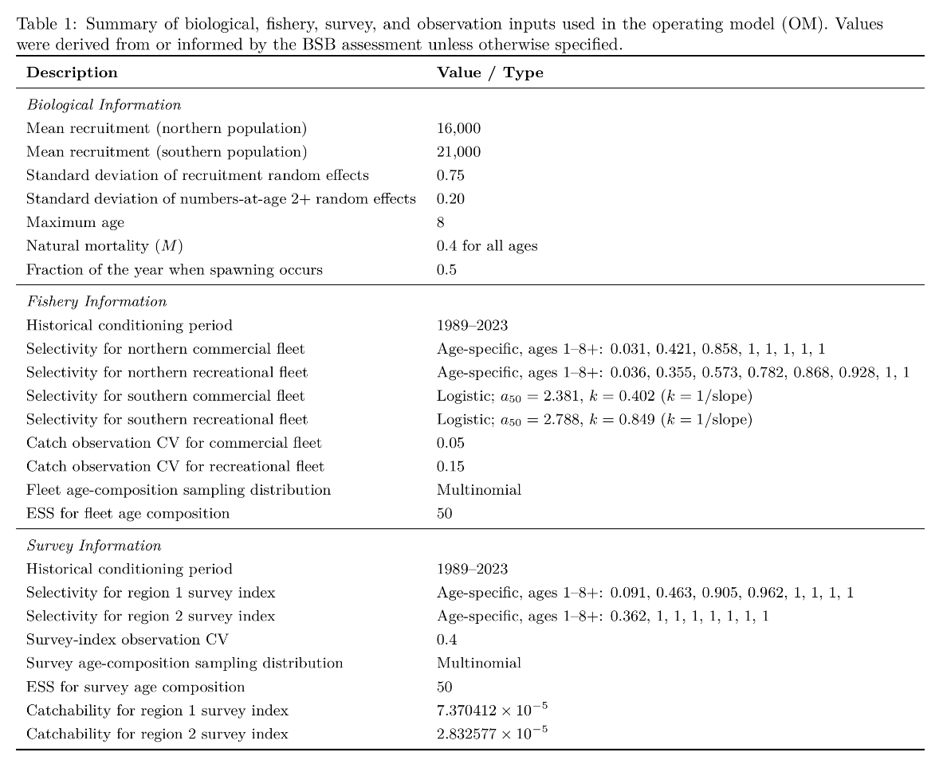
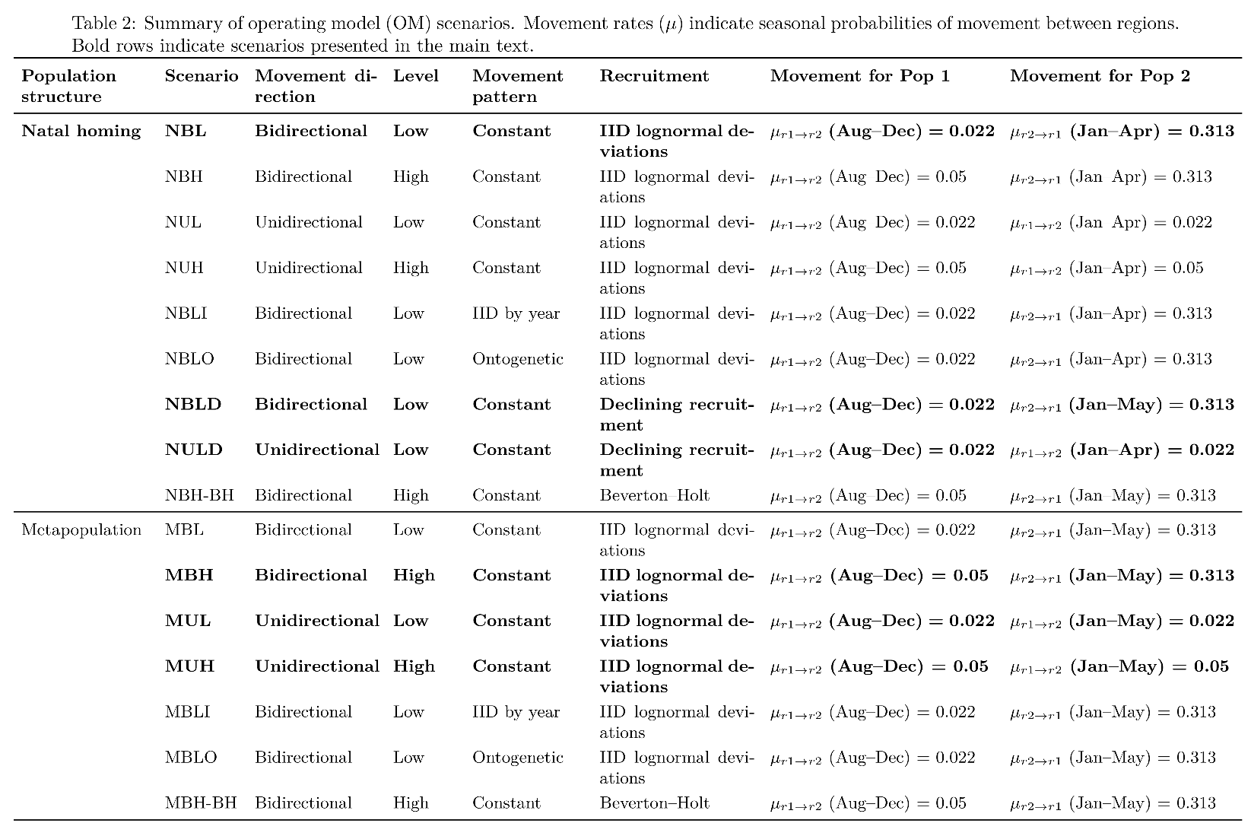
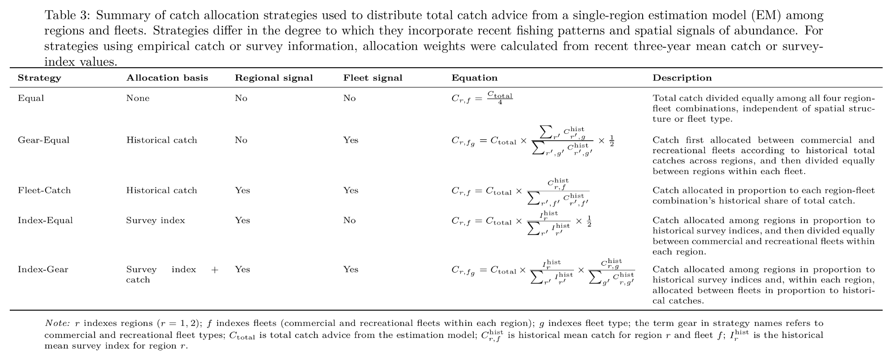
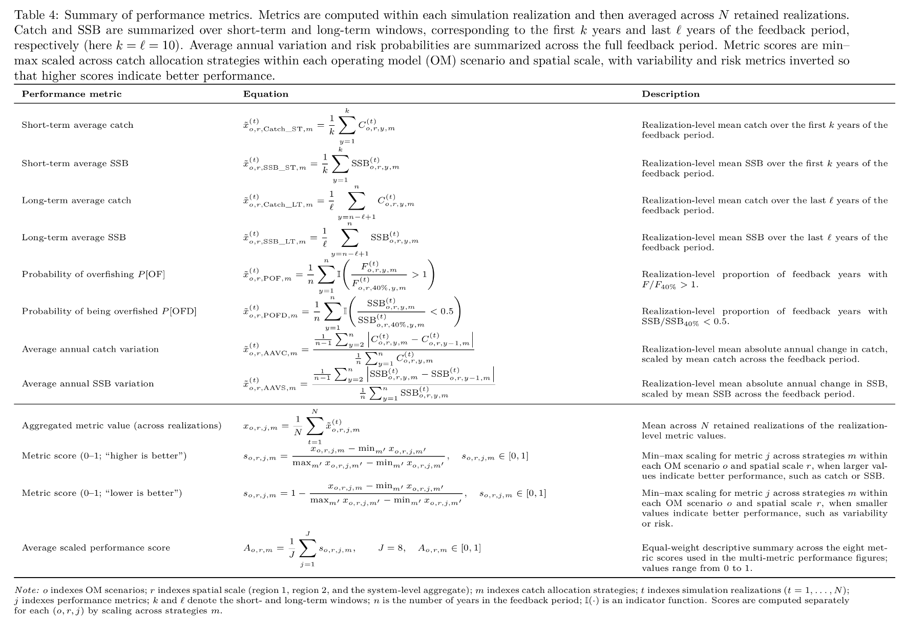
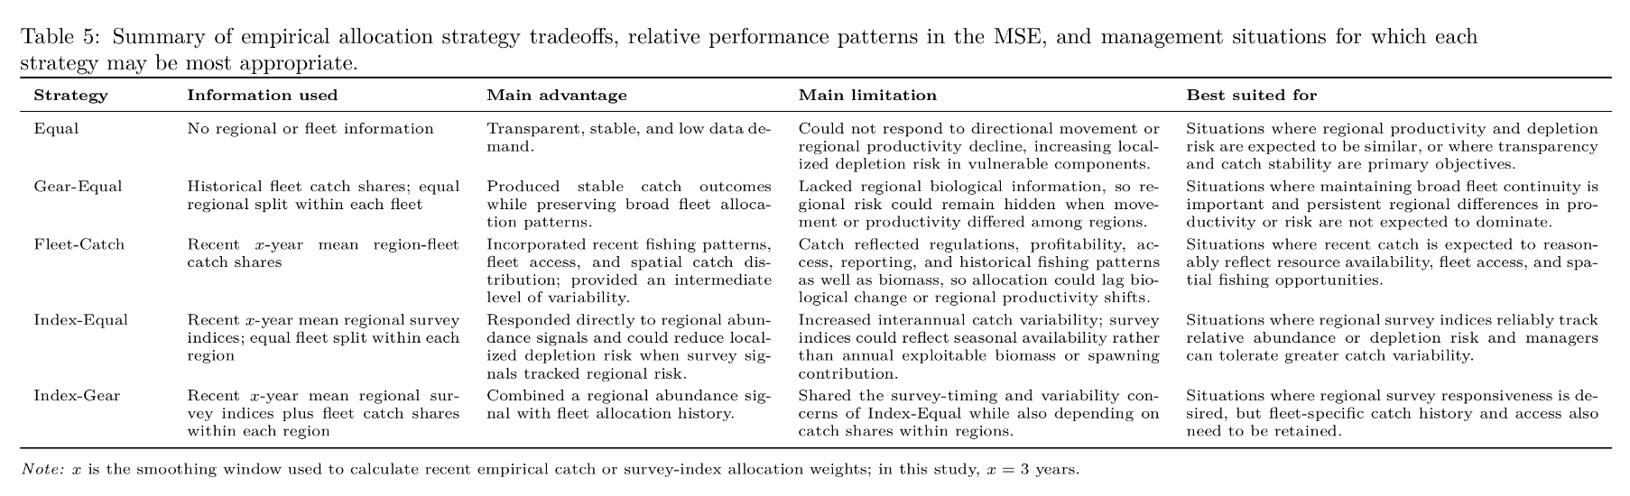

Supplementary Tables
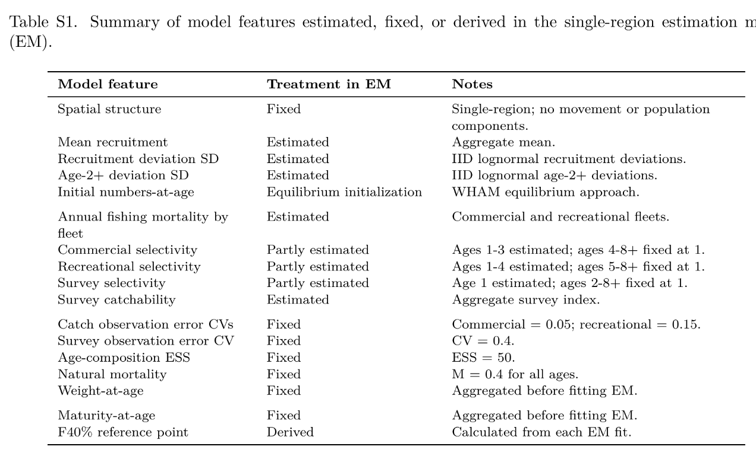
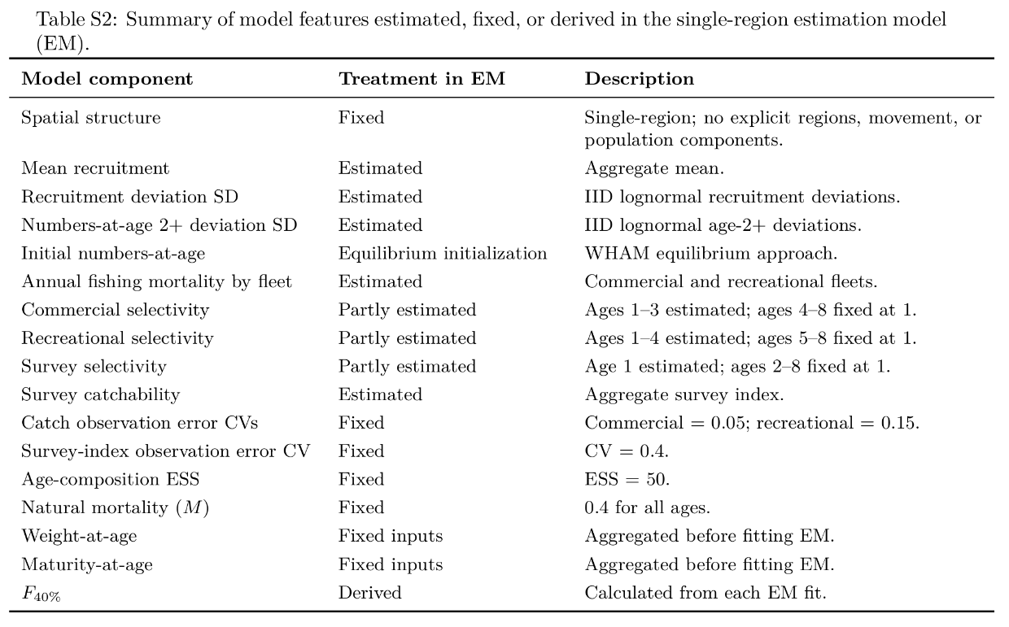

Figures
Figure 1. Life-history, selectivity, and fishery inputs used in the operating model. Panels show weight-at-age, maturity-at-age, fleet-specific selectivity-at-age, initial numbers-at-age by region, and annual fishing mortality by fleet used to condition the operating model. Lines are shown separately for regions, fleets, survey indices, and population components where applicable.
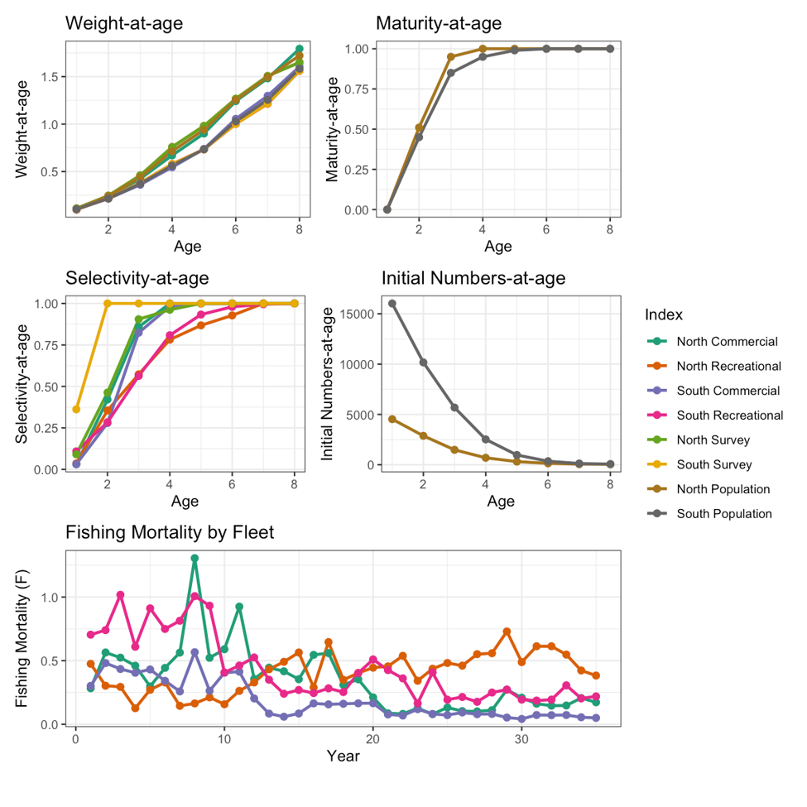
Figure 2. Conceptual overview of operating model scenarios. Green and blue circles represent the two population components. Vertical gray lines divide the annual cycle into seasonal movement windows; within each window, movement patterns are held constant. The yellow band indicates the natal-homing movement window before the spawning season. Arrows indicate movement pathways during each seasonal window. Solid arrows indicate required movement, with movement probability equal to 1, whereas dashed arrows indicate probabilistic seasonal movement, with movement probabilities varying among scenarios. Scenario abbreviations indicate population structure, movement directionality, movement magnitude, and recruitment process. Pink labels identify additional variants, including interannual variation in movement, ontogenetic movement, declining mean recruitment in population component 1, and Beverton-Holt density-dependent recruitment. Full parameter values are provided in Tables 2 and 3.
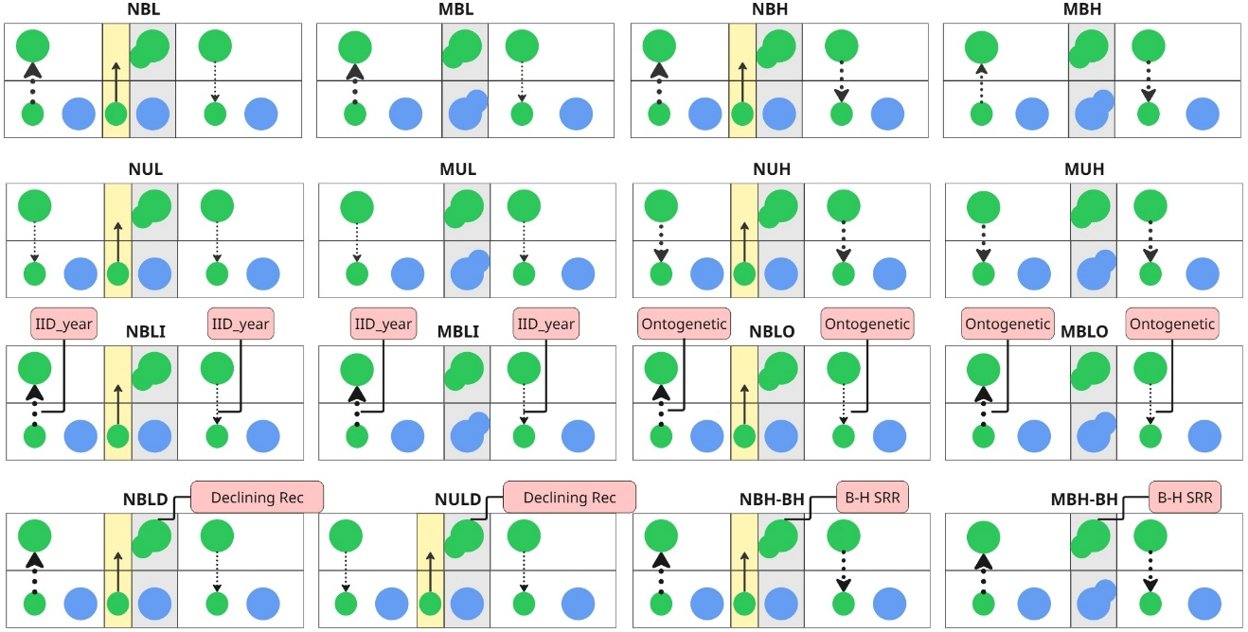

Figure 3. Short- and long-term catch performance across catch allocation strategies. Median catch is shown on the absolute catch scale for Region 1, Region 2, and the system-level aggregate across the six main-text operating model scenarios. Colored horizontal segments extend from zero to the median value, and points mark the median for each catch allocation strategy.
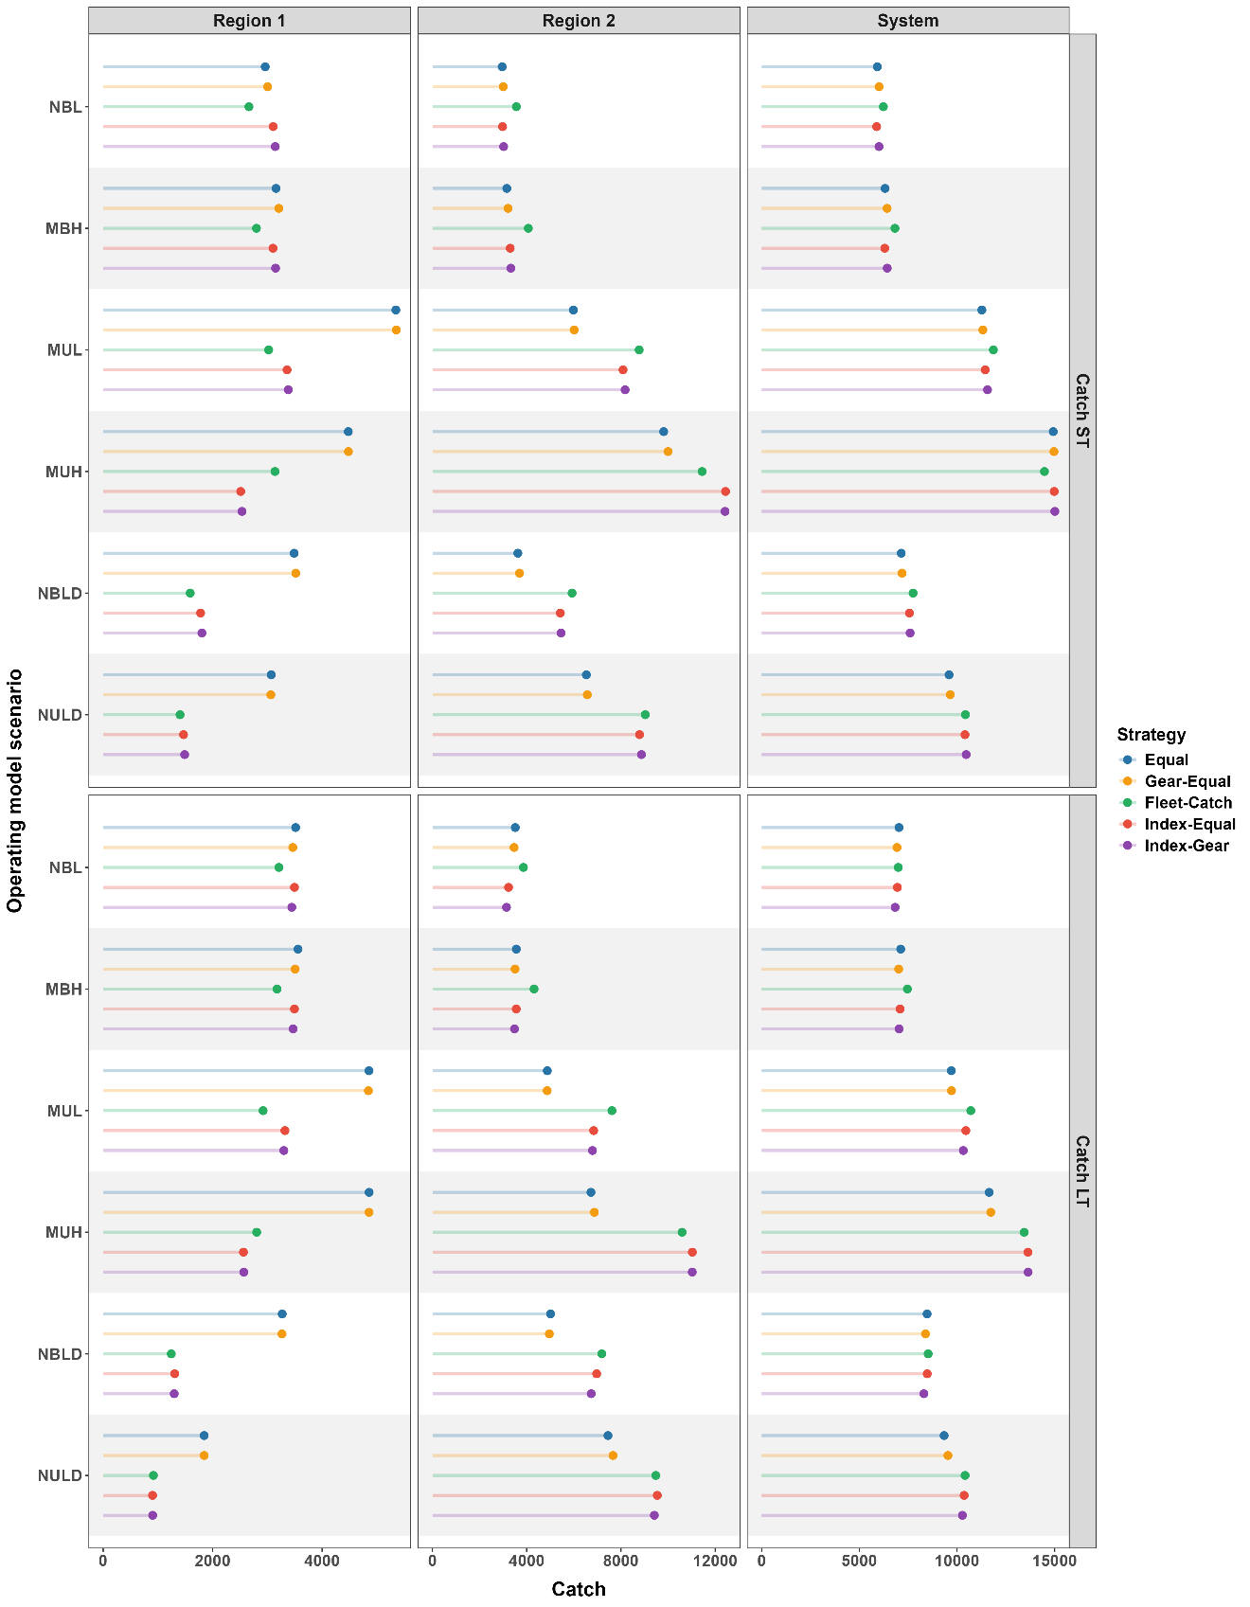
Figure 4. Short- and long-term spawning stock biomass (SSB) across catch allocation strategies. Median SSB is shown on the absolute SSB scale for Region 1, Region 2, and the system-level aggregate across the six main-text operating model scenarios. Colored horizontal segments extend from zero to the median value, and points mark the median for each catch allocation strategy.
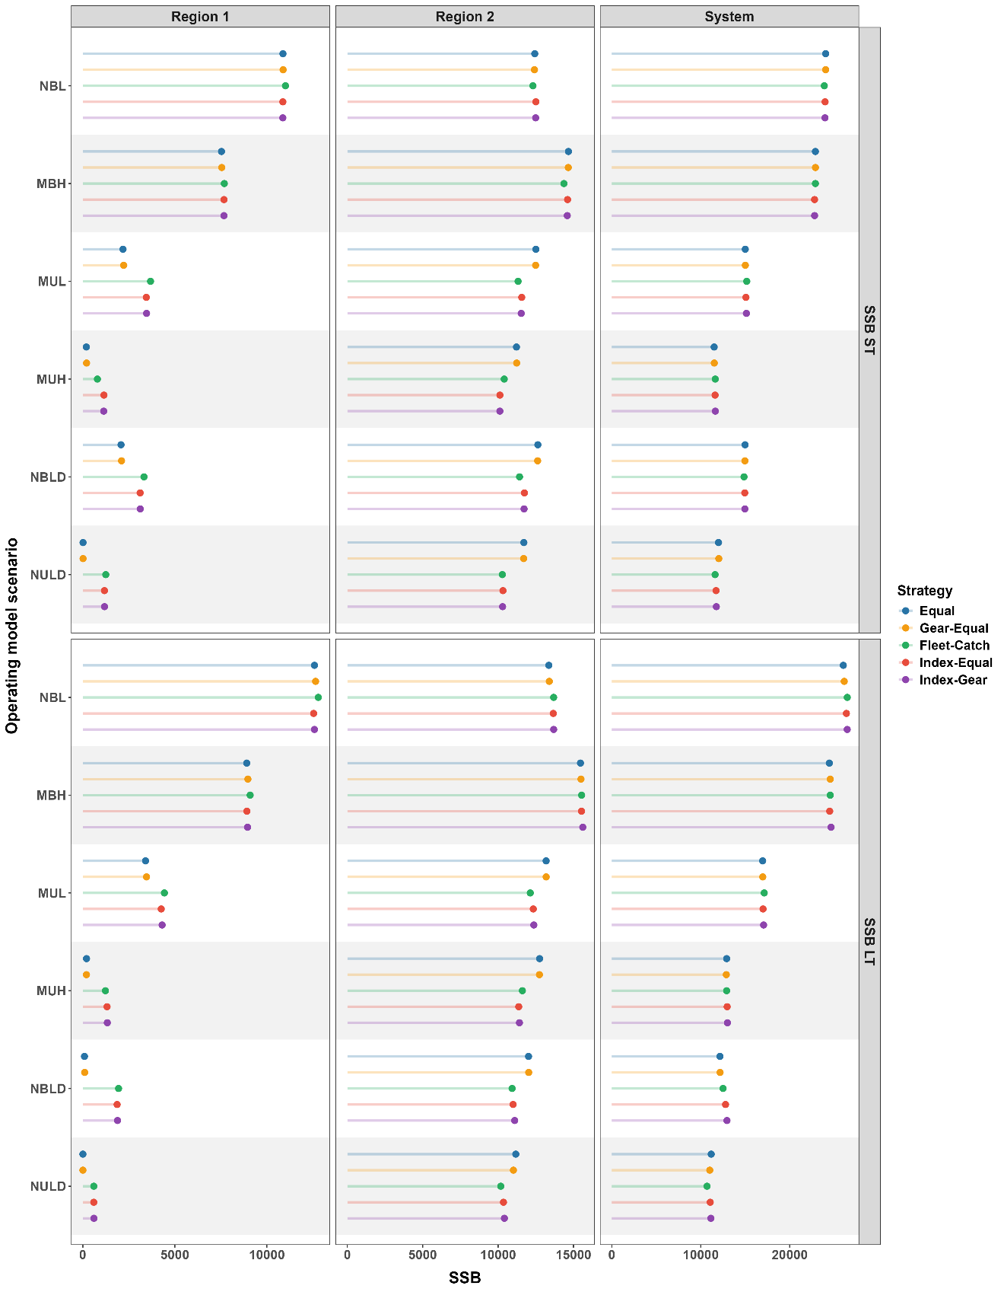
Figure 5. System-level performance scores for each of the six main-text operating model scenarios. Scores summarize normalized catch, spawning stock biomass (SSB), average annual variation, and risk metrics across catch allocation strategies, and average scores across metrics (top of each plot). Higher scores indicate more desirable outcomes after min-max scaling within each operating model scenario and spatial scale.
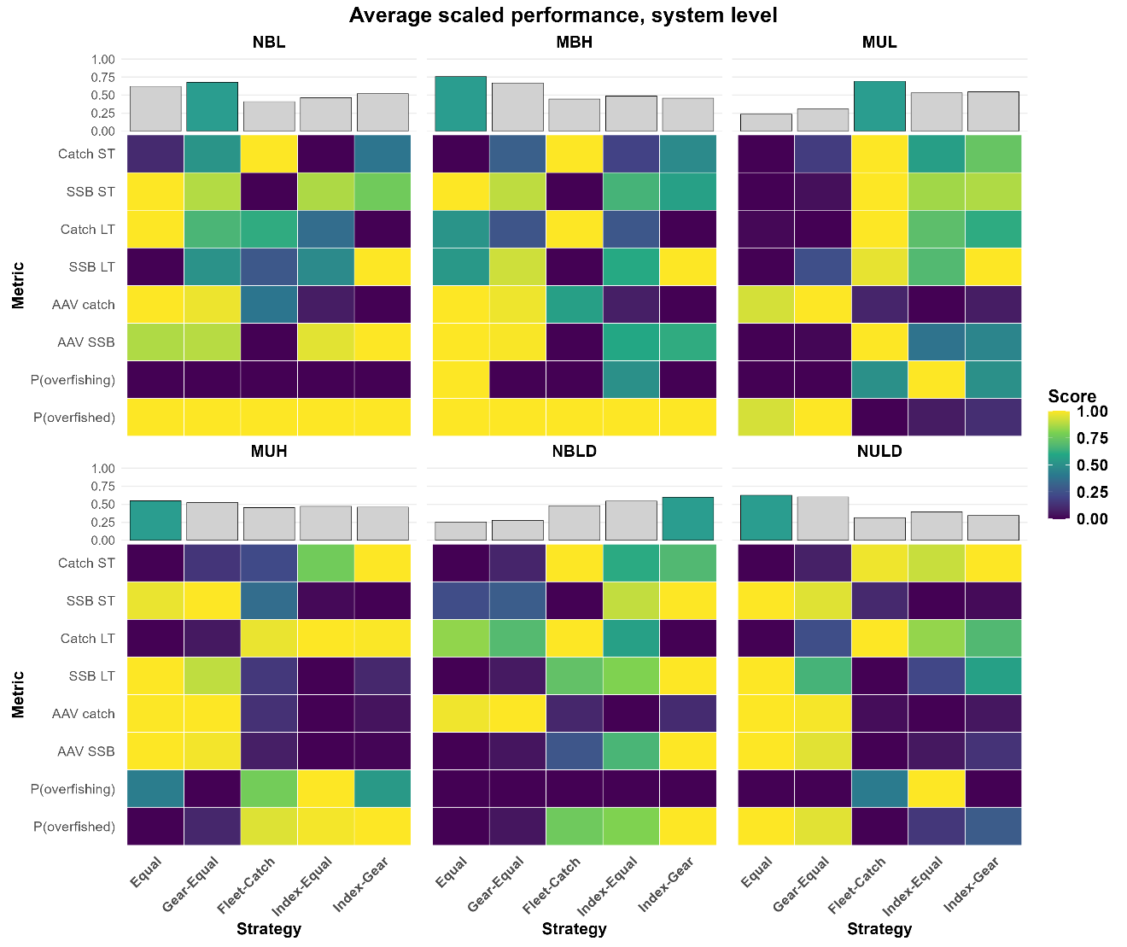

Figure 6. Region 1 performance scores for each of the six main-text operating model scenarios. Scores summarize normalized catch, spawning stock biomass (SSB), average annual variation, and risk metrics across catch allocation strategies, and average scores across metrics are shown at the top of each plot. Higher scores indicate more desirable outcomes after min-max scaling within each operating model scenario and spatial scale.
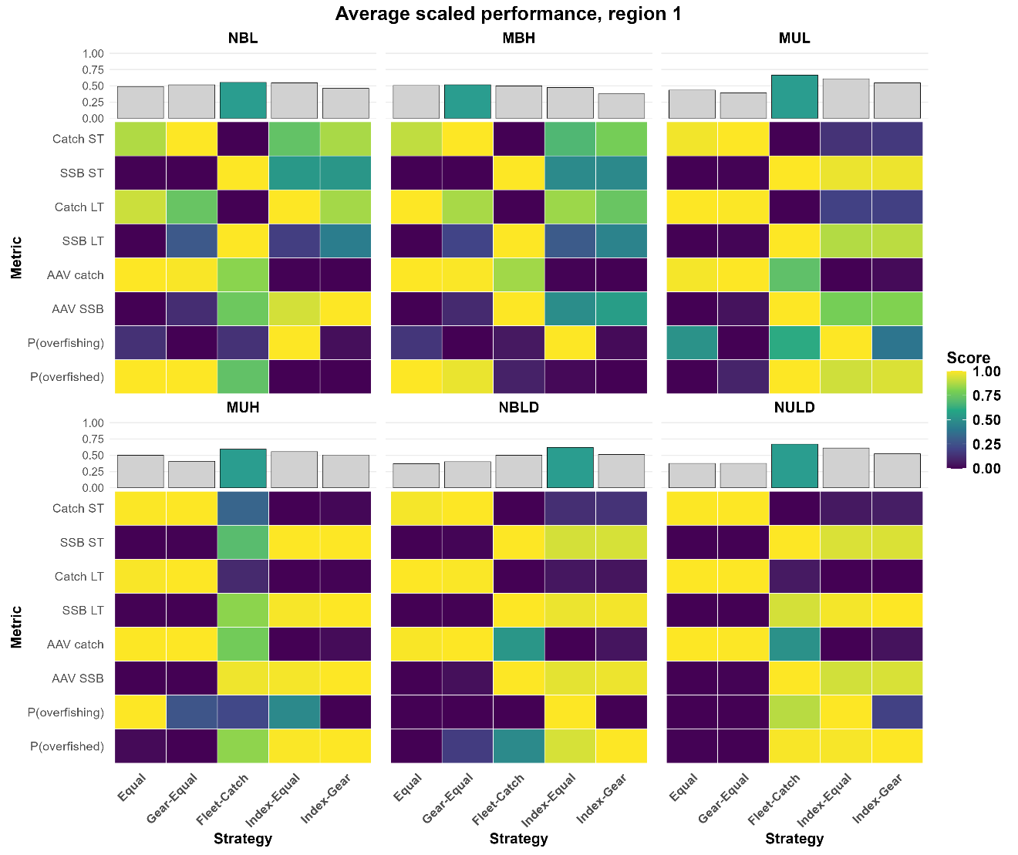

Figure 7. Region 2 performance scores for each of the six main-text operating model scenarios. Scores summarize normalized catch, spawning stock biomass (SSB), average annual variation, and risk metrics across catch allocation strategies, and average scores across metrics are shown at the top of each plot. Higher scores indicate more desirable outcomes after min-max scaling within each operating model scenario and spatial scale.
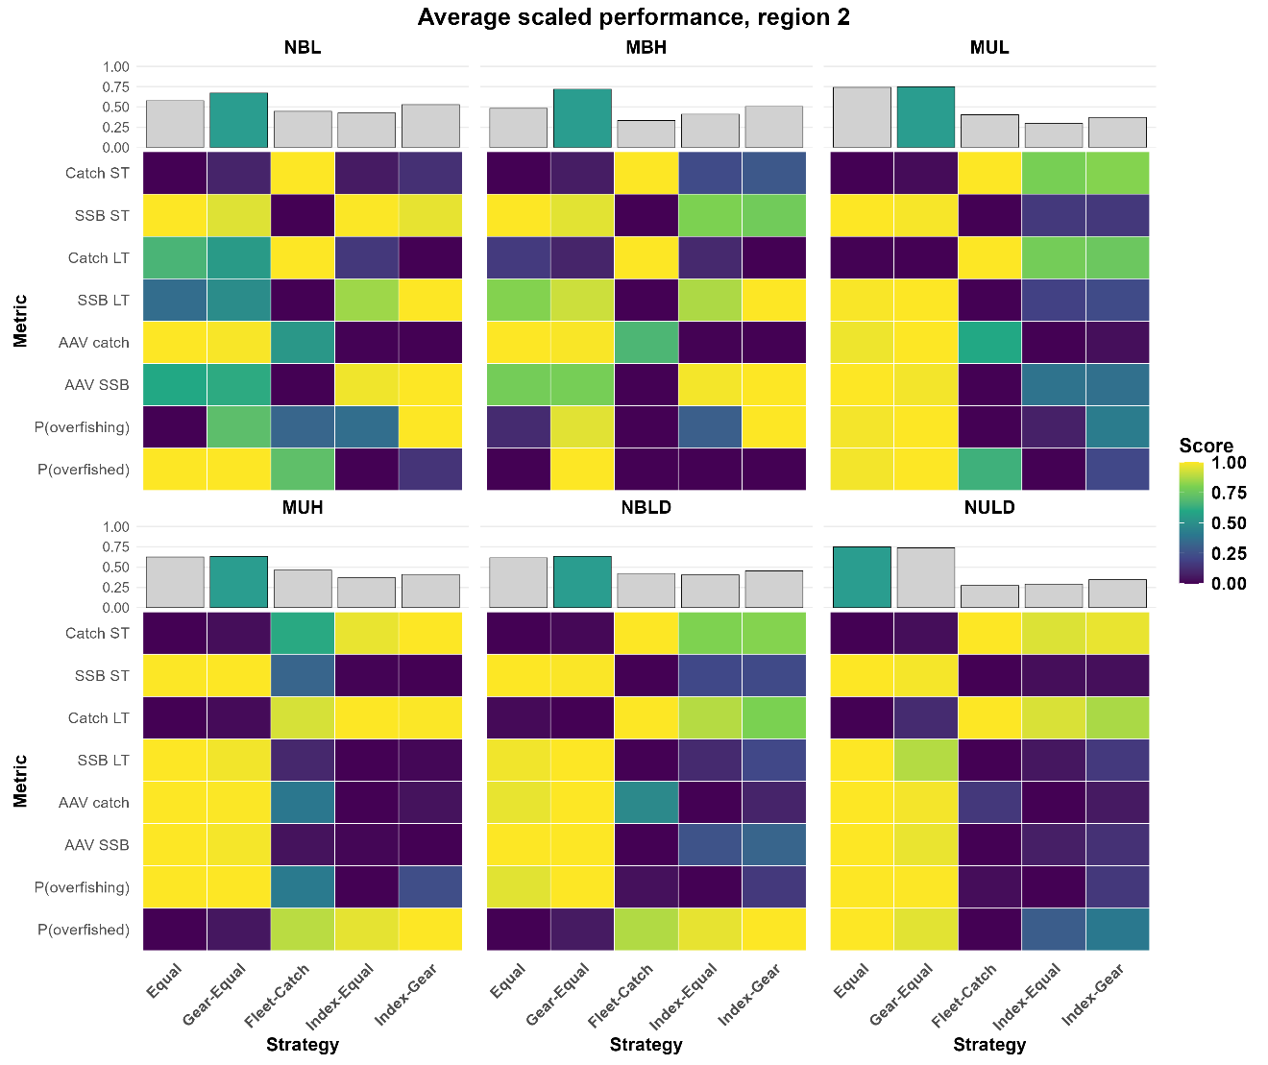

Supplementary Figures
Figure S1 shows an example trajectory from one NBL realization. Figures S2-S5 show metric-specific variation and risk outputs for the six main-text OM scenarios. Figures S6-S11 show the corresponding metric-specific outputs for the full OM scenario set. Figures S12-S14 summarize the full OM scenario set using the summed scaled performance-score framework.

Figure S1. Example operating-model trajectories from one stochastic realization of the BSB-conditioned baseline scenario (NBL). Lines show catch and spawning stock biomass (SSB) for Region 1, Region 2, and the system-level aggregate. The historical period (1989-2023) is shown in black, and the feedback period (2024-2073) is shown by catch allocation strategy. This figure illustrates the closed-loop simulation structure and strategy-specific divergence within a single realization; performance summaries in the main text are based on 100 retained realizations per OM scenario.
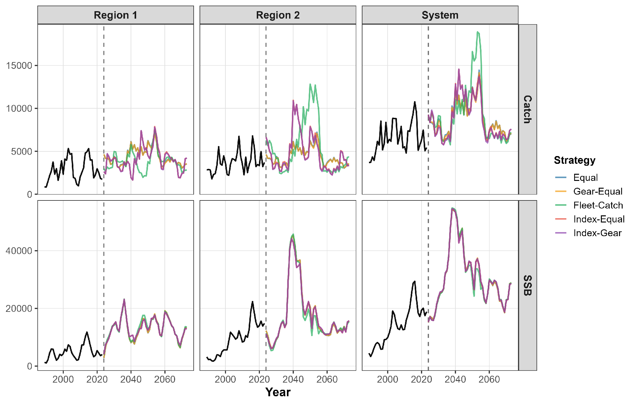

Figure S2. Average annual variation in catch across catch allocation strategies, spatial scales, and the six main-text operating model scenarios. Lower values indicate more stable catch over the feedback period.
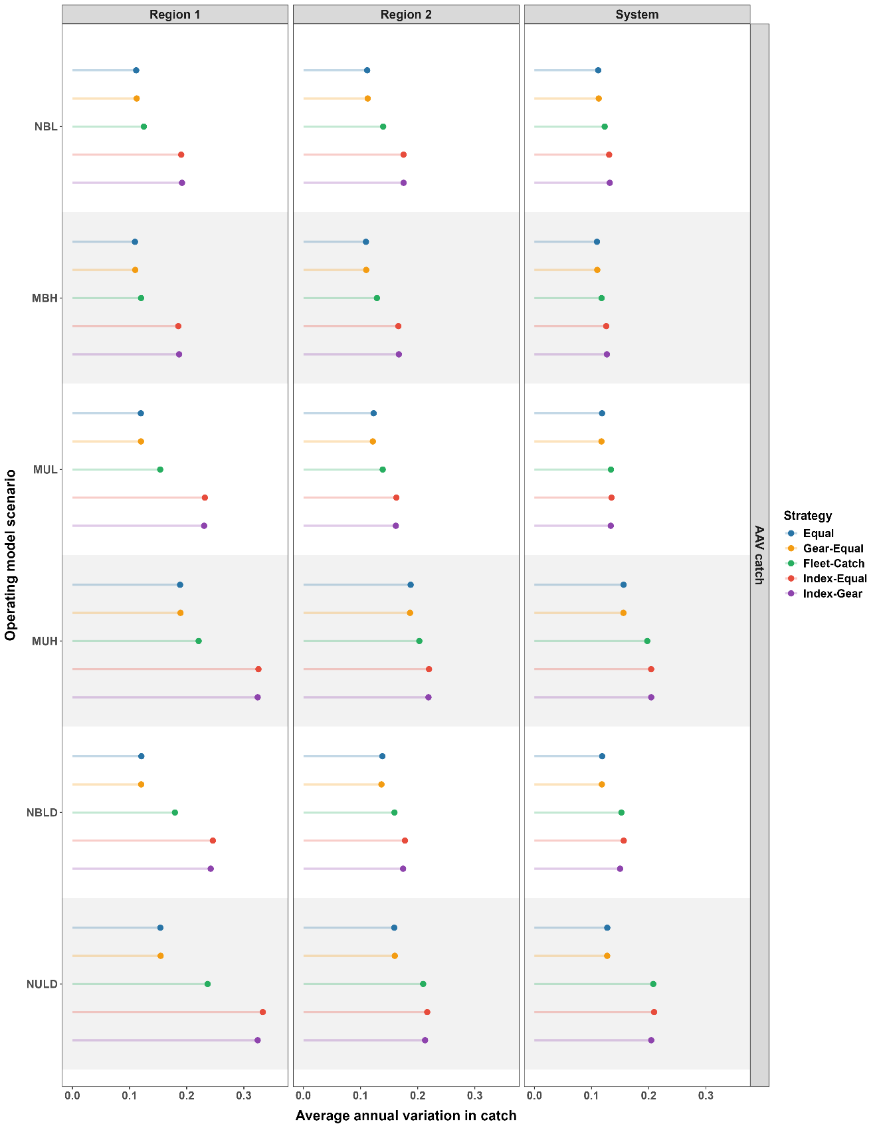
Figure S3. Average annual variation in spawning stock biomass (SSB) across catch allocation strategies, spatial scales, and the six main-text operating model scenarios. Lower values indicate more stable SSB over the feedback period.
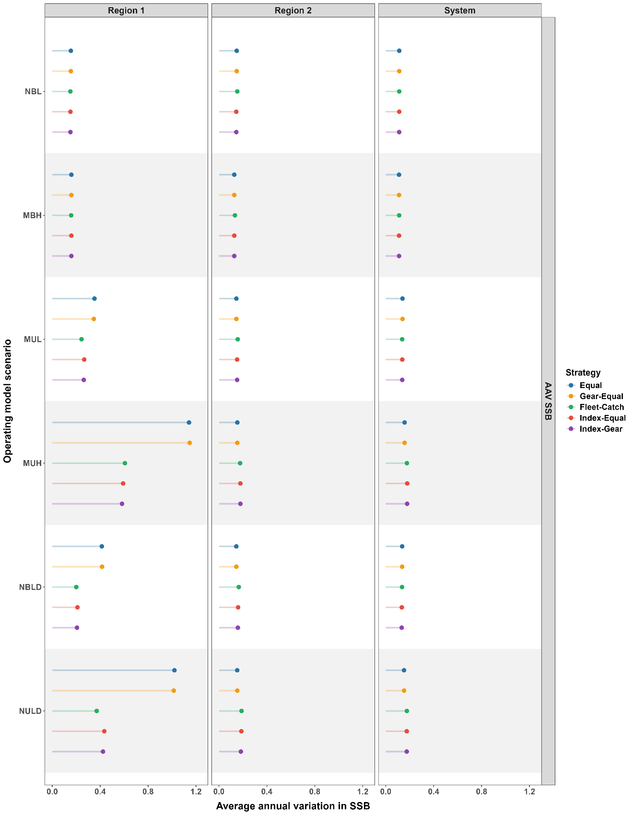
Figure S4. Probability of overfishing across catch allocation strategies, spatial scales, and the six main-text operating model scenarios. Probabilities were calculated over the feedback period from the proportion of years in which fishing mortality exceeded the scenario-specific reference level.
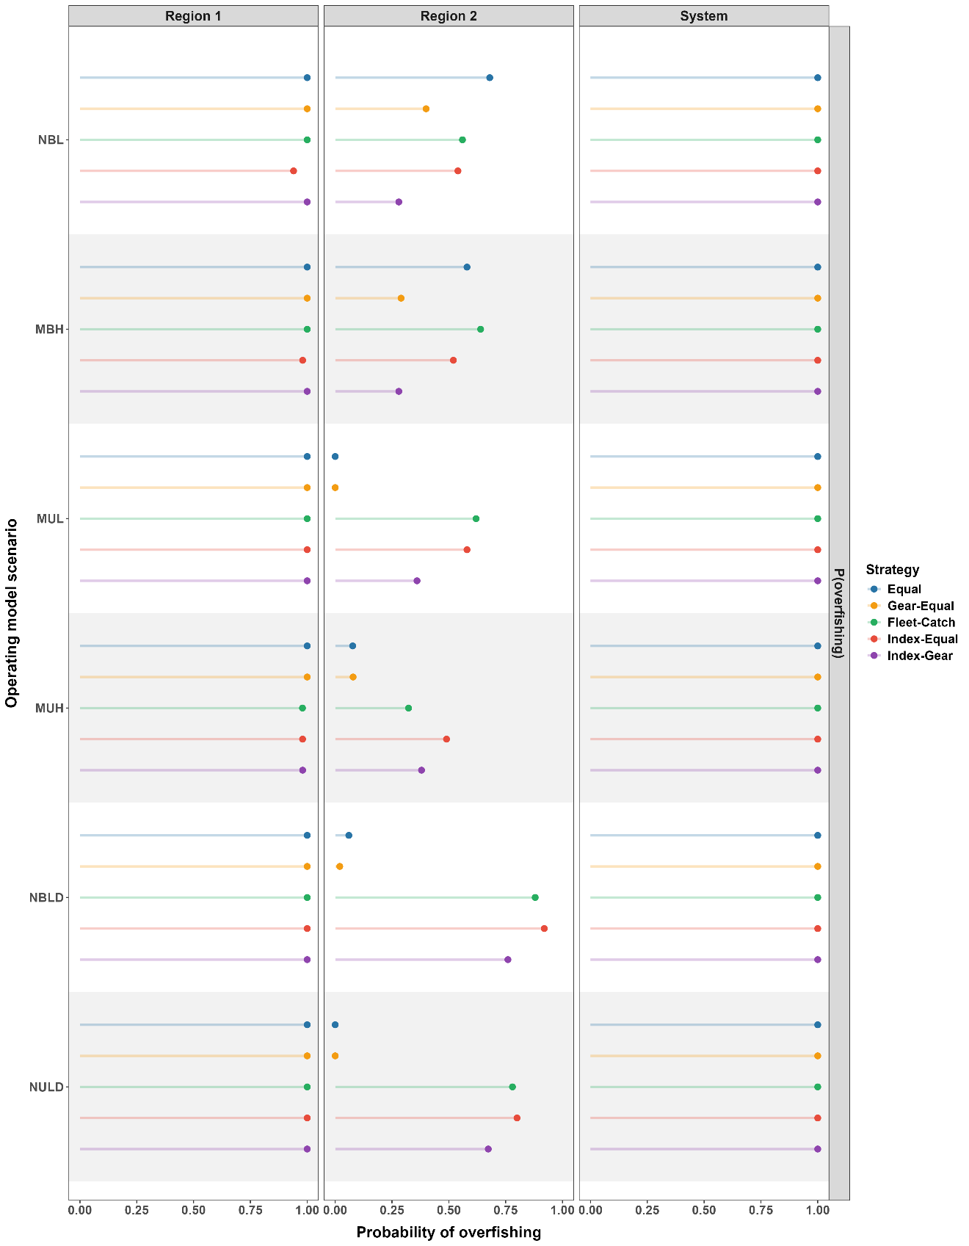
Figure S5. Probability of being overfished across catch allocation strategies, spatial scales, and the six main-text operating model scenarios. Probabilities were calculated over the feedback period from the proportion of years in which SSB fell below the depletion threshold.

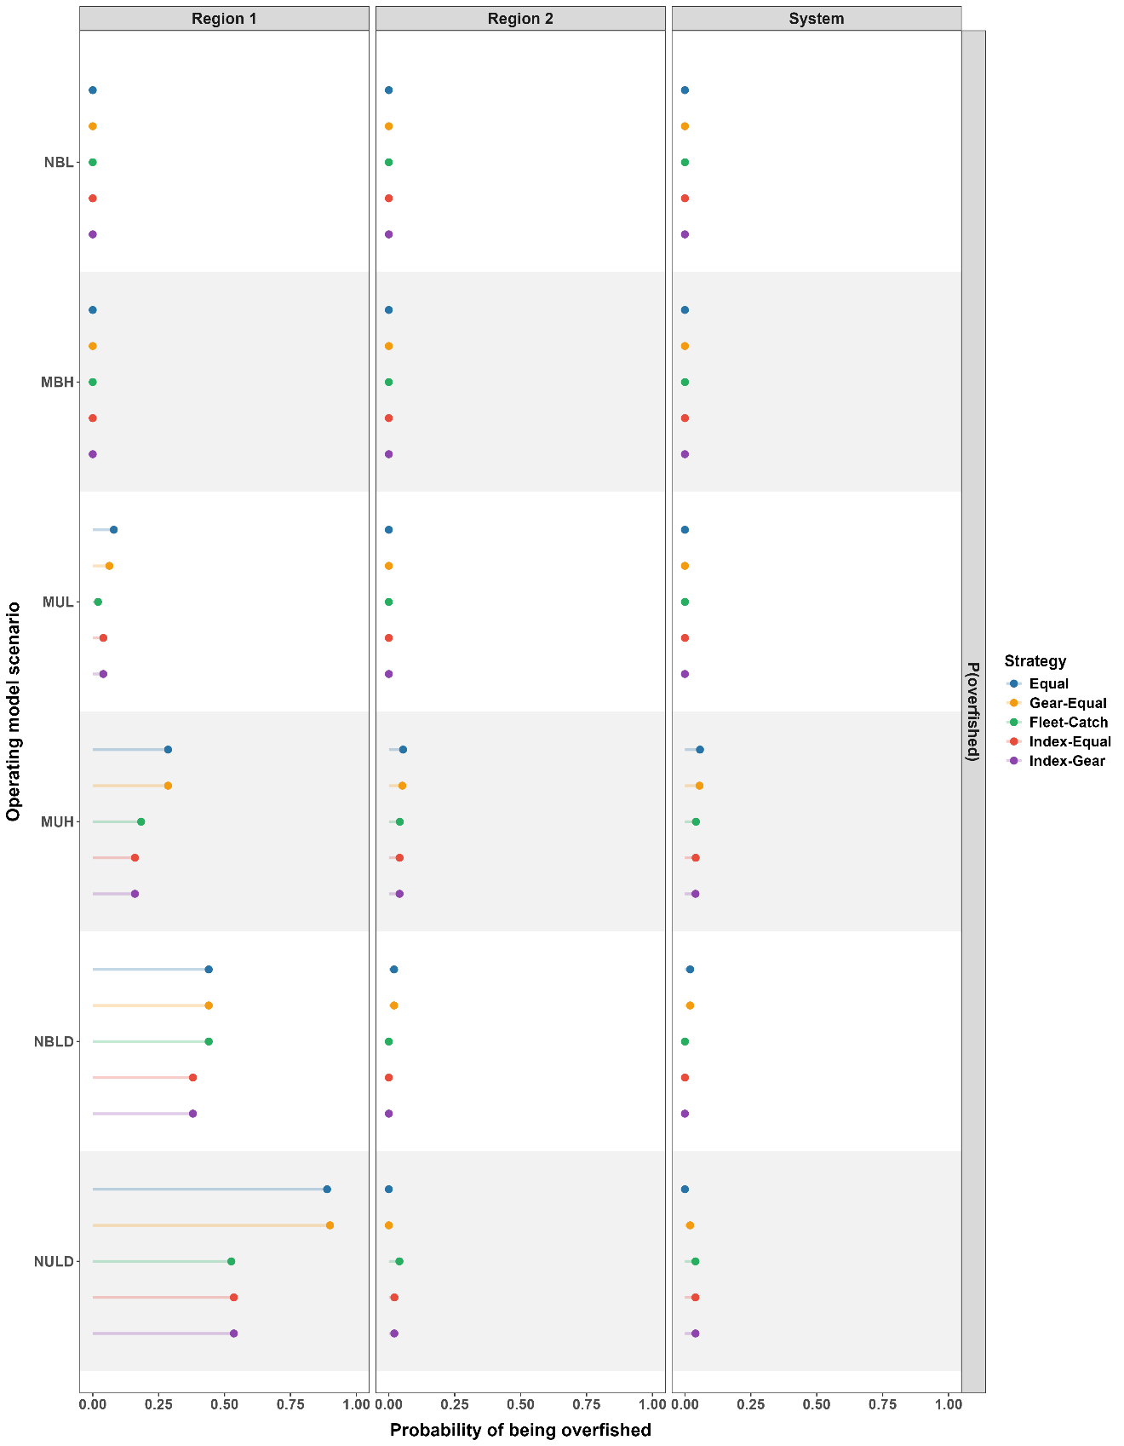
Figure S6. Short- and long-term catch performance across catch allocation strategies, spatial scales, and all operating model scenarios. Median catch is shown on the absolute catch scale for Region 1, Region 2, and the system-level aggregate. Points show medians across retained realizations; horizontal error bars show interquartile ranges (25th-75th percentiles).
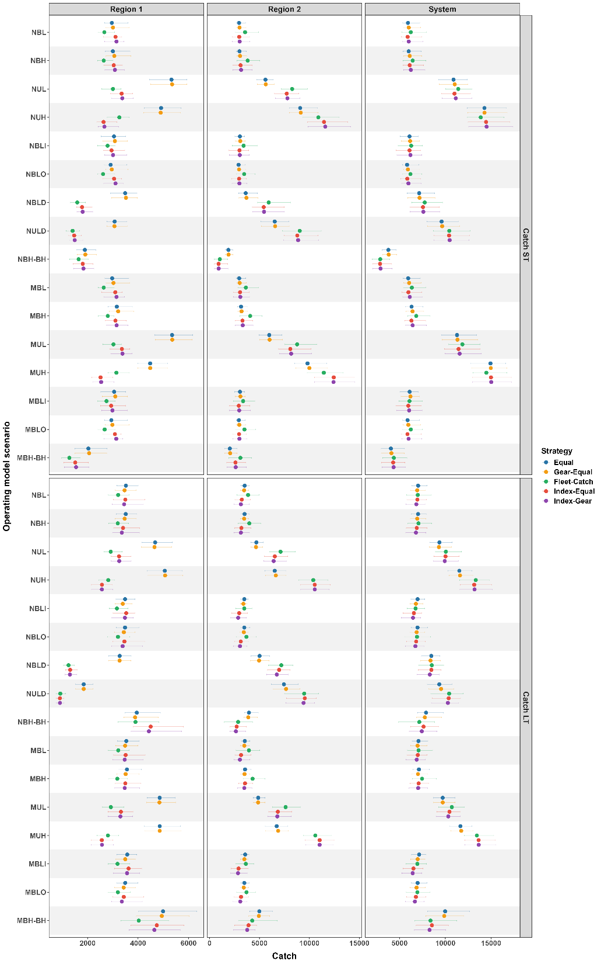
Figure S7. Short- and long-term spawning stock biomass (SSB) across catch allocation strategies, spatial scales, and all operating model scenarios. Median SSB is shown on the absolute SSB scale for Region 1, Region 2, and the system-level aggregate. Points show medians across retained realizations; horizontal error bars show interquartile ranges (25th-75th percentiles).
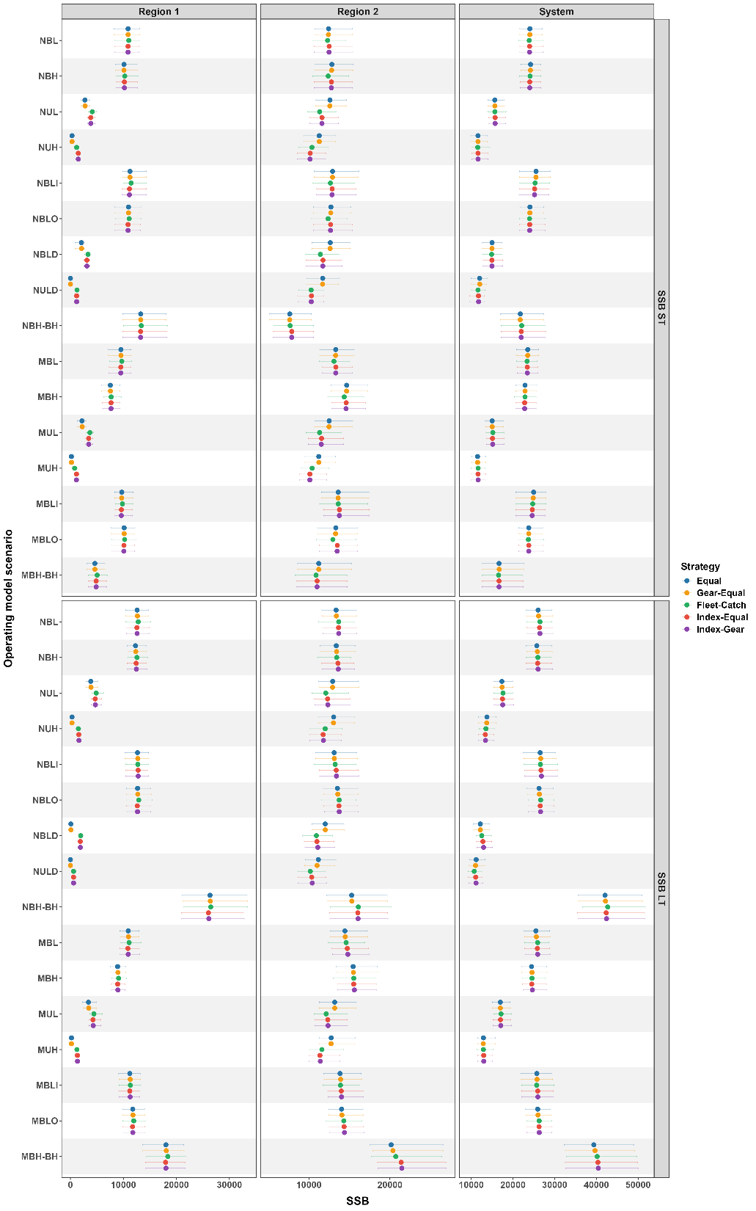
Figure S8. Average annual variation in catch across catch allocation strategies, spatial scales, and all operating model scenarios. Lower values indicate more stable catch over the feedback period. Points show medians across retained realizations; horizontal error bars show interquartile ranges (25th-75th percentiles).
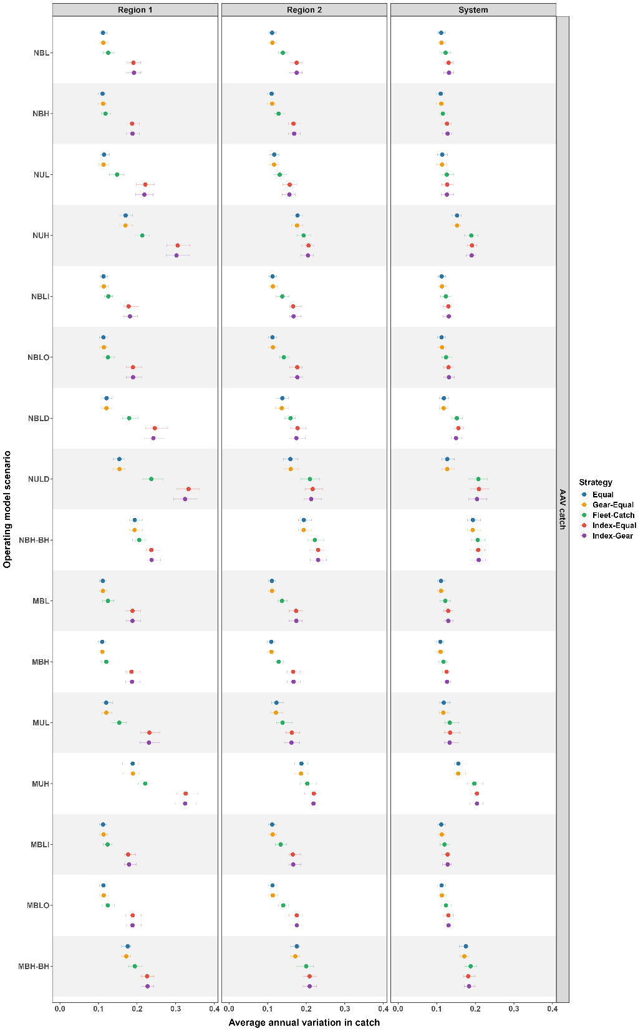
Figure S9. Average annual variation in spawning stock biomass (SSB) across catch allocation strategies, spatial scales, and all operating model scenarios. Lower values indicate more stable SSB over the feedback period. Points show medians across retained realizations; horizontal error bars show interquartile ranges (25th-75th percentiles).
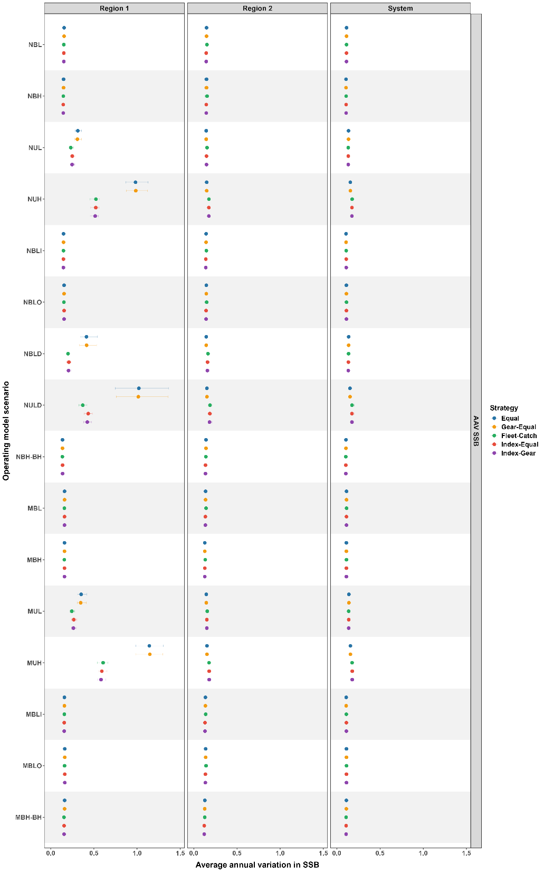
Figure S10. Probability of overfishing across catch allocation strategies, spatial scales, and all operating model scenarios. Probabilities were calculated over the feedback period from the proportion of years in which fishing mortality exceeded the scenario-specific reference level. Points show medians across retained realizations; horizontal error bars show interquartile ranges (25th-75th percentiles).
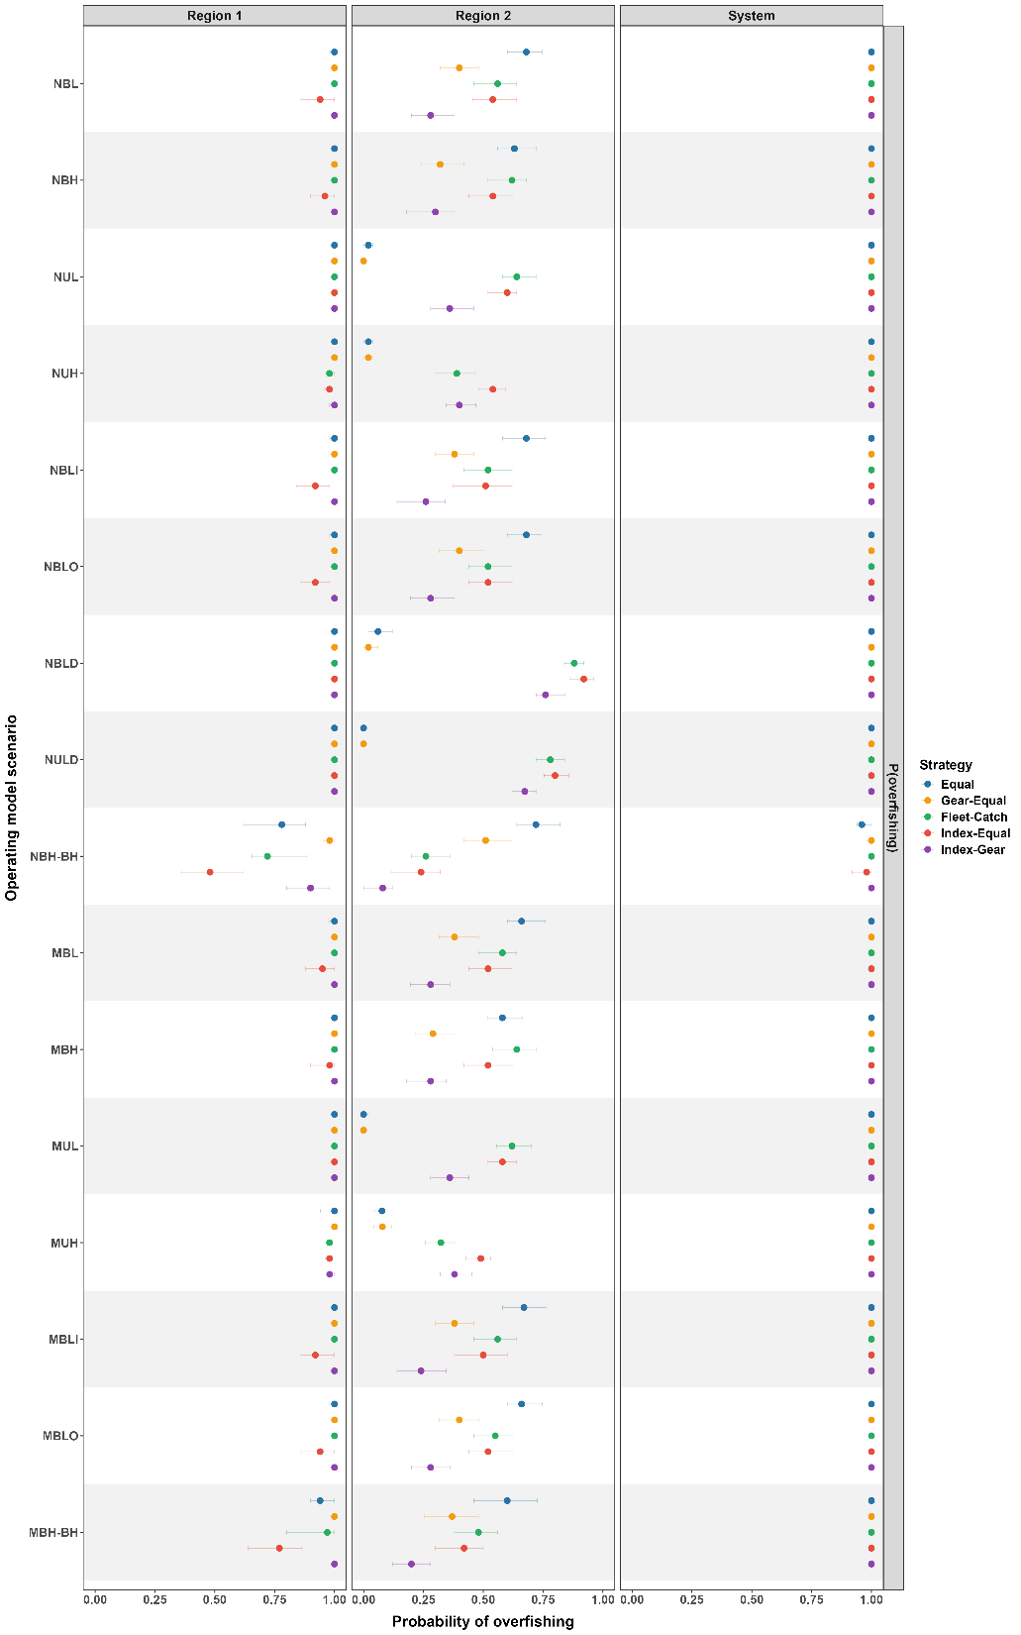
Figure S11. Probability of being overfished across catch allocation strategies, spatial scales, and all operating model scenarios. Probabilities were calculated over the feedback period from the proportion of years in which SSB fell below the depletion threshold. Points show medians across retained realizations; horizontal error bars show interquartile ranges (25th-75th percentiles).
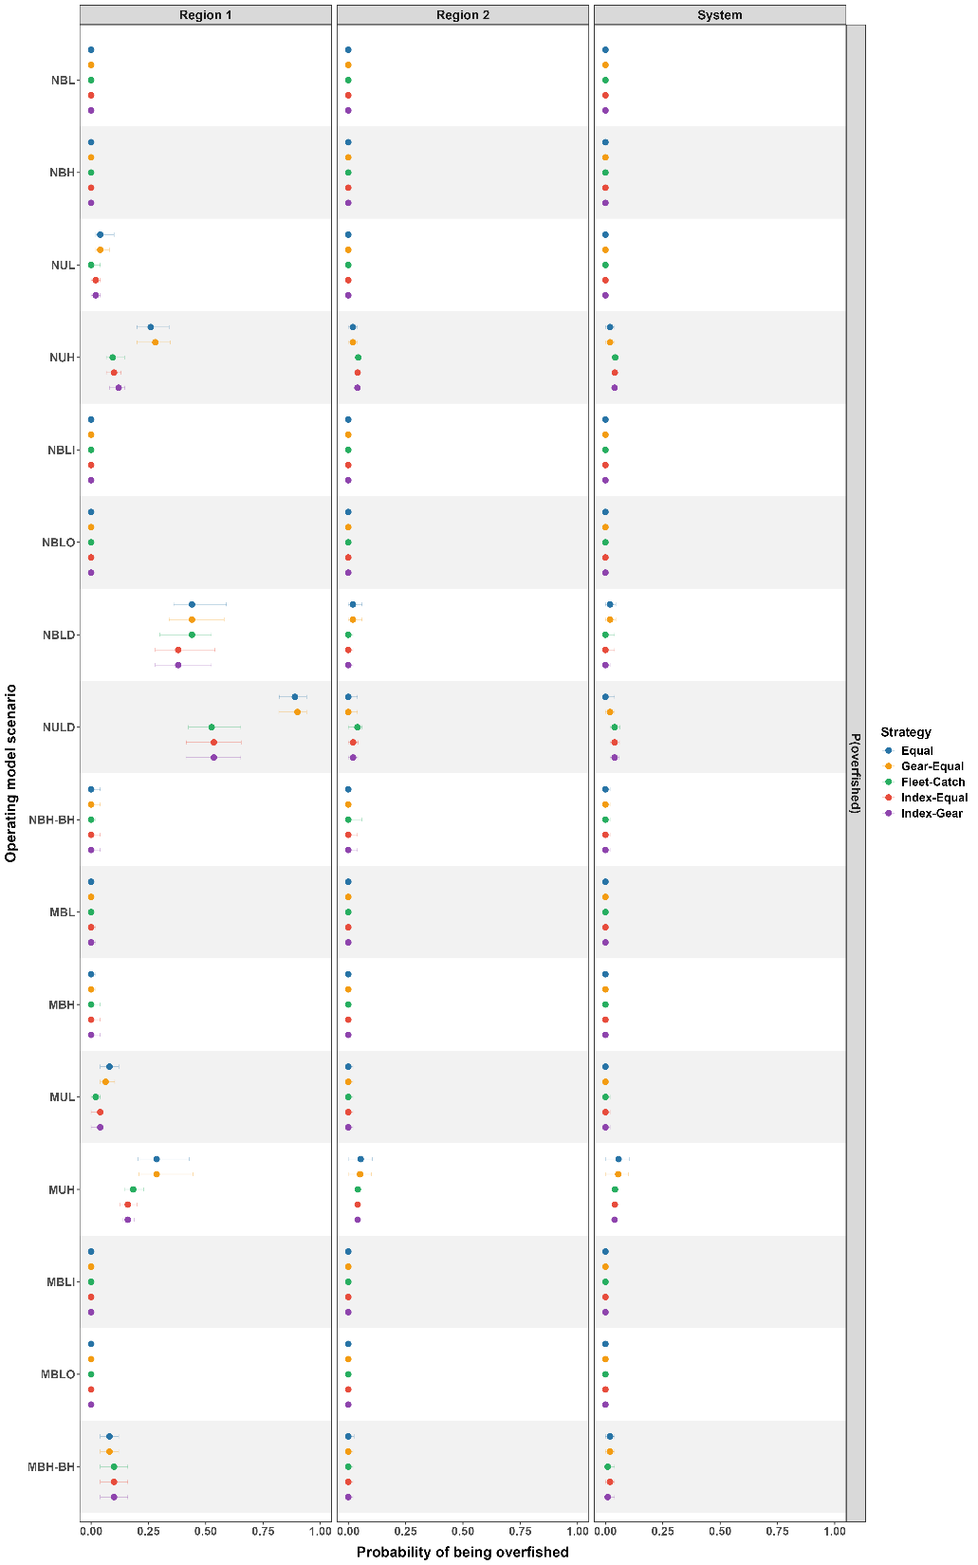
Figure S12. System-level performance scores for each operating model scenario. Scores summarize normalized catch, spawning stock biomass (SSB), average annual variation, probability of overfishing, and probability of being overfished across catch allocation strategies, and average scores across metrics are shown at the top of each plot. Higher scores indicate more desirable outcomes after min-max scaling within each operating model scenario and spatial scale.
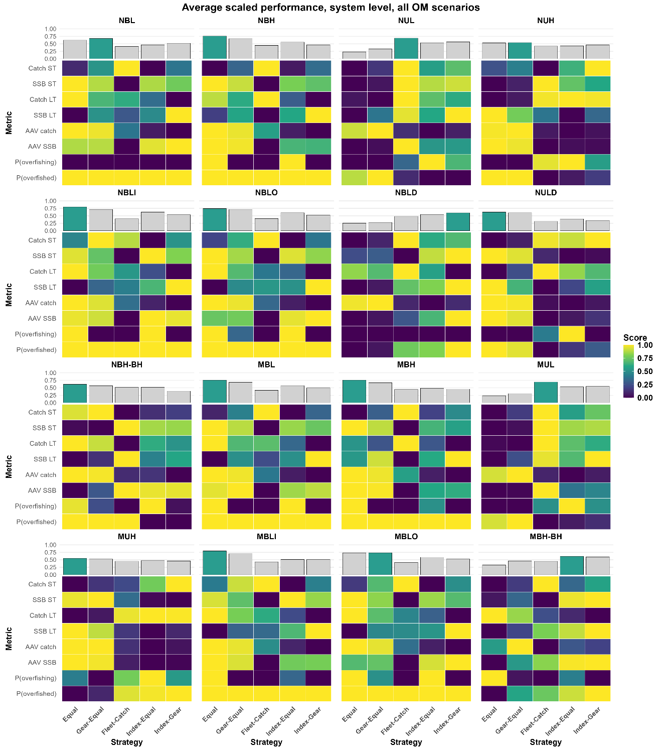
Figure S13. Region 1 performance scores for each operating model scenario. Scores summarize normalized catch, spawning stock biomass (SSB), average annual variation, probability of overfishing, and probability of being overfished across catch allocation strategies, and average scores across metrics are shown at the top of each plot. Higher scores indicate more desirable outcomes after min-max scaling within each operating model scenario and spatial scale.
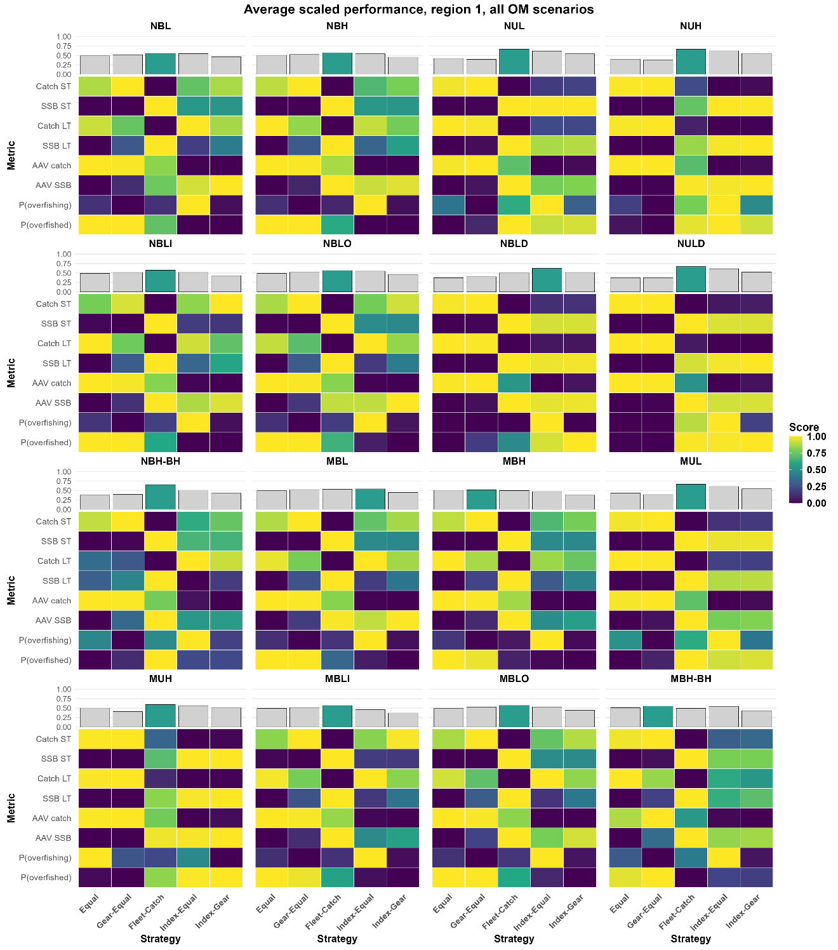
Figure S14. Region 2 performance scores for each operating model scenario. Scores summarize normalized catch, spawning stock biomass (SSB), average annual variation, probability of overfishing, and probability of being overfished across catch allocation strategies, and average scores across metrics are shown at the top of each plot. Higher scores indicate more desirable outcomes after min-max scaling within each operating model scenario and spatial scale.


