Can random effects on the survival process account for movement dynamics in a state-space stock assessment?
Li, C*, Deroba, J.J., et al
NOAA Northeast Fisheries Science Center, Woods Hole, MA, USA
*Corresponding author: chengxue.li@noaa.gov
Abstract (note CJFAS abstract word limit 175)
Keywords: spatial stock assessment, state-space model, movement dynamics, random effects,

1. Introduction
Random effects on inter-annual transitions in numbers at age (hereafter referred to as NAA) introduce flexibility into a stock assessment that can account for a wide range of population (e.g., movement, natural mortality) and fishery processes (e.g., selectivity, misreported catch) (Nielsen and Berg, 2014; Cadigan, 2016; Albertsen et al., 2018; Perretti et al., 2020; Stock and Miller, 2021; Stock et al., 2021). Simulation-estimation studies have consistently concluded that incorporating NAA random effects results in less biased estimates of management quantities (e.g., biomass, reference points), even when NAA random effects were included in the assessment model but absent in the operating model that generated the data (Li et al., 2024). Gudmundsson and Gunnlaugsson (2012) suggested that NAA deviations can be interpreted as migrations, or “irregular natural mortality.” However, the extent to which random effects on NAA deviations improve the assessment or management process when accounting for other processes, such as movement, has not been explicitly tested, despite paramount claims that they can do so (Gudmundsson and Gunnlaugsson, 2012; Nielsen and Berg, 2014; Cadigan, 2016; Stock and Miller, 2021).
Accounting for stock structure and movement dynamics in stock assessments is becoming increasingly desirable (Goethel et al., 2021; Bosley et al., 2022; Goethel et al., 2023; Berger et al., 2024), as climate change is likely to trigger fish movement and affect fish biology, predator-prey interactions, and habitat suitability (Pörtner and Peck, 2010; Ciannelli et al., 2013). This increased biocomplexity and spatial heterogeneity in fish distribution and demographics inevitably challenge the panmictic assumptions of traditional stock assessment models, wherein the modeled stock is considered a single population that is uniformly distributed, closed to migration, and reproductively isolated (Beverton, 1957; Cadrin, 2020). Not accounting for spatial structure and movement dynamics in assessment models can induce bias in estimates of population quantities, thereby resulting in a failure to achieve management objectives (Bosley et al., 2019; Goethel et al., 2023). Including stock structure and movement in stock assessments, however, can be challenging (Punt, 2019; Punt et al., 2020; Goethel et al., 2022; Berger et al., 2021, 2024), and in some cases may not be practical due to jurisdictional or management constraints (Kerr et al., 2017), low quality and quantity of geo-partitioned data (Cadrin, 2020; Punt et al., 2020), inadequate tagging information (Goethel et al., 2011, 2019), or other information on stock origin and connectivity (Berger et al., 2017).
Evaluating whether NAA random effects can account for movement in spatially mis-specified stock assessments and improve management outcomes remains a necessary research question. One effective practice to evaluate whether management procedures (e.g., stock assessment models) achieve management objectives (e.g., sustainable management advice) is through management strategy evaluation (Punt et al., 2017; Keymer et al., 2000). This approach involves considering different candidate spatial templates, data collection methods, model structures, and harvest control rules (Kerr and Goethel, 2014; Goethel et al., 2016). In this study, we use closed-loop simulations to evaluate the performance of several estimation models that do not explicitly account for movement but include random effects on NAA deviations, when the operating model that defines the true dynamics includes movement. Our objective is to evaluate the degree to which including NAA random effects in stock assessments can account for movement dynamics. We evaluate the effects of including NAA random effects on the discrepancy between estimated assessment quantities (i.e., simulation-estimation framework) and the ability to achieve likely management objectives (i.e., closed-loop simulation) under scenarios with varying movement dynamics and historical fishing pressure, both of which can lead to a spatially heterogeneous distribution of fish populations. Our results provide insights into the robustness of including NAA random effects to represent the uncertainty in population dynamics arising from movement within the state-space stock assessment modeling framework.

2. Methods

2.1 Overview
The Woods Hole Assessment Model (WHAM) is a state-space assessment model developed at the Northeast Fisheries Science Center (NEFSC, https://timjmiller.github.io/wham) (Stock and Miller, 2021). WHAM can incorporate time- and/or age-varying process errors on population and fishery processes, including recruitment, NAA transitions, natural mortality, movement, fishing selectivity, and survey catchability (Stock and Miller, 2021). WHAM is currently used to manage several stocks in the US northeast region, such as Atlantic cod (Gadus morhua) and black sea bass (Centropristis striata). Here we use a multi-stock and multi-region extension of WHAM (hereafter referred as Multi-WHAM) that includes options for modeling populations with spatial heterogeneity in biology and movement dynamics, as well as spatial heterogeneity in fleet dynamics. Below we only describe the differences from the original single-stock single-region WHAM (hereafter referred as Single-WHAM), which has been described in detail (Stock and Miller, 2021).

2.1.1 Population
For a single stock in a single region, the numbers at age 𝑎 surviving (𝑆), being harvested from the fishery (𝐻), and dying from natural mortality (𝑀) over the time interval 𝛿 (e.g. 1 year) are:
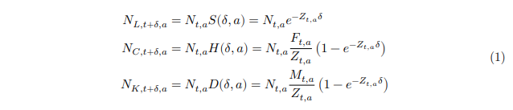
The vector of numbers at age 𝑎 at time 𝑡 that survived, were harvested, or died due to natural mortality can be defined as:

The probability transition matrix is:
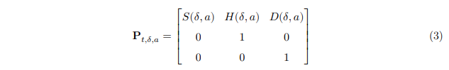
Thus, the numbers at age 𝑎 at the end of time interval 𝛿 (i.e. 𝑡 + 𝛿) is:
Also, the probability transition matrix over multiple time intervals is the product of individual probability transition matrices. For example:
When there are 𝑛_{𝑅} regions and 𝑛_{𝐹} fleets, the number at age 𝑎 at time 𝑡 is generalized as:
And the probability transition matrix is generalized as:

Thus the numbers at age 𝑎 at time 𝑡 + 𝛿 that are survived is generalized as:
where O is the 𝑛_{𝑅} × 𝑛_{𝑅} matrix defining survival and movement from one region to another over the time interval 𝑡. Note here movement is assumed to occur sequentially after survival and take place instantly at the end of the time interval, as shown below:
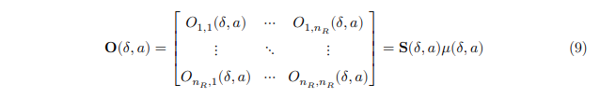
Here 𝑆 is a diagonal matrix representing the proportions of individuals surviving in each region, assuming they start from that region:

And μ is a matrix of proportions moving from one region to another or staying, assuming they start from that region:
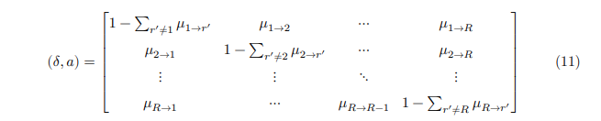
The numbers at age 𝑎 at time 𝑡 + 𝛿 that are harvested by fishery is generalized as:
where H is the 𝑛_{𝑅} × 𝑛_{𝐹} matrix (shown below) defining proportions captured by each fleet, given the number of survivors in each region at the beginning of the time interval:
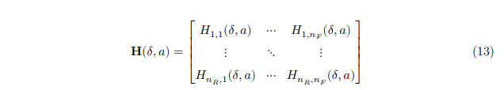
The numbers at age 𝑎 at time 𝑡 that are dead due to natural mortality is generalized as:
where D is the 𝑛_{𝑅} × 𝑛_{𝑅} matrix (shown below) defining proportions dead due to natural mortality, given the number of survivals in each region at the beginning of the time interval:


2.1.2 Stock Structure and Seasonality
A natal homing stock structure was assumed in all cases. Each stock was associated with a natal region and all fish from that natal region were required to return there for spawning. Outside of the spawning season, fish could move among regions (see details in the section of movement dynamics). Seasonality was included to support the assumption of natal homing. Specifically, a number of time intervals for a year ($\sum_{i=1}^{n}{δ_{i}=1}$) can be defined and used to indicate population dynamics particularly movement dynamics prior to the spawning season, during the spawning season, and after the spawning season. The probability transition matrix 107 over a year is a product of all “seasonal” matrices:
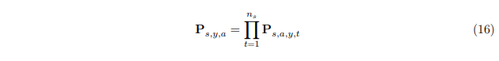

2.1.3 Fishing Mortality
𝐹 at age 𝑎 for fleet 𝑓 is calculated as a product of fully selected 𝐹 and selectivity at age for fleet 𝑓: 𝐹̃_{𝑓,𝑎} = 𝐹̃Sel_{𝑓,𝑎}. In Multi-WHAM, a fully selected total 𝐹 is the maximum of the total 𝐹 at age summed across fleets:


Note that here fleets can occur in different regions.

2.1.4 Reference Points
The fully selected total 𝐹 defined above allows the estimation a single universal 𝐹 reference point applicable to all stocks and regions. A ‘static’ SPR-based reference point is calculated by averaging all of the inputs (e.g. selectivity, natural mortality, movement, weight-at-age, maturity-at-age) over the most recent 5 model years, except for recruitment, which is averaged over all model years.
For 𝑋% SPR-based reference points, Multi-WHAM uses a Newton method to solve for the
universal 𝐹_{𝑋%} reference point:
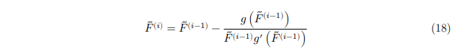where 𝑔(𝐹) is the difference between the weighted spawning biomass per recruit at 𝐹 and 𝑋% of the weighted unfished spawning biomass per recruit:
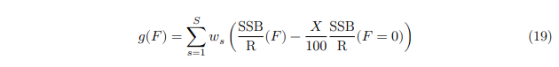
Here weights are determined by the average recruitment for different stocks:

The fully selected total 𝐹 reference point can be easily disaggregated to regional 𝐹 reference point, given the relative contribution of selectivity (𝑆𝑒𝑙) at age 𝑎 from each fleet in each region 𝑅:
It should be noted that the “regional 𝐹_{𝑋%}” calculated here does not guarantee achieving 40% of stock-specific SPR but serves to achieve 40% of SPR at the global scale. Regional 𝐹 reference points are not currently implemented, as a unique solution is not guaranteed in the presence of movement between regions.

2.2 Operating Models
Key parameters used for operating models (OMs) are listed in Table 1.
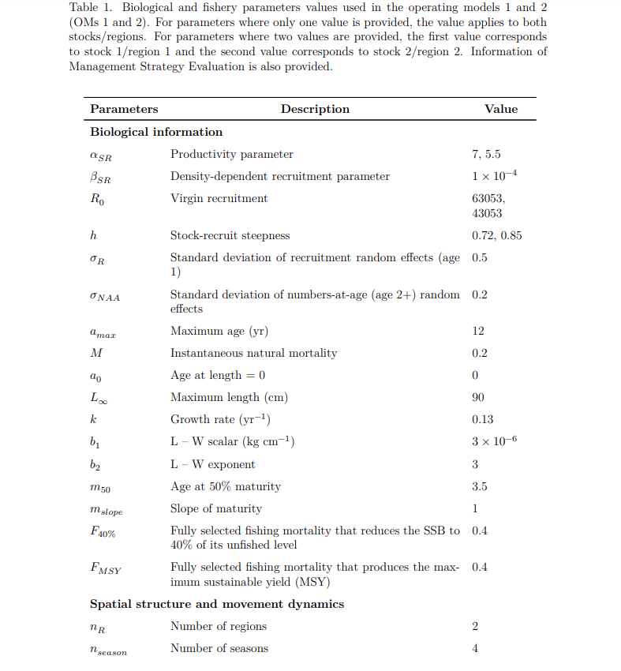
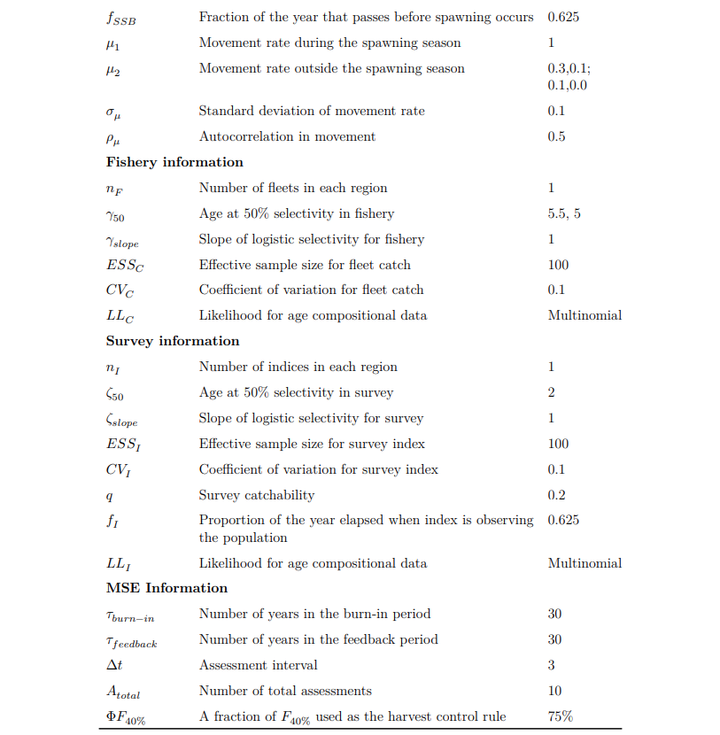

2.2.1 Biological Information
The OM, which represents the true dynamics of the system, was conditioned using parameters for fish with a medium-lived (maximum age = 12) life history (Wiedenmann et al., 2015). The spatial domain included two equal-sized regions, each inhabited by one stock. The Beverton-Holt stock-recruitment relationship was assumed for both stocks, with slightly different productivity (𝛼) parameters to create some discrepancy in biology between the two stocks. The corresponding steepness and virgin recruitment are shown in Table 1. Weight-at-age, maturity-at-age, natural mortality are assumed to be the same between the two stocks. Recruitment and NAA deviations for each stock were treated as independent random effects (i.e. IID), with standard deviation (𝜎) of 0.5 and 0.2, respectively.

2.2.2 Movement Dynamics
Four seasons (spring, summer, fall, and winter) were included in the OM to better model the natal homing dynamics. Specifically, 2 stocks with reproductive isolation exhibit natal homing migrations in the season prior to the spawning season and can migrate to other regions outside the spawning season. Two different movement scenarios were included in this study: bidirectional movement and unidirectional movement (see Figure 1). Bidirectional movement indicates that both stocks have probability to move between regions outside the spawning season. The movement rate from region 1 to region 2 was assumed to be much higher than the rate in the opposite direction, reflecting source-sink dynamics possibly driven by habitat suitability (Keymer et al., 2000). Unidirectional movement indicates that outside the spawning season (as opposed to the spawning season), stock 1 has probability to move from region 1 to region 2 and back from region 2 to region 1, whereas stock 2 cannot move between regions. This type of movement represents the movement dynamics of black sea bass. The movement rate outside the spawning season was assumed to be time-varying and treated as random effects, with a standard deviation of 0.5 and an AR1 autocorrelation coefficient of 0.5. An example of simulated movement rates can be found in Figure S1.
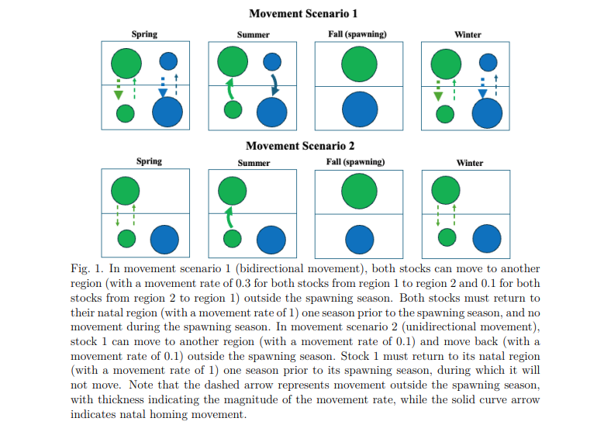

2.2.3 Fleet and Survey
A fleet was assumed to operate in each region, with logistic selectivity patterns differing slightly between the two fleets to reflect spatial heterogeneity in fleet/fishery dynamics. A survey was assumed to be conducted in each region during the spawning season to provide the most accurate index of stock-specific spawning stock biomass (𝑆𝑆𝐵). Both surveys share the same selectivity curve, with a lower 𝑎₅₀ than that of the fleet, ensuring that adequate information on young fish can be collected. A multinomial distribution with an effective sample size of 100 and a CV of 0.1 was assumed for both the fleet and survey data. Weight-at-age was assumed to be the same across stocks, regions, fleets, and surveys.

2.3 Estimation Models
Different estimation models (EMs) with varying population structures and complexities were included (Figure 2): 1. Spatially aggregated panmictic assessment model; 2. Spatially implicit (e.g. fleets-as-areas) assessment model; 3. Separate individual panmictic assessment models; 4. Spatially disaggregated assessment model; 5. Spatially explicit assessment model with movement fixed as known; 6. Spatially explicit assessment model with mean movement estimated using a prior distribution, with mean = 𝜇_{𝑇𝑟𝑢𝑒} and standard deviation = 0.5. It should be noted that in the EMs 1-3, the 𝐹 reference point (e.g. 𝐹_{40%}) and the associated harvest control rule (e.g. 𝑋%𝐹_{40%}) were calculated independently for each region; whereas in the EMs 4-6, the 𝐹 reference point (e.g. 𝐹_{40%}) and the associated harvest control rule (e.g. 𝑋%𝐹_{40%}) were global SPR-based and then dis-allocated to the regional scale (see Eq. 21). To demonstrate the utility of including NAA random effects, Each EM (EMs 1-4), with and without NAA random effects, was fit to pseudo-data. When random effects on NAA deviations were included in the EM, they were assumed to be distributed as independent and identically distributed as normal (N~IID), in log-space. All EMs modeled recruitment as N~IID random effects. Description of EM structures is shown below in Table 2.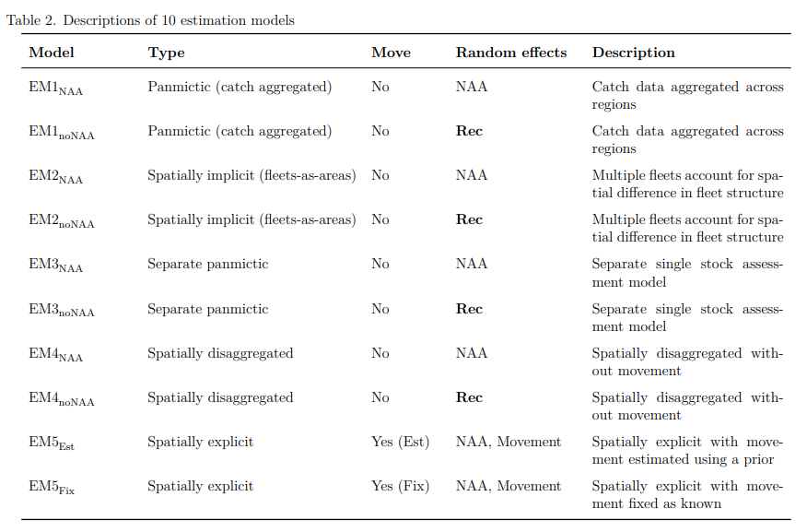
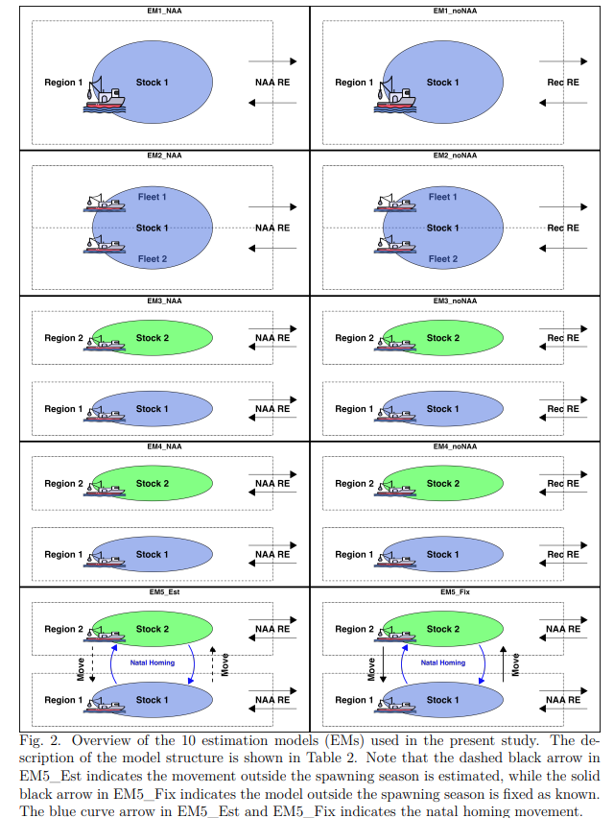

2.4 Management Strategy Evaluation (MSE)
A management strategy evaluation (MSE) was conducted to assess the performance of the EMs. A 30-year burn-in period was followed by a 30-year feedback period. Our preliminary results indicated this feedback period was sufficient to evaluate the long-term performance of the EMs. Assessments were conducted every 3 years using the last 20 years of data, resulting in 10 assessments by the end of the feedback period. Sensitivity analysis indicated marginal differences in convergence rate and parameter estimates of the EMs when the number of years of data was increased beyond 20. In the interim years between assessments, the population was projected using the average selectivity-at-age, maturity-at-age, weight-at-age, and natural mortality from the last 5 model years, and the average recruitment across all model years. In addition, for EMs with process errors (e.g. NAA, movement) treated as random effects, these stochastic processes were assumed to continue in the projection years (Stock and Miller, 2021). Target catch in those interim years, was based on a constant fishing mortality harvest control rule at 75% of 𝐹_{40%}. For EMs (i.e. EMs 4-5) using global SPR-based reference points, the weights were determined by the mean recruitment estimated from the EM. For EM 1 (i.e. spatially aggregated panmictic), the total catch target was allocated to region-specific catches using weights derived from the relative biomass catch from each survey in the terminal year of assessment (Bosley et al., 2019). For other EMs, the region-specific catch advice was automatically generated. Annual catch advice was then sequentially fed into the OM to update fishing mortality and population dynamics. This closed-loop simulation was performed iteratively until the end of the feedback period. It is possible that one or more assessment models did not converge in the course of the feedback period. When an EM failed to converge during a realization, the results of the entire realization were discarded, but a new random number seed was selected and the realization was attempted again. This process was repeated until 100 realizations were successful for elements of the study design.

2.4.1 Fishing History
Three fish histories (see Table 3) were proposed in the burn-in period: 𝐹_{𝐼}: Both stocks experience overfishing (2.5𝐹_{𝑀𝑆𝑌}) for the first 15 years and fishing at 𝐹_{𝑀𝑆𝑌} for the last 15 years; 𝐹_{𝑈}: Both stocks experience constant overfishing (2.5𝐹_{𝑀𝑆𝑌}) for the entire 30 years; 𝐹_{𝐶}: Stock 1 experiences overfishing (2.5𝐹_{𝑀𝑆𝑌}) for the first 15 years and fishing at 𝐹_{𝑀𝑆𝑌} for the last 15 years, while stock 2 follows the opposite fishing history.

2.4.2 EM Diagnostics
Performance was summarized over 100 ‘converged’ runs to ensure equal sample sizes across scenarios. Convergence rates, however, for each EM were calculated from the first 100 realizations for each scenario. Besides convergence rates, the relative difference between the baseline EM (i.e. EM_Fix) and other EMs in the estimated parameters (e.g., mean recruitment, the variances of recruitment and NAA random effects) was calculated using the 1000 ‘converged’ models (10 applications of the EM for each realization and 100 realizations).
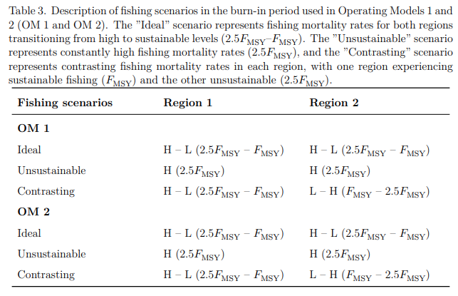

2.4.3 Performance Metrics
Short-term (first 5 years) and long-term (last 5 years) performance metrics were evaluated to quantify the performance of each management strategy (i.e. assessment model). The performance metrics at both global and regional scales include: 1. Catch; 2. 𝑆𝑆𝐵; 3. 𝐹; 4. 228 Probability of overfishing (defined as 𝐹/𝐹_{40%} > 1); 5. Probability of overfished (defined as 𝑆𝑆𝐵/𝑆𝑆𝐵_{40%} < 0.5); 6. Terminal-year stock status; 7. Average annual catch variation (defined as$AAV= \sum_{y=1}^{30}{\left|Catch\left(y\right)-Catch\left(y-1\right)\right|/\sum_{y=1}^{30}{Catch\left(y-1\right)}}$) (Kapur et al., 2024). The relative difference was calculated between the performance metrics of the ‘baseline’ EM (i.e. EM5_Fix) and other EMs, using 𝑅𝐸 = 𝐼𝑛𝑑𝑒𝑥_{𝐸𝑀𝑥}/𝐼𝑛𝑑𝑒𝑥_{𝐸𝑀5𝐹𝑖𝑥} − 1. In addition, all performance metrics at the global scale were collected to provide a holistic view of model performance under difference scenarios. Values of all performance metrics for each EM in each OM-fishing scenario were normalized to scores between 0 and 1, using Score = (𝑥 − min(𝑥))/(max(𝑥) − min(𝑥)). Note that for the relative difference in probability of overfishing, probability of overfished, overfishing status in the terminal year, and catch variation, additional adjustments were made because negative values represent better performance. Thus, the original values were multiplied by -1 before normalizing.

3 Results
EM5_Est performed similarly to the baseline EM (i.e. EM5_Fix) for most of the performance metrics presented below and performed relatively better than the other EMs. For simplicity, no further discussion of the results for EM5_Est is provided.

3.1 Parameter Estimates
Convergence rate was generally high (> 85%) for each EM across OMs and fishing scenarios (Figure S2). Only results from converged runs were summarized and presented hereafter. Total recruitment estimate from EMs 1-2 were similar to the sum of region-specific recruitment from EMs 3-4, all of which were slightly overestimated compared to the total recruitment estimated from the baseline EM (Figure S3). Estimated mean recruitment, standard deviations of recruitment and NAA random effects from EMs 1-4 appeared to adjust to account for the lack of movement process error (Figure S3).

3.2 Short-term Catch, F, SSB
In the short-term, regardless of OMs and fishing scenarios, EMs with NAA random effects, except EM1_NAA, produced median catches more similar to the baseline EM than EMs without NAA random effects (Figure 3). EMs with NAA random effects also produced smaller interquartile ranges of catch than EMs without NAA random effects (Figure 3). In additional, EMs without NAA random effects, in most cases, produced higher catch than the EMs with NAA random effects, both regionally and globally (Figure 3). Interestingly, compared to the baseline EM, a large increase of catch in region 1 and a large reduction of catch in region 2 were found when using EM1 (Figure 3). The magnitude of the relative difference in catch across EMs seemed to be magnified under high movement rate scenario with contrasting fishing history (Figure 3). Patterns of catch were similar between scenarios of ideal fishing history and unsustainable fishing history (Figure 3).
Fishing mortality (𝐹) exhibited significant changes across OM and fishing scenarios (Figure 3). Compared to the relatively similar total 𝐹 across EMs, region-specific 𝐹 showed distinct patterns depending on which EMs was used and whether or not NAA random effects were included (Figure 3). Corresponding to the pattern of catch, EM1 often produced higher 𝐹 in region 1 and lower 𝐹 in region 2 (Figure 3). In most cases, EMs without NAA random effects provided a more different 𝐹 relative to their counterparts with NAA random effects.
Spawning stock biomass (𝑆𝑆𝐵) showed marginal difference among EMs, except when using EM1 or under the scenario of high movement and contrasting fishing history (Figure 3). In most cases, 𝑆𝑆𝐵 tended to be higher for the baseline EM, compared to other EMs (Figure 3).
The spatially disaggregated EMs (EMs 3-4) with NAA random effects generally produced results more similar to the baseline EM than other EMs, and this was especially true for EM4 (Figure 3).
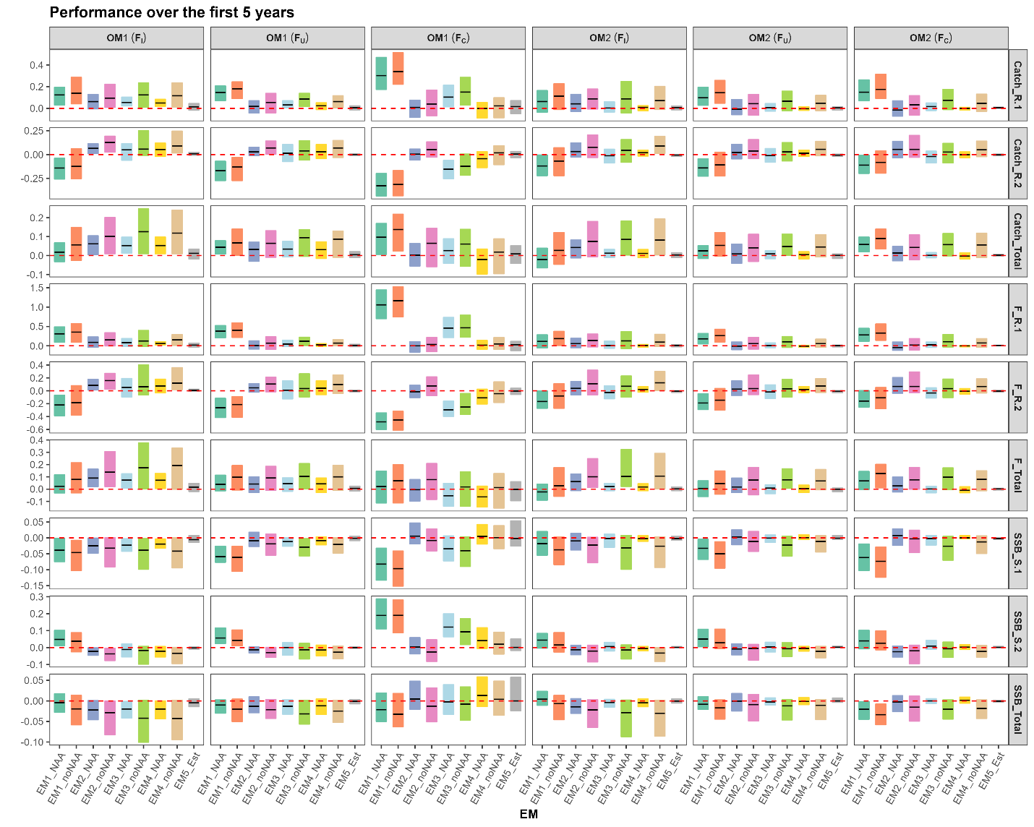
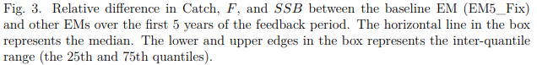

3.3 Long-term Catch, F, SSB
In the long-term, differences in catch among EMs became trivial and median catch was generally similar to the baseline EM, regardless of OMs and fishing scenarios. Variations in catch were larger for spatially aggregated EMs (EMs 1-2) (Figure 4). As with the short-term results, EMs with NAA random effects had smaller interquartile ranges than EMs without NAA random effects.
The relative difference in 𝐹 remained distinct across EMs (Figure 4). Compared to the baseline EM, the other EMs generally produced slightly higher 𝐹 under the high movement scenario and similar 𝐹 under the low movement scenario, both regionally and globally, except for EM1, which produced drastically higher 𝐹 in region 1 and lower 𝐹 in region 2 (Figure 4). No significant difference in median 𝐹 was found between EMs with and without NAA random effects, though variability in 𝐹 was larger for EMs without NAA random effects (Figure 4).
Regional and global 𝑆𝑆𝐵 differed across EMs, with the differences being larger under the high movement scenario (Figure 4). Notably, EMs without NAA random effects produced 𝑆𝑆𝐵, both regionally and globally that differed more from the baseline EM than EMs with NAA random effects (Figure 4). Spatially disaggregated EMs performed more similarly to the baseline EM than spatially aggregated EMs, and this effect was greater than the effect of including or excluding NAA random effects. The most simplified EM (i.e. EM1) with NAA random effects had similar total 𝑆𝑆𝐵 to the baseline EM, despite a decrease of 𝑆𝑆𝐵 in region 1 and an increase of 𝑆𝑆𝐵 in region 2 (Figure 4).
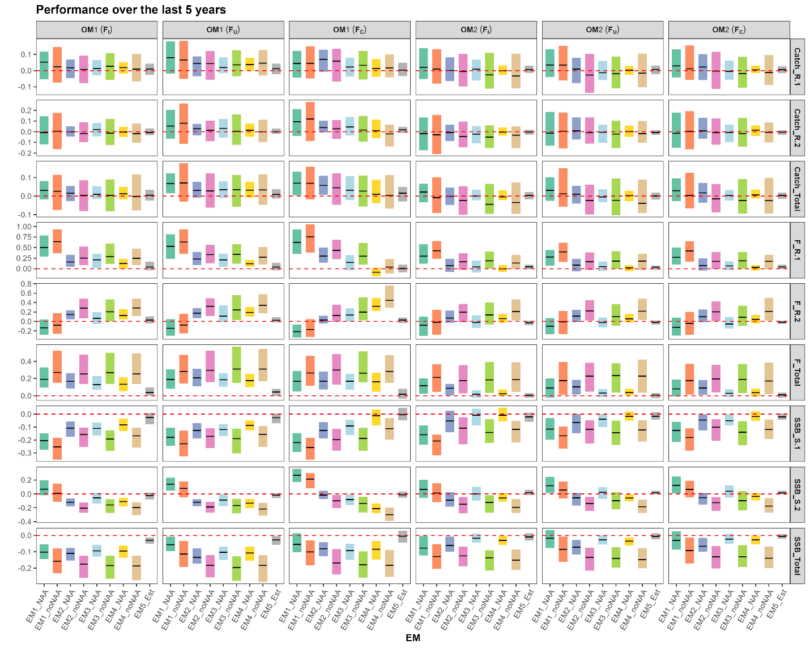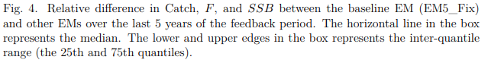

3.4 Probability of Overfished and Overfishing
In most cases, all EMs performed relatively well in preventing the stock from being overfished (Figure 5). In contrast, EMs showed different performance in preventing the stock from experiencing overfishing (Figure 5). For example, using EMs without NAA random effects were more likely to result in overfishing, compared to their counterparts with NAA random effects (Figure 5). All EMs with NAA random effects performed similarly and had a higher probability of overfishing than the baseline EM (Figure 5).
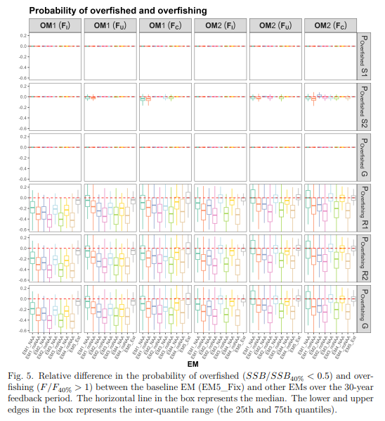

3.5 Terminal-year Stock Status
In all cases, the population in the terminal year for the baseline EM was not overfished and overfishing was not occurring (Figure 6). Using the EMs without NAA random effects mostly led to overfishing status in the terminal year; EMs with NAA random effects in contrast, performed well in preventing population from overfishing (Figure 6). The largest discrepancy among EMs in population status in the terminal year was observed in the scenario with high 310 movement and an unsustainable fishing history (Figure 6).
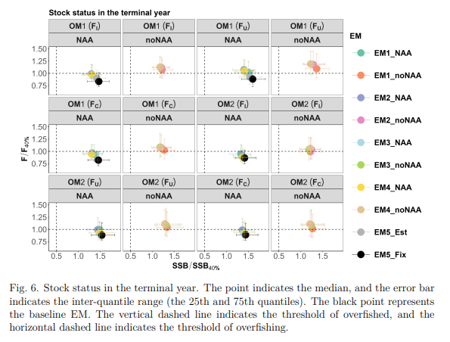

3.6 Average Annual Catch Variation
At the regional scale, relatively high annual catch variation occurred when using EM1 and EM3, regardless of the inclusion of NAA random effects (Figure 7). Interestingly, EM2 performed slightly better than EMs 4-5, by providing lower annual catch variation (Figure 7). EMs with NAA random effects had less annual catch variation than EMs without NAA random effects (see EMs 2-4, Figure 7). Annual catch variation at the global scale appeared similar across those EMs with NAA random effects, regardless of OMs and fishing histories (Figure 7).
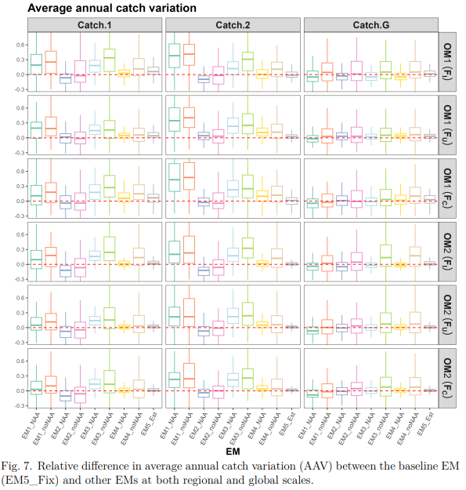

3.7 Relative Difference in Annual Catch
The relative difference in annual catch over the 30-year feedback period was plotted to highlight potential trends in the relative performance of each EM. A large discrepancy in total catch among EMs was observed during the first ~10 years, and the EMs, particularly the EMs with NAA random effects, tended to perform more similarly to the baseline EM as time progressed (Figure 8). A similar trend was also observed at the regional scale (Figure S4 and Figure S5).
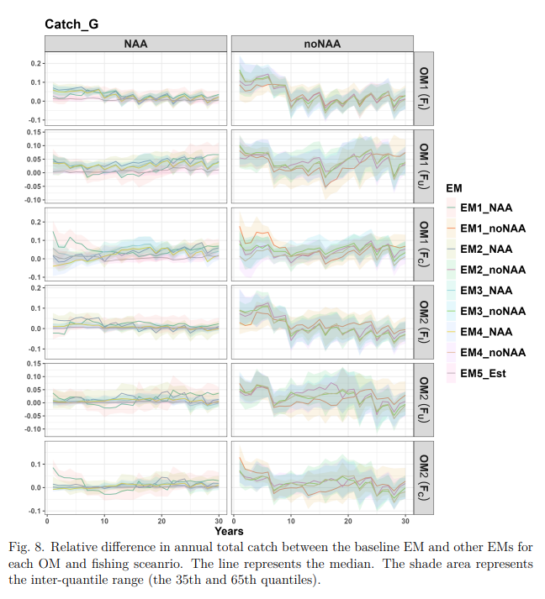

3.8 Relative Difference in Annual SSB
In most cases, relative difference in annual 𝑆𝑆𝐵, both at the global (Figure 9) and regional scales (Figure S6 & Figure S7), seemed to diverge from zero as time progressed. Notably, including NAA random effects in the EM showed potential to preserve 𝑆𝑆𝐵 at both global (Figure 9) and regional (Figure S6 & Figure S7) scales, compared to the EMs without NAA random effects; however, the extent to which 𝑆𝑆𝐵 was preserved was limited and depended on the movement rate and fishing history.
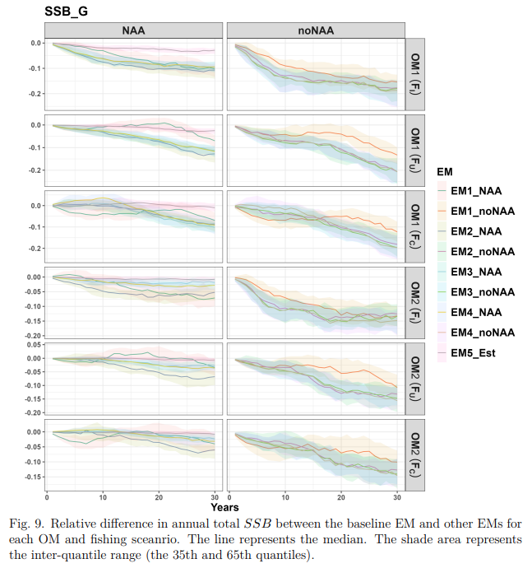

3.9 Holistic View of Performance
The global-based performance metrics were collected to provide a holistic view of model performance under difference movement dynamics and fishing scenarios. It is clear that EMs with NAA random effects outperformed their counterparts without NAA random effects (Figure 10). EM4_NAA performed relatively better than other EMs in most cases (Figure 10). EM1_NAA, though performed undesirably at the regional scale (as shown before), appeared to perform reasonably well at the global scale (Figure 10). Interestingly, EM3_noNAA and EM4_noNAA performed the worst in most scenarios (Figure 10).
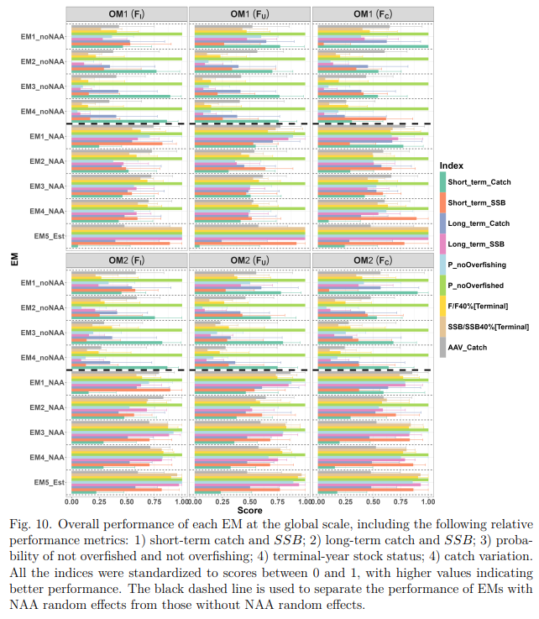

4 Discussion
Traditional fish stock assessments are typically based on the assumption that fish biology and local fish pressure are homogeneously distributed. Stock assessment models that stands on this “panmictic” assumption may still perform adequately in achieving management goals if the method for spatial quota allocation is appropriately applied (Bosley et al., 2019). Another alternative is the “fleets-as-areas” (also known as “areas-as-fleets”) approach, which includes multiple harvest units (e.g. fleets) to implicitly account for spatial dynamics (Punt, 2019). Spatially explicit models is often more desirable but also requires intensive data collection especially as spatial resolution increases, and as a result, which limits their application in real-world scenarios (Goethel et al., 2021). There is an increasing need in current fisheries management to seek a more cost-effective way to balance the trade-off between increased uncertainty due to data limitations and overparameterization, and decreased precision in estimates of management quantities from ignoring biological realism, especially as climate-driven distributional shifts are likely to intensify in the future.
Modern advances in population modeling techniques, particularly the application of state-space models, offers remarkable flexibility to model different process errors as random effects separable from observation error, which better reflect the underlying population dynamics (Nielsen and Berg, 2014). This, in turn, provides a way to circumvent the direct estimation of movement processes by allocating movement process error to other process errors, such as NAA random effects, as an alternative. Theoretically, using NAA random effects to account for unknown movement dynamics is feasible (Cadigan, 2016), and it is also practically feasible since NAA random effects have been shown to serve as a “catch-all” for absorbing errors from other confounding processes (Li et al., 2024).
The present study explored the utility of including NAA random effects into state-space assessment models, with increasing model complexity (panmictic, spatially implicit, spatially explicit), to identify the ‘best practice’ approaches for achieving management objectives under various scenarios of movement dynamics and historical fishing pressure. Our overall findings confirmed that management outcomes generally improved when NAA random effects were included, whereas excluding them from the assessment models led to undesirable discrepancies and increased variability in outcomes compared to the baseline, both regionally and globally. Although including NAA random effects shows some potential in addressing movement dynamics, it has limited ability to achieve desirable management outcomes under high rates of fish movement, particularly in the face of large spatial difference in fishing history (i.e. contrasting fishing history) which further complicates the spatial difference in population dynamics.
In the short-term, the relative performance among the EMs with NAA random effects improved as model complexity increased. EM1_NAA produced higher 𝐹 and catch in region 1, and lower 𝐹 and catch in region 2. This discrepancy between regions was more pronounced under contrasting fishing histories with high levels of movement, leading to over 100% higher 𝐹 and catch in region 1, and over 50% lower 𝐹 and catch in region 2, compared to the baseline. Consequently, 𝑆𝑆𝐵 decreased in region 1 and increased in region 2, though the changes in 𝑆𝑆𝐵 were relatively smaller in magnitude compared to those in 𝐹 and catch. Despite the large variability, these contrasting directional changes in catch, 𝐹, and 𝑆𝑆𝐵 counteracted each other, resulting in the medians similar to those of the baseline EM. Assessment models with NAA random effects that are spatially implicit (i.e. EM2_NAA) or spatially explicit (i.e. EM3_NAA and EM4_NAA) generally produced median short-term catch, 𝐹, and 𝑆𝑆𝐵 with less than 10% difference compared to the baseline, although variability remained relatively high. It should be noted that the “fleets-as-areas” model with NAA random effects (i.e. EM2_NAA) performed reasonably well in short-term catch, 𝐹, and 𝑆𝑆𝐵 across all cases and even outperformed the spatial explicit models at the regional scale under high levels of movement and contrasting fishing histories.
In the long term, no evident improvement in the performance of catch, 𝐹, and 𝑆𝑆𝐵 was found among EMs with NAA random effects (except for EM1_NAA), as the assessment model became more complex. Regional and global catch became relatively stable regardless of the assessment model used. However, the substantial variation of catch produced by EM1_NAA still suggests a high degree of uncertainty when totally ignoring spatial structure in the assessment model. Consistently high 𝐹 was observed for all EMs in both regions, indicating ongoing overharvesting at the end of the feedback period, though the response of 𝑆𝑆𝐵 to this high 𝐹 differed between the two regions across the assessment models. Specifically, the relative difference in 𝑆𝑆𝐵 in Region 1 increased from -25% to a range of -10% to 0% (compared to the baseline) as model complexity increased, while 𝑆𝑆𝐵 in Region 2 decreased from 25% to a range of 0% to 10%. EMs with NAA random effects showed great potential for maintaining catch and reducing catch variability at both regional and global scales. However, a drawback of these models was the potential for higher-than-baseline 𝐹, which had a strong impact on regional 𝑆𝑆𝐵. At the global scale, EMs with NAA random effects best maintained total 𝑆𝑆𝐵 under low levels of movement, yet resulted in slightly lower 𝑆𝑆𝐵 (~10%) under high levels of movement.
Regarding the probability of overfished and overfishing, all EMs (including those without NAA random effects) performed relatively well in preventing the stock from becoming overfished, but they differed in their ability to avoid overfishing. EMs without NAA random effects posed a higher risk of overfishing compared to those with NAA random effects. Interestingly, EM1_NAA, despite having the simplest model structure, exhibited the highest probability (compared to EMs 1-4 with NAA) of avoiding both regional and global overfishing. The relative performance of EM3_NAA and EM4_NAA was similar, providing a reasonably low probability of overfishing. This suggests that empirical regional SPR-based reference points perform similarly to global SPR-based reference points and are both effective in preventing overfishing and overfished. Notably, there was no evidence that the probability of overfishing was influenced by levels of movement and historical local fishing pressure.
A potential high risk of overfishing in the terminal year was identified, particularly when NAA random effects were not included in the assessment model. EMs with NAA random effects generally remained near or below the overfishing threshold, depending on the complexity of the model structure. The higher-than-baseline 𝐹 observed in some EMs did not always result in overfishing in the terminal year, likely due to the precautionary buffer provided by the harvest control rule used in this study (75% of 𝐹_{40%}) (Reason, Ref?). Notably, none of the EMs, including those without NAA random effects, experienced overfished at the global scale. Similar results were also reported in (Reason, Ref?).
Inter-annual variation in catch at both regional and global scales plays an important role in decision-making. An extraordinarily low inter-annual catch variation was observed at both scales when using the fleets-as-areas approach, even compared to the baseline EM (ranging from -20% to 0%). This likely benefits from the selectivity pattern of each fleet was modeled independently to account for the variation of fishery selectivity between regions. In addition, the catch from EM2 was based on independent region-specific 𝐹 reference points (compared to global-based 𝐹 reference points) that helped stabilize the regional catch. Excluding NAA random effects did not directly increase catch variation but instead introduced uncertainty into the inter-annual catch variation. EM4_NAA exhibited almost identical inter-annual catch variation as the baseline EM.
The relative difference in annual catch and 𝑆𝑆𝐵 over the 30-year feedback period highlighted potential trends in the relative performance of each EM. We found that relative difference in annual catch, regardless of which EM was used, tended to stabilize at the global scale and produced similar catch to the baseline catch after 10 years in the feedback period. By contrast, the trend in the relative difference in annual 𝑆𝑆𝐵 varied depending on the management strategy used and whether NAA random effects were included. In most cases, a worsening trend in 𝑆𝑆𝐵 was observed at both regional and global scales as time progressed and movement rates increased. However, it is also important to note that including NAA random effects (even EM1_NAA) effectively slowed this worsening trend and helped preserve 𝑆𝑆𝐵 in the long term.
For fisheries management where a global scale management is more practical than regional management, the holistic view of global-based performance metrics is more desirable. Our results indicated that EM4_NAA (spatially explicit with NAA random effects), using global SPR-based reference points to inform harvest control rules, generally performed satisfactorily at both regional and global scales. EM1_NAA (simplest panmictic with NAA random effects) performed reasonably well at the global scale—if global considerations are more important—though localized overexploitation and stock depletion may occur in the long term, as demonstrated in Cope and Punt (2011). Evidence has shown that panmictic models can perform well compared to a spatial model, especially when there is low spatial heterogeneity or data limitations make spatially explicit modeling difficult (Ref?). While EM2_NAA (spatially implicit with NAA random effects) did not perform the best in most cases, it provided more stable regional catch and, to some extent, balanced the management outcomes at both regional and global scales. However, we note that the performance of the fleets-as-areas approach is highly dependent on data quality and quantity (Cope and Punt, 2011), which partly explains the relatively well performance of EM2_NAA, given the high quality of our fleet catch data (e.g. low observation error, time of survey matched with the spawning season).
Our results demonstrated that estimating movement in spatial state-space assessment models by treating movement as random effects with a prior could be a potential solution to address complex movement dynamics, as reflected by improved accuracy in parameter estimation and promising management outcomes compared to strategies without movement included. However, this approach may require strong prior information about underlying movement, which is often unavailable due to the scarcity of tagging, genetic, or stable isotope data. Although testing the effects of prior distribution on movement parameter estimation is beyond the scope of the present study, we recommend that future research further investigate the sensitivity of model performance to different qualities of prior information in movement estimation.
Some caveats in the present study should be mentioned. First, in our study all fish were assumed reproductive isolation and exhibit natal homing spawning migration (with a probability of 100%), which provided the best chance for the survey (conducted during the spawning season) to collect the information of stock-specific 𝑆𝑆𝐵. Thus, mismatch in timing of the survey and the spawning season is likely to affect the utility of NAA random effects. Second, in our study, the movement rate was assumed to be the same across all ages. While ontogenetic (age-specific) movement may be more biologically meaningful (Waterhouse et al., 2014; Hanselman et al., 2015), it remains unclear whether a more complex structure of NAA random effects (e.g., age-varying) could adequately address this. Thus, further investigation is of need to determine the broader applicability of NAA random effects in handling different movement scenarios. Third, in our study, fish biology (stock-recruitment relationship) and fleet characteristics (e.g., fishing selectivity) were assumed to be slightly different. However, the relative impacts of these discrepancies on model performance, both with and without NAA random effects, remain unclear and warrant further investigation. Fourth, relatively well management outcomes in our study may benefit from the high resilience of stock-recruitment relationships assumed for both stocks. All in all, our simulation likely represents a best case scenario while reality is expected to be more complex than the simulation here, which may improve or degrade some “pros” of using NAA random effects.
While claims have been made that NAA random effects can account for other processes, including movement, this study found that NAA random effects outperformed their counterparts without NAA random effects but could not fully account for movement dynamics, particularly under high levels of movement. Thus, NAA random effects are not a panacea, and explicitly modeling movement dynamics is preferred. Several simulation-estimation studies have shown that including NAA random effects leads to more accurate stock assessments and management-relevant estimates (e.g., overfished status). The results of this study add to the growing body of literature suggesting that incorporating NAA random effects should be the default starting point in spatial state-space stock assessments.

5 Acknowledgements
This work was funded by NOAA Fisheries Northeast Fisheries Science Center.

6 Supplementary files
