Reply Letter to the Reviewers’ Comments

Title: **Maximizing Spatial-temporal Coverage in Mobile Crowd-Sensing Based on Public Transports with Predictable Trajectory**

**ID: DSN-18-0074.R1**

**-------------------------------------**

Dear Editor and Reviewer(s),

Thank you for your notification and the reviewers’ comments on our manuscript entitled **“Maximizing Spatial-temporal Coverage in Mobile Crowd-Sensing Based on Public Transports with Predictable Trajectory”.** Firstly, we wish to express our appreciation to the editor for assigning our article to such professional reviewers and giving us an opportunity to revise the manuscript. Furthermore, we are very grateful for the reviewers’ valuable questions and constructive suggestions on our paper. Your timely advices are helpful and illuminating to us. Accordingly, we have revised the manuscript in which all the changes are highlighted.

Based on the reviewers’ comments, we have tried our best to address the concerns and make appropriate corrections and clarifications through this reply letter. The concerns are highlighted in **bold**. For each reply, we also marked the key points in **bold** to **emphasize our response** and **guide modifications in the manuscript**. Details to the comments are appended to this letter.  
 We will be so honored if the revised manuscript can be accepted for publication in International Journal of Distributed Sensor Networks.

Thanks again!

Yours Sincerely,  
Chaowei Wang  
E-mail: wangchaowei@bupt.edu.cn

**Reviewer: 1**

**Comments:**

1. **What do you mean with the limited budget of CMP? Budget in terms of**

**what? Please elaborate more**

**R:**

Thank you for your meaningful comments. The budget is the total cost of a task initiators which can afford to CMP. On the one hand, modern crowd-sensing application are not only initiated by data centers deployed for large corporations, like Google, Alibaba and public security department, but also from individuals. It is affordable for large corporations to select all participants to carry out task, but the ordinary users can’t. So it is necessary to introduce a limited budget to restrict the number of participants. On the other hand, because nearby PTs usually sense similar information. If we select all PTs to carry out crowd-sensing task, it may introduce redundancy since only one PT is sufficient to conduct the task. In order to avoid redundancy, the limited budget is also important. In this paper, a PT who is selected to participant in crowd-sensing gains a sensing reward which is decided through online-bidding [30] from CMP. The equation (9) of manuscript, the limited budget, is the constraint condition of objective function. The detail are given **in the 2nd paragraph of Introduction and** in **the 2nd paragraph in the *subsection* A of Section III.**

[30] Yang D, Xue G, Fang X, et al. “Incentive mechanisms for crowd-sensing: crowdsourcing with smartphones,” *IEEE/ACM Transactions on Networking*, 2016, 24(3): 1732-1744.

1. **There are multiple errors in the text that should be corrected (e.g., trajectroy and others).**

**R:**

We are sorry for our defective expression. We have checked the expressions throughout the manuscript and corrected the grammatical mistakes, acronyms, possible typos, and incorrect forms of variables. All the changes are highlighted **in the “Supplemental File for Review.pdf”.**

1. **Each cell of the trajectory matrix is a GPS location or a trajectory, i.e., a set of GPS locations or the IDs of segments? If the former case is true, how the union operator is applied in Eq(5) and what it offers to your calculations? The use of sums and unions in Eq(5) is not clear? Are we talking about numbers or other type of data? (Q3 and Q5)**

**R:**

Thanks for your meaningful comments and we all highly praise your professionalism. In this paper, the trajectory matrix is a GPS location. As Fig.1 shown, an example to explain the meaning of equation (5). According to the system model, we divide the region into small segments, $R=\{AB, AC, AD, AE\}$. The period of time $T=\{t_{1},t_{2},t_{3}\}$. The trajectory matrix of PTs is:

$$L\left(V\right)=\left[\begin{matrix}l_{1}(t_{1}) & l_{1}(t_{2}) & l_{1}(t_{3}) \\ l_{2}(t_{1}) & l_{2}(t_{2}) & l_{2}(t_{3})\end{matrix}\right]$$

Clearly, $\left\{l_{1}\left(t_{1}\right),l_{1}\left(t_{2}\right)\right\}⊆AB, \left\{l_{2}\left(t_{1}\right),l_{2}\left(t_{2}\right)\right\}⊆AC and \{l_{1}\left(t_{3}\right),l_{2}(t_{3})\}⊆AD$, so the $L\left(V\right)$ can be rewritten as:

$$L\left(V\right)=\left[\begin{matrix}AB & AB & AD \\ AC & AC & AD\end{matrix}\right]$$

If we are able to select PT-1 and PT-2 to carry out crowd-sensing task. So

C:\Users\17336\AppData\Local\Packages\Microsoft.MicrosoftEdge_8wekyb3d8bbwe\TempState\Downloads\CodeCogsEqn (1).gif

We have introduced the priority power to state the importance degrees at different segments and time. So the $\{AB, AC, AD\}$ correspond to a value at different time and location, respectively, which can be calculate by equation (10) and equation (11).

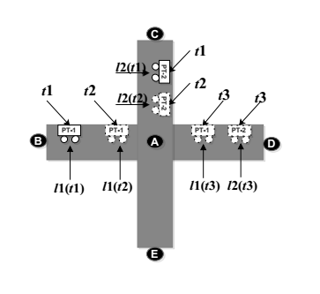

**Fig. 1**

The definition of STC is formulated as equation (5), which is the objective function of the SPTs. In order to achieve a maximum STC with limited budget, we need to select an optimal set of PTs to carry out crowd-sensing according to the trajectories of all PTs. Each PT equipped with a specific hardware system we have designed in reference [23] can collect various of data, such as temperature, humidity, video, etc. The hardware system as Fig. 2.

[23] Kang L, Poslad S, Wang W, et al. “A Public Transport Bus as a Flexible Mobile Smart Environment Sensing Platform for IoT,” *International* *Conference on Intelligent Environments*, 2016.

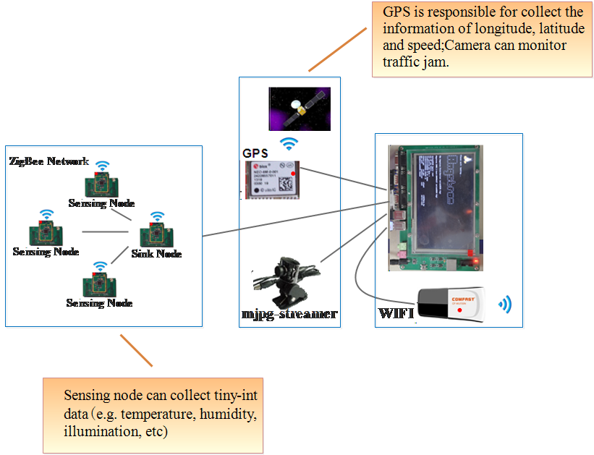

**Fig.2**

1. **For the trajectories of the vehicles you adopt a sliding window approach for filling table L? Please elaborate more.**

**R:**

Thanks for your professional comment. In this paper, the table L is actually the matrix L(V) as equation (1), which represents the trajectories of PTs. For instance, $\{l_{1}\left(t_{1}\right), l_{1}\left(t_{2}\right), l_{1}\left(t_{3}\right),…,l_{1}\left(t_{m}\right)\}$ is the trajectories of $v_{1}$. Due to the trajectories of PTs is scheduled, so the specific location at different time is known. We have make use of the T-Driver dataset to fill with the table L. But it is undeniable that exists some errors. In the future work, we plan to apply the machine learning or deep learning to predict the specific location at any time to improve the deficiencies of this manuscript.

1. **The statement 'We hope that the solution of SPTs ....' is not completed and acceptable. The intro 'we hope' means that you don't have the solution?**

**R:**

According to your suggestion, we have revised the above defective expression in this manuscript of **the 3rd paragraph in the *subsection* B of Section III.** We have replaced the statement ‘We hope that the solution of SPTs…’ by ‘As a practical matter, it is crucial to select an optimal set of PTs to conduct task with time efficient. Unfortunately …’.

**Reviewer: 3**

1. **The revised journal is consistent in writing and contains the necessary information to follow the idea. However, I advise the authors to read over the Journal again to eliminate some typing errors.**

**R:**

Thanks for your meaningful suggestion. We have checked the expressions throughout the manuscript and corrected the grammatical mistakes, acronyms, possible typos, and incorrect forms of variables. All the changes are highlighted **in the “Supplemental File for Review.pdf”.**