# Response to reviewers

## Reviewer 1

Thank you for the opportunity to review the paper "Supervised learning technique for the automated identification of white matter hyperintensities in traumatic brain injury". In this study, the authors present a machine learning algorithm for automated segmentation of white matter hyperintensities, a form of white matter degeneration visible in FLAIR-MRI that is observed in a wide range of clinical syndromes, and even in healthy controls. The method proposed by the authors relies on training random forests to learn the relationship between voxel intensities in a set of feature images derived from multimodal MRI (T1, T2, FLAIR) and lesions drawn manually by an expert. Since the method uses examples to learn what constitutes a lesion, this is correctly considered a supervised method. The method is applied on a set of 24 patients with clinically confirmed traumatic brain injury, and results are obtained with a leave-one-out cross validation.

Overall, the method proposed by the authors is innovative and thoughtful, and has great potential for bridging the gap between research findings and clinical needs. The method uses a series of cutting edge solutions to the segmentation problem: (1) multimodal imaging inputs, which is known to increase segmentation accuracy, (2) random forests, which are an excellent tool for finding multivariate nonlinear relationships, (3) voxel neighborhood information, which provide contextual information for each voxel, and (4) an algorithm that improves the segmentation in stages. However, the manuscript itself, to my opinion, is not well focused and needs significant improvement. Below are my specific comments in support of this.

Major comments:

1. The biggest issue I had while reading the manuscript is the lack of a coherent theme of what this paper is about. The authors span their exposé from multiple sclerosis to the automobile industry, without stating why these links to other diseases (or industries) have any relevance. It appears in some parts that the closest disease with similar white matter lesions is multiple sclerosis, but this is not clearly stated, nor the two types of lesions are compared. It is, therefore, unclear why counting how many MS lesion segmentation methods are publicly available is of any importance. When explaining methods, the authors mention the utility of support vector machines, or the existence of a python package called SciPy. Yet, it is unclear why these things have any importance, unless the authors make connections to their topic/method.
2. Second, the manuscript has no results. All the results section is focused on talking about feature ranking, which by the way is explained in the Results section instead of the Methods section. The most important results (the prediction accuracy of automated segmentation), are not mentioned in the manuscript but are only plotted in Figure 7. My advice is to put the focus of the results section on accuracy, i.e., give precise dice values and perhaps add other measures (metric displacement, Hausdorf distance, sensitivity, specificity, etc.). Also, the gain in accuracy from stage 1 to stage 2 cannot be guessed by looking at a plot, the authors must provide a statistical comparison. When investigating accuracy, the error in lesion size should be reported, both in terms of volume and in terms of individual lesions counts (i.e. out of 10 lesions 9 were found, 1 was missed, etc.). This information is crucial to clinicians, if the authors foresee the use of the method in a clinical setting, as it seems from the discussion. Beside adding results to the manuscript, it is equally important to give some results in the abstract. The abstract must be self-sufficient in reporting all the major points of the paper.
3. Third, there is no information about the manual lesion tracing procedure. Were lesion drawn on FLAIR or were other modalities used as well? If FLAIR was used as reference it is not surprising that FLAIR emerges as one of the top predictive modalities.

[1] [2]

Descriptive statistics on the lesions are also necessary: how big were the lesions, how many lesions were found in each patient (the range 1-20 is not sufficiently informative), where were the lesions located? This information helps understand why, for example, brain stem or cerebellum labels were not that important for achieving good lesion predictions.

1. Fourth, although the authors claim the method is available, I couldn't find any link for the public. Note, it would be equally important if the publication of the method online is associated with proper documentation on how a new (naive) user can apply it.

Minor comments:

1. In the abstract, the authors mention the creation of tailored features for segmenting WMHs. My understanding is that the method proposed by the authors has no tailoring (if we think of tailoring as custom cutting to WMH needs).

There was no feature selection process all the features were included as predictors.

A similar pitfall if found on pg. 6 ln 56, where the manuscript reads ``Crucial to these supervised segmentation approaches are the creation and selection of features as input in conjunction with expertly identified structures.'' What are the structures identified by the expert in this study?

1. The methods section is very confusing. The section "Feature images for WMH segmentation" starts with no explanation of what is Stage 1. The logical flow would require template registration explained first, and all feature computation performed later, and finally RF stages can be explained with the available features.

[3] [4], [5] [6]

The pipeline also seem to be repetitive, the N4 correction is mentioned in ln. 26 and then again in ln. 43, which sounds like it was performed twice. Tissue segmentation is mentioned in ln. 39, then it is stated is a Bayesian method (ln 45), and then it is referred to as Atropos in the next page.

[3] [7] [4] [5]

It is unclear what is ``the first set of images'' in pg. 9, or if there is a second set.

Also, mathematical formulas seem superfluous, particularly since it takes more space to explain the formula than to say in plain English that transformation matrices were applied to bring subject's images in template space.

1. Random forests are explained in a way that can be understood only by readers who already know how they work; a new reader (especially a clinician) would not be able to understand the method. For example, data pushed onto a tree is does not mean much, unless the reader knows what is an identification tree.

[8, 9] [10, 11]. [12]

1. The relationship between WMH and GOS-E is mentioned in pg. 2 but the reader is not informed what is GOS-E. A similar issue is met few lines after, where the ``outcome'' is mentioned, but there is no information what is referred to as outcome.

[13]

[13]

1. In pg. 3 the authors propose that automated methods ``may allow for identification of correlative patterns between WMH number, volume, distribution, and disease state''. Some of these correlations have been already identified in the literature, as the authors mention few lines before. Moreover, the authors do not report number, volume, or distribution of the lesions, to back up the utility of their method in this regard.
2. In pg. 4 ln 43, reads that the data is ``constructed.'' I don't think this is the right verb.

A similar issue is in pg 5 ln 52 where it is stated that ``feature images consisted of 26 subjects.'' It is not ethical to consider participants as feature images.

1. It is unclear to me the meaning of the sentence: ``Since the inverse transform is also derived as part of the registration process, we can warp the voxel index locations back to the space of the individual subject which motivates similar work by others [43].''

[14] [15] [16].

1. Why was Stage 1 segmentation based only on T1, while Stage 2 segmentation was based on multivariate segmentation using all three modalities?
2. Similar to the feature ranking method, which is explain in Results, Dice is also explained in Results.

Also, it is unclear why finding which direction of space is informative for the segmentation process would be a ``sanity check.''

1. The discussion starts with an ``intent to further refine the proposed paradigm,'' and proceeds by mentioning other work currently being performed which looks promising. The opening of the discussion with such statements truly make the manuscript sound like an incomplete effort that is not ready for publication.
2. The discussion also spends several paragraphs on defining literature that shows how WMHs are related to cognitive performance, or how WMHs can be applied in diagnosing TBI. Yet, this study makes no effort to test these efforts in these 24 patients. Consequently, those paragraphs sound wishful and speculative. Given the methodological nature of this paper, a more appropriate discussion would perhaps focus on the comparison with other methods in terms of accuracy, similarities, differences, etc.

## Reviewer: 2

Interesting paper which offers those without a current background in state-of-the-art brain analysis tools. A good introduction to their capabilities.

1. However the authors do little to establish clinical utility of the algorithm.
2. A graphical description of the pipeline would help most readers to understand how this might get into the clinic.

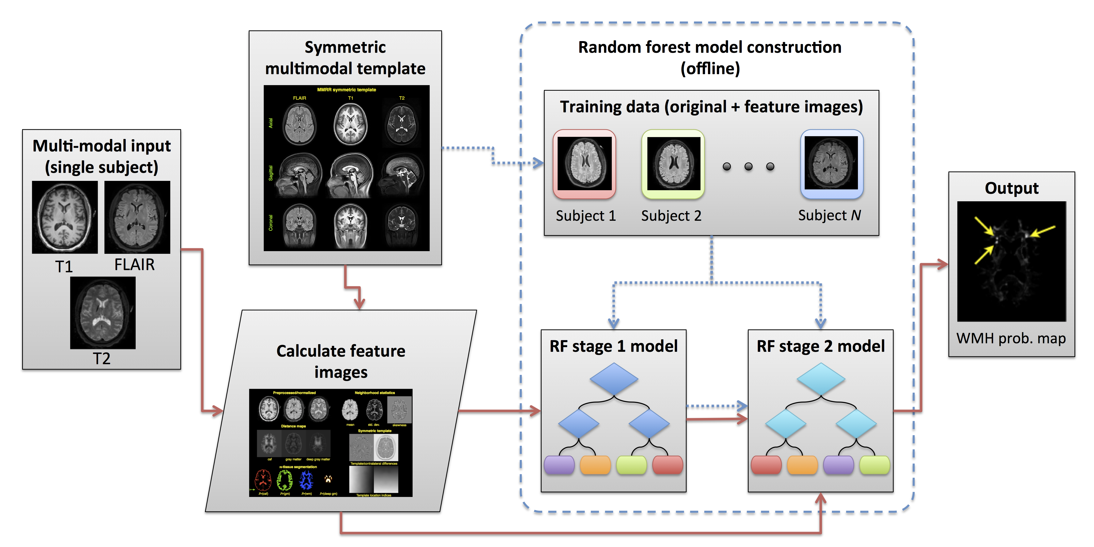

## References

1. Avants, B. B., Tustison, N. J., Stauffer, M., Song, G., Wu, B., and Gee, J. C. “**The Insight ToolKit Image Registration Framework**” *Front Neuroinform* 8, (2014): 44. doi:[10.3389/fninf.2014.00044](https://doi.org/10.3389/fninf.2014.00044)

2. Yushkevich, P. A., Piven, J., Hazlett, H. C., Smith, R. G., Ho, S., Gee, J. C., and Gerig, G. “**User-Guided 3D Active Contour Segmentation of Anatomical Structures: Significantly Improved Efficiency and Reliability**” *Neuroimage* 31, no. 3 (2006): 1116–28. doi:[10.1016/j.neuroimage.2006.01.015](https://doi.org/10.1016/j.neuroimage.2006.01.015)

3. Tustison, N. J., Cook, P. A., Klein, A., Song, G., Das, S. R., Duda, J. T., Kandel, B. M., Strien, N. van, Stone, J. R., Gee, J. C., and Avants, B. B. “**Large-Scale Evaluation of ANTs and FreeSurfer Cortical Thickness Measurements**” *Neuroimage* 99, (2014): 166–79. doi:[10.1016/j.neuroimage.2014.05.044](https://doi.org/10.1016/j.neuroimage.2014.05.044)

4. Tustison, N. J., Shrinidhi, K. L., Wintermark, M., Durst, C. R., Kandel, B. M., Gee, J. C., Grossman, M. C., and Avants, B. B. “**Optimal Symmetric Multimodal Templates and Concatenated Random Forests for Supervised Brain Tumor Segmentation (Simplified) with ANTsR**” *Neuroinformatics* 13, no. 2 (2015): 209–25. doi:[10.1007/s12021-014-9245-2](https://doi.org/10.1007/s12021-014-9245-2)

5. Landman, B. A., Huang, A. J., Gifford, A., Vikram, D. S., Lim, I. A. L., Farrell, J. A. D., Bogovic, J. A., Hua, J., Chen, M., Jarso, S., Smith, S. A., Joel, S., Mori, S., Pekar, J. J., Barker, P. B., Prince, J. L., and Zijl, P. C. M. van. “**Multi-Parametric Neuroimaging Reproducibility: A 3-T Resource Study**” *Neuroimage* 54, no. 4 (2011): 2854–66. doi:[10.1016/j.neuroimage.2010.11.047](https://doi.org/10.1016/j.neuroimage.2010.11.047)

6. Avants, B. B., Yushkevich, P., Pluta, J., Minkoff, D., Korczykowski, M., Detre, J., and Gee, J. C. “**The Optimal Template Effect in Hippocampus Studies of Diseased Populations**” *Neuroimage* 49, no. 3 (2010): 2457–66. doi:[10.1016/j.neuroimage.2009.09.062](https://doi.org/10.1016/j.neuroimage.2009.09.062)

7. Avants, B. B., Tustison, N. J., Wu, J., Cook, P. A., and Gee, J. C. “**An Open Source Multivariate Framework for -Tissue Segmentation with Evaluation on Public Data**” *Neuroinformatics* 9, no. 4 (2011): 381–400. doi:[10.1007/s12021-011-9109-y](https://doi.org/10.1007/s12021-011-9109-y)

8. Schapire, R. “**The Strength of Weak Learnability**” *Machine Learning* 5, (1990): 197–227.

9. Freund, Y. and Schapire, R. “**A Decision-Theoretic Generalization of on-Line Learning and an Application to Boosting**” *Journal of Computer and System Sciences* 55, (1997): 119–139.

10. Ho, T. K. “**Random Decision Forests**” *Document analysis and recognition, 1995., proceedings of the third international conference on* 1, (1995): 278–282 vol.1. doi:[10.1109/ICDAR.1995.598994](https://doi.org/10.1109/ICDAR.1995.598994)

11. Amit, Y. and Geman, D. “**Shape Quantization and Recognition with Randomized Trees**” *Neural Computation* 9, (1997): 1545–1588.

12. Breiman, L. “**Random Forests**” *Machine learning* (2001): 5–32.

13. Moen, K. G., Brezova, V., Skandsen, T., Håberg, A. K., Folvik, M., and Vik, A. “**Traumatic Axonal Injury: The Prognostic Value of Lesion Load in Corpus Callosum, Brain Stem, and Thalamus in Different Magnetic Resonance Imaging Sequences**” *J Neurotrauma* 31, no. 17 (2014): 1486–96. doi:[10.1089/neu.2013.3258](https://doi.org/10.1089/neu.2013.3258)

14. Anbeek, P., Vincken, K. L., Osch, M. J. P. van, Bisschops, R. H. C., and Grond, J. van der. “**Probabilistic Segmentation of White Matter Lesions in MR Imaging**” *Neuroimage* 21, no. 3 (2004): 1037–44. doi:[10.1016/j.neuroimage.2003.10.012](https://doi.org/10.1016/j.neuroimage.2003.10.012)

15. Tustison, N. J. and Avants, B. B. “**Explicit B-Spline Regularization in Diffeomorphic Image Registration**” *Front Neuroinform* 7, (2013): 39. doi:[10.3389/fninf.2013.00039](https://doi.org/10.3389/fninf.2013.00039)

16. Avants, B. B., Tustison, N. J., Song, G., Cook, P. A., Klein, A., and Gee, J. C. “**A Reproducible Evaluation of ANTs Similarity Metric Performance in Brain Image Registration**” *Neuroimage* 54, no. 3 (2011): 2033–44. doi:[10.1016/j.neuroimage.2010.09.025](https://doi.org/10.1016/j.neuroimage.2010.09.025)