01 / DECISION AUDIT

Review the decision in its own context.

Figure 1. Fictional illustration, not a site record.
This report follows five invented version events around a prompt-index decision. The choice is recorded at V3; V4 and V5 are later review entries, not information available at the decision point.
The exercise practises separating contemporary information from hindsight. It contains no real governance record, organisational performance or actual approval. Version labels indicate the fictional sequence and must not be presented as real calendar dates.

Analyst record / trace the source
Separate the supplied synthetic result from your interpretation and any real-world evidence still needed.
QUESTION FOR THE NEXT READER
What information was available when the fictional choice was made?
01 | VERSIONED RECORD | 5 invented events / choice at V3
02 | LATER INFORMATION | V4 and V5 are follow-up, not decision-time inputs
03 | Review question | Record review question and its source boundary.
04 | Decision point | Record decision point and its source boundary.
05 | Historical boundary | Record historical boundary and its source boundary.

02 / DECISION AUDIT

Recover the original question.
Figure 1. Fictional illustration, not a site record.
The initial question concerns how a reader could identify the current prompt copy. An audit should recover that question before judging a decision against a different goal introduced later.
V1 records uncertainty about version visibility and ownership. It does not establish demand for a new platform or a failure of the existing folder. The original problem is narrower than a general claim that the service needs transformation.

Analyst record / trace the source
Separate the supplied synthetic result from your interpretation and any real-world evidence still needed.
QUESTION FOR THE NEXT READER
Which later goal would unfairly change the standard used to judge the original decision?
01 | VERSIONED RECORD | 5 invented events / choice at V3
02 | LATER INFORMATION | V4 and V5 are follow-up, not decision-time inputs
03 | Original question | Record original question and its source boundary.
04 | Initial uncertainty | Record initial uncertainty and its source boundary.
05 | Goal not supplied | Record goal not supplied and its source boundary.

03 / DECISION AUDIT

Separate knowns and unknowns.
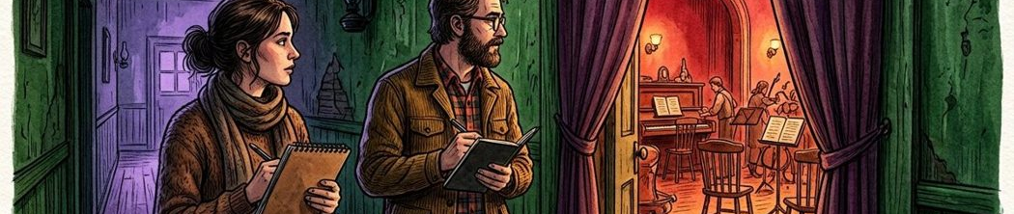
Figure 2. Fictional illustration, not a site record.
At the decision point, the record distinguishes an available prompt folder from an unconfirmed maintenance role. It supplies no measured user behaviour, cost estimate or implementation agreement.
A good audit preserves unknowns rather than filling them with an explanation that seems obvious afterwards. V4 still notes that ownership is unresolved, but that later note must not be misrepresented as a newly discovered fact that was confirmed at V3.

Analyst record / trace the source
Separate the supplied synthetic result from your interpretation and any real-world evidence still needed.
QUESTION FOR THE NEXT READER
What should remain uncertain even when the later sequence is visible?
01 | VERSIONED RECORD | 5 invented events / choice at V3
02 | LATER INFORMATION | V4 and V5 are follow-up, not decision-time inputs
03 | Known at V3 | Record known at v3 and its source boundary.
04 | Unknown at V3 | Record unknown at v3 and its source boundary.
05 | Later information | Record later information and its source boundary.

04 / DECISION AUDIT

Keep the considered options.
Figure 2. Fictional illustration, not a site record.
V2 lists retaining the folder, adding visible version labels or developing a full index. Record alternatives as they were framed rather than replacing them with a more sophisticated option invented later.
The lighter-label option aims at the narrow identification question with less proposed structure. The full index has broader ambitions and more maintenance questions. No actual resource availability, usability comparison or feasibility study is supplied for any option.

Analyst record / trace the source
Separate the supplied synthetic result from your interpretation and any real-world evidence still needed.
QUESTION FOR THE NEXT READER
Which trade-off was part of the original option set?
01 | VERSIONED RECORD | 5 invented events / choice at V3
02 | LATER INFORMATION | V4 and V5 are follow-up, not decision-time inputs
03 | Retain folder | Record retain folder and its source boundary.
04 | Add labels | Record add labels and its source boundary.
05 | Develop index | Record develop index and its source boundary.

05 / DECISION AUDIT

Trace the sequence without hindsight.

Figure 3. Fictional illustration, not a site record.
V1 frames the question, V2 records options, V3 selects labels for further exploration, V4 preserves the ownership gap and V5 requests a paper walkthrough. The export contains all five entries.
Only V1–V3 belong to the recorded decision-time set. The sequence shows how the discussion develops, not that the choice succeeded. It contains one choice event and two follow-up review events after that point.

Analyst record / trace the source
Separate the supplied synthetic result from your interpretation and any real-world evidence still needed.
QUESTION FOR THE NEXT READER
Which later entry must not be used as if it had justified the V3 choice?
01 | VERSIONED RECORD | 5 invented events / choice at V3
02 | LATER INFORMATION | V4 and V5 are follow-up, not decision-time inputs
03 | Before choice | Record before choice and its source boundary.
04 | Choice event | Record choice event and its source boundary.
05 | Follow-up entries | Record follow-up entries and its source boundary.

06 / DECISION AUDIT

Track an assumption as an assumption.
Figure 3. Fictional illustration, not a site record.
The V3 reasoning is that a lighter structure may fit the narrow question while maintenance remains unresolved. This is an authored rationale, not evidence that a real team lacked capacity or that labels would work.
V4 retains the ownership gap rather than declaring it solved. A traceable audit keeps the assumption, its status and any requested review together. It does not silently upgrade a plausible rationale into an established condition.

Analyst record / trace the source
Separate the supplied synthetic result from your interpretation and any real-world evidence still needed.
QUESTION FOR THE NEXT READER
Where could the report accidentally turn an assumption into a confirmed fact?
01 | VERSIONED RECORD | 5 invented events / choice at V3
02 | LATER INFORMATION | V4 and V5 are follow-up, not decision-time inputs
03 | Working assumption | Record working assumption and its source boundary.
04 | Status at choice | Record status at choice and its source boundary.
05 | Status at review | Record status at review and its source boundary.

07 / DECISION AUDIT

Distinguish follow-up from outcome.

Figure 4. Fictional illustration, not a site record.
V5 asks for a paper walkthrough. A request to inspect an option is not an implementation result, user outcome or completion of the proposed work.
The dataset supplies no actual walkthrough, publication, adoption or service change. A responsible audit cannot call the decision successful or unsuccessful on an outcome basis. It can only inspect the quality and limits of the recorded reasoning.

Analyst record / trace the source
Separate the supplied synthetic result from your interpretation and any real-world evidence still needed.
QUESTION FOR THE NEXT READER
What evidence would be needed to evaluate the actual outcome of a real decision?
01 | VERSIONED RECORD | 5 invented events / choice at V3
02 | LATER INFORMATION | V4 and V5 are follow-up, not decision-time inputs
03 | Follow-up requested | Record follow-up requested and its source boundary.
04 | Outcome not supplied | Record outcome not supplied and its source boundary.
05 | Permitted judgement | Record permitted judgement and its source boundary.

08 / DECISION AUDIT

Check for hindsight bias.
Figure 4. Fictional illustration, not a site record.
A later reviewer knows that ownership remains unresolved, but should still ask whether that uncertainty was visible and addressed appropriately at the time. Avoid judging an earlier choice as inevitable simply because the full sequence is now available.
The audit can compare the stated goal, available information and explicit conditions. It cannot reconstruct private intentions or blame real people from an invented record. Alternative explanations for a reasoning gap should remain questions.

Analyst record / trace the source
Separate the supplied synthetic result from your interpretation and any real-world evidence still needed.
QUESTION FOR THE NEXT READER
How would you phrase a critique without relying on information unavailable at the choice point?
01 | VERSIONED RECORD | 5 invented events / choice at V3
02 | LATER INFORMATION | V4 and V5 are follow-up, not decision-time inputs
03 | Later knowledge | Record later knowledge and its source boundary.
04 | Earlier information | Record earlier information and its source boundary.
05 | Fair review question | Record fair review question and its source boundary.

09 / DECISION AUDIT

Extract a reusable lesson.
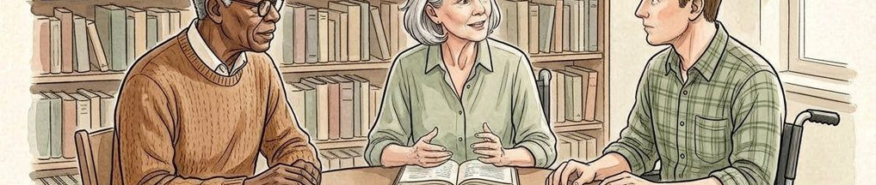
Figure 5. Fictional illustration, not a site record.
A lesson should identify a reasoning practice that could help a future decision, not claim that one fictional option is generally best. Keep the lesson connected to a visible part of the record.
For example, preserve the ownership question beside the option choice, and distinguish permission to explore from permission to implement. The lesson concerns documentation discipline; it does not establish a rule that labels are better than indexes.

Analyst record / trace the source
Separate the supplied synthetic result from your interpretation and any real-world evidence still needed.
QUESTION FOR THE NEXT READER
What practice could transfer to a different decision without copying the fictional choice?
01 | VERSIONED RECORD | 5 invented events / choice at V3
02 | LATER INFORMATION | V4 and V5 are follow-up, not decision-time inputs
03 | Traceable lesson | Record traceable lesson and its source boundary.
04 | Relevant entry | Record relevant entry and its source boundary.
05 | Generalisation limit | Record generalisation limit and its source boundary.

10 / DECISION AUDIT

Close the audit with open questions.
Figure 5. Fictional illustration, not a site record.
Package the original question, option set, decision-time information and later review entries together. Record what remains unknown and what further evidence would support a real outcome review.
The five-event source is complete for this exercise. It contains no real dates, appointments, approvals or results. Retain those boundaries when using the report structure for a genuine record, which would require verified context and appropriate access.

Analyst record / trace the source
Separate the supplied synthetic result from your interpretation and any real-world evidence still needed.
QUESTION FOR THE NEXT READER
What should a later reviewer verify before treating this as an account of a real decision?
01 | VERSIONED RECORD | 5 invented events / choice at V3
02 | LATER INFORMATION | V4 and V5 are follow-up, not decision-time inputs
03 | Audit boundary | Record audit boundary and its source boundary.
04 | Missing outcome source | Record missing outcome source and its source boundary.
05 | Next review question | Record next review question and its source boundary.

