01 / CHANGE CASE

Explain why a change deserves review.

Current concern | Proposed direction | Decision sought
Draft current concern: not yet confirmed. | Draft proposed direction: not yet confirmed. | Draft decision sought: not yet confirmed.

Figure 1. Fictional illustration, not a site record.
This proposal compares an imagined unstructured folder of discussion prompts with a versioned index. The decision sought is whether to investigate a change, not whether to replace a working system immediately.
The fictional concern is that a reader may not know which prompt version to use. No real incident, measured error rate or user complaint is supplied. The case for change therefore begins as a question requiring contextual evidence.

Working proposal record
Record a draft response in each labelled field. Keep unknowns visible and distinguish a proposal from an accepted commitment.
QUESTION FOR THE NEXT READER
Which source would show whether the proposed change addresses a real problem?

02 / CHANGE CASE

Describe the current state fairly.
Current strength | Possible limitation | Evidence gap
Draft current strength: not yet confirmed. | Draft possible limitation: not yet confirmed. | Draft evidence gap: not yet confirmed.

Figure 1. Fictional illustration, not a site record.
A current-state description should capture useful features as well as difficulties. Avoid making the existing approach look artificially poor to justify the preferred solution.
A simple folder can be easy to browse and require little maintenance. Its limitations might concern version visibility or ownership, but those are hypotheses until the actual context is examined. No real system audit has been performed.

Working proposal record
Record a draft response in each labelled field. Keep unknowns visible and distinguish a proposal from an accepted commitment.
QUESTION FOR THE NEXT READER
What should the proposed change preserve from the current approach?

03 / CHANGE CASE

Define the target condition.

Target capability | Intended reader benefit | Boundary
Draft target capability: not yet confirmed. | Draft intended reader benefit: not yet confirmed. | Draft boundary: not yet confirmed.

Figure 2. Fictional illustration, not a site record.
Describe the capability the change is intended to create rather than jumping straight to a product or tool. A target should be inspectable and remain open to more than one implementation.
The proposed condition is that a reader can identify a prompt version and a contact for questions. This does not require a particular platform, and it does not establish that a real contact or maintenance process exists.

Working proposal record
Record a draft response in each labelled field. Keep unknowns visible and distinguish a proposal from an accepted commitment.
QUESTION FOR THE NEXT READER
How could a reviewer recognise the target condition without assuming a particular tool?

04 / CHANGE CASE

Map the differences.
Current condition | Target condition | New dependency
Draft current condition: not yet confirmed. | Draft target condition: not yet confirmed. | Draft new dependency: not yet confirmed.

Figure 2. Fictional illustration, not a site record.
Compare current and target conditions using consistent dimensions. A difference map should show where a change creates new work as well as where it could reduce uncertainty.
Dimensions might include version labels, ownership information and update effort. A versioned index could clarify the current copy while creating an ongoing maintenance dependency. Both sides belong in the proposal.

Working proposal record
Record a draft response in each labelled field. Keep unknowns visible and distinguish a proposal from an accepted commitment.
QUESTION FOR THE NEXT READER
Which difference produces the largest new responsibility?

05 / CHANGE CASE

Consider affected roles.
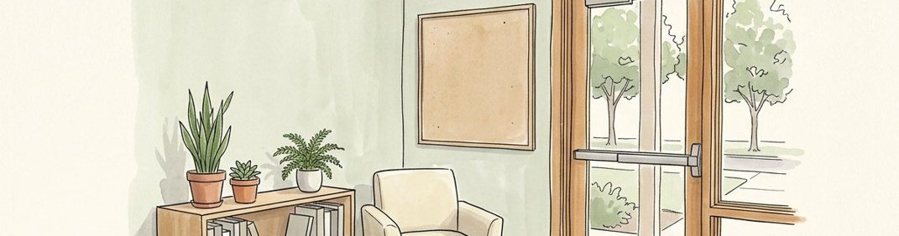
Role affected | Possible effect | Consultation question
Draft role affected: not yet confirmed. | Draft possible effect: not yet confirmed. | Draft consultation question: not yet confirmed.

Figure 3. Fictional illustration, not a site record.
Identify categories of people who could be affected and the questions each would need answered. Listing a role does not prove that a person has been consulted or has accepted the change.
A prompt author might need a revision route; a facilitator might need a stable reference; a maintainer might need update authority. These are discussion roles, not actual appointments or research findings about a workforce.

Working proposal record
Record a draft response in each labelled field. Keep unknowns visible and distinguish a proposal from an accepted commitment.
QUESTION FOR THE NEXT READER
Whose perspective could reveal a cost missing from the preferred change story?

06 / CHANGE CASE

Keep more than one option.
Full option | Lighter option | Retain-current option
Draft full option: not yet confirmed. | Draft lighter option: not yet confirmed. | Draft retain-current option: not yet confirmed.

Figure 3. Fictional illustration, not a site record.
Compare a full index, a lighter version label and retaining the current folder while clarifying its limits. An option set should include a credible no-change or smaller-change alternative.
The lighter option may require less maintenance but offer less discoverability. The full index may improve structure while increasing update work. No option is established as feasible or superior in a real environment.

Working proposal record
Record a draft response in each labelled field. Keep unknowns visible and distinguish a proposal from an accepted commitment.
QUESTION FOR THE NEXT READER
What criterion would distinguish a useful change from unnecessary complexity?

07 / CHANGE CASE

Propose a staged transition.
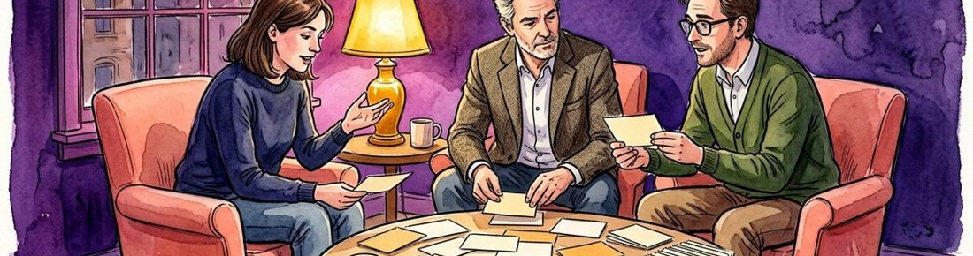
Review stage | Reversible step | Commitment boundary
Draft review stage: not yet confirmed. | Draft reversible step: not yet confirmed. | Draft commitment boundary: not yet confirmed.

Figure 4. Fictional illustration, not a site record.
A transition plan should make dependencies and reversibility visible. Do not present a fictional sequence as an agreed migration schedule or permission to change actual records.
A paper prototype could be reviewed before any real material is moved. A later trial, if independently authorised, could preserve the existing reference while examining the new structure. Actual access, retention and ownership conditions remain unresolved.

Working proposal record
Record a draft response in each labelled field. Keep unknowns visible and distinguish a proposal from an accepted commitment.
QUESTION FOR THE NEXT READER
Which step should remain reversible until the ownership questions are answered?

08 / CHANGE CASE

Name the change risks.
Uncertain event | Possible consequence | Review question
Draft uncertain event: not yet confirmed. | Draft possible consequence: not yet confirmed. | Draft review question: not yet confirmed.

Figure 4. Fictional illustration, not a site record.
Describe a risk as an uncertain event, a possible consequence and a question for responsible review. Avoid treating a short risk table as a complete assurance process.
A stale index could create false confidence about which copy is current. A missing maintainer could leave the new structure unsupported. These hypothetical risks point to governance questions, not evidence that a real failure has occurred.

Working proposal record
Record a draft response in each labelled field. Keep unknowns visible and distinguish a proposal from an accepted commitment.
QUESTION FOR THE NEXT READER
Which risk would undermine the reason for making the change at all?

09 / CHANGE CASE

Define what would count as useful evidence.

Review question | Suitable evidence | Unsupported inference
Draft review question: not yet confirmed. | Draft suitable evidence: not yet confirmed. | Draft unsupported inference: not yet confirmed.

Figure 5. Fictional illustration, not a site record.
Before recommending adoption, identify what a review would need to establish. Keep usability, maintenance and responsibility questions separate rather than reducing them to one success label.
A future review might examine whether the version is identifiable and whether update ownership is accepted. It could not infer a broader productivity improvement without suitable evidence. This document contains no trial results or real measurements.

Working proposal record
Record a draft response in each labelled field. Keep unknowns visible and distinguish a proposal from an accepted commitment.
QUESTION FOR THE NEXT READER
What evidence would justify revising or abandoning the preferred option?

10 / CHANGE CASE

Record a conditional decision.
Response | Prerequisite | Next review artifact
Draft response: not yet confirmed. | Draft prerequisite: not yet confirmed. | Draft next review artifact: not yet confirmed.

Figure 5. Fictional illustration, not a site record.
Invite a decision about the next review, with explicit prerequisites and unresolved questions. A conditional decision should not be written as completed implementation.
Possible response: develop a paper index after confirming the intended use and source material. Keep the alternative options and the current-state strengths attached, so a later reviewer can reconsider the direction rather than inherit a foregone conclusion.

Working proposal record
Record a draft response in each labelled field. Keep unknowns visible and distinguish a proposal from an accepted commitment.
QUESTION FOR THE NEXT READER
What exactly is authorised for discussion, and what remains outside this proposal?

