01 / CREATIVE TREATMENT

Give the concept a creative task.
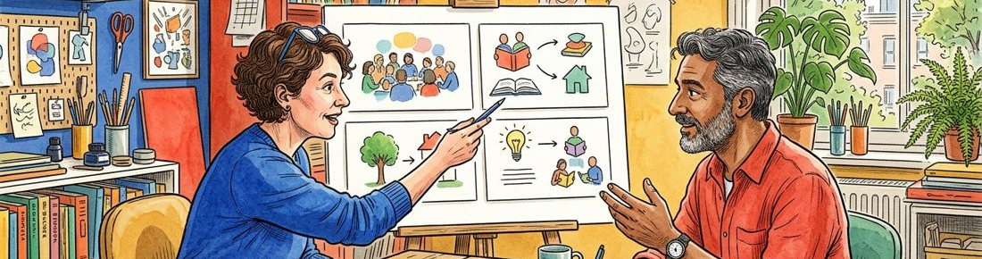
Figure 1. Fictional illustration, not a site record.
This treatment proposes a visual and verbal direction for an imaginary community-reading invitation. Begin with what the communication should help a reader understand, not a promise of campaign performance.
The working task is to invite a curious reader into a conversation about a short text. The decision sought is whether this direction is worth developing, not whether a real campaign should be published or funded.

Working proposal record
Record a draft response in each labelled field. Keep unknowns visible and distinguish a proposal from an accepted commitment.
QUESTION FOR THE NEXT READER
What should a reader understand after encountering the proposed invitation?
Communication task | Draft communication task: not yet confirmed.
Desired understanding | Draft desired understanding: not yet confirmed.
Direction decision | Draft direction decision: not yet confirmed.

02 / CREATIVE TREATMENT

State the audience assumption.
Figure 1. Fictional illustration, not a site record.
Describe the imagined communication situation and what remains unknown about a real audience. A fictional audience sketch is a design prompt, not evidence of demand or a tested preference.
The concept imagines an adult who is interested in reading but unsure what a discussion involves. Actual motivations, language needs, access conditions and participation choices would need contextual research before a real campaign.

Working proposal record
Record a draft response in each labelled field. Keep unknowns visible and distinguish a proposal from an accepted commitment.
QUESTION FOR THE NEXT READER
Which audience assumption should be challenged before developing the creative direction?
Imagined situation | Draft imagined situation: not yet confirmed.
Audience uncertainty | Draft audience uncertainty: not yet confirmed.
Research question | Draft research question: not yet confirmed.

03 / CREATIVE TREATMENT

Name the central idea.
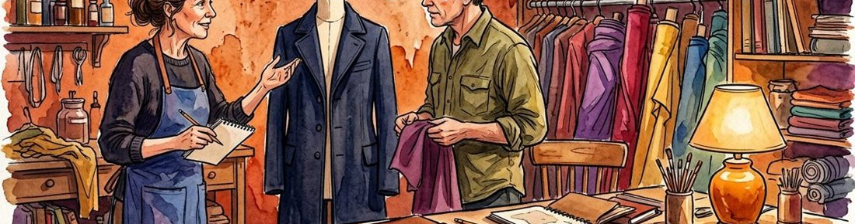
Figure 2. Fictional illustration, not a site record.
A useful concept can be stated simply enough to guide both words and images. The idea should explain the connection between the invitation and the intended conversation.
Working concept: a shared page can open more than one perspective. The line is a creative proposition, not a claim that reading produces a measured social outcome. Alternative wording should retain that distinction.

Working proposal record
Record a draft response in each labelled field. Keep unknowns visible and distinguish a proposal from an accepted commitment.
QUESTION FOR THE NEXT READER
What makes this one coherent direction rather than a collection of attractive references?
Concept sentence | Draft concept sentence: not yet confirmed.
Visual implication | Draft visual implication: not yet confirmed.
Claim boundary | Draft claim boundary: not yet confirmed.

04 / CREATIVE TREATMENT

Build a short narrative sequence.
Figure 2. Fictional illustration, not a site record.
Describe how the message unfolds across a beginning, a turn and an invitation. Narrative order helps a reviewer understand the intended experience without assuming a confirmed channel or running time.
Begin with a person noticing a passage, turn to two different readings of it, and close with a question about what the reader sees. The sequence is a proposed script, not a record of a real event.

Working proposal record
Record a draft response in each labelled field. Keep unknowns visible and distinguish a proposal from an accepted commitment.
QUESTION FOR THE NEXT READER
Which beat carries the main idea, and what could be removed without losing it?
Opening beat | Draft opening beat: not yet confirmed.
Perspective turn | Draft perspective turn: not yet confirmed.
Closing invitation | Draft closing invitation: not yet confirmed.

05 / CREATIVE TREATMENT

Set the visual language.
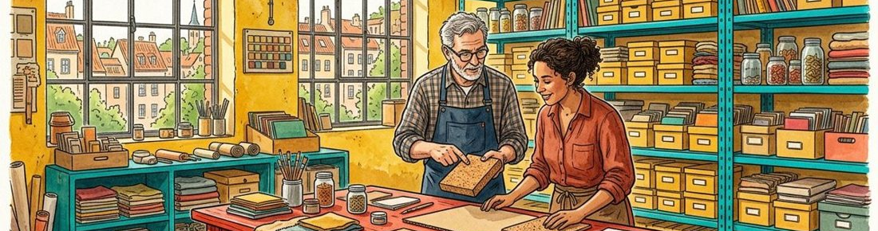
Figure 3. Fictional illustration, not a site record.
Explain the role of colour, composition and image treatment in the concept. A visual vocabulary should support the task rather than stand in for evidence about audience response.
Cobalt and vermilion can create contrast; close views of paper can keep the text central; two readings can be suggested through different annotations. The supplied watercolor images are illustrative references, not approved campaign assets.

Working proposal record
Record a draft response in each labelled field. Keep unknowns visible and distinguish a proposal from an accepted commitment.
QUESTION FOR THE NEXT READER
Which visual choice supports the idea, and which is only a stylistic preference?
Colour relationship | Draft colour relationship: not yet confirmed.
Composition principle | Draft composition principle: not yet confirmed.
Asset question | Draft asset question: not yet confirmed.

06 / CREATIVE TREATMENT

Write a sample scene.
Figure 3. Fictional illustration, not a site record.
Provide enough script detail to make the treatment discussable. Separate proposed copy from production instructions and from claims that would require substantiation.
Example scene: a hand rests beside a blank page; a voice asks What did you notice first? A second note offers another reading. This is an invented scene with no actual performer, consent, recording or production arrangement.

Working proposal record
Record a draft response in each labelled field. Keep unknowns visible and distinguish a proposal from an accepted commitment.
QUESTION FOR THE NEXT READER
What should the sample scene communicate without inventing an endorsement or result?
Proposed scene | Draft proposed scene: not yet confirmed.
Draft line | Draft draft line: not yet confirmed.
Meaning to preserve | Draft meaning to preserve: not yet confirmed.

07 / CREATIVE TREATMENT

Adapt the idea by medium.
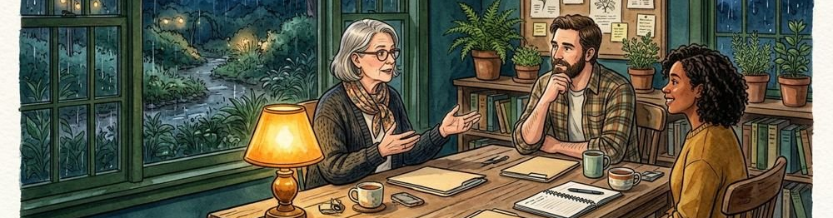
Figure 4. Fictional illustration, not a site record.
Show how the same concept could change across a poster, a short sequence or a discussion card. Adaptation should preserve the idea while acknowledging the limits of each format.
A poster might centre one question; a sequence could reveal two interpretations; a card could leave space for a response. No media slot, dimensions or real distribution arrangement is confirmed by these examples.

Working proposal record
Record a draft response in each labelled field. Keep unknowns visible and distinguish a proposal from an accepted commitment.
QUESTION FOR THE NEXT READER
Which part of the idea must stay consistent when the format changes?
Poster adaptation | Draft poster adaptation: not yet confirmed.
Sequence adaptation | Draft sequence adaptation: not yet confirmed.
Card adaptation | Draft card adaptation: not yet confirmed.

08 / CREATIVE TREATMENT

Expose production dependencies.
Figure 4. Fictional illustration, not a site record.
Name the decisions and permissions that would need resolution before real execution. A compelling treatment is not a production quote, license or approval.
Dependencies could include final copy, asset rights, accessibility review, responsible production roles and actual distribution specifications. Costs, dates and appointments are deliberately unconfirmed rather than represented by invented totals.

Working proposal record
Record a draft response in each labelled field. Keep unknowns visible and distinguish a proposal from an accepted commitment.
QUESTION FOR THE NEXT READER
Which unresolved dependency could change the creative direction itself?
Dependency | Draft dependency: not yet confirmed.
Review needed | Draft review needed: not yet confirmed.
Responsible role to confirm | Draft responsible role to confirm: not yet confirmed.

09 / CREATIVE TREATMENT

Ask reviewers useful questions.

Figure 5. Fictional illustration, not a site record.
Give reviewers a small set of questions linked to the creative task. This makes feedback more actionable than asking whether they like the artwork.
Questions might ask whether the central idea is clear, which line overstates the invitation and which visual cue is unnecessary. A reviewer’s reaction is not a representative audience result or permission to publish.

Working proposal record
Record a draft response in each labelled field. Keep unknowns visible and distinguish a proposal from an accepted commitment.
QUESTION FOR THE NEXT READER
What feedback would help choose between this direction and a credible alternative?
Idea clarity question | Draft idea clarity question: not yet confirmed.
Copy boundary question | Draft copy boundary question: not yet confirmed.
Visual question | Draft visual question: not yet confirmed.

10 / CREATIVE TREATMENT

Choose a direction with conditions.
Figure 5. Fictional illustration, not a site record.
Close with a record of what to develop, what to revise and what to leave unresolved. Choosing a direction for exploration is different from approving final production.
A bounded response could request a simpler opening scene and an alternative headline before another discussion. Keep the audience assumptions, image provenance and production dependencies attached when the treatment is shared.

Working proposal record
Record a draft response in each labelled field. Keep unknowns visible and distinguish a proposal from an accepted commitment.
QUESTION FOR THE NEXT READER
What should the next creative draft demonstrate before a production decision is considered?
Develop further | Draft develop further: not yet confirmed.
Revision requested | Draft revision requested: not yet confirmed.
Remaining condition | Draft remaining condition: not yet confirmed.

