01 / DEBATE ROOM

Set a bounded discussion question.
Figure 1. Fictional illustration, not a site record.
This course practises building and examining arguments. The issue is fictional: should an imagined reading group use one shared text or offer several choices?
The aim is to make reasoning visible, not to declare a universally correct policy or evaluate a real group. Keep the discussion within the stated exercise.

Issue / scope / decision not being made
Working record: Write the discussion question and one real-world conclusion it cannot settle. Keep your first attempt and your revised version so the change remains visible.
QUESTION FOR THE NEXT READER
Write the discussion question and one real-world conclusion it cannot settle.
ARGUMENT ELEMENT | WORKING POSITION
Issue | Write your issue here.
scope | Write your scope here.
decision not being made | Write your decision not being made here.



02 / DEBATE ROOM

Agree on the important terms.
Figure 1. Fictional illustration, not a site record.
Arguments become difficult to compare when speakers use the same word in different ways. Define the terms needed for this discussion before collecting reasons.
Shared text could mean one extract for one meeting, not a permanent reading rule. Choice could refer to selecting among three extracts rather than unrestricted material.

Term / working meaning / excluded meaning
Working record: Define shared, choice and useful for this particular exercise. Keep your first attempt and your revised version so the change remains visible.
QUESTION FOR THE NEXT READER
Define shared, choice and useful for this particular exercise.
ARGUMENT ELEMENT | WORKING POSITION
Term | Write your term here.
working meaning | Write your working meaning here.
excluded meaning | Write your excluded meaning here.

03 / DEBATE ROOM

Map a claim to its reasons.
Figure 2. Fictional illustration, not a site record.
State a claim, the reason offered for it and the assumption connecting them. A reason is not yet evidence, and the connecting assumption may be disputed.
Claim: one extract could focus the conversation. Reason: everyone can refer to the same passage. Assumption: a common reference is helpful for the intended discussion.

Claim / reason / connecting assumption
Working record: Build a three-part argument without claiming an observed learning outcome. Keep your first attempt and your revised version so the change remains visible.
QUESTION FOR THE NEXT READER
Build a three-part argument without claiming an observed learning outcome.
ARGUMENT ELEMENT | WORKING POSITION
Claim | Write your claim here.
reason | Write your reason here.
connecting assumption | Write your connecting assumption here.

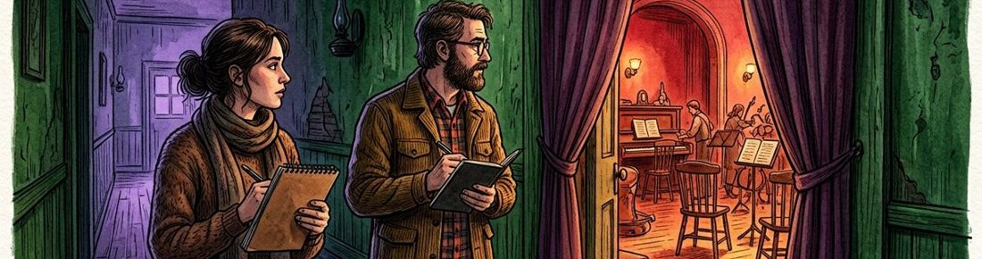

04 / DEBATE ROOM

Support the first position.
Figure 2. Fictional illustration, not a site record.
Develop the strongest bounded version of the shared-text argument. Separate a plausible mechanism from information that would be needed to establish it in practice.
A common passage may make references easier to locate. Whether that actually helps a particular group remains a question requiring suitable observation and participant context.

Supporting reason / mechanism / evidence needed
Working record: Write one strong supporting reason and the source needed to test its relevance. Keep your first attempt and your revised version so the change remains visible.
QUESTION FOR THE NEXT READER
Write one strong supporting reason and the source needed to test its relevance.
ARGUMENT ELEMENT | WORKING POSITION
Supporting reason | Write your supporting reason here.
mechanism | Write your mechanism here.
evidence needed | Write your evidence needed here.

05 / DEBATE ROOM

Represent the alternative fairly.
Figure 3. Fictional illustration, not a site record.
Build a version of the multiple-choice argument that its supporter would recognise. Do not weaken it simply to make your preferred position easier to defend.
Choice might let readers connect discussion to their interests. It could also make references harder to share. Both points belong in an honest comparison.

Alternative claim / strongest reason / acknowledged cost
Working record: Write the alternative argument before adding your response. Keep your first attempt and your revised version so the change remains visible.
QUESTION FOR THE NEXT READER
Write the alternative argument before adding your response.
ARGUMENT ELEMENT | WORKING POSITION
Alternative claim | Write your alternative claim here.
strongest reason | Write your strongest reason here.
acknowledged cost | Write your acknowledged cost here.



06 / DEBATE ROOM

Evaluate a source before using it.
Figure 3. Fictional illustration, not a site record.
Ask whether a source addresses the actual question, how it was produced and what it cannot establish. This exercise supplies no real empirical study.
A fictional preference quote can illustrate a viewpoint but cannot establish what most readers prefer. A beautiful illustration is not evidence about reading outcomes.

Source type / relevance / limit / permitted use
Working record: Classify an invented quotation and explain the narrow use you would allow. Keep your first attempt and your revised version so the change remains visible.
QUESTION FOR THE NEXT READER
Classify an invented quotation and explain the narrow use you would allow.
ARGUMENT ELEMENT | WORKING POSITION
Source type | Write your source type here.
relevance | Write your relevance here.
limit | Write your limit here.
permitted use | Write your permitted use here.

07 / DEBATE ROOM

Ask a question that could matter.
Figure 4. Fictional illustration, not a site record.
A useful challenge targets an assumption or a missing link rather than the speaker’s character. Give the other person room to clarify the argument.
Question: does the benefit of a common reference depend on the kind of discussion? That asks for a condition rather than assuming that the original claim is foolish.

Target claim / questioned assumption / clarification request
Working record: Write two respectful challenges addressed to different parts of the argument. Keep your first attempt and your revised version so the change remains visible.
QUESTION FOR THE NEXT READER
Write two respectful challenges addressed to different parts of the argument.
ARGUMENT ELEMENT | WORKING POSITION
Target claim | Write your target claim here.
questioned assumption | Write your questioned assumption here.
clarification request | Write your clarification request here.

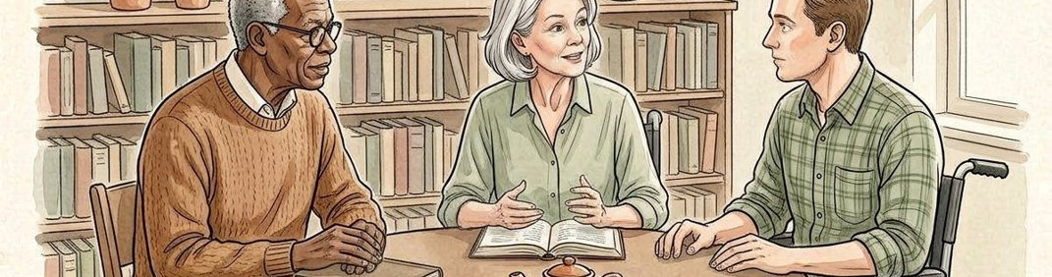

08 / DEBATE ROOM

Respond without changing the subject.
Figure 4. Fictional illustration, not a site record.
A response should identify the challenge, answer the part you can address and acknowledge what remains unresolved. It is acceptable to narrow the original claim.
A revised response might say a shared extract could help a close-reading exercise, while a broader discussion might benefit from several choices. The claim is now more conditional.

Challenge / response / qualification / unresolved issue
Working record: Answer one question and add a qualification that genuinely changes the claim. Keep your first attempt and your revised version so the change remains visible.
QUESTION FOR THE NEXT READER
Answer one question and add a qualification that genuinely changes the claim.
ARGUMENT ELEMENT | WORKING POSITION
Challenge | Write your challenge here.
response | Write your response here.
qualification | Write your qualification here.
unresolved issue | Write your unresolved issue here.

09 / DEBATE ROOM

Revise the argument map.
Figure 5. Fictional illustration, not a site record.
Update the claim, reasons and assumptions together. If the claim becomes narrower, check that the supporting reasons still address the revised version.
Replace one text is best with one shared extract may suit a session focused on close comparison. The revision concerns task fit rather than a universal ranking.

Earlier claim / revised claim / retained reason / removed assumption
Working record: Revise the map and cross out a reason that no longer fits. Keep your first attempt and your revised version so the change remains visible.
QUESTION FOR THE NEXT READER
Revise the map and cross out a reason that no longer fits.
ARGUMENT ELEMENT | WORKING POSITION
Earlier claim | Write your earlier claim here.
revised claim | Write your revised claim here.
retained reason | Write your retained reason here.
removed assumption | Write your removed assumption here.



10 / DEBATE ROOM

State a provisional position.
Figure 5. Fictional illustration, not a site record.
Finish with the position you can currently support, its strongest reason and a condition that could change your view. A provisional position is not a failure to decide.
For this invented close-reading session, a shared extract is a defensible starting option. Information about the actual group, purpose and materials could change that choice.

Position / reason / condition / open question
Working record: Write a closing position that leaves its evidence boundary visible. Keep your first attempt and your revised version so the change remains visible.
QUESTION FOR THE NEXT READER
Write a closing position that leaves its evidence boundary visible.
ARGUMENT ELEMENT | WORKING POSITION
Position | Write your position here.
reason | Write your reason here.
condition | Write your condition here.
open question | Write your open question here.

