01 / QUESTION LAB

Start with a noticed difference.
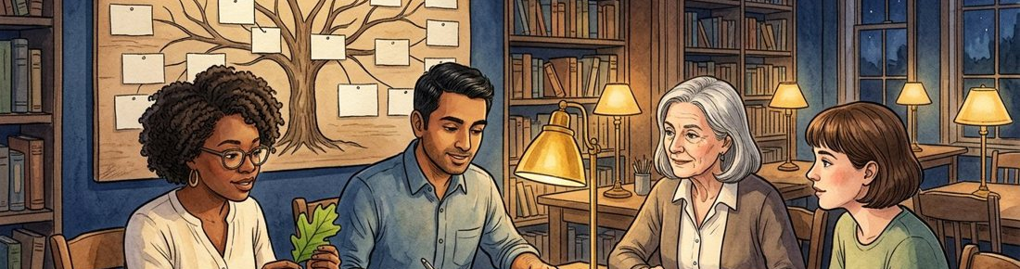
Figure 1. Fictional illustration, not a site record.
This inquiry course practises moving from a visible detail to a question that can be investigated. Use the fictional library scene as a prompt, not as research evidence.
An adult learner notices two differently coloured notebooks. The colour is visible; who uses them and why are unknown. The first task is to keep those statements separate.

Observation → question → assumption → evidence → revision
Working record: Record two visible details and one thing the picture cannot tell you. Keep your first attempt and your revised version so the change remains visible.
QUESTION FOR THE NEXT READER
Record two visible details and one thing the picture cannot tell you.
Observation → question → assumption → evidence → revision | Write your observation → question → assumption → evidence → revision here.

02 / QUESTION LAB

Build a question tree.
Figure 1. Fictional illustration, not a site record.
Put one broad curiosity at the root and divide it into smaller questions. Each branch should ask for a different kind of information rather than repeat the same judgement.
Root: how might a study corner support discussion? Branches might concern the purpose of the session, the material people use and how they choose a place to sit. None is established by a picture.

Root question / three branches / one selected leaf
Working record: Write a root question, three branches and the narrowest question worth pursuing first. Keep your first attempt and your revised version so the change remains visible.
QUESTION FOR THE NEXT READER
Write a root question, three branches and the narrowest question worth pursuing first.
Root question | Write your root question here.
three branches | Write your three branches here.
one selected leaf | Write your one selected leaf here.

03 / QUESTION LAB

Make an assumption card.
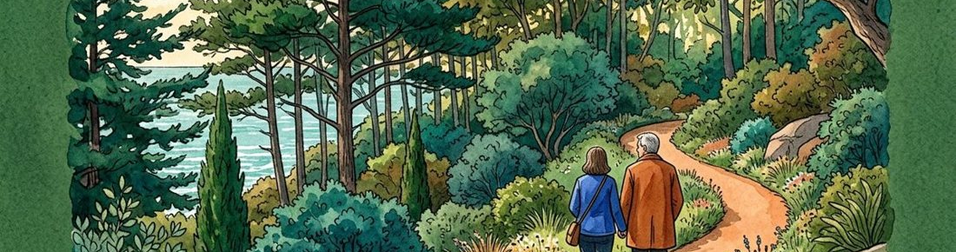
Figure 2. Fictional illustration, not a site record.
An assumption is a provisional explanation, not a finding. Give it a short name and record what you expect to observe if it were useful.
Assumption A: a shared sketch might help a discussion stay focused. A possible observation is whether speakers refer to the same sketch. Other explanations, such as a facilitator prompt, must remain visible.

Assumption / expected observation / alternative explanation
Working record: Complete one card without using the words proven or always. Keep your first attempt and your revised version so the change remains visible.
QUESTION FOR THE NEXT READER
Complete one card without using the words proven or always.
Assumption | Write your assumption here.
expected observation | Write your expected observation here.
alternative explanation | Write your alternative explanation here.

04 / QUESTION LAB

Request the evidence you need.
Figure 2. Fictional illustration, not a site record.
A useful evidence request names the question, the kind of material required and the limit of what that material could support. Do not collect personal data for this exercise.
For the shared-sketch question, an invented transcript with references to objects would be more relevant than a photograph of an attractive room. A transcript still would not establish a causal effect.

Question / source type / relevance / limitation
Working record: Write an evidence request that another learner could understand without seeing your notes. Keep your first attempt and your revised version so the change remains visible.
QUESTION FOR THE NEXT READER
Write an evidence request that another learner could understand without seeing your notes.
Question | Write your question here.
source type | Write your source type here.
relevance | Write your relevance here.
limitation | Write your limitation here.

05 / QUESTION LAB

Try a paper experiment.
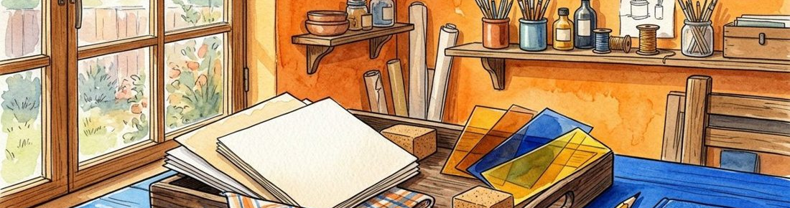
Figure 3. Fictional illustration, not a site record.
Use two short invented dialogue extracts to practise applying the same rule. This is a desk exercise in consistent reading, not an experiment involving real participants.
Extract A: I mean the left-hand shape. Extract B: I prefer this version. Code whether each sentence explicitly refers to a shared object. Keep the original wording beside your code.

Extract / coding rule / code / uncertainty
Working record: Apply one coding rule to both extracts and flag any ambiguous phrase. Keep your first attempt and your revised version so the change remains visible.
QUESTION FOR THE NEXT READER
Apply one coding rule to both extracts and flag any ambiguous phrase.
Extract | Write your extract here.
coding rule | Write your coding rule here.
code | Write your code here.
uncertainty | Write your uncertainty here.

06 / QUESTION LAB

Compare without inventing a winner.
Figure 3. Fictional illustration, not a site record.
A comparison should show the criterion before the judgement. If the material is too thin, an unresolved result is more useful than a confident ranking.
Sentence A names a shape; sentence B names a preference. That difference supports a description of the sentences, not a conclusion about which group learned more.

Criterion / example A / example B / bounded conclusion
Working record: Write a comparison that stays within what the two extracts actually contain. Keep your first attempt and your revised version so the change remains visible.
QUESTION FOR THE NEXT READER
Write a comparison that stays within what the two extracts actually contain.
Criterion | Write your criterion here.
example A | Write your example a here.
example B | Write your example b here.
bounded conclusion | Write your bounded conclusion here.

07 / QUESTION LAB

Invite a challenge.
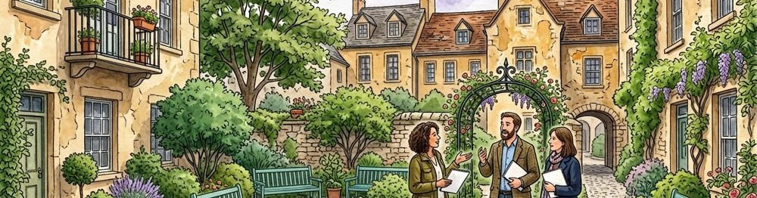
Figure 4. Fictional illustration, not a site record.
Peer feedback should identify a claim, ask which material supports it and offer one alternative reading. The aim is to improve the inquiry rather than evaluate a person.
A peer might ask whether left-hand refers to a shared diagram or only the speaker’s page. That question exposes a missing context which the coding rule should acknowledge.

Claim under review / challenge / missing context
Working record: Write one generous challenge and the exact passage it addresses. Keep your first attempt and your revised version so the change remains visible.
QUESTION FOR THE NEXT READER
Write one generous challenge and the exact passage it addresses.
Claim under review | Write your claim under review here.
challenge | Write your challenge here.
missing context | Write your missing context here.

08 / QUESTION LAB

Show your revision.
Figure 4. Fictional illustration, not a site record.
Keep the earlier wording visible beside the revision so a reader can see which assumption changed. Revision is a traceable decision rather than a replacement of the record.
Earlier: the shared sketch improved discussion. Revised: one invented sentence explicitly names a shape, while the setting and effect on discussion remain unknown.

Before / reason for change / after
Working record: Revise one claim and name the evidence boundary that prompted the change. Keep your first attempt and your revised version so the change remains visible.
QUESTION FOR THE NEXT READER
Revise one claim and name the evidence boundary that prompted the change.
Before | Write your before here.
reason for change | Write your reason for change here.
after | Write your after here.

09 / QUESTION LAB

Transfer the method.
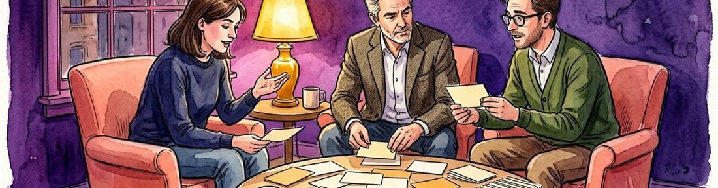
Figure 5. Fictional illustration, not a site record.
Apply the inquiry sequence to a different fictional scene. Transfer means retaining the reasoning steps while changing the subject, not copying the previous conclusion.
In a courtyard illustration, a learner notices an empty chair. Start with a question about what context is missing; do not infer low attendance, exclusion or preference from the empty seat.

New detail / new question / source request
Working record: Draft a fresh question tree for an object outside the library example. Keep your first attempt and your revised version so the change remains visible.
QUESTION FOR THE NEXT READER
Draft a fresh question tree for an object outside the library example.
New detail | Write your new detail here.
new question | Write your new question here.
source request | Write your source request here.

10 / QUESTION LAB

Keep an inquiry record.
Figure 5. Fictional illustration, not a site record.
Finish with a compact account of the route you took: noticed detail, selected question, assumption, source request and revised claim. A useful record includes an unresolved question.
This course provides no grade or accredited qualification. Its outcome is a more inspectable piece of reasoning and a clear account of which evidence you still do not have.

Detail / question / assumption / revision / next source
Working record: Choose the strongest revision in your record and explain why it is more careful. Keep your first attempt and your revised version so the change remains visible.
QUESTION FOR THE NEXT READER
Choose the strongest revision in your record and explain why it is more careful.
Detail | Write your detail here.
question | Write your question here.
assumption | Write your assumption here.
revision | Write your revision here.
next source | Write your next source here.

