01 / SELF-PACED ROUTE

Choose a useful starting point.
Current comfort | Write your current comfort here.
difficult step | Write your difficult step here.
chosen focus | Write your chosen focus here.

Figure 1. Fictional illustration, not a site record.
This self-paced course helps an adult learner practise reading and summarising a short fictional passage. Start by identifying which part of that task feels least clear.
You may want practice locating a main idea, distinguishing an example from a claim or writing a concise summary. This self-check is a personal choice, not a diagnostic assessment.

Current comfort / difficult step / chosen focus
Working record: Select one focus and describe it in observable terms. Keep your first attempt and your revised version so the change remains visible.
QUESTION FOR THE NEXT READER
Select one focus and describe it in observable terms.
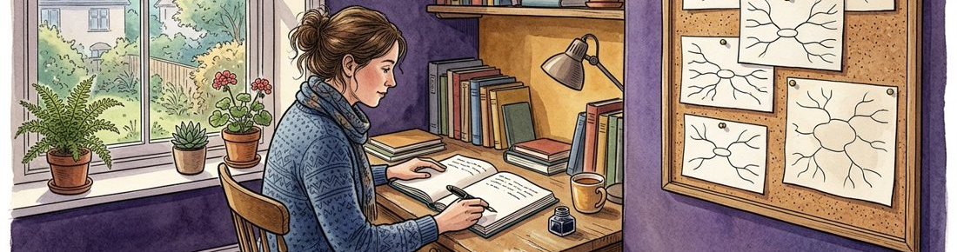

02 / SELF-PACED ROUTE

Set a small learning goal.
Action | Write your action here.
artifact | Write your artifact here.
review question | Write your review question here.

Figure 1. Fictional illustration, not a site record.
A useful goal describes an action you can review in your own work. Avoid a broad promise such as become an excellent reader by the end of the document.
Example: write a two-sentence summary that keeps the main claim and one qualification. The goal concerns a written artifact rather than a certificate or score.

Action / artifact / review question
Working record: Write a goal you can check against a short piece of your own writing. Keep your first attempt and your revised version so the change remains visible.
QUESTION FOR THE NEXT READER
Write a goal you can check against a short piece of your own writing.

03 / SELF-PACED ROUTE

Pick a route through the practice.
Route A | Write your route a here.
route B | Write your route b here.
route C | Write your route c here.
return point | Write your return point here.

Figure 2. Fictional illustration, not a site record.
Choose a route based on your focus while retaining the same final reflection. Route A starts with the main claim; route B starts with examples; route C starts with uncertainty.
Suggested route A: pages 4, 5, 6, 9, 10. Route B: pages 5, 4, 7, 9, 10. Route C: pages 6, 7, 8, 9, 10. You can revisit any page.

Route A / route B / route C / return point
Working record: Choose a route and name the reason it fits your present question. Keep your first attempt and your revised version so the change remains visible.
QUESTION FOR THE NEXT READER
Choose a route and name the reason it fits your present question.
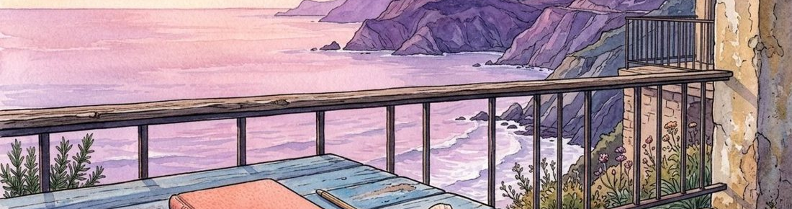

04 / SELF-PACED ROUTE

Take a note that separates roles.
Claim | Write your claim here.
example | Write your example here.
qualification | Write your qualification here.

Figure 2. Fictional illustration, not a site record.
Label the main claim, supporting example and qualification in an invented passage. Notes are easier to reuse when they preserve these distinctions.
Passage: A shared sketch may focus a conversation; for example, a speaker can point to a shape. This depends on the discussion task. The final sentence qualifies the first.

Claim / example / qualification
Working record: Make a three-part note without turning may into will. Keep your first attempt and your revised version so the change remains visible.
QUESTION FOR THE NEXT READER
Make a three-part note without turning may into will.

05 / SELF-PACED ROUTE

Try a summary station.
Original idea | Write your original idea here.
shorter wording | Write your shorter wording here.
retained condition | Write your retained condition here.

Figure 3. Fictional illustration, not a site record.
Write a short summary of the passage using fewer words while preserving its uncertainty. Concision should not erase the condition that makes the claim accurate.
Possible draft: A shared sketch can provide a common reference, but its usefulness depends on the task. This is a summary of an invented passage, not a research finding.

Original idea / shorter wording / retained condition
Working record: Write your own two-sentence summary and underline its qualification. Keep your first attempt and your revised version so the change remains visible.
QUESTION FOR THE NEXT READER
Write your own two-sentence summary and underline its qualification.
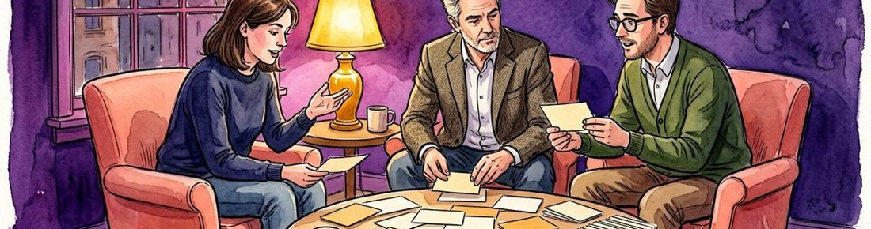

06 / SELF-PACED ROUTE

Review with a feedback key.
Claim retained | Write your claim retained here.
example handled | Write your example handled here.
condition retained | Write your condition retained here.

Figure 3. Fictional illustration, not a site record.
Compare the meaning of your summary with the source passage. The key checks whether a claim, example or condition disappeared; it does not assign a grade.
If your draft says shared sketches improve all discussions, it has expanded the original claim. If it merely lists a shape, it may have retained the example but lost the main idea.

Claim retained / example handled / condition retained
Working record: Identify one expansion or omission in your draft and explain its effect. Keep your first attempt and your revised version so the change remains visible.
QUESTION FOR THE NEXT READER
Identify one expansion or omission in your draft and explain its effect.

07 / SELF-PACED ROUTE

Use a targeted support page.
Difficulty | Write your difficulty here.
support move | Write your support move here.
new attempt | Write your new attempt here.

Figure 4. Fictional illustration, not a site record.
Return to the step that caused difficulty rather than restarting the whole course. A support exercise should address a specific confusion.
If examples dominate your notes, highlight only the sentence that makes the general claim. If uncertainty disappears, copy the conditional phrase before writing a new summary.

Difficulty / support move / new attempt
Working record: Choose one support move and use it on the same passage. Keep your first attempt and your revised version so the change remains visible.
QUESTION FOR THE NEXT READER
Choose one support move and use it on the same passage.
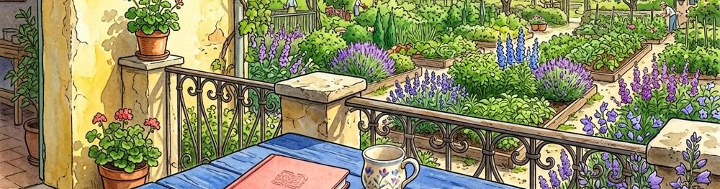

08 / SELF-PACED ROUTE

Apply the method to a new passage.
New claim | Write your new claim here.
condition | Write your condition here.
concise version | Write your concise version here.

Figure 4. Fictional illustration, not a site record.
Transfer the reading routine to another invented statement. Keep the main claim and its boundary visible instead of borrowing the conclusion from the earlier example.
New passage: offering several texts might invite different interests; however, a discussion needs a way to share references. Identify the claim and the condition before summarising.

New claim / condition / concise version
Working record: Write a fresh summary and note one difference from the shared-sketch passage. Keep your first attempt and your revised version so the change remains visible.
QUESTION FOR THE NEXT READER
Write a fresh summary and note one difference from the shared-sketch passage.

09 / SELF-PACED ROUTE

Collect the learning artifacts.
Artifact | Write your artifact here.
version | Write your version here.
change | Write your change here.
reason | Write your reason here.

Figure 5. Fictional illustration, not a site record.
Bring your first note, first summary, feedback note and revised summary together. A small portfolio makes the route visible even when you took the pages out of order.
Label each artifact by version, not an invented completion date. Include one line explaining why the revised version better matches the source.

Artifact / version / change / reason
Working record: Select four artifacts and arrange them so another reader can follow the revision. Keep your first attempt and your revised version so the change remains visible.
QUESTION FOR THE NEXT READER
Select four artifacts and arrange them so another reader can follow the revision.


10 / SELF-PACED ROUTE

Choose the next route.
Clearer step | Write your clearer step here.
remaining difficulty | Write your remaining difficulty here.
next practice | Write your next practice here.

Figure 5. Fictional illustration, not a site record.
Reflect on the step that became clearer and the difficulty that remains. The next route should follow from that observation rather than a generic instruction to practise more.
You might continue with conditional claims, compare two passages or practise separating examples from explanations. No result about real learner performance is supplied by this template.

Clearer step / remaining difficulty / next practice
Working record: Name one next practice task and the artifact you will use to review it. Keep your first attempt and your revised version so the change remains visible.
QUESTION FOR THE NEXT READER
Name one next practice task and the artifact you will use to review it.

